Results and Evaluation
Secure Federated Intelligence Platform: federated learning across hospitals with secure aggregation, distributed differential privacy and a verifiable blockchain ledger. All numbers are produced by the code in this repository (`python -m experiments.run_experiments all`, `python -m report.build_report`).

1 Experimental setup
All experiments use four real hospital silos (UCI Heart Disease). Results are means ± standard deviations over several random seeds; each table states its seed count.
Table 1. UCI Heart Disease: the four real hospital silos (75% train / 25% test per silo).
hospital (silo) | patients | positive (heart disease) | prevalence | features
Cleveland | 303 | 139 | 0.46 | 13
Hungarian | 294 | 106 | 0.36 | 13
Switzerland | 123 | 115 | 0.93 | 13
VA | 200 | 149 | 0.75 | 13
total | 920 | 509 |  | 13

Table 2. Experimental setup.
parameter | value
model | logistic regression (13+1 parameters); MLP (1,665) on Covertype
local training | 15 epochs SGD, lr 0.05, batch 32
update clipping | L2 norm C = 0.5
differential privacy | client-level Gaussian mechanism, RDP accountant, delta = 1e-5
noise split | distributed: sigma = zC/sqrt(h); local: sigma = zC
secure aggregation | X25519 pairwise masks + self mask, Shamir threshold floor(n/2)+1
commitments | Pedersen vector commitments, 1024-bit Schnorr group, 256-bit order
ZK norm proof | Sigma protocols + bit-decomposition range proof (Fiat-Shamir)
fixed point | 2^20
audit rate | 0.25 (default)
ledger | Solidity 0.8.24 contract; Hardhat chain or Besu QBFT (4 validators)
seeds | 5-20 per experiment, reported as mean ± s.d.

2 Privacy and utility
How much accuracy does privacy cost, and does splitting the noise across hospitals under secure aggregation help?
Table 3. Privacy-utility trade-off (5 rounds, 8 seeds, mean ± s.d.).
setting | eps_target | accuracy | AUC | runs
FedAvg (no DP) | none | 0.815 ± 0.015 | 0.887 ± 0.014 | 8
centralized | none | 0.815 ± 0.023 | 0.888 ± 0.018 | 8
distributed DP | 1.000 | 0.565 ± 0.089 | 0.589 ± 0.126 | 8
distributed DP | 2.000 | 0.597 ± 0.081 | 0.650 ± 0.108 | 8
distributed DP | 4.000 | 0.679 ± 0.051 | 0.751 ± 0.077 | 8
distributed DP | 8.000 | 0.770 ± 0.036 | 0.840 ± 0.035 | 8
distributed DP | 16.000 | 0.795 ± 0.023 | 0.874 ± 0.017 | 8
distributed DP | 32.000 | 0.806 ± 0.011 | 0.883 ± 0.015 | 8
local DP | 1.000 | 0.548 ± 0.088 | 0.556 ± 0.134 | 8
local DP | 2.000 | 0.564 ± 0.088 | 0.585 ± 0.126 | 8
local DP | 4.000 | 0.593 ± 0.077 | 0.641 ± 0.111 | 8
local DP | 8.000 | 0.667 ± 0.057 | 0.732 ± 0.083 | 8
local DP | 16.000 | 0.759 ± 0.036 | 0.826 ± 0.042 | 8
local DP | 32.000 | 0.788 ± 0.025 | 0.868 ± 0.019 | 8

Table 4. Effect of the number of communication rounds at epsilon = 8.
setting | rounds | accuracy | AUC
distributed DP | 3 | 0.755 ± 0.030 | 0.841 ± 0.025
distributed DP | 5 | 0.770 ± 0.036 | 0.840 ± 0.035
distributed DP | 10 | 0.783 ± 0.037 | 0.850 ± 0.041
distributed DP | 20 | 0.720 ± 0.073 | 0.799 ± 0.062
distributed DP | 40 | 0.712 ± 0.041 | 0.782 ± 0.050
local DP | 3 | 0.672 ± 0.070 | 0.745 ± 0.083
local DP | 5 | 0.667 ± 0.057 | 0.732 ± 0.083
local DP | 10 | 0.705 ± 0.076 | 0.767 ± 0.103
local DP | 20 | 0.652 ± 0.120 | 0.704 ± 0.122
local DP | 40 | 0.655 ± 0.067 | 0.733 ± 0.085

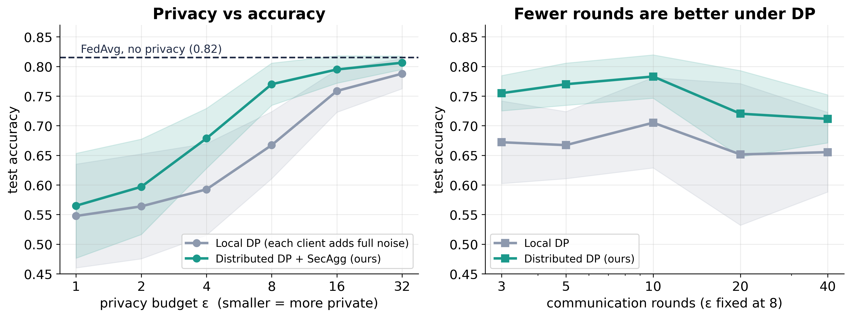
Figure 1. Privacy-utility trade-off. Left: test accuracy against the privacy budget epsilon for local DP (every hospital adds full noise) and our distributed DP under secure aggregation (noise split across hospitals); dashed line is FedAvg without privacy. Right: with epsilon fixed at 8, fewer communication rounds are better under DP. Mean +/- 1 s.d. over 8 seeds; four real hospital silos.
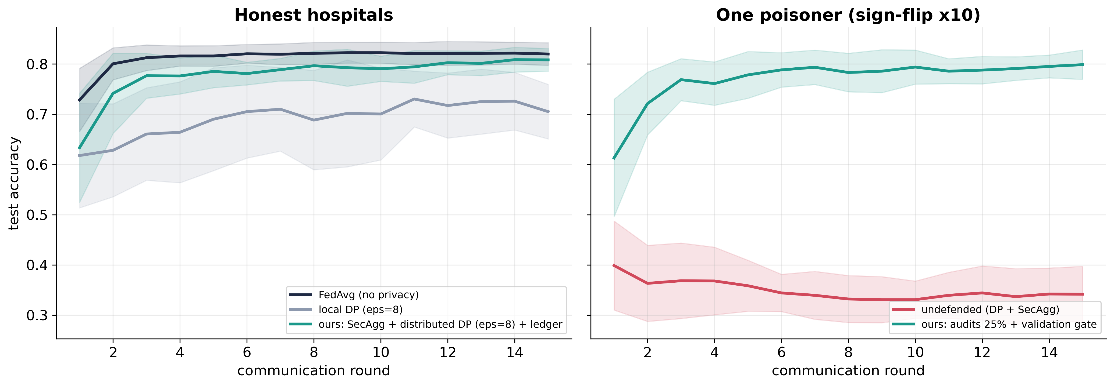
Figure 2. Test accuracy per round (mean +/- s.d., 10 seeds, 8 hospitals, epsilon = 8 over 15 rounds). Our system tracks FedAvg closely and clearly beats local DP; under a sign-flip poisoner the undefended model is destroyed while the defended one recovers after the attacker is banned.

3 What the system protects against
Membership inference, a curious server, malicious hospitals and a malicious server, and the defences that stop them.
Table 5. Membership inference on planted canary records (5 seeds).
eps_target | model accuracy | canary AUC | TPR @ 10% FPR
4.000 | 0.543 ± 0.061 | 0.488 ± 0.057 | 0.101 ± 0.028
16.000 | 0.556 ± 0.054 | 0.470 ± 0.047 | 0.085 ± 0.014
64.000 | 0.655 ± 0.076 | 0.531 ± 0.060 | 0.118 ± 0.058
256.000 | 0.771 ± 0.033 | 0.570 ± 0.053 | 0.152 ± 0.066
no DP | 0.787 ± 0.032 | 0.660 ± 0.060 | 0.176 ± 0.071

Table 6. Attack matrix: undefended vs defended (20 seeds).
attack | defence | accuracy | detected | rejected rounds | seeds
missing DP noise (under-report) | FedAvg+DP+SecAgg (no ledger) | 0.81 ± 0.03 | 0% | 0.0 | 20
missing DP noise (under-report) | ours, audit 25% | 0.81 ± 0.03 | 100% | 0.0 | 20
missing DP noise (under-report) | ours, audit 50% | 0.80 ± 0.03 | 100% | 0.0 | 20
none | FedAvg+DP+SecAgg (no ledger) | 0.80 ± 0.03 | 0% | 0.0 | 20
none | ours, audit 25% | 0.80 ± 0.02 | 0% | 0.0 | 20
none | ours, audit 50% | 0.80 ± 0.03 | 0% | 0.0 | 20
over-budget declaration | FedAvg+DP+SecAgg (no ledger) | 0.81 ± 0.03 | 0% | 0.0 | 20
over-budget declaration | ours, audit 25% | 0.80 ± 0.03 | 100% | 1.0 | 20
over-budget declaration | ours, audit 50% | 0.80 ± 0.03 | 100% | 1.0 | 20
poison: label-flip (2 clients) | FedAvg+DP+SecAgg (no ledger) | 0.76 ± 0.04 | 0% | 0.0 | 20
poison: label-flip (2 clients) | ours, audit 25% | 0.77 ± 0.04 | 0% | 0.0 | 20
poison: label-flip (2 clients) | ours, audit 50% | 0.76 ± 0.04 | 0% | 0.0 | 20
poison: sign-flip x10 | FedAvg+DP+SecAgg (no ledger) | 0.33 ± 0.05 | 0% | 0.0 | 20
poison: sign-flip x10 | ours, audit 25% | 0.74 ± 0.16 | 95% | 0.0 | 20
poison: sign-flip x10 | ours, audit 50% | 0.77 ± 0.08 | 100% | 0.0 | 20
server drops a client | FedAvg+DP+SecAgg (no ledger) | 0.80 ± 0.04 | 0% | 0.0 | 20
server drops a client | ours, audit 25% | 0.80 ± 0.03 | 100% | 4.0 | 20
server drops a client | ours, audit 50% | 0.80 ± 0.03 | 100% | 4.0 | 20
server reverses aggregate | FedAvg+DP+SecAgg (no ledger) | 0.68 ± 0.12 | 0% | 0.0 | 20
server reverses aggregate | ours, audit 25% | 0.79 ± 0.04 | 100% | 4.0 | 20
server reverses aggregate | ours, audit 50% | 0.80 ± 0.03 | 100% | 4.0 | 20
stealth poison (forged input) | FedAvg+DP+SecAgg (no ledger) | 0.70 ± 0.07 | 0% | 0.0 | 20
stealth poison (forged input) | ours, audit 25% | 0.79 ± 0.03 | 100% | 4.0 | 20
stealth poison (forged input) | ours, audit 50% | 0.79 ± 0.03 | 100% | 4.0 | 20

Table 7. Audit policies against persistent and sleeper poisoners.
scenario | policy | accuracy | attacker banned | emergency audits / run | honest exposure | seeds
honest | ZK norm proofs (audit 0%) | 0.795 ± 0.016 | 0% | 0.00 | 0.00 | 8
honest | audit 10% + validation gate | 0.807 ± 0.028 | 0% | 0.00 | 0.10 | 16
honest | audit 25% + validation gate | 0.803 ± 0.022 | 0% | 0.00 | 0.25 | 16
honest | audit 25% only | 0.804 ± 0.029 | 0% | 0.00 | 0.27 | 16
honest | no defence (DP+SecAgg) | 0.807 ± 0.026 | 0% | 0.00 | 0.00 | 16
persistent sign-flip x10 | ZK norm proofs (audit 0%) | 0.785 ± 0.031 | 100% | 0.00 | 0.00 | 8
persistent sign-flip x10 | audit 10% + validation gate | 0.800 ± 0.033 | 100% | 0.75 | 0.38 | 16
persistent sign-flip x10 | audit 25% + validation gate | 0.788 ± 0.028 | 100% | 0.62 | 0.47 | 16
persistent sign-flip x10 | audit 25% only | 0.708 ± 0.153 | 94% | 0.00 | 0.27 | 16
persistent sign-flip x10 | no defence (DP+SecAgg) | 0.340 ± 0.044 | 0% | 0.00 | 0.00 | 16
sleeper sign-flip (rounds 5-9) | ZK norm proofs (audit 0%) | 0.800 ± 0.027 | 100% | 0.00 | 0.00 | 8
sleeper sign-flip (rounds 5-9) | audit 10% + validation gate | 0.768 ± 0.060 | 100% | 0.75 | 0.30 | 16
sleeper sign-flip (rounds 5-9) | audit 25% + validation gate | 0.767 ± 0.063 | 94% | 0.31 | 0.32 | 16
sleeper sign-flip (rounds 5-9) | audit 25% only | 0.719 ± 0.098 | 88% | 0.00 | 0.27 | 16
sleeper sign-flip (rounds 5-9) | no defence (DP+SecAgg) | 0.556 ± 0.089 | 0% | 0.00 | 0.00 | 16

Table 8. Accuracy under attack: robust aggregation baselines vs our system (16 seeds).
system | server sees updates | honest | label-flip (2 clients) | sign-flip x1 (inside the bound) | sign-flip x10 | sleeper sign-flip x10
FedAvg (mean) | yes | 0.814 ± 0.021 | 0.805 ± 0.023 | 0.816 ± 0.014 | 0.336 ± 0.061 | 0.516 ± 0.101
Krum | yes | 0.761 ± 0.041 | 0.779 ± 0.034 | 0.792 ± 0.035 | 0.794 ± 0.032 | 0.770 ± 0.040
Multi-Krum | yes | 0.814 ± 0.021 | 0.814 ± 0.020 | 0.819 ± 0.021 | 0.819 ± 0.021 | 0.814 ± 0.020
coord. median | yes | 0.814 ± 0.021 | 0.793 ± 0.022 | 0.810 ± 0.020 | 0.808 ± 0.020 | 0.811 ± 0.018
ours (SecAgg + DP + ledger + gate) | no | 0.803 ± 0.022 | 0.773 ± 0.048 | 0.792 ± 0.026 | 0.788 ± 0.028 | 0.767 ± 0.063
trimmed mean | yes | 0.813 ± 0.021 | 0.805 ± 0.023 | 0.814 ± 0.018 | 0.811 ± 0.019 | 0.814 ± 0.018

Table 9. Ablation: final accuracy as layers are added (8 seeds).
layer | client skips DP noise | honest | poisoner (sign-flip x10) | server reverses aggregate | stealth forger
1 FedAvg | 0.82 | 0.82 | 0.33 | 0.81 | 0.74
2 + DP (noise) | 0.81 | 0.81 | 0.32 | 0.71 | 0.68
3 + SecAgg | 0.81 | 0.81 | 0.32 | 0.71 | 0.68
4 + ledger (commit, audit, verify) | 0.81 | 0.81 | 0.65 | 0.80 | 0.79
5 + validation gate | 0.81 | 0.79 | 0.78 | 0.80 | 0.80
6 + blame phase | 0.81 | 0.79 | 0.78 | 0.81 | 0.79

Table 10. Audit rate, audit mode and detection (20 seeds).
attacker | audit_mode | audit_rate | accuracy | caught | first detection round | honest exposure
no DP noise | seeded | 0.000 | 0.798 ± 0.035 | 0% | - | 0.00
no DP noise | seeded | 0.100 | 0.808 ± 0.027 | 70% | 3.7 | 0.09
no DP noise | seeded | 0.250 | 0.801 ± 0.030 | 100% | 3.1 | 0.27
no DP noise | seeded | 0.500 | 0.790 ± 0.033 | 100% | 0.8 | 0.50
no DP noise | seeded | 1.000 | 0.784 ± 0.027 | 100% | 0.0 | 1.00
no DP noise | statistical | 0.000 | 0.798 ± 0.035 | 0% | - | 0.00
no DP noise | statistical | 0.100 | 0.808 ± 0.027 | 0% | - | 0.10
no DP noise | statistical | 0.250 | 0.803 ± 0.025 | 0% | - | 0.24
no DP noise | statistical | 0.500 | 0.794 ± 0.037 | 0% | - | 0.50
no DP noise | statistical | 1.000 | 0.802 ± 0.029 | 0% | - | 1.00
sign-flip x10 | seeded | 0.000 | 0.358 ± 0.057 | 0% | - | 0.00
sign-flip x10 | seeded | 0.100 | 0.638 ± 0.195 | 80% | 4.6 | 0.11
sign-flip x10 | seeded | 0.250 | 0.720 ± 0.143 | 95% | 2.7 | 0.25
sign-flip x10 | seeded | 0.500 | 0.800 ± 0.025 | 100% | 0.4 | 0.50
sign-flip x10 | seeded | 1.000 | 0.789 ± 0.035 | 100% | 0.0 | 1.00
sign-flip x10 | statistical | 0.000 | 0.358 ± 0.057 | 0% | - | 0.00
sign-flip x10 | statistical | 0.100 | 0.638 ± 0.202 | 80% | 4.6 | 0.10
sign-flip x10 | statistical | 0.250 | 0.721 ± 0.143 | 95% | 2.7 | 0.23
sign-flip x10 | statistical | 0.500 | 0.792 ± 0.038 | 100% | 0.4 | 0.49
sign-flip x10 | statistical | 1.000 | 0.787 ± 0.024 | 100% | 0.0 | 1.00

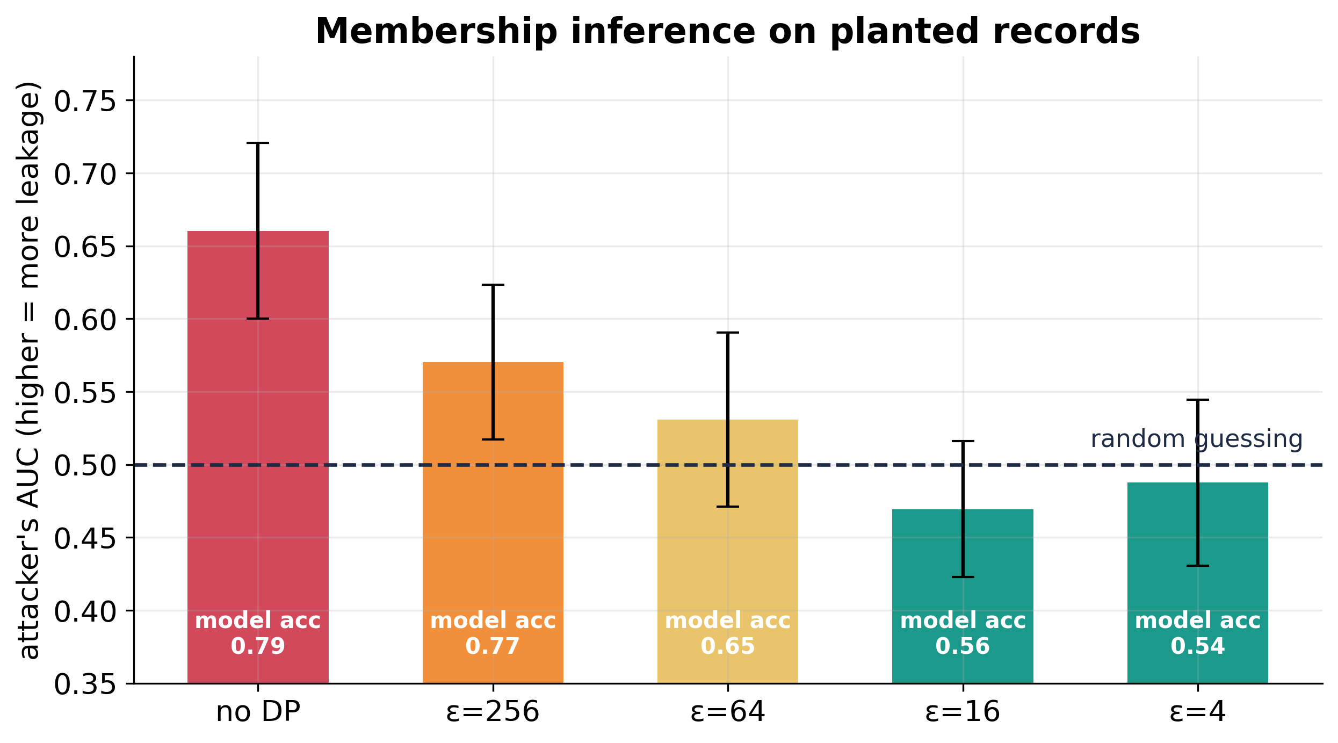
Figure 3. Membership inference on 50 planted canary records against an over-fitted model. Attacker AUC falls from 0.66 without DP to chance (0.5) for epsilon <= 16; bars annotate the accuracy cost. Mean +/- s.d. over 5 seeds.
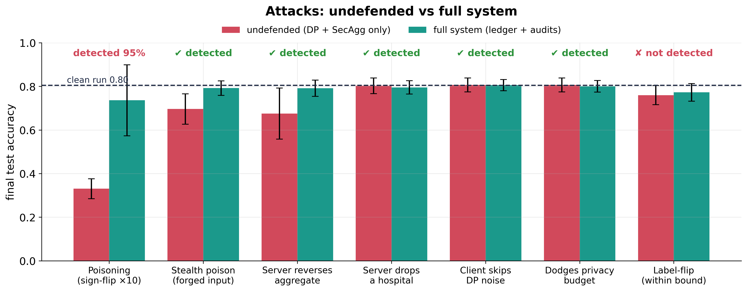
Figure 4. Seven attacks against the undefended system (DP + secure aggregation) and the full system. Labels show whether the full system detected the attack; label-flipping inside the norm bound is the stated limit. 20 seeds.
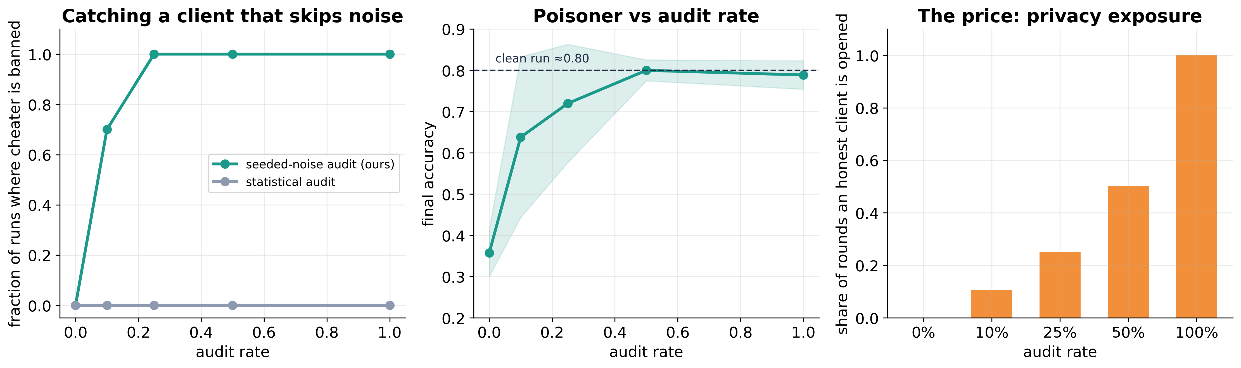
Figure 5. Audit-rate trade-off. Left: the seeded-noise audit catches a hospital that skips its DP noise (statistical audit never does at 14 parameters). Middle: accuracy with a poisoner present against audit rate. Right: the price, the share of rounds in which an honest hospital is opened.
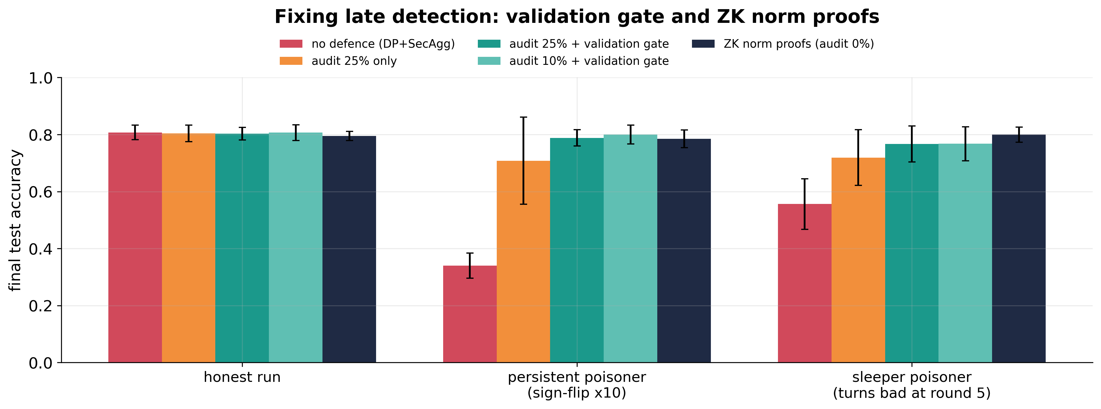
Figure 6. Fixing late detection. Random audits alone leave large variance (a late catch leaves a damaged model); the validation gate and the zero-knowledge norm proofs restore accuracy for persistent and sleeper poisoners. 16 seeds (ZK: 8).
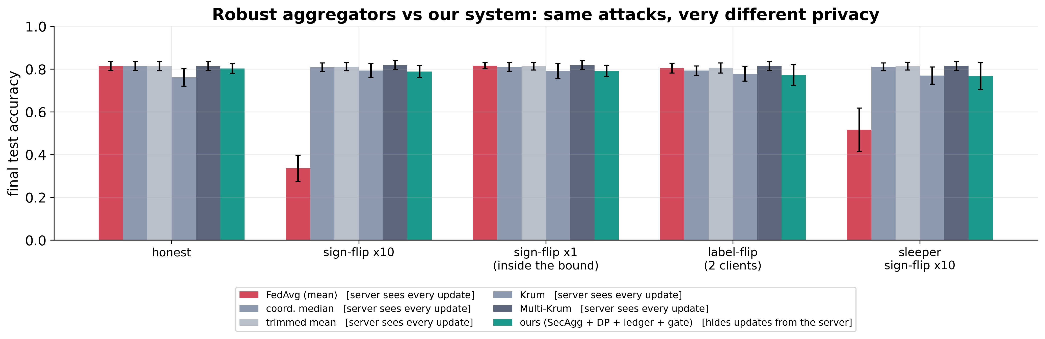
Figure 7. Comparison with robust aggregation. Krum, median and trimmed mean resist the same attacks but require the server to see every individual update; ours hides all updates from the server at a small accuracy cost. 16 seeds.
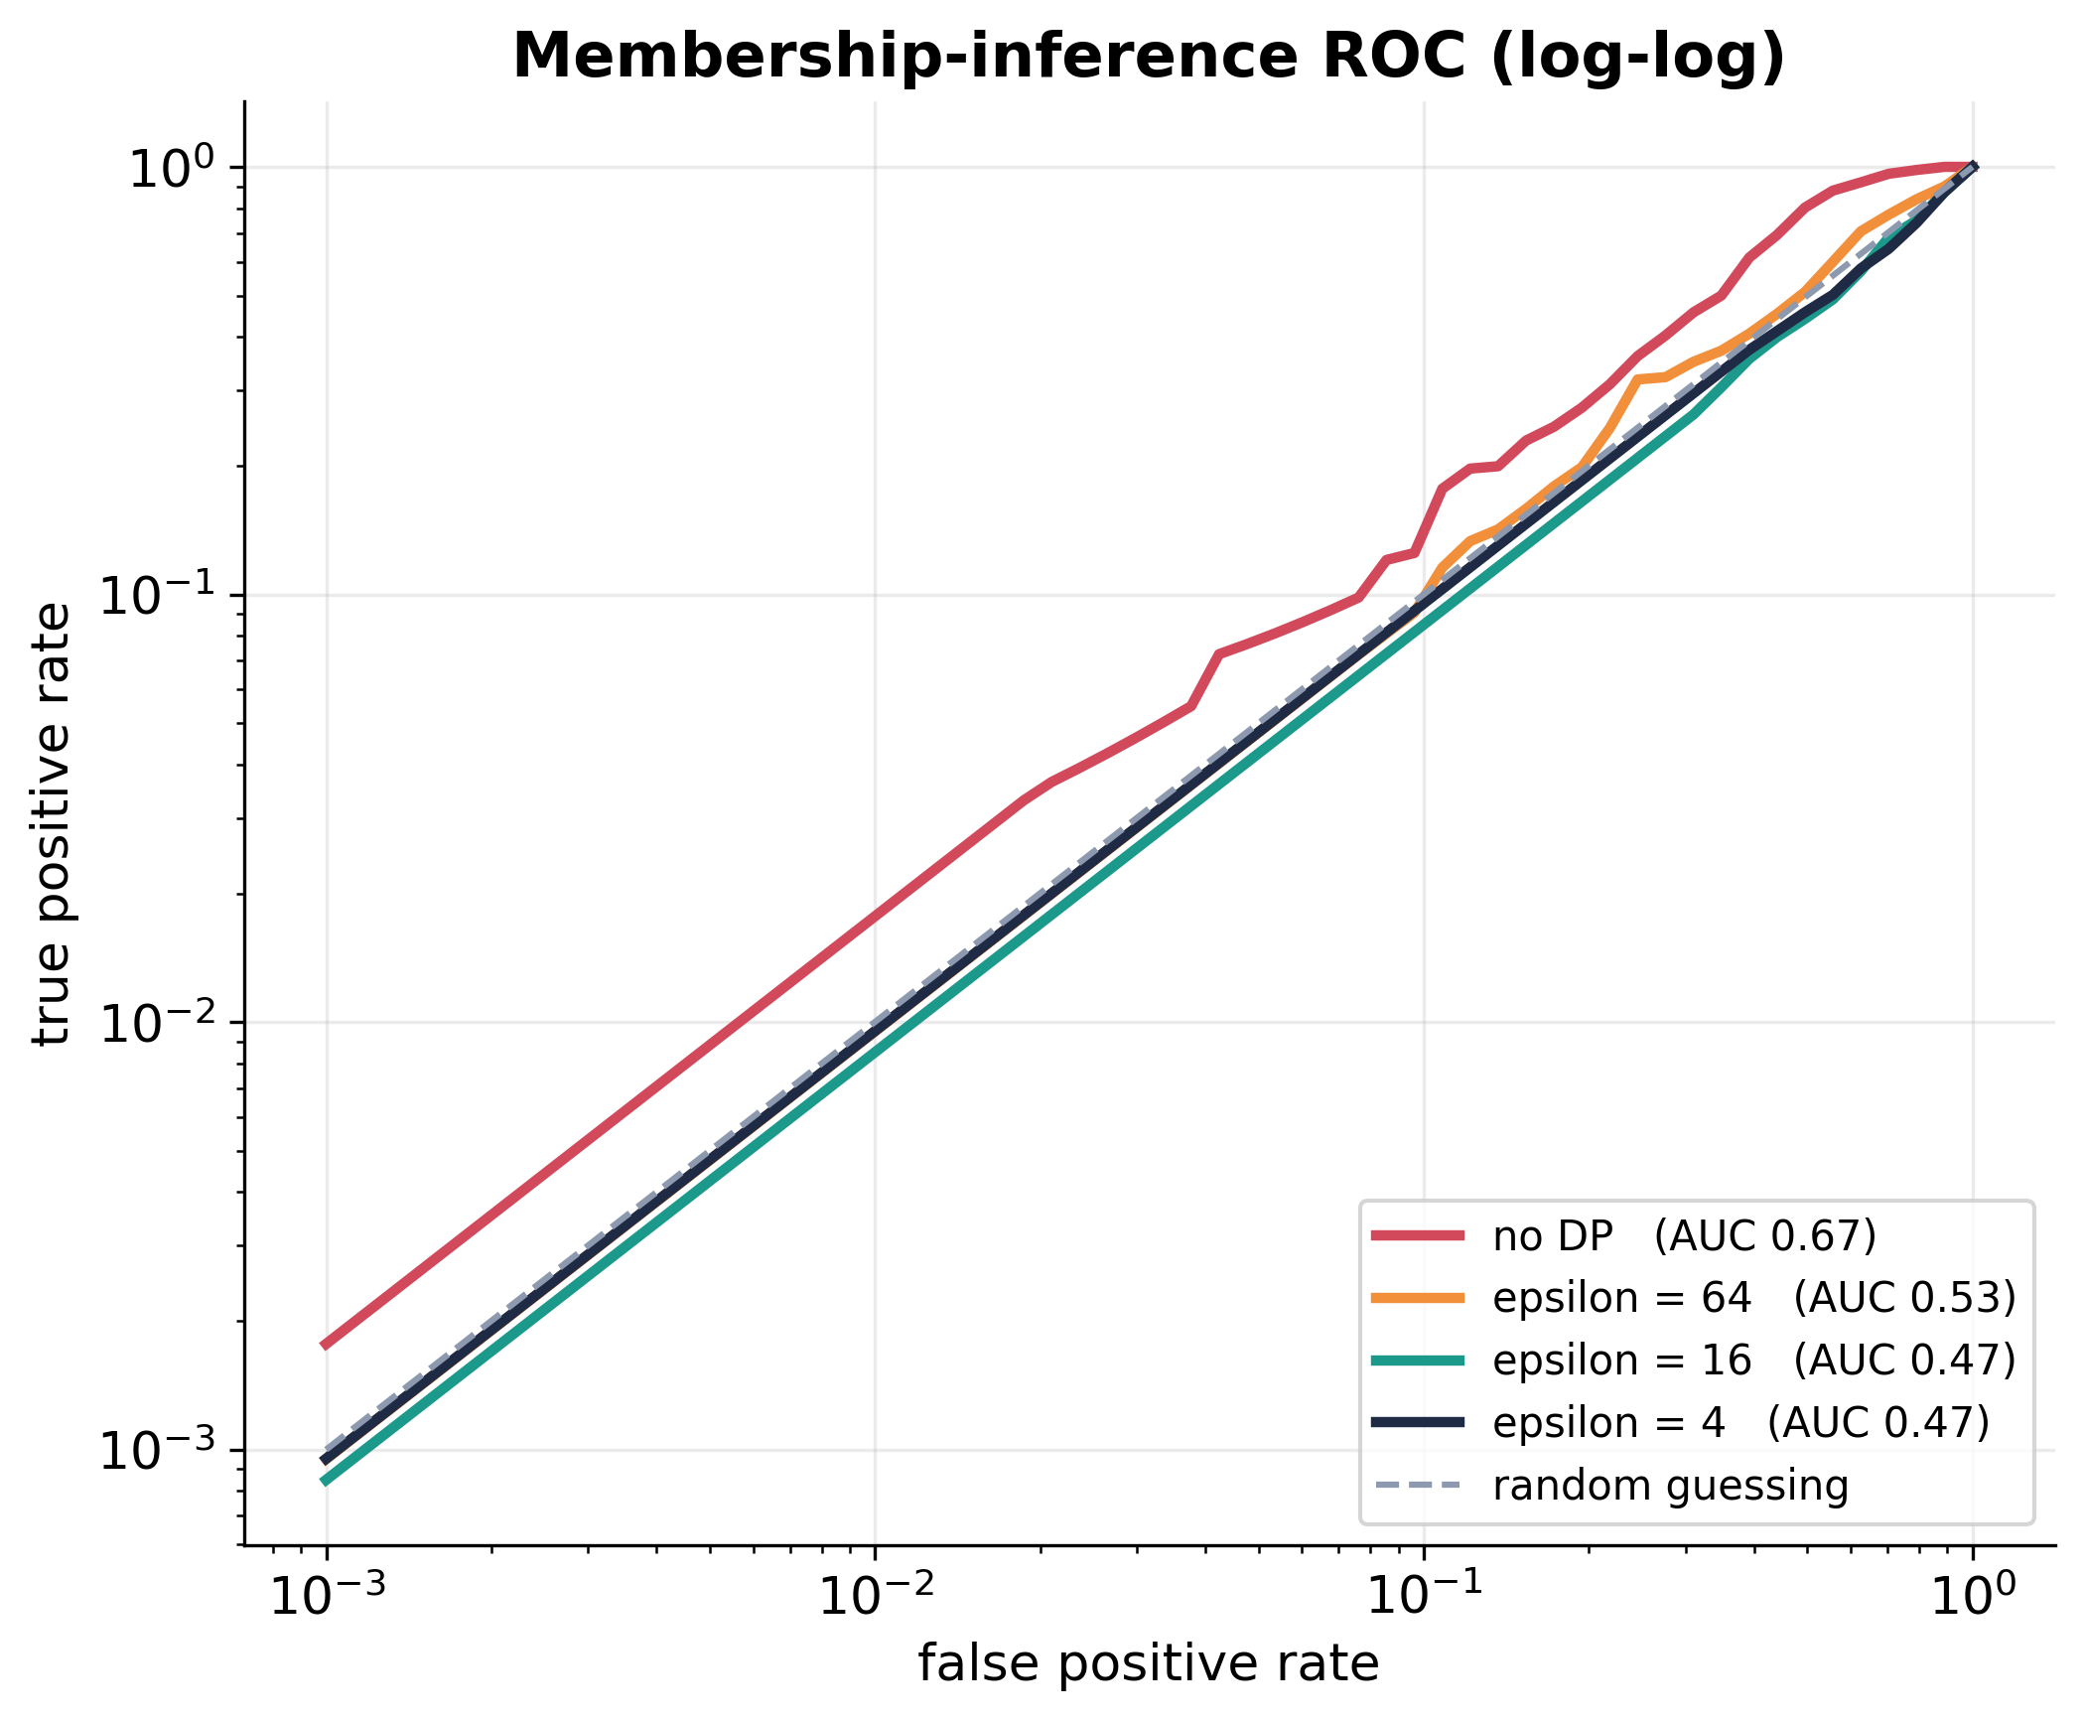
Figure 8. ROC curves of the loss-threshold membership-inference attack on planted canary records (log-log, the low-false-positive regime that matters for privacy). Without DP the curve lies above the diagonal; at epsilon <= 16 it collapses onto it. Mean over 6 seeds.
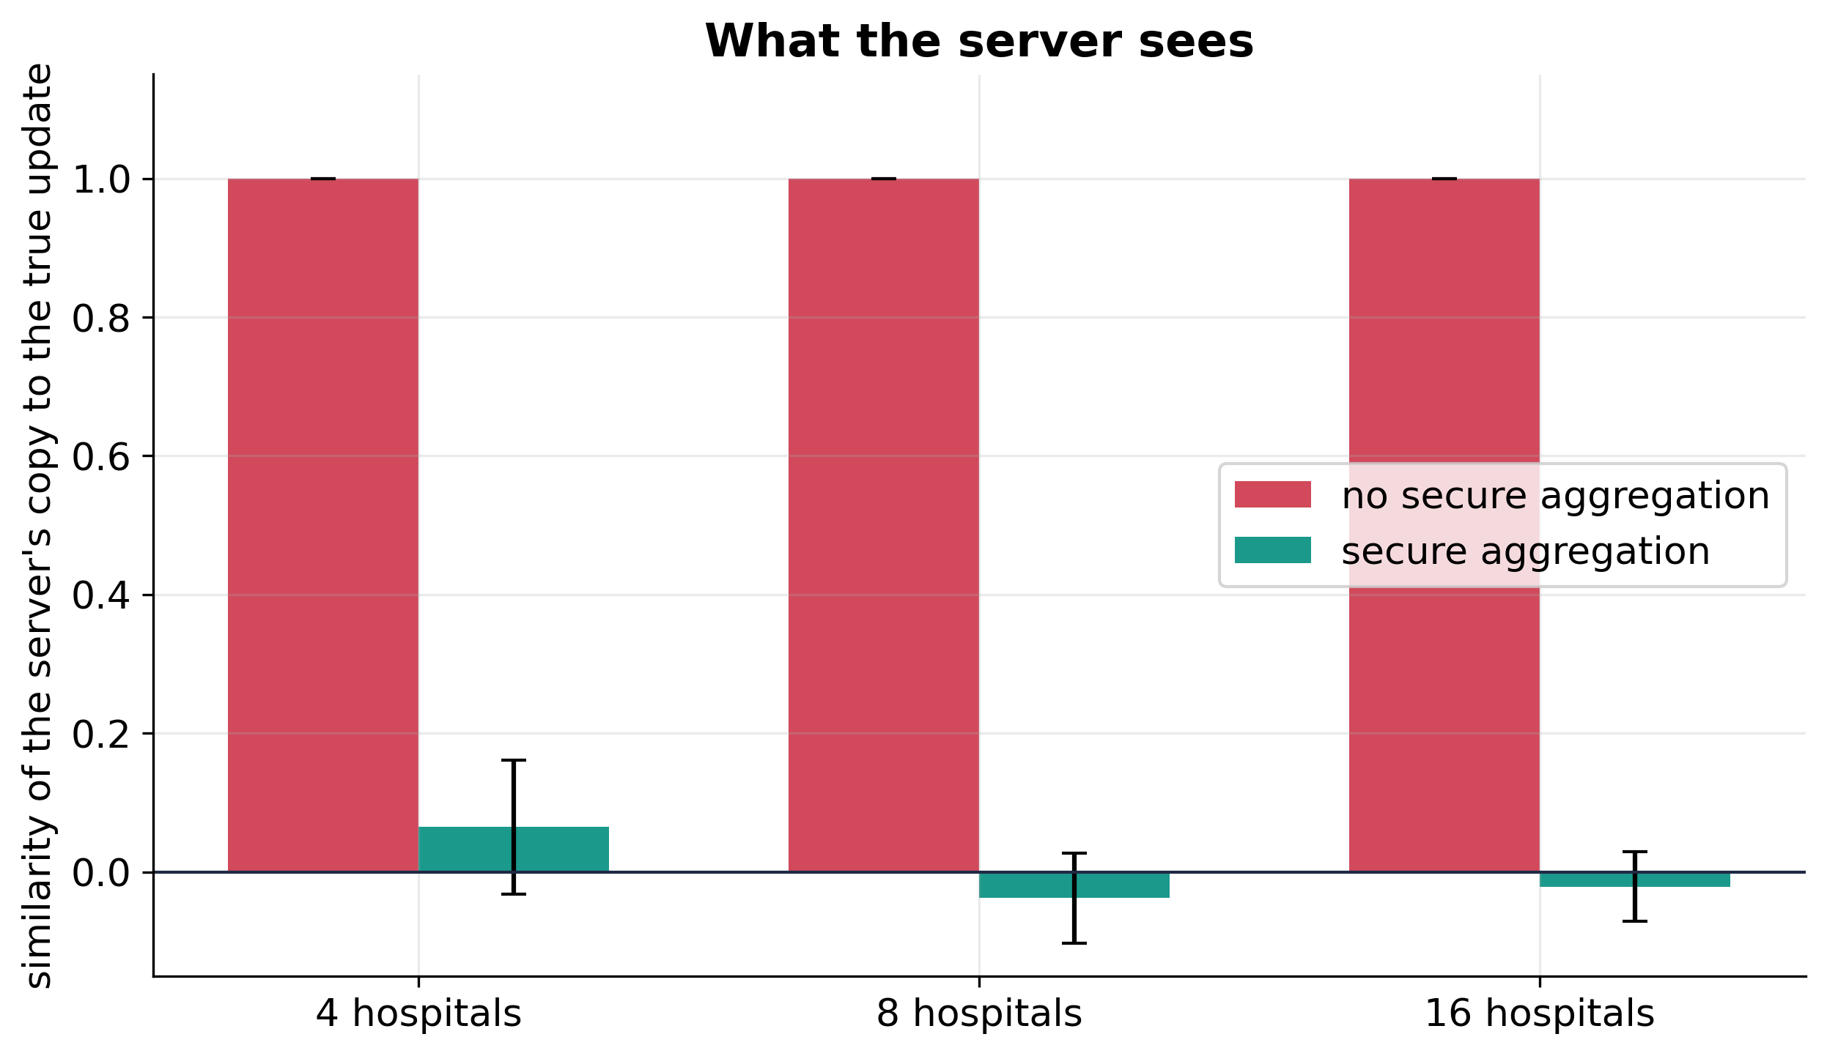
Figure 9. Cosine similarity between what the server receives from a hospital and that hospital's true update. Without secure aggregation the server reads every update (1.0); with it the similarity is zero for 4, 8 and 16 hospitals. 8 seeds.
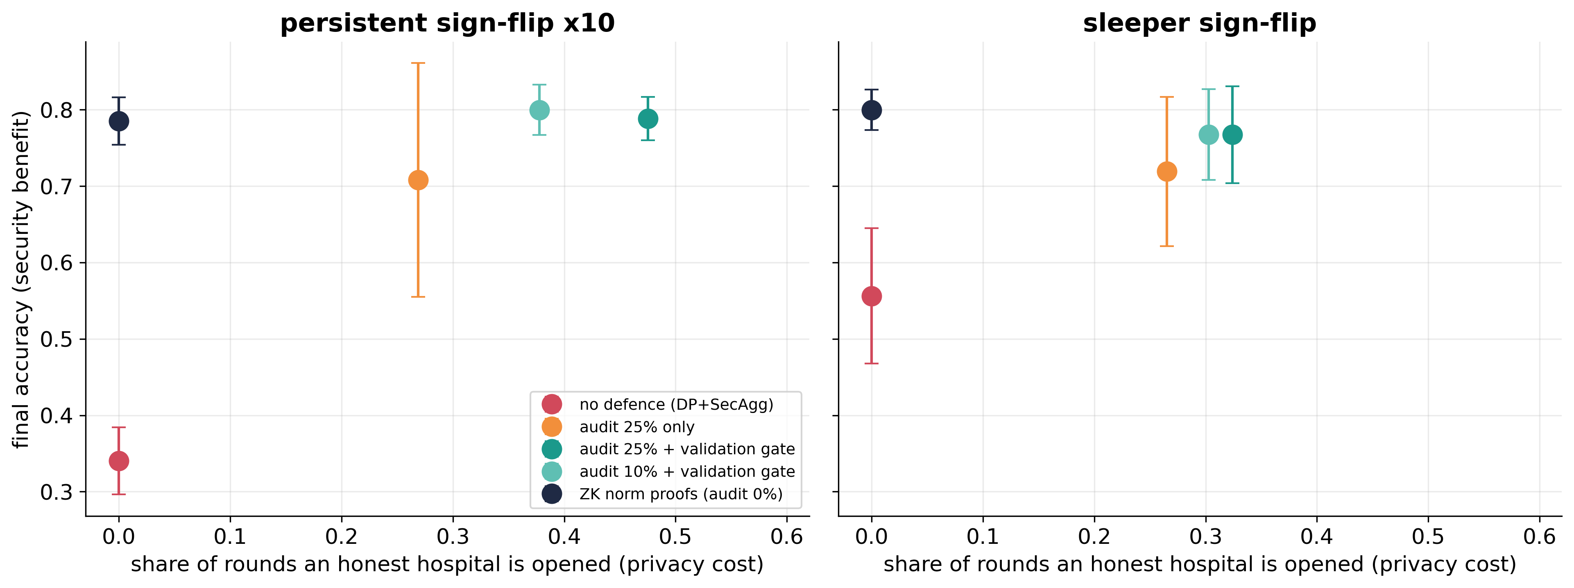
Figure 10. Security against privacy exposure for each defence policy. ZK norm proofs reach the best accuracy with zero exposure of any hospital's data; the validation gate buys accuracy by opening honest hospitals in a third to a half of the rounds. Up and to the left is better.
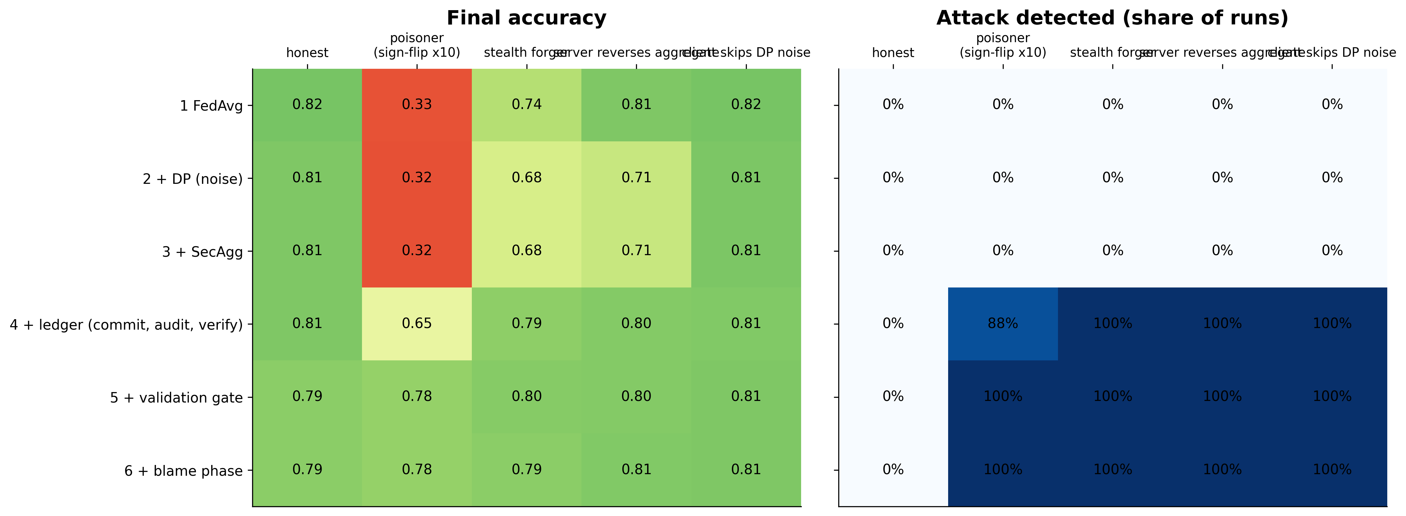
Figure 11. Ablation: what each layer buys. Rows add one component at a time (FedAvg -> + DP -> + secure aggregation -> + ledger (commit, audit, verify) -> + validation gate -> + blame phase); columns are scenarios. Left: final accuracy. Right: whether the attack was detected. The gate rows train on 8% less data (held out as the public validation set), which costs about 0.02 on the honest run. 8 seeds, 8 hospitals.

4 Cost and robustness of the system
Overhead of each layer, the real blockchain, the ZK proof, dropout, and a genuinely distributed run.
Table 11. Zero-knowledge norm proof: cost against model size.
parameters | prove_s | verify_s | proof_KB | valid
14 | 0.317 | 0.297 | 17.438 | True
51 | 0.746 | 0.642 | 37.094 | True
128 | 1.605 | 1.309 | 78.000 | True
256 | 2.932 | 2.364 | 146.000 | True

Table 12. Real chains with on-chain verification: Hardhat (1 node) vs Besu QBFT (4 validators).
backend | clients | rounds | tx_per_round | gas_per_round | verify_gas_per_round | seconds_per_round | rejected | acc
Hardhat (1 node) | 4 | 3 | 23.000 | 4685045.333 | 1685979.000 | 1.377 | 0 | 0.779
Hardhat (1 node) | 8 | 3 | 41.667 | 6662603.667 | 1697895.333 | 0.767 | 0 | 0.684
Besu QBFT (4 validators) | 4 | 3 | 23.000 | 3885528.667 | 886462.333 | 19.021 | 0 | 0.779
Besu QBFT (4 validators) | 8 | 3 | 41.667 | 5960287.667 | 995579.333 | 13.695 | 0 | 0.684

Table 13. Measured gas and latency on the real chain vs number of hospitals (5 rounds).
clients | rounds | transactions | tx_per_round | gas_per_round | max_single_tx_gas | deploy_gas | seconds_per_round | eps_on_chain | eps_analytic | acc
4.000 | 5.000 | 113.000 | 21.800 | 2193048.600 | 756255.000 | 3614006.000 | 1.051 | 8.006 | 8.000 | 0.810
8.000 | 5.000 | 203.000 | 39.000 | 3914493.600 | 1287327.000 | 3614006.000 | 0.759 | 8.006 | 8.000 | 0.827
16.000 | 5.000 | 386.000 | 74.000 | 7386502.200 | 2349495.000 | 3614006.000 | 1.315 | 8.006 | 8.000 | 0.827
32.000 | 5.000 | 739.000 | 141.400 | 14177619.000 | 4473819.000 | 3614006.000 | 2.424 | 8.006 | 8.000 | 0.835

Table 14. Distributed run: server and hospitals as separate OS processes (one with a real crash).
scenario | round | accepted | chain_verified | survivors | dropped | acc | processes | gas_total | wall_seconds
no crash | 0 | True | True | 5 | 0 | 0.593 | 6 | 10970907 | 23.075
no crash | 1 | True | True | 5 | 0 | 0.797 | 6 | 10970907 | 23.075
no crash | 2 | True | True | 5 | 0 | 0.810 | 6 | 10970907 | 23.075
no crash | 3 | True | True | 5 | 0 | 0.831 | 6 | 10970907 | 23.075
hospital 2 crashes in round 1 | 0 | True | True | 5 | 0 | 0.732 | 6 | 11895379 | 34.797
hospital 2 crashes in round 1 | 1 | True | True | 4 | 1 | 0.675 | 6 | 11895379 | 34.797
hospital 2 crashes in round 1 | 2 | True | True | 5 | 0 | 0.693 | 6 | 11895379 | 34.797
hospital 2 crashes in round 1 | 3 | True | True | 5 | 0 | 0.710 | 6 | 11895379 | 34.797

Table 15. Dropout tolerance with 16 hospitals (3 seeds).
dropout | accuracy | rounds completed | epsilon spent
0.000 | 0.817 ± 0.002 | 10.0 | 8.00
0.100 | 0.833 ± 0.011 | 10.0 | 8.60
0.200 | 0.811 ± 0.018 | 10.0 | 9.04
0.300 | 0.825 ± 0.007 | 8.3 | 8.34
0.400 | 0.821 ± 0.016 | 5.7 | 7.28

Table 16. Per-layer overhead against number of hospitals (simulated ledger: gas is an estimate).
clients | variant | time_per_round_s | bytes_per_client_round | gas_per_round
4 | FedAvg | 0.180 | 112.000 | 0.000
4 | +DP | 0.170 | 112.000 | 0.000
4 | +DP+SecAgg | 0.190 | 1240.000 | 0.000
4 | +DP+SecAgg+Ledger (full) | 0.210 | 1400.000 | 1361377.600
8 | FedAvg | 0.200 | 112.000 | 0.000
8 | +DP | 0.210 | 112.000 | 0.000
8 | +DP+SecAgg | 0.280 | 2032.000 | 0.000
8 | +DP+SecAgg+Ledger (full) | 0.320 | 2192.000 | 2553532.800
16 | FedAvg | 0.270 | 112.000 | 0.000
16 | +DP | 0.240 | 112.000 | 0.000
16 | +DP+SecAgg | 0.240 | 3616.000 | 0.000
16 | +DP+SecAgg+Ledger (full) | 0.260 | 3776.000 | 4824350.400
32 | FedAvg | 0.210 | 112.000 | 0.000
32 | +DP | 0.230 | 112.000 | 0.000
32 | +DP+SecAgg | 0.350 | 6784.000 | 0.000
32 | +DP+SecAgg+Ledger (full) | 0.390 | 6944.000 | 9577608.000

Table 17. Measured gas by contract method (8 hospitals, 5 rounds).
method | gas | calls
verifyAggregate | 8538461 | 5
beginRound | 6452072 | 5
deploy | 5458604 | 0
postIntent | 3358232 | 40
postCommitment | 2582480 | 40
revealNonce | 2399284 | 40
markSubmitted | 2356052 | 40
postProof | 1937072 | 40
setGroup | 1872701 | 1
postAggregate | 1616143 | 5
register | 994824 | 8
closeCommitments | 798898 | 5
selectAudits | 783920 | 5
closeReveals | 545063 | 5
reportAudit | 424443 | 13

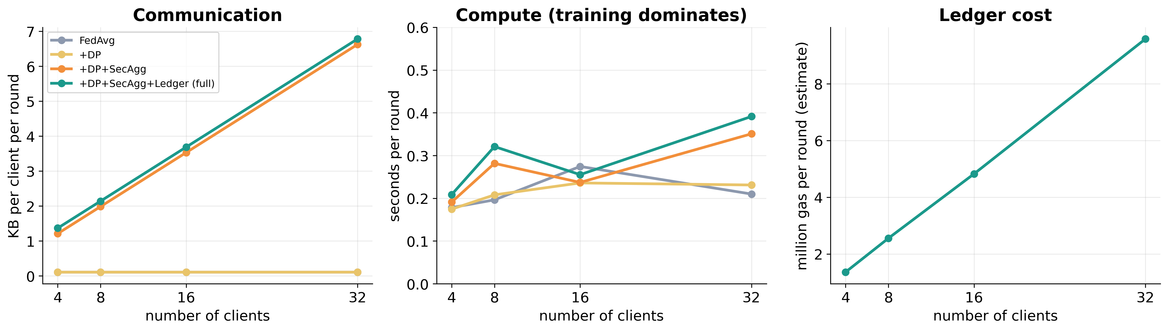
Figure 12. Overhead of each layer against the number of hospitals: communication per hospital per round, compute per round, and measured gas on the real chain.
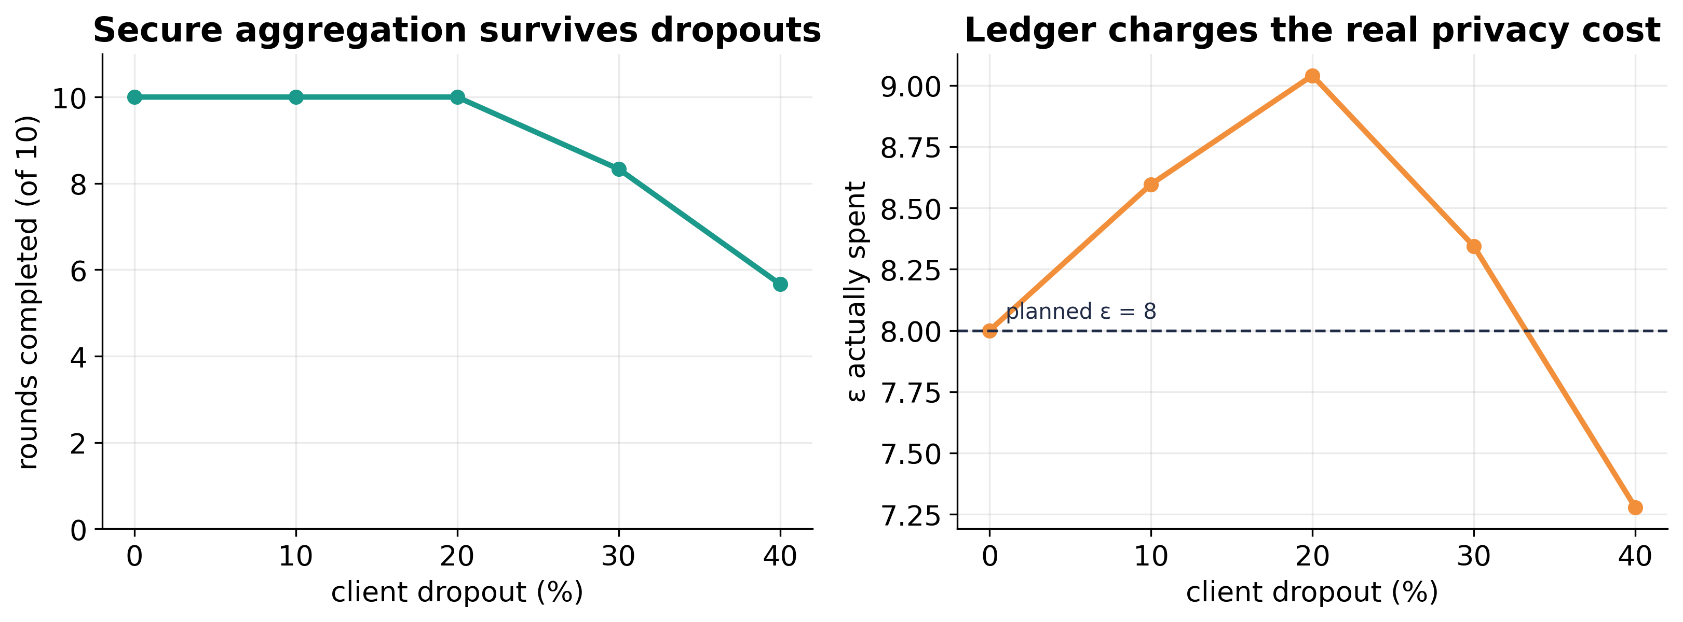
Figure 13. Dropout tolerance. Left: rounds completed against the share of hospitals that disconnect. Right: epsilon actually spent; the contract charges the real cost, which rises with dropout because dropped hospitals take their noise share with them.
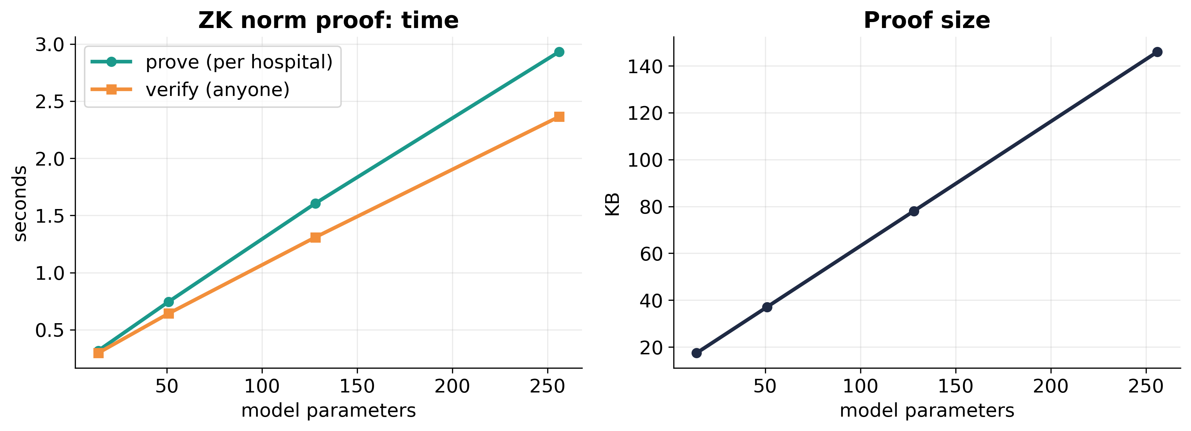
Figure 14. Cost of the zero-knowledge norm proof against model size: linear in the number of parameters (0.3 s at 14 parameters, 2.9 s at 256), so practical only for small models.
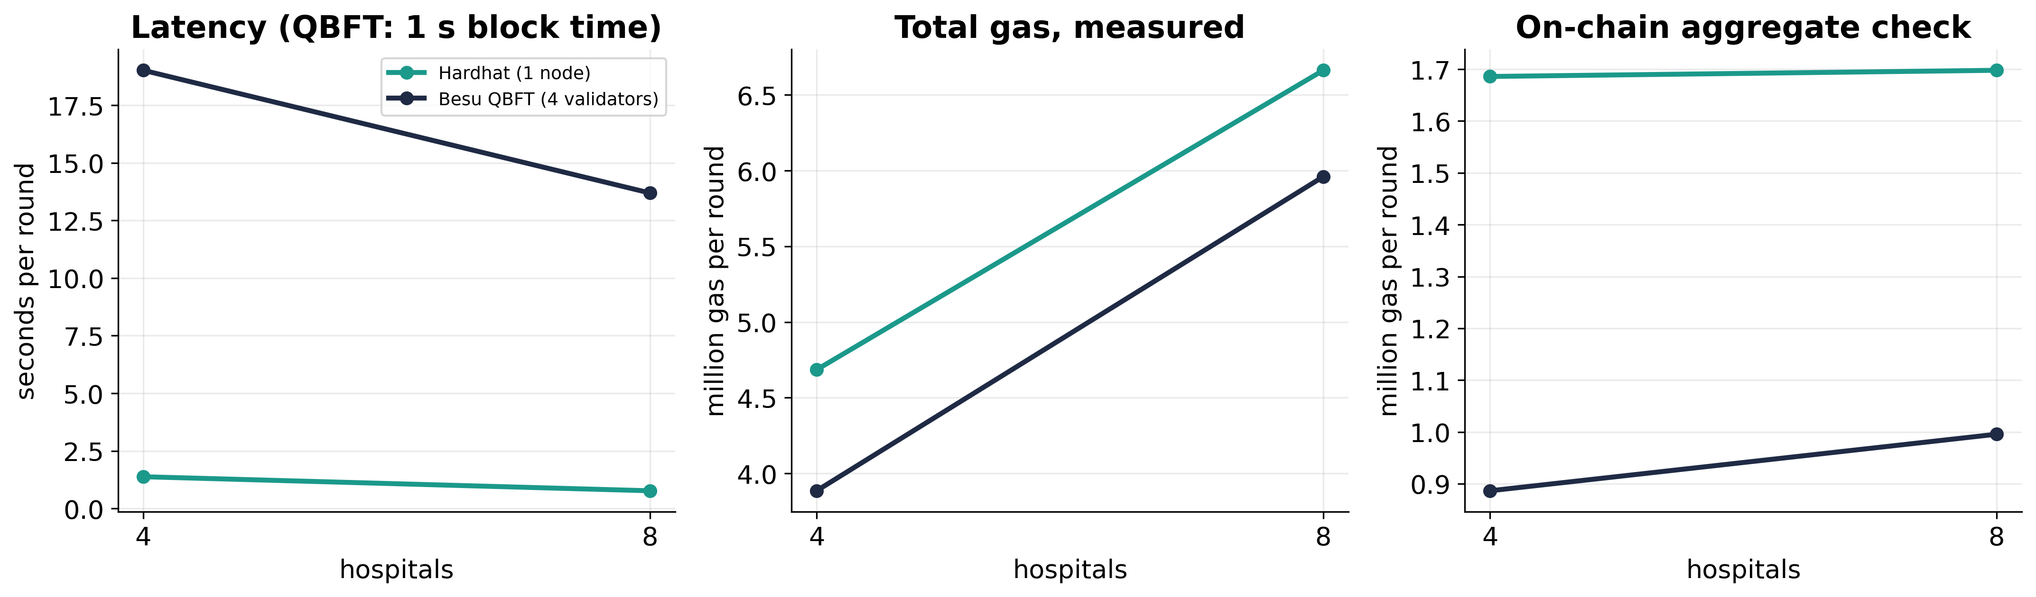
Figure 15. The same federation on one Hardhat node and on a real 4-validator QBFT network, with the contract verifying the aggregate. Gas differs because newer EVM hard forks reprice modexp.
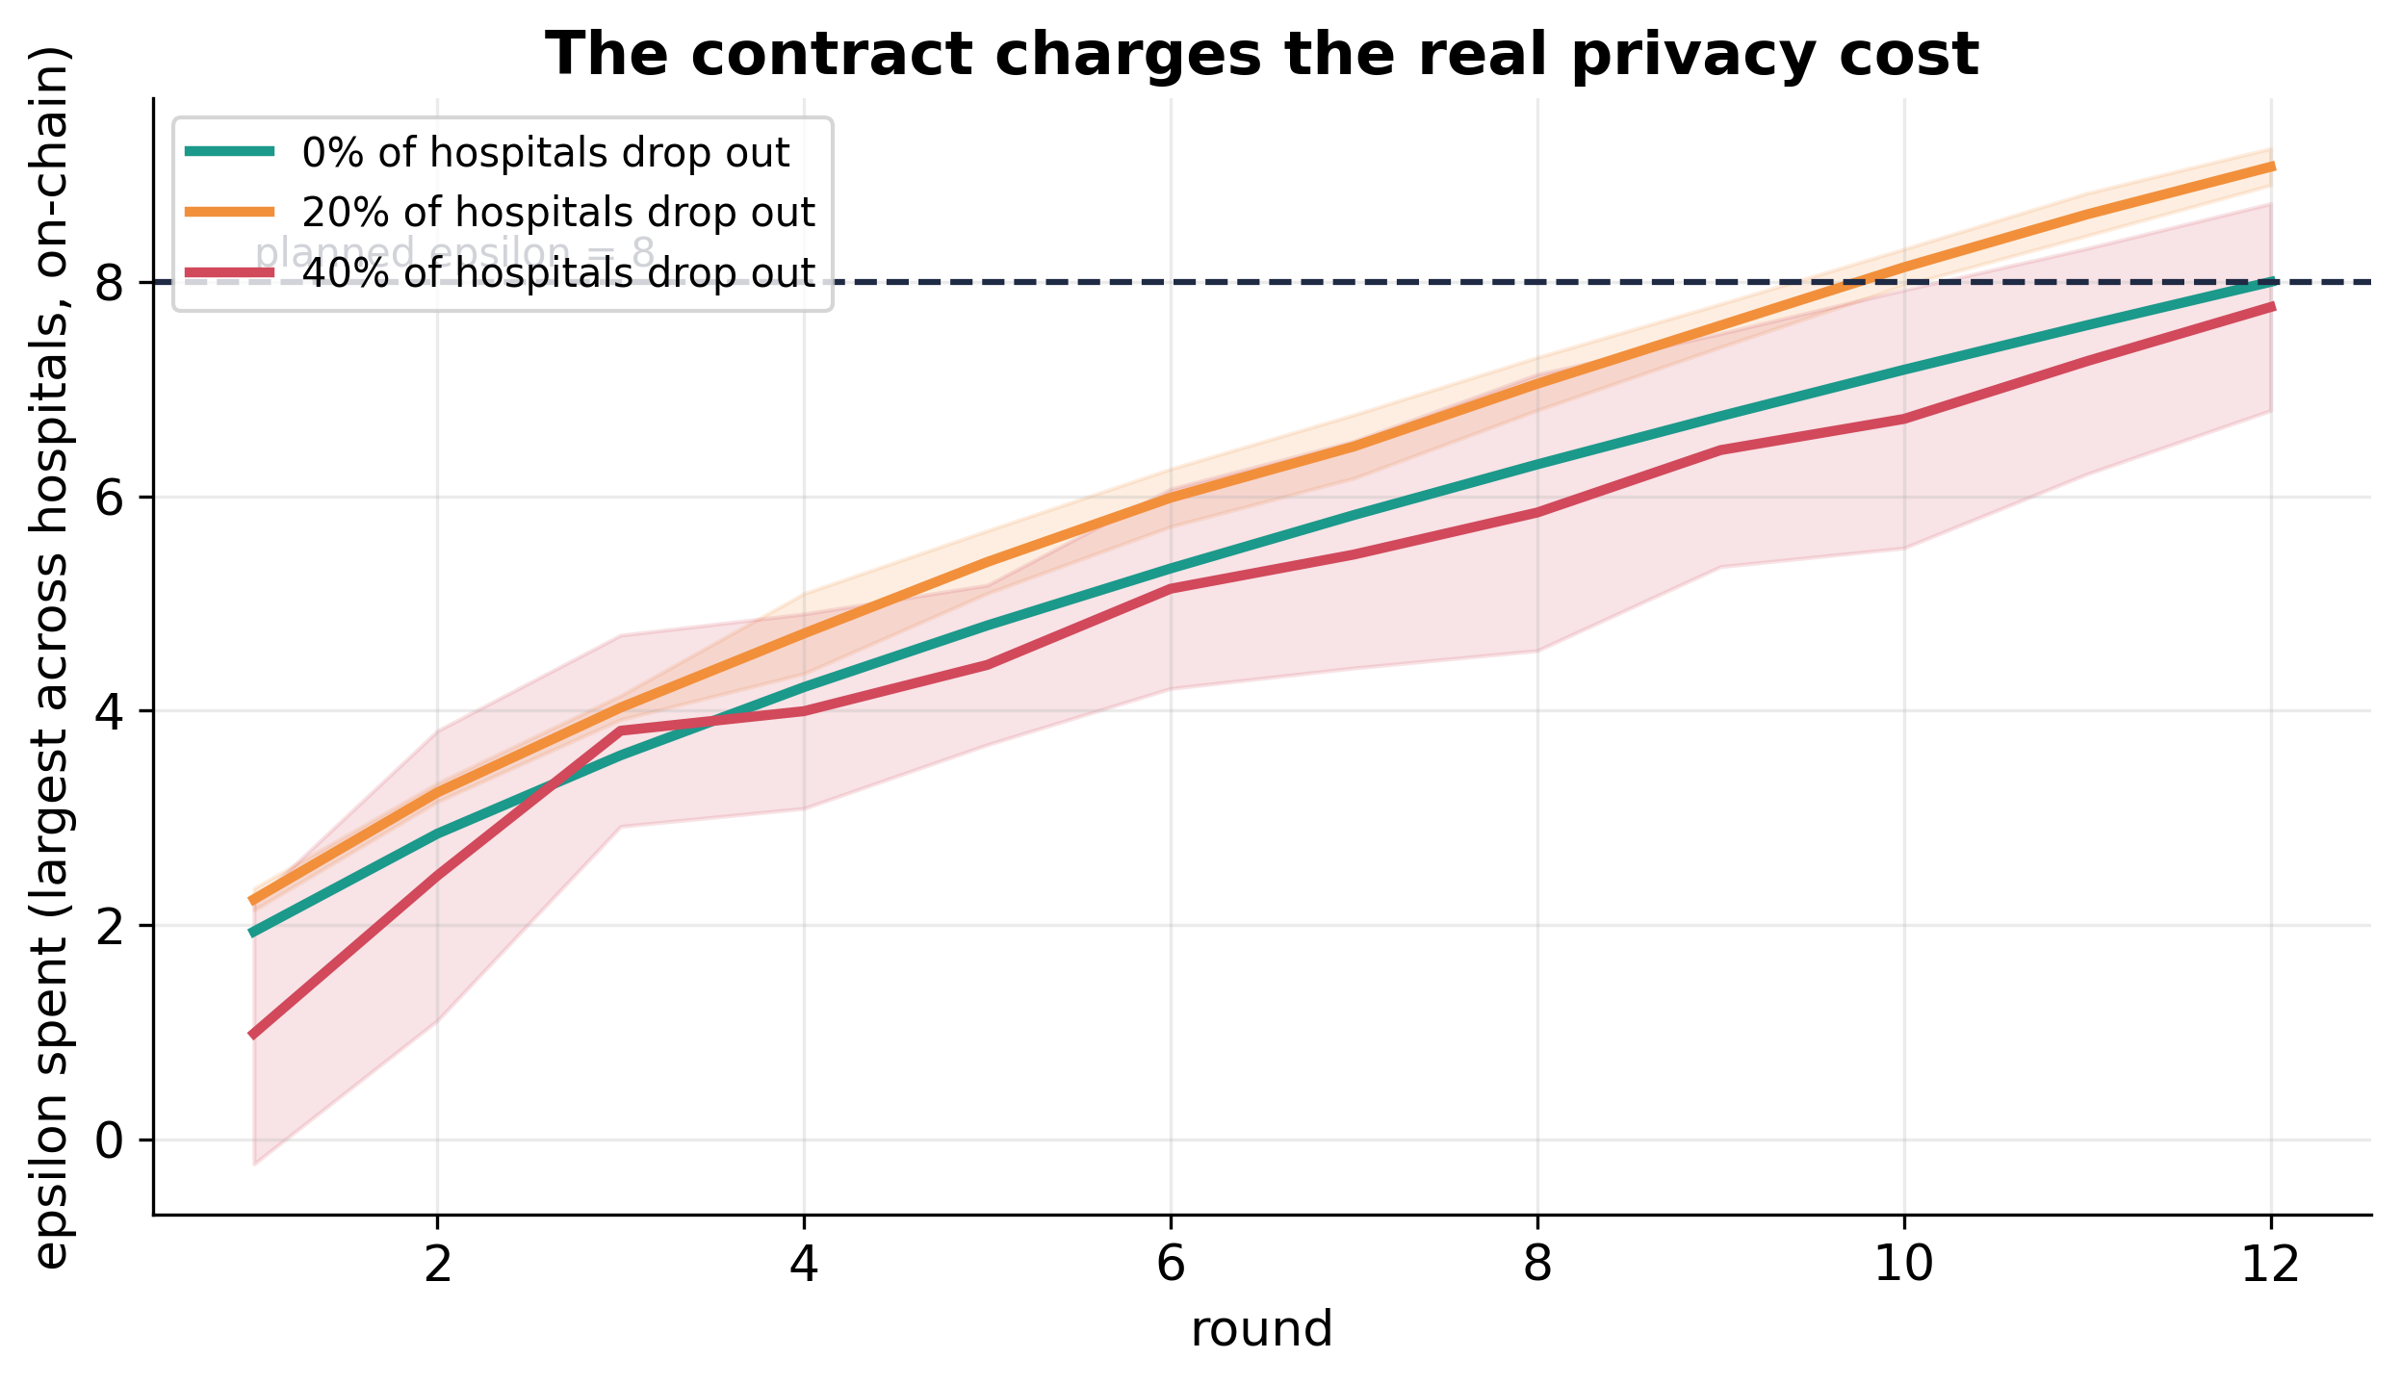
Figure 16. Privacy budget consumed per round as recorded by the contract, with 16 hospitals and 0/20/40% dropout (5 seeds). Dropped hospitals take their noise share with them, so the effective noise falls and epsilon grows faster than planned.
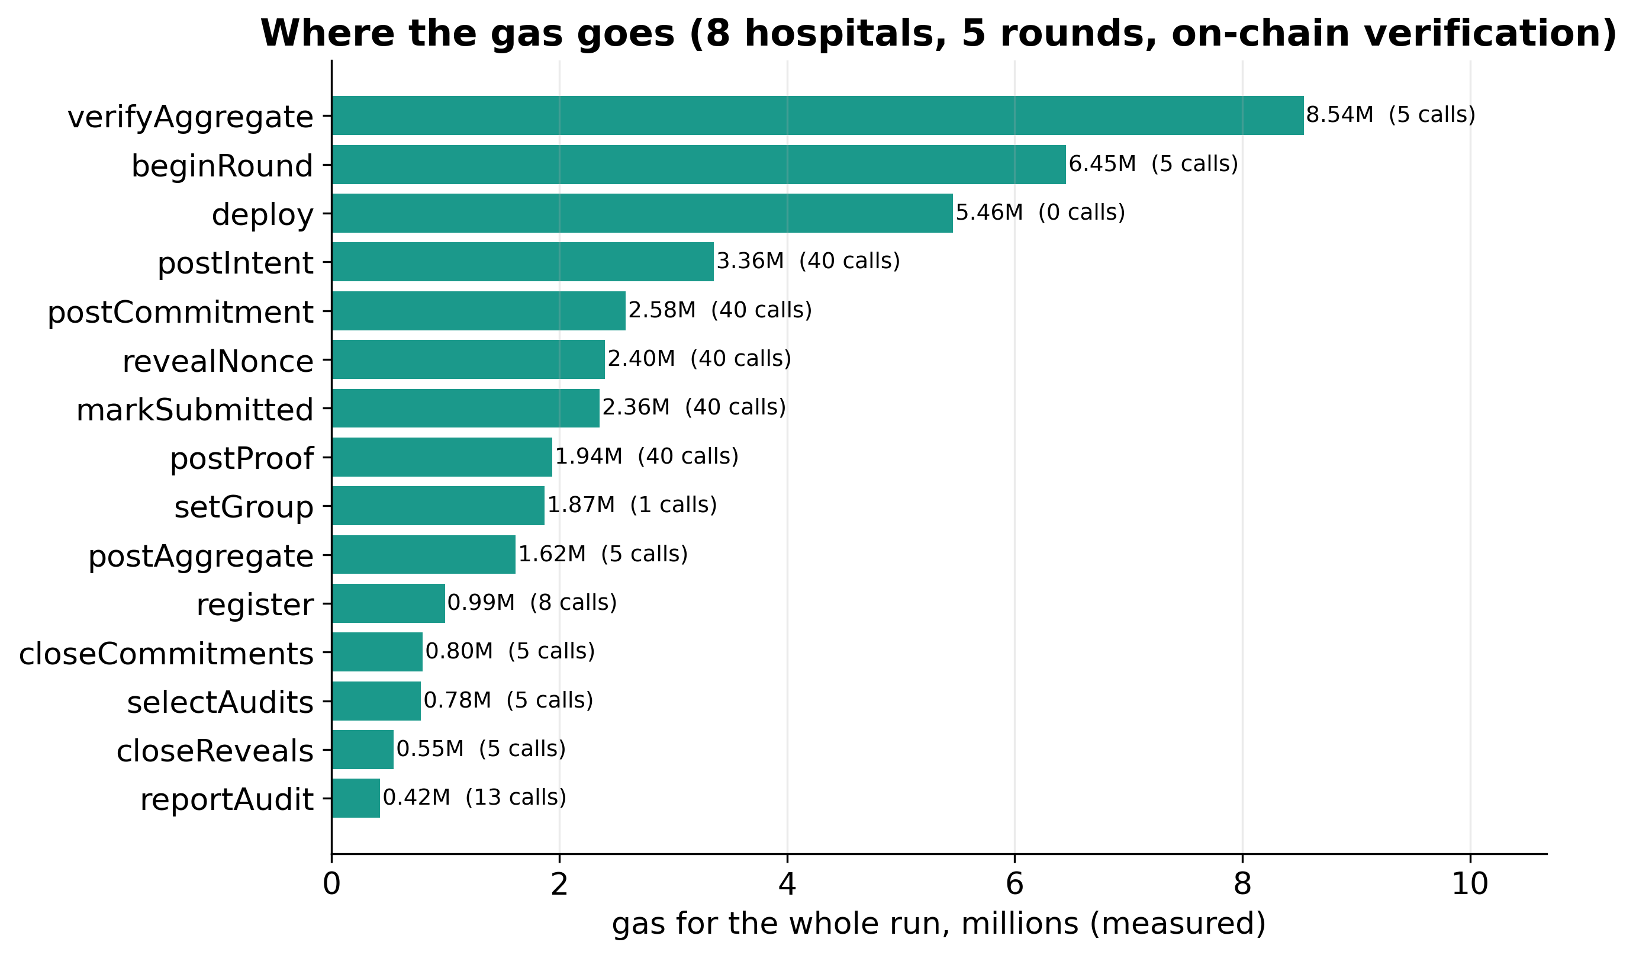
Figure 17. Measured gas by contract method for 5 rounds with 8 hospitals, on-chain verification of the aggregate and ZK proof hashes. Round opening and the on-chain homomorphic check dominate.

5 Generality and fairness
A second dataset, and accuracy for each hospital.
Table 18. Accuracy on each hospital's own test set (10 seeds, epsilon = 8).
system | cleveland | hungarian | switzerland | va
FedAvg (no privacy) | 0.828 ± 0.040 | 0.830 ± 0.027 | 0.897 ± 0.052 | 0.762 ± 0.058
local DP (eps=8) | 0.700 ± 0.072 | 0.714 ± 0.075 | 0.729 ± 0.180 | 0.664 ± 0.115
ours: distributed DP (eps=8) | 0.786 ± 0.048 | 0.822 ± 0.043 | 0.852 ± 0.066 | 0.720 ± 0.068

Table 19. Forest Covertype, MLP with 1,665 parameters (4 seeds).
setting | eps_target | accuracy | AUC | seeds
distributed DP | 8.000 | 0.580 ± 0.042 | 0.567 ± 0.042 | 4
distributed DP | 32.000 | 0.592 ± 0.039 | 0.587 ± 0.026 | 4
local DP | 8.000 | 0.576 ± 0.055 | 0.559 ± 0.040 | 4
local DP | 32.000 | 0.584 ± 0.036 | 0.571 ± 0.041 | 4
no DP | none | 0.778 ± 0.008 | 0.854 ± 0.013 | 4
sign-flip, audit 25% + gate | none | 0.622 ± 0.012 | 0.683 ± 0.027 | 4
sign-flip, no defence | none | 0.374 ± 0.008 | 0.477 ± 0.005 | 4

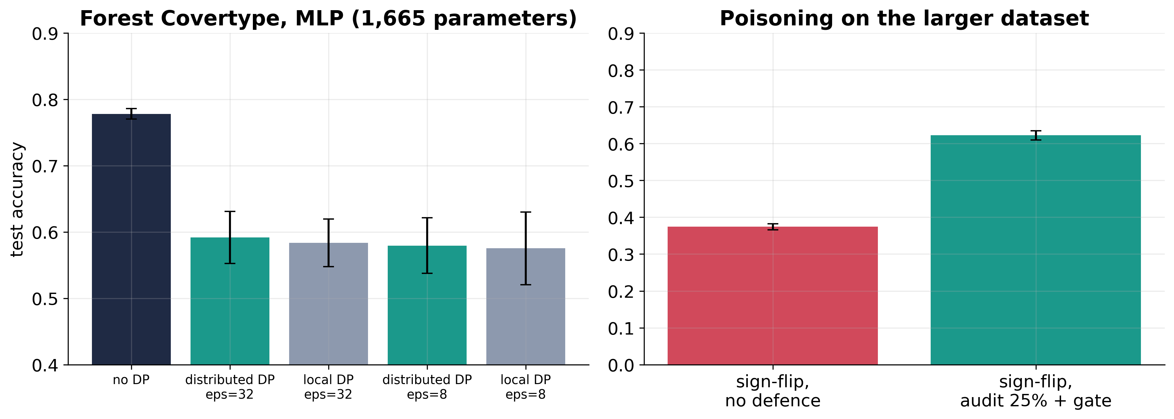
Figure 18. Second dataset (Forest Covertype, 4 wilderness-area silos, MLP with 1,665 parameters). Client-level DP is expensive at this size and distributed DP shows no advantage over local DP with only 4 clients (a negative result); poisoning is only partly recovered.
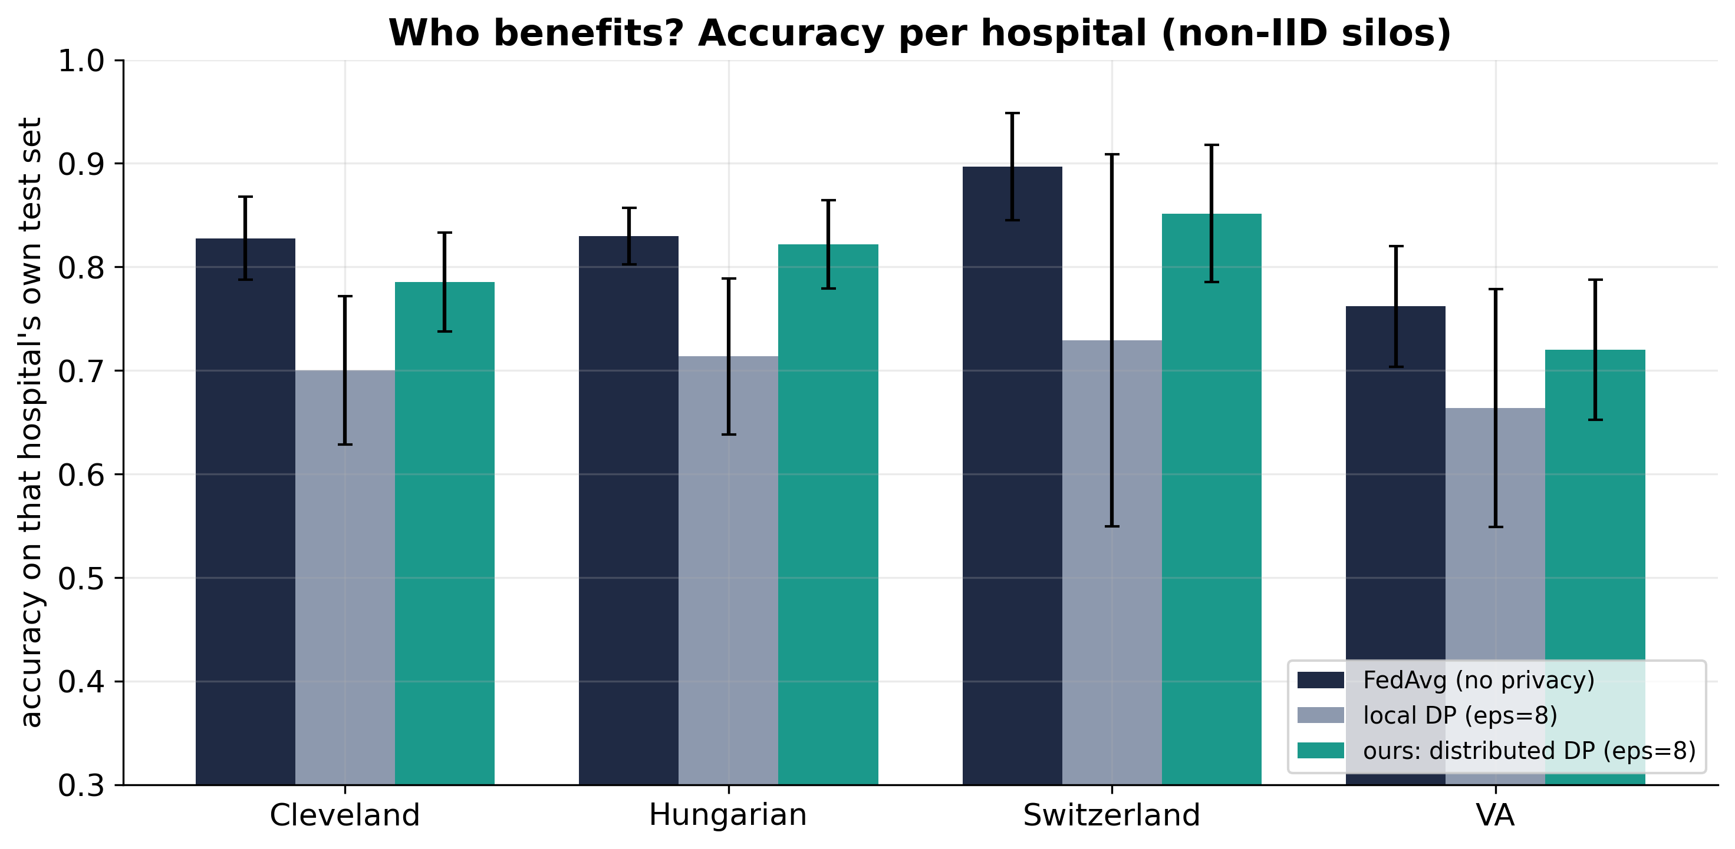
Figure 19. Accuracy on each hospital's own held-out patients. The four real silos differ in size and case mix, so DP noise does not cost every hospital equally; 10 seeds, 4 hospitals, epsilon = 8.

6 Design and threat model
Architecture and defence coverage.
Table 20. Which defence stops which attack.
attack | Secure aggregation | DP noise | Commitments + verify | Survivor check | Noise audit | ZK norm proof | Validation gate | Blame phase | Budget + stake | Hash chain / BFT
Server reads an update | primary
Membership inference |  | primary |  |  |  |  |  |  | partial
Poisoning (large norm) |  |  |  |  | partial | primary | partial |  | partial
Sleeper poisoning |  |  |  |  | partial | primary | partial |  | partial
Forged masked input |  |  | primary |  |  |  |  | primary | partial
Server tampers with aggregate |  |  | primary | partial |  |  |  | partial | partial | partial
Server drops a hospital |  |  |  | primary |  |  |  | partial |  | partial
Client skips DP noise |  |  |  |  | primary |  |  |  | partial
Under-declares noise (budget dodge) |  |  |  |  |  |  |  |  | primary
Over-spends privacy budget |  |  |  |  |  |  |  |  | primary
Rewrite ledger history |  |  |  |  |  |  |  |  |  | primary
Swap a stored model |  |  |  |  |  |  |  |  |  | primary
Label-flip inside the bound |  |  |  |  |  | partial | partial

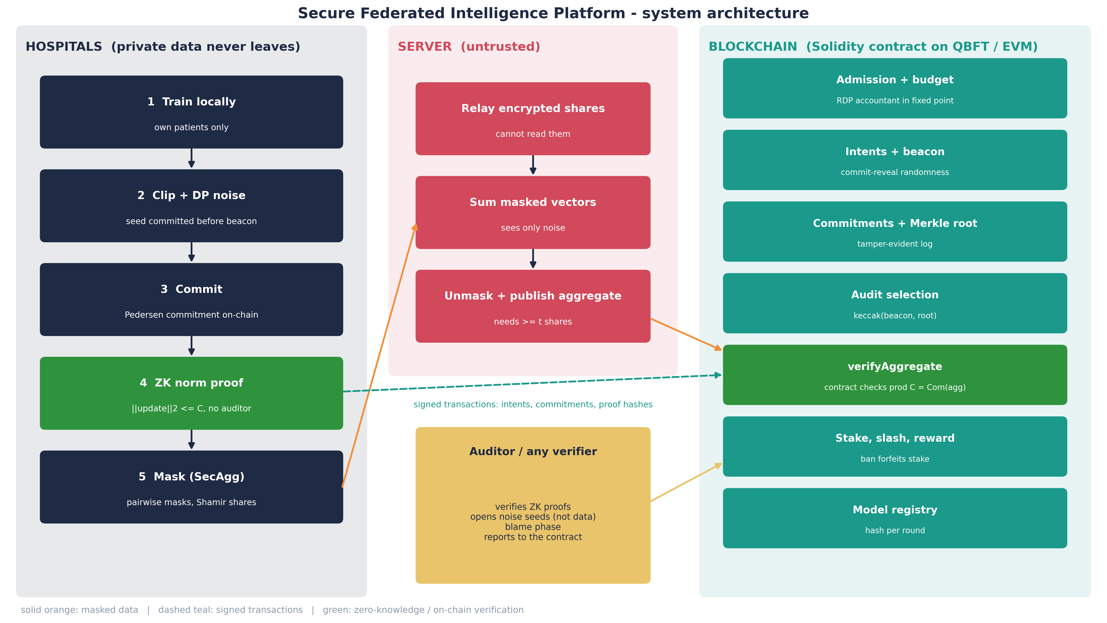
Figure 20. System architecture: hospitals, an untrusted server and the contract on a BFT chain; green marks zero-knowledge and on-chain verification.
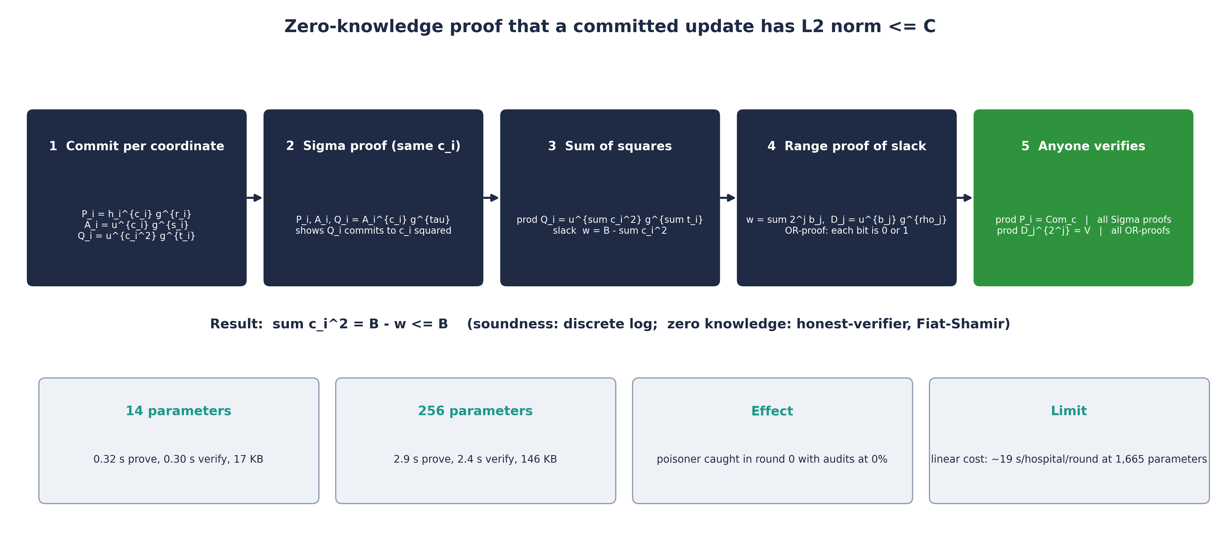
Figure 21. The zero-knowledge proof that a committed update has bounded L2 norm: per-coordinate commitments and a Sigma proof of squares, a slack commitment, and a bit-decomposition range proof.
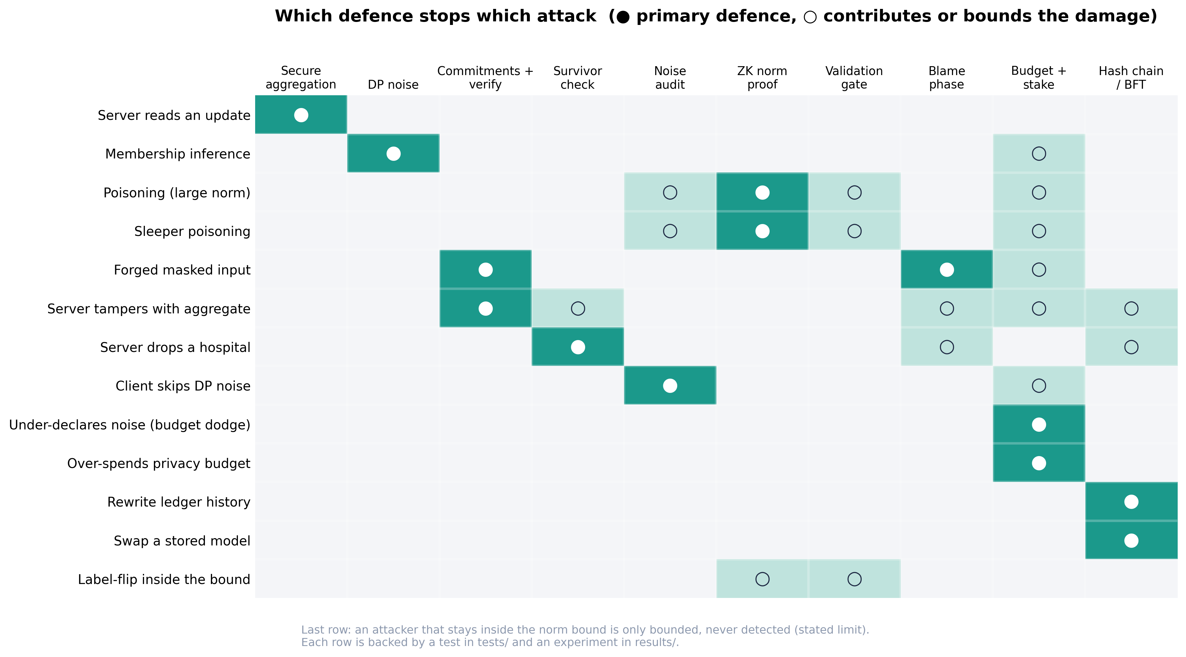
Figure 22. Defence coverage: which mechanism is the primary defence (filled) or a contributing one (open) for each attack. Each row is backed by a test and an experiment.
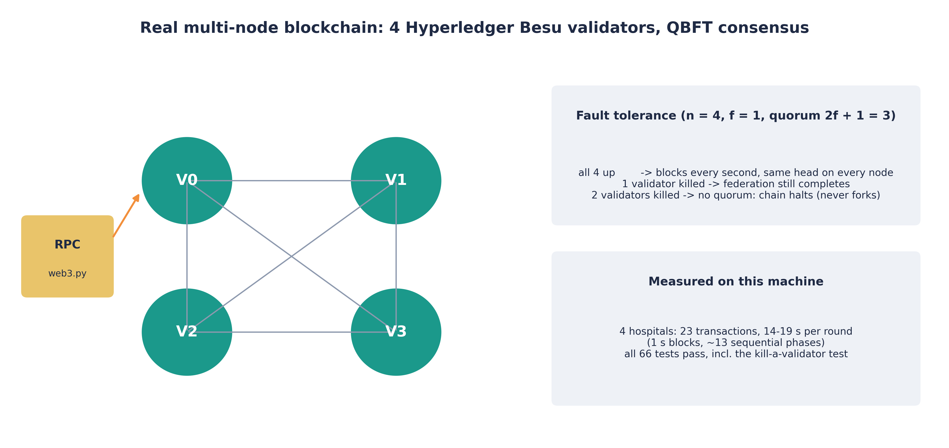
Figure 23. Real multi-node blockchain: 4 Besu validators on QBFT consensus tolerate 1 fault and halt safely with 2 down.
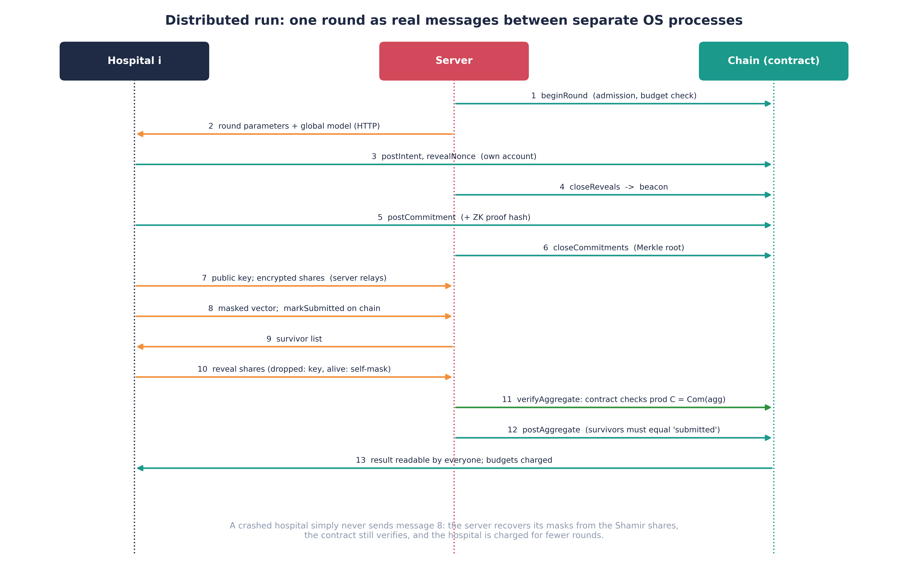
Figure 24. One federated round as messages between separate OS processes: hospitals, the untrusted server and the contract.

7 Limitations
What is not claimed.
Table 21. Known limitations and what is not claimed.
limitation | status
TEE-based audit | not implemented: needs secure-enclave hardware
Shapley rewards | not implemented: need individual updates, hidden by secure aggregation; stake/slash/reward used instead
Noise correctness | audited (seeded audit), not proven in zero knowledge
Label-flip inside the norm bound | bounded, not detected
Robust aggregation baselines | match or beat our accuracy under attack but see every individual update
Covertype (MLP, 4 clients) | client-level DP is expensive; no advantage of distributed DP
ZK proof cost | linear in parameters; impractical beyond a few hundred
Secure aggregation | passive-secure against the server (no consistency round)
Chain | one Hardhat node = no consensus; Besu QBFT = 4 validators on one machine
Cryptographic parameters | demo-sized (1024-bit group)

