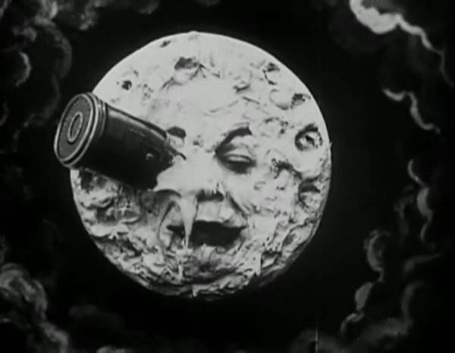

& C:/Users/srinu/AppData/Local/Programs/Python/Python39/python.exe "c:/Users/srinu/OneDrive/Desktop/python L/learn.py" | & C:/Users/srinu/AppData/Local/Programs/Python/Python39/python.exe "c:/Users/srinu/OneDrive/Desktop/python L/learn.py" | & C:/Users/srinu/AppData/Local/Programs/Python/Python39/python.exe "c:/Users/srinu/OneDrive/Desktop/python L/learn.py"

# About me

& C:/Users/srinu/AppData/Local/Programs/Python/Python39/python.exe "c:/Users/srinu/OneDrive/Desktop/python L/learn.py"

# Work Experience

**& C:/Users/srinu/AppData/Local/Programs/Python/Python39/python.exe "c:/Users/srinu/OneDrive/Desktop/python L/learn.py"** *& C:/Users/srinu/AppData/Local/Programs/Python/Python39/python.exe "c:/Users/srinu/OneDrive/Desktop/python L/learn.py"-& C:/Users/srinu/AppData/Local/Programs/Python/Python39/python.exe "c:/Users/srinu/OneDrive/Desktop/python L/learn.py"*& C:/Users/srinu/AppData/Local/Programs/Python/Python39/python.exe "c:/Users/srinu/OneDrive/Desktop/python L/learn.py"