Fli E-Pilots: A System to Predict Hard Landing During the Approach Phase of Commercial Flights

In this project author is introducing Hybrid LSTM algorithm to predict Hard or Not Hard Landing (HL). Timely prediction of Hard Landing can avoid accident and save passenger lives. In propose paper author is applying machine learning model for cockpit which will read data from flight such as Tyre elevation, speed and other values and then predict type of landing, if hard landing predicted then it instruct pilot to avoid landing or divert landing route.

Many existing machine learning (SVM, logistic regression and many more) and deep learning LSTM algorithm already implemented and LSTM give better landing prediction accuracy compare to other machine learning algorithms but LSTM is not trained to predict the vertical acceleration at TD at the next time interval after the current observation. In fact, a recurrent network can only predict acceleration at the immediate time interval from the current observation and its capability for long term predictions is not clear. Since HL depends on the values of such vertical acceleration in a tight temporal window at the time of TD, this limits the deployability of system in a cockpit.

LSTM get trained on full datasets which further limits its capability and to overcome from this problem author has used different variables from dataset to train different LSTM algorithms and then merge all algorithms to form a HYBRID model and this model is giving better accuracy compare to machine learning algorithms. Training specific algorithm with specific features can help algorithm to filter and extract efficient features which can give better accuracy.

In propose paper author has trained LSTM with different features such as Pilot (DH2TD), Actuator (AP2DH) and Physical (AP2TD). 3 different LSTM algorithms trained on above 3 different features and then merge all algorithms to form a hybrid model.

To implement this project we have used FLIGHT landing dataset which contains 2 labels such as HARD LANDING (0) and Not Hard Landing (1). Dataset contains 3 different files for 3 different features. Below screen showing dataset files used in this project

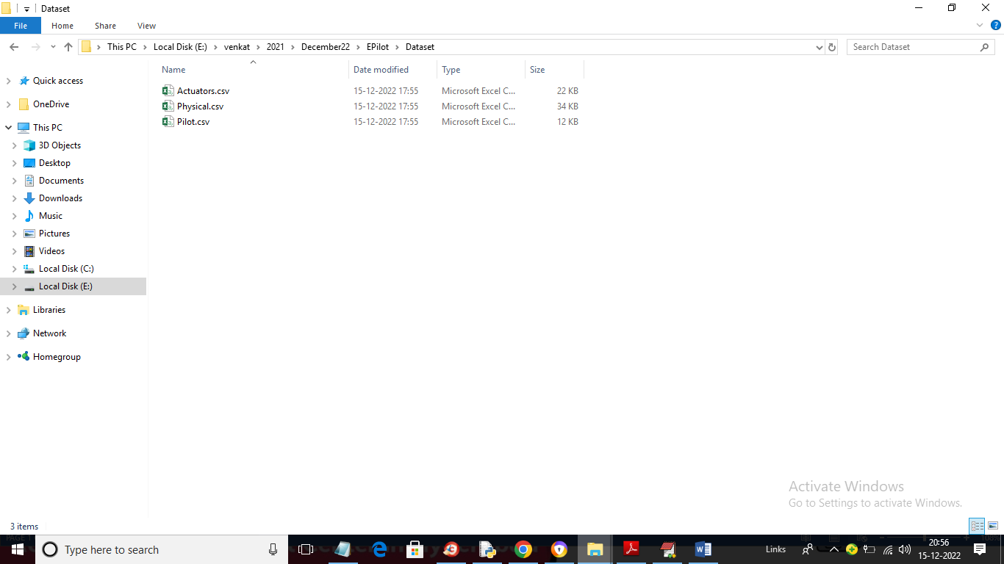

In above screen we have 3 different dataset features files to train different LSTM models.

To implement this project we have designed following modules

1. Upload Flight Landing Dataset: using this module we will upload dataset folder with 3 files and then application read all 3 files and then find and plot graph with number of HARD and NOT Hard Landing graph
2. Preprocess Dataset: using this module we will normalize and shuffle dataset and then split dataset into train and test where application used 80% dataset for training and 20% for testing.
3. Run SVM Algorithm: using this module we will train SVM with all features using 80% dataset and then perform prediction on 20% test data and then calculate SVM sensitivity and specificity score and then plot graph. Graph closer to 1 will reflect good performance of the algorithm
4. Run Logistic Regression Algorithm: using this module we will train SVM with all features using 80% dataset and then perform prediction on 20% test data and then calculate SVM sensitivity and specificity score and then plot graph. Graph closer to 1 will reflect good performance of the algorithm
5. Run AP2TD Algorithm: this module train LSTM on PHYSICAL features and then perform prediction on test data and calculate sensitivity and specificity
6. Run AP2DH Algorithm: this module train LSTM on ACTUATOR features and then perform prediction on test data and calculate sensitivity and specificity
7. Run DH2TD Algorithm: this module train LSTM on PILOT features and then perform prediction on test data and calculate sensitivity and specificity. This module merge all modules to get HYBRID LSTM sensitivity and specificity values
8. Comparison Graph: using this module we will plot sensitivity and specificity graph

SCREEN SHOTS

To run project double click on ‘run.bat’ file to get below output

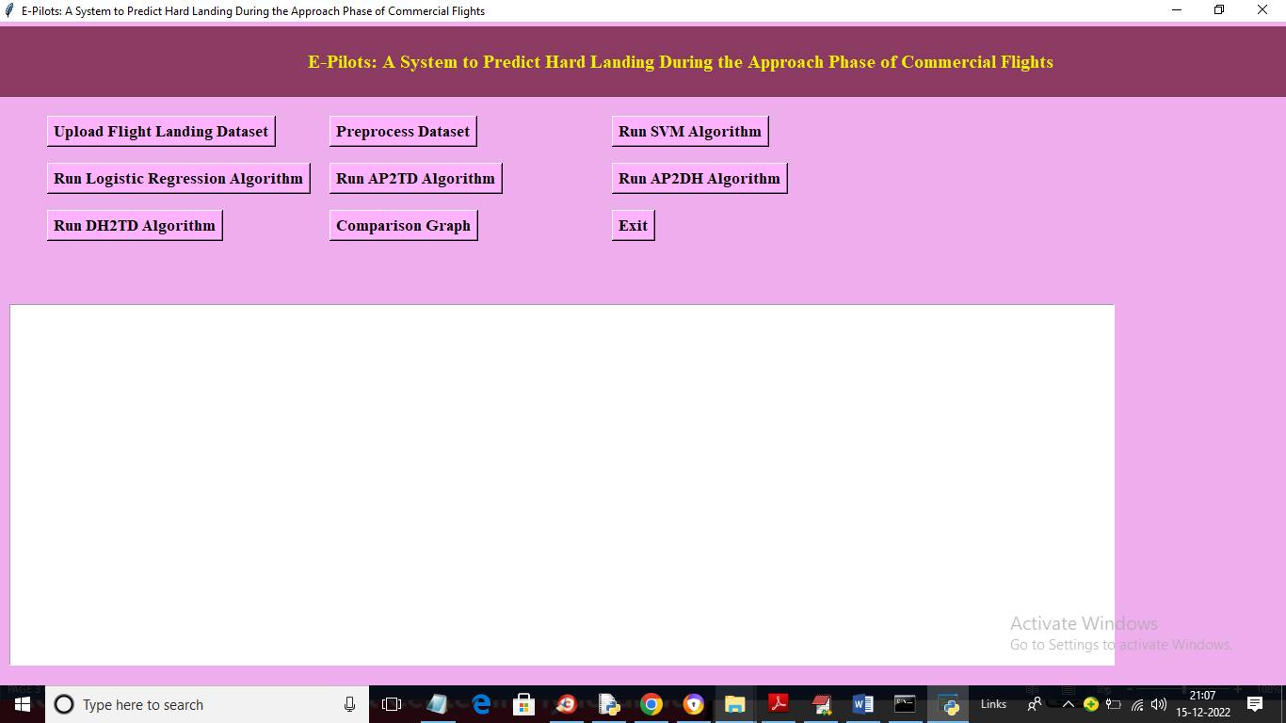

In above screen click on ‘Upload Flight Landing Dataset’ button to upload dataset and get below output

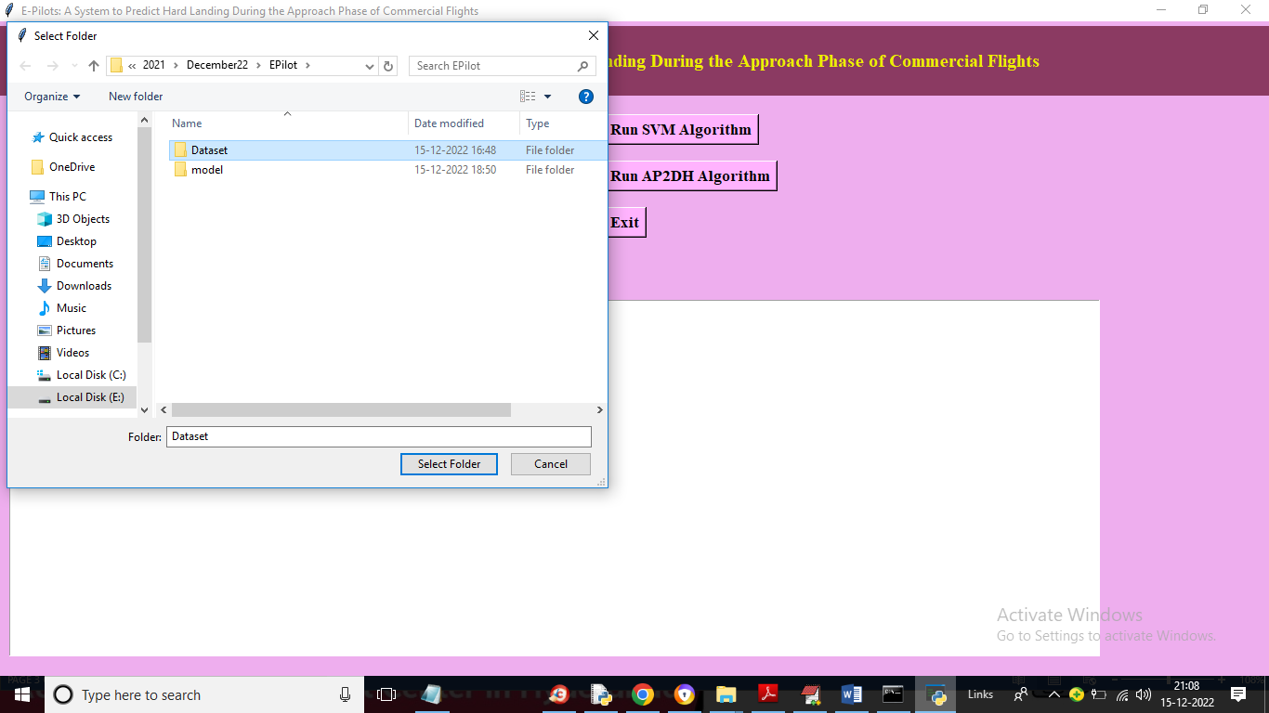

In above screen selecting and uploading entire dataset folder with 3 files and then click on ‘Select Folder’ button to load dataset and get below output

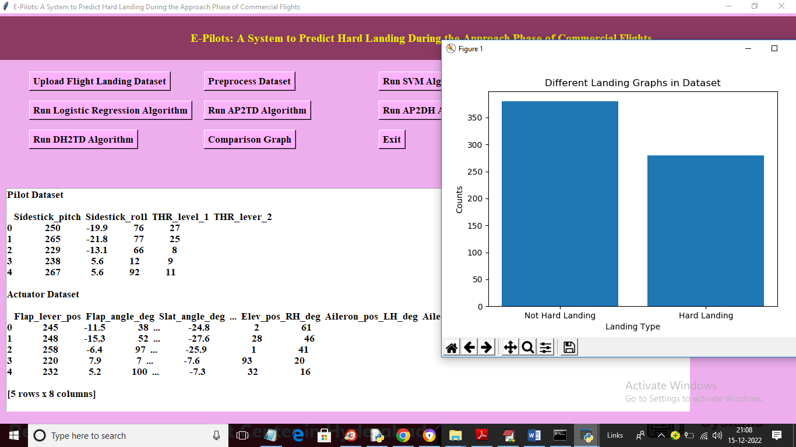

In above screen dataset loaded and we can see some records from PILOT and ACTUATOR dataset and you can scroll down above screen text area to view Physical dataset values and in graph x-axis represents type of landing and y-axis represents counts of landing found in dataset. Now close above graph and then click on ‘Preprocess Dataset’ button to normalize, shuffle and split dataset into train and test and get below output

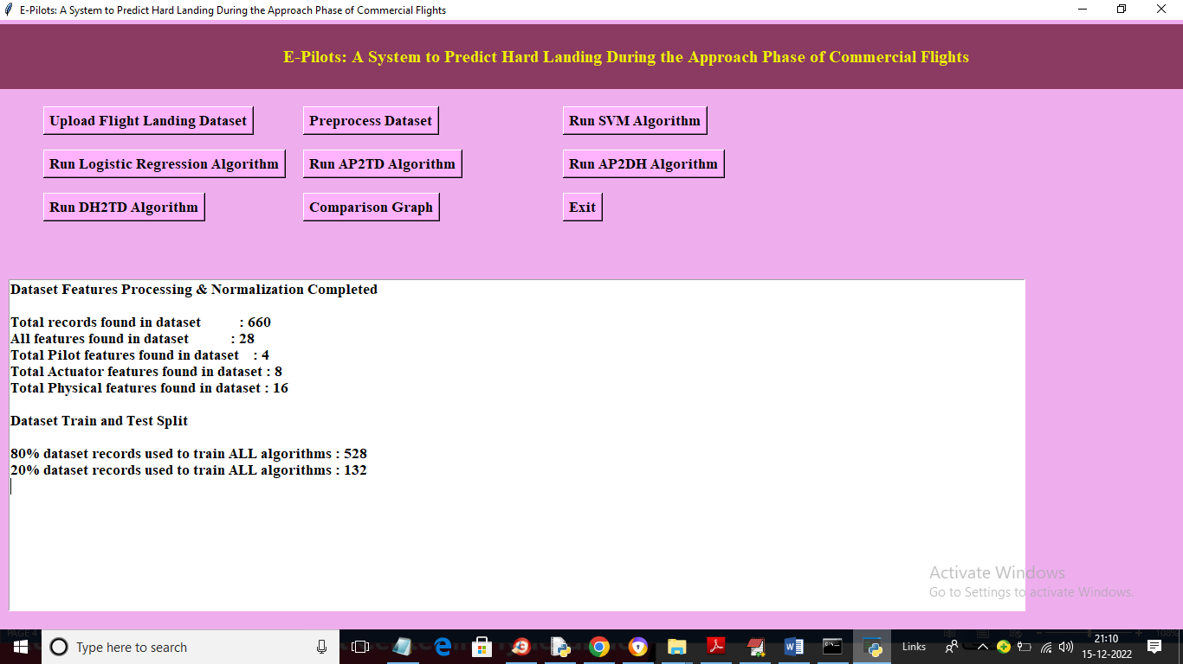

In above screen we can see total records in dataset and then we can see total features in all dataset and we can see total dataset in pilot and other dataset and then showing training and testing records size. Now train and test data is ready and now click on ‘Run SVM Algorithm’ button to train SVM and get below output

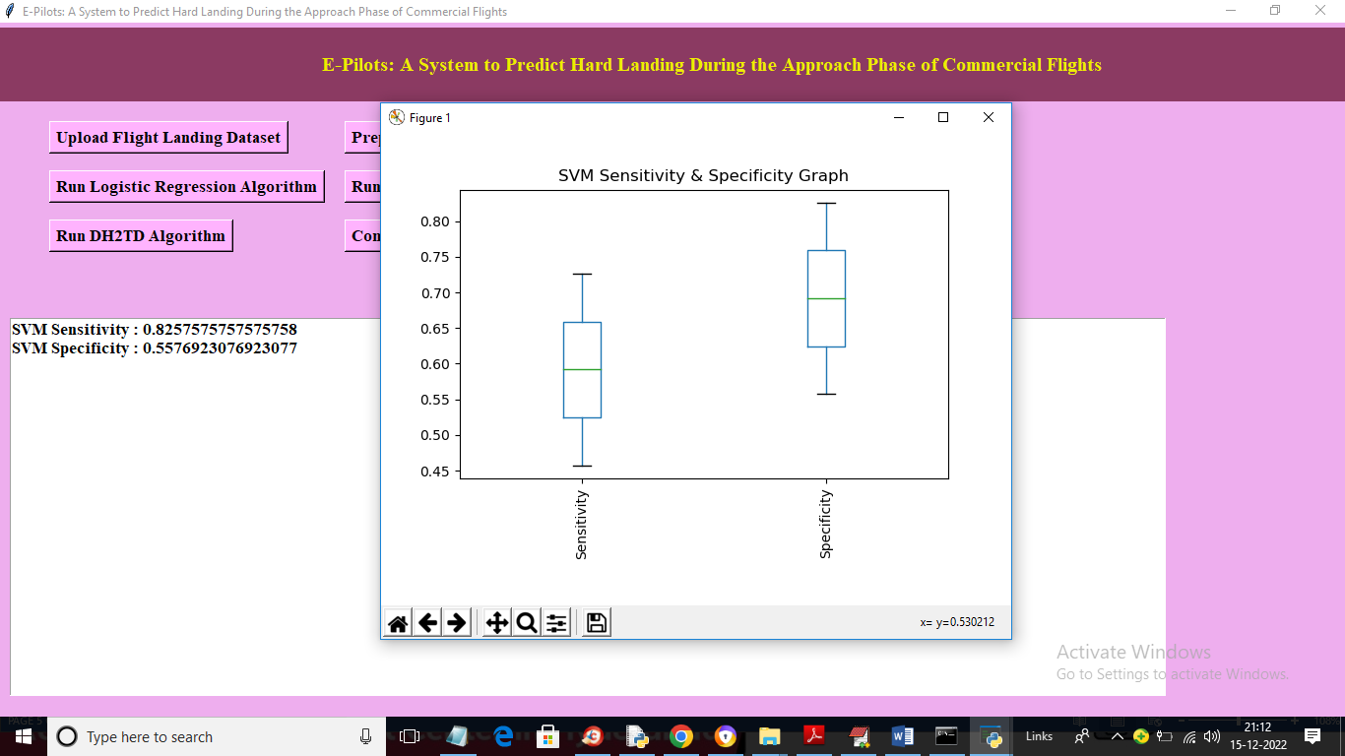

In above screen with SVM we got sensitivity as 0.82 and Specificity as 0.55 and in box plot x-axis represents metric names and y-axis represents values. Now close above graph and then click on ‘Run Logistic Regression Algorithm’ button to train logistic regression and get below output

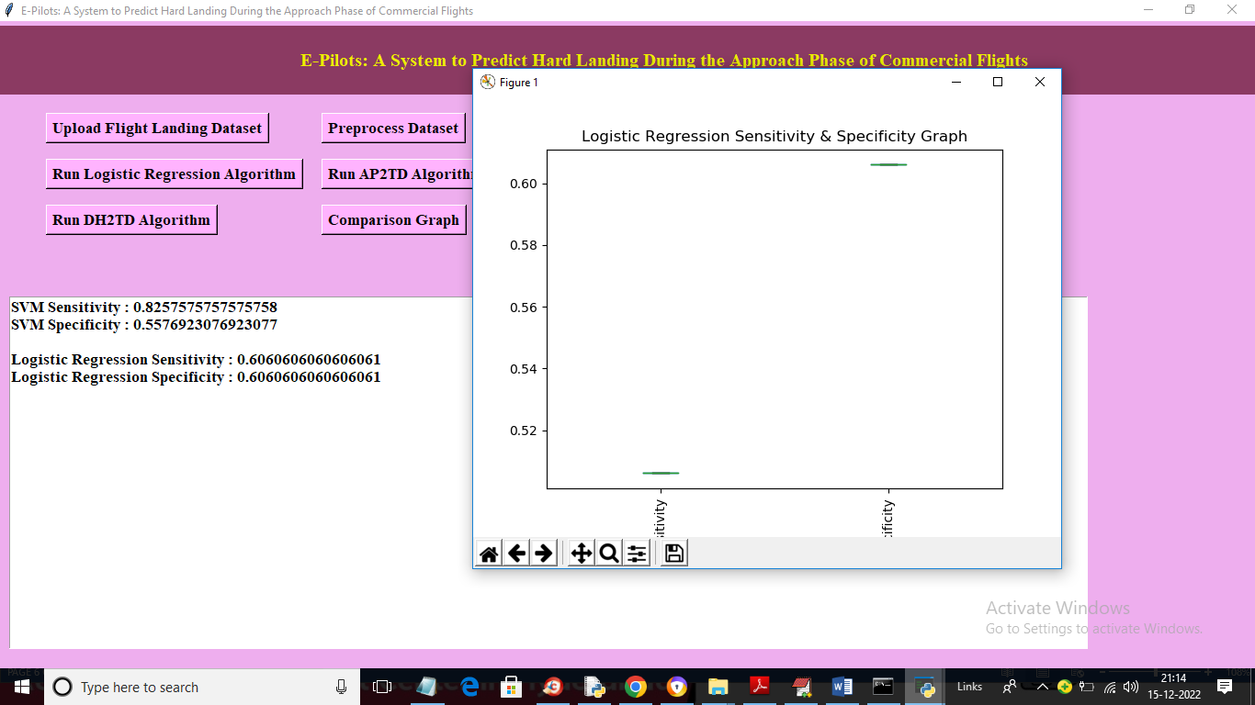

In above screen with logistic regression we got 0.60% sensitivity values and now click on ‘Run AP2TD Algorithm’ button to train LSTM on ‘Physical Features’ and get below output

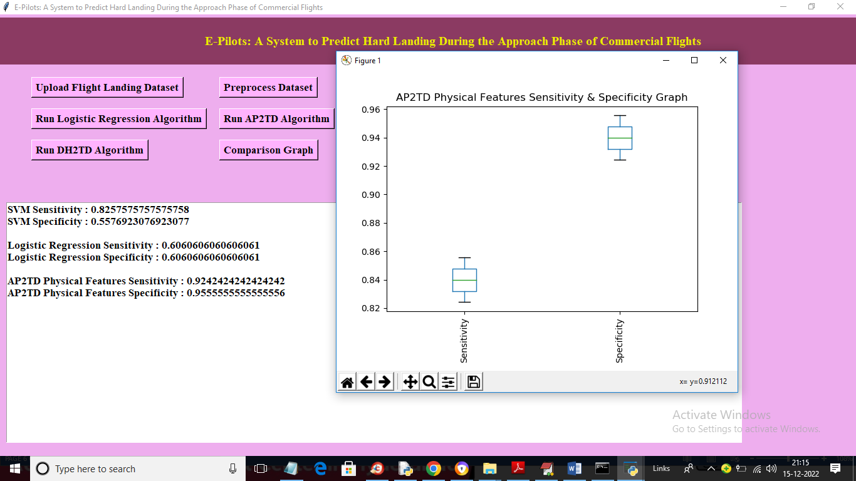

In above screen with AP2TD physical features we got LSTM sensitivity as 0.92 and specificity as 0.95 and now click on ‘Run AP2DH Algorithm’ to train LSTM on Actuator features and get below output

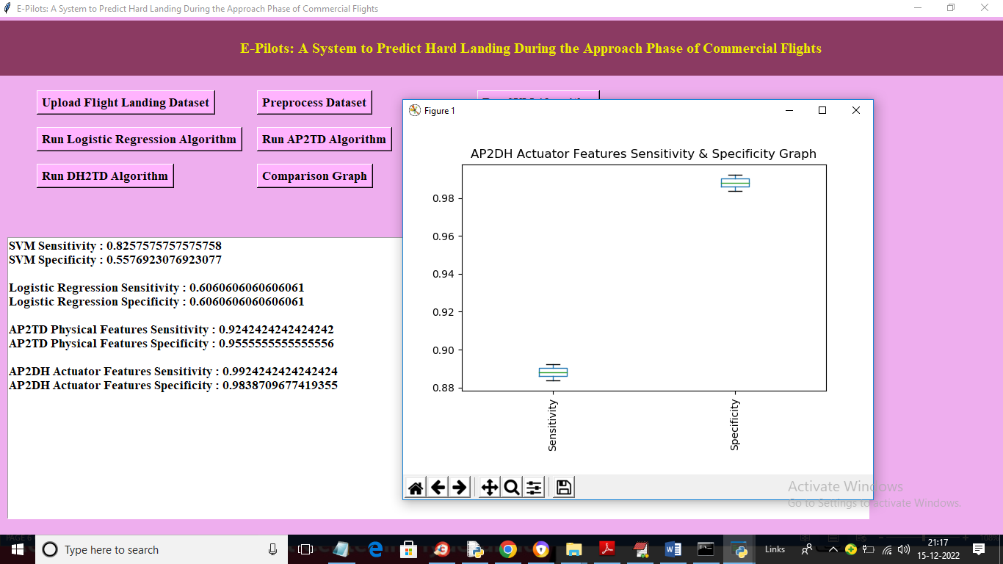

In above screen with AP2DH LSTM got 0.99% sensitivity and 0.98 specificity and now click on ‘Run DH2TD Algorithm’ button to train LSTM on PILOT features and get below output

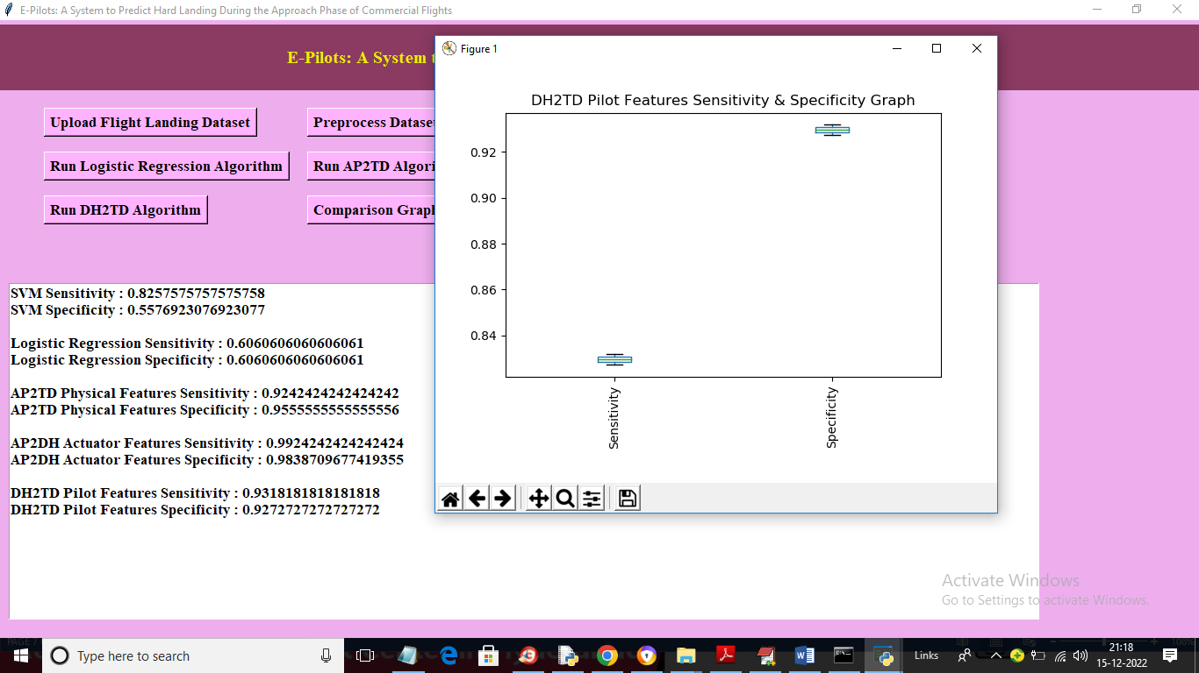

In above screen with DH2TD we got LSTM sensitivity as 0.93 and specificity as 0.92 and now click on ‘Comparison Graph’ button to get below comparison graph

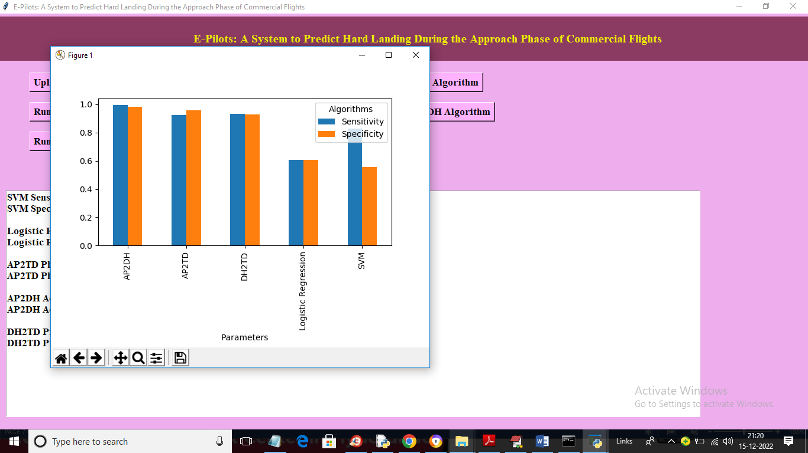

In above graph x-axis represents algorithm names and y-axis represents sensitivity and specificity values. Blue bar represents sensitivity and orange bar represents Specificity. In above graph we can see propose AP2TD, AP2DH and DH2TD got high sensitivity and specificity values compare to existing LSTM and logistic Regression.

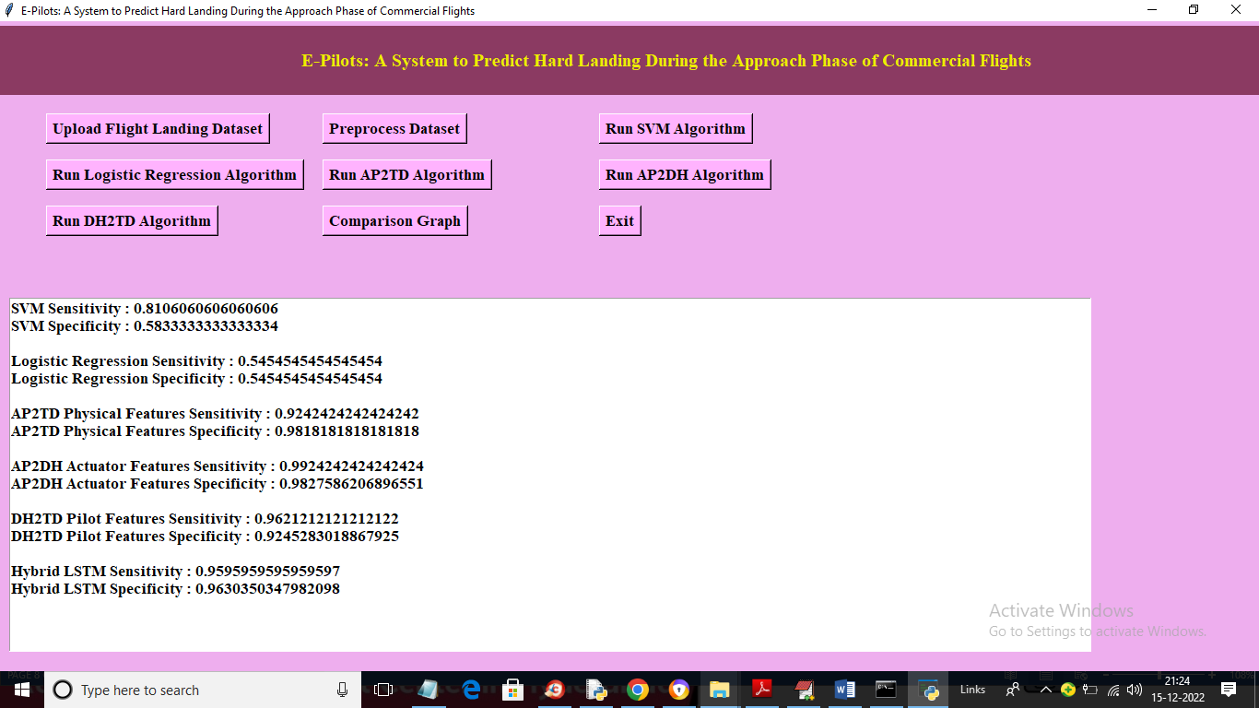

In above screen in last we can see sensitivity and specificity values for HYBRID LSTM by combining all 3 models. For hybrid LSTM we got sensitivity as 0.95 and specificity as 0.96%. This values are closer to value given in base paper