Assignment-2

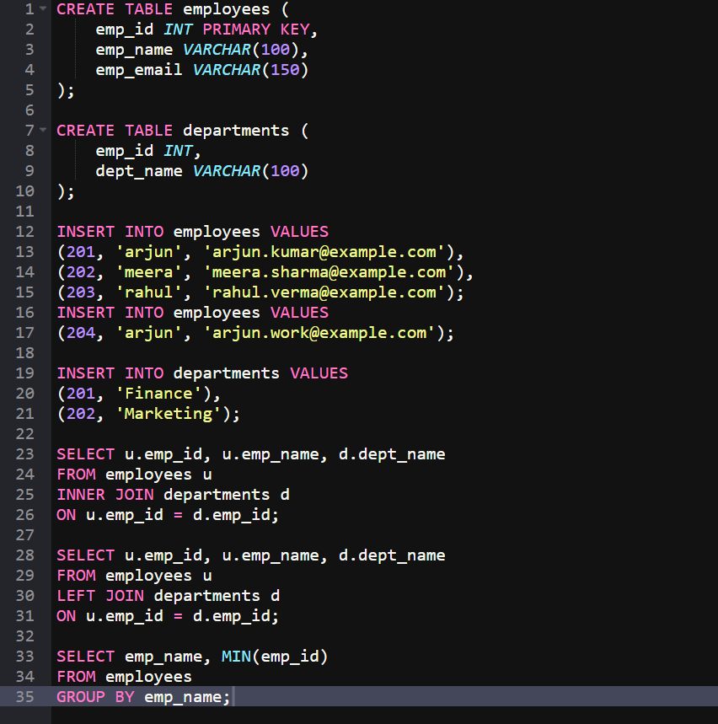
OUTPUT:
