Closed-Loop Robotic Exosuit Digital Twin for Real-Time Bone Loading Restoration in Microgravity

Core Problem:
When in space, an astronaut faces approximately 1-2% loss in bone density per month which is detrimental to the astronaut In long duration spaceflight.
To tackle this problem, ARED systems were introduced as workout equipment in microgravity.
This however is not a complete solution due to the 3 following reasons:
- The astronaut must use the equipment for 2+ hours per day
- The equipment itself is extremely heavy
- It doesn’t engage all joints equally

Our Solution:
A closed loop system where a real time musculoskeletal digital twin continuously monitors joint loading and commands joint specific resistance.

Methods used:
- Musculoskeletal Digital Twin – Based on Gait2354 model
- Microgravity Simulation – all ground reaction forces were eliminated and only inertial forces from the limb were accounted for
- Bone loading metric – force time integral (Derived from bone remodelling according to wolff’s law)
- Closed loop controller – rate based scheduling with PID feedback and time aware urgency
- Exosuit Force Model – modelled through the relationship between applied resistance torque and resulting muscle coordination

How the exosuit basically works:
The exosuit generates additional bone force through this chain:
torque → muscle force → joint reaction force
where, muscle force = (torque / moment arm) × co-contraction (approximately)

Results:
The study used a digital twin model to confirm that human joints experience significant, healthy pressure on Earth, but in simulated microgravity, these forces drop to just 6% of normal levels. This extreme lack of loading is what leads to bone loss in space. To combat this, we tested a robotic exosuit designed to restore at least 50% of Earth-like joint pressure. Over 6,000 walking cycles, the suit’s adaptive controller successfully ramped up resistance, significantly improving joint loading: hip forces increased by 52%, knees by 38%, and ankles by 24% compared to unassisted microgravity. However, even with the suit working at its maximum capacity, we failed to reach the 50% restoration target at any joint. The hip performed best, reaching about 64% of the goal, while the ankle struggled the most, reaching only 36%. The results show that while the "smart" control system works well to identify and fill the loading gap, the current hardware hit its power limits too early. Essentially, the suit helps significantly, but to fully protect an astronaut's bone health, we need more powerful motors—especially at the ankle—to match the intense forces the human body naturally generates on Earth.

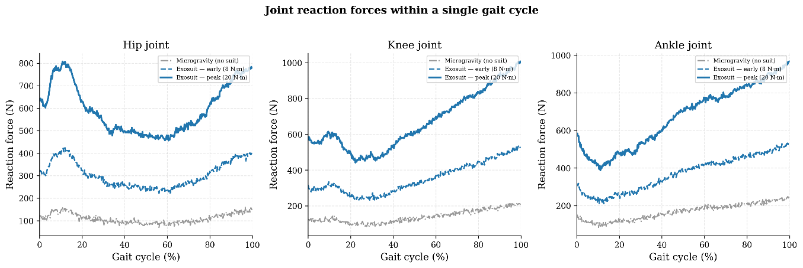
Figure 1. Joint reaction force profiles from the OpenSim Gait2354 digital twin during one gait cycle at Earth gravity. The microgravity baseline (grey) shows the 94% reduction in loading. Exosuit-augmented profiles at early (8 N·m, dashed) and peak (20 N·m, solid) resistance levels demonstrate progressive force restoration.

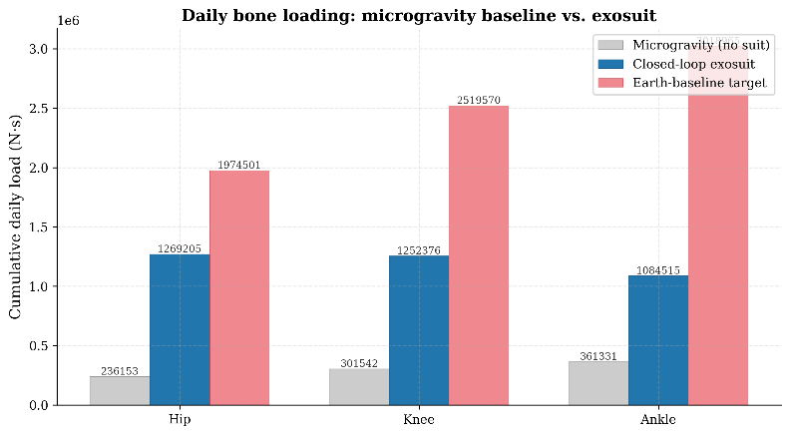
Figure 2. Daily cumulative bone loading comparison: microgravity baseline (grey), closed-loop exosuit (blue), and Earth-baseline 50% restoration target (red). The exosuit substantially increases loading but does not reach the target at any joint with current actuator limits.

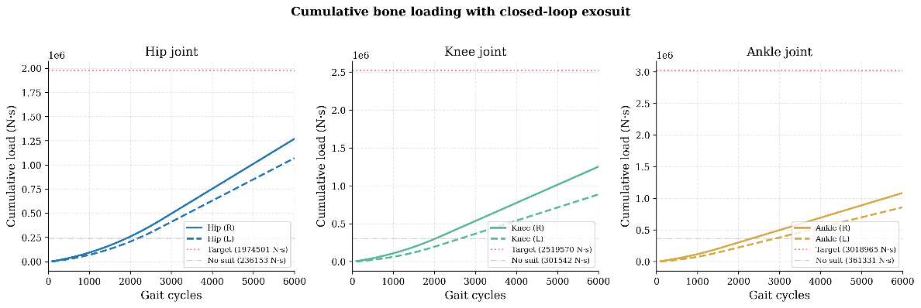
Figure 3. Cumulative bone loading trajectories over one simulated day (6,000 gait cycles). Solid/dashed lines show right/left joints. The gap between the exosuit trajectory and the target line quantifies the unmet loading deficit.

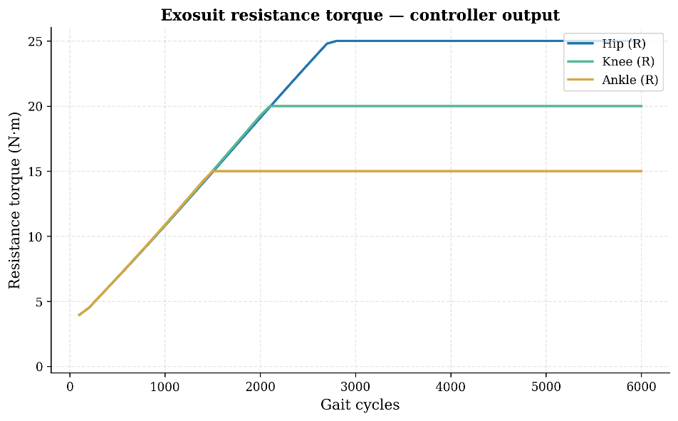
Figure 4. Exosuit resistance torque profiles showing the adaptive ramp-up and saturation behavior. The hip requires the longest ramp to reach its 25 N·m limit.
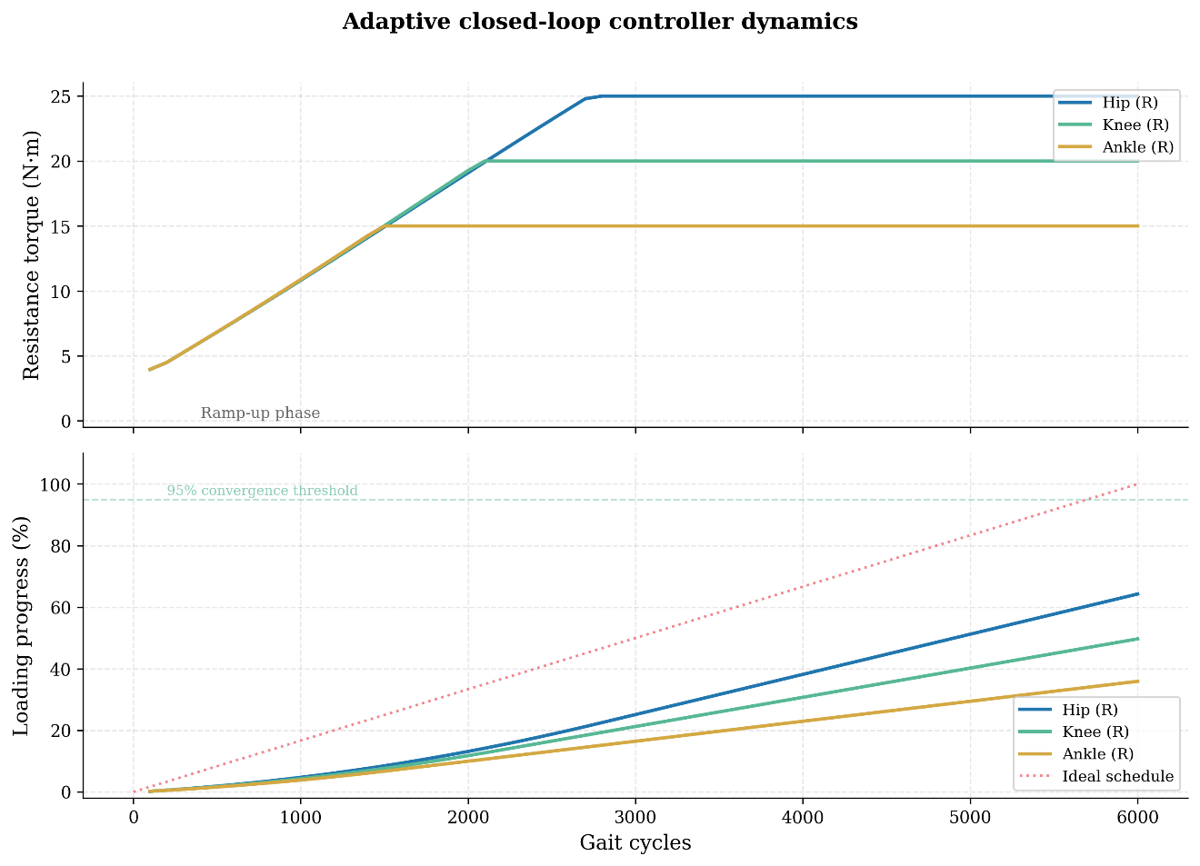
Figure 5. Top: Resistance torque commands over time, showing staggered saturation. Bottom: Loading progress versus ideal linear schedule, demonstrating the widening gap between achieved and required loading rates.
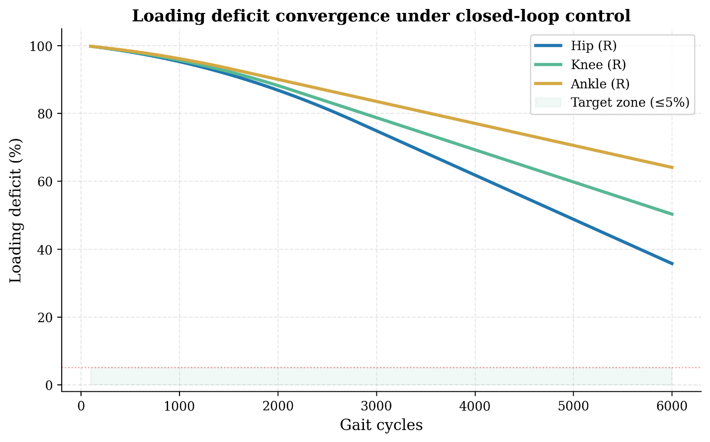
Figure 6. Loading deficit convergence under closed-loop control. The hip converges fastest (to 36% remaining deficit), while the ankle shows the slowest convergence (64% remaining). None reach the 5% target zone with current actuator limits.

