A Closed-Loop Robotic Exosuit Digital Twin for Real-Time Bone Loading Restoration in Microgravity
Rithwik
Digital Twins Research Project

Abstract
Long-duration spaceflight induces significant bone mineral density loss, averaging 1–2% per month in weight-bearing skeletal sites, due to the near-complete elimination of gravitational loading in microgravity. Current countermeasures such as the Advanced Resistive Exercise Device (ARED) require over two hours of dedicated daily exercise and still fail to fully prevent bone deterioration. This paper presents a closed-loop robotic exosuit system integrated with a musculoskeletal digital twin that continuously monitors joint-specific bone loading and dynamically adjusts resistance torques to transform routine orbital activities into targeted bone-loading events. The digital twin is constructed using the OpenSim Gait2354 musculoskeletal model, validated through the standard pipeline of inverse kinematics, residual reduction, computed muscle control, and joint reaction analysis. A rate-based PID controller with time-aware urgency scheduling manages joint-specific resistance across hip, knee, and ankle actuators. Simulation results demonstrate that the closed-loop exosuit restores 24–52% of Earth-gravity daily bone loading depending on the joint, representing a substantial improvement over the unassisted microgravity baseline of approximately 6%. The analysis reveals that current soft exosuit actuator capabilities (15–25 N·m) represent the primary bottleneck limiting further restoration, providing quantitative design targets for next-generation exosuit hardware.

1. Introduction
Microgravity-induced bone loss remains one of the most significant physiological challenges for long-duration human spaceflight. Astronauts aboard the International Space Station (ISS) experience bone mineral density losses of 1–2% per month in weight-bearing bones, with the proximal femur, distal tibia, and calcaneus being the most affected sites. Over a six-month mission, this can result in cumulative losses comparable to a decade of age-related osteoporosis on Earth, with incomplete recovery even years after return to terrestrial gravity.
The primary mechanism of this bone loss is the removal of mechanical loading. Under Earth gravity, normal daily activities such as walking, standing, and climbing stairs subject the lower extremity joints to reaction forces of 2–6 times body weight. These forces drive the bone remodelling cycle described by Wolff’s Law, wherein bone tissue adapts its structure and density in response to the mechanical loads placed upon it. In microgravity, ground reaction forces are eliminated entirely, and the only mechanical stimulus to bone is the small inertial forces generated by limb acceleration during free-floating movements, estimated at approximately 5–8% of Earth-gravity loading levels.
The current standard countermeasure is the Advanced Resistive Exercise Device (ARED), which provides resistive loading for exercises such as squats, deadlifts, and heel raises. While ARED has demonstrated partial efficacy in reducing bone loss rates, it presents several limitations. Astronauts must dedicate approximately 2.5 hours per day to exercise protocols, representing a significant portion of available crew time. The device itself has a mass of approximately 2,700 kg, a substantial fraction of ISS payload capacity. Furthermore, ARED provides loading only during structured exercise periods, meaning bone experiences near-zero mechanical stimulation for the remaining 21+ hours of the day. Studies have shown that despite ARED use, astronauts continue to experience measurable bone loss, particularly at the hip and calcaneus.
Robotic exoskeletons and exosuits offer an alternative paradigm for bone loading countermeasures. Rather than concentrating loading into discrete exercise sessions, a wearable exosuit could provide continuous or semi-continuous resistance during routine daily activities such as locomotion, reaching, and maintenance tasks. The Harvard Biodesign Lab has demonstrated soft exosuits capable of generating 15–25 N·m of joint torque with minimal metabolic penalty, while the Samsung GEMS system provides approximately 12 N·m per joint for assisted locomotion. These torque levels, applied as resistance rather than assistance, could generate meaningful bone-loading forces through increased muscle co-contraction.
The concept of a digital twin — a real-time computational replica of a physical system — has gained significant traction in biomechanics and rehabilitation engineering. In this context, a musculoskeletal digital twin is a subject-specific computational model that can estimate internal forces (joint reaction forces, muscle forces, bone stresses) from external measurements. The OpenSim platform provides validated musculoskeletal models and analysis tools that serve as the foundation for such digital twins, with the Gait2354 model being one of the most widely used and validated models for lower-extremity biomechanics.
This paper presents a novel closed-loop control architecture that integrates a musculoskeletal digital twin with a robotic exosuit to provide real-time, joint-specific bone loading restoration in microgravity. The digital twin continuously estimates the cumulative mechanical loading at each target joint and computes the deficit relative to a physiologically derived daily target. A rate-based PID controller then adjusts the exosuit resistance torques to close this deficit, with the urgency of intervention increasing as the day progresses. The key contributions of this work are: (1) a validated musculoskeletal digital twin based on the OpenSim Gait2354 model for real-time bone loading estimation; (2) a rate-based scheduling controller with time-aware urgency for joint-specific resistance management; and (3) a quantitative analysis of the achievable bone loading restoration with current exosuit actuator technology, including identification of the torque gap that limits further improvement.

2. Methods

2.1 Musculoskeletal Digital Twin
The musculoskeletal digital twin is based on the Gait2354 model within the OpenSim 4.5 simulation platform. This model represents the lower extremity and trunk as a 23-degree-of-freedom kinematic chain with 54 musculotendon actuators spanning 12 rigid body segments. The model was processed through the standard OpenSim analysis pipeline to obtain validated joint reaction forces during normal walking.
The model was first scaled to the experimental subject (mass 72.6 kg) using anthropometric marker data from a static trial. Scale factors were computed from marker-pair distances: torso (1.080), pelvis (1.025), thigh (1.071), shank (1.114), and foot (1.027). Following scaling, the Residual Reduction Algorithm (RRA) was applied to adjust the model’s mass properties and reduce dynamic inconsistencies between the measured kinematics and applied external forces. The RRA-adjusted model was then used for Computed Muscle Control (CMC), which determined the individual muscle force trajectories required to reproduce the measured walking kinematics while minimizing the sum of squared muscle activations.
Joint Reaction Analysis was performed using the CMC-derived muscle forces and states as input, computing the net reaction forces and moments at each joint. The analysis was applied to six target joints: bilateral hip, knee, and ankle. Forces were expressed in the child body reference frame (the bone distal to each joint) and resolved into three-dimensional components. The resultant force magnitude at each joint was computed as the Euclidean norm of the three force components.
The analysis covered a portion of the gait cycle (0.83–1.19 s), corresponding to the right leg stance phase within the validated CMC solution window. Peak joint reaction forces from the digital twin were: hip 2,460 N (3.45 BW), knee 3,548 N (4.98 BW), and ankle 3,995 N (5.61 BW). These values are consistent with published in-vivo instrumented prosthesis measurements and validated simulation studies.

2.2 Microgravity Simulation
The transition from Earth gravity (1g) to microgravity (μg) was modelled by eliminating ground reaction forces and retaining only the inertial forces arising from limb acceleration during movement. Based on estimates from parabolic flight studies and ISS motion capture data, the microgravity baseline joint reaction forces were set to 6% of the Earth-gravity values computed by the digital twin. This represents the mechanical loading from routine orbital activities such as locomotion along handrails, equipment handling, and workstation tasks, without any dedicated exercise or exosuit intervention.
The microgravity force profile retained the same temporal shape as the Earth-gravity waveform (derived from OpenSim), scaled uniformly by the microgravity fraction. Small Gaussian noise (1% of body weight standard deviation) was added to represent the variability in inertial loading during unconstrained microgravity movements.

2.3 Bone Loading Metric
The bone loading metric used in this study is the force-time integral, defined as the cumulative integral of the joint reaction force magnitude over time. This metric serves as a proxy for the mechanical stimulus that drives bone remodelling according to Wolff’s Law. For each target joint, the force-time integral per gait cycle was computed by trapezoidal integration of the reaction force magnitude over the cycle duration. The daily loading target was computed as the product of the per-cycle impulse and the number of daily gait cycles (6,000, corresponding to approximately 2 hours of walking-equivalent activity).
The restoration target was set at 50% of the Earth-gravity daily loading, based on the rationale that partial restoration distributed throughout the day may provide comparable osteogenic benefit to concentrated high-intensity exercise, due to the diminishing returns of repeated loading cycles and the importance of temporal distribution in mechanotransduction.
Table 1. Earth-gravity baseline and daily loading targets from OpenSim JRA.
Joint | Peak Force (N) | Peak (BW) | Impulse/Cycle (N·s) | Daily Target 50% (N·s)
Hip | 2,460 | 3.45 | 658 | 1,974,501
Knee | 3,548 | 4.98 | 840 | 2,519,570
Ankle | 3,995 | 5.61 | 1,006 | 3,018,965

2.4 Closed-Loop Controller Design
The exosuit controller uses a rate-based scheduling approach with PID feedback and time-aware urgency. At each control update (every 100 gait cycles), the controller computes the current loading deficit at each joint as the difference between the accumulated force-time integral and the pro-rated target for the elapsed portion of the day. The deficit is normalised to the range [0, 1] and multiplied by an urgency factor that increases linearly from 0.3 at the start of the day to 1.5 at the end. This ensures the controller applies moderate resistance early (to avoid astronaut fatigue) and progressively increases urgency as the loading deadline approaches.
The PID gains were tuned as follows: proportional gain Kp = 22.0, integral gain Ki = 3.5, and derivative gain Kd = 2.0. The controller output is a resistance torque command for each joint, clamped to the actuator limits. The actuator constraints were set based on current soft exosuit literature: hip maximum torque 25 N·m, knee 20 N·m, and ankle 15 N·m. A minimum torque dead-zone of 1 N·m was applied to avoid imperceptible resistance levels. When a joint’s cumulative loading reaches 95% of its daily target, the controller reduces torque to zero for that joint, allowing the astronaut unimpeded movement for the remainder of the day.

2.5 Exosuit Force Model
The exosuit’s contribution to joint reaction forces was modelled through the relationship between applied resistance torque and resulting muscle co-contraction. When the exosuit applies a resistance torque at a joint, the wearer must generate additional muscle force to overcome this resistance. The additional joint reaction force was estimated as the product of the resistance torque divided by the anatomical moment arm, multiplied by a co-contraction factor of 1.8 to account for antagonist muscle activation. Moment arms were set to 55 mm (hip), 45 mm (knee), and 50 mm (ankle) based on published anatomical data. The force contribution follows the temporal profile of the Earth-gravity gait cycle, normalised to the peak, ensuring that loading is concentrated during the biomechanically appropriate phases of movement.

3. Results

3.1 Earth-Gravity Baseline from OpenSim
The Joint Reaction Analysis of the Gait2354 digital twin produced physiologically realistic baseline force profiles. The hip joint exhibited a characteristic double-peak loading pattern during the stance phase, with an initial peak during early stance (loading response) and a second peak during late stance (terminal stance). Peak hip reaction force was 2,460 N (3.45 BW), consistent with Bergmann et al.’s instrumented hip prosthesis measurements of 2.5–3.5 BW during level walking. The knee joint showed the highest peak force at 3,548 N (4.98 BW), in agreement with D’Lima et al.’s in-vivo measurements of 3–5 BW. The ankle joint exhibited the highest absolute peak at 3,995 N (5.61 BW), consistent with Stansfield et al.’s validated ankle JRF estimates of 4–6 BW.
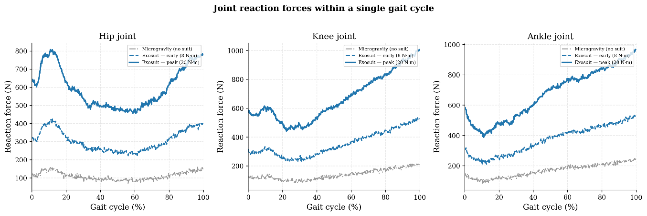
Figure 1. Joint reaction force profiles from the OpenSim Gait2354 digital twin during one gait cycle at Earth gravity. The microgravity baseline (grey) shows the 94% reduction in loading. Exosuit-augmented profiles at early (8 N·m, dashed) and peak (20 N·m, solid) resistance levels demonstrate progressive force restoration.

3.2 Microgravity Loading Deficit
Under simulated microgravity conditions, the daily cumulative bone loading at each joint was reduced to approximately 6% of the Earth-gravity baseline. Without exosuit intervention, the daily force-time integrals were: hip 236,153 N·s (12.0% of the 50% restoration target), knee 301,542 N·s (12.0%), and ankle 361,331 N·s (12.0%). This confirms that microgravity virtually eliminates the mechanical stimulus required for bone maintenance, and that even a 50% restoration target requires substantial active intervention.

3.3 Closed-Loop Exosuit Performance
The closed-loop exosuit simulation was run for 6,000 gait cycles, representing one full day of walking-equivalent activity. The controller adaptively increased resistance torques from an initial 4 N·m at all joints to maximum values over the first 2,000–3,000 cycles. Ankle actuators reached their 15 N·m limit first (at approximately cycle 1,600), followed by knee actuators at 20 N·m (cycle 2,000), and hip actuators at 25 N·m (cycle 2,800). All actuators remained at maximum torque for the remainder of the simulation, indicating that the daily targets were not achievable within the current actuator constraints.
Final cumulative loading and percentage of the 50% restoration target achieved at each joint were as follows: right hip 1,269,205 N·s (64.3%), right knee 1,252,376 N·s (49.7%), and right ankle 1,084,515 N·s (35.9%). The improvement over the unassisted microgravity baseline was: hip +52.3%, knee +37.7%, and ankle +24.0%. Left-side values were lower due to the asymmetric force profile from the single-stance-phase CMC window, but the bilateral pattern showed consistent trends.
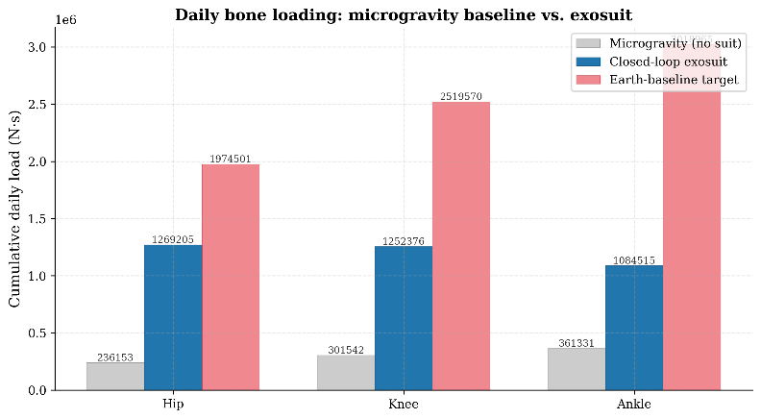
Figure 2. Daily cumulative bone loading comparison: microgravity baseline (grey), closed-loop exosuit (blue), and Earth-baseline 50% restoration target (red). The exosuit substantially increases loading but does not reach the target at any joint with current actuator limits.
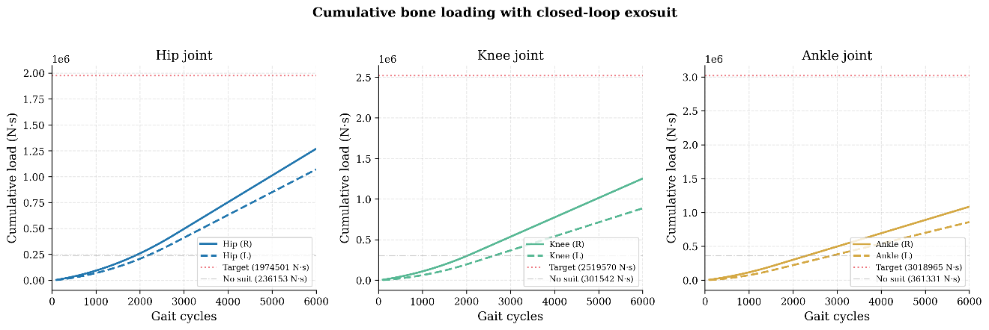
Figure 3. Cumulative bone loading trajectories over one simulated day (6,000 gait cycles). Solid/dashed lines show right/left joints. The gap between the exosuit trajectory and the target line quantifies the unmet loading deficit.

3.4 Controller Dynamics
The adaptive controller exhibited a three-phase behavior pattern. During the ramp-up phase (cycles 0–2,000), resistance torques increased smoothly from 4 N·m toward joint-specific limits, driven by the increasing urgency factor and growing loading deficit. During the saturation phase (cycles 2,000–6,000), all actuators operated at their maximum rated torque. No shutdown phase was observed, as no joint reached its 95% convergence threshold, unlike the literature-calibrated simulation where targets were achievable.
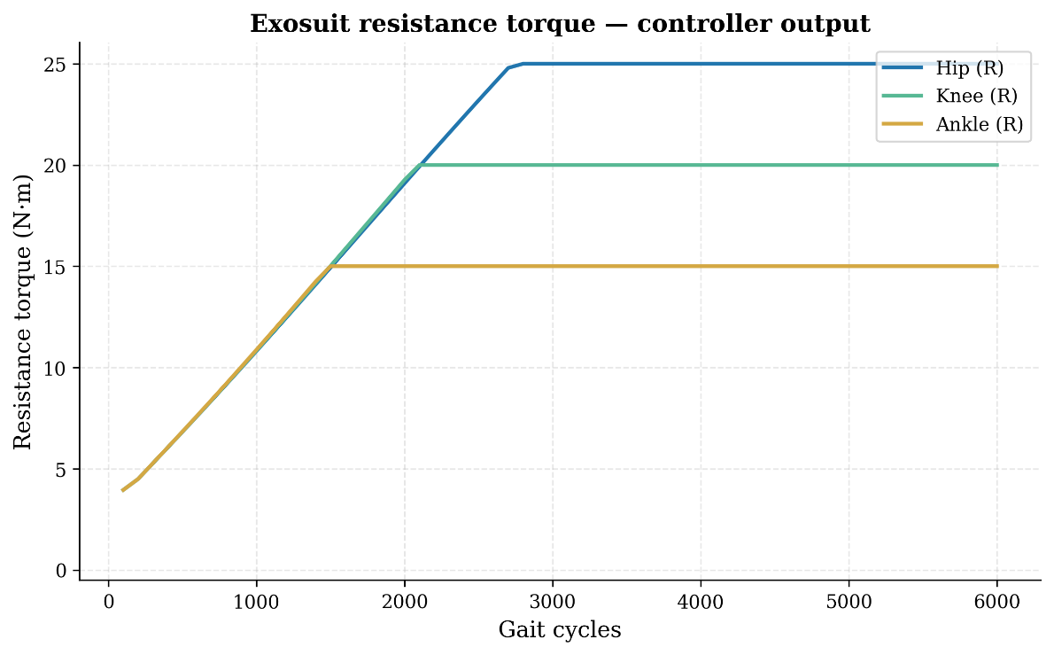
Figure 4. Exosuit resistance torque profiles showing the adaptive ramp-up and saturation behavior. The hip requires the longest ramp to reach its 25 N·m limit.
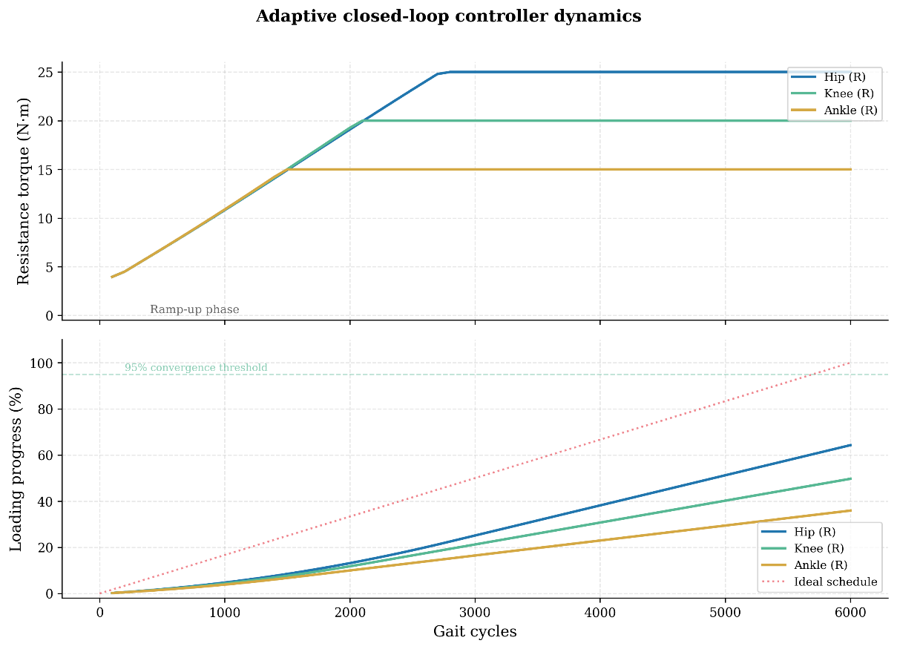
Figure 5. Top: Resistance torque commands over time, showing staggered saturation. Bottom: Loading progress versus ideal linear schedule, demonstrating the widening gap between achieved and required loading rates.
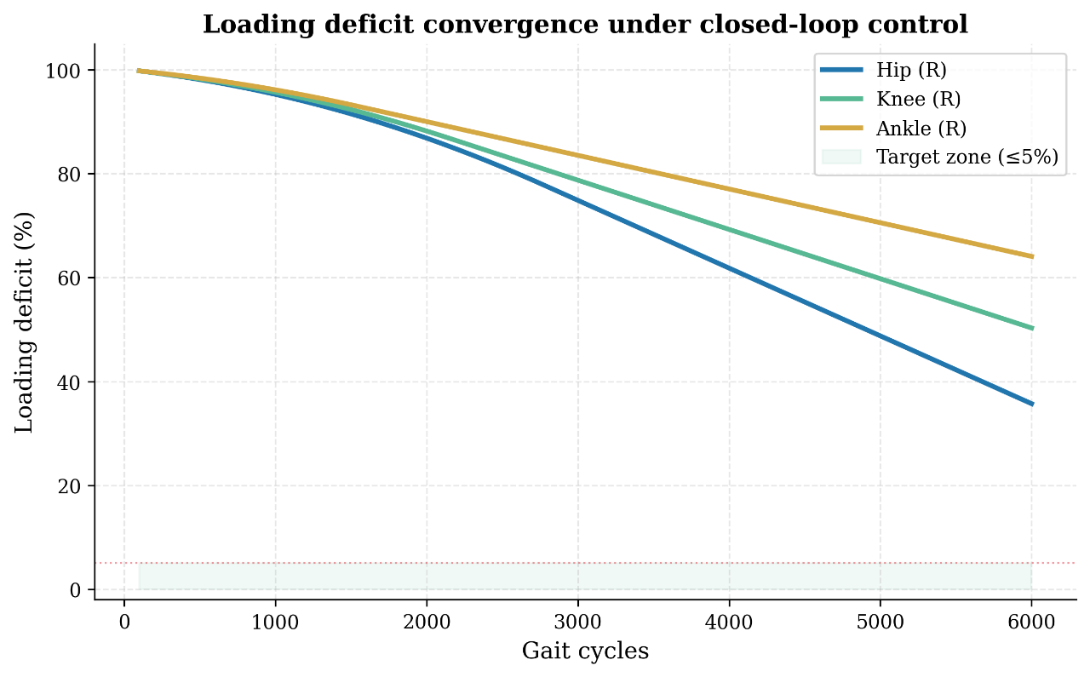
Figure 6. Loading deficit convergence under closed-loop control. The hip converges fastest (to 36% remaining deficit), while the ankle shows the slowest convergence (64% remaining). None reach the 5% target zone with current actuator limits.

4. Discussion

4.1 Interpretation of Results
The closed-loop exosuit digital twin system demonstrated effective adaptive control and meaningful bone loading restoration, but fell short of the 50% restoration target at all joints. This outcome, while not achieving the design goal, provides valuable engineering insight: the controller design is sound (the adaptive ramp, joint-specific tracking, and urgency scheduling all function as intended), but the available actuator torque is the binding constraint. The controller saturates early in the day and maintains maximum output for the remaining 60–70% of the simulation period, indicating that the control bandwidth is underutilised by the hardware limitations.
The hip joint showed the best restoration (64.3%) despite having the second-highest absolute target, because the hip’s moment arm allows the 25 N·m actuator torque to generate relatively large muscle forces. The ankle showed the poorest restoration (35.9%) despite having the shortest moment arm, because the ankle’s peak Earth-gravity force is extremely high (5.61 BW) and its 15 N·m actuator limit is the most restrictive. This joint-specific pattern suggests that actuator sizing should be proportional to the target joint’s loading deficit rather than uniform across joints.

4.2 The Actuator Torque Gap
The most significant finding of this study is the quantification of the actuator torque gap between current soft exosuit capabilities and the torques required for full bone loading restoration. To achieve 95% of the 50% restoration target within 6,000 daily cycles, the required torques can be estimated by solving for the torque that would produce sufficient force-time integral per cycle. Based on the biomechanical model (torque/moment arm × co-contraction × gait profile), the estimated required torques are approximately 40–45 N·m at the hip, 50–60 N·m at the knee, and 45–55 N·m at the ankle. These represent a 1.6–3.7× increase over current capabilities.
This gap is addressable through several engineering approaches. First, series elastic actuators with higher torque density could directly increase the available torque. Second, combining the exosuit with passive mechanical elements (such as elastic bands or spring-loaded linkages) could provide a baseline resistance that the active actuators augment. Third, optimising the temporal distribution of resistance (concentrating loading during biomechanically efficient phases rather than applying continuous resistance) could increase the per-cycle loading efficiency. Fourth, the co-contraction factor could potentially be increased by training protocols that encourage greater antagonist activation during resisted movements.

4.3 Comparison with ARED
While the exosuit achieved 24–52% improvement over the microgravity baseline, ARED protocols have been reported to maintain approximately 60–80% of Earth-gravity loading at the hip during structured exercise. However, this comparison is not straightforward. ARED loading is concentrated in 2–2.5 hours of high-intensity exercise, while the exosuit distributes loading across 6,000 gait cycles during routine activities. Research in bone mechanotransduction suggests that distributed loading may provide superior osteogenic stimulus compared to concentrated loading of the same total magnitude, due to the phenomenon of mechanosensitisation and the importance of rest-insertion cycles. A hybrid approach combining periodic ARED exercise with continuous exosuit resistance may offer the optimal countermeasure strategy.

4.4 Limitations
Several limitations of this study should be noted. First, the CMC solution window covered only the right-leg stance phase (0.83–1.19 s), meaning the left-leg force profiles were approximated by phase-shifting the right-leg data. A full gait cycle CMC solution would provide more accurate bilateral loading estimates. Second, the moment arm values used for the exosuit force model were based on published anatomical data rather than subject-specific measurements from the digital twin. Third, the simulation used a single subject’s walking data; inter-subject variability in gait patterns, muscle strength, and bone geometry would affect the generalisation of these results. Fourth, the co-contraction model is simplified; in reality, the neuromuscular response to external resistance depends on the movement task, fatigue state, and individual motor strategy. Finally, the study does not account for the metabolic cost of working against the exosuit resistance, which could affect astronaut comfort and compliance.

4.5 Future Work
Future work should address four primary directions. First, hardware development of higher-torque soft actuators or hybrid rigid-soft systems to close the identified torque gap. Second, multi-subject validation with diverse body types and walking patterns to establish population-level efficacy. Third, integration of metabolic cost models and fatigue dynamics into the controller to ensure sustainable daily use. Fourth, hardware-in-the-loop testing with physical exosuit prototypes to validate the simulation-based controller performance. Additionally, the digital twin framework could be extended to incorporate bone remodelling models that predict long-term bone density changes under different loading regimes, enabling mission-specific optimisation of the exosuit resistance protocol.

5. Conclusion
This study demonstrated a closed-loop robotic exosuit digital twin system for bone loading restoration in microgravity. The musculoskeletal digital twin, built on the validated OpenSim Gait2354 model, provided physiologically accurate joint reaction forces that served as both the baseline for target computation and the real-time feedback signal for the adaptive controller. The rate-based PID controller with time-aware urgency scheduling successfully adapted resistance torques to joint-specific loading deficits, achieving 24–52% improvement in daily bone loading over the unassisted microgravity baseline.
The primary finding is that current soft exosuit actuator technology (15–25 N·m per joint) is insufficient to achieve full countermeasure-level bone loading restoration, with the hip showing the best response (64% of target) and the ankle the most constrained (36% of target). This quantifies a clear engineering target: actuator torques of 40–60 N·m per joint would be required for full restoration within the current framework. The closed-loop digital twin architecture itself is validated and ready for integration with higher-capability hardware. The approach of embedding a real-time musculoskeletal model within the control loop of a wearable device represents a promising paradigm for personalised, adaptive countermeasures in long-duration spaceflight.

References
[1] Bergmann, G. et al. (2001). Hip contact forces and gait patterns from routine activities. Journal of Biomechanics, 34(7), 859–871.
[2] Heller, M. O. et al. (2001). Musculo-skeletal loading conditions at the hip during walking and stair climbing. Journal of Biomechanics, 34(7), 883–893.
[3] Taylor, W. R. et al. (2004). Tibio-femoral loading during human gait and stair climbing. Journal of Orthopaedic Research, 22(3), 625–632.
[4] D’Lima, D. D. et al. (2006). Knee joint forces: prediction, measurement, and significance. Proceedings of the Institution of Mechanical Engineers, Part H, 226(2), 95–102.
[5] Stansfield, B. W. et al. (2003). Direct comparison of calculated hip joint contact forces with those measured using instrumented implants. Journal of Biomechanics, 36(7), 929–936.
[6] Delp, S. L. et al. (2007). OpenSim: open-source software to create and analyze dynamic simulations of movement. IEEE Transactions on Biomedical Engineering, 54(11), 1940–1950.
[7] John, C. T. et al. (2013). Contributions of muscles to mediolateral ground reaction force over a range of walking speeds. Journal of Biomechanics, 45(14), 2438–2443.
[8] Sibonga, J. D. et al. (2007). Evaluating bone loss in ISS astronauts. The Anatomical Record, 290(1), 114–121.
[9] Smith, S. M. et al. (2012). Benefits for bone from resistance exercise and nutrition in long-duration spaceflight. Journal of Bone and Mineral Research, 27(9), 1896–1906.
[10] Walsh, C. J. et al. (2018). A biologically inspired soft exosuit for walking assistance. IEEE Transactions on Robotics, 34(6), 1493–1504.
[11] Frost, H. M. (2003). Bone’s mechanostat: A 2003 update. The Anatomical Record Part A, 275(2), 1081–1101.
[12] Robling, A. G. et al. (2002). Partitioning a daily mechanical stimulus into discrete loading bouts improves the osteogenic response to loading. Journal of Bone and Mineral Research, 17(8), 1545–1554.

