AIM

Evaluation of the postfix expression

ALGORTHIM

Step 1:START

For each character in the post expression,do

If operand is encountered ,push it onto the stack.

Else if operator is encountered,pop two elements out.

A->TOP ELEMENT

B->NEXT TO THE TOP ELEMENT.

RESULT=B OPERATOR A

PUSH THE RESULT INTO THE STACK.

RETURN THE ELEMENT OF THE STACK TOP.

END.

PROGRAM

#include<stdio.h>//standard input output header file//

#include<ctype.h>//

int stack[20];//initializing the stack size to 20//

int top=-1;//initializing the top value to -1//

void push(int x)//push function//

{

stack[++top]=x;//stack value to the x//

{

}

return stack[top--];//stack decrement//

int main()//main function//

{

char exp[20];//initializing the expression length to the 20//

char \*e;//declaring the pointer variable to \*e//

int n1,n2,n3,num;//declaring the n1,n2,n3,num//

printf("enter the expression\n");//prints the statement//

scanf("%s",exp);//scans the statement and store the value//

e=exp;//e is initialized to the exp//

while(\*e!='\0')//checks the condition//

{

if(isdigit(\*e))//checks the condition//

{

num=\*e-48;//do the operation//

push(num);//pushes the number in to the stack//

}

else

{

n1=pop();

n2=pop();

switch(\*e)//condition case//

{

case '+':n3=n1+n2;//perform the operation when

the condition satisfies//

break;

when the condition satisfies//

case '-':n3=n2-n1; //perform the operation

break;

when the condition satisfies//

case '\*':n3=n1\*n2; //perform the operation

break;

case '/':n3=n2/n1; //perform the operation

when the condition satisfies//

break;

}

push(n3);//pushes the n3 in to the stack//

}

e++;//increment//

}

printf("the result of the expression is %d\n",pop());//prints the statement and the value//

}

OUTPUT

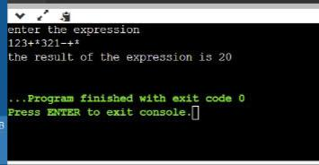

LINK OF GITHUB: