ALGORTIM

Step 1:start

Step 2:read the number y

Step 3:call the fact x

Step 4:print factorial x

Step 5:stop

Fact(y)

Step 1:if y==1||y==0 then return to 1

Step 2:return y\*fact(y-1)

PROGRAM

#include<stdio.h>

int fact(int);

int main()

{

int n,f;

printf("enter the number\n");

scanf("%d",&n);

f=fact(n);

printf("factorial is %d",f);

return 0;

}

int fact(int n)

{

if(n==0)

return 1;

else

if(n==1)

return 1;

else

return n\*fact(n-1);

}

OUTPUT

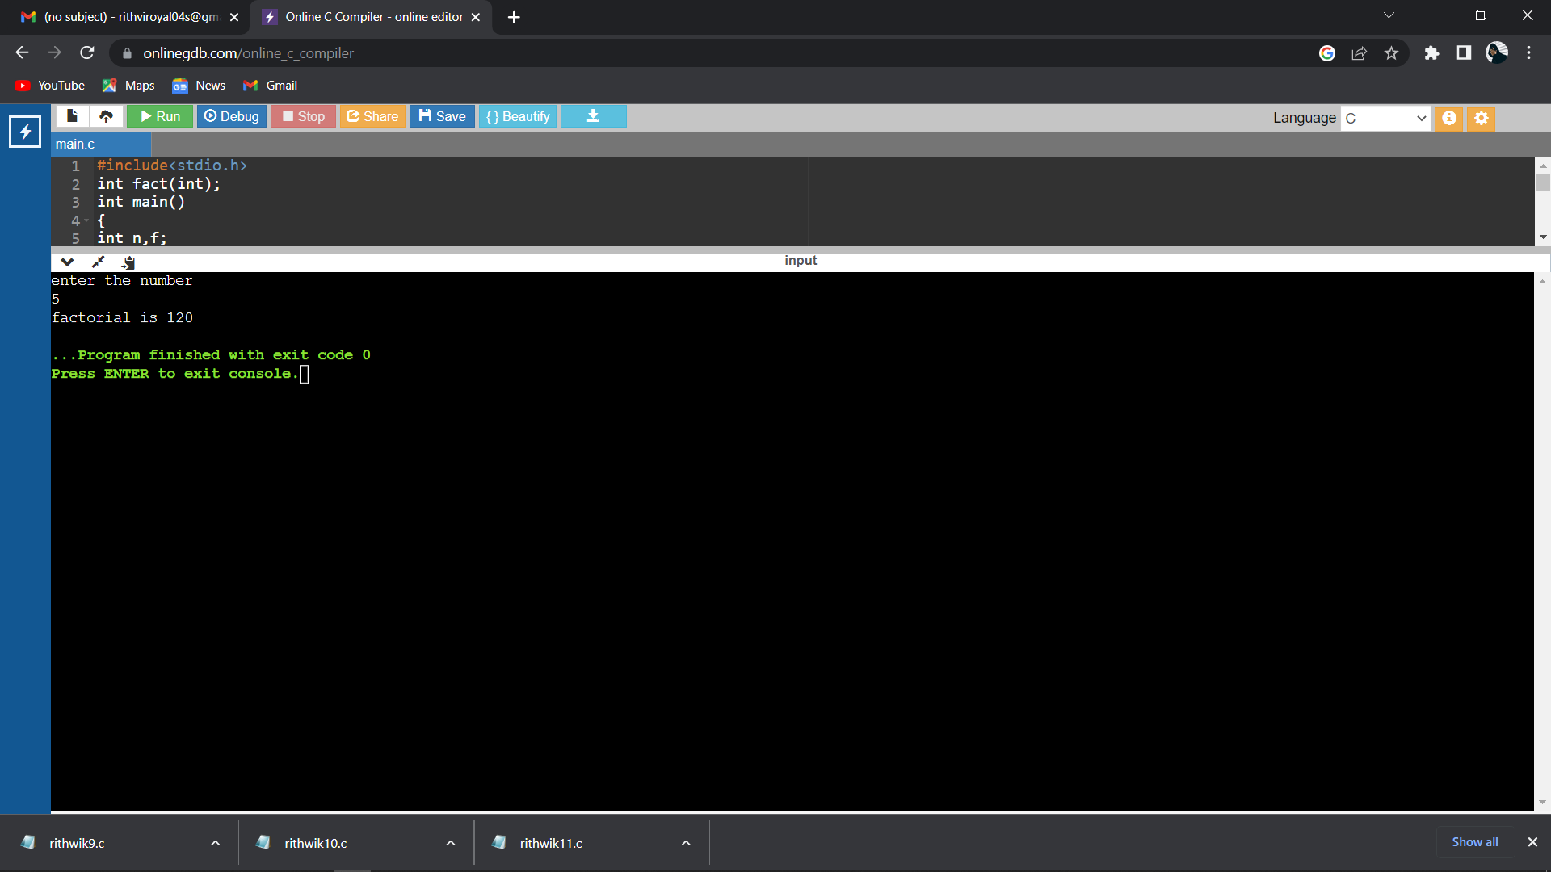

LINK OF THE GITHUB: