AIM

Fibonacci series using recursion

ALGORTHIM

Start

Declare variables I,x

Initialize the variables i==0,x by entering the number

Enter the number of terms of Fibonacci series to be printed

Print first two terms of the series

Use loop for the following steps

->x==0==fibo(0)

->x==1==fibo(1)

->fibo(x-1)+fibo(x-2)

->Increase the value of I each by one time

->print the value of fibo(i)

End

PROGRAM:

#include <stdio.h>

int fib();

int main()

{

int i,n;

printf("enter the value of n\n");

scanf("%d",&n);

for(i=0;i<n;i++)

{

printf("%d\n",fib(i));

}

return 0;

}

int fib(int i)

{

if(i==0)

return 0;

else if(i==1)

return 1;

else return fib(i-1)+fib(i-1);

}

OUTPUT:

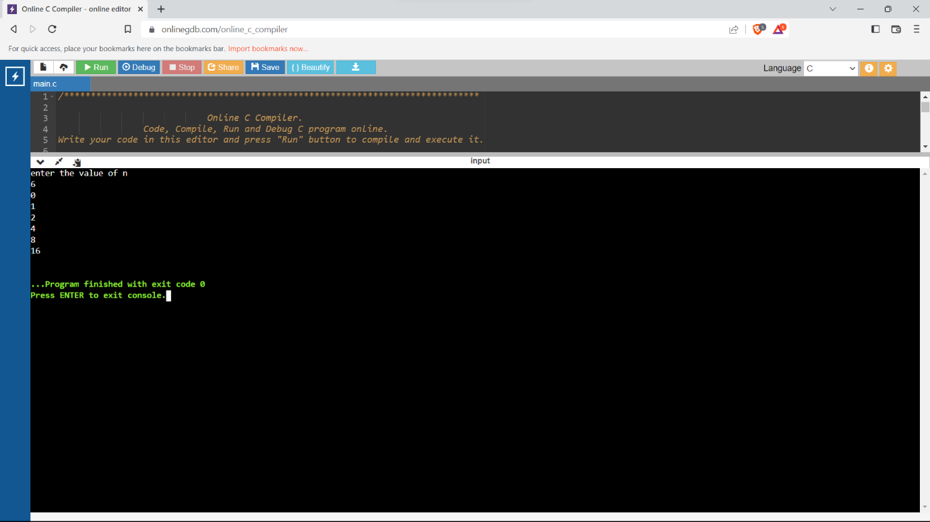

LINK OF THE GITHUB: