VisitNow
Product & Technical Overview
A token-first digital queue platform for local doctors and clinics

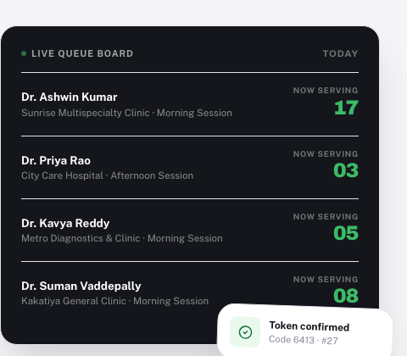

Prepared for investor review · August 2026
Confidential

Contents
1. Executive Summary
2. The Problem
3. The Product
4. User Roles & the Permission Model
5. Core Workflows
6. Feature Catalog
7. System Architecture
8. Data Model
9. Business Model
10. Security & Trust Model
11. Current State & Roadmap
12. Glossary

1. Executive Summary
VisitNow is a token-first digital queue platform for local doctors, clinics, and small hospitals. It replaces the two disconnected systems most clinics run today (a paper register for walk-ins, and a separate booking app or phone line for online patients) with one unified queue: a single, fair call order that a patient reaches whether they booked from their phone, walked in, or converted a scheduled appointment.
The product exists today as a complete, working full-stack application: a patient-facing web app to find a doctor and get a real numbered token; a hospital console for reception to run the live queue, collect payments, and see revenue; a personal dashboard for doctors across every clinic they practice at; and a platform administration layer for VisitNow itself to onboard hospitals, manage staff permissions, run promotions, and see a directory of every patient across every tenant.
This document describes the product as it exists: who uses it, how each of them uses it, the permission model that keeps every tenant's data separate, the workflows that connect the pieces, and the technical architecture underneath. It is written for an investor audience evaluating the product's depth and readiness, not as a sales brochure.

Metric | Current demo environment
Cities | 3 (Hyderabad, Warangal, Bengaluru)
Partner clinics (tenants) | 9
Doctors | 19
VisitNow platform fee | Flat ₹9 per online token
Account roles | 5 (Super Admin, Super Admin Staff, Hospital Admin, Hospital Staff, Doctor)
Permission modules | 11 platform-level, 6 hospital-level, individually assignable

These are demo-environment figures, seeded to make the multi-tenant, multi-city product story demonstrable end to end. They describe the platform's working capacity, not live customer traction.

2. The Problem
Local clinics and small hospitals in India run patient queues in one of two ways today, and both break down in the same predictable places.

2.1 For patients
- No visibility into how long a wait actually is. "Come at 10am" is the entire instruction; showing up and waiting is the only way to find out where the queue really stands.
- Walk-in and phone/online bookings are tracked as two separate lists at most clinics, so a patient who booked ahead has no real assurance of their position relative to walk-ins.
- No single place to see which doctor is live right now, across every clinic they visit, with today's actual wait.

2.2 For clinics and hospital owners
- Reception runs on a paper register or a basic token-number display, with no digital record of who was seen, when, or what was collected.
- No visibility into daily or monthly revenue by doctor, by clinic, or by how the patient arrived (online, walk-in, appointment).
- No safe way to delegate staff access. A front-desk login that can generate tokens can usually also see revenue and issue refunds, whether or not that person should.

2.3 For doctors working multiple clinics
- A doctor covering a morning shift at one clinic and an evening shift at another has no single dashboard for their own total patients seen or revenue earned across both.
- Priority and emergency handling is informal and undocumented, no record of who assigned it or why.

3. The Product
VisitNow's central idea is token-first, not appointment-first. A patient gets a real numbered token immediately, whether they book online or walk in. That token holds their place in a single, unified queue; there is no fixed appointment slot to be exactly on time for, and no separate "online queue" reconciled against a paper one at the counter.

3.1 The patient experience
A patient discovers doctors and clinics by browsing or searching, sees which doctors are live right now and which open later today, and gets a token in under a minute.
- Find a doctor by name, specialty, or clinic, with real-time "now serving" numbers shown on every card.
- Open a session to see the live queue, the clinic's own token fee, and today's date selector for upcoming sessions.
- Get a token: pick pay-online or pay-at-hospital, apply a coupon if one exists, and confirm. A 4-digit verification code is issued for online tokens.
- Track the token live: current position, estimated wait, and a cancel option, updating without a manual refresh.
- Walk in when the queue is genuinely close, and show the 4-digit code at the desk if asked.
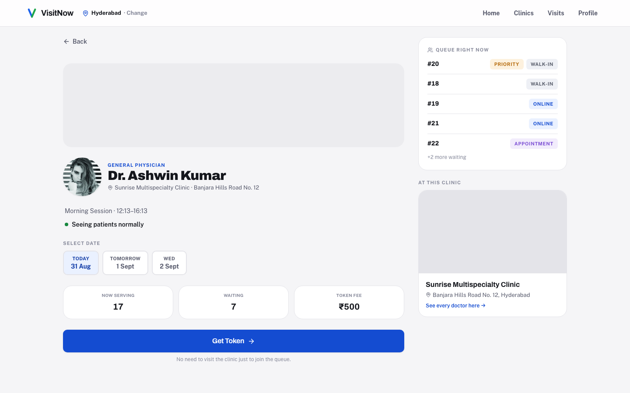
A session detail page: live queue, token fee, and today's date selector.

3.2 The hospital console
Reception and clinic staff work from one console per active session: call the next patient, mark a consultation complete, skip or requeue, flag priority or emergency, generate a walk-in token, verify a patient's 4-digit code, and collect a "pay at hospital" fee in person with a permanent record of who collected it.
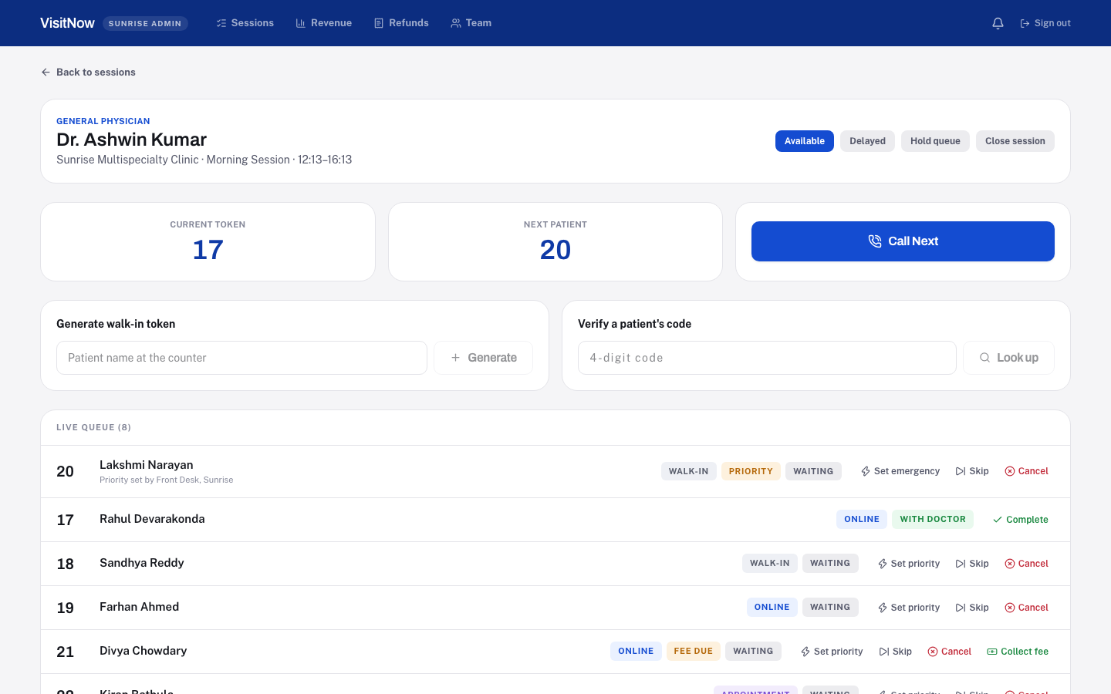
The live queue console, used by reception and by doctors for their own sessions.

3.3 The doctor's own dashboard
Every doctor account has a personal dashboard, scoped entirely to their own sessions across every clinic they practice at: today's and this month's revenue, a daily-average token count, revenue broken down clinic by clinic, how patients actually reach their queue (online, walk-in, or appointment), day-by-day trend charts, and a full downloadable and printable report of every token they have ever seen.
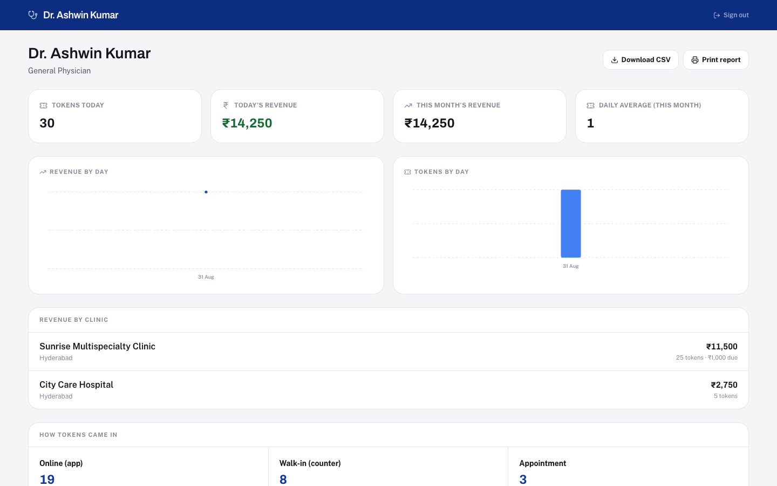
A doctor's dashboard, showing revenue split across two clinics.

3.4 The hospital owner's view
A hospital admin sees everything belonging to their one clinic: live sessions, a full revenue and analytics report with day-by-day trend charts, refund oversight, and a team roster where staff accounts are created and handed exactly the modules their job needs.
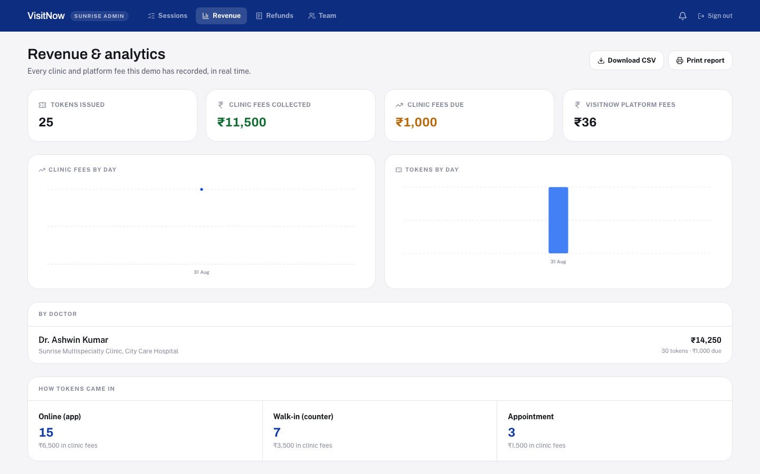
Revenue and analytics: totals, day-by-day trend charts, and a full token-level report.

3.5 The platform administration layer
VisitNow's own team runs the platform from a separate console: onboarding new hospitals as tenants, managing platform-level staff and exactly which modules they hold, running promotional coupons, and a cross-clinic patient directory. A location filter narrows every view to one city at a time.
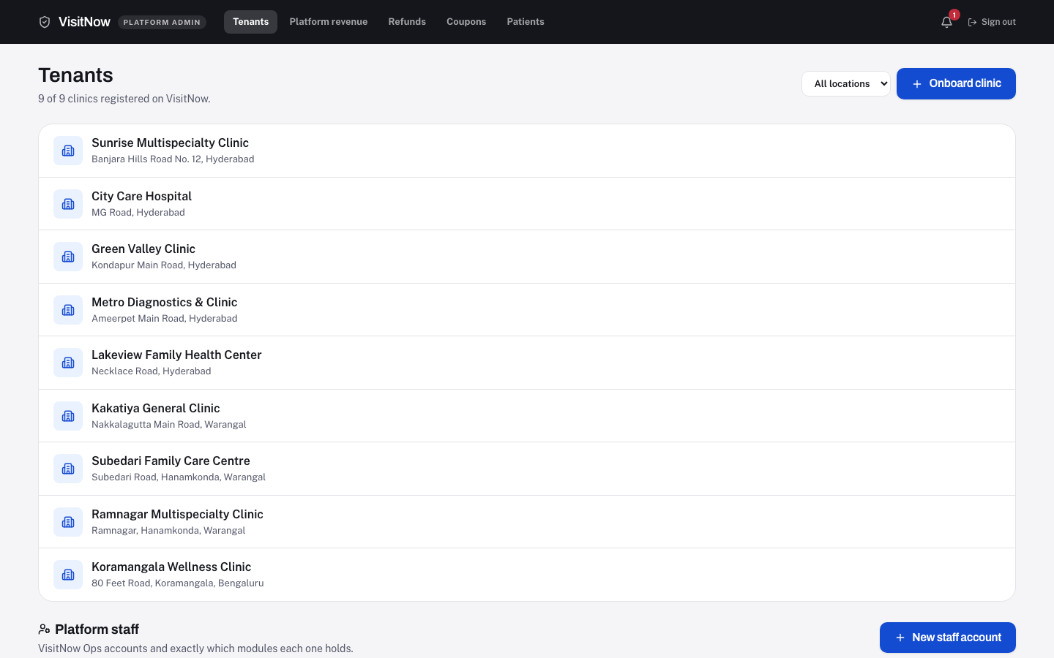
The platform admin console: every tenant, and the platform staff permission grid below it.

4. User Roles & the Permission Model
VisitNow is built as a genuine multi-tenant system: every hospital is its own tenant, seeing only its own data, with its own staff accounts. On top of that, staff accounts are not fixed roles with an all-or-nothing set of abilities. An owner account grants a specific subset of capabilities, called modules, to each staff account it creates.

4.1 The five account types
Role | Scope | How it works
Super Admin | Entire platform | Everything, every clinic, every module, always. Onboards new hospitals as tenants and manages platform staff permissions.
Super Admin Staff | Entire platform, limited | A VisitNow team account holding only the modules the Super Admin explicitly grants it (for example: Hospitals + Doctors, or Payments + Refunds + Coupons).
Hospital Admin | One hospital | Everything belonging to their one clinic, always, including creating and managing that clinic's own staff accounts and permissions.
Hospital Staff | One hospital, limited | A clinic account holding only the modules the Hospital Admin explicitly grants it (for example: Queue + Tokens + Appointments for reception, or Payments + Refunds for a cashier).
Doctor | Themselves only | Their own queue actions and their own dashboard, across every clinic they have a session at. Never payments, refunds, or another doctor's data.

4.2 The module catalog
A staff account's permissions are a list of modules drawn from one of two catalogs, depending on whether the account is platform-level or hospital-level.
Platform modules (Super Admin Staff) | Hospital modules (Hospital Staff)
Hospitals: onboard and view tenants | Queue: call-next, doctor status, entry actions
Doctors: attach doctor logins | Tokens: walk-in generation, code verification
Payments: unscoped revenue view | Appointments: scheduled-slot management
Settlements: clinic payout status | Payments: collect fee, scoped revenue view
Refunds: issue/view any clinic's refunds | Refunds: issue/view this clinic's refunds
Coupons: full promo-code management | Notifications: this clinic's activity feed
Users: create platform staff accounts
CRM: cross-clinic patient directory
Notifications: platform activity feed
Reports: trend analytics access
System settings: read-only platform info

4.3 How permissions are enforced
- A newly created staff account starts with no permissions and can do nothing until explicitly granted, module by module.
- Every permission check happens twice: once in the interface, to hide actions a staffer can't use (a courtesy, not the real boundary), and once again on every single server request, regardless of what the interface showed.
- Ownership and capability are always two separate checks. A request must both belong to the right tenant and hold the right module; neither check substitutes for the other.
- Only the true owner account (Super Admin for platform staff, Hospital Admin for hospital staff) can ever create a staff account or edit its permissions. This is never delegable, even to a staff account that already holds every other module.
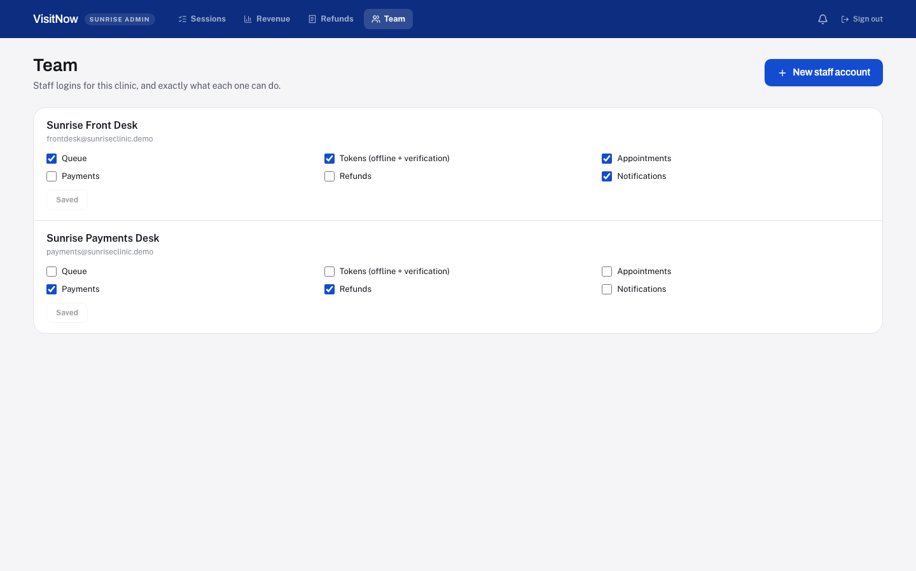
A hospital's own permission editor: staff accounts, each with an independent module grid.

5. Core Workflows

5.1 Patient journey: from search to seen
- Discover a doctor or clinic by browsing or searching, filtered to the patient's chosen city.
- Open a session and see the live queue, today's fee, and how many patients are waiting.
- Choose a payment method: pay the token fee online in one step, or pay VisitNow's ₹9 platform fee now and settle the clinic's own fee at the counter.
- Apply a coupon if one exists; the real discount is always recomputed and verified on the server before a token is issued.
- Receive a token number and a 4-digit verification code (online tokens only).
- Track the token's live position from a dedicated "my visit" screen, with an option to cancel.
- Walk in when the queue is genuinely close, show the 4-digit code if reception asks, and get called.

5.2 Reception journey: running a live session
- Open the day's session from the hospital console.
- Set doctor status (available, delayed, queue on hold, or session closed) so patients see accurate live information.
- Call the next patient in the unified queue order; mark each consultation complete, skipped, or a no-show as it happens.
- Generate a walk-in token directly at the counter, or verify an online patient's 4-digit code when they arrive.
- Collect a "pay at hospital" fee in person and mark it collected, with the collecting account's name recorded permanently.
- Issue a refund for an eligible cancelled or no-show token, if the staff account holds the refunds module.

5.3 Hospital onboarding journey
- A Super Admin (or a Super Admin Staff account holding the Hospitals module) creates a new clinic as a tenant, with its own name, address, and city.
- A Hospital Admin account is created in the same step, with a one-time-shown password to hand to the clinic.
- The Hospital Admin signs in, sees their own empty console, and starts adding doctors' sessions and staff accounts.
- The Hospital Admin builds their team: each staff account created with exactly the modules that job needs, editable at any time.

5.4 Doctor's day, across two clinics
A doctor working a morning session at one clinic and an evening session at another opens the same personal dashboard either way. It shows today's tokens and revenue combined across both clinics, a clinic-by-clinic revenue breakdown, and a direct link into whichever session's live queue they need to run right now.

6. Feature Catalog

Queue & tokens
- A single unified queue: online, walk-in, and appointment-converted tokens share one call order.
- Priority tiers (emergency, priority, regular), assignable only by a staff account, never self-declared by a patient.
- Every status transition (waiting → called → in progress → completed, or skipped / cancelled / no-show) enforced server-side.
- A 4-digit, visit-specific verification code for online tokens, looked up by reception, not used as a login.

Payments
- Two payment paths per online token: pay in full now, or pay VisitNow's flat ₹9 platform fee and the clinic fee later at the counter.
- A real "collect fee" action for reception, closing the gap where a pay-at-hospital fee could be marked due and never actually recorded as collected.
- A simulated payment gateway UI, visually and interactionally like a real one, with no live payment processor connected yet.

Refunds
- Refunds for cancelled or no-show tokens that had a fee actually collected, issued by a staff account holding the refunds module.
- A permanent record of who issued each refund, when, the amount, and an optional reason.
- Refund status layered on top of payment status; a refunded token's original payment record is never overwritten, only extended.

Coupons
- Platform-wide or single-clinic promo codes, percentage or flat-amount, applicable to the clinic fee, the platform fee, or both.
- A real-time validation preview at checkout, with the actual discount recomputed and enforced on the server when the token is created.
- An optional maximum-redemption cap per coupon; coupons are retired, never hard-deleted, preserving their own redemption history.

Patient directory (CRM)
- Every patient across every clinic, grouped from real visit history by phone number.
- Visit count, total amount paid, every clinic visited, and the most recent visit status, all computed live from queue records.
- A platform-level capability, reflecting that VisitNow itself, not any single clinic, has the cross-tenant view.

Notifications
- An in-app activity feed for genuinely notable events: a hospital onboarded, a staff or doctor account created, a refund issued, a coupon created.
- Deliberately not wired to high-frequency actions like ordinary queue moves or fee collection, which would drown out anything worth noticing.
- Scoped by account: platform accounts see platform-wide events, hospital accounts see only their own clinic's.

Analytics & reporting
- Live totals for tokens issued, fees collected, fees still due, and platform fees, recomputed from the same records the queue itself runs on.
- Day-by-day trend charts for both revenue and token volume, for doctors, hospitals, and the platform.
- A full, filterable line-item report, downloadable as CSV and formatted for printing, at every level: doctor, hospital, and platform.
- A location filter, letting a platform account narrow every report to a single city.

Permissions & administration
- A real, module-based permission system for staff accounts, not fixed all-or-nothing roles.
- A reusable permission editor: any owner can grant or revoke a staff account's modules at any time.
- An explicit anti-escalation rule: only the true owner account can ever edit permissions, never a staff account, no matter what it already holds.

7. System Architecture
VisitNow is a real, working full-stack application today: a React frontend, an Express/TypeScript backend, and a REST API connecting them. It is built as a demonstrable, production-shaped prototype, with every architectural decision made explicitly rather than left implicit.

7.1 Frontend
- React 19, built with Vite, written entirely in TypeScript.
- Tailwind CSS v4 with a custom design system: a distinct visual language for the patient app, the hospital console, and the platform admin console.
- Native responsive web: one codebase serving phone, tablet, and desktop layouts, not a phone layout stretched to fill a desktop screen.
- A short-interval polling model gives every live screen a real-time feel (the live queue, position tracking, revenue totals) without requiring a WebSocket infrastructure.
- Client-side routing with role-aware guards: a signed-in account of the wrong role or missing permission is redirected to its own correct home, never bounced to a login screen that would look like a broken session.

7.2 Backend
- Node.js with Express, written entirely in TypeScript.
- A REST API, one clear route per action, grouped by resource (sessions, queue entries, appointments, staff, dashboards, admin, coupons, CRM, notifications).
- All business rules for queue ordering, fee computation, refund eligibility, and coupon discounts live in the backend and are never trusted from the client.
- Authentication is a real account system: email and password, an opaque bearer token issued at login, checked on every protected request.
- A single ownership-check function is reused by every scoped route, so "does this account actually own this session/entry" is answered in exactly one place in the codebase.
- A single permission-check function is reused the same way for module capability, kept as a deliberately separate concern from ownership.

7.3 Data model, at a glance
Entity | What it represents
Clinic | One tenant: a hospital or clinic, with a name, address, and city.
Doctor | A clinician, who may practice at more than one clinic.
Session | One doctor, at one clinic, for one working window (for example, a morning shift). Owns its own queue.
QueueEntry | One token: its number, source (online / offline / appointment), status, priority, payment and refund state.
Appointment | A scheduled slot that becomes a normal queue entry the moment it's converted.
Account | A login: role, and for staff roles, the specific list of granted permission modules.
Coupon | A promo code: discount type and value, scope, and where it applies.
NotificationEvent | One entry in the in-app activity feed.

Every session belongs to exactly one clinic and one doctor, and every queue entry belongs to exactly one session. This is what lets the same doctor run two completely independent, simultaneous queues at two different clinics without either one needing to know the other exists.

7.4 How a token moves through the system
Regardless of source (online, walk-in, or a converted appointment) every token becomes an identical QueueEntry, placed into the same session's single queue. Ordering follows a strict tier: emergency first, then priority, then regular, and within a tier, the order tokens actually arrived. Every state transition is validated against the entry's current state before it is allowed, so the console can never display an impossible sequence.

8. Data Model: Permission Matrix
The full module-to-role matrix, as actually enforced by the backend on every request.
Module | Super Admin | Super Admin Staff | Hospital Admin | Hospital Staff | Doctor
Hospitals (onboard/view tenants) | Always | If granted | — | — | —
Doctors (attach doctor logins) | Always | If granted | Own clinic only | — | —
Payments (revenue visibility) | Always | If granted | Own clinic, always | If granted | —
Settlements | Always | If granted | — | — | —
Refunds | Always (any clinic) | If granted (any clinic) | Own clinic, always | If granted, own clinic | —
Coupons | Always | If granted | — | — | —
Users / Team (create & edit staff) | Always | Never (anti-escalation) | Own clinic, always | Never (anti-escalation) | —
CRM (patient directory) | Always | If granted | — | — | —
Notifications | Always | If granted | Own clinic, always | If granted, own clinic | —
Reports (trend analytics) | Always | If granted | Own clinic, always | If granted | —
Queue (run live session) | — | — | Own clinic, always | If granted | Own sessions only
Tokens (walk-in + verify code) | — | — | Own clinic, always | If granted | —
Appointments | — | — | Own clinic, always | If granted | —

"Own clinic, always" reflects that a Hospital Admin holds every hospital-level capability implicitly; there is nothing to grant because there is nothing to withhold from the owner of the tenant. "If granted" reflects a staff account's specific, individually assigned module list, which starts empty on every new account.

9. Business Model
VisitNow earns a flat platform fee of ₹9 on every online token, regardless of the clinic's own price for that consultation. The clinic sets and keeps its own token fee in full, whether the patient pays online or at the counter; VisitNow never takes a percentage of it.

9.1 Why a flat fee
- Simple to explain to a clinic evaluating the product: a fixed, small, and predictable cost per online booking, never a negotiated percentage.
- Revenue scales directly with token volume, which scales with patient adoption, not with the size or pricing power of any one clinic.
- A flat fee removes a common objection to adopting digital tools: that the platform is taking a cut of the clinic's own margin.

9.2 Levers already built
- Coupons: platform-funded promotional codes to drive first-time adoption, or clinic-funded codes a hospital runs itself.
- Settlements: the module exists in the permission catalog for a future automated payout flow to clinics.
- Walk-in tokens still flow through the same unified queue even when a patient never pays VisitNow directly, meaning the product becomes the clinic's operating system for queue management before every patient necessarily pays online.

10. Security & Trust Model
- Every account is a real login: email and password, checked server-side on every request via a bearer token, never trusted from client-side state alone.
- Multi-tenancy is enforced at the data layer: a request is checked against both which tenant it belongs to and what capability the account holds, as two separate, composable rules.
- A staff account with no permissions can do nothing. Access is granted explicitly, never assumed.
- Permission editing itself is restricted to true owner accounts only, an explicit anti-escalation rule preventing a staff account from ever expanding its own or a peer's access.
- A doctor's queue-control access is scoped by which session they actually own, never by clinic membership alone, correctly modeling doctors who practice at more than one clinic.
- All monetary computations (fees, discounts, refund amounts) are computed and re-verified server-side; a client-submitted total is never trusted directly.
Not yet built, and explicitly out of scope for the current stage: password hashing, token expiry, real payment-gateway integration, and real SMS/push/email delivery. These are the standard next steps for a production launch, not gaps hidden from this review.

11. Current State & Roadmap

11.1 What exists today
A complete, working full-stack product across every role described in this document: patient discovery and booking, live queue tracking, a hospital reception console, doctor dashboards, platform administration, coupons, refunds, a patient directory, notifications, and analytics reporting at every level. Every feature described above is implemented, not mocked, and has been verified end to end for every account role it applies to.

11.2 What a production launch adds
Area | Current state | Production requirement
Payments | Simulated checkout, realistic UI | Real gateway integration (for example Razorpay or Cashfree)
Notifications | In-app activity log only | Real SMS / push / WhatsApp delivery
Settlements | Module scaffolded, not automated | Automated payout runs to clinics
Authentication | Plain-text password check, opaque token | Password hashing, token expiry, session management
Coverage | 3 cities, 9 clinics (demo) | Onboarding flow already supports scaling; needs sales/ops to fill it
Native apps | Responsive web, works on any device | iOS / Android wrappers for App Store presence
Predictive wait times | Estimate from average consult time | A real model trained on historical consultation data, once that history exists

12. Glossary
Token: A numbered place in a doctor's queue for one session, issued online, at the counter, or from a converted appointment.
Session: One doctor, at one clinic, for one working window (for example, a morning shift). Owns exactly one queue.
Tenant: One clinic or hospital on the platform, with its own staff, sessions, and data, isolated from every other tenant.
Module: One specific capability (for example "Refunds" or "Queue") that can be individually granted to a staff account.
Verification code: A 4-digit code issued with an online token, used by reception to look up that visit, not a login credential.
Unified queue: The single call order every token joins, regardless of whether it came in online, as a walk-in, or from an appointment.
Platform fee: VisitNow's own flat ₹9 fee on every online token, separate from and never a share of the clinic's own fee.
Anti-escalation rule: The rule that only a true owner account (Super Admin or Hospital Admin) can ever edit a staff account's permissions.

End of document.

