# WATER QUALITY ANALYSIS

PROJECT DEFINITION

Water quality analysis is to measure the required parameters of water, following standard methods, to check whether they are in accordance with the standard.

DESIGN THINKING

1. Analysis objectives:

The objective of water quality monitoring is to obtain quantitative information on the physical, chemical, and biological characteristics of water via statistical sampling

1. Data collection:

Correlation and linear regression are commonly used to assess water quality data. Environmental data, however, are often characterized by temporal and spatial dependency structures in the data thus making ordinary

PH **level:** The pH of water is a measure of the acid–base equilibrium and, in most natural waters, is controlled by the carbon dioxide–bicarbonate–carbonate equilibrium system. An increased carbon dioxide concentration will therefore lower pH, whereas a decrease will cause it to rise. Temperature will also affect the equilibria and the pH. In pure water, a decrease in pH of about 0.45 occurs as the temperature is raised by 25 °C. In water with a buffering capacity imparted by bicarbonate, carbonate and hydroxyl ions, this temperature effect is modified (APHA, 1989). The pH of most drinking-water lies within the range 6.5–8.5. Natural waters can be of lower pH, as a result of, for example, acid rain or higher pH in limestone areas.ast squares techniques inappropriate.

**Hardenss of water**: The simple definition of water hardness is the amount of dissolved calcium and magnesium in the water. Hard water is high in dissolved minerals, largely calcium and magnesium. You may have felt the effects of hard water, literally, the last time you washed your hands. Depending on the hardness of your water, after using soap to wash you may have felt like there was a film of residue left on your hands. In hard water, soap reacts with the calcium (which is relatively high in hard water) to form "soap scum". When using hard water, more soap or detergent is needed to get things clean, be it your hands, hair, or your laundry.

**TDS**: TDS means concentration of dissolved particles or solids in water. TDS comprises of inorganic salts such as calcium, magnesium, chlorides, sulfates, bicarbonates, etc, along with many more inorganic compounds that easily dissolve in water.

3.VISUALIZATION STRATEGY:

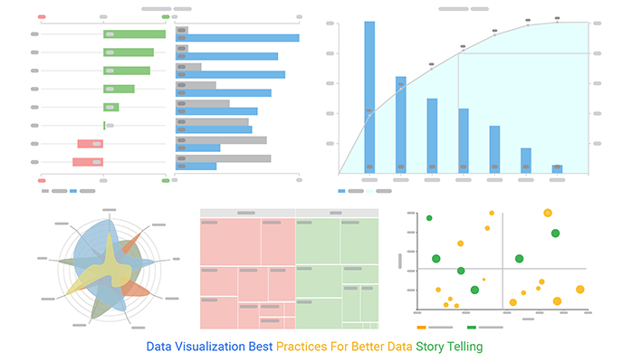

4.Predictive modelling:

FEATURES

|  |  |  |  |  |  |  |  |  |  |  |  |  |  |  |  |  |  |  |  |  |  |  |  |  |  |  |
| --- | --- | --- | --- | --- | --- | --- | --- | --- | --- | --- | --- | --- | --- | --- | --- | --- | --- | --- | --- | --- | --- | --- | --- | --- | --- | --- |
| |  |  | | --- | --- | |  | | | Parameters | WHO limits | |  | | | Ph | 6.5–8.5 | | Hardness | 200 mg/L | | Solids | 1000 ppm | | Chloramines | 4 ppm | | Sulfate | 1000 mg/L | | Conductivity | 400 *μ*S/cm | | Organic carbon | 10 ppm | | Trihalomethanes | 80 ppm | | Turbidity | 5 NTU | |  | | |

WATER POTABILITY ALGORITHMS:

Input Data Water Portability Dataset from Kaggle  Output Yes (If water is portable), No

 Data preprocessing

  Normalization using Z-score

   Oversampling using SMOTE

 Calculate the WQI using equation ([4](https://static.hindawi.com/articles/cin/volume-2022/9283293/figures/#EEq4)).

Visualize and analyze the data

  Correlation analysis

  Data splitting

Apply different Machine Learning Model for the water quality prediction

the performance of the different model

Apply hyper parameter tuning to improve the performance of the model