1. Product Scope
Model | Rated Load | Lift Height | Truck Size (L × W × H)
XQE122 | 1.2 t | 5.5 m | 2426 × 1240 × 3053 mm

2. Mast Options
Confirm lowered height against every door, gate, and overhead obstacle on the travel route before order confirmation.
Spec | Mast | Lift (mm) | Lowered w/ Nav LiDAR (mm) | Lowered w/o Nav LiDAR (mm) | Free Lift (mm) | Max Height (mm) | Lift Speed
Standard | 3-F | 4500 | 2718 | 2393 | 1368 | 5523 | 0.17 m/s
Option | 2-F | 3200 | 2965 | 2640 | — | 4240 | 0.17 m/s
Option | 2-F | 3200 | 2823 | 2498 | — | 4173 | 0.17 m/s
Option | 3-F | 5500 | 3053 | 2728 | 1700 | 6825 | 0.17 m/s

3. Travel Path
 | Load Carrier | Operation | Aisle Type |  | Min. Width | Remarks
 | Euro Pallet / Cage / Bin | Straight Travel | Single direction |  | 1600 mm | Speed ≤ 0.3 m/s
 | Euro Pallet / Cage / Bin | Straight Travel | Two-way traffic |  | 3360 mm | Controlled — one truck at a time
 | Euro Pallet / Cage / Bin | Turn | Single aisle (90° turn) |  | 2450 mm
 | Cage / Bin 1200 × 1200 mm | Pick-up / Drop-off | Single aisle — single-side |  | 3000 mm
 | Cage / Bin 1200 × 1200 mm | Pick-up / Drop-off | Single aisle — dual-side (two main aisles) |  | 3000 mm | One aisle between each rack row
 | Cage / Bin 1200 × 1200 mm | Pick-up / Drop-off | Single aisle — dual-side (one main aisle) |  | 3520 mm | Both sides from one aisle
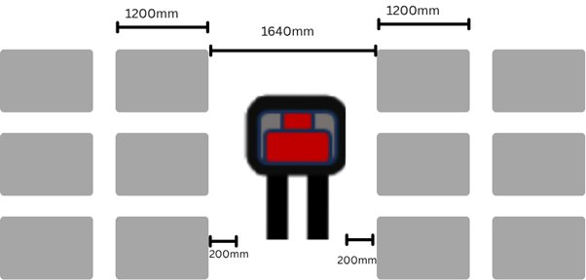 |  |  |  | 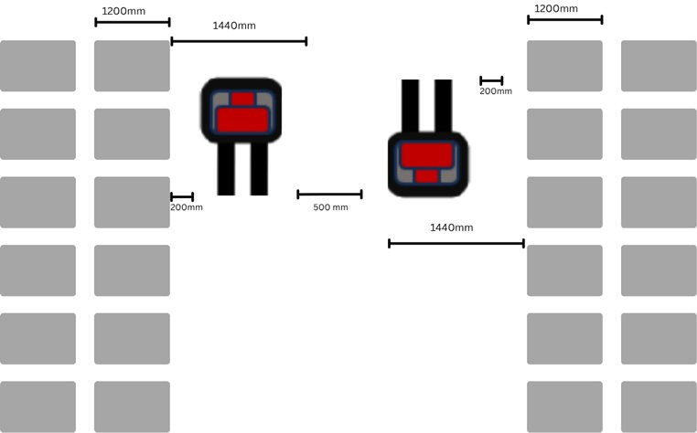

4. Turning / Aisle Change
Area | Minimum | Recommended
Aisle change clear space | 2900 mm | 3150 mm

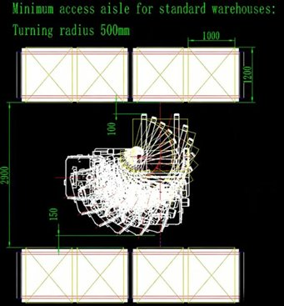 | 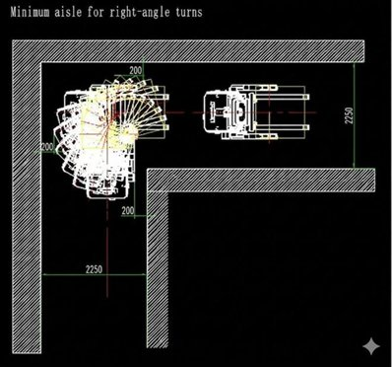

5. Dense Stacking Channel
Item | Value | Note
Truck width | 1240 mm
Clearance — all sides (left, right, front, back) | 200 mm | From load face on each side

Confirm fork length and pallet depth per project before quoting channel dimensions.

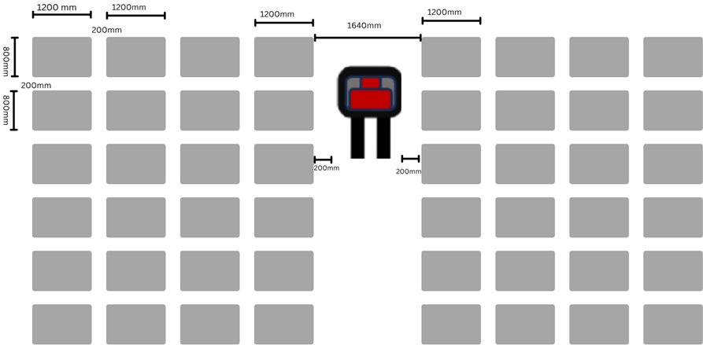

6. Rack Aisle & Dimensions
Rack Aisle Required
Load Carrier | Operation | Aisle Type | Min. Width | Remarks
Euro Pallet / Load ≤ Euro Pallet | Pick-up / Drop-off | Single aisle — single-side | 2900 mm
Euro Pallet / Load ≤ Euro Pallet | Pick-up / Drop-off | Single aisle — dual-side (two main aisles) | 2900 mm | One aisle between each rack row
Euro Pallet / Load ≤ Euro Pallet | Pick-up / Drop-off | Single aisle — dual-side (one main aisle) | 3520 mm | Both sides from one aisle
If pallet overhangs rack face, measure 200 mm clearance from pallet edge — not rack face.
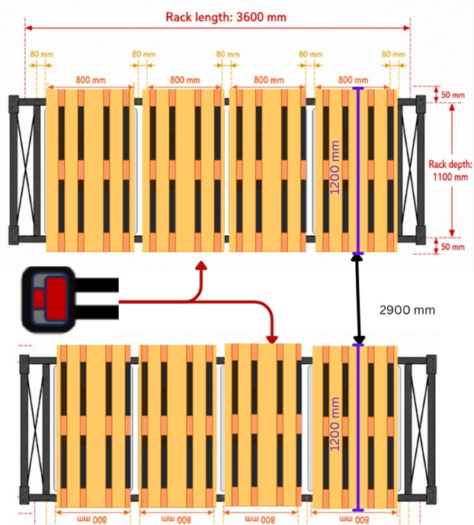 | 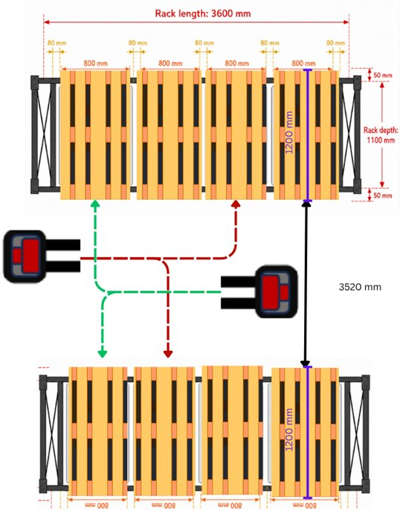

Minimum distance between two adjacent rack rows (face to face): 200 mm.
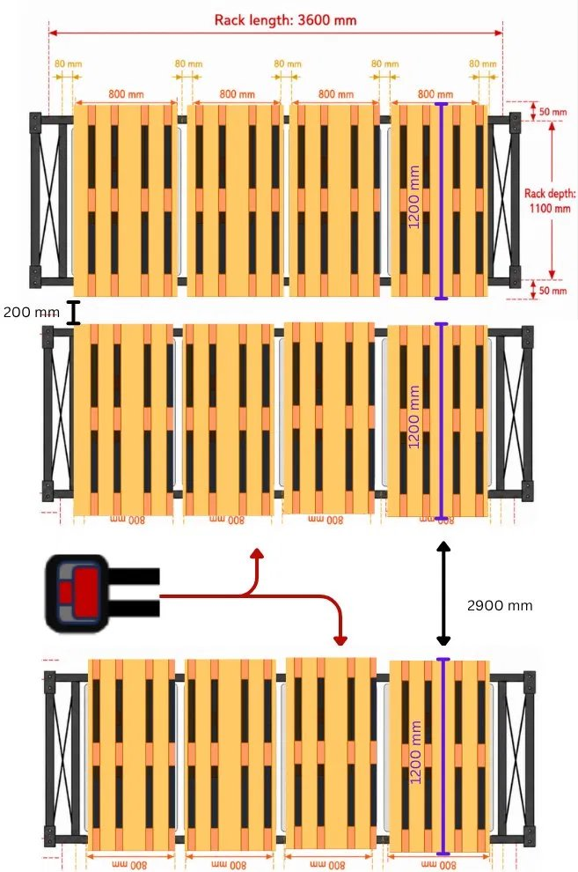

EU Pallet — 800 × 1200 mm
Beam Length | Rack Depth | Pallets / Beam | Pallet Spacing
1900 mm | 1100 mm | 2 pcs | 75 mm min — 100 mm recommended
2700 mm | 1100 mm | 3 pcs | 75 mm min — 100 mm recommended
3600 mm | 1100 mm | 4 pcs | approx. 80 mm
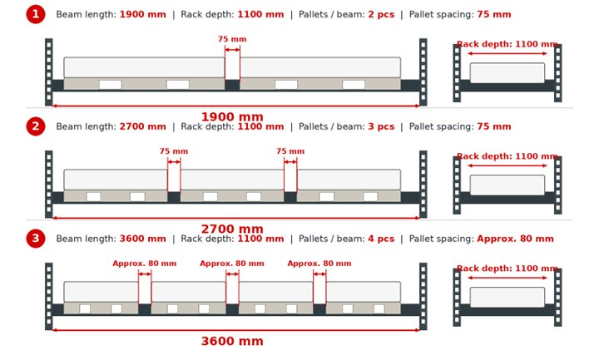

Industrial Pallet — 1000 × 1200 mm
Beam Length | Rack Depth | Pallets / Beam | Pallet Spacing
2700 mm | 1100 mm | 2 pcs | 75–100 mm
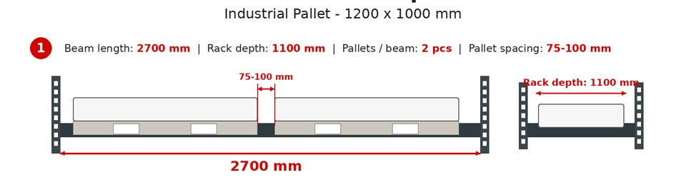
Rack depth minimum 1100 mm across all configurations.

Load Placement Requirements
Operating conditions — not recommendations. Loads outside these limits cause task rejection or collision risk.

Item | Requirement
Load overhang | Not permitted on any side
Load edge to pallet edge (all sides) | ≥ 50 mm
Centre of gravity height (from fork surface) | ≤ 900 mm
Stacking alignment deviation | ≤ 10 mm
Side clearance inside rack (clear space) | ≥ 75 mm — recommended ≥ 100 mm
Vertical clearance between rack levels | ≥ 150 mm

7. Charging Area

Item | Single Charger | 5-Charger Setup
Bay width | 1732 mm | 1732 × 5 = 8660 mm
End clearance (each side) | 400 mm | 400 mm each side
Total width required | 2532 mm | 9460 mm
Approach corridor depth | 3181 mm | 3181 mm (shared)
Parked truck length | 2426 mm | 2426 mm
Rear clearance | 800 mm | 800 mm
Total depth required | 6407 mm | 6407 mm
Total floor area | ~ 16.2 m² | ~ 60.6 m²
Trucks charging simultaneously | 1 | 5
Approach lane | Dedicated | Shared — 1 truck at a time
Number of charger units | 1 | 5
Plan charging position into the layout from the start — cannot be added after rack layout is fixed.
