**LAB -ASSIGNMENT – 3**

Name- Ritik Kumar

Roll no.- 201IT250

g-drive - <https://drive.google.com/file/d/1VucYG2v0-OzCjicQM9ShdJL3jPNdKP22/view?usp=sharing>

Repository - <https://github.com/Ritik-2245/Probability-lab-assignment.git>



Poisson ratio



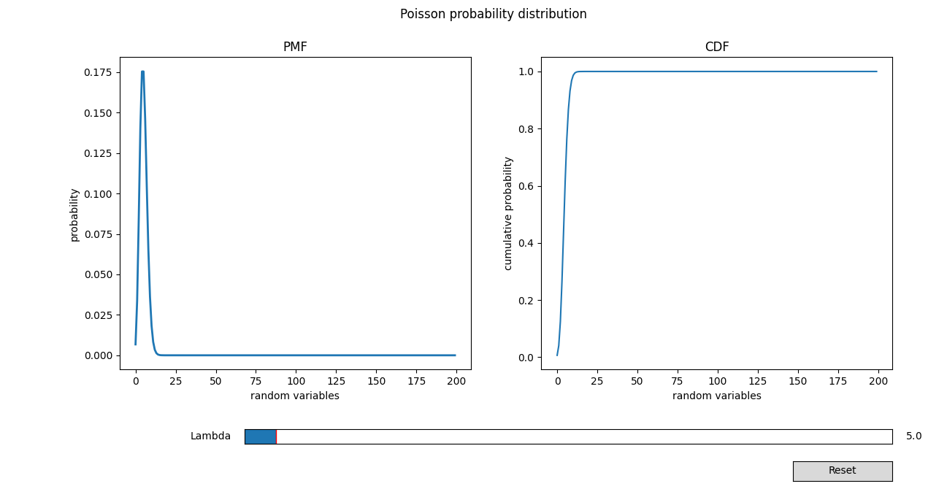

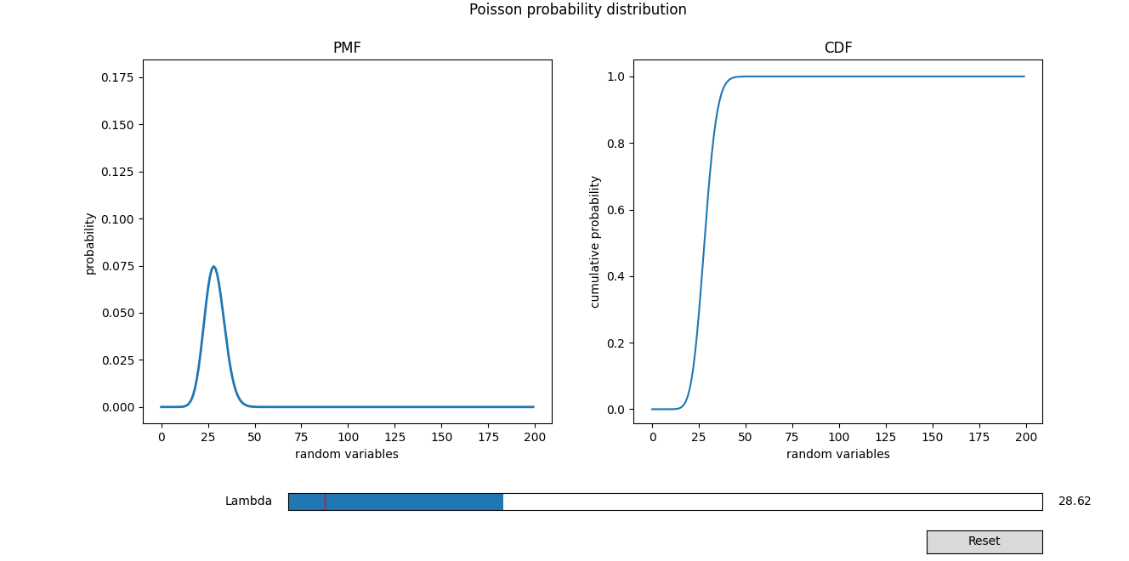

Value of mean and variance in poisson distribution is same as lambda.



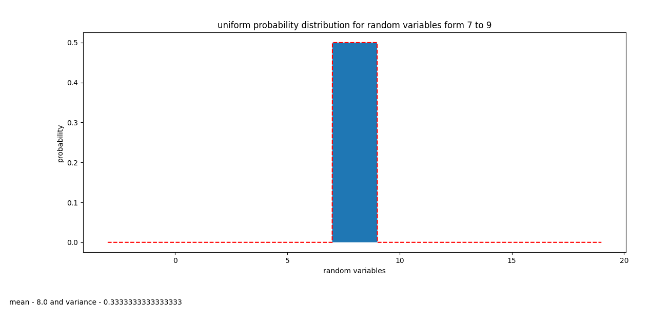

**3. normal distribution**



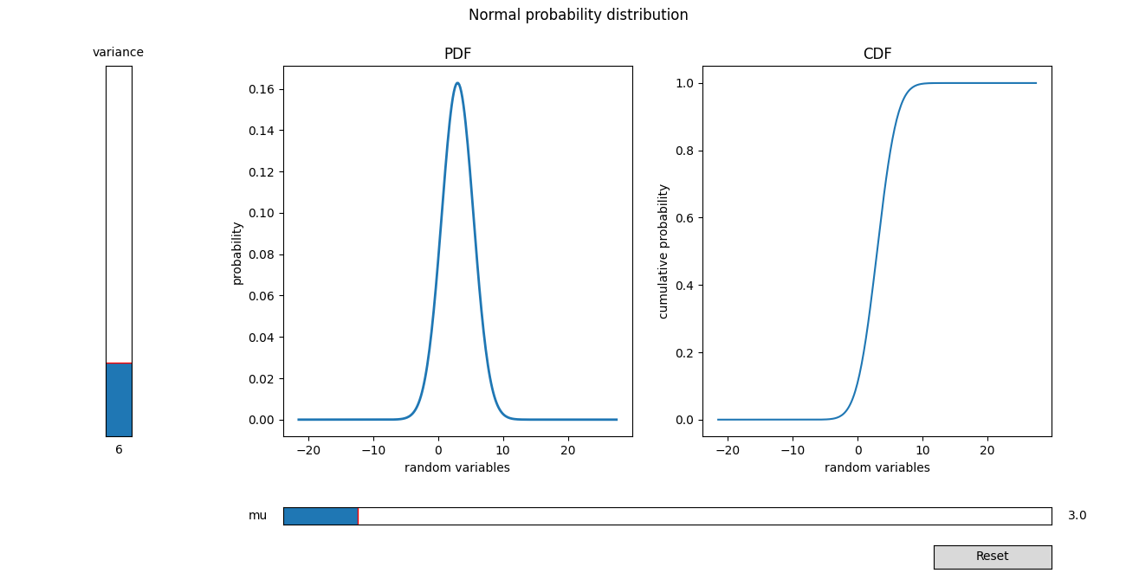

**After varying variance**

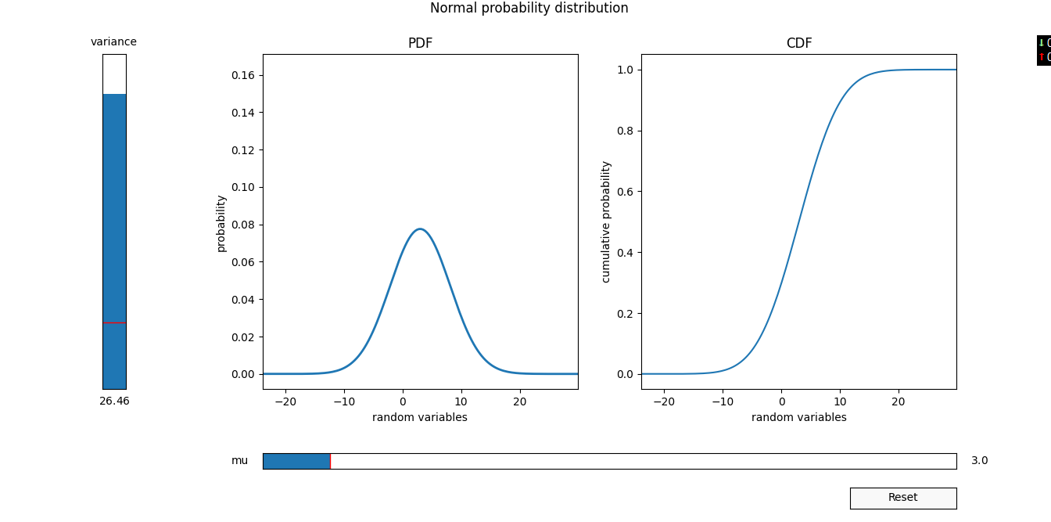

**Ans e.**  bernouli and binom

Event - **success of india in winning a match is 0.55046**

Bernouli talks about success of event for single time.

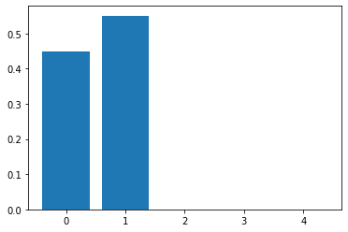

**creating binomial distribution for next 30 matches of india**

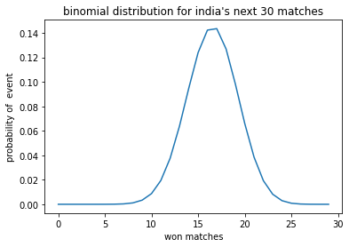

**graph shows that probability of winning approx 16-17 matches out of is max.**