**COMPUTER ORGANIZATION & ARCHITECTURE**

**RITIK SINGH CO-206**

**2K19/CO/319 ASSIGNMENT SHEET – 1**

**Question 1: Explain asynchronous data transfer using both strobe pulse and handshaking. Support your answer with block diagram and sequence of events.**

**Solution 1:** Asynchronous Data transfer between two independent units requires that control signals be transmitted between the communicating units to indicate the time at which data is being transmitted.

One way of achieving this is by means of a strobe pulse supplied by one of the units to indicate to the other unit when the transfer has to occur.

Another method commonly used is to accompany each data item being transferred with a control signal that indicates the presence of data in the bus. The unit receiving the data item responds with another control signal to acknowledge receipt of the data. This type of agreement between two independent units is referred to as handshaking.

**Strobe Control**

The strobe control method of asynchronous data transfer employs a single control line to time each transfer. The strobe may be activated by either the source or the

destination unit.

Source Initiated transfer:

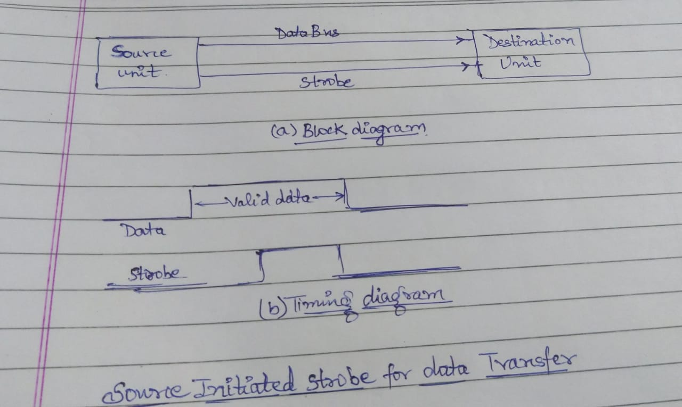

The data bus carries the binary information from source unit to the destination unit. Typically, the bus has multiple lines to transfer an entire byte or word. The strobe is a single line that informs the destination unit when a valid data word is available in the bus.

As shown in the timing diagram, the source unit first places the data on the data bus. After a brief delay to ensure that the data settle to a steady value, the source activates the strobe pulse. The information on the data bus and the strobe signal remains in the active state for a sufficient time period to allow the destination unit to receive the data. Often, the destination unit uses the falling edge of the strobe pulse to transfer the contents of the data bus into one of its internal registers. The source removes the data from the bus a brief period after it disables its strobe pulse. Actually, the source does not have to change the information in the data bus.

Destination Initiated transfer

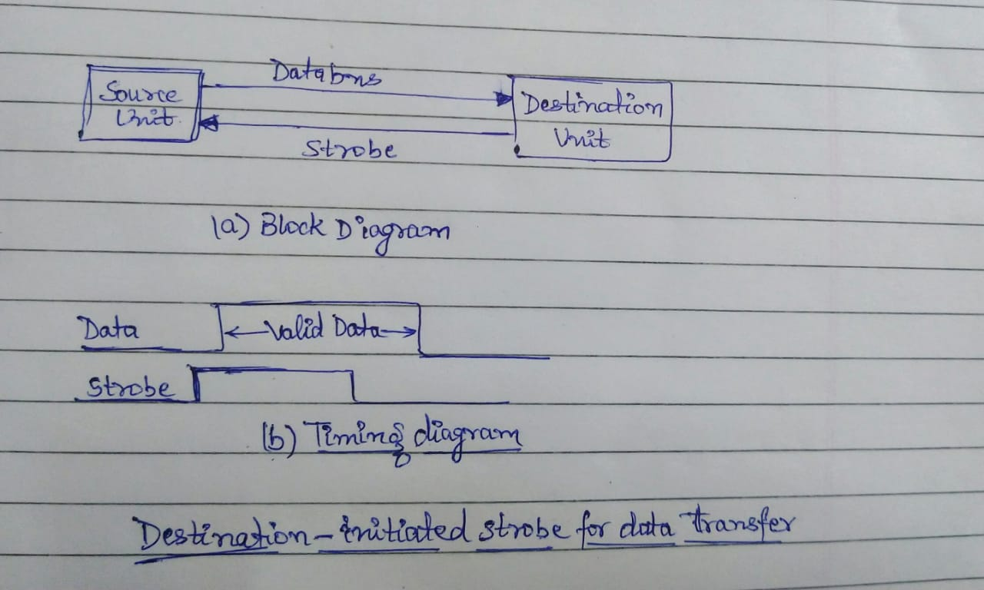

In this case the destination unit activates the strobe pulse, informing the source to provide the data. The source unit responds by placing the requested binary information on the data bus. The data must be valid and remain in the bus long enough for the destination unit to accept it. The falling edge of the strobe pulse can be used again to trigger a destination register. The destination unit. Then disables the strobe. The source removes the data from the bus after a predetermined time interval.

**Handshaking**

The disadvantage of the strobe method is that the source unit that initiates the transfer has no way of knowing whether the destination unit has actually received the data item that was placed in the bus. Similarly, a destination unit that initiates the transfer has no way of knowing whether the source unit has actually placed the data on the bus. The handshake method solves this problem by introducing a second control signal that provides a reply to the unit that initiates the transfer. The basic principle of the two-wire handshaking method of data transfer is as follows. One control line is in the same direction as the data flow in the bus from the source to the destination. It is used by the source unit to inform the destination unit whether there are valid data in the bus. The other control line is in the other direction from the destination to the source. It is used by the destination unit to inform the source whether it can accept data. The sequence of control during the transfer depends on the unit that initiates the transfer.

The source unit initiates the transfer by placing the data on the bus and enabling its data valid signal. The data accepted signal is activated by the destination unit after it accepts the data from the bus. The source unit then disables its data valid signal, which invalidates the data on the bus. The destination unit then disables its data accepted signal and the system goes into its initial state. The source does not send the next data item until after the destination unit shows its readiness to accept new data by disabling its data accepted signal. This scheme allows arbitrary delays from one state to he next and permits each unit to respond at its own data transfer rate. The rate of transfer is determined by the slowest unit.

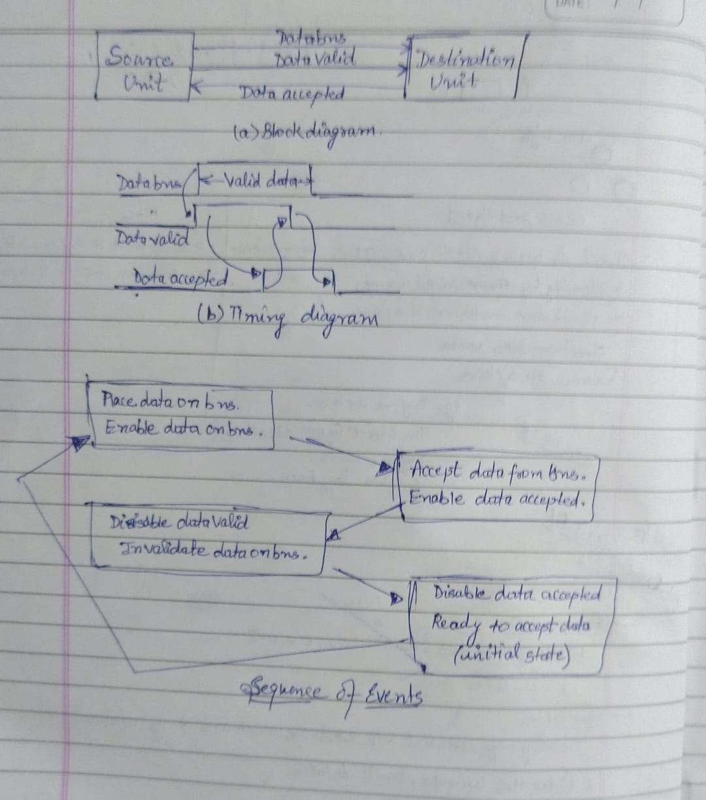

**Question 2: Discuss serial communication.**

**Solution 2:** In serial communication, data is in the form of binary pulses. In other words, we can say Binary One represents a logic HIGH or 5 Volts, and zero represents a logic LOW or 0 Volts. Serial communication can take many forms depending on the type of transmission mode and data transfer. The ****transmission modes**** are classified as Simplex, Half Duplex, and Full Duplex. There will be a source (also known as a sender) and destination (also called a receiver) for each transmission mode.

**How Serial communication Works:**

Advanced CPU such as [microcontroller](https://www.codrey.com/microcontroller/microcontroller-basics/) and Microprocessor make use of serial communication to communicate with the external world as well as on the chip peripherals. To get familiar, let us take a simple example. For suppose, you want to send a file present in your laptop to smartphone. How would you send? Probably using Bluetooth or WiFi protocol, Right.

So, here are the steps to establish the serial communication

Add the connection.

In the first step, your laptop will search for devices nearby 100m and will list out the devices found. This process is often called roaming.

Select the device you want to communicate.

To connect to your mobile, the pairing has to be done. The default configuration is already present in the software. So no need to configure the baud rate manually. Beyond this, there are four unknown rules. They are baud rate, data bit selection (framing), start-stop bit, and parity.

**Question 3: Compare Asynchronous and Synchronous Serial Communication.**

**Solution 3:** **[Synchronous Transmission](https://www.geeksforgeeks.org/computer-organization-synchronous-data-transfer/" \t "https://www.geeksforgeeks.org/difference-between-synchronous-and-asynchronous-transmission/_blank):**

In Synchronous Transmission, data is sent in form of blocks or frames. This transmission is the full duplex type. Between sender and receiver the synchronization is compulsory. In Synchronous transmission, There is no gap present between data. It is more efficient and more reliable than asynchronous transmission to transfer the large amount of data.

**[Asynchronous Transmission](https://www.geeksforgeeks.org/asynchronous-serial-data-transfer/" \t "https://www.geeksforgeeks.org/difference-between-synchronous-and-asynchronous-transmission/_blank):**

In Asynchronous Transmission, data is sent in form of byte or character. This transmission is the half duplex type transmission. In this transmission start bits and stop bits are added with data. It does not require synchronization.

|  |  |  |
| --- | --- | --- |
| S.NO | Synchronous Transmission | Asynchronous Transmission |
| 1. | In Synchronous transmission, Data is sent in form of blocks or frames. | In asynchronous transmission, Data is sent in form of byte or character. |
| 2. | Synchronous transmission is fast. | Asynchronous transmission is slow. |
| 3. | Synchronous transmission is costly. | Asynchronous transmission is economical. |
| 4. | In Synchronous transmission, time interval of transmission is constant. | In asynchronous transmission, time interval of transmission is not constant, it is random. |
| 5. | In Synchronous transmission, There is no gap present between data. | In asynchronous transmission, There is present gap between data. |
| 6. | Efficient use of transmission line is done in synchronous transmission. | While in asynchronous transmission, transmission line remains empty during gap in character transmission. |
| 7. | Synchronous transmission needs precisely synchronized clocks for the information of new bytes. | Asynchronous transmission have no need of synchronized clocks as parity bit is used in this transmission for information of new bytes. |

**Question 4: How many characters per second can be transmitted over a 4800 baud rate line in each of the following modes? (Assume character code of 8 bits)**

a) Synchronous serial transmission => 4800/8=600

b) Asynchronous serial transmission with two stop bits => 4800/11 =437

c) Asynchronous serial transmission with one stop bit=> 4800/10 = 480

**Question 5:** **Describe the following standard communication interfaces**

1. **Peripheral Component Interface(PCI)**

Stands for "Peripheral Component Interconnect." PCI is a hardware [bus](https://techterms.com/definition/bus) used for adding internal [components](https://techterms.com/definition/component) to a [desktop computer](https://techterms.com/definition/desktop_computer). For example, a PCI card can be inserted into a PCI slot on a [motherboard](https://techterms.com/definition/motherboard), providing additional [I/O](https://techterms.com/definition/io) ports on the back of a computer.

The PCI architecture, also known as "conventional PCI," was designed by Intel and introduced in 1992. Many desktop [PCs](https://techterms.com/definition/pc) from the early 1990s to the mid 2000s had room for two to five PCI cards. Each card required an open slot on the motherboard and a removable panel on the back of the [system unit](https://techterms.com/definition/system_unit). Adding PCI cards was an easy way to upgrade a computer, since you could add a better [video card](https://techterms.com/definition/videocard), faster [wired](https://techterms.com/definition/wired) or [wireless](https://techterms.com/definition/wireless) networking, or add new [ports](https://techterms.com/definition/port), like [USB 2.0](https://techterms.com/definition/usb).

**How Does PCI Work?**

A PCI bus lets you change different peripherals that are attached to the computer system. Usually, there are three or four PCI slots on a motherboard. With PCI, you can unplug the component you want to swap and plug in the new one in the PCI slot. If you have an open slot, you can add another peripheral like a second hard drive.

**Advantages:**

1. You’ll interface a greatest of five components to the PCI and you’ll be able moreover supplant each of them by settled gadgets on the motherboard.

2. You have different PCI buses on the same computer.

3. The PCI transport will improve the speed of the exchanges from 33MHz to 133 MHz with a transfer rate of 1 gigabyte per second.

4. The PCI can handle gadgets employing a greatest of 5 volts and the pins utilized can exchange more than one flag through one stick.

**Disadvantages:**

1. PCI Graphics Card cannot get to system memory.

2. PCI does not support pipeline.

1. **Small Computer System Interface (SCSI)**

is a once-popular type of connection for storage and other devices in a PC. The term refers to the cables and ports used to connect certain types of [hard drives](https://www.lifewire.com/what-is-a-hard-disk-drive-2618152), [optical drives](https://www.lifewire.com/what-is-an-optical-disc-drive-2618157), scanners, and other [peripheral](https://www.lifewire.com/peripheral-device-2625951) devices to a computer.

The SCSI standard is no longer common in consumer hardware devices, but you'll still find it used in some business and enterprise server environments. More recent versions include USB Attached SCSI (UAS) and Serial Attached SCSI (SAS).

Most computer manufacturers have stopped using onboard SCSI completely and use much more popular standards like [USB](https://www.lifewire.com/universal-serial-bus-usb-2626039) and [FireWire](https://www.lifewire.com/what-is-firewire-2625918) for connecting external devices to computers. USB is much faster with a maximum incoming speed approaching 40 [Gbps](https://www.lifewire.com/bits-per-second-kbps-mbps-gbps-818122).

**How Does SCSI Work?**

SCSI interfaces used internally in computers to connect different types of [hardware](https://www.lifewire.com/computer-hardware-2625895) devices directly to a [motherboard](https://www.lifewire.com/motherboards-system-boards-and-mainboards-2618154) or storage controller card. When used internally, devices are attached through a ribbon cable.

External connections are also common and typically connect via an external port on a storage controller card using a cable.

Within the controller is a memory chip that holds the SCSI BIOS, which is a piece of integrated software that's used to control the connected devices.

**Advantages:**

1. Its performance is much faster than IDE or SATA.

2. Many devices (nearly 16) can be attached at the same time on a single controller.

3. The interfacing for different types of devices is done through the same cable.

4. The peripheral devices of the same type have common characteristics so it is easy to replace the old devices.

5. The peripheral devices are independent so the computer can do other work.

**Disadvantages:**

1. The SCSI drives and hardware are more expensive than IDE or SATA.
2. It may be difficult to configure older models because each device needs a special ID number and correct termination.
3. **Universal Serial Bus(USB)**

USB, or Universal Serial Bus is a data interface used with computers enabling the computer to send and receive data as well as providing power to some peripherals like disc drives, Flash memory sticks and the like so that separate power sources are not needed for each item.

USB is now the most common form of computer interface and it has taken over from other forms of computer interface ports that normally tend to be much slower. Having a standard type of interface port significantly increases the flexibility of computers because it is not necessary to have cables for the variety of ports that used to be used.

**How Does USB Work?**

USB uses a serial form of data transmission, and it allows up to a maximum of 127 different peripherals to be connected to a single port - this would require the use a a hub or hubs to enable this number to be connected.

**Advantages:**

1. The USB interface is self-configuring. This means that the user need not adjust settings on the device and interface for speed or data format, or configure interrupts, input/output addresses, or direct memory access channels.

2. USB connectors are standardized at the host, so any peripheral can use any available receptacle. USB takes full advantage of the additional processing power that can be economically put into peripheral devices so that they can manage themselves. USB devices mostly do not have user-adjustable interface settings.

3. The USB interface is hot pluggable or plug and play, meaning devices can be exchanged without rebooting the host computer. Small devices can be powered directly from the USB interface thus removing extra power supply cables.

4. The USB interface defines protocols for improving reliability over previous interfaces and recovery from common errors.

5. Installation of a device relying on the USB standard minimal operator action is required.

**Disadvantages:**

1. USB cables are limited in length.

2. USB has a strict “tree” topology and “master-slave” protocol for addressing peripheral devices. Peripheral devices cannot interact with one another except via the host, and two hosts cannot communicate over their USB ports directly.

3. Some very high-speed peripheral devices require sustained speeds not available in the USB standard.

4. For a product developer, use of USB requires implementation of a complex protocol and implies an intelligent controller in the peripheral device.

5. Use of the USB logos on the product require annual fees and membership in the organization.