## **DELHI TECHNOLOGICAL UNIVERSITY**

## Shahbad Daulatpur, Main Bawana Road, Delhi-110042

## **ENGINEERING ECONOMICS**

## **PROJECT**

## 

## **Topic:**

## **Covid-19 and its likely impact on Government Revenue**

**SUBMITTED BY: SUBMITTED TO:**

**Ritik Singh Mr. Bharat Singh**

**(2K19/CO/319)**

## **ACKNOWLEDGEMENT**

We, the students of Computer Engineering department, are overwhelmed in all humbleness and gratefulness to acknowledge our deep gratitude to all those who have helped us put our ideas to perfection and have assigned tasks well above the level of simplicity and into something concrete and We, whole heartedly thank **Mr. Bharat Singh** for having faith in us, selecting us to be a part of his valuable project and for constantly motivating us to do better. We thank our teacher for providing us the opportunity to work on this project. We are also very thankful to our mentor for her valuable suggestions. He was and is always there to show us the right track when needed help. With help of him brilliant guidance and encouragement, we all were able to complete our tasks properly and were up to the mark in all the tasks assigned. During the process, we got a chance to see the stronger side of our technical and nontechnical aspects and also strengthen our concepts. Last but not the least,

we whole heartedly thank all our other colleagues working in different projects under our teacher for helping us evolve better with their critical advice.

**TABLE OF CONTENT**

**TOPIC P.NO**

1. Acknowledgement………………………………………………. 2
2. Abstract………………………………………………………….. 4
3. Introduction……………………………………………………... 5
4. How have different sectors been affected due to Covid-19…….. 9
   1. Centre’s Revenue
   2. Agriculture Sector
   3. Exports and Imports Sector
   4. Manufacturing Sector
   5. Aviation and Travel Sector
   6. Automobile Sector
   7. Tourism Sector
   8. E-commerce Sector
   9. Stocks Market Sector
   10. Defence Sector
5. Devolution to States…………………………………………
6. Sales Tax/VAT and State Excise……………………………

## **Abstract**

In the year 2019–2020, Indian economy was already on its trough and the incidence of coronavirus pandemic in 2020–2021 has further deteriorated the economic condition, limiting the fiscal space of the government. As need of the hour was to take some supportive measures to handle such an unusual situation, therefore various monetary and fiscal measures were taken by the government to overcome the impact of the pandemic. This resulted in overshooting of the fiscal deficit target set under the Fiscal Responsibility and Budget Management (FRBM) Act (2003) and made the government to revise its fiscal deficit target of 3.5% of Gross Domestic Product (GDP) in 2020–2021 Budget Estimates (BE) and 9.5% in 2020–2021 Revised Estimates (RE), and further it is projected as 6.8% of GDP for 2021–2022 (BE). After an estimated 7.7% pandemic-driven contraction in 2020–2021, India’s real GDP is projected to record growth of 11.0% in 2021–2022 and nominal GDP by 15.4%. The government is expected to generate 23% more revenue and has budgeted to increase its spending by only 0.95% in FY22 as compared to FY21 (RE). In order to deal with pandemic situation, the economists have suggested more active, counter-cyclical fiscal policy to enable growth during economic downturn. However, due to lack of revenue sources, it also becomes important to strategise the path for fiscal consolidation for the ensuing years.

The [Government of India](https://en.wikipedia.org/wiki/Government_of_India" \o "Government of India) announced a variety of measures to tackle the situation, from [food security](https://en.wikipedia.org/wiki/Food_security" \o "Food security) and extra funds for healthcare and for the states, to sector related incentives and tax deadline extensions. On 26 March a number of economic relief measures for the poor were announced totaling over [₹](https://en.wikipedia.org/wiki/Indian_rupee" \o "Indian rupee)170,000 [crore](https://en.wikipedia.org/wiki/Crore" \o "Crore). The next day the [Reserve Bank of India](https://en.wikipedia.org/wiki/Reserve_Bank_of_India" \o "Reserve Bank of India) also announced a number of measures which would make available [₹](https://en.wikipedia.org/wiki/Indian_rupee" \o "Indian rupee)374,000 [crore](https://en.wikipedia.org/wiki/Crore" \o "Crore)  to the country's financial system. The World Bank and [Asian Development Bank](https://en.wikipedia.org/wiki/Asian_Development_Bank" \o "Asian Development Bank) approved support to India to tackle the coronavirus pandemic.

The different phases of India's lockdown up to the "first unlock" on 1 June had varying degrees of the opening of the economy. On 17 April, the [RBI Governor](https://en.wikipedia.org/wiki/RBI_Governor" \o "RBI Governor) announced more measures to counter the economic impact of the pandemic including [₹](https://en.wikipedia.org/wiki/Indian_rupee" \o "Indian rupee)50,000 [crore](https://en.wikipedia.org/wiki/Crore" \o "Crore) special finance to [NABARD](https://en.wikipedia.org/wiki/National_Bank_for_Agriculture_and_Rural_Development" \o "National Bank for Agriculture and Rural Development), [SIDBI](https://en.wikipedia.org/wiki/Small_Industries_Development_Bank_of_India" \o "Small Industries Development Bank of India), and [NHB](https://en.wikipedia.org/wiki/National_Housing_Bank" \o "National Housing Bank). On 18 April, to protect Indian companies during the pandemic, the government changed [India's foreign direct investment policy](https://en.wikipedia.org/wiki/Foreign_direct_investment_in_India" \o "Foreign direct investment in India). The [Department of Military Affairs](https://en.wikipedia.org/wiki/Department_of_Military_Affairs" \o "Department of Military Affairs) put on hold all capital acquisitions for the beginning of the financial year. The [Chief of Defence Staff](https://en.wikipedia.org/wiki/Chief_of_Defence_Staff_(India)" \o "Chief of Defence Staff (India)) has announced that India should minimize costly defense imports and give a chance to domestic production; also making sure not to "misrepresent operational requirements".

**Introduction**

To mitigate the spread of coronavirus in India, the central government imposed a nation-wide lockdown on March 25, 2020.  The lockdown necessitated the suspension of all economic activities, except the ones classified as ‘essential’ from time to time, and the ones that can be carried out from home.  Subsequently, all monetary exercises which expect people to travel or work outside home, like assembling of superfluous merchandise and development, have halted from that point forward. While this has resulted in a loss of income for many individuals and businesses, the ongoing 40-day lockdown is also going to severely impact the revenue of the central and state governments, primarily the tax revenue that they would have generated from all such economic activities.

The situation of Covid pandemic has been depicted as once-in-a-century emergency where the governments across economies have taken various financial and money related measures to limit the monetary effect of the pandemic. In India as well, the public authority has sent a scope of macroeconomic approach reactions to manage the financial emergency, coming about both from supply side disturbances and decreases in total interest.  As an economic revival strategy, the Government of India (GoI) declared a progression of Aatmanirbhar Bharat or Self-Reliant India (ANB) bundles. As per the Budget 20202021 introduced by finance clergyman of India, the absolute monetary effect of all ANB bundles, including measures taken by Reserve Bank of India (RBI), was assessed to be around 27.1 lakh crore, which adds up to over 13% of the GDP.

The effect of pandemic brought about powerless duty and non-charge income inflow and an extended consumption. As per the Union Budget FY22, Centers non-charge incomes were assessed to shrink by ()35.6% in FY21 (RE) over FY20 actuals. While the flow of tax revenue from direct tax, Corporate Income Tax (CIT), Personal Income Tax (PIT) and indirect taxes, especially GST, also contracted. Accordingly, such a situation constrained the public authority to give fundamental alleviation to weak areas of the general public and expected it to push the monetary limitations of the economy.

In such a situation, it becomes relevant to take a survey of the financial circumstance of the economy in pre-Covid-19 period; how it will be in next couple of years given the Covid-19 effect; and what methodology the public authority will embrace for the following a long time for monetary union. Moreover, it isn't just with regards to the degrees of deficiencies yet additionally redoing the financing example of shortage which is pertinent.

Against this setting, the review is coordinated in seven areas. Other than the presentation, the subsequent area audits the Indian economy in pre-Covid-19 period. The third segment clarifies the episode of Covid pandemic internationally and in India. The fourth segment gives subtleties of the preventive measures taken by the public authority to manage the pandemic. The fifth area analyzes the financial effect of Covid pandemic during 20202021. The 6th area manages the Covid sway on states. At last, the last segment closes by giving monetary procedure for resulting a long time as recommended by the Union government and the Fifteenth Finance Commission.

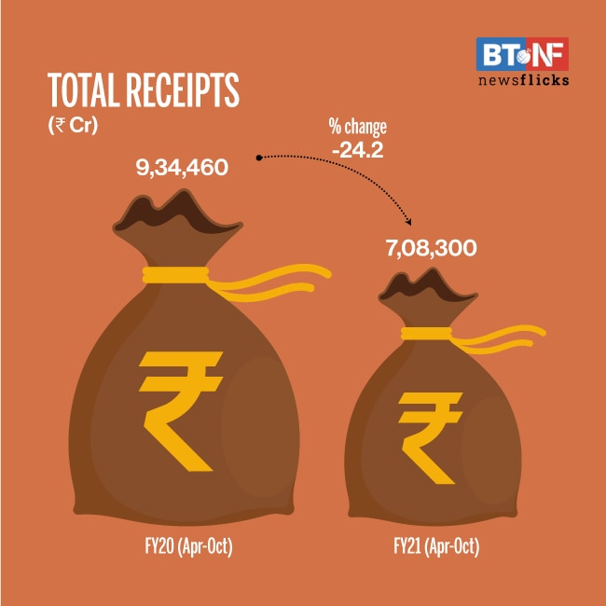

Total receipts have declined 24.2% in April-October 2020 compared to same period last year. Capital expenditure is 1.9% lower and only 48% of the budget estimate. Financing of the fiscal deficit is mainly by way of market borrowings.

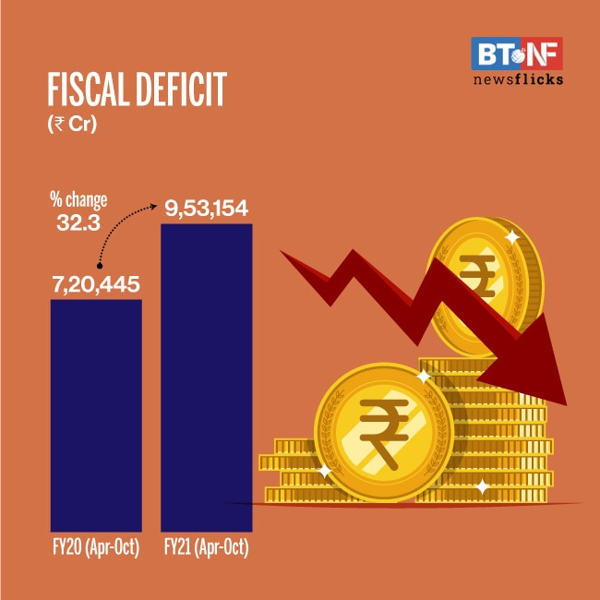

Fiscal deficit of the Central government has surpassed budget estimate for the full year by 19.7%. In Apr-Oct'2020, fiscal deficit was 119.7% of the budget estimate compared to 102.4% in same period last year.

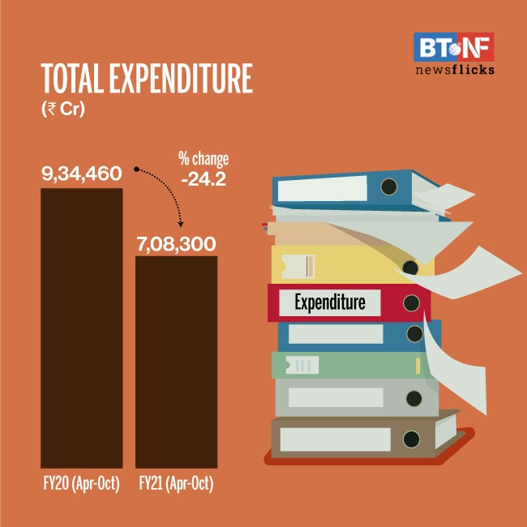

Total expenditure has increased marginally by 0.4% primarily on account of increase in revenue expenditure. Revenue Expenditure accounted for 89% of the expenditure and registered a 0.7% YoY growth. Capital expenditure declined 1.9% in Apr-Oct'20 compared to same period last year.

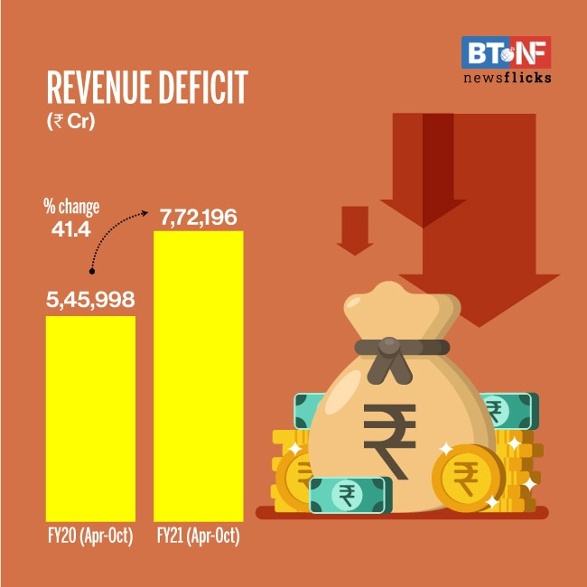

Revenue deficit of the central government has reached 126.7% of the budget estimate. Revenue deficit from Apr-Oct FY21 was estimated at Rs 7.7 lakh crore.

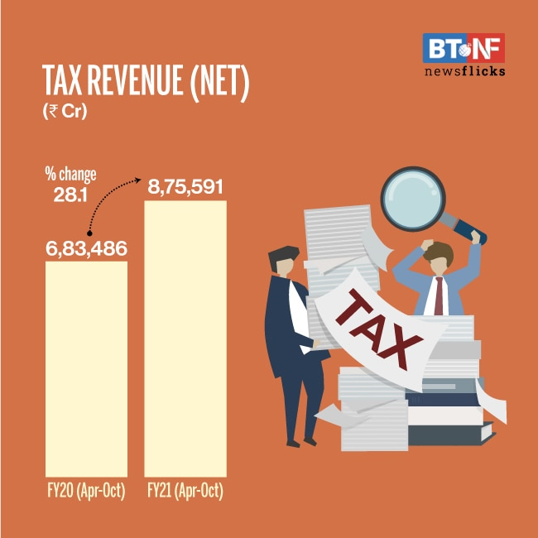

The pandemic-led economic disruption has weighed on tax revenues of the government. In April-October 2020, tax revenue was only 35% of the budget estimate. However, when compared with the same period of last year it was nearly 28% higher. Barring excise duties all major heads of taxes have declined.

**How have different sectors been affected due to Covid-19?**

****Centre’s revenue****

Table 1 shows the revenue expected by the central government from various sources in 2020-21.  73% of the revenue (Rs 16.36 lakh crore) is expected to come through taxes.   Because of the impact of lockdown, the actual tax revenue realised at the end of the year could be much lower, depending on how much the nominal GDP growth in 2020-21 gets affected.  To estimate the impact on tax revenue, we assume that the tax-GDP ratio (i.e. an estimate of the tax generated out of each unit of economic activity) in 2020-21 will remain the same as the budget estimate.   This may be a conservative estimate of loss of revenue due to lockdown as many permitted activities such as agriculture, government services and essential services have zero or lower-than-average taxes.

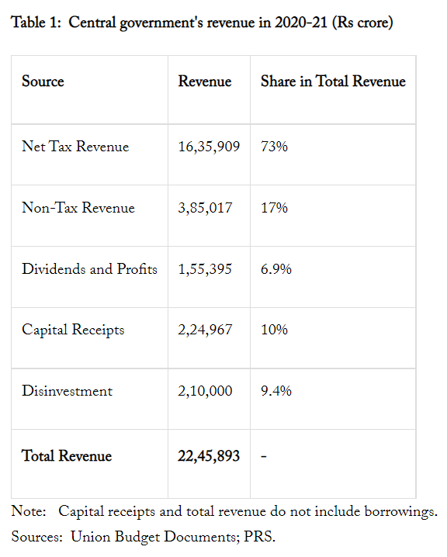

Based on this assumption, a 1%-point fall in the nominal GDP growth rate could decrease centre’s net tax revenue by about Rs 15,000 crore in 2020-21, i.e. 0.7% of its total revenue.  The IMF has projected GDP growth for 2020-21 at 1.9%; given the inflation target of 4%, nominal GDP growth could be about 6%.  In that scenario where the nominal GDP growth falls by 4% point from 10% to 6% in 2020-21, net tax revenue loss could be about Rs 60,000 crore (2.7% of total revenue).  As mentioned above, the tax-GDP ratio would likely be lower than the budget estimate because of the type of activities permitted during the lockdown.   This would increase the adverse impact on tax revenue.

There is a further assumption being made above regarding tax-GDP.  While GST tends to move with overall GDP, direct taxes would depend on income growth of individuals and profit growth of companies.  In a lower GDP growth environment, the effect on these two items may be higher than the deceleration of nominal GDP, bringing down the tax-GDP ratio.  Further, customs duties depend on the value of imports, which may have a lower growth.   This would, to some extent, be mitigated by the increase in the rate of excise duty on petroleum products.

### **Agriculture Sector**

A study during the first two weeks of May month by the [Public Health Foundation of India](https://en.wikipedia.org/wiki/Public_Health_Foundation_of_India" \o "Public Health Foundation of India), [Harvard T H Chan School of Public Health](https://en.wikipedia.org/wiki/Harvard_T.H._Chan_School_of_Public_Health" \o "Harvard T.H. Chan School of Public Health) and the [Centre for Sustainable Agriculture](https://en.wikipedia.org/wiki/Centre_for_Sustainable_Agriculture" \o "Centre for Sustainable Agriculture) found that "10% of farmers could not harvest their crop in the past month and 60% of those who did harvest reported a yield loss" and that a majority of farmers are facing difficulty for the next season.Due to logistical problems following the lockdown tea estates were unable to harvest the [first flush](https://en.wikipedia.org/wiki/First_flush_tea" \o "First flush tea). The impact of this on the second flush is not known. The entire Darjeeling tea based tea industry will see significant fall in revenue. Tea exports could see a yearly drop up to 8% as a result. In March 2020, tea exports from India fell 33% in March as compared to March 2019. During the lockdown, food wastage increased due to affected supply chains, affecting small farmers.

From 20 April, under new lockdown guidelines to reopen the economy and relax the lockdown, agricultural businesses such as dairy, tea, coffee, and rubber plantations, as well as associated shops and industries, reopened. By the end of April, [₹](https://en.wikipedia.org/wiki/Indian_rupee" \o "Indian rupee)17,986 [crore](https://en.wikipedia.org/wiki/Crore" \o "Crore) had been transferred to farmers under the [PM-KISAN](https://en.wikipedia.org/wiki/Pradhan_Mantri_Kisan_Samman_Nidhi" \o "Pradhan Mantri Kisan Samman Nidhi) scheme. Odisha passed new laws promoting [contract farming](https://en.wikipedia.org/wiki/Contract_farming" \o "Contract farming).

### **Exports and imports Sector**

India's exports in April 2020 fell by −36.65% year-on-year, while imports in April 2020 fell by −47.36% as compared to April 2019.

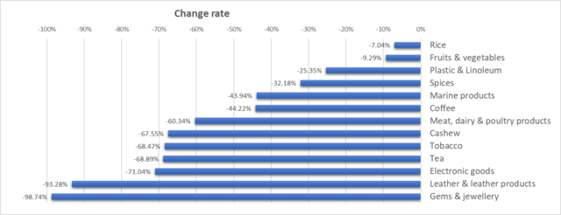

India's exports fell across numerous sectors in April 2020 as compared to the same period last year.

**Manufacturing Sector**

Major companies in India such as [Larsen and Toubro](https://en.wikipedia.org/wiki/Larsen_&_Toubro" \o "Larsen & Toubro), [Bharat Forge](https://en.wikipedia.org/wiki/Bharat_Forge" \o "Bharat Forge), [UltraTech Cement](https://en.wikipedia.org/wiki/UltraTech_Cement" \o "UltraTech Cement), [Grasim Industries](https://en.wikipedia.org/wiki/Grasim_Industries" \o "Grasim Industries), the fashion and retail wing of [Aditya Birla Group](https://en.wikipedia.org/wiki/Aditya_Birla_Group" \o "Aditya Birla Group), [Tata Motors](https://en.wikipedia.org/wiki/Tata_Motors" \o "Tata Motors) and [Thermax](https://en.wikipedia.org/wiki/Thermax" \o "Thermax) momentarily suspended or significantly reduced operations in a number of manufacturing facilities and factories across the country. [iPhone](https://en.wikipedia.org/wiki/IPhone" \o "IPhone) producing companies in India also suspended a majority of operations. Nearly all two-wheeler and four-wheeler companies put a stop to production till further notice. Many companies have decided to remain closed till at least 31 March such as [Cummins](https://en.wikipedia.org/wiki/Cummins" \o "Cummins) which has temporarily shut its offices across Maharashtra.  [Hindustan Unilever](https://en.wikipedia.org/wiki/Hindustan_Unilever" \o "Hindustan Unilever), [ITC](https://en.wikipedia.org/wiki/ITC_Limited" \o "ITC Limited) and [Dabur India](https://en.wikipedia.org/wiki/Dabur_India_Limited" \o "Dabur India Limited) shut manufacturing facilities except for factories producing essentials.  [Foxconn](https://en.wikipedia.org/wiki/Foxconn" \o "Foxconn) and [Wistron Corp](https://en.wikipedia.org/wiki/Wistron_Corp." \o "Wistron Corp.), iPhone producers, suspended production following the 21-day lockdown orders.

**Aviation and Travel sector**

Aviation and other sector establishments faced a massive struggle during the second wave of the pandemic. The larger travel sector is also taking a hit as people are scared to step out of their homes. For airlines and the broader travel sector, its recovery will depend on whether people in future will opt for such services. At present, the outlook for the aviation and broader travel sector does not look good.

**Automobile sector**

The automobile sector is expected to remain under pressure in the near term due to the covid-19 situation in India.

Real Estate and Construction sector:

The real estate and construction activities have started facing a disruption during the second wave as a large number of migrant workers have left the urban areas. The situation has not been grave as of 2020 for this sector.

**Tourism Sector**

The hospitality sector is linked to the tourism sector. The sector that employs millions of Indians started bouncing back after the first wave, but the second wave of covid was back for the devastation! The tourism sector contributes nearly 7% to India’s annual GDP.

It comprises hotels, homestays, motels and more. The restrictions due to the second wave have crippled the tourism sector, which was already struggling to recover from the initial loss suffered by the businesses in 2020.

**E-commerce Sector**

In the third week of March, [Amazon](https://en.wikipedia.org/wiki/Amazon_(company)" \o "Amazon (company)) announced that it would stop sale of non-essential items in India so that it could focus on essential needs. Amazon followed the same strategy in Italy and France. On 25 March, [Walmart](https://en.wikipedia.org/wiki/Walmart" \o "Walmart)-owned [Flipkart](https://en.wikipedia.org/wiki/Flipkart" \o "Flipkart) temporarily suspended some of its services on its e-commerce platform and would only be selling and distributing essentials. BigBasket and [Grofers](https://en.wikipedia.org/wiki/Grofers" \o "Grofers) also ran restricted services, facing disruptions due to the lockdown. [Delhi Police](https://en.wikipedia.org/wiki/Delhi_Police" \o "Delhi Police) began issuing delivery agents curfew passes to make it easier for them to keep the supply chain open. E-commerce companies also sought legal clarity related to defining "essentials".

**Stock markets Sector**

On 23 March 2020**,** stock markets in India post worst losses in history.[SENSEX](https://en.wikipedia.org/wiki/BSE_SENSEX" \o "BSE SENSEX) fell 4000 points (13.15%) and [NSE NIFTY](https://en.wikipedia.org/wiki/NIFTY_50" \o "NIFTY 50) fell 1150 points (12.98%).However, on 25 March, one day after a complete 21-day lock-down was announced by the Prime Minister, [SENSEX](https://en.wikipedia.org/wiki/SENSEX" \o "SENSEX) posted its biggest gains in 11 years, adding a value of [₹](https://en.wikipedia.org/wiki/Indian_rupee" \o "Indian rupee)4.7 [lakh](https://en.wikipedia.org/wiki/Lakh" \o "Lakh) [crore](https://en.wikipedia.org/wiki/Crore" \o "Crore)  for investors. On 8 April, following positive indication from the Wall Street that the pandemic may have reached its peak in the US, the stock markets in India rose steeply once again. By 29 April, Nifty held the 9500 mark.

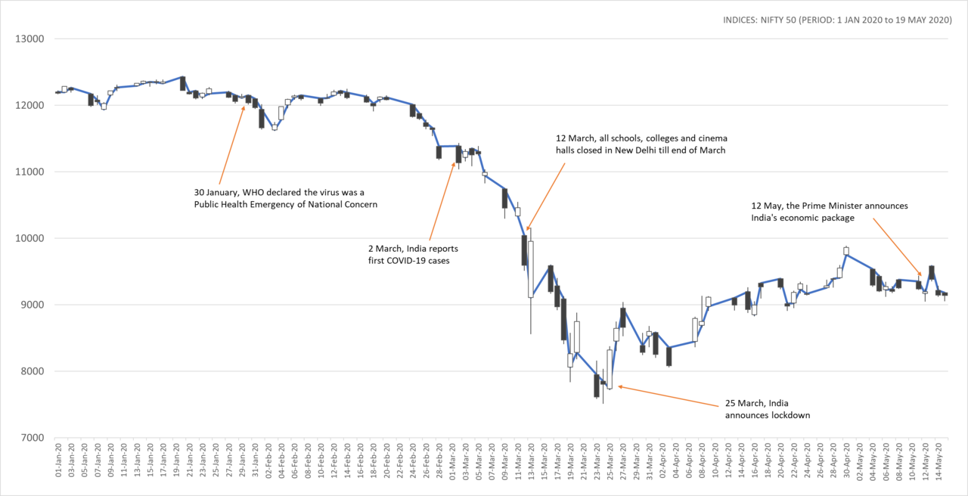

### **Defence Sector**

The [Department of Military Affairs](https://en.wikipedia.org/wiki/Department_of_Military_Affairs" \o "Department of Military Affairs) led by the [Chief of Defence Staff](https://en.wikipedia.org/wiki/Chief_of_Defence_Staff_(India)" \o "Chief of Defence Staff (India)) postponed all capital acquisitions until the coronavirus pandemic recedes. No new major defense deals would be made in the beginning of the financial year 2020–21. While the delivery of [S-400 missile systems](https://en.wikipedia.org/wiki/S-400_missile_system" \o "S-400 missile system) won't be affected, the delivery of [Rafale fighter jets](https://en.wikipedia.org/wiki/Dassault_Rafale" \o "Dassault Rafale) was reported to maybe being affected. However, on 24 March, France confirmed that there will be no delay in the delivery of the 36 Rafale jets.

In May, the [Chief of Defence Staff](https://en.wikipedia.org/wiki/Chief_of_Defence_Staff_(India)" \o "Chief of Defence Staff (India)) General [Bipin Rawat](https://en.wikipedia.org/wiki/Bipin_Rawat" \o "Bipin Rawat) again emphasized the need for India to minimize costly defense imports and boost domestic production.

*"Covid-19 has affected everybody have a major relook at our operational priorities and what we actually need. boost 'Make in India' by hand-holding our domestic industry even if they deliver weapons with only 70% of the GSQRs (general staff qualitative requirements) in the beginning…given the opportunity, they will eventually deliver cutting-edge technology. We are not expeditionary forces that have to deploy around the globe we should not go in for large amounts of imports by misrepresenting our operational requirements"*

During the announcement of the economic package, the Finance Minister announced a change in the FDI cap from 49% to 74% for defense, the corporatization of India's ordnance production and a list for the ban of select defense imports.

****Devolution to States****

Like the centre, states also rely on taxes for most of their revenue.  As per their 2020-21 budget, on an average, nearly 70% of their revenue is estimated to come from taxes (45% from their own taxes and 25% from their share of centre’s taxes).  Lower collections in centre’s taxes because of the lockdown will also impact states’ share in them (also known as devolution).  Table 2 shows the share of states in centre’s tax revenue and how they could get impacted by a lower economic growth rate due to the lockdown.

****Table 2:  Impact of lower economic growth during the lockdown on devolution in 2020-21 (Rs crore)****

|  |  |  |  |  |
| --- | --- | --- | --- | --- |
| ****State/ UT**** | ****Share in divisible pool (%)**** | ****Devolution**** | ****Impact of 1% point drop in national nominal GDP growth rate on Devolution**** | ****Revenue impact as a percentage of state’s revenue receipts**** |
| Andhra Pradesh | 4.11 | 32,238* | 293 | NA |
| Arunachal Pradesh | 1.76 | 13,802 | 125 | 0.61% |
| Assam | 3.13 | 26,776 | 243 | 0.26% |
| Bihar | 10.06 | 91,181 | 829 | 0.45% |
| Chhattisgarh | 3.42 | 26,803 | 244 | 0.29% |
| Delhi | - | - | - | - |
| Goa | 0.39 | 3,027 | 28 | 0.21% |
| Gujarat | 3.4 | 26,646 | 242 | 0.15% |
| Haryana | 1.08 | 8,485 | 77 | 0.09% |
| Himachal Pradesh | 0.8 | 6,266 | 57 | 0.15% |
| Jammu and Kashmir | - | 15,200 | 138 | 0.16% |
| Jharkhand | 3.31 | 25,980 | 236 | 0.31% |
| Karnataka | 3.65 | 28,591 | 260 | 0.14% |
| Kerala | 1.94 | 20,935 | 190 | 0.17% |
| Madhya Pradesh | 7.89 | 61,841* | 562 | NA |
| Maharashtra | 6.14 | 48,109 | 437 | 0.13% |
| Manipur | 0.72 | 5,630 | 51 | 0.28% |
| Meghalaya | 0.77 | 5,999* | 55 | NA |
| Mizoram | 0.51 | 3,968 | 36 | 0.37% |
| Nagaland | 0.57 | 4,493 | 41 | 0.28% |
| Odisha | 4.63 | 36,300 | 330 | 0.27% |
| Punjab | 1.79 | 14,021 | 127 | 0.14% |
| Rajasthan | 5.98 | 46,886 | 426 | 0.25% |
| Sikkim | 0.39 | 3,043 | 28 | 0.35% |
| Tamil Nadu | 4.19 | 32,849 | 299 | 0.14% |
| Telangana | 2.13 | 16,727 | 152 | 0.11% |
| Tripura | 0.71 | 5,560 | 51 | 0.30% |
| Uttar Pradesh | 17.93 | 1,52,863 | 1,389 | 0.33% |
| Uttarakhand | 1.1 | 8,657 | 79 | 0.19% |
| West Bengal | 7.52 | 65,835 | 598 | 0.33% |
| ****Total**** | ****100**** | ****8,38,710**** | ****7,624**** | ****0.22%**** |

****Sales tax/ VAT and State Excise****

These two taxes have been major sources of revenue for states, estimated to contribute 16% of states’ revenue in 2020-21.  With implementation of GST, states can now levy sales tax only on petroleum products (petrol, diesel, crude oil, natural gas, and aviation turbine fuel) and alcohol for human consumption.  However, the lockdown has severely impacted the consumption, and thus sale, of all of these goods as most of the transportation is prohibited and businesses selling alcohol are also shut.  As a result, the revenue coming from these taxes is likely to see a much larger impact as compared to the other taxes.

In addition, alcohol is also subject to state excise.   Table 4 shows the average monthly impact of the lockdown on revenue from state excise.  That is, this estimates the loss of revenue for each month of lockdown, with the assumption that there is no production of alcohol for human consumption during such periods.

****Table 4:  Average monthly impact of the lockdown on state excise revenue in 2020-21 (Rs crore)****

|  |  |  |  |
| --- | --- | --- | --- |
| ****State/ UT**** | ****State excise revenue**** | ****Average monthly impact on state excise revenue**** | ****Monthly revenue impact as a percentage of state’s revenue receipts**** |
| Andhra Pradesh | NA | NA | NA |
| Arunachal Pradesh | 157 | 13 | 0.06% |
| Assam | 1,750 | 146 | 0.16% |
| Bihar | 0 | 0 | 0.00% |
| Chhattisgarh | 5,200 | 433 | 0.52% |
| Delhi | 6,300 | 525 | 0.95% |
| Goa | 548 | 46 | 0.34% |
| Gujarat | 144 | 12 | 0.01% |
| Haryana | 7,500 | 625 | 0.69% |
| Himachal Pradesh | 1,788 | 149 | 0.39% |
| Jammu and Kashmir | 1,450 | 121 | 0.14% |
| Jharkhand | 2,301 | 192 | 0.25% |
| Karnataka | 22,700 | 1,892 | 1.05% |
| Kerala | 2,801 | 233 | 0.20% |
| Madhya Pradesh | NA | NA | NA |
| Maharashtra | 19,225 | 1,602 | 0.46% |
| Manipur | 15 | 1 | 0.01% |
| Meghalaya | NA | NA | NA |
| Mizoram | 1 | 0 | 0.00% |
| Nagaland | 6 | 0 | 0.00% |
| Odisha | 5,250 | 438 | 0.35% |
| Punjab | 6,250 | 521 | 0.59% |
| Rajasthan | 12,500 | 1,042 | 0.60% |
| Sikkim | 248 | 21 | 0.26% |
| Tamil Nadu | 8,134 | 678 | 0.31% |
| Telangana | 16,000 | 1,333 | 0.93% |
| Tripura | 266 | 22 | 0.13% |
| Uttar Pradesh | 37,500 | 3,125 | 0.74% |
| Uttarakhand | 3,400 | 283 | 0.67% |
| West Bengal | 12,732 | 1,061 | 0.59% |
| ****Total**** | ****1,74,164**** | ****14,514**** | ****0.48%**** |

Note:  Andhra Pradesh, Madhya Pradesh, and Meghalaya passed a vote on account, so data not available.  
Sources:  State Budget Documents; PRS.

Sales tax/VAT is collected from sale of alcohol and petroleum products.  We do not have any data on the reduction of sale of these items -- news reports indicating sale of alcohol in some states while petroleum products would be used by providers of essential services.  For estimating the impact on sales tax/ VAT revenue, we have assumed the following three scenarios: (i) 40% shortfall in tax collections, (ii) 60% shortfall in tax collections, and (iii) 80% shortfall in tax collections in any month of lockdown.   Table 5 shows the average monthly impact of the lockdown on sales tax/ VAT revenue under the three scenarios.

****Table 5:  Impact of lockdown on sales tax/ VAT revenue in 2020-21 (Rs crore)****

|  |  |  |  |  |  |  |
| --- | --- | --- | --- | --- | --- | --- |
| ****State/ UT**** | ****Loss of sales tax/ VAT revenue per lockdown month**** | | | ****As a percentage of state’s revenue receipts**** | | |
| ****40% shortfall**** | ****60% shortfall**** | ****80% shortfall**** | ****40% shortfall**** | ****60% shortfall**** | ****80% shortfall**** |
| Andhra Pradesh | NA | NA | NA | NA | NA | NA |
| Arunachal Pradesh | 9 | 14 | 18 | 0.04% | 0.07% | 0.09% |
| Assam | 178 | 267 | 356 | 0.19% | 0.29% | 0.39% |
| Bihar | 194 | 292 | 389 | 0.11% | 0.16% | 0.21% |
| Chhattisgarh | 138 | 207 | 276 | 0.16% | 0.25% | 0.33% |
| Delhi | 207 | 310 | 413 | 0.37% | 0.56% | 0.75% |
| Goa | 41 | 62 | 83 | 0.31% | 0.47% | 0.62% |
| Gujarat | 774 | 1,162 | 1,549 | 0.48% | 0.72% | 0.95% |
| Haryana | 357 | 535 | 713 | 0.40% | 0.59% | 0.79% |
| Himachal Pradesh | 56 | 84 | 112 | 0.15% | 0.22% | 0.29% |
| Jammu and Kashmir | 50 | 75 | 100 | 0.06% | 0.09% | 0.11% |
| Jharkhand | 195 | 293 | 391 | 0.26% | 0.39% | 0.52% |
| Karnataka | 593 | 889 | 1,186 | 0.33% | 0.49% | 0.66% |
| Kerala | 775 | 1,163 | 1,551 | 0.68% | 1.01% | 1.35% |
| Madhya Pradesh | NA | NA | NA | NA | NA | NA |
| Maharashtra | 1,333 | 2,000 | 2,667 | 0.38% | 0.58% | 0.77% |
| Manipur | 9 | 14 | 18 | 0.05% | 0.08% | 0.10% |
| Meghalaya | NA | NA | NA | NA | NA | NA |
| Mizoram | 3 | 4 | 5 | 0.03% | 0.04% | 0.06% |
| Nagaland | 9 | 13 | 18 | 0.06% | 0.09% | 0.12% |
| Odisha | 292 | 438 | 583 | 0.23% | 0.35% | 0.47% |
| Punjab | 186 | 279 | 372 | 0.21% | 0.32% | 0.42% |
| Rajasthan | 700 | 1,050 | 1,400 | 0.40% | 0.61% | 0.81% |
| Sikkim | 7 | 11 | 15 | 0.09% | 0.14% | 0.18% |
| Tamil Nadu | 1,868 | 2,802 | 3,736 | 0.85% | 1.28% | 1.70% |
| Telangana | 880 | 1,320 | 1,760 | 0.61% | 0.92% | 1.23% |
| Tripura | 15 | 22 | 30 | 0.09% | 0.13% | 0.17% |
| Uttar Pradesh | 943 | 1,414 | 1,886 | 0.22% | 0.33% | 0.45% |
| Uttarakhand | 66 | 98 | 131 | 0.15% | 0.23% | 0.31% |
| West Bengal | 251 | 377 | 503 | 0.14% | 0.21% | 0.28% |
| ****Total**** | ****10,130**** | ****15,195**** | ****20,260**** | ****0.34%**** | ****0.51%**** | ****0.67%**** |

Note:   Andhra Pradesh, Madhya Pradesh, and Meghalaya passed a vote on account, so data not available.  
Sources:  State Budget Documents; PRS.

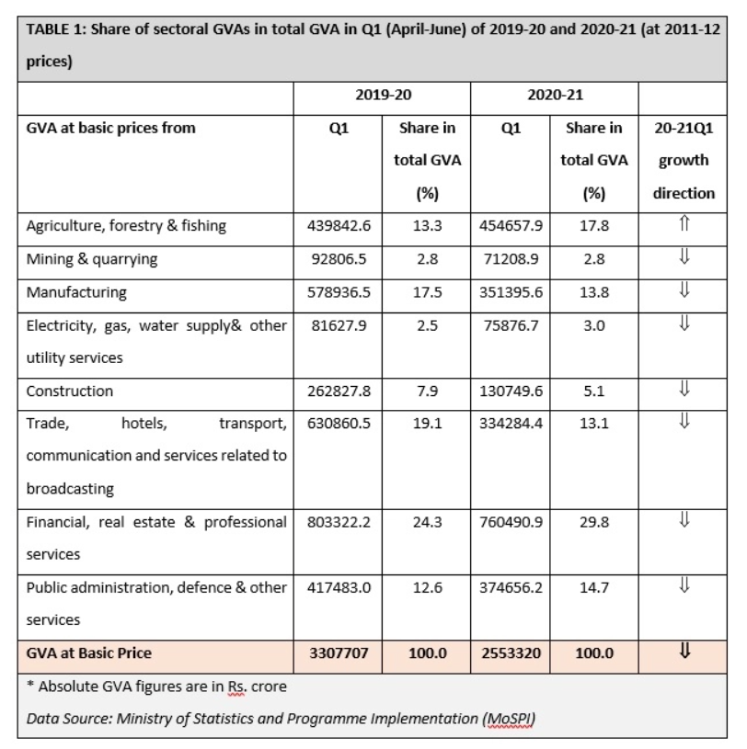

**What is the path to recovery?**

In the beginning of May, [Duvvuri Subbarao](https://en.wikipedia.org/wiki/Duvvuri_Subbarao" \o "Duvvuri Subbarao), a former [RBI governor](https://en.wikipedia.org/wiki/List_of_governors_of_the_Reserve_Bank_of_India" \o "List of governors of the Reserve Bank of India), said that India could look forward to a V-shaped recovery. A V-shaped recovery is the best outcome. [Arthur D. Little](https://en.wikipedia.org/wiki/Arthur_D._Little" \o "Arthur D. Little), an international consulting firm, has suggested that India will most probably see a W-shaped recovery. Mythili Bhusnurmath writes in [The Economic Times](https://en.wikipedia.org/wiki/The_Economic_Times" \o "The Economic Times) that U- shaped recovery is the most likely followed by an L-shaped recovery. [CRISIL](https://en.wikipedia.org/wiki/CRISIL" \o "CRISIL) chief economist says if things go well, that if the virus is contained, we can expect a V- recovery, otherwise it will end up as a U-recovery. On 24 July 2020 [Ajay Bhushan Pandey](https://en.wikipedia.org/wiki/Ajay_Bhushan_Pandey" \o "Ajay Bhushan Pandey), the Finance Secretary of India, said that the "Indian economy could revive sooner than we expect" while Tarun Bajaj, the [Economic Affairs Secretary](https://en.wikipedia.org/wiki/Economic_Affairs_Secretary" \o "Economic Affairs Secretary) said that he expects a [V-shaped](https://en.wikipedia.org/wiki/Recession_shapes" \o "Recession shapes) recovery. On 24 September 2020, [Economic Times](https://en.wikipedia.org/wiki/The_Economic_Times" \o "The Economic Times) reported that while speaking at the ET Global Summit, [Kevin Sneader](https://en.wikipedia.org/wiki/Kevin_Sneader" \o "Kevin Sneader), global managing partner of McKinsey and Co. said that, "many economists have been talking about 'V', 'U' and 'K' shape recoveries ever since the COVID-19 pandemic began. Yet, in all likelihood, there could be an 'X' shaped recovery for global economies, including India."

**V-shaped recovery**

In the second week of May, companies started preparations for restarting operations. Some companies opened offices with the maximum permitted strength of 33% while others took a more cautious approach of as low as five per cent. The beginning of June saw companies further reopen and making plans to reopen. A study by Elara Securities Inc. found that five Indian states, Kerala, Punjab, Tamil Nadu, Haryana and Karnataka, are contributing 27% to India's GDP as India emerges from a total lockdown. By mid-June, unemployment levels were back to pre-lockdown levels. Online sales reached pre-COVID-19 level sales by June end. [Hindustan Unilever](https://en.wikipedia.org/wiki/Hindustan_Unilever" \o "Hindustan Unilever) registered pre-COVID-19 levels in sales in late June. On 2 July 2020, [The Times of India](https://en.wikipedia.org/wiki/The_Times_of_India" \o "The Times of India) reported that a number of economic indicators such as the manufacturers [Purchasing Managers' Index](https://en.wikipedia.org/wiki/Purchasing_Managers'_Index" \o "Purchasing Managers' Index), goods movement, GST collections, electricity usage and [rail freight transport](https://en.wikipedia.org/wiki/Rail_freight_transport" \o "Rail freight transport) showed significant improvement as compared to previous months. Localised intermittent shutdowns in July were seen to negatively affect aspects of the country's economic recovery. On 29 July 2020, the [Cabinet of India](https://en.wikipedia.org/wiki/Cabinet_of_India" \o "Cabinet of India) passed the [National Educational Policy 2020](https://en.wikipedia.org/wiki/National_Education_Policy_2020" \o "National Education Policy 2020) aimed at strengthening the economy. By 13 September 2020, [Nomura](https://en.wikipedia.org/wiki/Nomura_Holdings" \o "Nomura Holdings) India's Business Resumption Index showed that economic activity was nearly back to pre-lockdown levels.

By mid-January 2021 only agriculture, forestry and fishing saw positive growth. Sectors such as manufacturing, real estate, professional services, constructuion, tourism, public utility and defence were still in recession. The [economic survey of India](https://en.wikipedia.org/wiki/Economic_survey_of_India" \o "Economic survey of India) for 2021, tabled during the Budget Session of the [Parliament](https://en.wikipedia.org/wiki/Parliament_of_India" \o "Parliament of India) on 31 January 2020, stated that "starting July (2020), a resilient V-shaped recovery is underway". This conclusion was based on indicators such as [E-Way Bills](https://en.wikipedia.org/wiki/E-Way_Bill" \o "E-Way Bill), [GST revenue statistics](https://en.wikipedia.org/wiki/Goods_and_Services_Tax_(India)_Revenue_Statistics" \o "Goods and Services Tax (India) Revenue Statistics), [commercial paper](https://en.wikipedia.org/wiki/Commercial_paper" \o "Commercial paper), steel demand and recovery in GDP growth. On 26 February 2021, India's GDP was back to pre-lockdown levels. Due to [low base effect](https://en.wikipedia.org/wiki/Low_base_effect" \o "Low base effect) a number of infrastructure sectors such as natural gas and cement saw high double digit growth in March 2021; a number of related sector such as coal were still in recession. In April the output of the core infrastructure sectors again saw high growth, again a consequence of the low base effect.