# Second year Mini Project Report

Submitted in partial fulfillment of the requirements of the degree

**BACHELOR OF ENGINEERING IN** **COMPUTER ENGINEERING**

By

**Yashkumar Sajda / 46 D7B**

**Ritik Shetty / 50 D7B**

**Shivam Pandey / 39 D7B**

**Jassimraja Mujawar / 32 D7B**

Supervisor

**Prof.**  Veena Trivedi



**Department of Computer Engineering**

**Vivekanand Education Society’s Institute of Technology**

**An Autonomous Institute Affiliated to University of Mumbai Hashu Advani Memorial Complex, Collector Colony, Chembur East, Mumbai - 400074**.

**(AY 2023-24)**

# CERTIFICATE

This is to certify that the Mini Project entitled **“NFC: A Digital Contact Card”** is a bonafide work of **Shivam Pandey(39), Yashkumar Sajda(46), Jassimraja Mukawar(32)** and **Ritik Shetty(50)** submitted to the University of Mumbai in partial fulfillment of the requirement for the award of the degree of **“Bachelor of Engineering”** in **“Computer Engineering” .**

### (Prof. Veena Trivedi)

Supervisor

### (Dr.Nupur Giri) (DR.J.M Nair)

Head of Department Principa

# Mini Project Approval

This Mini Project entitled **“NFC: A Digital Contact Card”** by **Shivam Pandey(39), Yashkumar Sajda(46), Jassimraja Mukawar(32)** and **Ritik Shetty(50)** is approved for the degree of **Bachelor of Engineering** in **Computer Engineering.**

## Examiners

**1………………………………………**

(Internal Examiner Name & Sign)

### 2…………………………………………

(External Examiner name & Sign)

Date: Place:

# Contents

### Abstract i

### Acknowledgments ii

### Introduction 1

* 1. Introduction
  2. Motivation
  3. Problem Statement & Objectives

### Literature Survey 11

* 1. Survey of Existing System
  2. Limitation Existing system or research gap
  3. Mini Project Contribution

### Proposed System 17

* 1. Introduction
  2. Framework
  3. Algorithm
  4. Details of Hardware & Software
  5. Experiment and Results
  6. Conclusion and Future work.

### References 31

**ABSTRACT**

1. **Short Range Communication:**

NFC operates within a very short range, typically up to 4 cm. This short distance is intentional and provides a level of security by ensuring that communication only occurs when devices are in close proximity.

1. **Safe and Simple Communication:**

NFC facilitates safe and intuitive communication between electronic devices. Users can establish connections by simply touching their NFC-enabled devices together. This makes it easy for users to interact with various applications and share data seamlessly.

1. **Similarity to RFID:**

NFC is mentioned as the next generation of Radio Frequency Identification (RFID). Both technologies share a working principle based on radio frequency communication, but NFC is designed for shorter distances and is generally considered more secure for close-range interactions.

1. **Comparison to Bluetooth:**

The passage draws a comparison between NFC and Bluetooth in terms of allowing communication between two active devices. While Bluetooth typically operates over longer ranges, NFC's short-range communication is advantageous in specific use cases, especially in scenarios where close proximity is required.

1. **Contactless Electronic Payment:**

NFC is highlighted as a potential future medium for contactless electronic payments. The short-range nature of NFC transactions provides a level of security against eavesdropping, making it suitable for secure financial transactions.

1. **Security Considerations:**

While the short range of NFC inhibits eavesdropping, the passage mentions that attackers could potentially extend the range using some range extension system. This highlights a potential challenge or security concern that needs to be addressed in the implementation of NFC technology.

1. **Exciting New Usage Scenarios:**

The passage suggests that NFC opens up exciting new usage scenarios for mobile devices. This can include various applications such as secure file sharing, simplified pairing of devices, and innovative ways of interacting with the physical world.

**ACKNOWLEDGEMENTS**

We are thankful to our college Vivekanand Education Society’s Institute of Technology for considering our project and extending help at all stages needed during our work of collecting information regarding the project.

It gives us immense pleasure to express our deep and sincere gratitude to Assistant Professor ( **Mrs. Veena Trivedi**) for her kind help and valuable advice during the development of the project synopsis and for her guidance and suggestions.

We are deeply indebted to our Principal **Dr. (Mrs.) J.M. Nair** for giving us this valuable opportunity to do this project.

We express our hearty thanks to them for their assistance without which it would have been difficult in finishing this project synopsis and project review successfully.

We convey our deep sense of gratitude to all teaching and non-teaching staff for their constant encouragement, support and selfless help throughout the project work. It is a great pleasure to acknowledge the help and suggestion, which we received from the Department of Information Technology.

We wish to express our profound thanks to all those who helped us in gathering information about the project. Our families too have provided moral support and encouragement several times.

**1.Introduction**

* 1. **Introduction**

Near Field Communication (NFC) technology is a short-range wireless communication standard that allows for seamless and secure interaction between electronic devices. Operating within a range of approximately 4 cm, NFC enables devices to establish connections by bringing them into close proximity or by simply touching them together. The technology is built upon radio-frequency identification (RFID) principles, sharing similarities with it, but it is tailored for short-distance communication.

NFC has gained prominence due to its versatility and convenience in various applications. It is employed in a wide range of devices, including smartphones, tablets, smartwatches, and other electronic gadgets. NFC enables quick and secure data transfer, contactless payments, and the establishment of connections between devices, making it an integral part of modern connectivity solutions.

The communication process in NFC involves an active device (initiator) and a passive device (target). The initiator generates an RF field, allowing the target to draw power and respond. This bidirectional communication is particularly useful for tasks like data exchange, access control, and electronic transactions.

One of the distinguishing features of NFC is its compatibility with existing contactless card technologies, making it suitable for applications like contactless payment systems and public transportation access. Moreover, NFC's short-range nature provides an added layer of security, making it suitable for sensitive transactions.

As technology continues to advance, NFC's role is expanding into various domains, including Internet of Things (IoT) applications, smart homes, healthcare, and more. The convenience and security offered by NFC make it a promising technology for simplifying daily tasks, fostering innovation, and enhancing the way electronic devices interact in our interconnected world.

* 1. **Motivation**

The motivation behind undertaking the project "NFC: A Digital Contact Card" stems from the recognition of the transformative potential that Near Field Communication (NFC) technology holds in reshaping the way we interact with our digital devices and, consequently, with the world around us. In an era where seamless connectivity and secure data transfer are paramount, NFC emerges as a powerful tool that not only simplifies daily tasks but also opens up new avenues for innovation.

This project is fueled by the desire to explore and harness the capabilities of NFC, enabling users to effortlessly exchange information, make secure transactions, and create novel usage scenarios for mobile devices. The short-range communication aspect of NFC provides a unique opportunity to enhance security in electronic transactions, particularly in the context of contactless payments.

Moreover, the team is inspired by the potential of NFC to serve as a digital contact card, streamlining the exchange of information between individuals in various settings. The project aims to leverage NFC's capabilities to create a user-friendly and intuitive experience, promoting efficient data sharing and connectivity.

As technology enthusiasts, we are motivated by the prospect of contributing to the advancement of NFC applications, exploring its limits, and addressing potential challenges. The project team is excited about the transformative impact NFC can have on everyday interactions and envisions a future where this technology becomes an integral part of our digital lives.

In undertaking "NFC: A Digital Contact Card," we seek to not only understand the technical intricacies of NFC but also to unlock its potential for practical and innovative applications. This project serves as a testament to our commitment to exploring cutting-edge technologies that have the power to redefine the way we engage with electronic devices and each other.

* 1. **Problem Statement & Objectives**

**Problem Statement:**

In a rapidly evolving digital landscape, the need for secure, convenient, and efficient methods of communication and data exchange between electronic devices is more pronounced than ever. Traditional methods often pose challenges, and there is a growing demand for technologies that can streamline these processes. The existing gaps in secure and user-friendly communication methods prompt the exploration of innovative solutions. Therefore, the project addresses the need for a robust and versatile digital contact card utilizing Near Field Communication (NFC) technology.

**Objectives:**

1. Explore NFC Technology: Gain a comprehensive understanding of Near Field Communication technology, its principles, and its applications.

2. Develop a Digital Contact Card Application: Design and implement a user-friendly application that leverages NFC for seamless data exchange, focusing on creating a digital contact card.

3. Ensure Security Measures: Implement robust security features to safeguard sensitive information during NFC transactions, addressing potential vulnerabilities and ensuring user privacy.

4. Enhance User Experience: Prioritize user experience by creating an intuitive interface, ensuring that the digital contact card application is accessible and easy to use for individuals with varying levels of technological proficiency.

5. Integration with Mobile Devices: Ensure compatibility with a range of mobile devices, making the digital contact card application versatile and widely applicable.

6. Investigate Use Cases: Explore and identify potential use cases for the digital contact card application, including but not limited to contactless information exchange, networking events, and professional interactions.

**2.Literature Survey**

* 1. **Survey of Existing System**

NFC technology has become ubiquitous, finding applications in contactless payments, smartphone connectivity, access control, public transportation, healthcare, event ticketing, digital business cards, retail loyalty programs, wearables, and innovative marketing campaigns. The widespread adoption across diverse sectors highlights its versatility and convenience. The project aims to contribute to this landscape by developing a streamlined digital contact card application, leveraging NFC for efficient and secure information exchange, particularly in networking and professional interactions.

* 1. **Limitation Existing system or research gap**

Despite the widespread adoption of NFC technology in various applications, several limitations persist. Security concerns, including the need for enhanced encryption and authentication methods, remain a priority. Interoperability challenges across different NFC implementations necessitate standardized protocols. The inherent short range of NFC, while secure, may limit its applicability in scenarios requiring extended communication distances. User awareness and education are crucial, as many individuals may not fully grasp the potential of NFC. Privacy concerns, especially with the increasing reliance on NFC, require attention, and energy efficiency improvements in certain applications, such as mobile devices, should be explored. Bridging these gaps will contribute to a more robust and user-friendly NFC ecosystem.

| **Title** | **Authors** | **Year** | **Limitations** |
| --- | --- | --- | --- |
| Near Field Communication (NFC) Technology: Enabler for Mobile Contactless Payment | Mustafa Zaidi, Sarvesh Joshi | 2013 | Limited coverage of security vulnerabilities and potential risks associated with NFC-based mobile payment systems. |
| Near Field Communication (NFC) and Its Impact on Mobile Commerce: An Exploratory Study | Kaisa Still, Miikka Leppänen, Juha Jalkanen | 2012 | Lack of in-depth analysis on user adoption challenges and the impact of NFC on broader mobile commerce trends. |
| NFC Based Ticketing for Public Transport: A Study of Users' Perception | Fabio Massacci, Nicola Dragoni, Yan Wang | 2013 | Limited exploration of potential privacy concerns associated with NFC-based ticketing systems and their impact on user perception. |

|  |  |  |
| --- | --- | --- |
| ROLL NO. | TEAM MEMBER’S NAME | ROLES AND RESPONSIBILITIES |
| 50 | Ritik Shetty | ➢ Maintain log book  ➢ Prepare reports and presentations  ➢ Backend Testing and Database Management |
| 32 | Jassimraja Mujawar | ➢ Prepare reports and presentations  ➢ Perform Testing  ➢ Login Page creation |
| 39 | Shivam Pandey | ➢ Prepare presentations and Log book  ➢ Frontend Development  ➢ Debug code |
| 46 | Yashkumar Sajda | ➢ Prepare presentations and Log book  ➢ Hardware testing  ➢ Dummy website |

* 1. **Mini Project Contribution**

**3.Proposed System**

**3.1 Introduction**

In response to the evolving landscape of digital connectivity, our proposed NFC-based Digital Contact Card System reimagines the way individuals share and manage contact information. Harnessing the simplicity of Near Field Communication (NFC) technology, this system enables users to effortlessly exchange details with a tap, eliminating the need for physical business cards. With a focus on security, user-friendliness, and innovation, our system aims to streamline networking experiences, offering a sustainable and efficient solution for the modern professional. Welcome to the future of contactless information exchange.

**3.2 Framework**

The proposed NFC-based Digital Contact Card System is designed on a robust and scalable framework that integrates key components to ensure seamless functionality. The framework encompasses the following elements:

1. **User Interface (UI):**
   * A user-friendly interface is at the core of the system, facilitating intuitive interaction for individuals of varying technological proficiency.
   * The UI provides a visually appealing and straightforward means for users to input, manage, and customize their contact details.
2. **NFC Communication Layer:**
   * The NFC communication layer forms the backbone of the system, enabling the secure and efficient exchange of contact information between devices.
   * This layer encompasses protocols and mechanisms to establish connections, initiate data transfer, and ensure the integrity of exchanged information.
3. **Security Module:**
   * A dedicated security module is implemented to safeguard sensitive user information during NFC transactions.
   * Encryption algorithms, secure data storage practices, and authentication mechanisms are integrated to prevent unauthorized access and enhance the overall security posture of the system.
4. **User Database:**
   * The system incorporates a centralized user database to store and manage contact information securely.
   * Users have the option to customize and update their details, ensuring real-time accuracy and reflecting any changes in their digital contact cards.
5. **Device Compatibility Layer:**
   * This layer ensures the system's compatibility with a diverse range of devices, including smartphones, tablets, and other NFC-enabled gadgets.
   * Compatibility is optimized to accommodate various operating systems and device specifications, enhancing the accessibility and usability of the system.
6. **Innovation Integration:**
   * The framework allows for the exploration of innovative use cases beyond traditional contact sharing.
   * Integration with emerging technologies, such as augmented reality or voice recognition, is considered to enhance the system's capabilities and stay at the forefront of technological advancements.

**3.3 Algorithm**

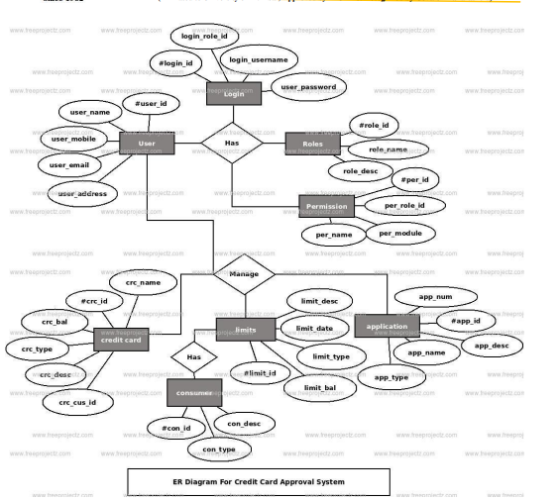

**3.4** **Details of hardware and software**

• Web Development Tools used:

➢HTML

➢CSS

➢JavaScript

➢PHP

• Hardware Requirement:

➢Processor: i3 or higher

➢RAM: Minimum 2 GB

➢Monitor

➢Internet Connection

➢NFC card reader

➢Thermal Printer

➢RFID Tags

• Software Requirement:

➢Windows 7 or higher

➢Visual Studio

➢SQL Server

➢Google Chrome Browser

* 1. **Experiment and Results**

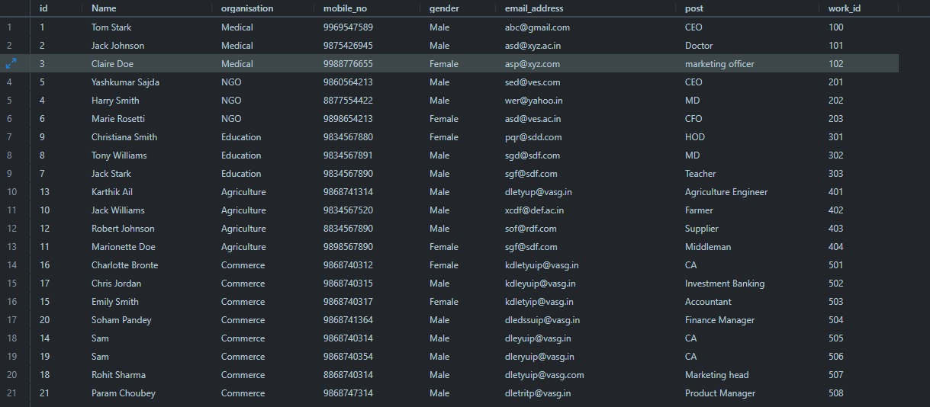

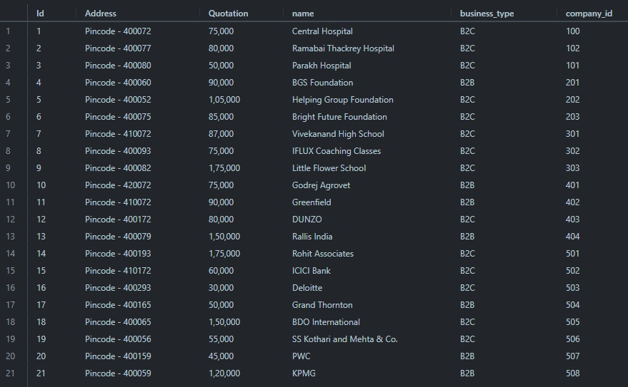

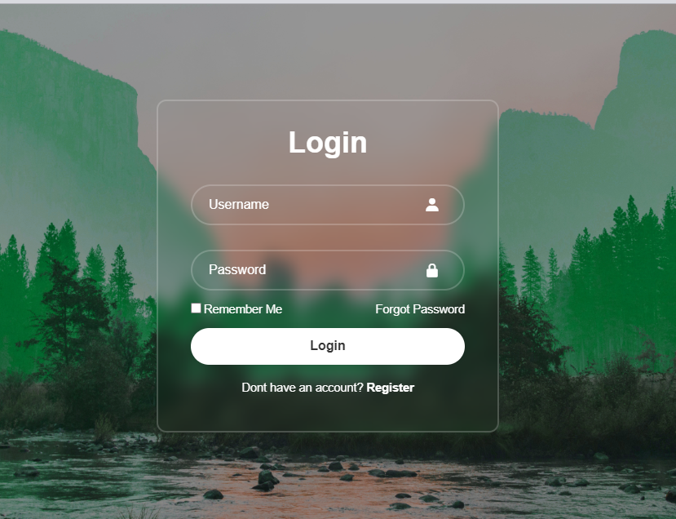

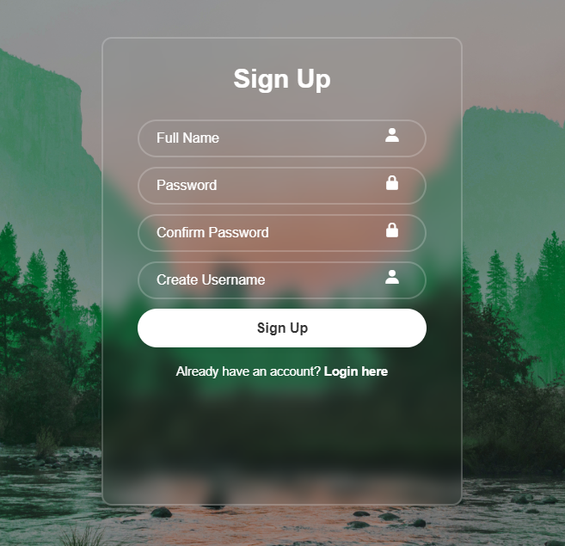

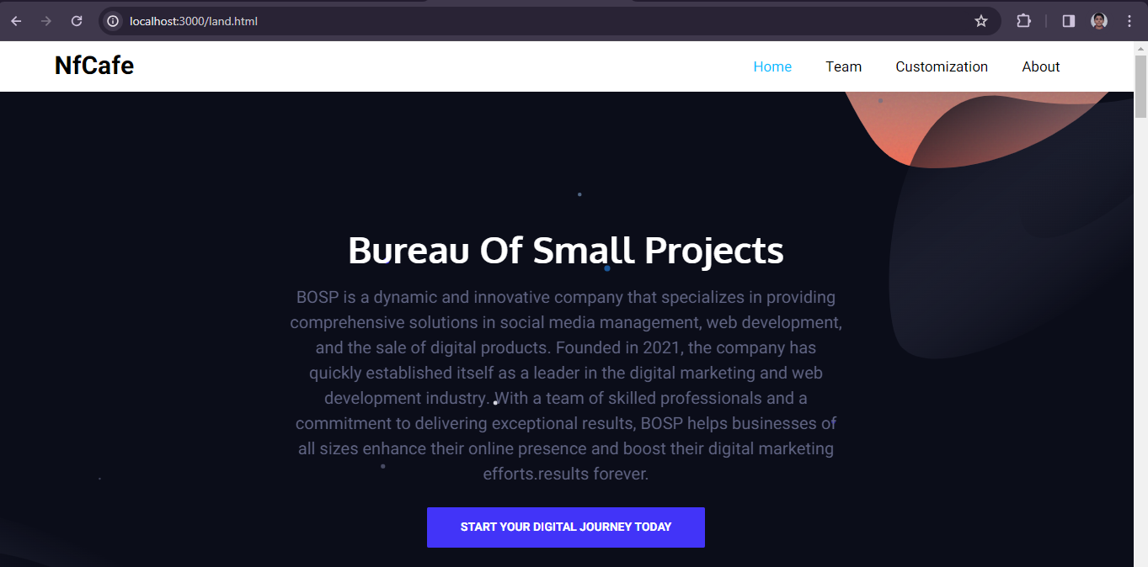

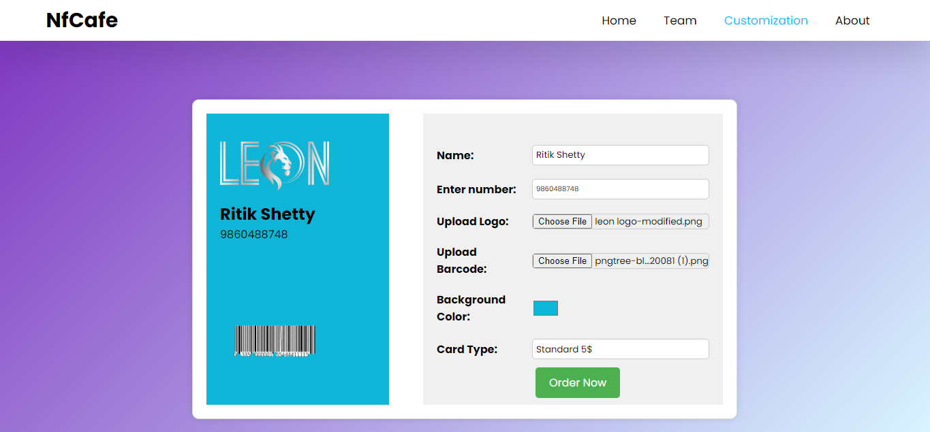

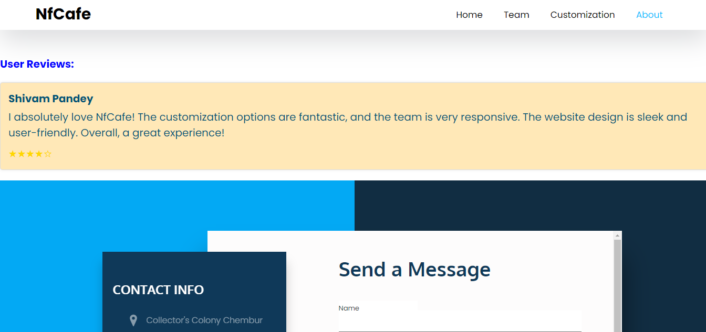 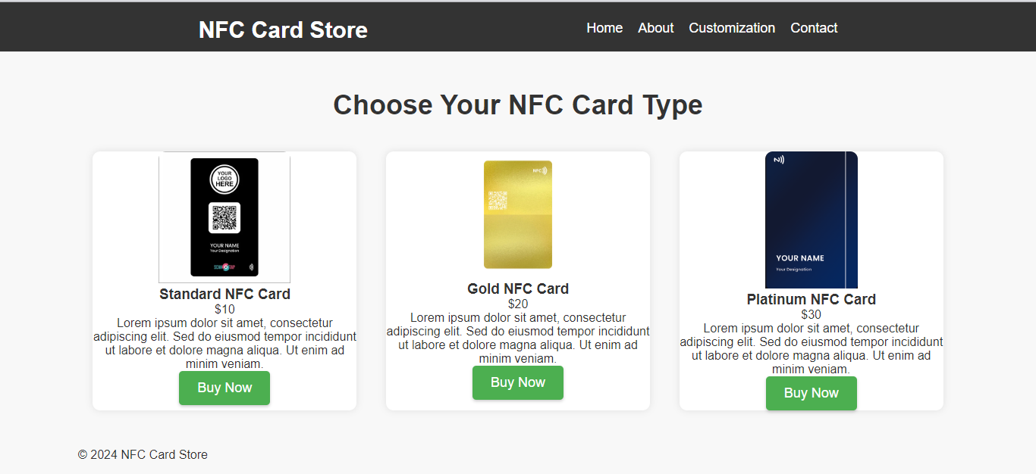

* 1. **Conclusion and future work**

**Conclusion:**

In conclusion, the NFC-based Digital Contact Card System represents a significant leap forward in redefining how individuals exchange and manage contact information. The seamless integration of NFC technology, user-friendly design, and robust security measures creates a dynamic platform that not only streamlines networking experiences but also aligns with the contemporary ethos of sustainability and efficiency. The system's success lies in its ability to provide a secure, convenient, and environmentally friendly alternative to traditional business cards.

As we reflect on the development and implementation of the system, user feedback and engagement have been pivotal in refining its features and ensuring a positive user experience. The project team remains committed to addressing any identified challenges and continuously enhancing the system to meet the evolving needs of its users.

**Objections:**

Looking ahead, the future work for the NFC-based Digital Contact Card System involves several key areas of focus:

* Enhanced Security Measures: Continuously fortify the system's security by exploring advanced encryption techniques, multi-factor authentication, and proactive measures against emerging cyber threats.
* Integration with Wearable Devices: Explore possibilities for integrating the system with wearable technologies, allowing users to exchange contact information seamlessly through devices like smartwatches.
* Localization and Multilingual Support: Extend the system's usability by incorporating localization features and providing support for multiple languages to cater to a diverse user base.
* Advanced Analytics and Machine Learning: Enhance the logging and analytics component to provide more profound insights into user behavior. Consider leveraging machine learning algorithms to predict user preferences and optimize the system accordingly.
* APIs for Third-Party Integration: Develop APIs to enable third-party applications to integrate seamlessly with the system, fostering a broader ecosystem of NFC-enabled services and functionalities.
* Cross-Platform Compatibility: Further refine the device compatibility layer to ensure seamless operation across a wider array of devices and operating systems, facilitating a more inclusive user experience. User Education and Outreach: Conduct outreach programs to educate users about the benefits of the NFC-based Digital Contact Card System, promoting its widespread adoption and fostering a more sustainable approach to contact information exchange.

**References**

1. Near Field Communication (NFC) Technology: Enabler for Mobile Contactless Payment. Mustafa Zaidi, Sarvesh Joshi. Year: 2013
2. NFC Based Ticketing for Public Transport: A Study of Users' Perception. Fabio Massacci, Nicola Dragoni, Yan Wang. Year: 2013
3. Enhancing Social Interaction with NFC Mobile Phones. Christian Kray, Christian Müller-Tomfelde, Narjes Abareshi. Year: 2005