**VISVESVARAYA TECHNOLOGICAL UNIVERSITY**



### Belagavi-590018

**A Project Report on**

**CONNECT CARE- A FOOD DONATION APP**

#### Submitted by

**ROSHAN 4SN20CS062**

**PRANAVA 4SN20CS049**

**SHRADHA V S 4SN20CS073**

**GAYATRI NAIK 4SN20CS023**

**In partial fulfillment of the requirements for the degree of**

### BACHELOR OF ENGINEERING

**IN**

**COMPUTER SCIENCE & ENGINEERING**

### Under the Guidance of

**Prof. RAKESH SHARMA**

**Assistant Professor**

**Department of Computer Science & Engineering**

**SRINIVAS INSTITUTE OF TECHNOLOGY**

**(NAAC ACCREDITED) MANGALURU-574143, KARNATAKA.**

**2023 - 2024**

## SRINIVAS INSTITUTE OF TECHNOLOGY

### (NAAC ACCREDITED) MANGALURU - 574143, KARNATAKA.

**DEPARTMENT OF COMPUTER SCIENCE & ENGINEERING**

**CERTIFICATE**

*Certified that the project work entitled* ***“CONNECT CARE- A FOOD DONATION APP”*** *is a bonafide work carried out by*

**ROSHAN 4SN20CS062**

**PRANAVA 4SN20CS049**

**SHRADHA V S 4SN20CS073**

**GAYATRI N AI K 4SN20CS023**

*in partial fulfillment for the award of* ***BACHELOR OF ENGINEERING*** *in* ***COMPUTER SCIENCE & ENGINEERING*** *of the* ***VISVESVARAYA TECHNOLOGICAL***

***UNIVERSITY, BELAGAVI*** *during the year 2023-2024.It is certified that all corrections/suggestions indicated for Internal Assessment have been incorporated in the report deposited in the departmental library. The project report has been approved as it satisfies the academic requirements in respect of Project work prescribed for the Bachelor of Engineering Degree.*

**Prof. Rakesh Sharma. Prof. Ravishankara K. Dr. Shrinivasa Mayya D. Project Guide Head of the Department Principal**

**Name of the Examiners 1.**

**Signature with Date**



**2.**

## ACKNOWLEDGEMENT

The success and final outcome of this project required a lot of guidance and assistance from many people and we are extremely fortunate to have got their support all along the completion of our project.

We are highly grateful and would like to express our wholehearted thankfulness to our Project Guide and Coordinator, **Prof. Rakesh Sharma**, Assistant Professor, Department of Computer Science and engineering, who has been our source of inspiration. She has communicated various ideas for improving the project and has been especially enthusiastic in giving her opinions and critical reviews in a constructive manner. We will remember her contribution forever.

We express a deep sense of gratitude to **Mr. Ravishankara K**, Head of the Department, Computer Science and Engineering, for his cordial support, valuable information and guidance, which helped us in completing this project through various stages.

We also express our heartfelt gratitude to our Principal **Dr. Shrinivasa Mayya D.** for his kind co-operation and encouragement which helped us in the completion of this project.

We also thank our **Management** who helped us directly and indirectly for the successful completion of our project.

We are thankful to and fortunate enough to get constant encouragement, support and guidance from all the **Teaching and Non-teaching staff** of Department of Computer Science and Engineering who helped us in successfully completing our project.

Lastly, we would like to thank our **Parents** for their moral support and our **Friends** with whom we shared our day-to-day experiences and received lots of suggestions that improved our quality of work.

* ROSHAN
* PRANAVA
* SHRADHA V S
* GAYATRI NAIK

## ABSTRACT

In this era, people often overeat, make parties or events, where there is excessive availability of food. As well as shops or restaurants that sell food, has ready-to-eat foods that only lasts one day and then treated as expired food. Often this precious food is thrown in the trash, and meanwhile, many destitute people cannot eat enough per day. Therefore, this app aims to mobilize people who overeat and donate their excess food that can still be consumed to those in need. This smartphone application is equipped with activities such as registering for new donors who want to join the mobile application and logging in for donors who are already registered in the mobile application. Donors can monitor couriers taking photos of recipients with food donated from donors. In addition, donors can select the food category for donation and input amount, track the donated food that the courier has picked up, and send it to the recipient. This mobile application is also equipped with donors to share experiences, ideas, and views based on topics created by staff and available threads. The name reflects the app's mission of connecting individuals and communities to provide care and support to those in need, including the homeless and those facing food insecurity. It conveys the essence of fostering connections and compassion in addressing critical social issues. "Connect- Care" embodies a vision where excess food is shared, hunger is alleviated, and connections are formed. Join us in this transformative journey, where every meal rescued and every act of care brings us closer to a more compassionate and sustainable world.

**TABLE OF CONTENTS**

|  |  |  |
| --- | --- | --- |
| **CHAPTER No.** | **TITLE** | **PAGE No.** |

|  |  |  |
| --- | --- | --- |
| **1** | **INTRODUCTION** | **1** |
| 1.1 | Problem Statement | 2 |
| 1.2 | Existing System | 2 |
| 1.3 | Proposed System | 3 |
| 1.4 | Objective | 3 |
| **2** | **LITERATURE SURVEY** | **4** |
| **3** | **SOFTWARE REQUIREMENT ANALYSIS** | **7** |
| 3.1 | Feasibility Study | 7 |
| 3.1.1 | Technical Feasibility | 7 |
| 3.1.2 | Social Feasibility | 7 |
| 3.1.3 | Economic Feasibility | 8 |
| **4** | **SYSTEM REQUIREMENT SPECIFICATION** | **9** |
| 4.1 | Functional Overview | 9 |
| 4.2 | Operating Environment | 9 |
| 4.2.1 | Software Requirements | 9 |
| 4.2.2 | Hardware Requirements | 10 |
| 4.3 | Functional Requirements | 10 |
| 4.4 | Non-functional Requirements | 11 |
| 4.5 | Performance Requirements | 12 |
| **5** | **SYSTEM DESIGN** | **13** |
| 5.1 | High Level Design | 13 |

|  |  |  |
| --- | --- | --- |
| 5.2 | DETAILED DESIGN | 17 |
| 5.2.1 | Use Case Diagram of Connect Care | 18 |
| **6** | **SYSTEM IMPLEMENTATION** | **19** |
| 6.1 | Technology Stack Selection | 20 |
| 6.2 | Development Environment Setup | 21 |
| 6.3 | Backend Development | 21 |
| 6.4 | Integration and Testing | 23 |
| 6.5 | Deployment | 24 |
| 6.6 | Maintenance and Updates | 24 |
| **7** | **TESTING** | **26** |
| 7.1 | Testing Methodologies | 26 |
| 7.2 | Testing Criteria | 29 |
| **8** | **RESULT AND EXECUTIONS** | **32** |
| 8.1 | Donor Registration Page | 32 |
| 8.2 | Volunteer Registration Page | 33 |
| 8.3 | Login Page | 33 |
| 8.4 | NGO List Page | 34 |
| 8.5 | Community Page | 35 |
| 8.6 | Profile Page | 35 |
| 8.7 | Post Upload Page | 36 |
|  | **CONCLUSION AND FUTURE SCOPE** | **37** |
|  | **REFERENCES** |  |

|  |  |
| --- | --- |
| **FIGURE No. TITLE** | **PAGE No.** |
| 5.1 System Architecture of Connect Care | 13 |
| 5.2 DFD Diagram | 17 |
| 5.4 Use Case Diagram for Connect Care | 18 |
| 8.1 Donor Registration Page | 32 |
| 8.2 Volunteer Registration Page | 33 |
| 8.3 Login Page | 33 |
| 8.4 NGO List Page | 34 |
| 8.5 Community Page | 35 |
| 8.6 Profile Page | 35 |
| 8.7 Post Upload Page | 36 |

|  |  |  |
| --- | --- | --- |
| **TABLE No.** | **TITLE** | **PAGE No.** |
| 7.2.1 | Test cases for Registration screen | 29 |
| 7.2.2 | Test cases for Volunteer registration screen | 30 |
| 7.2.3 | Test cases for Donor,Volunteer and Receiver login screen | 31 |
| 7.2.4 | Test cases Donation screen | 31 |
| 7.2.5 | Test cases for Image upload screen | 31 |

**Chapter 1**

# INTRODUCTION

**CHAPTER 1**

**INTRODUCTION**

This comprehensive report delves into the multifaceted dimensions of "Connect Care," an innovative mobile application designed to revolutionize the landscape of food donation and sharing within local communities. Recognizing the urgency of addressing both food insecurity and surplus food wastage, Connect Care serves as a beacon of hope, leveraging digital connectivity to foster a sense of communal responsibility and bridge the gap between those with excess food and those in need. The app operates on a principle of inclusivity, seamlessly integrating diverse stakeholders into a unified network committed to eradicating hunger. Users are empowered to effortlessly contribute surplus food items, each with a detailed description of its nutritional content and expiration date, thus ensuring transparency and reliability in the donation process. Connect Care's core functionalities are examined in detail, highlighting its real- time food donation and tracking mechanisms. Furthermore, Connect Care distinguishes itself by incorporating a robust social engagement layer into its framework. Connect Care goes beyond the transactional nature of food donation, emphasizing the creation of a virtual community committed to alleviating hunger and promoting social welfare. The report also addresses the app's strategic partnerships with local and non-profit organizations. Connect Care's collaborative approach is evaluated for its effectiveness in establishing a sustainable and scalable model, thereby expanding its reach and impact on a broader societal level. By facilitating the seamless transfer of surplus food to those in need, the app contributes to the reduction of food wastage, alleviation of hunger, and minimization of the environmental footprint associated with food decomposition in landfills. In conclusion, Connect Care emerges as a transformative force in the realm of digital solutions addressing food insecurity and waste. This report provides an in-depth analysis of the app's features, technological foundations, and its potential to bring about positive societal change. As communities grapple with the dual challenges of food inequality and environmental sustainability, Connect Care exemplifies the power of technology to connect hearts and foster a collective commitment towards a hunger-free future.

* 1. **Problem Statement**

In the face of persistent global challenges related to food insecurity and surplus food wastage, there exists a critical need for an effective, scalable, and technologically-driven solution that can bridge the gap between those with excess food resources and individuals or organizations facing hunger. Current inefficiencies in traditional food donation systems, compounded by limited connectivity and community engagement, highlight the pressing need for an innovative mobile application that fosters seamless, transparent, and socially connected food sharing. The Connect Care app aims to address these challenges by leveraging digital connectivity to create a dynamic and inclusive platform that transforms surplus food into a valuable resource for community welfare, thereby contributing to the broader goals of reducing food waste and alleviating hunger.

### Existing system

The increased use of Before the implementation of the Connect Care Food Donation App, traditional methods and systems were often relied upon to facilitate food donation and assistance initiatives. These methods typically involved manual processes, phone calls, and in-person coordination, which were often inefficient, time-consuming, and prone to errors. Overall, the existing system faced challenges in terms of efficiency, transparency, and scalability, highlighting the need for a more streamlined and technology-driven approach to food donation and assistance initiatives. The Connect Care Food Donation App aims to address these challenges by providing a centralized platform for donors, recipients, and volunteers to connect, coordinate, and collaborate in a more efficient and effective manner. The lack of a centralized platform for food donation and assistance meant that there was limited transparency and accountability in the donation process. Donors and recipients often had limited information about the status and outcomes of their donations. Food donation efforts were primarily coordinated offline, with donors, recipients, and volunteers communicating through phone calls, emails, or physical meetings to arrange donations, pickups, and deliveries. There was a lack of structured feedback mechanism in the existing system, making it challenging for donors, recipients, and volunteers to provide feedback on their experiences. This limited the ability to assess the effectiveness of donation efforts and identify areas for improvement.

### Proposed System

In the face of persistent global challenges related to food insecurity and surplus food wastage, there exists a critical need for an effective, scalable, and technologically-driven solution that can bridge the gap between those with excess food resources and individuals or organizations facing hunger. Current inefficiencies in traditional food donation systems, compounded by limited connectivity and community engagement, highlight the pressing need for an innovative mobile application that fosters seamless, transparent, and socially connected food sharing. The Connect Care app aims to address these challenges by leveraging digital connectivity to create a dynamic and inclusive platform that transforms surplus food into a valuable resource for community welfare, thereby contributing to the broader goals of reducing food waste and alleviating hunger.

* 1. **Objective**

The Connect Care project envisions a comprehensive solution to address the challenges of food waste and hunger through a mobile application. The scope includes the development of user- friendly interfaces for individuals, charitable organizations to seamlessly contribute surplus food. The project aims to establish strategic partnerships with local entities, ensuring scalability and sustainable impact. Through this scope, Connect Care aspires to create a connected and caring ecosystem that leverages technology for transparent, efficient, and community-driven food donation and sharing.

**Chapter 2**

# LITERATURE SURVEY

**CHAPTER 2**

## LITERATURE SURVEY

### Sharing Food With Foodlifesavr Smartphone

The proposed method involves creating a smartphone application for food sharing. The process includes donor registration, login, and monitoring food deliveries through couriers. Donors can select food categories, input amounts, track donations, and share experiences through discussion threads on the mobile application. The aim is to encourage people to donate excess food to help those in need.[1]

The food sharing mobile application demonstrates promising potential in reducing food wastage and addressing hunger by connecting donors with surplus food to those in need. However, challenges such as limited reach, potential misuse, and privacy concerns must be carefully addressed to ensure the equitable and effective implementation of the initiative. Success will hinge on overcoming technological and logistical barriers while fostering a sense of responsibility and trust within the user community.[1]

### 2.2 A Food Waste Reduction Mobile Application

The method used in developing the "FoodReduction App" involves creating an Android mobile application using Android Studio. The app utilizes Firebase for authentication, storage, and real- time database functionalities. Users, including restaurants and those in need, can register, log in, view available food items, add items to a cart, remove items, and log out. The application aims to address food wastage by allowing restaurants to upload images and descriptions of leftover meals, enabling users in need to request and pick up the food instead of it being discarded. [2]

The "FoodReduction App" offers a promising solution to reduce food waste, improve nutrition for vulnerable populations, and enhance community engagement. However, challenges such as technological barriers, privacy concerns, and dependence on restaurant participation need careful consideration. Success hinges on addressing these challenges to create an inclusive, secure, and efficient platform. With proper implementation, the app has the potential to make a significant positive impact on food waste management, fostering a more sustainable and socially responsible approach to addressing hunger and environmental concerns.[2]

### SeVa: A FOOD DONATION APP FOR SMART LIVING

An important goal in our world today is to eliminate food waste by reutilizing available food sources within local communities: leftover food items in restaurants, stores and food distribution centers that may be approaching expiration; and any perishable items not used in entirety within their desired period. This is highly significant, particularly during crises such as the COVID-19 pandemic. This paper focuses on creating an interesting mobile application (app) called SeVa that provides a ubiquitous platform wherein users can visualize available food resources in their local area and consequently gain access to food, thereby tackling two major issues, i.e. hunger and food waste. [3]

This app is pertinent to the UN SDGs (United Nations Sustainable Development Goals) and fits the general realm of AI for Smart Living in Smart Cities. In addition to entailing IoT (Internet of Things) and ubiquitous computing, this work makes positive impacts on both healthcare and environment by reducing hunger and food waste respectively.

We describe our SeVa app development using principles from AI, and especially HCI (Human Computer Interaction), along with its evaluation encompassing user surveys. We also list some open issues with the scope for future work.[3]

### Food Wastage Management Application Using Android Studio

Society struggles with food waste on a regular basis. As a result, proper food waste management can improve the environment as well as the economic situation. Poverty will be alleviated if people reduce food waste, and the environment will be conserved.[4]

This research study intends to create a mobile app that will efficiently collect food and other items and delivers donated ones. Donors and recipients can register their details, as well as post availability or requirement of food, via the mobile application. This app accepts both cooked food as well as raw food. Donors can use the app to upload photos of their food, which serves as proof that there is food available and also motivate others to donate.[4]

### FOODERNITY: A Mobile And Web Application For Food Sharing

Food insecurity has been a chronic and significant issue in our society, specifically in low-income areas. Hunger, poor nutrition and health, and early death are only a few of the terrible impacts. Hunger is caused more often than not by a lack of food; rather, it is a matter of figuring out how to make the food that is available, accessible to everybody. Non-profit organization work to alleviate the negative consequences of food insecurity by giving food and services to those who are hungry. This organization rely on the generosity of donors, food donations, to achieve their goals. This paper focuses on creating a mobile and web application called Foodernity with the goal of easing the burden of needy people who require food to survive.[5]

This is critical, especially in times of crisis like the COVID-19 pandemic, where most of the people in low-income areas don't have enough budget for their food every day. Furthermore, the application also wants to help in reducing the problem of food waste. The whole process of developing both mobile and web application, in particular, followed the Agile Model's formal and logical processes. This study recommends that the beneficiary to use this application to evaluate its functionality. Those who are hungry or needy people who relies mostly on food donation from the organization will benefit from this application by allowing the donors to give donation to the organization that helps needy people to have access to food, which serves as proof that there is food available and also motivate others to donate. [5]

### Zero Food Waste: Food wastage sustaining mobile application

A Food is the third most essential part of everyone's lives. But generally global food loss and wastage amount has been increased to an amount between one third and one half of all food produced. The reasons can be specified as a lack of appropriate planning, purchase and preparation of too much food, over the preparation of food in restaurants. As a solution, the project team has implemented a mobile application which is capable of capturing an image of a food and identify it and measure the weight. [6]

With the gathered data, the implemented system contains an intelligent agent providing suggestions of food recipes with leftover foods and several additional features such as guidance to the user to prepare any kind of food with the help of an interactive Chatbot as well as the user has been directed to get healthy meals by considering the previous meal plans and statistical report analysis. As the results, the implemented recipe generation algorithm of sentimental analysis has obtained 76% accuracy and moreover the team has obtained more accurate unique technique for weight estimation than the currently available calibration techniques.[6]

**Chapter 3**

# SOFTWARE REQUIREMENT ANALYSIS

**CHAPTER 3**

## SOFTWARE REQUIREMENT ANALYSIS

Systems engineering and software engineering are responsible for the methods used to identify the needs or prerequisites that must be satisfied for a new or modified product or project, taking into account the potentially conflicting needs of the various owners. These methods also include examining, listing, maintaining, and controlling software or system prerequisites.

### Feasibility Study

The major goal of the feasibility study is to determine whether expanding the application is technically, operationally, and financially feasible. A project's viability is determined by its feasibility. A feasibility study is the procedure utilized to make that decision. Given infinite resources and time, all buildings are possible. The project's feasibility assessment entails the following:

* Technical Feasibility
* Social Feasibility
* Economic Feasibility

### Technical Feasibility

The Connect Care app must be technically feasible, ensuring that it doesn't place heavy demands on the available technical resources. It should be designed with efficiency in mind, requiring minimal adjustments for implementation. The app should utilize technologies that are readily available and compatible with the existing infrastructure to minimize technical strain.

### Social Feasibility

User acceptance is crucial for the success of Connect Care. The app should be user-friendly, with intuitive navigation and clear instructions to ensure that users feel comfortable and empowered while using it. Efforts should be made to educate and inform users about the benefits of the app, emphasizing its role in addressing food insecurity and waste within their communities.

### 3.1.3 Economic Feasibility

The economic impact of the Connect Care app on the organization should be carefully evaluated. Development costs should be justified, with a focus on utilizing cost-effective technologies and resources. Open-source or freely available technologies should be prioritized to keep development costs within budget constraints, with any necessary customized products being purchased judiciously.

**Chapter 4**

# SYSTEM REQUIREMENT SPECIFICATION

**CHAPTER 4**

## SYSTEM REQUIREMENT SPECIFICATION

The fundamental goal of a system requirement specification is to turn the objectives that a client has in mind into a document that has been authorized. System requirement specifications help both the customer and the developer understand exactly what they need from the created method and what level of expertise is needed to build the system. It consists of a number of components that attempt to describe the expected functionality needed by the client to fulfil their various users.

### Functional Overview

* Our system uses blockchain technology for decentralized access control management.
* FairAccess introduces new transaction types for granting, obtaining, delegating, and revoking access.
* Transactions are verified by a distributed network, minimizing human error.
* Each transaction is securely recorded on the blockchain, ensuring transparency and tamper-proof records.Real-time processing of donation transactions.
* Errors are isolated to a single blockchain copy, making widespread errors nearly impossible.
* The system reduces administrative overhead and costs through automated processes.
* FairAccess provides a robust, secure solution for managing access rights.
* Blockchain technology enhances security by preventing unauthorized alterations.
* The system supports seamless access management for multiple users and entities.

### Operating Environment

The operating environment requires the system to have minimum software and hardware requirements.

### Software Requirements

* + - * Operating System : Windows
      * Tools used : Visual Studio Code, Ganache, Metamask

### Hardware Requirements

* + - * Processor : Intel Core Pentium Gold and above
      * Input device : Standard Keyboard and Mouse
      * RAM : 4GB or above
      * Hard Disk : 80GB or above
      * Output device : Monitor

### Functional Requirements

A device's or its component feature's functional criteria determine it. A function is described as a collection of inputs, procedures, and outputs. System-specific outcomes are specified by functional requirements. Functional requirements shape a system's application architecture. The following list summarizes the functional requirements used in the project.

* **Business Rules:** To work effectively, the commercial center empowered by blockchain requires the various members to concede to the principles. To have the option to do that, specialists from every taking part element must have the option to comprehend the rationale actualized in the keen agreements.
* **Transaction, correction adjustments and cancellations:** Transactions on the blockchain are verified by a network of thousands or even millions of computers. This minimizes human involvement in the verification process, resulting in fewer errors and a more accurate record of information. Even if a computer on the network were to make a computational mistake, the error would only affect one copy of the blockchain. For the error to propagate across the rest of the blockchain, it would need to be replicated by at least 51% of the network’s computers, which is nearly impossible.
* **Administrative function:** Similarly to banks, governments can leverage blockchain technology for their key record keeping and verification functions, resulting in significant administrative cost savings.
* **Authorization levels:** To implement our model, we adapt blockchain technology into a decentralized access control manager. Unlike financial Bitcoin transactions, fair access introduces new types of transactions that are used to grant, obtain, delegate, and revoke access.
* **External interfaces:** The brilliant agreement is kind of code conjured by an outside customer application The API interface uncovered the administrations gave by the blockchain arrange spaces, for example, flexibly chain, vitality exchanging, and information commercial center.

### Non-Functional Requirements

Non-functional requirements specify norms rather than specific behaviors that can be utilized to determine how a system operates. System quality characteristics are frequently referred to as non-functional requirements. The application's non-functional requirements are listed below.

* **Performance:**

The system should be responsive and able to handle concurrent user interactions, ensuring smooth user experience even during peak usage times.

* **Reliability:**

Data ownership reliability could be enhanced through a collaborative, decentralized approach, with information sourced from the communities that use it and stored on a blockchain. The emergence of blockchain as a shared, immutable ledger has the potential to provide the platform for this innovation.

* **Security:**

Blockchain is a distributed database that provides a secure, yet transparent way to make record and verify any type of transaction. Blockchain eliminates the need for centralized control instead all transactions are decentralized, and verified by the blockchain database itself in the distributed ledger.

* **Availability:**

On Availability for Blockchain-Based Systems. Conceptual: Blockchain has as of late picked up force. Reliability properties, similar to accessibility, are basic for a large number of these applications, however the transactions offered by the blockchain innovation stay indistinct, particularly from an application point of view.

* **Maintainability:**

The bigger the arrangement of members in the system, the more troublesome it is to make changes to the standard or convention of the appropriated record. The equivalent applies to keen agreements. Fixing a bug to keen agreement is very awkward. Changing an agreement without assent of the members isn’t attractive.

**Chapter 5**

# SYSTEM DESIGN

**CHAPTER 5**

## SYSTEM DESIGN

The design phase's requirement is to develop a solution to the issue outlined in the requirement document. The design of a system is perhaps the most challenging issue determining the software standards, and it has a significant impact on the following stages, particularly testing and maintenance. The design document is the product of this step. Two distinct phases of the design process are usually separated. System design and detailed design are process.

### High Level Design

System design, also known as high-level design, seeks to define the modules that should be in the system, the identifications of these modules, and how they interact with one another to create the desired results. The principal data structures, file formats, output formats, main system modules, and their needs are all listed at the conclusion of the system design process.

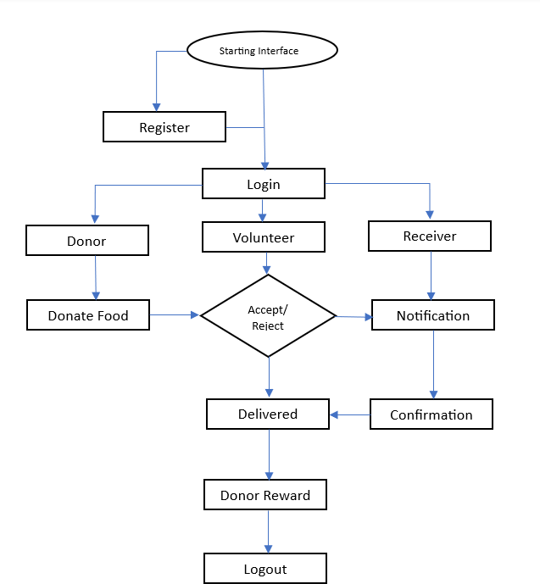

***Figure 5.1:*** *System Architecture of Connect-Care*

#### Over Client-Side Application (Flutter):

User interfaces developed using Flutter framework for seamless cross-platform compatibility. Implements features for user registration, authentication, donation posting, request submission, and community engagement. Utilizes Flutter plugins for integration with Google Maps APIs for location- based functionalities.

#### Server-Side Infrastructure (Supabase):

Backend services provided by Supabase, offering data storage, authentication, and real-time database functionality. PostgreSQL database used for secure storage of user data, donation information, and transaction records. Supabase APIs utilized for CRUD operations, real-time data synchronization, and user authentication.

#### Authentication and Authorization:

User authentication handled by Supabase, supporting email/password authentication and social login options. Role-based access control (RBAC) enforced to manage user permissions and access levels within the app.

#### Data Management:

Data stored securely in PostgreSQL database, with Supabase APIs facilitating CRUD operations and real-time data synchronization. Encryption and security measures applied to protect sensitive user information and transaction data.

#### Integration with Google Maps APIs:

Integration of Google Maps APIs within the Flutter application for location-based functionalities.

Utilizes Google Maps SDK for features such as displaying maps, geocoding, and route optimization for donation pickups and deliveries.

#### Scalability and Performance:

Designed to be scalable, with Supabase providing scalability and elasticity to accommodate increasing user demand and data volumes. Performance optimizations implemented to ensure fast response times and efficient data processing.

#### Monitoring and Maintenance:

Monitoring tools and dashboards utilized to track system performance, monitor usage metrics, and troubleshoot issues. Regular maintenance and updates conducted to ensure reliability, security, and performance of the app.

### Detailed Design

The internal logic of each and every unit of the modules defined in the system design is established during the detailed design phase. More information on the data structures and algorithmic design of each module is stated in this phase. The logic of each unit is often definedusing a high-level design description language, which is separate from the target language in which the programme will finally be implemented.

### Data Flow Diagram

A data flow diagram (DFD) illustrates the flow of data within a system, showing how information moves between processes, data stores, and external entities. Here's a high-level data flow diagram for the Connect Care app.

#### DFD Level-0

DFD Level 0 illustrates how data flows between external entities, processes, and data stores within the Connect Care app to facilitate food donation and assistance activities within local communities**.**

* + - * **Users (Donors, Volunteers, Recipients):** External entities representing individuals interacting with the Connect Care app. They include users who donate food (Donors), volunteer to help with food distribution (Volunteers), and recipients who receive food assistance (Recipients).

#### DFD Level-1

In the DFD Level 1 for the Connect Care app, each process identified in the Level 0 is further broken down into subprocesses, along with their associated data flows and data stores.

#### User Authentication:

* + **External Entities:** Users (Donors, Volunteers, Recipients)

#### Processes:

* + - **User Registration:** Users can register for an account by providing necessary detail such as username, email, and password. This information is stored in the User Data store.
    - **Authentication Request:** Users attempt to log into the system by providing their credentials. The system verifies the credentials against the User Data store.
    - **Authentication Response:** Upon successful authentication, the system grants access to the user's account and retrieves relevant user data from the User Data store.

#### Donation Management:

* + **External Entities:** Donors

#### Processes:

* + - **Donation Posting:** Donors post details of available food donations, including descriptions, quantities, and pickup/delivery locations. This information is stored in the Donation Information store.

#### Volunteer Management:

* + **External Entities:** Volunteers

#### Processes:

* + - **Volunteer Assignment:** Volunteers accept tasks for pickup and delivery of food donations. Assignments are recorded in the Transaction Records store, along with volunteer details.

#### Event Management:

* + **External Entities:** Community Events

#### Processes:

* + - **Event Posting:** External entities post community events related to food donation and assistance. Event details are stored in the Community Event Data store.
    - **Event Retrieval:** Users can view upcoming community events related to food donation. The system retrieves event information from the Community Event Data store and presents it to users.

In summary, the DFD provides a detailed breakdown of the processes identified, illustrating how data flows within each process to support food donation and assistance activities within the Connect Care app.

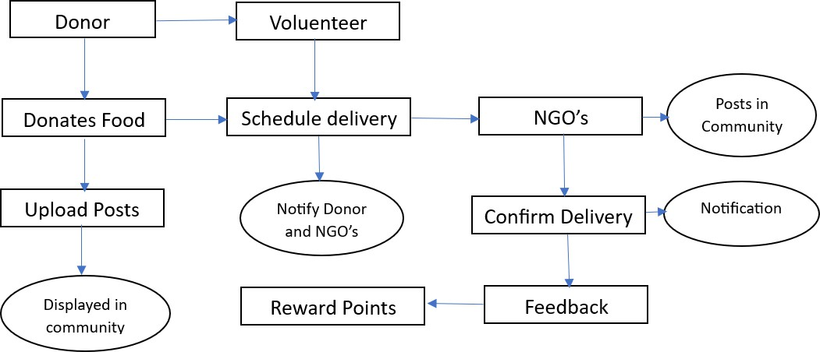

***Figure 5.3:*** *DFD Diagram for Connect Care*

### 5.2.1 Use Case Diagram of Connect Care -A Food Donation App

A use case diagram shows the way a user interacts with the system and shows the use case specifications. The many user types and the varied methods in which they interact with a system can be displayed in a case diagram of use.

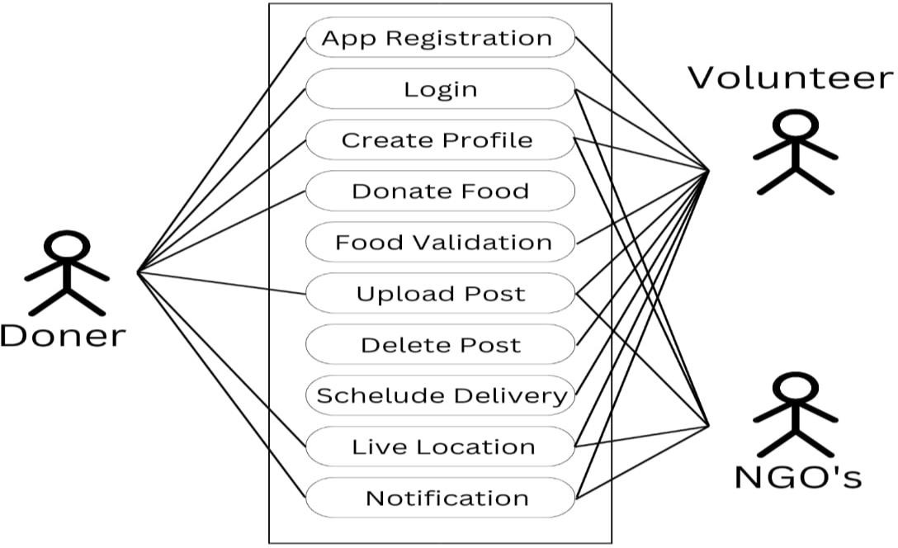

***Figure 5.4:*** *Use Case Diagram for Connect Care App*

Figure 5.4 shows the use case diagram of Connect Care -A Food Donation App. All Donor’s, Volunteer’s, Recipient’s functions and features are mapped here.

**Chapter 6**

# SYSTEM IMPLEMENTATION

**CHAPTER 6**

## SYSTEM IMPLEMENTATION

During the implementation of the Connect Care app, we encountered several challenges that required strategic solutions. Initially, setting up the development environment posed difficulties due to compatibility issues with different software tools and platforms. Additionally, integrating complex functionalities, such as real-time data updates and user authentication, proved to be challenging and required careful planning and testing. Ensuring seamless communication between the frontend and backend systems was another obstacle, particularly in managing data flow and maintaining data consistency. Moreover, incorporating third-party APIs, such as Google Maps for location-based services, presented challenges in terms of integration and configuration. Addressing scalability and performance issues during deployment was crucial to ensure the app could handle increasing user traffic and data volume effectively. Additionally, ensuring data security and compliance with privacy regulations posed significant concerns throughout the development process. Furthermore, managing user feedback and incorporating necessary changes and updates to meet evolving user requirements required continuous monitoring and iteration. Balancing feature development with resource constraints and project timelines was also a key challenge, requiring prioritization and efficient resource allocation. Overall, navigating these challenges required a collaborative approach, effective communication among team members, and agile project management practices to successfully implement the Connect Care app and deliver a high-quality solution that meets user needs and expectations.

### 6.1 Technology Stack Selection

In developing the Connect Care app, we meticulously chose the most suitable technologies to ensure a seamless implementation process. For frontend development, Flutter emerged as the optimal framework due to its ability to facilitate cross-platform mobile app development. With Flutter, we could write code once and deploy it across both iOS and Android platforms, saving valuable time and resources while ensuring a consistent user experience across devices.Supabase was selected for backend services, encompassing data storage, authentication, and real-time database functionality. Its robust feature set, including PostgreSQL database and authentication services, provided the necessary infrastructure to support the app's backend requirements.

Supabase's simplicity and ease of use further expedited development and deployment, empowering developers to focus on implementing core functionalities efficiently.To integrate location-based functionalities into the app, we utilized Google Maps APIs, which offered comprehensive tools and services for maps, geolocation, and routing functionalities. Leveraging Google Maps APIs enabled us to provide users with accurate location data, optimize delivery routes, and enhance the overall user experience. These technologies collectively contributed to the successful development of the Connect Care app, ensuring its effectiveness in facilitating food donation and assistance initiatives within local communities.

#### Development Environment Setup

Setting up the development environment for the Connect Care app was a crucial step in ensuring smooth and efficient development processes. We began by installing the necessary software tools required for frontend and backend development. This included installing the Flutter SDK, which served as the foundation for developing the app's frontend components. Additionally, we set up Android Studio or Visual Studio Code as our preferred IDEs for Flutter development, providing powerful tools and features to streamline the coding process.

For backend development, we created accounts and configured the Supabase environment to serve as the backend infrastructure for the Connect Care app. This involved setting up authentication settings, configuring database settings, and defining API routes for communication between the frontend and backend systems. The Supabase dashboard provided a user-friendly interface for managing backend services, making it easy to set up and customize according to our project requirements.

Ensuring compatibility and seamless workflow between different development environments was another essential aspect of the setup process. We configured the development environments to ensure that Flutter and Supabase worked harmoniously together, allowing for efficient data exchange and communication between the frontend and backend systems. This involved configuring API endpoints, handling authentication tokens, and testing data flow to ensure data integrity and security.

Overall, the development environment setup for the Connect Care app laid the foundation for successful development and deployment. By carefully configuring software tools, establishing backend infrastructure, and ensuring compatibility between different components, we created an environment conducive to rapid development and iteration. This enabled our development team to focus on implementing core functionalities and delivering a high-quality app that meets the needs of users and stakeholders effectively.

### Backend Development

Backend development for the Connect Care app played a pivotal role in creating a robust and scalable infrastructure to support its functionalities. We utilized Supabase as the backend platform due to its comprehensive features, including data storage, authentication, and real-time database functionality. Setting up Supabase involved creating a project, configuring authentication settings, and defining database schemas to store user data, donation information, transaction records, and community event data.

One of the primary tasks in backend development was defining the database schema to ensure efficient storage and retrieval of data. We designed tables to store user profiles, authentication credentials, and preferences, ensuring data integrity and security. Additionally, we created tables to store donation information, including details such as descriptions, quantities, and pickup/delivery locations, and transaction records to track the flow of food donations, volunteer assignments, and assistance requests.

Implementing backend services for user authentication was another crucial aspect of backend development. Supabase provided authentication services, allowing us to securely manage user registration, login, and authorization processes. We configured authentication settings to support various authentication methods, including email/password authentication and social login options, ensuring a seamless and secure authentication experience for users.

Furthermore, we developed APIs to facilitate communication between the frontend and backend systems, enabling CRUD operations and user authentication. These APIs handled requests from the frontend, processed data, and returned responses to update the user interface in real-time. We implemented security measures, such as access control and data validation, to protect against unauthorized access and ensure data integrity.

Throughout the backend development process, we prioritized scalability, performance, and security to create a reliable backend infrastructure that can handle increasing user traffic and data volume effectively. By leveraging Supabase's robust features and adhering to best practices in backend development, we were able to build a scalable and secure backend for the Connect Care app, ensuring its reliability and performance in supporting food donation and assistance initiatives within local communities.

### Integration and Testing

Integration and testing are pivotal stages in the development lifecycle of the Connect Care app, ensuring its functionality, reliability, and usability. Integration involves merging the frontend and backend components, ensuring seamless communication and interaction between them. This process involves integrating APIs, libraries, and services to enable data exchange and functionality across the app's various features.

During integration, we ensure that all components work harmoniously together, addressing any compatibility issues or conflicts that may arise. This involves rigorous testing of API endpoints, data flows, and user interfaces to verify that they meet the specified requirements and function as expected. Integration testing focuses on verifying the integration of individual components, ensuring that they work together as a cohesive system.

Once integration is complete, the app undergoes comprehensive testing to identify and resolve any bugs, errors, or issues. This includes various types of testing such as unit testing, which evaluates individual components or modules in isolation to ensure they perform as intended, and integration testing, which examines the interactions between different components to ensure they work together seamlessly.

User acceptance testing (UAT) is a crucial part of the testing process, involving real users testing the app to provide feedback on its usability, functionality, and overall user experience. UAT helps validate that the app meets the needs and expectations of its intended users, allowing for refinements and improvements to be made based on user feedback.

Additionally, compatibility testing ensures that the app functions correctly across different devices, operating systems, and screen sizes. This involves testing the app on a variety of devices and platforms to identify any issues related to device-specific behavior or platform- specific features.

Throughout the testing process, thorough documentation of test cases, test results, and any issues or defects encountered is maintained. This documentation helps track the progress of testing, identify areas for improvement, and ensure that all issues are addressed before deployment.

Ultimately, integration and testing are iterative processes that continue throughout the development lifecycle of the Connect Care app. By conducting comprehensive testing and validation, we ensure that the app meets the highest standards of quality, reliability, and usability, providing users with a seamless and satisfying experience.

### Deployment

Finalize all app features, conduct thorough testing, and resolve any outstanding issues or bugs. Prepare documentation such as user guides or release notes to assist users in navigating the app seamlessly. Configure servers or leverage cloud platforms to host the app's backend services. Provision necessary resources such as computing power and storage, and configure network settings for optimal performance and reliability. Generate executable files or packages for the app suitable for deployment on iOS and Android platforms. For Flutter-based apps, compile the code into native binaries tailored for each platform.

Distribute the app directly to users through alternative channels, such as email, file- sharing platforms, or direct download links accessible via websites or social media. Ensure users have easy access to the app files for installation. Configure the app for the production environment and conduct rigorous testing to verify proper functionality and performance. Test across different devices and platforms to ensure compatibility and usability.

Inform users about the app's availability and provide instructions for installation and usage. Utilize communication channels such as email newsletters, social media announcements, or messaging platforms to reach users effectively. Continuously monitor user feedback and app performance post-deployment. Address any issues or bugs promptly to ensure a seamless user experience. Make necessary optimizations to enhance app performance and usability over time.

By following these steps, the Connect Care app can be successfully deployed and accessed by users, enabling them to benefit from its features in supporting food donation and assistance initiatives within local communities.

### Maintenance and Updates

We're keeping a close eye on the app's performance, user feedback, and any potential issues that may arise. Through proactive monitoring, we can identify and address any issues promptly, ensuring a smooth user experience. If any bugs or technical issues are reported or discovered, our development team jumps into action to fix them as quickly as possible. We prioritize resolving bugs based on their severity and impact on users. We’re always looking for ways to improve the app and enhance the user experience. Based on user feedback and market trends, we're continuously adding new features and functionalities to meet the evolving needs of our users. To ensure optimal performance, we regularly optimize the app's code, database queries, and server configurations. By fine-tuning performance, we can deliver a faster, more responsive experience for users.

We actively engage with our user community to gather feedback, suggestions, and feature requests. By listening to our users and incorporating their input into our development roadmap, we ensure that the app continues to meet their needs and expectations. Overall, our approach to maintenance and updates is proactive, responsive, and user-centric. By staying vigilant, addressing issues promptly, and continuously improving the app, we're committed to delivering a seamless and rewarding experience for our users.

**Chapter 7**

# TESTING

**CHAPTER 7**

## TESTING

Software testing is that the accustomed method helps to assess the correctness, completeness, protection and consistency of the built computer applications. This includes the way the appliance or scheme is executed with the intention of finding errors. Quality isn't an objective reality; it's something useful to some person. Testing with that in mind can never fully establish the rightness of arbitrary computer software.

The first step in identifying program errors is testing. It is evident that the effectiveness of testing relies significantly on how well the test cases reveal program flaws. Testing is crucial because it is the stage where any remaining errors from previous processes must be detected, as the code is the only product that can be executed and have its actual behavior observed. A series of test cases are used to run the programme that needs to be verified, and the software's performance for the test cases is then examined to determine whether the programming is unmistakably executed. The first step in identifying problems in a system is to test it. Success of research systems in identifying errors is a critical aspect of the intervention.

### Testing Methodologies

The following are the testing methodologies:

* + 1. **Unit Testing:** It is the primary step of the test; the varied modules or components are individually tested, often dispensed by the coder himself. Unit testing for our supply chain management system involves verifying entity registration, supply chain control, and product tracking. We validate that owners can register suppliers, manufacturers, distributors, and retailers, and that only registered entities can manage the supply chain. Additionally, we ensure consumers can track products accurately using QR codes, reflecting real-time supply chain updates.
    2. **Integration Testing:** Most Test the interaction between different modules, such as blockchain nodes, smart contracts, and supply chain management interfaces. Ensure seamless data flow and proper functioning of integrated components.
    3. **System Testing:** Here Evaluate the entire system’s performance, including the blockchain network and supply chain management application. Ensure the system meets specified requirements and functions correctly under various conditions.
    4. **Acceptance Testing:** It's It is conducted using real client data to showcase satisfactory software performance, testing against specifications to ensure meeting business requirements and user expectations.

### Testing Criteria

|  |  |  |  |  |
| --- | --- | --- | --- | --- |
|  | Test Cases | Expected Output | Observed Output | Result |
| 1 | Register Raw Material Supplier | Supplier successfully added to blockchain with unique identifier | As expected | Pass |
| 2 | Register Manufacturer | Manufacturer registered and recorded on blockchain with unique ID | As expected | Pass |
| 3 | Register Distributor | Distributor registration completed, recorded on blockchain | As expected | Pass |
| 4 | Register Retailer | Retailer registration successful, reflected on blockchain | As expected | Pass |
| 5 | Manage Supply Chain by Registered Entities | Actions by registered entities recorded accurately on blockchain. | As expected | Pass |
| 6 | Prevent Unauthorized Access | Unauthorized attempts rejected, system logs unauthorized access. | As expected | Pass |
| 7 | Track Product Using QR Code | QR code scan displays accurate product journey and status. | As expected | Pass |
| 8 | Verify Product Information Accuracy | Product tracking interface shows up-to-date, accurate information | As expected | Pass |

**Table 7.2.1:** Test cases for registration screen

**Chapter 8**

# RESULT AND

**EXECUTIONS**

**CHAPTER 8**

## RESULT AND EXECUTIONS

### 8.1 Donor Registration

The Figure 8.1 shows the Donor Registration of the application. The donor registration page serves as the gateway for individuals who wish to contribute to the Connect Care Food Donation App by listing surplus food items for donation. This screenshot showcases the user-friendly registration interface, where donors can easily create an account to begin their journey of making a positive impact in their community.

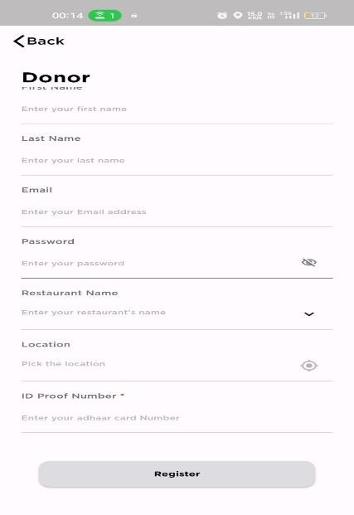

***Figure 8.1*** *Donor Registration Page*

### 8.2 Volunteer Registration

The Figure 8.2 shows Volunteer Registration of the application. The volunteer registration page is a vital component of the Connect Care Food Donation App, designed to onboard individuals eager to lend their support in facilitating food donation initiatives. This screenshot highlights the intuitive registration process, empowering volunteers to sign up and contribute their time and effort towards the noble cause of alleviating food insecurity within their community.

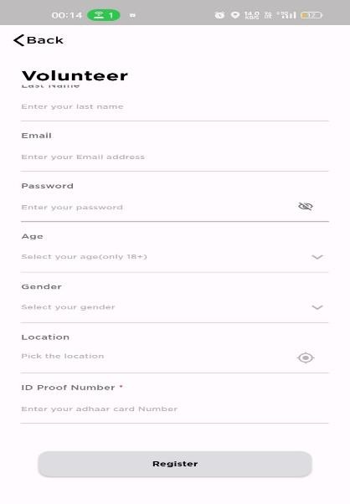

***Figure 8.2:*** *Volunteer Registration Page*

### 8.3 Login Page

Figure 8.3 shows Login Page of the application. The login page for recipients, donors, and volunteers is a central access point within the Connect Care Food Donation App, enabling registered users to securely access their accounts and engage with the platform's features. This screenshot showcases the user-friendly login interface, where users can enter their credentials to gain entry and participate in food donation and assistance activities tailored to their respective roles.

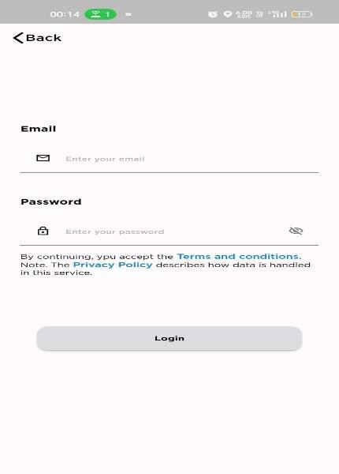

***Figure 8.3:*** *Upload page*

### 8.1 NGO List Page

Figure 8.4 shows the Donor NGO list page. The Donator NGO list page is a pivotal feature of the Connect Care Food Donation App, providing a comprehensive directory of registered non- governmental organizations (NGOs) that actively participate in food donation initiatives. This screenshot highlights the user-friendly interface, where donors can browse through the list of NGOs and explore their respective profiles.

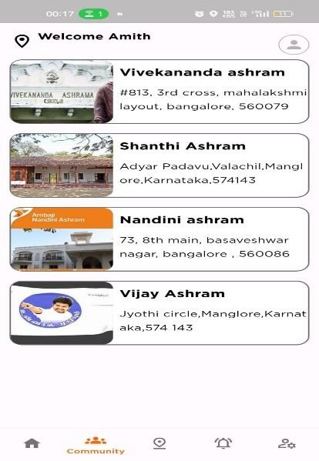

***Figure 8.4:*** *NGO List Page.*

### Community

Figure 8.5 shows the Community page of application. The Community page serves as a dynamic hub within the Connect Care Food Donation App, fostering a sense of community and collaboration among all app users. This screenshot showcases a vibrant feed where recipients, donors, and volunteers can share posts, updates, and announcements related to food donation initiatives. Users can explore various posts uploaded by their peers, each accompanied by a description detailing the nature of the contribution, whether it be a donation listing, volunteer opportunity, or recipient request.

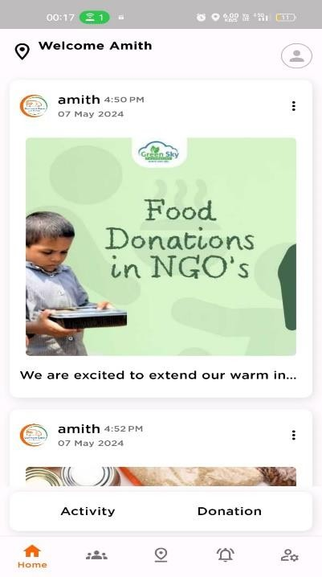

***Figure 8.5:*** *Community Page.*

### Profile Page

Figure 8.6 shows the Profile page of application. This screenshot showcases the user's profile, prominently displaying essential details such as name, email address, and phone number.

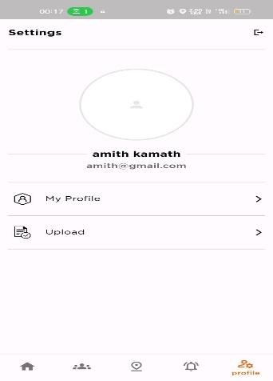

***Figure 8.6:*** *Profile Page*

### 

### Post Upload Page

Figure 8.7 shows post upload page. The Post Upload page is a vital component of the Connect Care Food Donation App, empowering users, including donors, volunteers, and recipients, to contribute to the app's community-driven initiatives. This screenshot highlights the intuitive interface, where users can easily upload posts related to community activities, donation listings, volunteer opportunities, or recipient requests. Additionally, users can provide detailed descriptions for their posts, ensuring clarity and relevance for other app users. By facilitating seamless communication and collaboration, the Post Upload page fosters a sense of unity and collective action towards addressing food insecurity within the community.

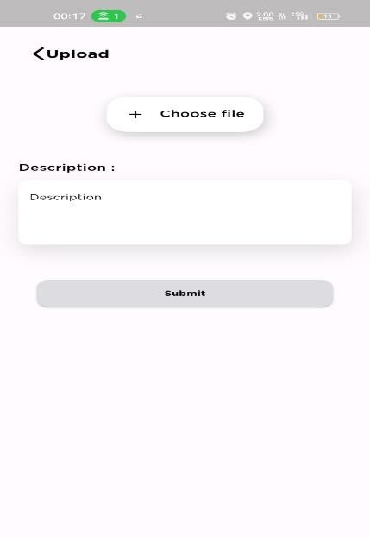

***Figure 8.7:*** *Post Upload Page.*

# CONCLUSION AND

**FUTURE SCOPE**

Connect Care -A Food Donation App Conclusion and Future Scope

## CONCLUSION AND FUTURE SCOPE

The Connect Care Food Donation App represents a significant step forward in addressing food waste and insecurity within communities. By leveraging mobile technology and community engagement, the app has successfully connected donors with surplus food items to recipients in need, fostering a sense of solidarity and collective action. Through intuitive features such as donation listing, request submission, and volunteer coordination, Connect Care has streamlined the process of food donation, making it more accessible and efficient for all stakeholders involved. Additionally, the app prioritizes user privacy and security, ensuring that personal information is protected and confidentiality is maintained throughout the donation process. Overall, Connect Care has demonstrated its potential to make a tangible impact on reducing food waste, alleviating hunger, and promoting social welfare within local communities.

Department of CSE, SIT, Mangaluru Page 37

# REFERENCES

## REFERENCES

[**1**]. “Sharing Food With Foodlifesavr Smartphone”, published in: 2022 Second International Conference on Artificial Intelligence and Smart Energy (ICAIS) by Arfandi Andres, Edwin Setiawan Tanjaya, Ghaniyardi, Joshua Christian Sandhi, Harco Leslie Hendric Spits Warnars.

[**2**]. Hassan Hajjdiab , Wedad Ahmed , Hadeel A. Tabaza , Ayesha Anzer “A Food Waste Reduction Mobile Application “ Published in: 2018 6th International Conference on Future Internet of Things and Cloud Workshops (FiCloudW).

[**3**]. Christina Varghese, Drashti Pathak and Aparna S. Varde “SeVa: A Food Donation App For Smart Living”.

[**4**]. Katakam Sudheepa, Padmashetti Rashmitha, P. Sardar Maran “Food Wastage Management Application Using Android Studio” , published in : 2023 2nd International Conference on Applied Artificial Intelligence and Computing (ICAAIC).

[**5**]. John Amiel R. Morilla,Fhillip Carl Bagsic, Mark Kenneth Dela Cruz, Carl Daniel A. Patio, Emeliza R. Yabut “Foodernity: A Mobile And Web Application For Food Sharing” ,Published in: 2021 1st International Conference in Information and Computing Research (iCORE).

[**6**]. M.D.C.J Gunawardane, H.A.N Pushpakumara, E.N.M.R.L Navarathne, Shashika Lokuliyana,

K.T.I. Kelaniyage, Narmadha Gamage “Zero Food Waste: Food wastage sustaining mobile application” published in: 2019 International Conference on Advancements in Computing (ICAC).