Use Case Name: Enter Tax-Exempt ID

Primary Actor: Cashier, Manager

Use Case Story: This use case enables the use case to enter Tax-Exempt ID and help non-profit business customers remove the tax associated with the purchase.

Trigger: Cashier clicking ‘Enter Tax-Exempt ID’ hyperlink

Pre-Condition: None

Post-Condition: System removes the tax associated with the purchase

Primary Flow:
Title: Cashier is able to remove the Tax associated with the purchase.
Actor Action | System Response
- Cashier clicks ‘Enter Tax-Exempt ID’  (Refer Wireframe 1) | - System displays a pop-up for the Cashier to enter Tax-Exempt ID (refer Wireframe 2)
- Cashier enters the Tax-ID
- If the Cashier decides to click ‘Submit’ button, go to next step,
Else,
If the cashier decides to click ‘Cancel’ button, go to Exception Flow 1 (EF1)
- Cashier clicks ‘Submit’ button | - System validates the Tax-ID format.  If valid, go to next step,  Else,  If invalid, go to Alternate Flow 1 (AF1)
- System validates if the entered Tax-ID is a Tax-Exempt ID.
If a Tax-Exempt ID, go to next step,
Else,
If not a Tax-Exempt ID, go to Exception Flow 2 (EF2)
- System checks the value of tax-exempt amount.
If the amount is <=50, go to next step,
Else,
If the amount is > $50, go to Alternate Flow 2 (AF2)
- System closes
- the pop-up
- updates the Tax to $0.00
- updates the grand total
- Hides ‘Enter Tax-Exempt ID’ link
(Refer Wireframe 3)

Alternate Flow 1 (AF1):
Title: Invalid Tax-ID Format
Actor Action | System Response
- System displays the following error message: Invalid Tax-ID format
(Refer Wireframe 4)
- Go to step 3 of PF.

Alternate Flow 2 (AF2):
Title: Tax amount >$50
Actor Action | System Response
- System displays the pop-up for Manager Approval
(Refer Wireframe 5)
- Manager enters the username and pin
- If the Manager decides to click ‘Submit’ button, go to next step,
Else,
If the Manager decides to click ‘Cancel’ button, go to Exception Flow 1 (EF1)
- Manager clicks ‘Submit’ button | - System validates the User ID and Pin.  If valid, go to next step,  Else,  If invalid, go to Alternate Flow 3 (AF3)
 | - Go to step 9 of PF

Alternate Flow 3 (AF3):
Title: Invalid Manager User ID/Pin
Actor Action | System Response
- System displays the following error message: Invalid User ID/Pin
(Refer Wireframe 6)
- Go to step 2 of Alternate Flow 2 (AF2)

Exception Flow 1 (EF1):
Title: Invalid Manager User ID/Pin
Actor Action | System Response
- Cashier/Manager clicks ‘Cancel’ button | - System closes the pop-up and the tax value remains the same.

Exception Flow 2 (EF2):
Title: Tax ID Entered is Not Tax Exempt
Actor Action | System Response
- System does the following:
- Displays the following error message: Entered Tax ID is NOT tax-Exempt
- Hides ‘Submit’ button
(Refer Wireframe 7)
2. Cashier clicks ‘Cancel’ button | 3. System closes the pop-up and the tax value remains the same.

Wireframe 1:
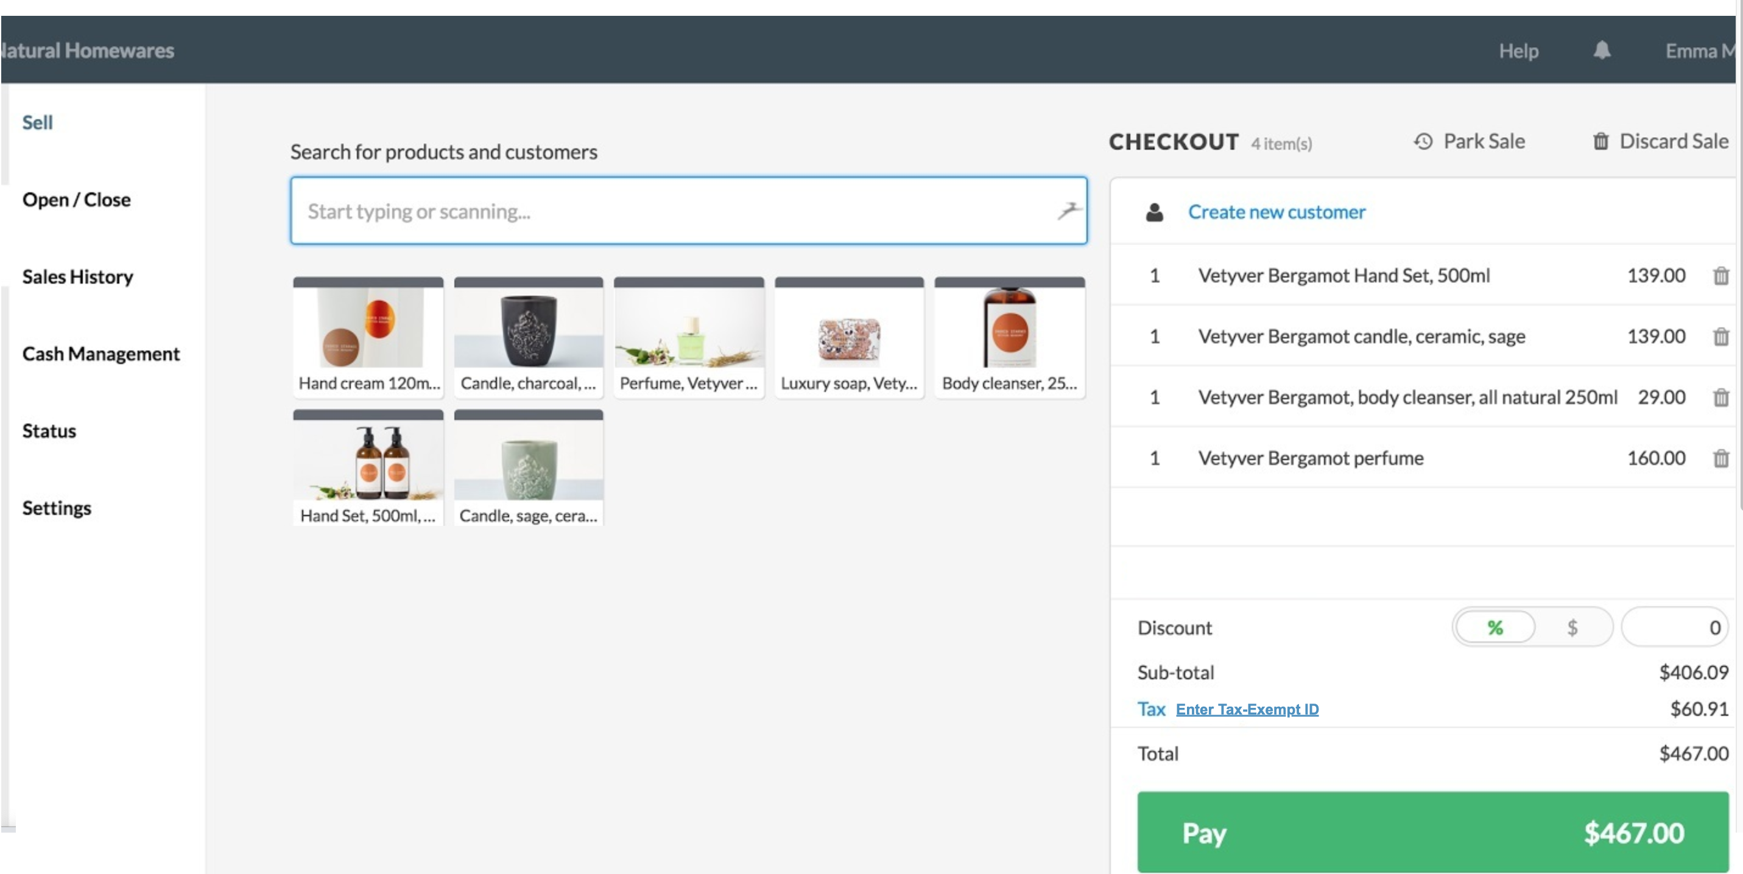

Field Name | Field Type | Required? | Min. Char | Max Char | Notes
Enter Tax-Exempt ID | Hyperlink | No | N/A | N/A | On click, displays the pop-up for the cashier to enter Tax-Exempt ID

Wireframe 2:
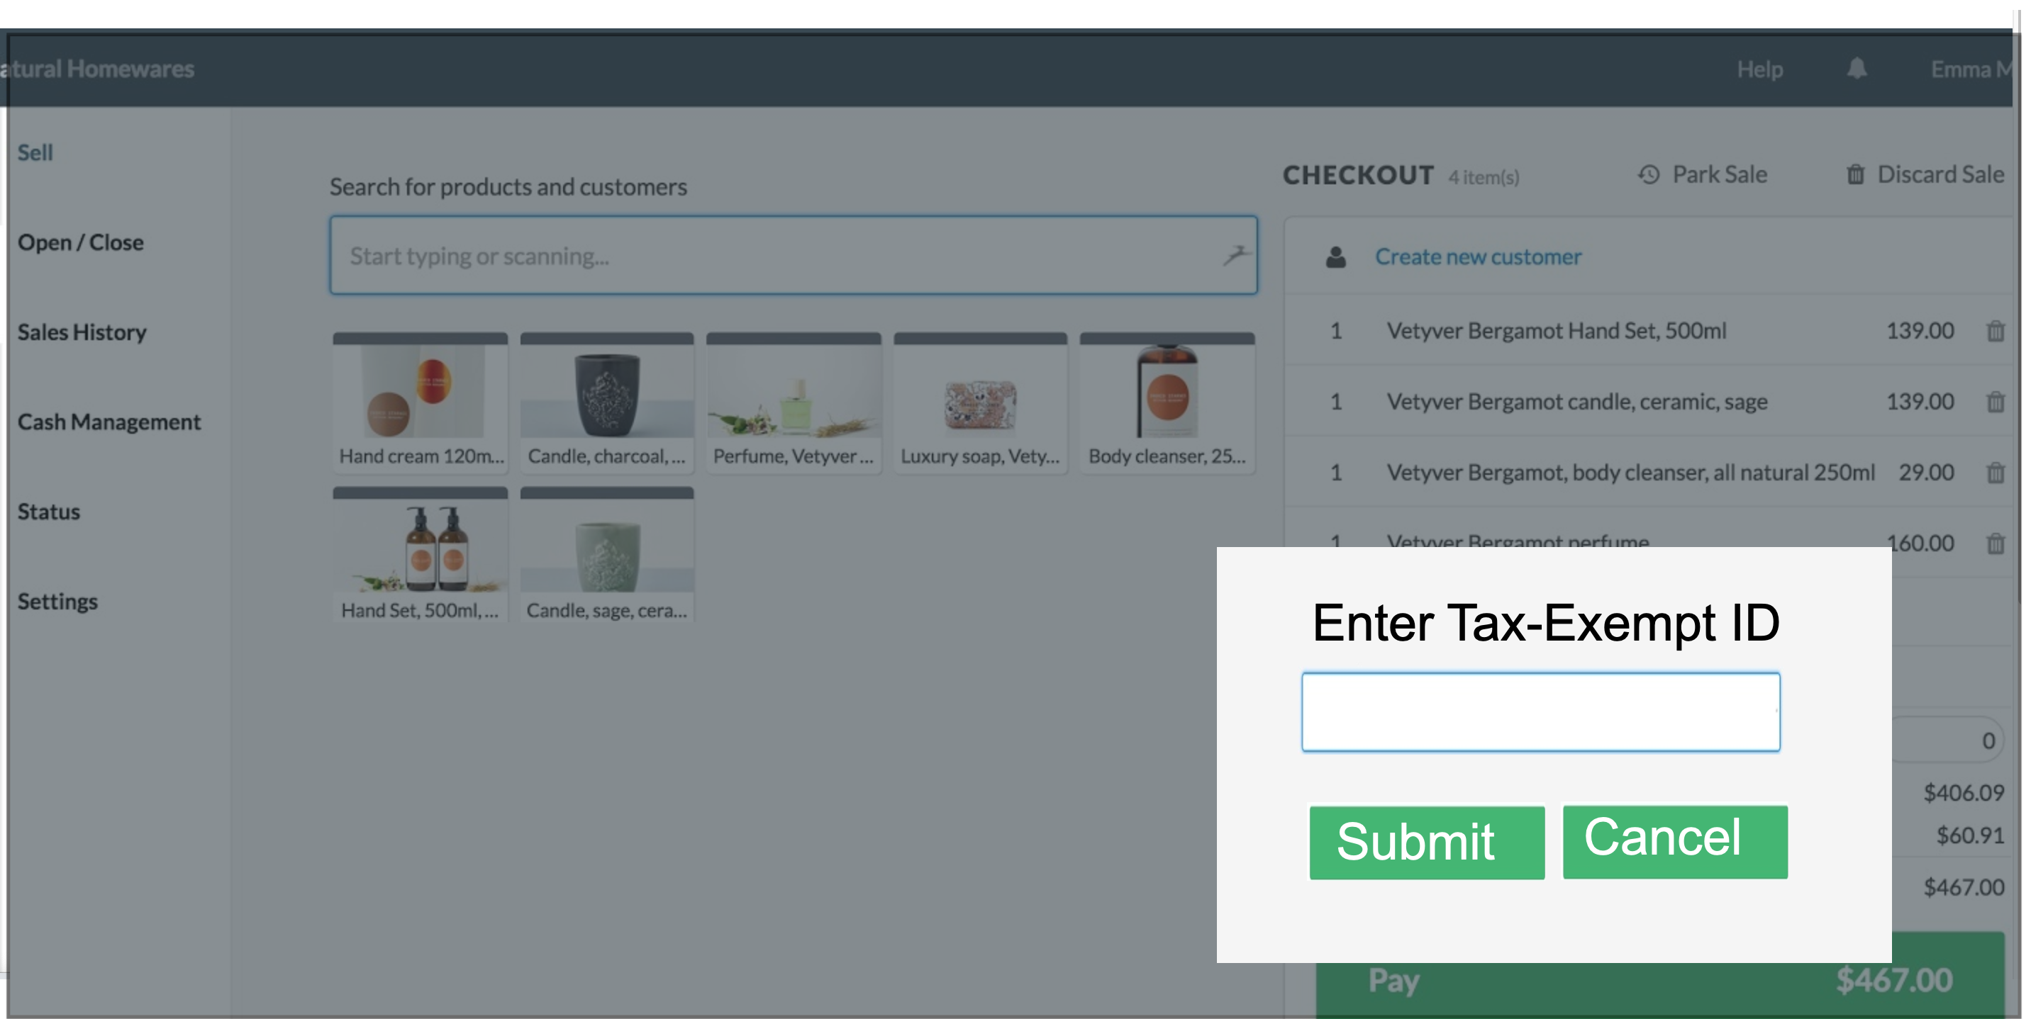

Field Name | Field Type | Data Type | Required? | Min. Char | Max Char | Notes
Enter Tax-Exempt ID | Text Box | Numeric | Yes | 9 | 9
Submit | Button | N/A | N/A | N/A | N/A | On click, if validations pass:  - Displays manager approval pop up if Tax amount >50, closes the pop-up
Cancel | Button | N/A | N/A | N/A | N/A | Closes the pop-up

Wireframe 3:
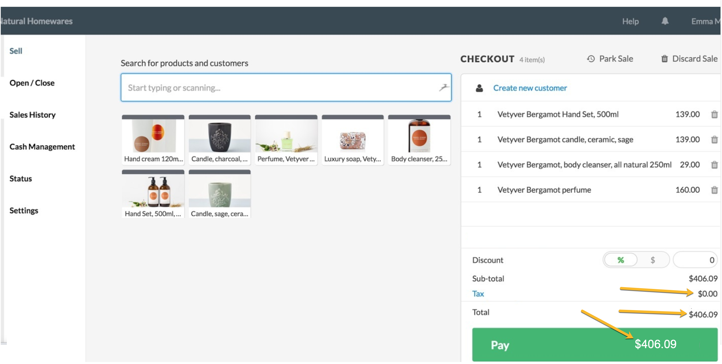

Wireframe 4:
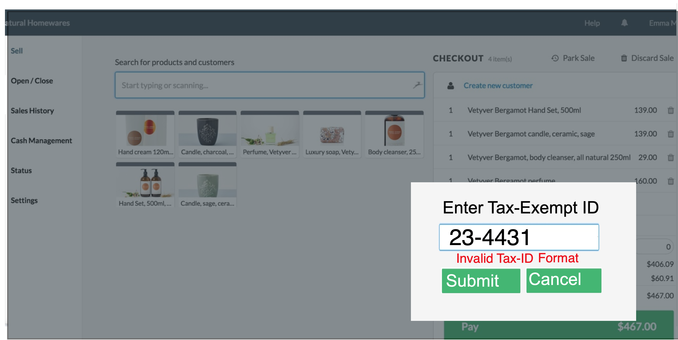

Wireframe 5:
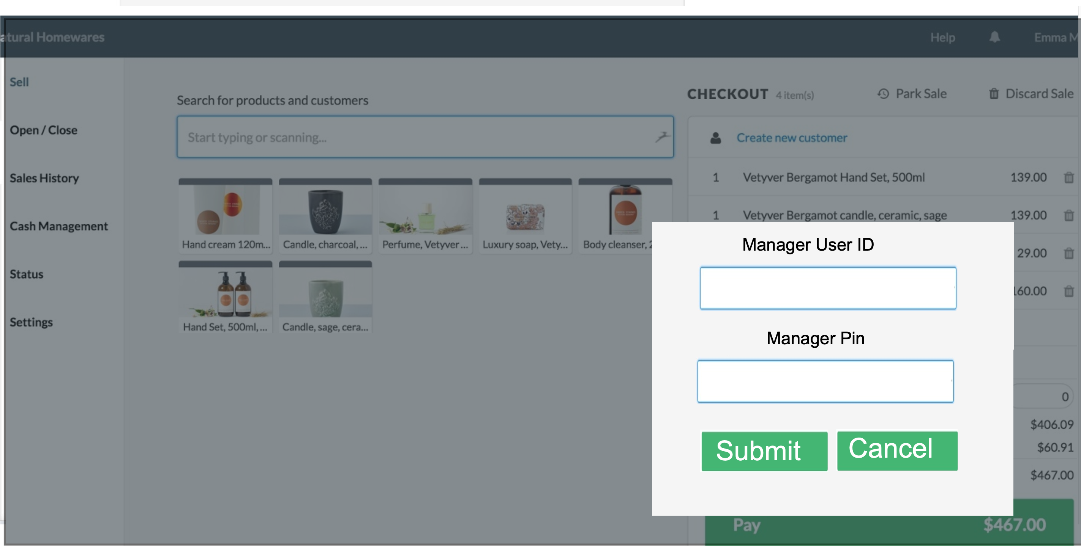

Field Name | Field Type | Data Type | Required? | Min. Char | Max Char | Notes
Manager User ID | Text Box | Alphanumeric | Yes | 5 | 5
Manager Pin | Text Box | Numeric | Yes | 4 | 4 | Encrypt the entered data
Submit | Button | N/A | N/A | N/A | N/A | On click, if validations pass, close the pop else display error message
Cancel | Button | N/A | N/A | N/A | N/A | Closes the pop-up

Wireframe 6:
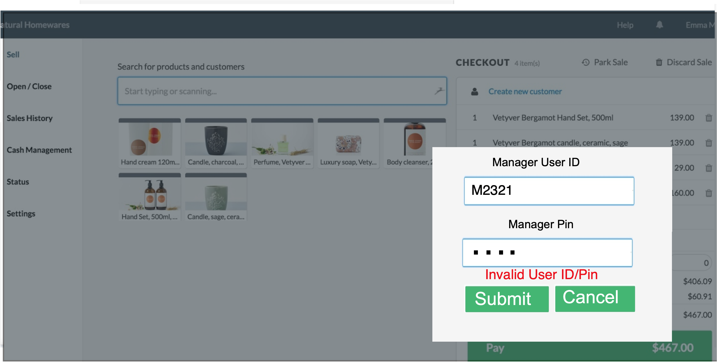

Wireframe 7:
