

Computer Graphics
LAB FILE

Name- Ritik Agarwal
Branch- B.Tech CSE – G&G
SAPID- 500061629
Roll no. – R142217023
Batch - 2017-21
Submitted to – Mr. Pankaj Badhoni
Experiment 1
Aim: To create a triangle with green color
Program:
#include <GL/freeglut.h>
void bitmap_char(int x, int y, char *string, void *font)
{
int len, i;
glRasterPos2f(x, y);
len = (int) strlen(string);
for (i = 0; i < len; i++) {
glutBitmapCharacter(font, string[i]);
}
}
void display_char()
{
glColor3f(1.0,0,0);
bitmap_char(0.5,0.5 , "-:RITIK AGARWAL",GLUT_BITMAP_TIMES_ROMAN_24);

}
void display()
{
glClear(GL_COLOR_BUFFER_BIT);
display_char();
glColor3f(0,1,0);
glBegin(GL_TRIANGLES);
glVertex2f(-0.5,-0.5);
glVertex2f(0.5,-0.5);
glVertex2f(0,0.5);
glEnd();
glFlush();
}
int main(int argc,char** argv)
{
glutInit(&argc,argv);
glutInitDisplayMode(GLUT_SINGLE|GLUT_RGB);
glutInitWindowSize(500,500);
glutInitWindowPosition(200,200);
glutCreateWindow("Green Triangle");
glutDisplayFunc(display);
glutMainLoop();
return 0;
}

Output:
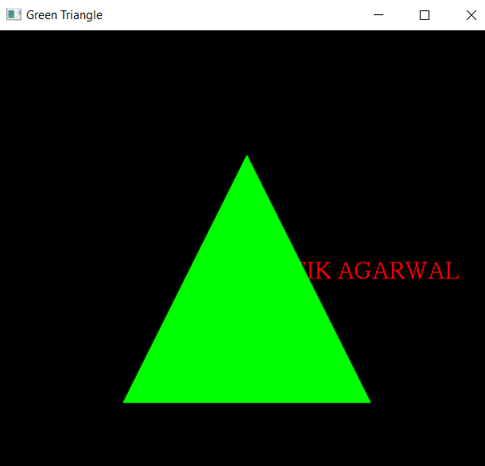

Experiment 2
Aim: To create a hut using OpenGL.
Program:
#include <GL/glut.h>
#include<stdio.h>
#include<math.h>
void display()
{
glClear(GL_COLOR_BUFFER_BIT);

float x1,y1,x2,y2;
float angle;
// double radius= 0.2;
double r = 0.15;

x1 = 0.8;
y1 = 0.8;
glColor4f(0.9,0.5,0.0,1.0);

glBegin(GL_TRIANGLE_FAN);
glVertex2f(x1,y1);
for(angle=1.0f; angle<361.0f ; angle+= 0.2)
{
x2 = x1+sin(angle)*r;
y2 = y1+cos(angle)*r;
glVertex2f(x2,y2);
}
glEnd();
// Grass
{glColor4f(0.0,1.0,0.0,0.0);
glBegin(GL_POLYGON);

glVertex2f(-0.8,-0.6);

glVertex2f(-1.0,-0.6);

glVertex2f(-1.0,-1.0);

glVertex2f(1.0,-1.0);
glVertex2f(1.0,-0.6);
glVertex2f(-0.8,-0.6);
glEnd();
}
// Ground gate wall
{glColor4f(1.0,1.0,0.0,0.0);
glBegin(GL_QUADS);

glVertex2f(-0.2,-0.8);

glVertex2f(0.2,-0.8);

glVertex2f(0.2,-0.2);

glVertex2f(-0.2,-0.2);
glEnd();
}
{ // Ground wall left
glColor4f(0.5,0.3,0.0,1.0);
glBegin(GL_QUADS);
glVertex2f(-0.8,-0.8);
glVertex2f(-0.2,-0.8);
glVertex2f(-0.2,-0.2);
glVertex2f(-0.8,-0.2);
glEnd();
}
{ // Ground wall right
glColor4f(0.5,0.3,0.0,1.0);
glBegin(GL_QUADS);
glVertex2f(0.2,-0.8);
glVertex2f(0.8,-0.8);
glVertex2f(0.8,-0.2);

glVertex2f(0.2,-0.2);
glEnd();
}
{// 1st floor wall
glColor4f(0.5,0.3,0.0,1.0);
glBegin(GL_QUADS);

glVertex2f(0.2,0.0);

glVertex2f(0.2,0.5);

glVertex2f(-0.7,0.5);

glVertex2f(-0.7,0.0);
glEnd();
}

{
glColor4f(0.0,1.0,0.0,1.0);
glBegin(GL_QUADS);

glVertex2f(0.2,-0.2);

glVertex2f(1.0,-0.2);

glVertex2f(0.7,0.0);

glVertex2f(0.06,0.0);
glEnd();
}
{
glColor4f(0.0,1.0,0.0,1.0);
glBegin(GL_QUADS);

glVertex2f(-0.2,-0.2);

glVertex2f(-1.0,-0.2);

glVertex2f(-0.7,0.0);

glVertex2f(-0.06,0.0);
glEnd();
}
{// lower gate triangle
glColor4f(0.3,0.7,0.1,1.0);
glBegin(GL_TRIANGLES);

glVertex2f(-0.2,-0.2);

glVertex2f(0.2,-0.2);

glVertex2f(0.0,0.1);
glEnd();
}
// UPPER QUAD WITHOUT WINDOW
{glColor4f(1.0,1.0,0.0,1.0);
glBegin(GL_QUADS);

glVertex2f(0.2,0.0);

glVertex2f(0.7,0.0);

glVertex2f(0.7,0.5);

glVertex2f(0.2,0.5);
glEnd();
glColor4f(0.0,0.0,0.0,1.0);
glBegin(GL_LINES);

glVertex2f(0.45,0.0);

glVertex2f(0.45,0.5);
glEnd();
}
{
// MOST UPPER QUAD
glColor4f(0.0,1.0,0.0,1.0);
glBegin(GL_QUADS);

glVertex2f(0.2,0.5);

glVertex2f(0.4,0.7);

glVertex2f(0.0,1.0);

glVertex2f(-0.9,0.5);
glEnd();
}
{ //UPPER TRIANGLE
glColor4f(0.6,0.3,0.2,1.0);
glBegin(GL_TRIANGLES);

glVertex2f(0.2,0.5);

glVertex2f(0.7,0.5);

glVertex2f(0.45,0.8);

//glVertex2f(0.0,0.6);
glEnd();
}
{ glColor4f(0.5,0.3,0.0,1.0);
glBegin(GL_QUADS);

glVertex2f(0.0,-0.3);

glVertex2f(0.15,-0.3);

glVertex2f(0.15,-0.7);

glVertex2f(0.0,-0.7);
glEnd();
}
// Window RIGHT
{
glColor4f(1.0,1.0,1.0,1.0);
glBegin(GL_QUADS);

glVertex2f(0.3,-0.3);

glVertex2f(0.7,-0.3);

glVertex2f(0.7,-0.7);

glVertex2f(0.3,-0.7);
glEnd();
glColor4f(0.0,0.0,0.0,1.0);
glBegin(GL_LINES);

glVertex2f(0.3,-0.4);

glVertex2f(0.7,-0.4);

glVertex2f(0.3,-0.5);

glVertex2f(0.7,-0.5);

glVertex2f(0.3,-0.6);

glVertex2f(0.7,-0.6);

glVertex2f(0.4,-0.3);

glVertex2f(0.4,-0.7);

glVertex2f(0.5,-0.3);

glVertex2f(0.5,-0.7);

glVertex2f(0.6,-0.3);

glVertex2f(0.6,-0.7);
glEnd();
}
//Window LEFT
{
glColor4f(1.0,1.0,1.0,1.0);
glBegin(GL_QUADS);
glVertex2f(-0.3,-0.3);
glVertex2f(-0.7,-0.3);
glVertex2f(-0.7,-0.7);
glVertex2f(-0.3,-0.7);
glEnd();
glColor4f(0.0,0.0,0.0,1.0);
glBegin(GL_LINES);
glVertex2f(-0.3,-0.4);
glVertex2f(-0.7,-0.4);
glVertex2f(-0.3,-0.5);
glVertex2f(-0.7,-0.5);
glVertex2f(-0.3,-0.6);
glVertex2f(-0.7,-0.6);
glVertex2f(-0.4,-0.3);
glVertex2f(-0.4,-0.7);
glVertex2f(-0.5,-0.3);
glVertex2f(-0.5,-0.7);
glVertex2f(-0.6,-0.3);
glVertex2f(-0.6,-0.7);
glEnd();
}
//wINDOW uPPER
{
glColor4f(1.0,1.0,1.0,1.0);
glBegin(GL_QUADS);
glVertex2f(-0.1,0.1);
glVertex2f(-0.4,0.1);
glVertex2f(-0.4,0.4);
glVertex2f(-0.1,0.4);
glEnd();
glColor4f(0.0,0.0,0.0,1.0);
glBegin(GL_LINES);
glVertex2f(-0.2,0.1);
glVertex2f(-0.2,0.4);
glVertex2f(-0.3,0.1);
glVertex2f(-0.3,0.4);
glVertex2f(-0.1,0.2);
glVertex2f(-0.4,0.2);
glVertex2f(-0.1,0.3);
glVertex2f(-0.4,0.3);
glEnd();
}

glFlush();

}

void init()
{
//glClear(GL_COLOR_BUFFER_BIT);
glClearColor(0.0,1.0,1.0,1.0);
//glColor4f(1.0,0.0,0.0,0.0);
}

int main(int argc, char **argv)
{
glutInit(&argc, argv);
glutInitDisplayMode(GLUT_SINGLE | GLUT_RGB);
glutInitWindowPosition(100,100);
glutInitWindowSize(800,800);
glutCreateWindow("Hut");
init();
glutDisplayFunc(display);

glutMainLoop();
return 0;
}

Output:
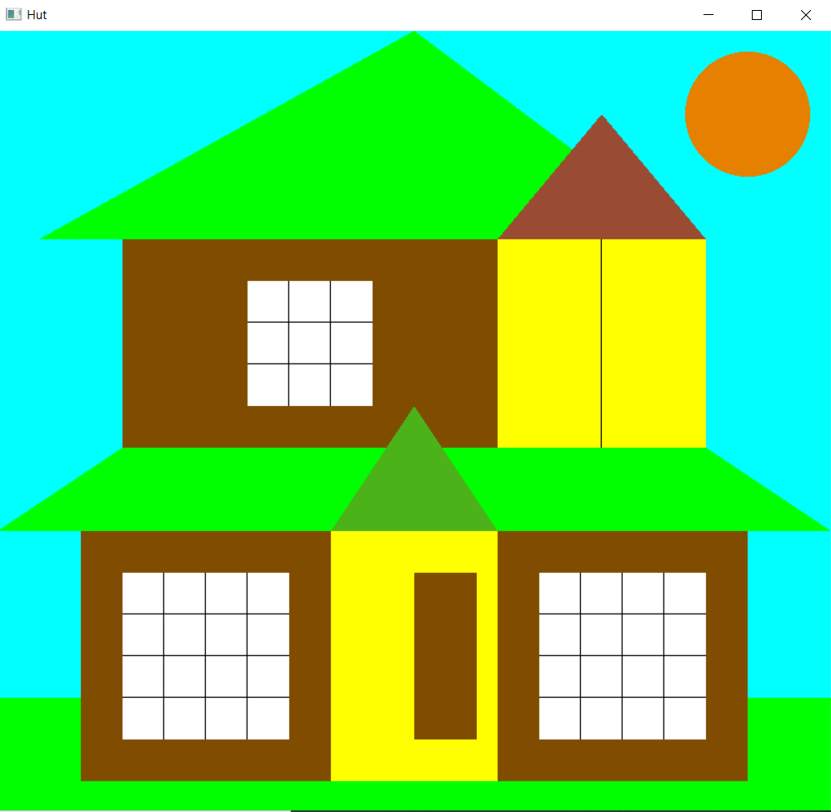

Experiment 3
Aim: To create an Animation using OpenGL.
Program:

#include <GL/glut.h>
#include<stdio.h>
#include<math.h>
int carStatus = 1;
float carX = -800;
float carY = 0;

void DrawCar();

void display()
{
glPushMatrix();
glClear(GL_COLOR_BUFFER_BIT);

//Upper Rectangle
glBegin(GL_QUADS);
glColor4f(0.0,1.0,1.0,1.0);
glVertex2f(-800.0,400.0);
glVertex2f(800.0,400.0);
glVertex2f(800.0,800.0);
glVertex2f(-800.0,800.0);
glEnd();

//Hut 1

glBegin(GL_QUADS);
glColor4f(0.5,0.3,0.0,1.0);
glVertex2f(-50.0,100.0);
glVertex2f(50.0,100.0);
glVertex2f(50.0,180.0);
glVertex2f(-50.0,180.0);
glEnd();

glBegin(GL_QUADS);
glColor4f(0.5,0.0,0.0,1.0);
glVertex2f(50.0,100.0);
glVertex2f(200.0,100.0);
glVertex2f(200.0,180.0);
glVertex2f(50.0,180.0);
glEnd();

glBegin(GL_QUADS);
glColor4f(0.5,0.0,1.0,1.0);
glVertex2f(50.0,180.0);
glVertex2f(200.0,180.0);
glVertex2f(150.0,300.0);
glVertex2f(0.0,300.0);
glEnd();

glBegin(GL_TRIANGLES);
glColor4f(0.5,0.3,0.0,1.0);
glVertex2f(-50.0,180.0);
glVertex2f(50.0,180.0);
glVertex2f(0.0,300.0);
glEnd();

//Hut 2
glBegin(GL_QUADS);
glColor4f(0.5,0.3,0.0,1.0);
glVertex2f(-750.0,200.0);
glVertex2f(-700.0,200.0);
glVertex2f(-700.0,275.0);
glVertex2f(-750.0,275.0);
glEnd();

glBegin(GL_QUADS);
glColor4f(0.5,0.0,0.0,1.0);
glVertex2f(-700.0,200.0);
glVertex2f(-600.0,200.0);
glVertex2f(-600.0,275.0);
glVertex2f(-700.0,275.0);
glEnd();

glBegin(GL_QUADS);
glColor4f(0.5,0.0,1.0,1.0);
glVertex2f(-700.0,275.0);
glVertex2f(-600.0,275.0);
glVertex2f(-625.0,300.0);
glVertex2f(-725.0,300.0);
glEnd();

glBegin(GL_TRIANGLES);
glColor4f(0.5,0.3,0.0,1.0);
glVertex2f(-700.0,275.0);
glVertex2f(-725.0,300.0);
glVertex2f(-750.0,275.0);
glEnd();

//Hut 3
glBegin(GL_QUADS);
glColor4f(0.5,0.3,0.0,1.0);
glVertex2f(-650.0,-750.0);
glVertex2f(-550.0,-750.0);
glVertex2f(-550.0,-500.0);
glVertex2f(-650.0,-500.0);
glEnd();

glBegin(GL_QUADS);
glColor4f(0.5,0.0,0.0,1.0);
glVertex2f(-550.0,-750.0);
glVertex2f(-400.0,-750.0);
glVertex2f(-400.0,-500.0);
glVertex2f(-550.0,-500.0);
glEnd();

glBegin(GL_QUADS);
glColor4f(0.5,0.0,1.0,1.0);
glVertex2f(-550.0,-500.0);
glVertex2f(-400.0,-500.0);
glVertex2f(-450.0,-350.0);
glVertex2f(-600.0,-350.0);
glEnd();

glBegin(GL_TRIANGLES);
glColor4f(0.5,0.3,0.0,1.0);
glVertex2f(-650.0,-500.0);
glVertex2f(-550.0,-500.0);
glVertex2f(-600.0,-350.0);
glEnd();

{ //Sun
float x1,y1,x2,y2;
float angle;
double r = 100.0;
x1 = -430.0;
y1 = 600.0;
glColor4f(0.9,0.5,0.0,1.0);
glBegin(GL_TRIANGLE_FAN);
glVertex2f(x1,y1);
for(angle=1.0f; angle<361.0f ; angle+= 0.2)
{
x2 = x1+sin(angle)*r;
y2 = y1+cos(angle)*r;
glVertex2f(x2,y2);
}
glEnd();

}

// Mountains

glBegin(GL_TRIANGLES);
glColor4f(0.0,1.0,0.0,1.0);
glVertex2f(-800.0,400.0);
glVertex2f(-400.0,400.0);
glVertex2f(-600.0,700.0);
glEnd();

glBegin(GL_QUADS);
glColor4f(0.0,1.0,0.0,1.0);
glVertex2f(-400.0,400.0);
glVertex2f(0.0,400.0);
glVertex2f(-200.0,700.0);
glVertex2f(-450.0,450.0);
glEnd();

glBegin(GL_QUADS);
glColor4f(0.0,1.0,0.0,1.0);
glVertex2f(0.0,400.0);
glVertex2f(400.0,400.0);
glVertex2f(200.0,700.0);
glVertex2f(-50.0,450.0);
glEnd();

glBegin(GL_QUADS);
glColor4f(0.0,1.0,0.0,1.0);
glVertex2f(400.0,400.0);
glVertex2f(800.0,400.0);
glVertex2f(600.0,700.0);
glVertex2f(350.0,450.0);
glEnd();

glBegin(GL_QUADS);
glColor4f(0.5,0.3,0.0,1.0);
glVertex2f(325.0,0.0);
glVertex2f(350.0,0.0);
glVertex2f(350.0,100.0);
glVertex2f(325.0,100.0);
glEnd();

glBegin(GL_TRIANGLES);
glColor4f(0.0,1.0,0.0,1.0);
glVertex2f(300.0,100.0);
glVertex2f(375.0,100.0);
glVertex2f(337.5,180.0);
glEnd();

glBegin(GL_TRIANGLES);
glColor4f(0.0,1.0,0.0,1.0);
glVertex2f(300.0,150.0);
glVertex2f(375.0,150.0);
glVertex2f(337.5,230.0);
glEnd();

glBegin(GL_TRIANGLES);
glColor4f(0.0,1.0,0.0,1.0);
glVertex2f(300.0,200.0);
glVertex2f(375.0,200.0);
glVertex2f(337.5,260.0);
glEnd();

glBegin(GL_LINES);
glColor4f(1.0,0.0,0.0,1.0);
glVertex2f(-800.0,-175.0);
glVertex2f(800.0,-175.0);
glEnd();
glPopMatrix();
}

void Drawcar()
{
glPushMatrix();
glBegin(GL_POLYGON);
glColor4f(0.0,0.0,1.0,1.0);
glVertex2f(-770.0,-150.0);
glVertex2f(-800.0,-150.0);
glVertex2f(-785.0,-100.0);
glVertex2f(-760.0,-100.0);
glVertex2f(-745.0,-50.0);
glVertex2f(-655.0,-50.0);
glVertex2f(-640.0,-100.0);
glVertex2f(-615.0,-100.0);
glVertex2f(-600.0,-150.0);
glVertex2f(-630.0,-150.0);
glEnd();

{
float x1,y1,x2,y2;
float angle;
double r = 25.0;
x1 = -755.0;
y1 = -150.0;
glColor4f(0.9,0.5,0.0,1.0);
glBegin(GL_TRIANGLE_FAN);
glVertex2f(x1,y1);
for(angle=1.0f; angle<361.0f ; angle+= 0.2)
{
x2 = x1+sin(angle)*r;
y2 = y1+cos(angle)*r;
glVertex2f(x2,y2);
}
glEnd();

}
{

float x1,y1,x2,y2;
float angle;
double r = 25.0;

x1 = -645.0;
y1 = -150.0;
glColor4f(0.9,0.5,0.0,1.0);

glBegin(GL_TRIANGLE_FAN);
glVertex2f(x1,y1);
for(angle=1.0f; angle<361.0f ; angle+= 0.2)
{
x2 = x1+sin(angle)*r;
y2 = y1+cos(angle)*r;
glVertex2f(x2,y2);
}
glEnd();
}

glBegin(GL_QUADS);
glColor4f(1.0,1.0,1.0,1.0);
glVertex2f(-655.0,-100.0);
glVertex2f(-655.0,-65.0);
glVertex2f(-680.0,-65.0);
glVertex2f(-680.0,-100.0);
glEnd();

glBegin(GL_QUADS);
glColor4f(1.0,1.0,1.0,1.0);
glVertex2f(-745.0,-100.0);
glVertex2f(-720.0,-100.0);
glVertex2f(-720.0,-65.0);
glVertex2f(-745.0,-65.0);
glEnd();
glPopMatrix();

}
void car()
{
if(carStatus == 1)
{
carX += 0.8;
}
if(carX>1600)
{
carX = 0;
}
glPushMatrix();
glTranslatef(carX, carY, 0);
Drawcar();
glPopMatrix();

}
void Mydisplay()
{
display();
//Drawcar();
car();
glFlush();

glutPostRedisplay();
glutSwapBuffers();
}

void init()
{
glClearColor(0.0,0.0,0.0,1.0);
glColor3f(1.0f,1.0f,1.0f);
glPointSize(0.0);
glMatrixMode(GL_PROJECTION);
glLoadIdentity();
gluOrtho2D(-800.0, 800.0, -800.0, 800.0);
}

int main(int argc, char **argv)
{
glutInit(&argc, argv);
glutInitDisplayMode(GLUT_SINGLE | GLUT_RGB);
glutInitWindowPosition(00,00);
glutInitWindowSize(500,500);
glutCreateWindow("Car Animation");

glutDisplayFunc(Mydisplay);
init();
// glutDisplayFunc(Drawcar);

glutMainLoop();
return 0;
}

Output:
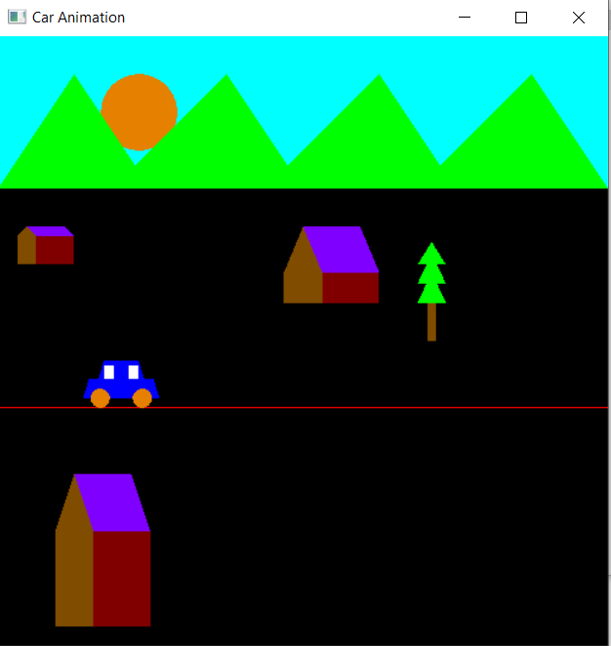

EXPERIMENT -4
Aim: Implement concentric circles using mouse click.
Program:
#include<GL/freeglut.h>
#include<stdio.h>
#include<math.h>
float a,b,c,radius=0.1;
void init()
{ glClearColor(1,1,1,1);
glClear(GL_COLOR_BUFFER_BIT);

}
void mouse(int button,int state,int x,int y)
{
if(button==GLUT_LEFT_BUTTON && state==GLUT_DOWN)
{
printf("X axis is %d and Y axis is %d\n",x,y);
if (radius<1)
{radius=radius+0.1;}
else
{radius = 1;}
}
if(button==GLUT_RIGHT_BUTTON && state==GLUT_DOWN)
{
printf("x axis is %d and Y axis is %d\n",x,y);
if (radius<1)
{
radius=radius-0.05;
}
else
{radius = 1;}

glutPostRedisplay();
}

}
void bitmap_char(int x, int y, char *string, void *font)
{
int len, i;

glRasterPos2f(x, y);
len = (int) strlen(string);
for (i = 0; i < len; i++) {
glutBitmapCharacter(font, string[i]);
}
}
void display_char()
{
glColor3f(1.0,0,0);
bitmap_char(-0.8,0.8 , "-:RITIK AGARWAL",GLUT_BITMAP_TIMES_ROMAN_24);

}

void display()
{
display_char();
glBegin(GL_POINTS);
glVertex2f(0,0);
for(a=0;a<6.28;a+=0.005)
{b=0+sin(a)*radius;
c=0+cos(a)*radius;
glColor3f(0,1,1);
glVertex2f(b,c);
}
glEnd();
glFlush();
}
int main(int argc,char** argv)
{
glutInit(&argc,argv);
glutInitDisplayMode(GLUT_SINGLE|GLUT_RGB);
glutInitWindowSize(500,500);
glutInitWindowPosition(00,00);
glutCreateWindow("Increasing Circle");
init();

glutDisplayFunc(display);
glutMouseFunc(mouse);
glutMainLoop();
return 0;
}

Output:
Before Mouse Clicks:

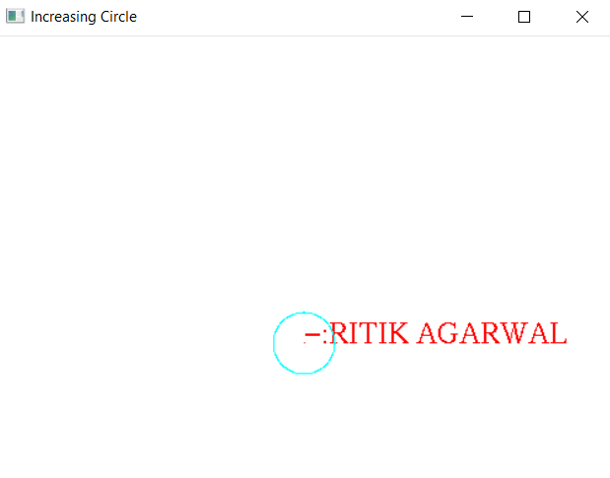

After Mouse Clicks:

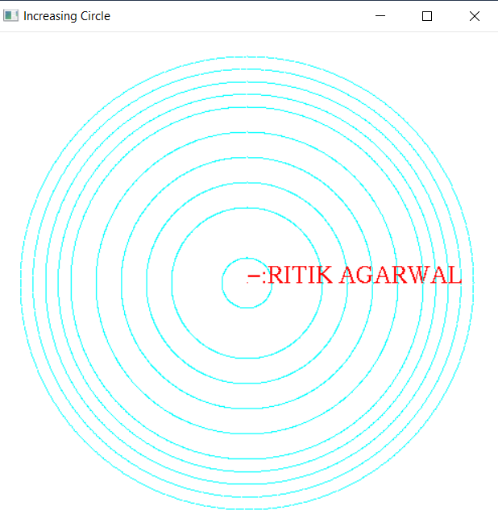

EXPERIMENT - 5

Aim: Implementation of DDA algorithm for drawing line using mouse clicks.
Program:
#include<GL/Glut.h>
#include<stdlib.h>
#include<iostream>
using namespace std;

float xstart,ystart,xend, yend;

bool flag=true;

void init(){

glClear(GL_COLOR_BUFFER_BIT);
glClearColor(1,1,1,1);
glMatrixMode(GL_PROJECTION);
glLoadIdentity();
gluOrtho2D(0, 500, 0, 500);

}

void renderbitmap(float x, float y, void *font, char *string) {
char *c=0;
glRasterPos2f(x, y);
for(c = string; *c != '\0'; c++)
glutBitmapCharacter(font, *c);
}

void displaySlope(float z) {
glColor3f(0.0f, 1.0f, 1.0f);
char str[] = "Slope: ";
renderbitmap(300, 400, GLUT_BITMAP_TIMES_ROMAN_10, str);
char buf[100] = {0};
gcvt(z, 6, buf);
renderbitmap(335, 400, GLUT_BITMAP_TIMES_ROMAN_10, buf);
glFlush();
}

void display(void)
{
float dy=0.0,dx=0.0,slope=0.0;

float i,j;

dy = yend - ystart;
dx = xend - xstart;

slope = dy/dx;

displaySlope(slope);
cout<<slope<<endl;

glColor3f(0,1,0);
glPointSize(3);

if(slope<=1 && slope>0) //1st octant
{
cout<<"I am in first Octant"<<endl;
for(i=xstart, j=ystart; i<=xend && j<=yend ; i+=1, j= j+slope)
{
glBegin(GL_POINTS);
glVertex2f(i,j);
glEnd();
}

if(xend<=xstart && yend<=ystart) //5th octant
{
cout<<"I am in fifth Octant"<<endl;
for(i=xstart, j=ystart; i>=xend && j>=yend ; i-=1, j= j-slope)
{
glBegin(GL_POINTS);
glVertex2f(i,j);
glEnd();
}
}
}

else if(slope>1) //2nd Octant
{

cout<<"I am in Second Octant"<<endl;
for(i=xstart, j=ystart; i<=xend && j<=yend ; i=i+(1/slope), j+=1)
{
glBegin(GL_POINTS);
glVertex2f(i,j);
glEnd();
}

}

else if(slope < (-1)) //3rd Octant
{
cout<<"I am in third Octant"<<endl;
for(i=xstart, j=ystart; i>=xend && j<=yend ; i=i+(1/slope), j+=1)
{
glBegin(GL_POINTS);
glVertex2f(i,j);
glEnd();
}

}

else if(slope >= (-1) && slope <=0) //4th Octant
{
cout<<"I am in fourth Octant"<<endl;
for(i=xstart, j=ystart; i>=xend && j<=yend ; i=i-1, j=j-slope)
{
glBegin(GL_POINTS);
glVertex2f(i,j);
glEnd();
}
if(xend>xstart && yend<ystart) //7th octant
{
cout<<"I am in 8th Octant"<<endl;
for(i=xstart, j=ystart; i<=xend && j>=yend ; i=i+1, j= j+slope)
{
glBegin(GL_POINTS);
glVertex2f(i,j);

glEnd();
}
}
}

glFlush();

}

void mouse(int button, int state, int mousex, int mousey)
{

if (button == GLUT_LEFT_BUTTON && state == GLUT_DOWN)
{
if(flag == true)
{
xstart=mousex;
ystart=500-mousey;
flag = false;
cout << "coordinates of first point: " << xstart << "\t" << ystart << endl;
}
else
{
xend=mousex;
yend=500-mousey;
flag = true;

cout << "coordinates of second point: " << xend << "\t" << yend << endl;

glClear(GL_COLOR_BUFFER_BIT);
glutPostRedisplay();

}
}

else if (button == GLUT_RIGHT_BUTTON && state == GLUT_DOWN)
{
glClearColor(0,0,0,1);
flag=true;
xstart = 0;
ystart = 0;
xend = 0;
yend = 0;

glClear(GL_COLOR_BUFFER_BIT);
glutPostRedisplay();
}
}

int main(int argc,char** argv)
{
glutInit(&argc,argv);
glutInitWindowSize(500,500);
glutInitWindowPosition(100,100);
glutInitDisplayMode(GLUT_SINGLE | GLUT_RGB);
glutCreateWindow("DD Line");
init();
glutMouseFunc(mouse);
glutDisplayFunc(display);
glutMainLoop();
return 0;
}

Output:
Before any click on the Screen:
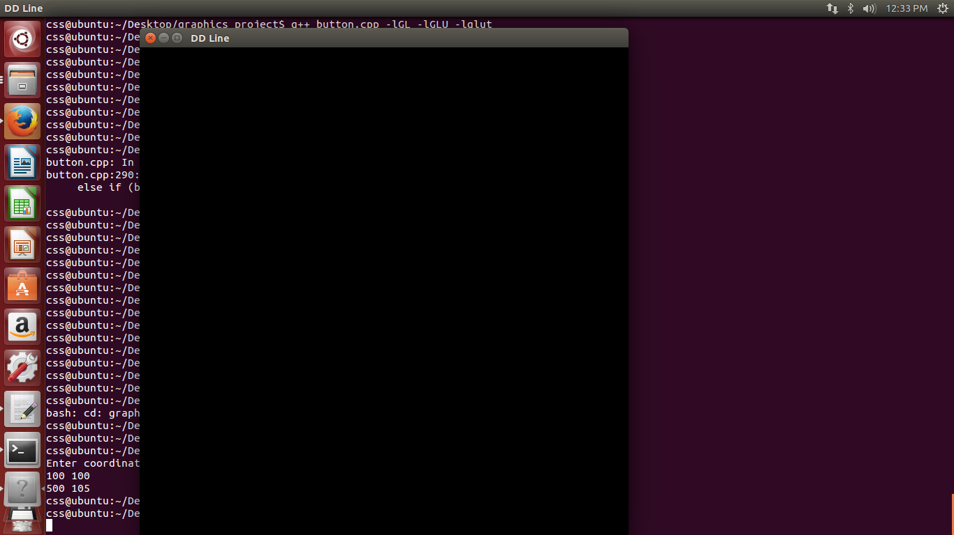

After clicking two points on the Screen:
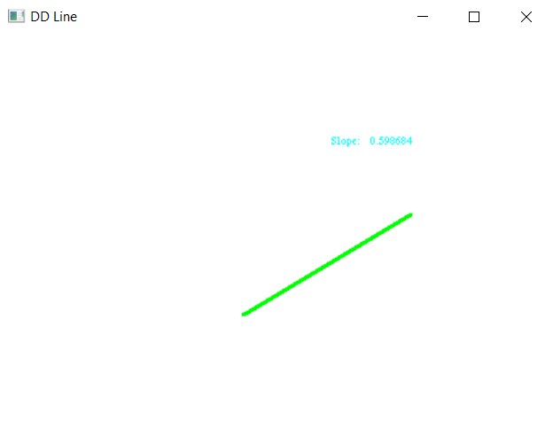

Experiment 4
Aim: Implementation of DDA algorithm for drawing line using mouse clicks.
Program:
#include<GL/glut.h>
#include<math.h>
#include<iostream>
using namespace std;

double x_1, y_1, x_2, y_2; // x_1 and y_1 x and y coordinates for 1st point
// x_2 and y_2 x and y coordinates for 2nd point
int flag {1}; // it is used to take coordinates in mouse functionality (go down)

//For slope print on screen.
void renderbitmap(float x, float y, void *font, char *string)
{
char *c;
glRasterPos2f(x, y);
for(c = string; *c != '\0'; c++)
glutBitmapCharacter(font, *c);
}

void displaySlope(float z) {
glColor3f(0.0f, 0.0f, 1.0f);
char str[] = "Slope: ";
renderbitmap(200, 450, GLUT_BITMAP_TIMES_ROMAN_10, str);
char buf[100] = {0};
gcvt(z, 6, buf);
renderbitmap(230, 450, GLUT_BITMAP_TIMES_ROMAN_10, buf);
glFlush();
}

void init()
{
glClear(GL_COLOR_BUFFER_BIT);
gluOrtho2D(0, 500, 0, 500);
glClearColor(1, 1, 1, 1);
}

void display()
{

float m; //slope
int dy, dx;

dy=(y_2-y_1);
dx=(x_2-x_1);

m=(y_2-y_1)/(x_2-x_1); // calculating slope of a line
displaySlope(m);
cout << "Value of m is : " << m << endl;

int P{0}, x=0, y=0;

x=x_1;
y=y_1;

if(m >= 0 && m<=1) // 1st octant
{
if(x <= x_2 && y<= y_2)
{
P=(2*dy)-dx;
cout << "This is 3rd "<< P << endl;
while(x <= x_2 && y<= y_2)
{
x++;

if (P < 0){
P=P+(2*dy);
}

else{
P=P+(2*dy)-(2*dx);
y++;
}

glColor3f(1, 0, 0);
glPointSize(3);
glBegin(GL_POINTS);

glVertex2f(x, y);
glEnd();

}
}

else if(x >= x_2 && y>= y_2) //5th octant
{
P=dx-(2*dy);
cout << "This is 5th" << endl;

while(x >= x_2 && y >= y_2)
{
--x;
if (P < 0){
P=P-(2*dy);
}

else{
P=P-(2*dy)+(2*dx);
y--;
}

glColor3f(0, 1, 1);
glPointSize(3);
glBegin(GL_POINTS);
glVertex2f(x, y);
glEnd();

}
}
}

else if(m > 1) // 2nd octant
{
if(x<=x_2 && y<=y_2)
{

P=(2*dx)-dy;
cout << "This is 2nd "<< P << endl;
while(x <= x_2 && y<= y_2)
{
y++;

if (P < 0){
P=P+(2*dx);
}

else{
P=P+(2*dx)-(2*dy);
x++;
}

glColor3f(0, 1, 0);
glPointSize(3);
glBegin(GL_POINTS);
glVertex2f(x, y);
glEnd();

}

}
/*else if(x >= x_2 && y>= y_2) //6th octant
{
P=dy-(2*dx);
cout << "i am in 6th" << endl;

while(x >= x_2 && y >= y_2)
{
y--;

if (P < 0){
P=P-(2*dx);
}

else{
P=P-(2*dx)+(2*dy);
x--;
}

glColor3f(1, 0, 1);
glPointSize(3);
glBegin(GL_POINTS);
glVertex2f(x, y);
glEnd();*/
// glFlush();

}

else if(m < -1) // 3rd octant
{

P=(2*dx)+dy;
cout << "This is 3rd "<< P << endl;
while(x >= x_2 && y<= y_2)
{
y++;

if (P < 0){
x--;
P=P+(2*dx)+(2*dy);
}

else{
P=P+(2*dx);
}

glColor3f(0, 0, 1);
glPointSize(3);
glBegin(GL_POINTS);
glVertex2f(x, y);
glEnd();

}

}

else if(m <= 0 && m >=(-1)) // 4th octant
{
if(x>=x_2 && y<= y_2)
{
cout << "This is 4th" << endl;
P=-(2*dy)-dx;

while(x >= x_2 && y<= y_2)
{
x--;

if (P < 0){
P=P+(2*dy);
}

else{
P=P+(2*dy)+(2*dx);
y++;
}

glColor3f(1, 1, 0);
glBegin(GL_POINTS);
glVertex2f(x, y);
glEnd();
}
}

else if(x <= x_2 && y >= y_2) //8th octant
{
cout << "i am in 8th" << endl;
P=-(2*dy)-dx;

while(x <= x_2 && y >= y_2)
{
x++;

if (P < 0){
P=P-(2*dy);
}

else{
P=P-(2*dy)-(2*dx);
y--;
}

glColor3f(1, 1, 1);
glBegin(GL_POINTS);
glVertex2f(x, y);
glEnd();

}
}
}

glFlush();
}

void mouse(int button, int state, int mousex, int mousey)
{

if(button==GLUT_LEFT_BUTTON && state==GLUT_DOWN)
{

if(flag == 1)
{
x_1 = mousex; // first point x coordinate
y_1 = 500-mousey; // first point y coordinate
flag = 0;

cout << "x and y coordinates for 1st point " << x_1 << " " << y_1 << endl;

}

else
{ x_2 = mousex; // second point x coordinate
y_2 = 500-mousey; // second point y coordinate
flag = 1;

cout << "x and y coordinates for 2nd point " << x_2 << " " << y_2 << endl;

glClear(GL_COLOR_BUFFER_BIT);
glutPostRedisplay();
}

}

else if(button==GLUT_RIGHT_BUTTON && state==GLUT_DOWN) // clear buffer // reset
{
glClearColor(0, 0, 0, 1);

flag = 1;
x_1 = 0;
y_1 = 0;
x_2 = 0;
y_2 = 0;
glClear(GL_COLOR_BUFFER_BIT);
glutPostRedisplay();

}

}

int main(int argc,char** argv)
{
glutInit(&argc,argv);
glutInitDisplayMode(GLUT_SINGLE|GLUT_RGB);
glutInitWindowSize(500,500);
glutInitWindowPosition(0,0);
glutCreateWindow("Bresenham Line");
init();
glutMouseFunc(mouse);
glutDisplayFunc(display);
glutMainLoop();
return 0;
}

Output:
Before any click on the Screen:
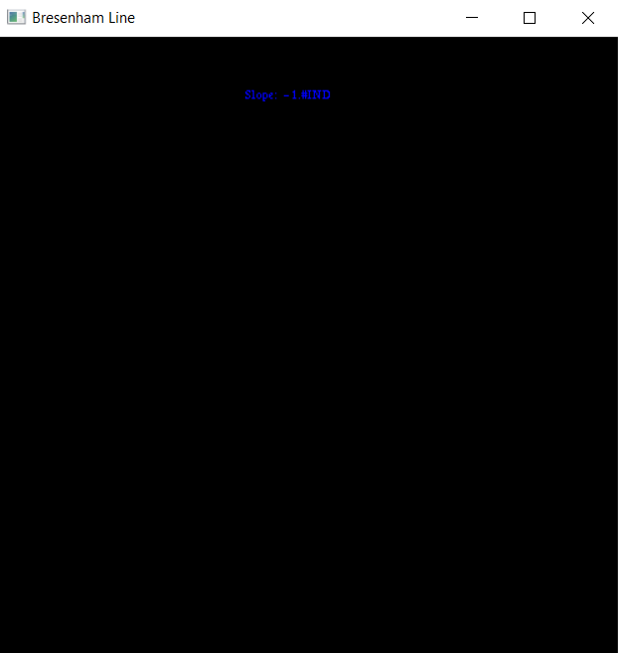

After clicking two points on the Screen:
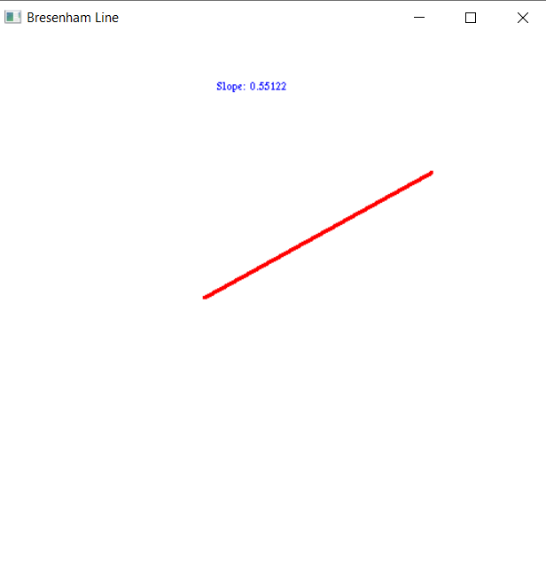

Experiment 5
Aim: Write a program for generating circle and elipse using mid-point algorithm using subwindows.
Program:
#include <stdio.h>
#include <GL/freeglut.h>
#include <math.h>

void display()
{
glClearColor(1.0,1.0,1.0,1.0);
glClear(GL_COLOR_BUFFER_BIT);
glFlush();
}
void display_s1()
{
glClearColor(1.0,0.0,0.0,1.0);
glClear(GL_COLOR_BUFFER_BIT);
float p;
int r=10;
p=5.0/4.0-r;
int x=0,y=200;
glColor3f(0.0,0.0,0.0);
glBegin(GL_POINTS);
while(x<=y)
{
glVertex2i(x,y);
glVertex2i(y,x);
glVertex2i(-1*x,-1*y);
glVertex2i(-1*y,-1*x);
glVertex2i(x,-1*y);
glVertex2i(-1*y,x);
glVertex2i(-1*x,y);
glVertex2i(y,-1*x);
if(p>=0)
{
p=2*x-2*y+5+p;
x++;
y--;
}
else
{
p=2*x+3+p;
x++;
}

}
glEnd();
glFlush();

}

void display_s4()
{glClearColor(0.0,1.0,1.0,1.0);
glClear(GL_COLOR_BUFFER_BIT);
int a=100,b=200;
double p;
float root2=pow(2,0.5);
int x=0,y=b;
int xn,yn;
p=b*b-a*a*b+a*a/4.0;
glColor3ub(100,0,0);
glBegin(GL_POINTS);
while(b*b*x<=a*a*y)
{
glVertex2i(x,y);
glVertex2i(x,-1*y);
glVertex2i(-1*x,y);
glVertex2i(-1*x,-1*y);
if(p>0)
{
p=p+b*b*(2*x+3)-a*a*(2*y-2);
x++;
y--;
}
else
{
p=p+b*b*(2*x+3);
x++;
}
xn=x;
yn=y;
}

p=(double)b*b*(xn+0.5)*(xn+0.5)+(double)a*a*(yn-1)*(yn-1)-(double)a*a*b*b;

x=xn;
y=yn;

while(y>=0)
{

glVertex2i(x,y);
glVertex2i(x,-1*y);
glVertex2i(-1*x,y);
glVertex2i(-1*x,-1*y);

if(p<=0)
{
p=p-2*a*a*(y-1)+a*a+b*b*(2*x+2);
x++;
y--;
}
else
{
p=p-2*a*a*(y-1)+a*a;
y--;
}

}
glEnd();

glFlush();

}

void myinit()
{glClearColor(1.0,0.0,0.0,1.0);
glClear(GL_COLOR_BUFFER_BIT);
glLoadIdentity();
glMatrixMode(GL_PROJECTION);
gluOrtho2D(-400.0,400.0,-350.0,350.0);
}

void init()
{

glLoadIdentity();

glMatrixMode(GL_PROJECTION);
gluOrtho2D(-400.0,400.0,-350.0,350.0);
}
int m,s1,s2,s3,s4;

void initdisplay()
{
int w=glutGetWindow();
if(w==s1)
{
glClearColor(1.0,0.0,0.0,1.0);
glClear(GL_COLOR_BUFFER_BIT);
}

else if(w==s4)
{
glClearColor(0.0,1.0,1.0,1.0);
glClear(GL_COLOR_BUFFER_BIT);
}

}

void mouse(int button,int state,int x,int y)
{
if(button == GLUT_LEFT_BUTTON && state == GLUT_DOWN) {
int w=glutGetWindow();

if(w==s1)
{
glutDisplayFunc(display_s1);
glutPostRedisplay();

}

else if(w==s4)
{
glutDisplayFunc(display_s4);
glutPostRedisplay();

}

}
}

void resize(int width,int height)
{
myinit();
glutSetWindow(s1);
init();
glutReshapeWindow(397,397);
glutPositionWindow(0,0);
glutPostRedisplay();

glutSetWindow(s4);
init();
glutReshapeWindow(397,397);
glutPositionWindow(401,0);
glutPostRedisplay();

}

int main(int argc,char** argv)
{
glutInit(&argc,argv);
glutInitDisplayMode(GLUT_SINGLE|GLUT_RGB);
glutInitWindowSize(800,400);
glutInitWindowPosition(100,200);
m=glutCreateWindow("Circles");
myinit();
glutDisplayFunc(display);
glutReshapeFunc(resize);

s1=glutCreateSubWindow(m,0,0,400,400);
init();
glutDisplayFunc(initdisplay);
glutMouseFunc(mouse);

s4=glutCreateSubWindow(m,400,0,400,400);
init();
glutDisplayFunc(initdisplay);
glutMouseFunc(mouse);

glutMainLoop();
return 0;
}

Output:
Intial Screen:
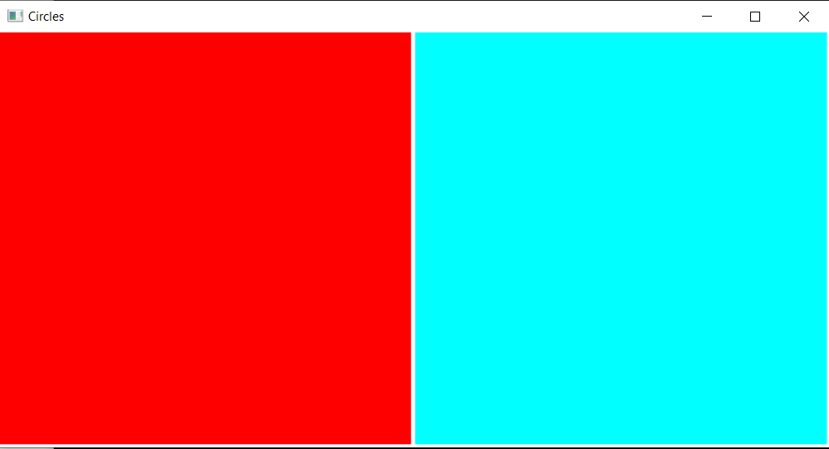

After clicking both windows:

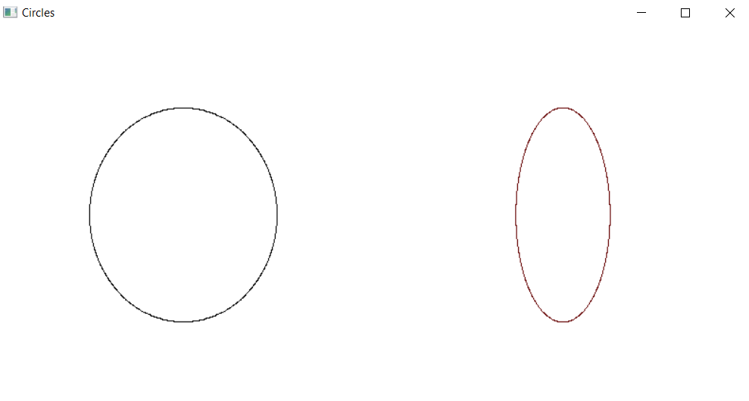

Experiment - 6

Aim: Write a program for implementing boundary fill algorithms.
Program:
#include <iostream>
#include <math.h>
#include <time.h>
#include <GL/glut.h>

using namespace std;

void init(){
glClearColor(1.0,1.0,1.0,0.0);
glMatrixMode(GL_PROJECTION);
gluOrtho2D(0,640,0,480);
}
void bitmap_char(int x, int y, char *string, void *font)
{
int len, i;

glRasterPos2f(x, y);
len = (int) strlen(string);
for (i = 0; i < len; i++) {
glutBitmapCharacter(font, string[i]);
}
}
void display_char()
{
glColor3f(1.0,0,0);
bitmap_char(10,20 , "-:RITIK AGARWAL",GLUT_BITMAP_TIMES_ROMAN_24);

}

void bound_it(int x, int y, float* fillColor, float* bc)
{
float color[3];
glReadPixels(x,y,1.0,1.0,GL_RGB,GL_FLOAT,color);
if((color[0]!=bc[0] || color[1]!=bc[1] || color[2]!=bc[2])&&(
color[0]!=fillColor[0] || color[1]!=fillColor[1] || color[2]!=fillColor[2]))
{
glColor3f(fillColor[0],fillColor[1],fillColor[2]);
glBegin(GL_POINTS);
glVertex2i(x,y);
glEnd();
glFlush();
bound_it(x+1,y,fillColor,bc);
bound_it(x-2,y,fillColor,bc);
bound_it(x,y+2,fillColor,bc);
bound_it(x,y-2,fillColor,bc);
}
}

void mouse(int btn, int state, int x, int y)
{
y = 480-y;
if(btn==GLUT_LEFT_BUTTON)
{
if(state==GLUT_DOWN)
{
float bCol[] = {0,0,1};
float color[] = {1,0,0};

bound_it(x,y,color,bCol);
}
}
}

void BFill(){

glLineWidth(3);
glPointSize(2);
glClear(GL_COLOR_BUFFER_BIT);
display_char();
glColor3f(0,0,1);
glBegin(GL_LINE_LOOP);
glVertex2i(150,100);
glVertex2i(150,200);
glVertex2i(350, 200);
glVertex2i(350,100);
glEnd();
glFlush();
}

int main(int argc, char** argv){
glutInit(&argc, argv);
glutInitDisplayMode(GLUT_SINGLE|GLUT_RGB);
glutInitWindowSize(640,480);
glutInitWindowPosition(200,200);
glutCreateWindow("Boundary Fill");
glutDisplayFunc(BFill);
glutMouseFunc(mouse);
init();
glutMainLoop();
return 0;
}

Output:

Initial Screen:
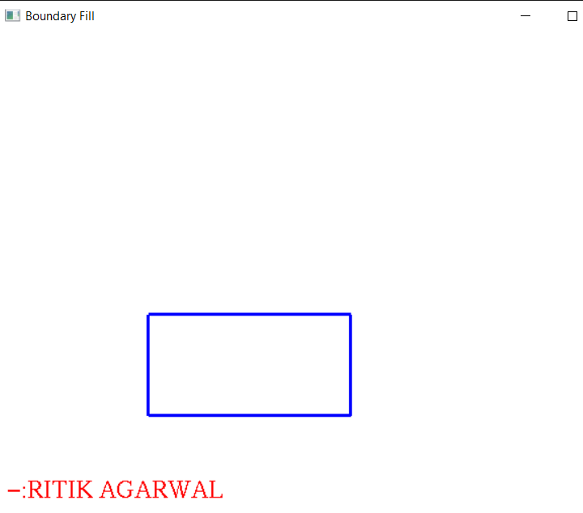

After clicking inside the polygons:
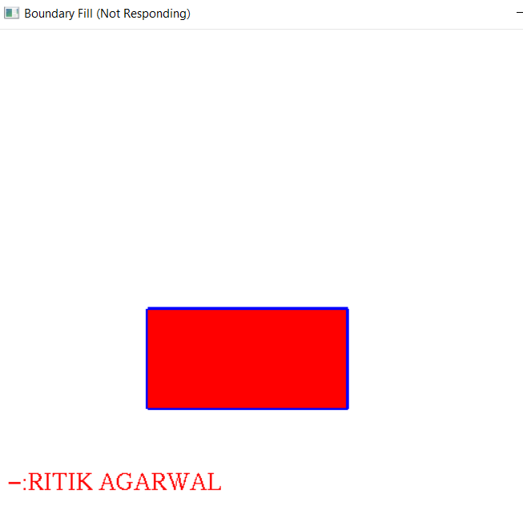

Experiment - 7

Aim: Write a program for implementing Flood fill algorithms.
Program:
#include <math.h>
#include <gl/glut.h>

struct Point {
GLint x;
GLint y;
};

struct Color {
GLfloat r;
GLfloat g;
GLfloat b;
};

void bitmap_char(int x, int y, char *string, void *font)
{
int len, i;

glRasterPos2f(x, y);
len = (int) strlen(string);
for (i = 0; i < len; i++) {
glutBitmapCharacter(font, string[i]);
}
}
void display_char()
{
glColor3f(1.0,0,0);
bitmap_char(10,20 , "-:RITIK AGARWAL",GLUT_BITMAP_TIMES_ROMAN_24);

}

void init() {
glClearColor(1.0, 1.0, 1.0, 0.0);
glColor3f(0.0, 0.0, 0.0);
glPointSize(1.0);
glMatrixMode(GL_PROJECTION);
glLoadIdentity();
gluOrtho2D(0, 640, 0, 480);
}

Color getPixelColor(GLint x, GLint y) {
Color color;
glReadPixels(x, y, 1, 1, GL_RGB, GL_FLOAT, &color);
return color;
}

void setPixelColor(GLint x, GLint y, Color color) {
glColor3f(color.r, color.g, color.b);
glBegin(GL_POINTS);
glVertex2i(x, y);
glEnd();
glFlush();
}

void floodFill(GLint x, GLint y, Color oldColor, Color newColor) {
Color color;
color = getPixelColor(x, y);

if(color.r == oldColor.r && color.g == oldColor.g && color.b == oldColor.b)
{
setPixelColor(x, y, newColor);
floodFill(x+1, y, oldColor, newColor);
floodFill(x, y+1, oldColor, newColor);
floodFill(x-1, y, oldColor, newColor);
floodFill(x, y-1, oldColor, newColor);
}
return;
}

void onMouseClick(int button, int state, int x, int y)
{
Color newColor = {0.0f, 0.0f, 1.0f};
Color oldColor = {1.0f, 1.0f, 1.0f};

floodFill(x, 480-y, oldColor, newColor);
}

void display(void) {

glClear(GL_COLOR_BUFFER_BIT);
display_char();
glBegin(GL_POINTS);
glBegin(GL_LINE_LOOP);
glColor3f(1.0,0,0);
glVertex2i(150,100);

glColor3f(0,1.0,0);
glVertex2i(150,200);
glColor3f(0,0,1.0);
glVertex2i(200,200);
glColor3f(0,0,0);
glVertex2i(200,100);

glEnd();
glFlush();
}

int main(int argc, char** argv)
{
glutInit(&argc, argv);
glutInitDisplayMode(GLUT_SINGLE|GLUT_RGB);
glutInitWindowSize(640, 480);
glutInitWindowPosition(200, 200);
glutCreateWindow("Flood_Fill");
init();
glutDisplayFunc(display);
glutMouseFunc(onMouseClick);
glutMainLoop();
return 0;
}
Output :
Initial Screen:
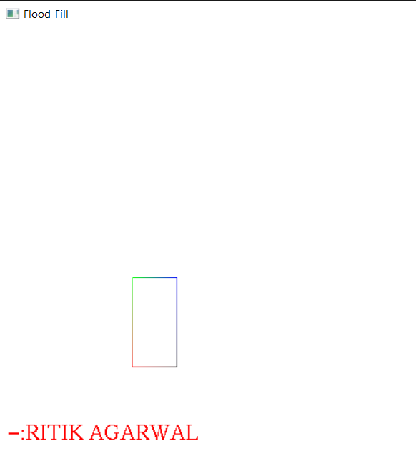

After clicking inside the polygons:
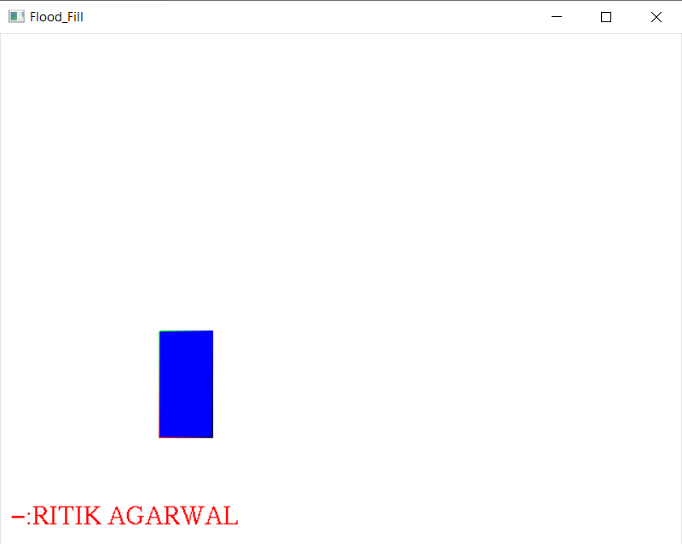
EXPERIMENT - 8
Aim: Write a program for implementing Liang Barsky and Cohen-Sutherland algorithms of line clipping.
Program:
#include<stdio.h>
#include<GL/gl.h>
#include<GL/glut.h>
#include<string.h>
#include<math.h>
#include<stdlib.h>
#include<time.h>

int ww = 800, wh = 800;
int first = 0;
int xi=0, yi=0, xf=0, yf=0;

int xmin,ymin,xmax,ymax;
double p[4],q[4];
int xt1;
int yt1;
int xt2;
int yt2;
void delay(float secs)
{
int end = clock() / CLOCKS_PER_SEC + secs;
while ((clock() / CLOCKS_PER_SEC) <end);
}

void display()
{
glClearColor(1.0,1.0,1.0,1.0);
glClear(GL_COLOR_BUFFER_BIT);
glFlush();
}
int LiangAlgo(int x1,int y1,int x2,int y2)
{
glClearColor(0.98,0.80,0.0,1.0);
glClear(GL_COLOR_BUFFER_BIT);
float t1=0.0,t2=1.0;
int dx=x2-x1;
int dy=y2-y1;
int i;
float t;
p[0]=-dx; q[0]=x1-xmin;
p[1]=dx; q[1]=xmax-x1;
p[2]=-dy; q[2]=y1-ymin;
p[3]=dy; q[3]=ymax-y1;
for(i=0;i<4;i++)
{
if(p[i]==0 && q[i]<0)
return 0;
if(p[i]<0.0)
{
t=q[i]/p[i];
if(t>t1)
{
t1=t;
}
}
if(p[i]>0.0)
{
t=q[i]/p[i];
if(t<t2)
{t2=t;}
}
}
if(t1<t2)
{
xt1=x1+t1*(x2-x1);
yt1=y1+t1*(y2-y1);
xt2=x1+t2*(x2-x1);
yt2=y1+t2*(y2-y1);
glClear(GL_COLOR_BUFFER_BIT);
glFlush();
glColor3f(0.0,0.0,1.0);
glBegin(GL_LINES);
glVertex2f(xmin,ymin);
glVertex2f(xmax,ymin);
glVertex2f(xmax,ymin);
glVertex2f(xmax,ymax);
glVertex2f(xmax,ymax);
glVertex2f(xmin,ymax);
glVertex2f(xmin,ymax);
glVertex2f(xmin,ymin);
glEnd();
glFlush();

glColor3f(1.0,0.0,0.0);
glBegin(GL_LINES);
glVertex2f(xt1,yt1);
glVertex2f(xt2,yt2);
glEnd();
glFlush();

glColor3f(0.0,0.0,1.0);
glBegin(GL_LINES);
glVertex2f(-400,-400);
glVertex2f(xt1,yt1);
glEnd();
glFlush();

glColor3f(0.0,0.0,1.0);
glBegin(GL_LINES);
glVertex2f(xt2,yt2);
glVertex2f(400,400);
glEnd();
glFlush();

return 1;
}
else{
return 0;
}
}

void radomWindow1()
{
int flag=0;
while(flag==0)

{
int randomX=(rand()%500)-200;
int randomY=(rand()%500)-200;
if(randomX<400&&randomX>-400)
{

if(randomY<400&&randomY>-400)
{
glClear(GL_COLOR_BUFFER_BIT);
glColor3f(1.0,0.0,0.0);
glFlush();
glColor3f(0.0,0.0,1.0);
glBegin(GL_LINES);
glVertex2f(-400,-400);
glVertex2f(400,400);
glEnd();
glFlush();
glColor3f(0.0,0.0,0.0);
xmin=randomX;
xmax=randomX+50;
ymin=randomY;
ymax=randomY+50;
glColor3f(0.0,0.0,0.0);
glBegin(GL_LINES);
glVertex2f(xmin,ymin);
glVertex2f(xmax,ymin);
glVertex2f(xmax,ymin);
glVertex2f(xmax,ymax);
glVertex2f(xmax,ymax);
glVertex2f(xmin,ymax);
glVertex2f(xmin,ymax);
glVertex2f(xmin,ymin);
glEnd();
glFlush();

int x=LiangAlgo(-400,-400,400,400);
delay(1.0);

}
}
}

}
void radomWindow2()
{
int flag=0;
while(flag==0)

{
int randomX=(rand()%500)-200;
int randomY=(rand()%500)-200;
if(randomX<400&&randomX>-400)
{

if(randomY<400&&randomY>-400)
{
glClear(GL_COLOR_BUFFER_BIT);
glColor3f(1.0,0.0,0.0);
glFlush();
glColor3f(0.0,0.0,1.0);
glBegin(GL_LINES);
glVertex2f(-400,-400);
glVertex2f(400,400);
glEnd();
glFlush();
glColor3f(0.0,0.0,0.0);
xmin=randomX;
xmax=randomX+50;
ymin=randomY;
ymax=randomY+50;
glColor3f(0.0,0.0,0.0);
glBegin(GL_LINES);
glVertex2f(xmin,ymin);
glVertex2f(xmax,ymin);
glVertex2f(xmax,ymin);
glVertex2f(xmax,ymax);
glVertex2f(xmax,ymax);
glVertex2f(xmin,ymax);
glVertex2f(xmin,ymax);
glVertex2f(xmin,ymin);
glEnd();
glFlush();

int x=LiangAlgo(-400,-400,400,400);
delay(1.0);

}
}
}

}

void keyboardkey(unsigned char key,int x,int y)
{
glClear(GL_COLOR_BUFFER_BIT);
glFlush();
if(key=='s')
{
radomWindow1();

}

}
void keyboardkey1(unsigned char key,int x,int y)
{
glClear(GL_COLOR_BUFFER_BIT);
glFlush();
if(key=='d')
{
radomWindow2();
}

}
void myinit()
{glClearColor(1.0,1.0,1.0,1.0);
glClear(GL_COLOR_BUFFER_BIT);
glLoadIdentity();
glMatrixMode(GL_PROJECTION);
gluOrtho2D(-400.0,400.0,-400.0,400.0);
}

void init()
{

glLoadIdentity();

glMatrixMode(GL_PROJECTION);
gluOrtho2D(-400.0,400.0,-400.0,400.0);
}int m,s1,s4;

void initdisplay()
{
int w=glutGetWindow();
if(w==s1)
{
glClearColor(0.93,0.80,0.0,1.0);
glClear(GL_COLOR_BUFFER_BIT);
}

else if(w==s4)
{
glClearColor(0.0,1.0,1.0,1.0);
glClear(GL_COLOR_BUFFER_BIT);
}

}

void resize(int width,int height)
{
myinit();
glutSetWindow(s1);
init();
glutReshapeWindow(397,600);
glutPositionWindow(0,0);
glutPostRedisplay();

glutSetWindow(s4);
init();
glutReshapeWindow(397,600);
glutPositionWindow(401,0);
glutPostRedisplay();

}
int main(int argc,char** argv)
{
glutInit(&argc,argv);
glutInitDisplayMode(GLUT_SINGLE|GLUT_RGB);
glutInitWindowSize(800,600);
glutInitWindowPosition(0,0);
m=glutCreateWindow("Cohen&Liang");
myinit();
glutDisplayFunc(display);
glutReshapeFunc(resize);

s1=glutCreateSubWindow(m,0,0,400,800);

init();
glutDisplayFunc(initdisplay);

glutKeyboardFunc(keyboardkey);

s4=glutCreateSubWindow(m,400,0,400,800);
init();
glutDisplayFunc(initdisplay);
glutKeyboardFunc(keyboardkey1);

glutMainLoop();
return 0;
}

Output:
Liang-Barsky(Press s key)
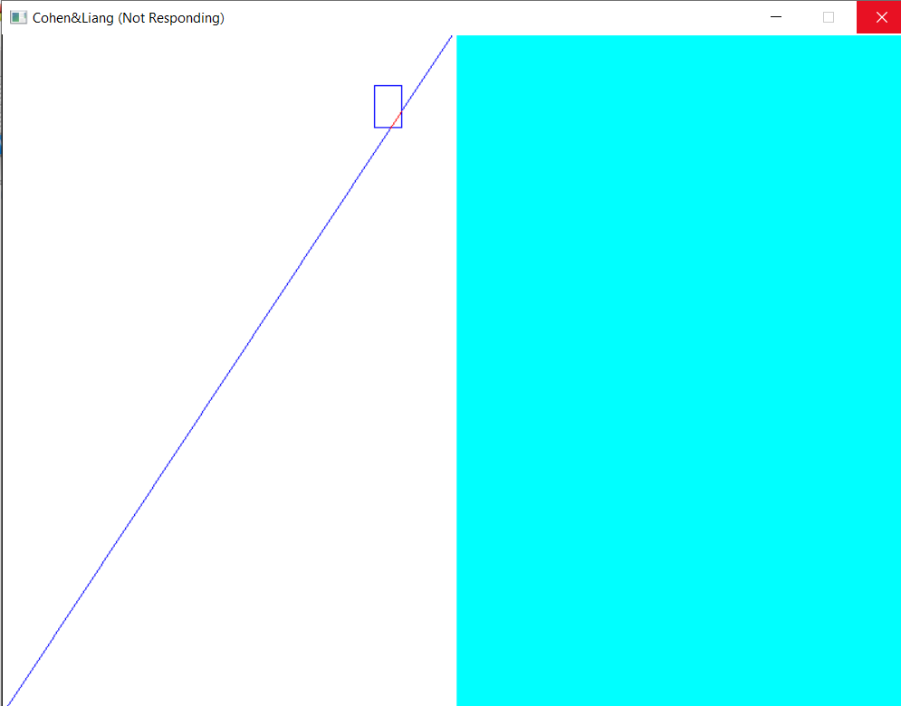

Cohen-Sutherland(Press d key)
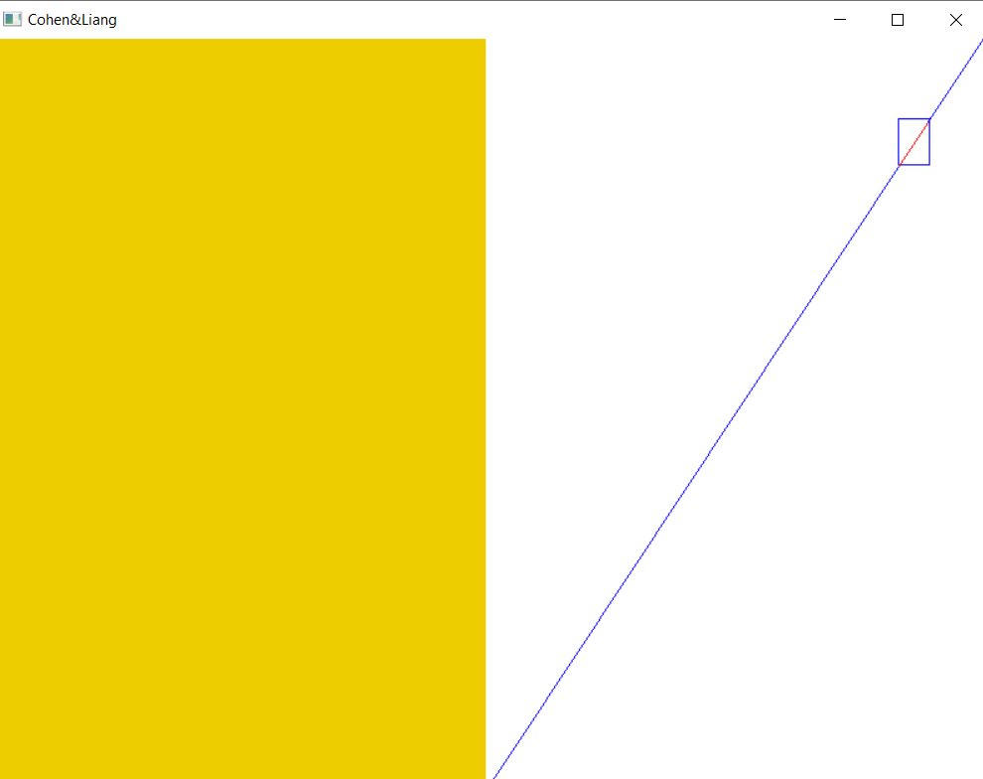

EXPERIMENT - 9
Aim: Write a program for implementing various affine transformations.
Program:
#include <stdio.h>
#include <stdlib.h>
#include "GL/freeglut.h"
#include <math.h>
#include<ctype.h>
#include<iostream>
using namespace std;

float tx=50.0,ty=50.0,sx=3.0,sy=3.0,theta=30.0;
int choice,n,vertex,shx=2,shy=2;
float xd[10],yd[10],X1[10],Y1[10];
float SX, SY, TX, TY;

void initt()
{
glClearColor(1.0,1.0,0.0,1.0);
glMatrixMode (GL_PROJECTION);
gluOrtho2D(-800,800,-800,800);
}

void translation(){
int i;
for(i=1;i<=vertex;i++){
X1[i]=xd[i]+tx;
Y1[i]=yd[i]+ty;
}
}

void scaling(){
float xh[10],yh[10]; int i=1;

for(i=1;i<=vertex;i++){
xh[i]=xd[i]-xd[1];
yh[i]=yd[i]-yd[1];
}

for(i=1;i<=vertex;i++){
xh[i]=xh[i]*sx;
yh[i]=yh[i]*sy;
}
for(i=1;i<=vertex;i++){
X1[i]=xh[i]+2*xd[1];
Y1[i]=yh[i]+yd[1];
}
}

void rotation(){

float t,xh[10],yh[10];
int i;
t= -1*(theta * 3.14/180);
double coss = cos(t);
double sinn = sin(t);

for(i=1;i<=vertex;i++){
X1[i] = xd[1] + (xd[i]*coss - yd[i]*sinn);
Y1[i] = yd[1] + (xd[i]*sinn + yd[i]*coss);
}
}

void shearX(){
int i;
for(i=0;i<=vertex;i++){
X1[i]=xd[i]+shx*yd[i];
Y1[i]=yd[i];
}
}

void shearY(){
int i;
for(i=0;i<=vertex;i++){
Y1[i]=yd[i]+shy*xd[i];
X1[i]=xd[i];
}
}

void reflectionX(){
int i;
for(i=0;i<=vertex;i++){
Y1[i]= -yd[i];
X1[i]=xd[i];
}
}

void reflectionY(){
int i;
for(i=0;i<=vertex;i++){
X1[i]=-xd[i];
Y1[i]= yd[i];
}
}
void bitmap_char(int x, int y, char *string, void *font)
{
int len, i;

glRasterPos2f(x, y);
len = (int) strlen(string);
for (i = 0; i < len; i++) {
glutBitmapCharacter(font, string[i]);
}
}
void display_char()
{
glColor3f(0,0,0);
bitmap_char(-750, 665, "2D-TRANSFORMATION",GLUT_BITMAP_TIMES_ROMAN_24);
bitmap_char(-750, 625, "PRESS GIVEN KEYS FOR DIFFERENT OPERATIONS",GLUT_BITMAP_9_BY_15);
bitmap_char(-750, 585, "Press t for Translation",GLUT_BITMAP_9_BY_15);
bitmap_char(-750, 555, "Press s for Scaling",GLUT_BITMAP_9_BY_15);
bitmap_char(-750, 525, "Press r for Rotation",GLUT_BITMAP_9_BY_15);
bitmap_char(-750, 495, "Press x for Reflection in x-direction",GLUT_BITMAP_9_BY_15);
bitmap_char(-750, 465, "Press y for Reflection in y-direction",GLUT_BITMAP_9_BY_15);
bitmap_char(-750, 435, "Press X for Shearing in x-direction",GLUT_BITMAP_9_BY_15);
bitmap_char(-750, 405, "Press Y for Shearing in y-direction",GLUT_BITMAP_9_BY_15);

glColor3f(1.0,0,0);
bitmap_char(-750, 350, "-:RITIK AGARWAL",GLUT_BITMAP_TIMES_ROMAN_24);

}
void display(){
int i;
glClear(GL_COLOR_BUFFER_BIT);

display_char();
glColor3f(0.0, 0.0, 1.0);
if(vertex==2){
glBegin(GL_LINES);
for(i=1;i<=vertex;i++){
glVertex2f(xd[i], yd[i]);
}
}
else{
glBegin(GL_POLYGON);
for(i=1;i<=vertex;i++){
glVertex2f(xd[i], yd[i]);
}
}
glEnd();
glColor3f(1.0, 0.0, 0.0);

if(vertex==2){
glBegin(GL_LINES);
for(i=1;i<=vertex;i++){
glVertex2f(X1[i], Y1[i]);
}
}
else{
glBegin(GL_POLYGON);
for(i=1;i<=vertex;i++){
glVertex2f(X1[i], Y1[i]);
}
}

glEnd();
glutSwapBuffers();
glFlush();
}

void operation(GLubyte key, GLint x, GLint y)
{
float currentX,currentY;
switch(key)
{
case 't':
translation();
glutPostRedisplay();
break;
case 's':
scaling();
glutPostRedisplay();
break;
case 'r':
rotation();
glutPostRedisplay();
break;
case 'x':
reflectionX();
glutPostRedisplay();
break;
case 'y':
reflectionY();
glutPostRedisplay();
break;
case 'X':
shearX();
glutPostRedisplay();
break;
case 'Y':
shearY();
glutPostRedisplay();
break;
}
}

int main(int argc, char **argv){
int i;
printf("ENTER NO. OF VERTICES:-\n");
scanf("%d",&vertex);
if(vertex<2 || vertex>10){
printf("Invalid Input......Exiting......\n");
exit(0);
}

for(i=1;i<=vertex;i++){
printf("Enter coordinates(x,y):-\n");
scanf("%f %f", &xd[i], &yd[i]);
}
glutInit(&argc, argv);
glutInitDisplayMode(GLUT_SINGLE | GLUT_RGB);
glutCreateWindow("2D TRANSFORMATION ");
initt();
glutDisplayFunc(display);
glutKeyboardFunc(operation);
glutMainLoop();
return 0;
}

Output:
Intial Screen:
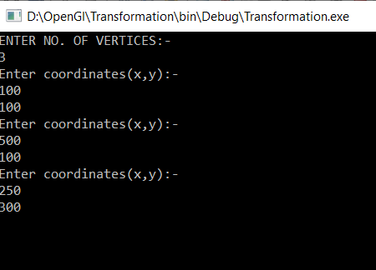

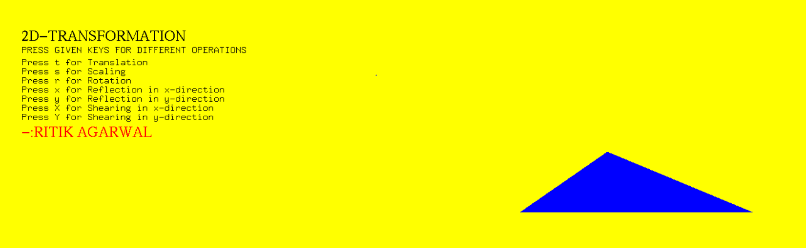

On pressing t:
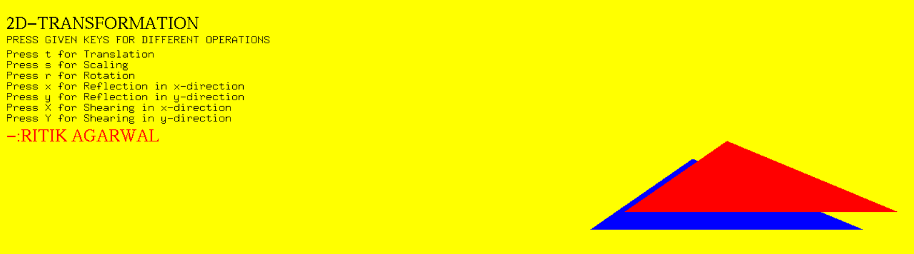
On pressing s:
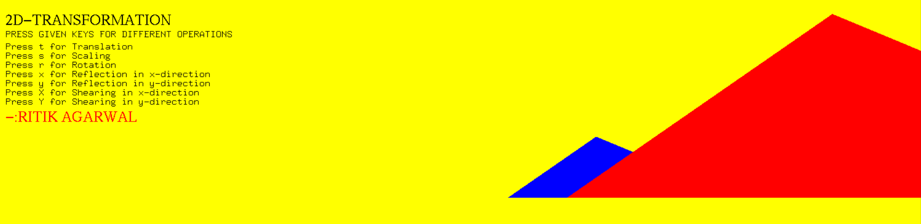
On pressing r :
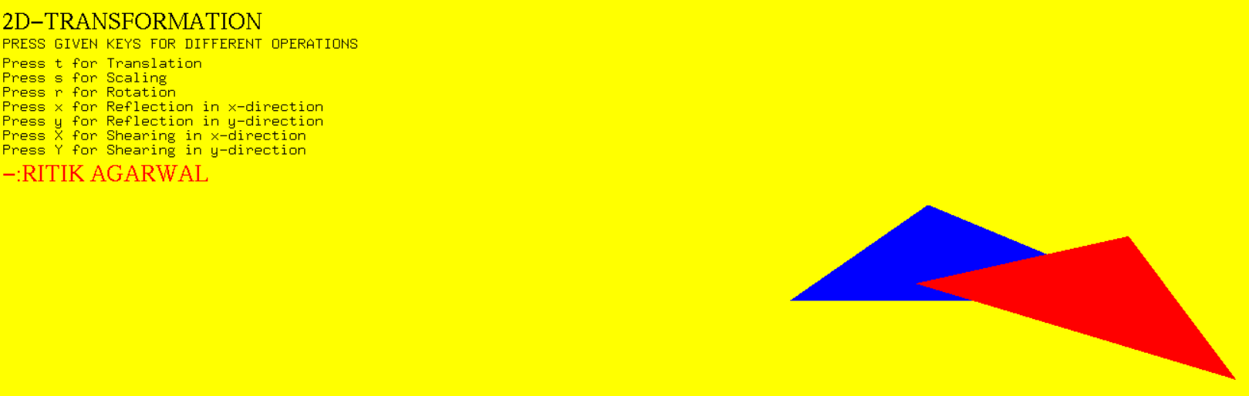
On pressing x :
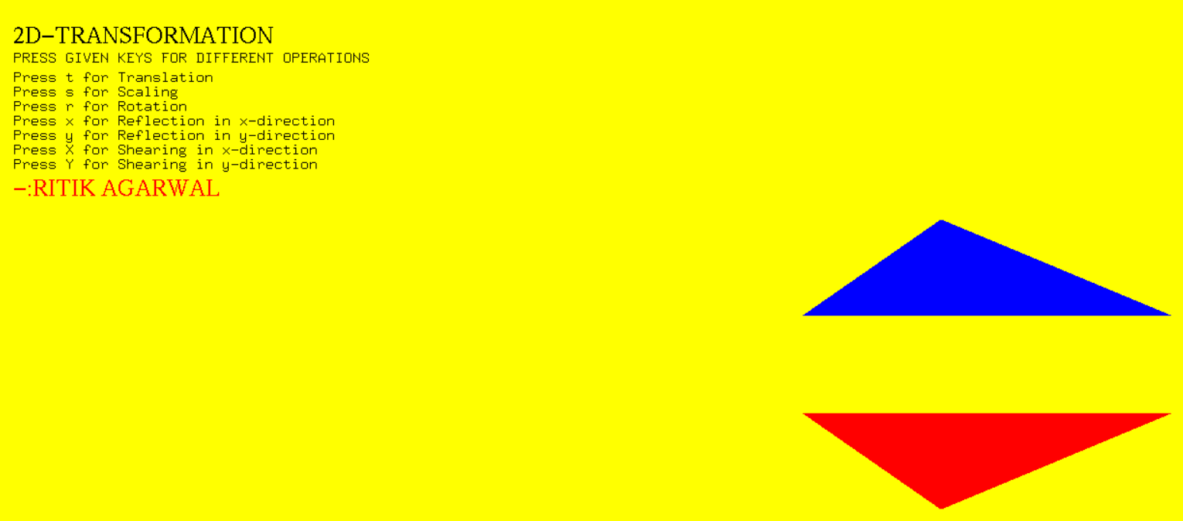

On Clock y :
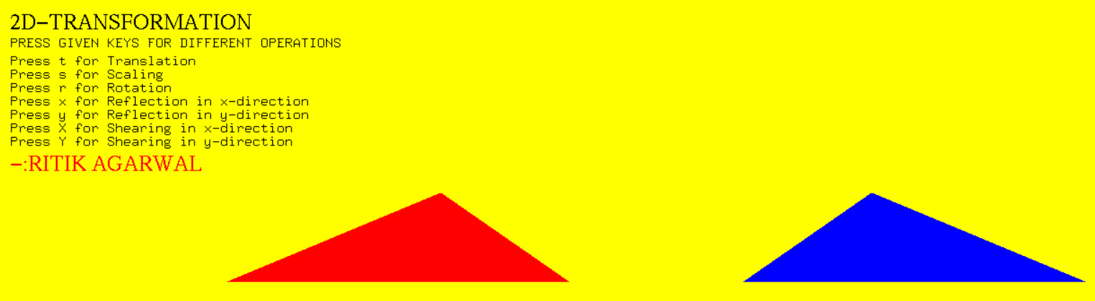
On Click X(capital) :
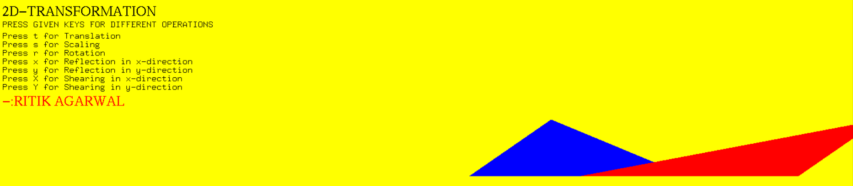

On Click Y(Capital):
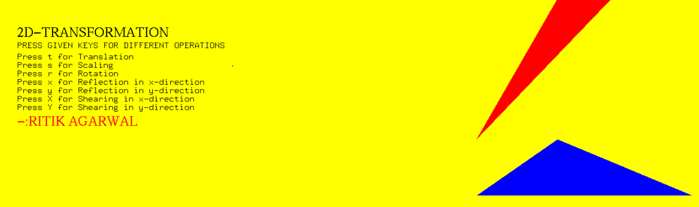

EXPERIMENT - 10
Aim: Write a program for implementing Beizer Curve.
Program :

#define GL_SILENCE_DEPRECATION
#include<GL/glut.h>
#include<iostream>
#include<math.h>

using namespace std;

int c_x[6],c_y[6];

int clicks=5;
int count_1=0;

void myInit(void)
{
glClearColor(1,1,1,1);
glMatrixMode(GL_PROJECTION);
glLoadIdentity();
gluOrtho2D(0.0,600.0,0.0,600.0);
}

void drawcontrolpoints(int a,int b)
{
glColor3f(0.9019607843,0.9019607843,0);
glPointSize(5.2);
glBegin(GL_POINTS);
glVertex2f(a,b);
glEnd();
glFlush();
}

int factorial(int n)
{
if(n<=1)
return 1;

else
n=n*factorial(n-1);
return n;
}

float combination(float n,float r)
{
float res;
res=factorial(n)/(factorial(n-r)*factorial(r));
return res;
}

void drawline(double a,double b,double c,double d)
{
glColor3f(0,0,0);
glLineWidth(3.0);
glBegin(GL_LINES);
glVertex2f(a,b);
glVertex2f(c,d);
glEnd();
glFlush();
}

double* bezierCurveStandard(double t)
{
static double pn[2];

pn[0]=0;
pn[1]=0;

for(int i=0;i<clicks;i++)
{
pn[0]=pn[0]+combination((float)(clicks-1),(float)i)*pow(t,(double)i)*pow((1-t),(clicks-1-i))*c_x[i];

pn[1]=pn[1]+combination((float)(clicks-1),(float)i)*pow(t,(double)i)*pow((1-t),(clicks-1-i))*c_y[i];
}

return pn;
}

void display()
{
glClear(GL_COLOR_BUFFER_BIT);

glFlush();
}

void mouse(int button, int state, int mousex, int mousey)
{
if(button==GLUT_LEFT_BUTTON && state==GLUT_DOWN)
{
c_x[count_1]=mousex;
c_y[count_1]=600-mousey;

drawcontrolpoints(c_x[count_1],c_y[count_1]);

count_1++;

if(count_1==clicks)
{
cout<<"Control Points:"<<endl<<endl;
for(int j=0;j<clicks;j++)
{
cout<<c_x[j]<<","<<c_y[j]<<endl<<endl;
}

double ps_x=c_x[0];
double ps_y=c_y[0];

for(double t=0.0;t<=1.0;t+=0.02)
{

double* pn=bezierCurveStandard(t);
cout<<"Next Point:"<<endl;
cout<<pn[0]<<","<<pn[1]<<endl;

drawline(ps_x,ps_y,pn[0],pn[1]);
ps_x=pn[0];
ps_y=pn[1];
}
drawline(ps_x,ps_y,c_x[5],c_y[5]);

count_1=0;
}

}

}

int main(int argc,char** argv)
{
glutInit(&argc,argv);
glutInitDisplayMode(GLUT_SINGLE|GLUT_RGB);
glutInitWindowSize(600,600);
glutCreateWindow("Bezier Curve");
glutDisplayFunc(display);
glutMouseFunc(mouse);
myInit();
glutMainLoop();
return 0;
}

Output:
Beizer Curve :
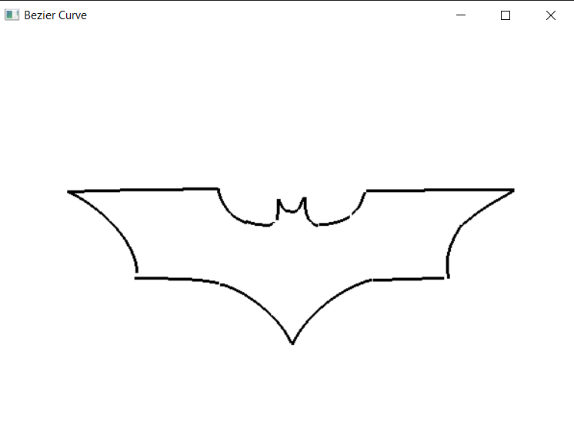

EXPERIMENT - 11
Aim: Write a program for implementing Fractal.
Program :
#include <windows.h>
#include <stdio.h>
#include <stdlib.h>
#include <GL/glut.h>

//#define BARNSLEY 3
int points=50000;

void myinit(void)
{
/* attributes */
glClearColor(1.0, 1.0, 1.0, 1.0); /* white background */
glColor3f(0.133,0.545,0.133);
glMatrixMode(GL_PROJECTION);
glLoadIdentity();
gluOrtho2D(0.0, 500.0, 0.0, 500.0);
glMatrixMode(GL_MODELVIEW);
}

/* Where the fractal is drawn-FERN*/
void barnsleyFern(void)
{
typedef GLfloat point2[2];
point2 p = {0.0,50.0},newPoint;

/*Probability table of the 3 transformations*/
double prob[3] = {85, 92, 99};

glClear ( GL_COLOR_BUFFER_BIT );

/*main drawing loop*/
for(int i=0; i<points; i++)
{
GLfloat prevx=p[0];
GLfloat randnum=rand()%100 +1;
if (randnum<prob[0])
{
p[0]=p[0]*0.85+0.04*p[1];
p[1]=prevx*(-0.04)+0.85*p[1]+1.6;
}
else if(randnum<prob[1])
{
p[0]=0.2*p[0]-0.26*p[1];
p[1]=0.23*prevx+0.22*p[1]+1.6;
}
else if(randnum<prob[2])
{
p[0]=-0.15*p[0]+0.28*p[1];
p[1]=0.26*prevx+0.24*p[1]+0.44;
}
else
{
p[0]= 0.00 * p[0] + 0.00 * p[1] + 0.0;;
p[1]= 0.00 * p[0] + 0.16 * p[1] + 0.0;;
}

newPoint[0]=p[0]*50+250;
newPoint[1]=p[1]*50;
if(i>100)
{
/*Plot new point*/
glBegin(GL_POINTS);
glVertex2fv(newPoint);
glEnd();
}
}

// Clear all buffers.
glFlush ( );
glutSwapBuffers();
}

/* myDisplay */
void myDisplay()
{
barnsleyFern();
}
int main(int argc, char** argv)
{
/* Standard GLUT initialization */
glutInit(&argc,argv);
glutInitDisplayMode (GLUT_DOUBLE | GLUT_RGB); /* double buffering */
glutInitWindowSize(500,500); /* 500 x 500 pixel window */
glutInitWindowPosition(0,0); /* place window top left on display */
glutCreateWindow("Fractals"); /* window title */
glutDisplayFunc(myDisplay);
myinit();

glutMainLoop(); /* enter event loop */

return 0;
}

Output:
