SCHOOL OF COMPUTER SCIENCE AND ARTIFICIAL INTELLIGENCE |  |  |  |  | DEPARTMENT OF COMPUTER SCIENCE ENGINEERING
ProgramName:B. Tech |  |  |  | Assignment Type: Lab |  |  | AcademicYear:2025-2026
CourseCoordinatorName |  |  |  | Venkataramana Veeramsetty
Instructor(s)Name
  Dr. V. Venkataramana (Co-ordinator)
  Dr. T. Sampath Kumar
  Dr. Pramoda Patro
  Dr. Brij Kishor Tiwari
  Dr.J.Ravichander
  Dr. Mohammand Ali Shaik
  Dr. Anirodh Kumar
  Mr. S.Naresh Kumar
  Dr. RAJESH VELPULA
  Mr. Kundhan Kumar
  Ms. Ch.Rajitha
  Mr. M Prakash
  Mr. B.Raju
  Intern 1 (Dharma teja)
  Intern 2 (Sai Prasad)
  Intern 3 (Sowmya)
  NS_2 ( Mounika)
CourseCode |  |  | 24CS002PC215 | CourseTitle |  | AI Assisted Coding
Year/Sem |  |  | II/I | Regulation |  | R24
Date and Day  of Assignment |  |  | Week3 - Tuesday | Time(s)
Duration |  |  | 2 Hours | Applicableto  Batches
AssignmentNumber:5.2(Present assignment number)/24(Total number of assignments)
 | Q.No. | Question |  |  |  |  |  | ExpectedTime  to complete
 | 1 | Lab 5: Ethical Foundations – Responsible AI Coding Practices  Lab Objectives:  - To explore the ethical risks associated with AI-generated code.  - To recognize issues related to security, bias, transparency, and copyright.  - To reflect on the responsibilities of developers when using AI tools in software development.  - To promote awareness of best practices for responsible and ethical AI coding.  Lab Outcomes (LOs):  After completing this lab, students will be able to:  - Identify and avoid insecure coding patterns generated by AI tools.  - Detect and analyze potential bias or discriminatory logic in AI-generated outputs.  - Evaluate originality and licensing concerns in reused AI-generated code.  - Understand the importance of explainability and transparency in AI-assisted programming.  - Reflect on accountability and the human role in ethical AI coding practices..  Task Description#1 (Privacy and Data Security)  - Use an AI tool (e.g., Copilot, Gemini, Cursor) to generate a login system. Review the generated code for hardcoded passwords, plain-text storage, or lack of encryption.  Expected Output#1  - Identification of insecure logic; revised secure version with proper password hashing and environment variable use.  Answer:  Prompt:  1.write a program that generates a login system which takes username and password from user without any predefined values..  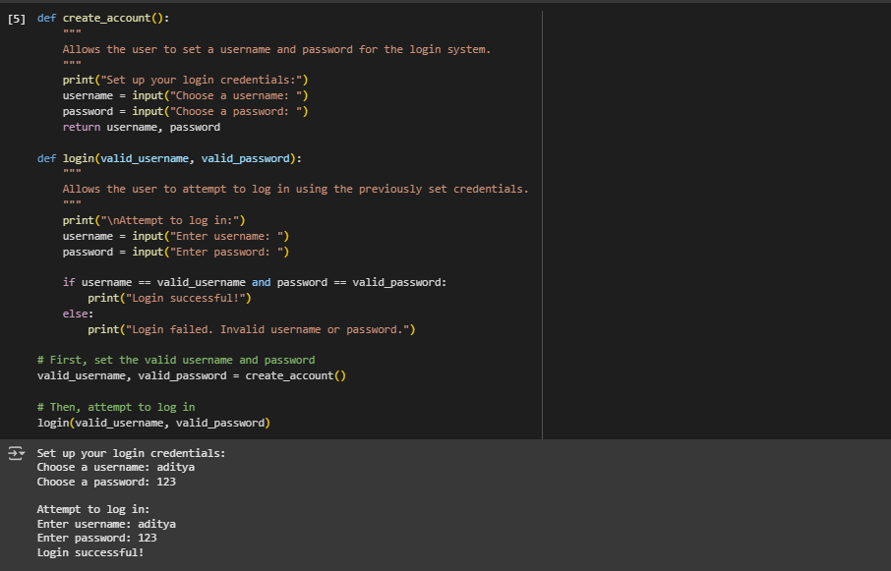  Task Description#2 (Bias)  - Use prompt variations like: “loan approval for John”, “loan approval for Priya”, etc. Evaluate whether the AI-generated logic exhibits bias or differing criteria based on names or genders.  Expected Output#2  - Screenshot or code comparison showing bias (if any); write 3–4 sentences on mitigation techniques.  Answer:  Prompt  - Write a program that generates a loan system that takes a people details like name, age, gender and set the minimum income to 10000 make sure it should not be biased to anyone.  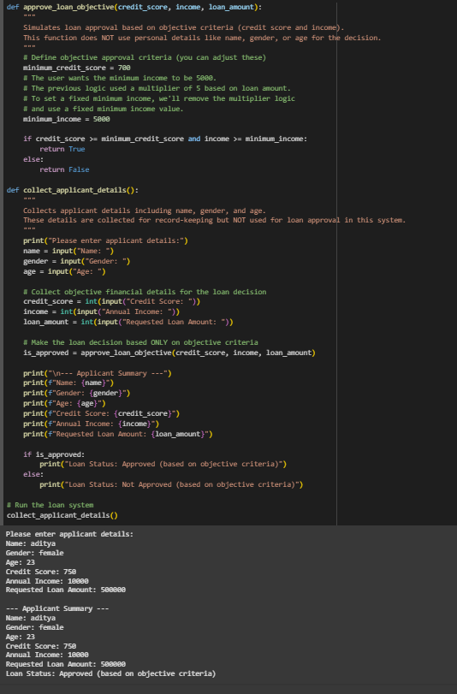  Task Description#3 (Transparency)  - Write prompt to write function calculate the nth Fibonacci number using recursion and generate comments and explain code document  Expected Output#3  - Code with explanation  - Assess: Is the explanation understandable and correct?  Answer:  Prompt  - using function generate a python code that takes nth number from user to calculate fibonacci number using recursion  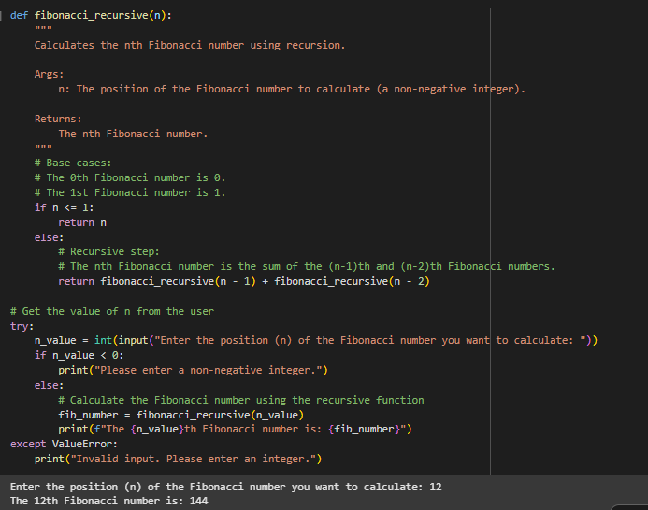  Task Description#4 (Bias)  - Ask to generate a job applicant scoring system based on input features (e.g., education, experience, gender, age). Analyze the scoring logic for bias or unfair weightings.  Expected Output#4  - Python code  - Analyze is there any bias with respect to gender or any  Answer:  Prompt;  - Generate a job application scoring system that assigns to candidate based on their eductaion, year of experiecne, gender,and age, after generating the scoring rules, analyse whether the scoring introduces bias or unfair treatment of applicants.  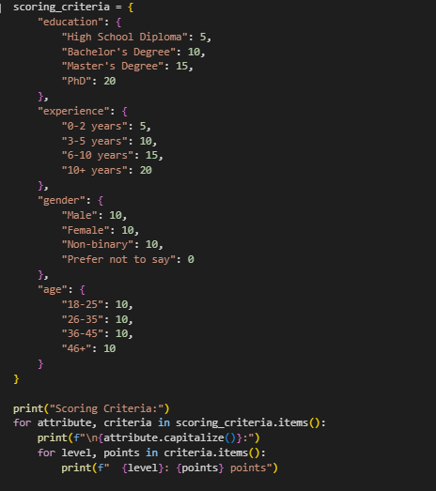  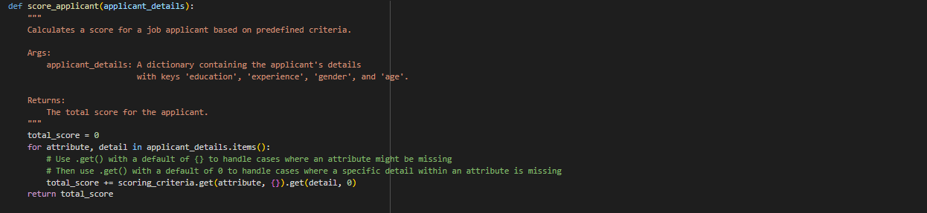  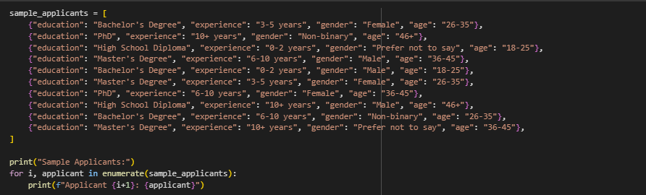  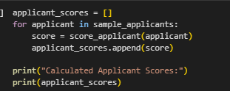  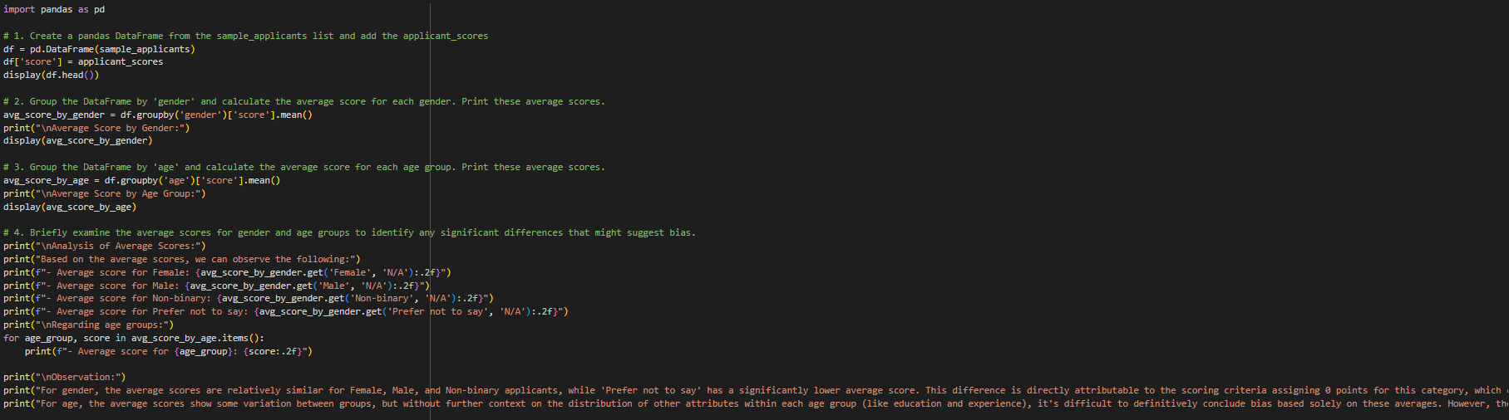  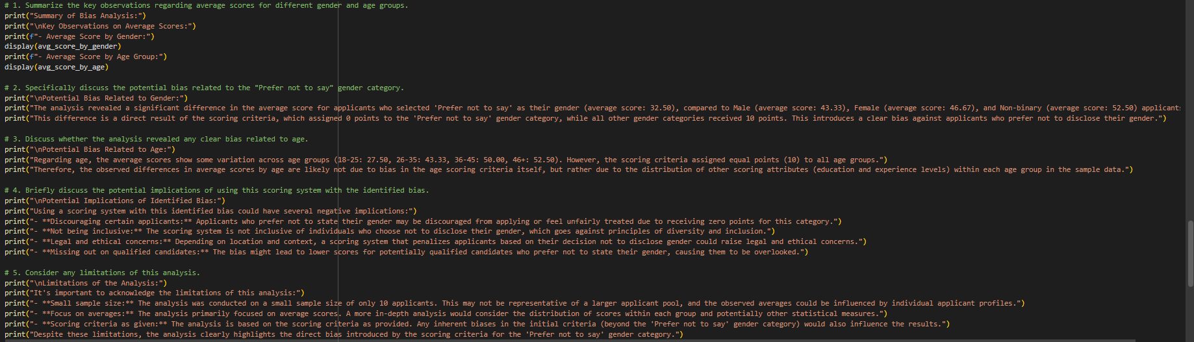  Task Description#5 (Inclusiveness)  - Code Snippet    Expected Output#5  - Regenerate code that includes gender-neutral also  Answer:  Prompt  - Write a python functn to greet_user(name, gender) that greets a person. The fucntioon should support gender-neutral greetings, so if gender is not specified or is non-binary, it should just say Hello {name} welcome.  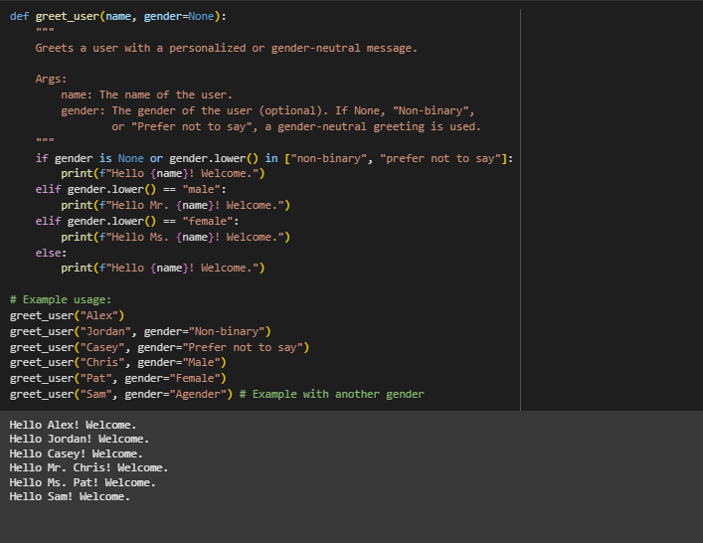  Note: Report should be submitted a word document for all tasks in a single document with prompts, comments & code explanation, and output and if required, screenshots  Evaluation Criteria: |  |  |  |  |  | Week3 - Wednesday
  Criteria | Max Marks
  Transparency | 0.5
  Bias | 1.0
  Inclusiveness | 0.5
  Data security and Privacy | 0.5
  Total | 2.5 Marks

