SCHOOL OF COMPUTER SCIENCE AND ARTIFICIAL INTELLIGENCE |  |  |  |  | DEPARTMENT OF COMPUTER SCIENCE ENGINEERING
Program Name: B. Tech |  |  |  | Assignment Type: Lab |  |  | Academic Year:2025-2026
Course Coordinator Name |  |  |  | Venkataramana Veeramsetty
Instructor(s)Name |  |  |  | 1. Dr. Mohammed Ali Shaik  2. Dr. T Sampath Kumar  3. Mr. S Naresh Kumar  4. Dr. V. Rajesh  5. Dr. Brij Kishore  6. Dr Pramoda Patro  7. Dr. Venkataramana  8. Dr. Ravi Chander  9. Dr. Jagjeeth Singh
Course Code |  |  | 24CS002PC215 | Course Title |  | AI Assisted Coding
Year/Sem |  |  | II/I | Regulation |  | R24
Date and Day  of Assignment |  |  | 06-08-2025 | Time(s)
Duration |  |  | 2 Hours | Applicable to  Batches
AssignmentNumber:6.5(Present assignment number)/24(Total number of assignments)
 | Q.No. | Question |  |  |  |  |  | ExpectedTime  to complete
 | 1 | Lab 6: AI-Based Code Completion: Working with suggestions for classes, loops, conditionals  Lab Assignment 1: Intelligent Code Completion for Object-Oriented Programming  Objective: To explore AI-powered code assistants for writing Python classes, constructors, and methods through intelligent suggestions.  Suppose that you are hired as an intern at a tech company that develops inventory management systems. Your manager asks you to create a Product class and a Warehouse class with some basic methods. You have decided to use AI-powered code suggestions to help speed up development and reduce syntax errors.  Tasks to be completed are as below  1. Setup AI Coding Tool:  - Install and configure GitHub Copilot or Kite with VS Code or JetBrains IDE.  - Enable real-time code suggestions.  2. Class Design Using AI Assistance:  - Begin defining a Product class with attributes: name, price, quantity.  - Use the AI suggestion feature to automatically complete the __init__() method.  - Add a method calculate_value() to return price * quantity.  Answers:  Prompt: Create a Product class and a warehouse class with basic methods for inventory management.  SCREENSHOTS:  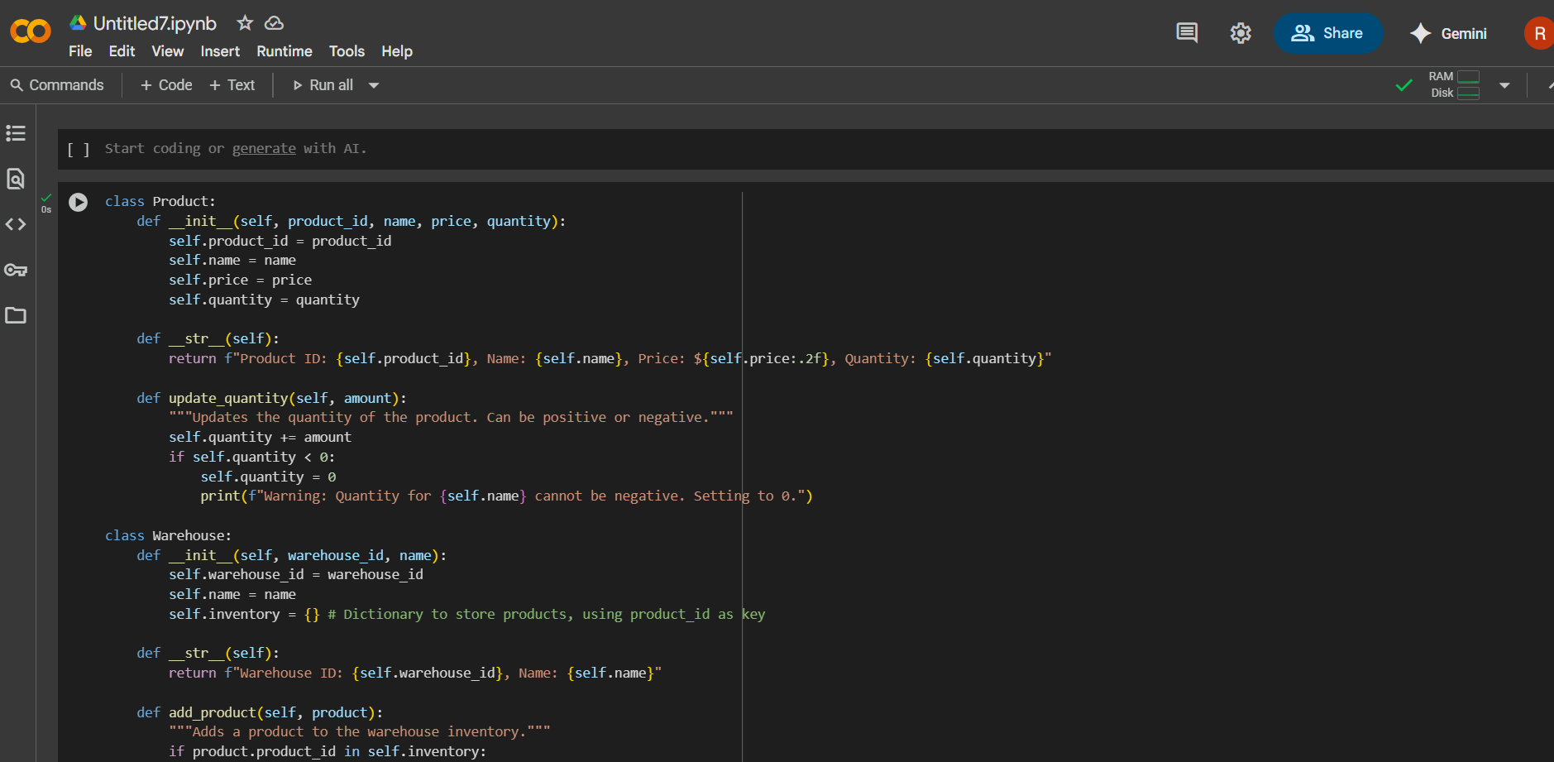  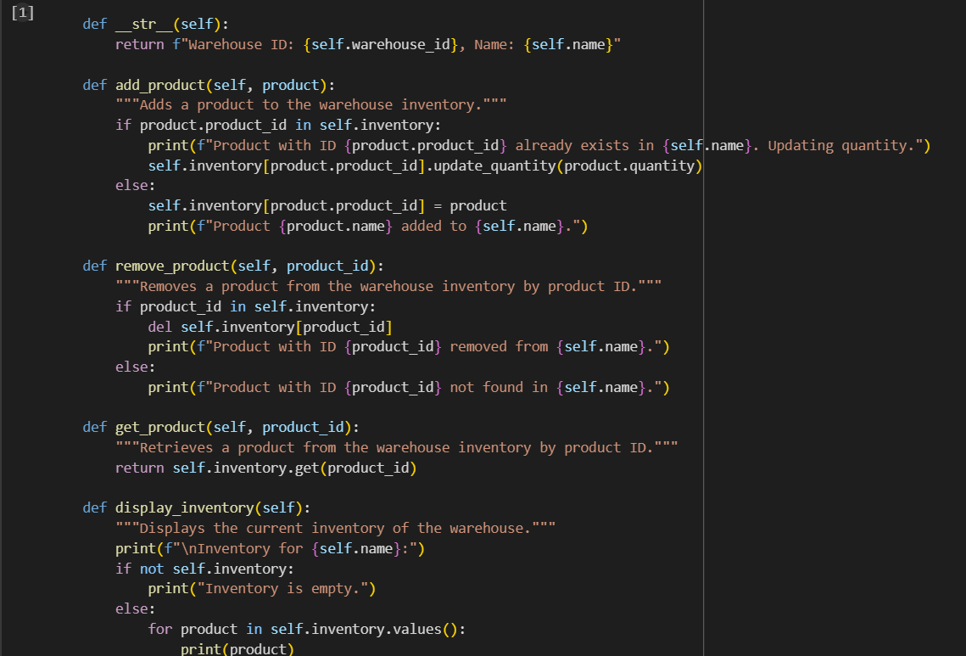  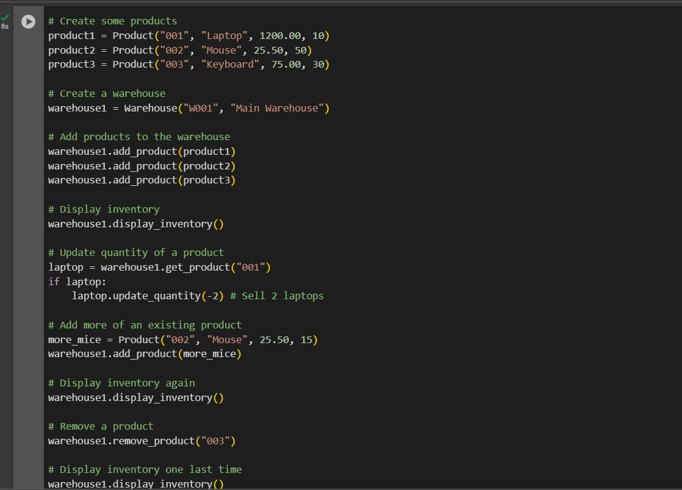  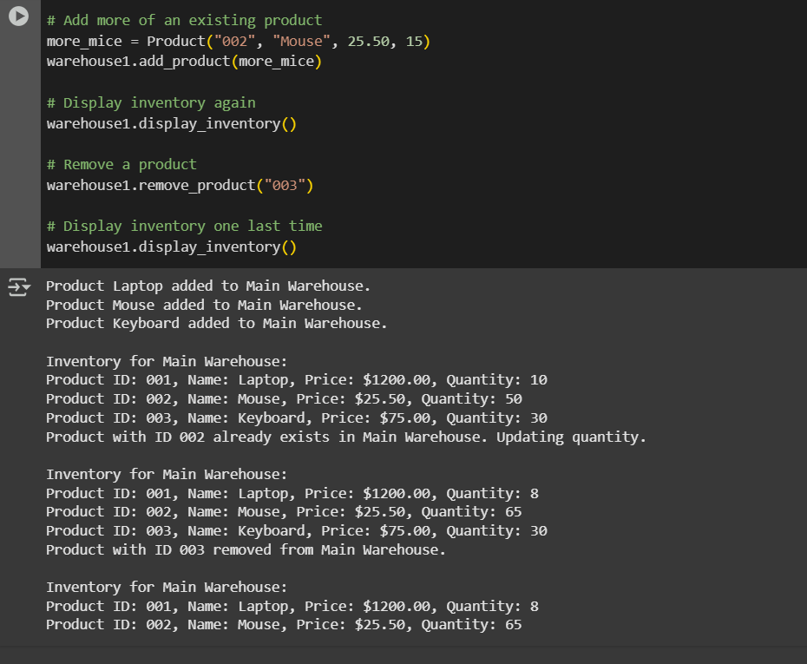  3. Create Another Class:  - Define a Warehouse class with a list of Product objects.  - Use code completion to help implement:  - A method to add a product.  - A method to display the most valuable product.  ANSWERS:  PROMPTS:  1.CREATE ANOTHER CLASS WHICH DEFINE A WAREHOUSE CLASS WITH A LIST OF PRODUCT OBJECTS  2.ALSO IMPLEMENT A METHOD TO ADD A PRODUCT AND A METHOD TO DISPLAY THE MOST VALUABLE PRODUCT  SCREENSHOTS:  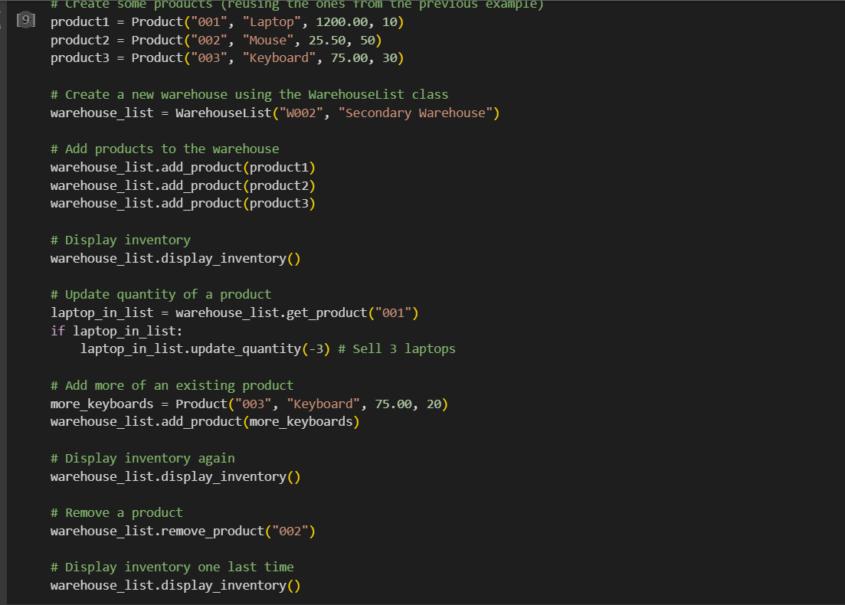  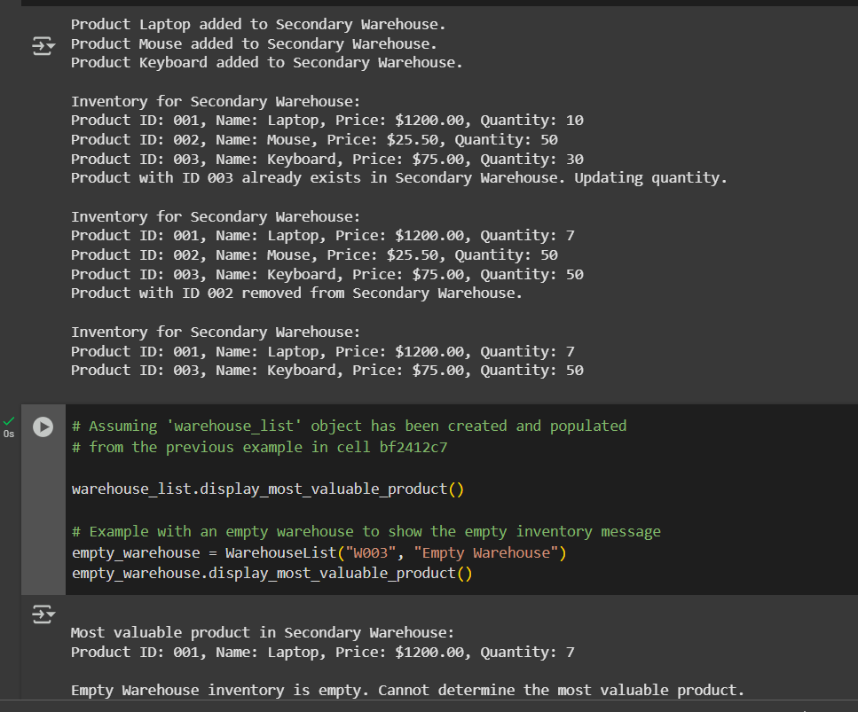  4. Reflection:  - Identify how much of the code was completed by AI and what manual edits were needed.  - Comment on the relevance and accuracy of AI suggestions.  Requirements:  - VS Code with Github Copilot or Cursor API and/or Google Colab with Gemini  Deliverables:  - Python script with both classes and comments on AI-generated suggestions.  - Short report (1 page) summarizing your experience with AI code completion.  .  We created Python classes for basic inventory management, including a Product class and two versions of a Warehouse class (one using a dictionary and one using a list to store products). We added methods to add, remove, and display products, and also a method to find the most valuable product in the list-based warehouse. We also worked through an execution error by clarifying the steps needed to run the updated code correctly. |  |  |  |  |  | 15.08.2025 EOD

