BINARY DISTILLATION COLUMN DESIGN AND PARAMETRIC ANALYSIS OF AN ETHANOL–WATER MIXTURE USING DWSIM AND CHEMSEP
Deepanshu Kumar | Roll No. 124CH0061
Department of Chemical Engineering
National Institute of Technology Rourkela, Odisha | 2026
TABLE OF CONTENTS
Abstract 1
1. Introduction 1
2. Theory 2
2.1 Vapour–Liquid Equilibrium and Relative Volatility 2
2.2 Reflux Ratio and Number of Theoretical Stages 3
2.3 Feed Stage, Total Condenser and Partial Reboiler 3
2.4 The McCabe–Thiele Method 3
2.5 The NRTL Thermodynamic Model 4
2.6 Material and Energy Balances 4
3. Process Simulation Methodology 4
3.1 Software Used and Process Description 4
3.2 Feed Conditions and Column Specifications 5
3.3 Thermodynamic Package, Procedure and Study Matrix 5
4. Simulation Results and Discussion 6
4.1 Effect of Reflux Ratio 6
4.2 Effect of Number of Stages 8
4.3 Effect of Feed Temperature 9
4.4 McCabe–Thiele Interpretation and the Azeotropic Limit 10
4.5 Comparative Assessment of the Design Variables 10
5. Conclusions 11
6. Future Scope 11
References 12
Appendix A – McCabe–Thiele Diagrams 13
ABSTRACT
A continuous binary distillation column separating an equimolar ethanol–water mixture was analysed in DWSIM using the ChemSep rigorous equilibrium-stage column with the NRTL model. A feed of 112.353 kmol/h at 0.50 mole fraction ethanol entered a column at 101.325 kPa with a total condenser and partial reboiler, the bottoms ethanol mole fraction fixed at 0.05 throughout so all cases share a basis. Reflux ratio was varied from 2 to 5 at 12 stages, stage count from 8 to 20 at R = 2, and feed temperature from 25 °C to 78 °C. Raising reflux from 2 to 5 lifted purity from 0.9170 to 0.9779, each unit delivering about half the gain of the one before while the vapour rate rose 87 per cent. Raising stages from 8 to 20 lifted purity from 0.7738 to 0.9883 and proved more energy-efficient, the 20-stage column at R = 2 beating the 12-stage column at R = 5 at half the vapour rate. Feed temperature moved purity less than one percentage point over 53 K. McCabe–Thiele constructions confirmed that the azeotrope, not the equipment, caps purity.
1. INTRODUCTION
Distillation exploits the difference in volatility between the components of a liquid mixture. A single partial vaporisation gives only modest enrichment; the power of the operation comes from cascading many of them in counter-current contact inside one shell, vapour raised in a reboiler rising against liquid falling from a condenser and being progressively enriched in the light key. Energy enters at the reboiler and leaves at the condenser, which is why distillation is among the most energy-intensive unit operations in industry, dominating refining, petrochemicals and the concentration of fermentation ethanol. In the binary case one variable describes any stream and the equilibrium behaviour collapses onto a single x–y curve, which is what makes the McCabe–Thiele construction possible; the design problem reduces to splitting a fixed separation duty between two substitutable resources, stages and reflux.
Ethanol and water form the classical strongly non-ideal binary: both self-associate through hydrogen bonding and the cross-association is weaker, giving large positive deviations from Raoult's law and a minimum-boiling azeotrope near 0.894 mole fraction ethanol and 78.15 °C at atmospheric pressure. No reflux ratio and no stage count in a simple atmospheric column can beat this, since as that point is approached the equilibrium curve converges on the diagonal and the driving force vanishes — a limit that governs every result in Chapter 4. Because hand construction assumes constant molar overflow and cannot easily carry a pressure profile or a third component, the column was instead solved rigorously in DWSIM, an open-source CAPE-OPEN simulator, using the ChemSep column hosted within it, which supplies the MESH solver and the McCabe–Thiele constructions. The objectives were to build a converged model, quantify the effect of reflux ratio, stage count and feed temperature on purity, product distribution and column temperatures, and relate the performance ceiling to the azeotrope. Hydraulics, sizing, control and economics are taken up in Chapter 6.
2. THEORY
2.1 Vapour–Liquid Equilibrium and Relative Volatility
Equilibrium requires equal fugacity of each component in both phases. At low to moderate pressure the vapour may be treated as ideal and the liquid non-ideality carried by the activity coefficient, giving the modified Raoult's law and the relative volatility of the light key:
yᵢ P = xᵢ γᵢ Pᵢˢᵃᵗ (2.1)
α₁₂ = K₁/K₂ = (γ₁P₁ˢᵃᵗ)/(γ₂P₂ˢᵃᵗ) , y₁ = α₁₂x₁/[1 + (α₁₂ − 1)x₁] (2.2)
Here yᵢ and xᵢ are mole fractions, P the pressure in Pa, γᵢ the activity coefficient and Pᵢˢᵃᵗ the saturation vapour pressure from the Antoine equation. For an ideal solution γᵢ = 1; ethanol–water departs severely, γ for ethanol nearing 5 at infinite dilution, and this deviation produces the azeotrope. The larger α, the wider the gap between equilibrium curve and diagonal and the fewer the stages needed; here α falls from roughly 8 at high dilution to unity at x ≈ 0.894, which is why the separation grows harder as the distillate is enriched.
2.2 Reflux Ratio and Number of Theoretical Stages
The external reflux ratio is R = L/D. At total reflux the operating lines lie on the diagonal, the driving force is maximal and the stage requirement minimal, given for constant α by the Fenske equation
Nₘᵢₙ = ln{[x_D/(1 − x_D)]·[(1 − x_B)/x_B]} / ln α_avg (2.3)
At minimum reflux the rectifying line touches the equilibrium curve, a pinch forms and infinite stages are needed, so practical columns run at R = 1.2 to 1.5 Rₘᵢₙ: raising R raises purity but also the vapour rate V = (R + 1)D and hence both duties and the column diameter. Real trays fall short of equilibrium by the overall efficiency Eₒ, typically 0.6 to 0.8 here; all stage counts quoted are theoretical stages including condenser and reboiler. Stage count and reflux are inversely related for a fixed duty, a relation captured by the Gilliland correlation.
2.3 Feed Stage, Total Condenser and Partial Reboiler
The feed should enter where the tray liquid composition matches that of the liquid part of the feed; entering elsewhere remixes streams and wastes separation work. Its thermal condition is the quality q = (Hᵛ − H_F)/(Hᵛ − Hˡ), above unity for a sub-cooled liquid, and the operating lines meet on the q-line
y = [q/(q − 1)]x − x_F/(q − 1) (2.4)
A colder feed raises stripping-section liquid traffic but also the reboiler duty, so its effect is second-order. In a total condenser the whole overhead condenses, so x_D = y₁ and it is not an equilibrium stage; in a partial reboiler the returned vapour leaves in equilibrium with the bottoms, so the reboiler counts as one additional stage.
2.4 The McCabe–Thiele Method
Under constant molar overflow the stage balances become straight lines on the x–y diagram:
yₙ₊₁ = [R/(R + 1)]xₙ + x_D/(R + 1) , yₘ₊₁ = [L̄/(L̄ − B)]xₘ − [B/(L̄ − B)]x_B (2.5)
The rectifying line has slope R/(R + 1), so as R rises it approaches the diagonal and its gap from the equilibrium curve widens. That gap is the driving force on each stage and is the mechanism by which reflux improves separation; stages are stepped off between curve and operating lines from x_D down to x_B.
2.5 The NRTL Thermodynamic Model
The Non-Random Two-Liquid model assumes the local composition around a molecule differs from the bulk composition:
ln γ₁ = x₂²[τ₂₁(G₂₁/(x₁ + x₂G₂₁))² + τ₁₂G₁₂/(x₂ + x₁G₁₂)²] (2.6)
τᵢⱼ = (gᵢⱼ − gⱼⱼ)/RT , Gᵢⱼ = exp(−αᵢⱼτᵢⱼ) (2.7)
with gᵢⱼ interaction energy parameters in J/mol and αᵢⱼ the non-randomness parameter, commonly 0.3 here. NRTL was preferred to an equation of state because this liquid phase is dominated by hydrogen bonding, which cubic equations represent poorly, and it reproduces the azeotrope accurately.
2.6 Material and Energy Balances
For one feed and two products, F = D + B and F x_F = D x_D + B x_B, giving the product split and light-key recovery:
D/F = (x_F − x_B)/(x_D − x_B) , η = D x_D/(F x_F) (2.8)
Equation 2.8 is central to Chapter 4: with x_F and x_B fixed, any rise in purity necessarily cuts the distillate flow. The energy balance is F h_F + Q_R = D h_D + B h_B + Q_C, and for a total condenser Q_C = (R + 1)Dλ, so doubling (R + 1) doubles both duties. Since the reboiler burns high-grade steam, it dominates operating cost, which is why the diminishing returns of Section 4.1 imply a real economic optimum.
3. PROCESS SIMULATION METHODOLOGY
3.1 Software Used and Process Description
The work was carried out in DWSIM, the column solved by the ChemSep CAPE-OPEN unit operation hosted in the flowsheet. Stream conditions, feed composition and the thermodynamic model were set at the DWSIM level; stage count, feed location, condenser and reboiler type and the column specifications inside ChemSep, with converged results returned as product stream properties — these are what Chapter 4 tabulates. The process is a single fractionating column splitting the feed into an ethanol-rich distillate and a water-rich bottoms, shown as built in Figure 3.1.
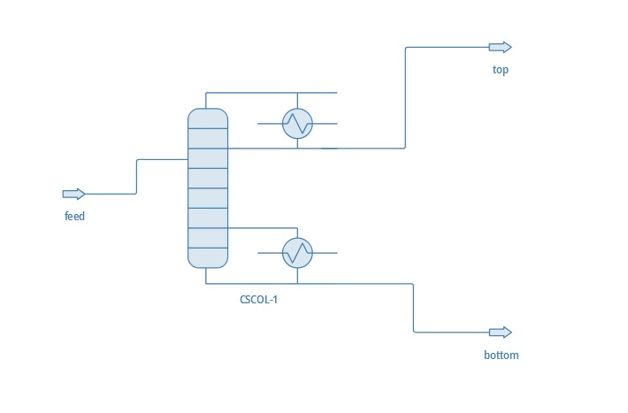
Figure 3.1 DWSIM flowsheet: the feed stream, the ChemSep block CSCOL-1 with its overhead condenser and bottom reboiler, and the top and bottom product streams.
The exchanger symbols are the total condenser and partial reboiler, both internal to CSCOL-1 rather than separate units, which is why their duties appear as column results.
3.2 Feed Conditions and Column Specifications
Table 3.1 Feed stream specification.
Parameter | Value | Unit | Parameter | Value | Unit
Molar flow rate, F | 112.353 | kmol/h | Pressure | 101.325 | kPa
Ethanol mole fraction, x_F | 0.50 | – | Base-case temperature | 25 | °C
Water mole fraction | 0.50 | – | Temperature range studied | 25 – 78 | °C

Table 3.2 Base-case column specifications.
Parameter | Value | Parameter | Value
Number of equilibrium stages | 12 | Operating pressure | 101.325 kPa
Feed stage (from top) | 7 | Bottoms ethanol fraction, x_B | 0.05
Reflux ratio, R | 2 | Condenser type | Total
Stage efficiency | 1.0 | Reboiler type | Partial

At 25 °C the feed is a sub-cooled liquid, the equimolar bubble point lying near 81 °C; even the hottest case, 78 °C, is below saturation, so the feed stays single-phase and q > 1 throughout, which matters to Section 4.3. Two specifications close the degrees of freedom of such a column, taken here as the reflux ratio and the bottoms ethanol mole fraction. Fixing x_B at 0.05 is deliberate: it holds the ethanol loss concentration constant so all cases share a basis and differences in purity trace solely to the variable manipulated. Had purity been specified instead, reflux would have become a result rather than an input and the studies would not be comparable.
3.3 Thermodynamic Package, Procedure and Study Matrix
NRTL was selected for the liquid phase with an ideal vapour phase and Antoine vapour pressures, using regressed ethanol–water parameters from the built-in databank. The system is polar, strongly hydrogen-bonding and below 1 MPa, pointing directly to an activity-coefficient model; Peng–Robinson cannot reproduce the azeotrope with conventional mixing rules and would have given a meaningless prediction of purity.
Ethanol and water were added to a new steady-state simulation, the NRTL package assigned and its parameters checked for non-zero regressed values rather than defaults, and the unit set configured to SI. The feed was specified per Table 3.1 and solved alone to confirm a single liquid phase at 25 °C. The ChemSep column was then placed and its ports connected; within ChemSep the equilibrium-stage model was selected at unit efficiency, the stage count set to 12, condenser total and reboiler partial, and the pressure fixed at 101.325 kPa on all stages with no pressure drop. The feed entered at stage 7, counting the condenser as stage 1; for the stage study it was moved to hold roughly the same fractional position, which is why the feed stage in Table 4.3 varies with the total — a fixed absolute number would have confounded stage count with feed misplacement. Every case was checked for material-balance closure before acceptance: product flows summed to 112.353 kmol/h and the ethanol balance closed to 56.18 kmol/h in all thirteen runs.
Table 3.3 Parametric study matrix. All other specifications held at the base-case values of Table 3.2.
Study | Variable | Levels investigated | Fixed conditions
A | Reflux ratio | 2, 3, 4, 5 | 12 stages, feed stage 7, feed at 25 °C
B | Number of stages | 8, 10, 12, 15, 20 | R = 2, feed at 25 °C, feed stage scaled with height
C | Feed temperature | 25, 40, 60, 78 °C | 12 stages, feed stage 7, R = 2

A one-factor-at-a-time design isolates the mechanism by which each variable acts; its limitation, that interactions are not captured, is noted in Chapter 6.
4. SIMULATION RESULTS AND DISCUSSION
In all thirteen runs the bottoms ethanol mole fraction met its specified 0.05 and the bottoms temperature converged to 90.9011 °C — expected, since with bottoms composition and pressure both fixed the bottoms bubble point is thermodynamically determined and cannot respond to changes elsewhere. Its constancy confirms the specification was met each time and is not remarked on again.
4.1 Effect of Reflux Ratio
Table 4.1 Reflux ratio study: inputs and converged results. All cases 12 stages, feed stage 7, feed 112.353 kmol/h at 25 °C and x_F = 0.50, bottoms specification x_B = 0.05.
Case | R | Top T (°C) | Bottom T (°C) | D (kmol/h) | B (kmol/h) | x_D ethanol | x_D water | x_B ethanol | x_B water
1 | 2 | 79.8687 | 90.9011 | 58.3130 | 54.0400 | 0.917026 | 0.082974 | 0.05 | 0.95
2 | 3 | 79.3087 | 90.9011 | 55.8790 | 56.4740 | 0.954792 | 0.045208 | 0.05 | 0.95
3 | 4 | 79.0838 | 90.9011 | 54.9425 | 57.4106 | 0.970215 | 0.029785 | 0.05 | 0.95
4 | 5 | 78.9728 | 90.9011 | 54.4885 | 57.8645 | 0.977881 | 0.022119 | 0.05 | 0.95

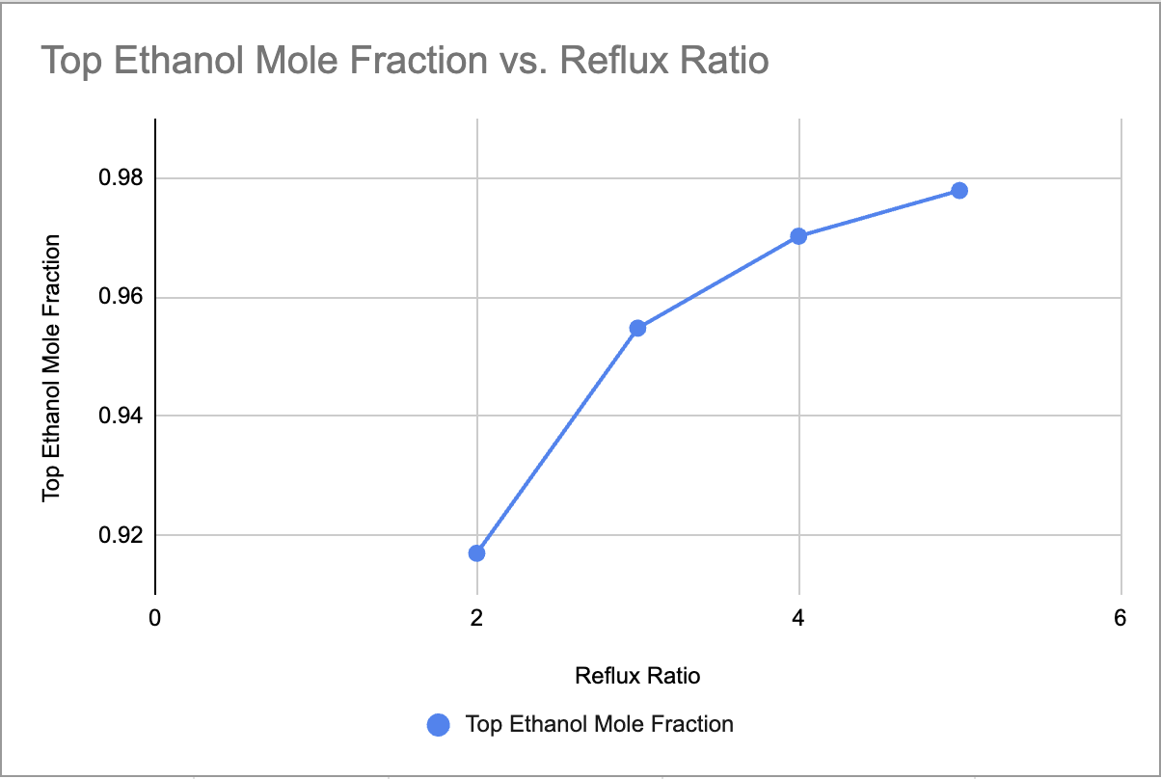  Figure 4.1 x_D versus reflux ratio. | 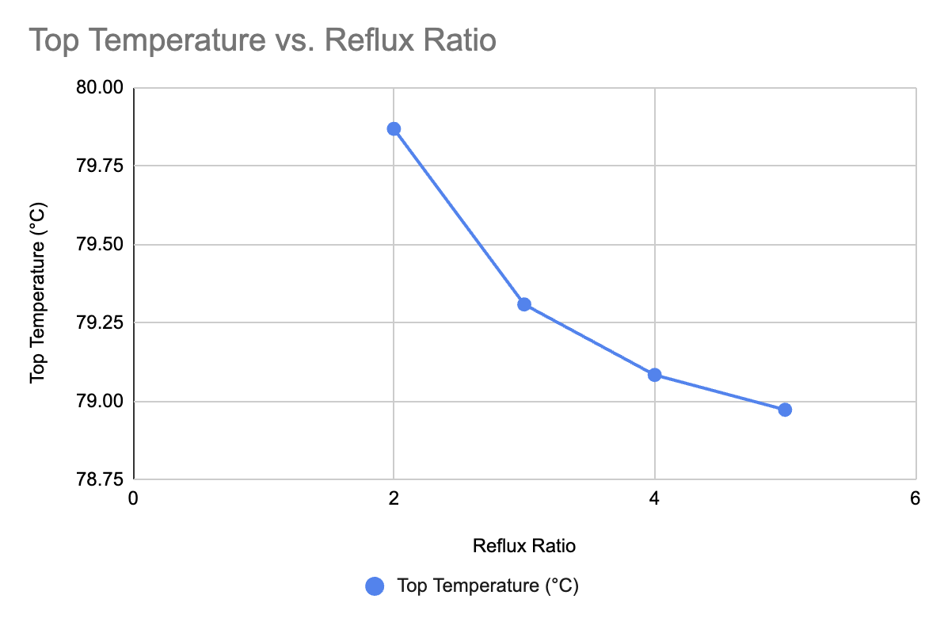  Figure 4.2 Top temperature versus reflux ratio. | 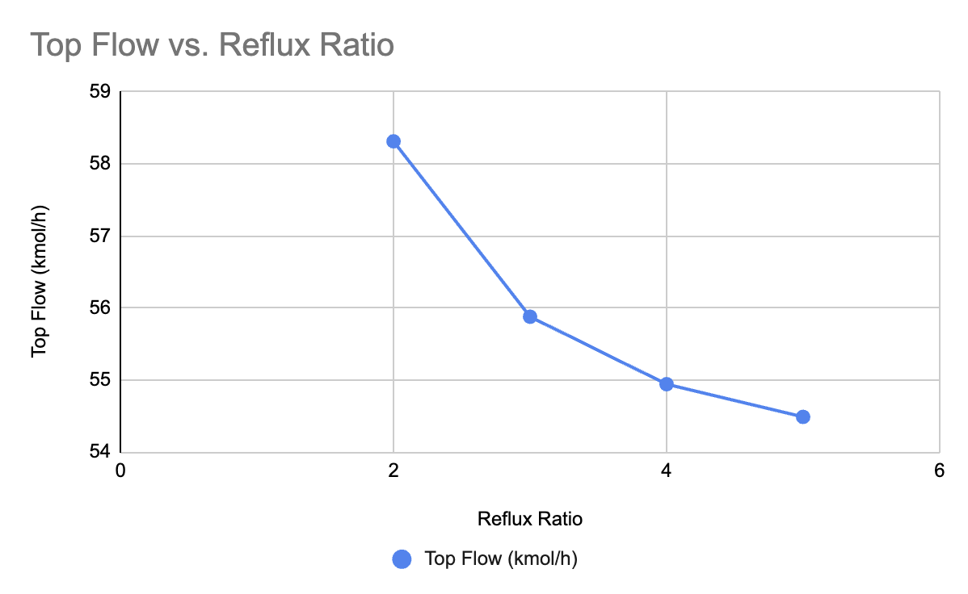  Figure 4.3 Distillate flow versus reflux ratio.

Table 4.1 and Figure 4.1 show purity rising from 0.9170 to 0.9779 as R goes from 2 to 5. Its distribution matters more than its size: the successive steps gained 0.0378, 0.0154 and 0.0077, each unit of reflux delivering about half the benefit of the one before. The mechanism is Equation 2.5 — the operating line slope R/(R + 1) takes the values 0.667, 0.750, 0.800 and 0.833, rotating the line towards the diagonal and widening the driving force on each stage — but the slope saturates, its increment falling from 0.083 to 0.033, so further reflux has less geometric room in which to act. Superimposed is the approach to the azeotrope, where the curve meets the diagonal and the driving force collapses whatever the slope; the flattening beyond R = 4 is that pinch setting in.
Figure 4.2 shows the condenser temperature falling from 79.8687 °C to 78.9728 °C. The top temperature is not independent but the bubble point of the distillate, so enriching it in ethanol lowers it; the decrements of 0.560, 0.225 and 0.111 K mirror the purity increments almost exactly in ratio, a useful consistency check. At R = 5 the value of 78.97 °C approaches the azeotropic boiling point of 78.15 °C, and in practice the overhead temperature is used this way as an inferential composition measurement for control.
Figure 4.3 shows the distillate flow falling from 58.3130 to 54.4885 kmol/h with the bottoms rising to match — the material balance, Equation 2.8, since D = 112.353 × 0.45/(0.9170 − 0.05) = 58.31 kmol/h at R = 2 and 54.49 kmol/h at R = 5, both reproducing the simulation. Under a fixed bottoms specification, purity and yield are not independent.
Table 4.2 Ethanol recovery and internal vapour rate versus reflux ratio, computed from the data of Table 4.1.
R | x_D | D (kmol/h) | Ethanol in D (kmol/h) | Ethanol in B (kmol/h) | Recovery η (%) | V = (R+1)D (kmol/h)
2 | 0.9170 | 58.313 | 53.474 | 2.702 | 95.19 | 174.9
3 | 0.9548 | 55.879 | 53.354 | 2.824 | 94.97 | 223.5
4 | 0.9702 | 54.943 | 53.306 | 2.871 | 94.89 | 274.7
5 | 0.9779 | 54.489 | 53.283 | 2.893 | 94.85 | 326.9

Table 4.2 exposes what the purity plot conceals: recovery does not improve with reflux but declines slightly, from 95.19 to 94.85 per cent, because the bottoms specification is a concentration rather than a quantity — as the bottoms flow grows from 54.04 to 57.86 kmol/h it carries more ethanol out of the base. Meanwhile the vapour rate rises 87 per cent and the duties with it, so the column would burn 87 per cent more energy and need a diameter about 37 per cent larger to gain six points of purity and a slightly worse recovery. Unless the specification demands better than 95 mole per cent, R = 3 is the defensible choice, capturing 62 per cent of the gain for 32 per cent of the extra vapour traffic.
4.2 Effect of Number of Stages
Table 4.3 Stage number study: inputs and converged results. All cases R = 2, feed 112.353 kmol/h at 25 °C and x_F = 0.50, bottoms specification x_B = 0.05.
Case | Stages | Feed stage | Top T (°C) | Bottom T (°C) | D (kmol/h) | B (kmol/h) | x_D ethanol | x_D water | x_B ethanol
1 | 8 | 4 | 82.1224 | 90.9011 | 69.8515 | 42.5015 | 0.773805 | 0.226195 | 0.05
2 | 10 | 5 | 80.6800 | 90.9011 | 62.1200 | 50.2330 | 0.863890 | 0.136110 | 0.05
3 | 12 | 7 | 79.8687 | 90.9011 | 58.3130 | 54.0401 | 0.917026 | 0.082974 | 0.05
4 | 15 | 8 | 79.2356 | 90.9011 | 55.5722 | 56.7808 | 0.959787 | 0.040213 | 0.05
5 | 20 | 11 | 78.8227 | 90.9011 | 53.8829 | 58.4702 | 0.988311 | 0.011689 | 0.05

Table 4.3 and Figure 4.4 show purity rising from 0.7738 to 0.9883 as the stage count goes from 8 to 20 at R = 2 — 21.45 percentage points, more than three times what the whole reflux study delivered. At R = 2 this column is stage-limited, not reflux-limited: eight stages give too few contacting steps to climb the equilibrium curve from the feed to a useful overhead purity. The gains are again uneven, the marginal contribution falling from 0.0450 mole fraction per stage between 8 and 10 stages to 0.0057 between 15 and 20, a factor of eight. The reason is geometric and visible in Appendix A: at low ethanol composition the equilibrium curve bows far above the diagonal and each step is wide, whereas above x = 0.8 it descends towards the diagonal and the steps narrow, so stages added at the top are intrinsically less productive than stages in the middle.
Comparing the two studies gives the most useful result of this project. At 12 stages and R = 5 the distillate reached 0.9779; at 20 stages and R = 2 it reached 0.9883, at a vapour rate of 161.6 against 326.9 kmol/h — roughly half the energy. Eight extra stages of height permanently displace a doubling of the reboiler steam load, which for a column of this size would almost certainly be justified over any realistic operating life.
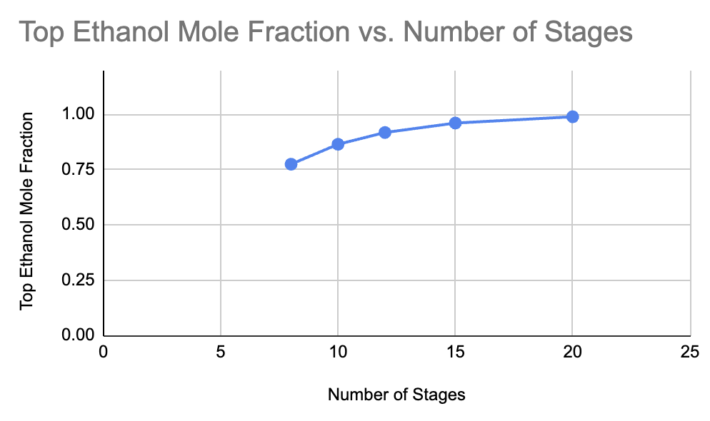  Figure 4.4 x_D versus number of stages. | 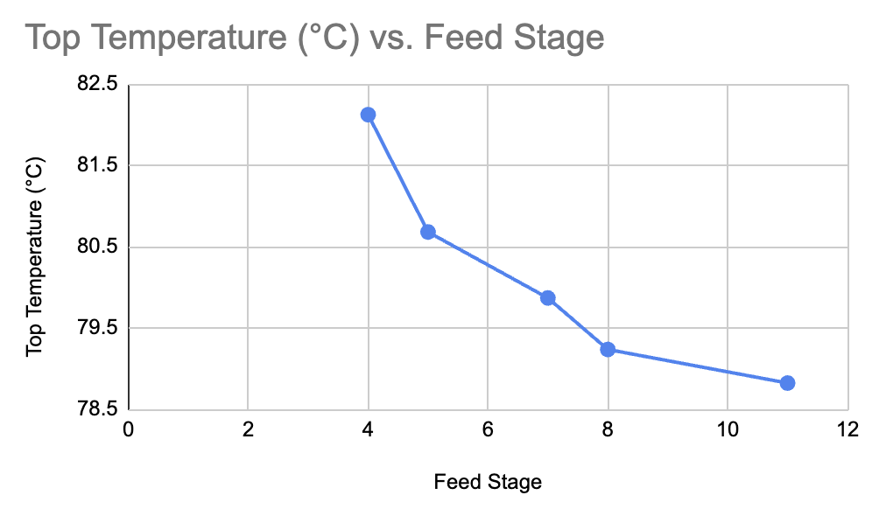  Figure 4.5 Top temperature versus number of stages. | 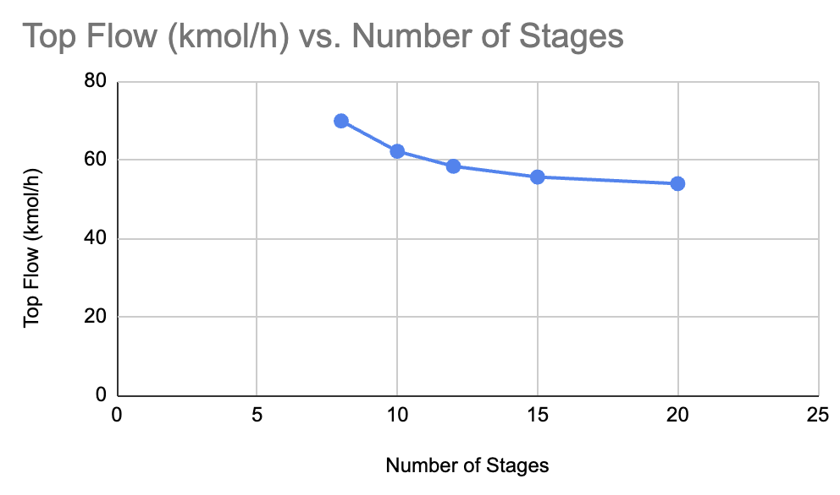  Figure 4.6 Distillate flow versus number of stages.

Figure 4.5 shows the top temperature falling from 82.1224 °C to 78.8227 °C, about four times the response to reflux. At eight stages the distillate bubble point is close to the feed's own, showing very little rectification; at twenty it lies within 0.7 K of the azeotropic boiling point. Efficiency can also be judged through the separation factor S = [x_D/(1 − x_D)]·[(1 − x_B)/x_B], taking from Table 4.3 the values 65.0, 120.5, 210.1, 454.1 and 1606; on the logarithmic basis Equation 2.3 implies, ln S rises from 4.17 to 7.38, almost linearly with stage count — a useful check that the Fenske relation keeps its descriptive value even in rigorous MESH results on a strongly non-ideal system.
Figure 4.6 shows the distillate flow falling from 69.8515 to 53.8829 kmol/h, again by Equation 2.8: at eight stages the distillate is large and impure, because with the bottoms held at 0.05 a poor distillate must be a large one to carry away the ethanol the bottoms may not retain, and D = 112.353 × 0.45/(0.7738 − 0.05) = 69.85 kmol/h matches the simulation exactly. Recovery is again nearly constant, 96.2 against 94.8 per cent, for the reason given in Table 4.2: both stages and reflux buy concentration rather than recovery, and had recovery been the objective the specification should have been a fixed ethanol loss rate.
4.3 Effect of Feed Temperature
Table 4.4 Feed temperature study: inputs and converged results. All cases 12 stages, feed stage 7, R = 2, feed 112.353 kmol/h at x_F = 0.50, bottoms specification x_B = 0.05.
Case | Feed T (°C) | Top T (°C) | Bottom T (°C) | D (kmol/h) | B (kmol/h) | x_D ethanol | x_D water | x_B ethanol | x_B water
1 | 25 | 80.0375 | 90.9011 | 59.0765 | 53.2766 | 0.905821 | 0.094179 | 0.05 | 0.95
2 | 40 | 80.0700 | 90.9011 | 59.2251 | 53.1279 | 0.903673 | 0.096327 | 0.05 | 0.95
3 | 60 | 80.1176 | 90.9011 | 59.4439 | 52.9091 | 0.900530 | 0.099470 | 0.05 | 0.95
4 | 78 | 80.1654 | 90.9011 | 59.6648 | 52.6883 | 0.897382 | 0.102618 | 0.05 | 0.95

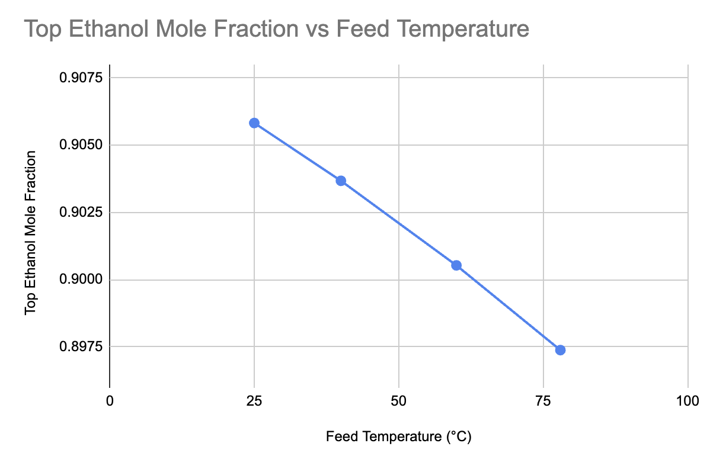  Figure 4.7 x_D versus feed temperature. | 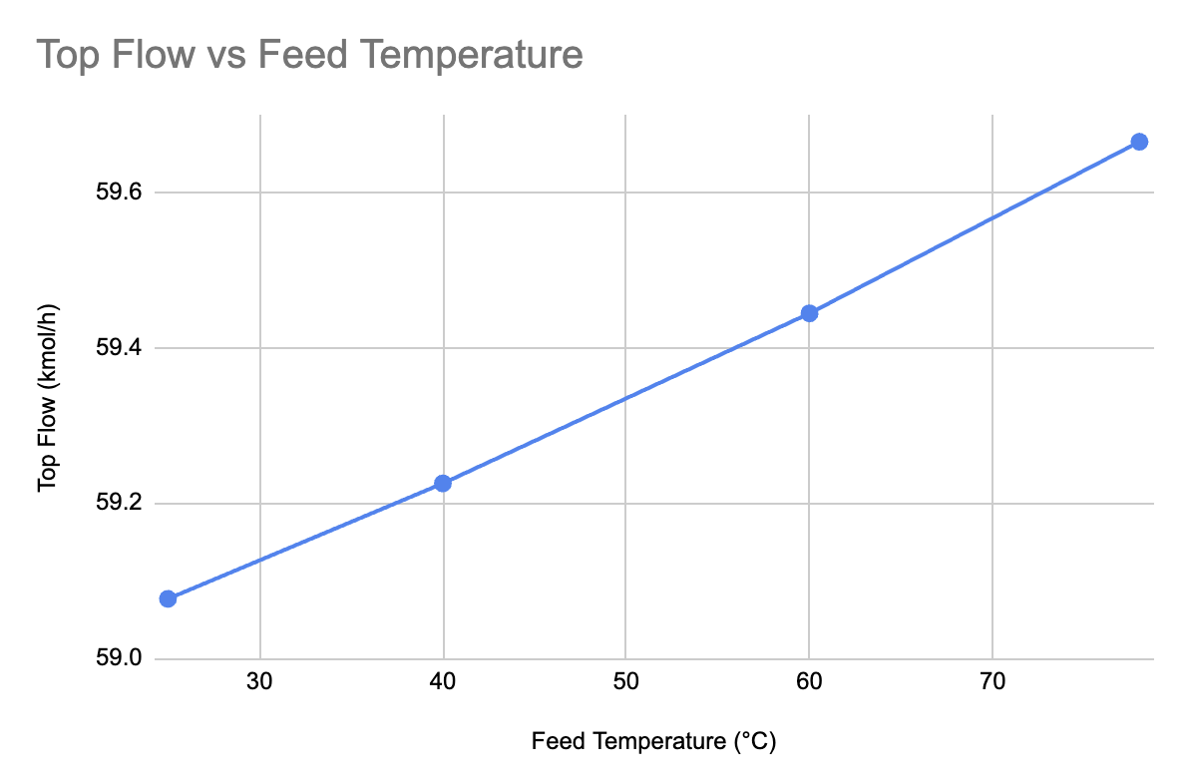  Figure 4.8 Distillate flow versus feed temperature.

Over 53 K of preheat the distillate ethanol mole fraction fell from 0.9058 to 0.8974, a decline of 0.0084. The compressed vertical scale of Figure 4.7 should be borne in mind, since the apparently steep line hides a change an order of magnitude smaller than those of the other two variables. The direction is meaningful rather than noise, purity falling monotonically by 0.0021, 0.0032 and 0.0031, which is what q-line theory predicts: preheating drives q towards unity, cutting the liquid the feed gives the stripping section, so the liquid-to-vapour ratio below the feed falls and the section recovers ethanol slightly less effectively. With the bottoms held at 0.05 the solver compensates with a larger, less pure distillate, which is what Figure 4.8 shows, D rising from 59.0765 to 59.6648 kmol/h — exactly what Equation 2.8 requires at that purity. The top temperature rose 0.128 K.
Three reasons account for the weakness of the effect. First and most importantly, the feed stayed sub-cooled throughout: the equimolar bubble point is near 81 °C, so even the 78 °C feed holds no vapour and q changed only from roughly 1.3 to 1.0, never entering the two-phase region where the q-line swings through the large angular range that rotates the operating lines substantially. Second, feed enthalpy acts only through the internal flows, and with reflux fixed at 2 the rectifying section — where purity is actually determined — saw no change at all in its operating line. Third, the two specifications constrain the outcome tightly; had purity been specified instead, the effect would have surfaced as a change in reboiler duty, which is where its economic significance lies. Preheating here is a heat-integration measure, not a separation one.
4.4 McCabe–Thiele Interpretation and the Azeotropic Limit
At R = 2 (Figure A.1) the construction terminates near 0.90 mole fraction, consistent with the tabulated 0.9170; the operating lines stand clear of the equilibrium curve over the middle of the diagram and the steps there are wide, while the change in slope at x = 0.50 marks the feed stage. At R = 5 (Figure A.2) the lines lie closer to the diagonal as Equation 2.5 requires and the construction reaches about 0.98, matching 0.9779, but the steps at the upper-right end are markedly narrower, crowded into the region where the equilibrium curve converges on the diagonal. That crowding is the graphical signature of the pinch — the same effect seen in Figure 4.1 as the flattening purity curve and in Section 4.2 as the collapsing marginal value of a stage.
That convergence is the azeotrope, which NRTL places near 0.894 mole fraction, and it caps the column. The purities obtained at high reflux and high stage count, 0.9779 and 0.9883, lie at or beyond it and should be read with caution: they represent the column driven hard against its thermodynamic limit, where the result is acutely sensitive to the binary interaction parameters and the unit-efficiency assumption is least defensible, and a real column at 0.6 to 0.8 tray efficiency would not reproduce them. Beyond roughly 0.95 mole fraction the phase equilibrium itself is the limit, so anhydrous ethanol demands a change of process — pressure-swing or extractive distillation, or distillation to about 0.93 followed by molecular-sieve dehydration.
4.5 Comparative Assessment of the Design Variables
Table 4.5 Comparative sensitivity of the three design variables.
Variable | Range studied | Δx_D over range | Sensitivity | Δ Top T (K) | Δ D (kmol/h)
Reflux ratio | 2 → 5 | +0.0609 | 0.0203 per unit R | −0.90 | −3.82
Number of stages | 8 → 20 | +0.2145 | 0.0179 per stage | −3.30 | −15.97
Feed temperature | 25 → 78 °C | −0.0084 | −0.00016 per K | +0.13 | +0.59

Table 4.5 shows stage count to be the dominant variable, both in the improvement it delivers and in delivering it without raising the vapour rate. Reflux is comparably effective per unit but carries a proportional energy penalty, and feed temperature is orders of magnitude weaker and acts unfavourably. It should be recorded that the base case of the feed temperature study (Table 4.4, Case 1) returned 0.9058 whereas the nominally identical base case of the reflux study (Table 4.2, Case 1) returned 0.9170, a difference of 0.0112 arising from the convergence path of two separate run sequences. Each study is internally self-consistent and the trends within each are unaffected, but absolute values compared across studies are indicative only to about one percentage point.
5. CONCLUSIONS
Raising the reflux ratio from 2 to 5 at 12 stages lifted distillate purity from 0.9170 to 0.9779 and lowered the condenser temperature from 79.87 °C to 78.97 °C, but with strongly diminishing returns: the gain per unit of reflux halved at each step, because the operating line slope R/(R + 1) saturates and the distillate was approaching the azeotrope, while the vapour rate and both duties rose 87 per cent. Operation near R = 3 captures about 62 per cent of the available purity gain for 32 per cent of the additional vapour traffic. Stage count was the more effective variable: at R = 2, going from 8 to 20 stages raised purity from 0.7738 to 0.9883 and lowered the condenser temperature from 82.12 °C to 78.82 °C, the marginal contribution of a stage falling eightfold as added stages fell increasingly in the pinched region near the azeotrope. Decisively, the 20-stage column at R = 2 beat the 12-stage column at R = 5 at roughly half the vapour rate, so column height is the more economical route to purity here. Feed temperature had comparatively little influence, preheating from 25 °C to 78 °C moving purity by only −0.0084 and the condenser temperature by +0.13 K — correctly signed and monotonic, but an order of magnitude weaker, principally because the feed stayed sub-cooled and q never entered the two-phase region. Preheating here cuts reboiler duty rather than improving purity.
Two results came from the material balance rather than any single study. Under a fixed bottoms specification, purity and distillate flow are rigidly and inversely coupled through D = F(x_F − x_B)/(x_D − x_B), which the simulated flows reproduced in all thirteen runs; and recovery fell slightly with both reflux and stages, from 95.19 to 94.85 per cent, because a fixed bottoms concentration on a growing bottoms stream carries away more ethanol, so recovery and concentration are distinct objectives needing distinct specifications. Finally, the McCabe–Thiele constructions confirmed that the ceiling on purity is set by the azeotrope near 0.894 mole fraction and not by the equipment, so purities computed above it are the limit of the model rather than an achievable outcome.
6. FUTURE SCOPE
The reflux study showed the vapour rate rising 87 per cent between R = 2 and R = 5, but the reboiler and condenser duties were not extracted; recording them as specific energy in MJ per kmol of ethanol would turn the purity curves of Chapter 4 into energy curves and locate the true minimum-energy operating point, with the optimum feed stage found by minimising reboiler duty rather than assumed. A total annualised cost analysis would then fix the economic optimum in the (N, R) plane, which Section 4.2 suggests lies at higher stage count and lower reflux than the base case. Heat integration follows from Section 4.3: a feed–bottoms exchanger recovering heat from the bottoms at 90.9 °C would quantify the reboiler duty saved, and with only about 12 K between condenser and reboiler this column is a strong candidate for mechanical vapour recompression. Beyond that, the model could be extended to the congeners of real fermentation broth, to the azeotrope-breaking schemes of Section 4.4, to ChemSep's rate-based mode with a defined tray geometry, and to a response-surface design capturing the interactions a one-factor-at-a-time study cannot.
REFERENCES
[1] W. L. McCabe, J. C. Smith, and P. Harriott, Unit Operations of Chemical Engineering, 7th ed. New York, NY, USA: McGraw-Hill, 2005.
[2] J. M. Coulson and J. F. Richardson, Chemical Engineering, Volume 2, 5th ed. Oxford, U.K.: Butterworth-Heinemann, 2002.
[3] R. K. Sinnott, Coulson and Richardson's Chemical Engineering, Volume 6: Chemical Engineering Design, 4th ed. Oxford, U.K.: Butterworth-Heinemann, 2005.
[4] D. W. Green and M. Z. Southard, Eds., Perry's Chemical Engineers' Handbook, 9th ed. New York, NY, USA: McGraw-Hill Education, 2019.
[5] J. D. Seader, E. J. Henley, and D. K. Roper, Separation Process Principles, 3rd ed. Hoboken, NJ, USA: John Wiley & Sons, 2011.
[6] H. Renon and J. M. Prausnitz, “Local compositions in thermodynamic excess functions for liquid mixtures,” AIChE J., vol. 14, no. 1, pp. 135–144, Jan. 1968.
[7] J. M. Smith, H. C. Van Ness, and M. M. Abbott, Introduction to Chemical Engineering Thermodynamics, 7th ed. New York, NY, USA: McGraw-Hill, 2005.
[8] J. M. Prausnitz, R. N. Lichtenthaler, and E. G. de Azevedo, Molecular Thermodynamics of Fluid-Phase Equilibria, 3rd ed. Upper Saddle River, NJ, USA: Prentice Hall, 1999.
[9] H. Z. Kister, Distillation Design. New York, NY, USA: McGraw-Hill, 1992.
[10] E. R. Gilliland, “Multicomponent rectification: Estimation of the number of theoretical plates as a function of the reflux ratio,” Ind. Eng. Chem., vol. 32, no. 9, pp. 1220–1223, Sep. 1940.
[11] R. Taylor and R. Krishna, Multicomponent Mass Transfer. New York, NY, USA: John Wiley & Sons, 1993.
[12] H. A. Kooijman and R. Taylor, The ChemSep Book, 2nd ed. Norderstedt, Germany: Books on Demand, 2006.
[13] D. W. Medeiros, DWSIM Process Simulator — User Guide, Version 8. [Online]. Available: https://dwsim.org/. [Accessed: Jul. 2026].
[14] CAPE-OPEN Laboratories Network, CAPE-OPEN Interface Specification: Unit Operations, Version 1.1. [Online]. Available: https://www.colan.org/. [Accessed: Jul. 2026].
[15] J. Gmehling, U. Onken, and W. Arlt, Vapor–Liquid Equilibrium Data Collection, DECHEMA Chemistry Data Series, Vol. I, Part 1a. Frankfurt, Germany: DECHEMA, 1981.
APPENDIX A – McCABE–THIELE DIAGRAMS
The green curve is the ethanol–water equilibrium curve at 101.325 kPa from the NRTL model, the blue lines the rectifying and stripping operating lines, the black line the 45° diagonal and the red staircase the stage-to-stage construction; the grey marker is the feed stage.
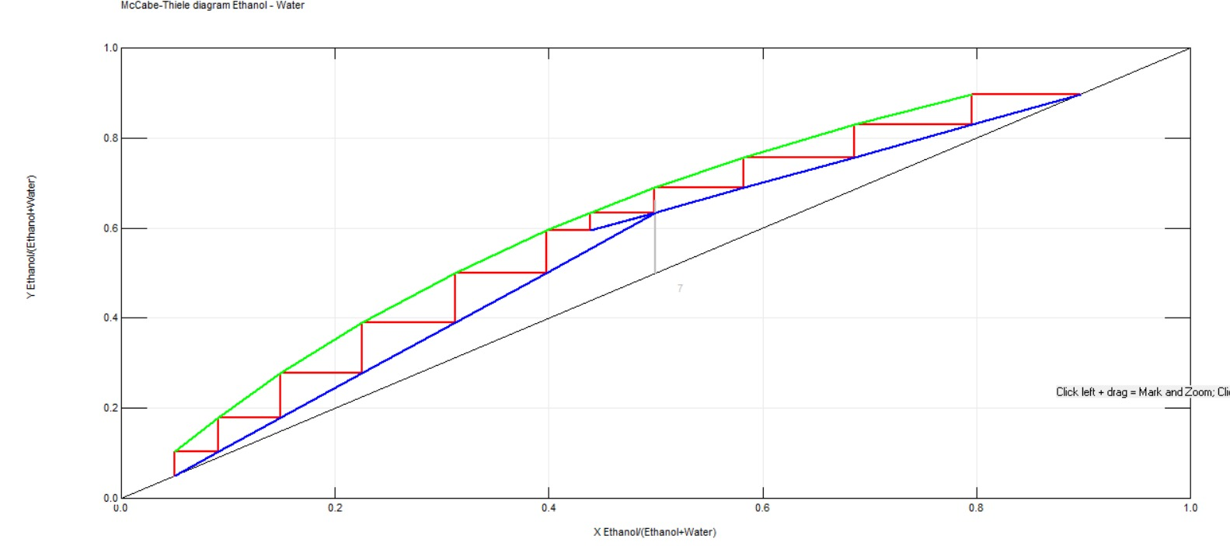
Figure A.1 McCabe–Thiele construction at R = 2 (12 stages, feed stage 7), corresponding to Case 1 of Table 4.1.
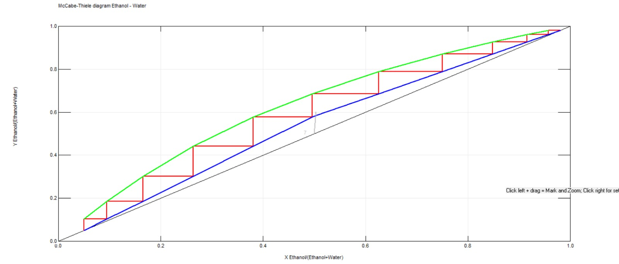
Figure A.2 McCabe–Thiele construction at R = 5 (12 stages, feed stage 7), corresponding to Case 4 of Table 4.1.

