High Level Design (HLD)

Thyroid Detection

Revision Number: 1.0

Last date of revision:

## Document Version Control

|  |  |  |  |
| --- | --- | --- | --- |
| Date Issued | Version | Description | Author |
| 01/07/2022 | 1.0 | Initial HLD – V I .0 | Ritik Bhambid |
|  |  |  |  |
|  |  |  |  |
|  |  |  |  |
|  |  |  |  |
|  |  |  |  |
|  |  |  |  |

Contents

Document Version Control**……………………………………………………………………………………**2

Abstract**………………………………………………………………………………………………………..**4

1. Introduction…………………......................................................................................................5
   1. Why this High-Level Design Document?.................................................................5

1.2 Scope………………………………..……………………………………………………………………………..…5

1.3 Definitions………………………………………………………………………………………………………….6

2. General Description………………………………………………………………………………………….…………….7

2.1 Product Perspective……………………………………………………………………………………………7

2.2 Problem Statement…………………………………………………………………………………………….7

2.3 Proposed Solution………………………………………………………………………………………………7

2.4 Furher Improvements…………………………………………………………………………………………8

2.5 Data Requirements…………………………………………………………………………………………….8

2.6 Tools used…………………………………………………………………………………………………………..9

2.7 Constraints……………………………….……………………………………………………….……………….9

2.9 Assumptions……………………………………………………………………………………………………….9

3. Design Details…………………………………………………………………………………………………………………10

3.1 Process Flow…………………………………………………………………………………………………….10

3.1.1 Model Training and Evaluation………………………………………………………….11

3.1.2 Deployment Process………………………………………………………………………….12

3.2 Event log…………………………………………………………………………………………………………..12

3.3 Error Handling…………………………………………………………………………………………………..13

4. Performance……………………………………………………………………………………………………………………14

4.1 Reusability………………………………………………………………………………………………………..14

4.2 Application Compatibility………………………………………………………………………………….14

4.3 Resource Utilization………………………………………………………………………………………….14

4.4 Deployment………………………………………………………………………………………………………14

6. Dashboard……………………………………………………………………………………………………………………….15

5. Conclusion………………………………………………………………………………………………………………………16

Abstract

Thyroid disease is a major cause of formation in medical diagnosis and in the prediction, onset to which it is a difficult axiomin the medical research. Thyroid gland is one of the most important organs in our body. The secretions of thyroid hormones are culpable in controlling the metabolism. Hyperthyroidism and hypothyroidism are one of the two common diseases of the thyroid that releases thyroid hormones in regulating the rate of body's metabolism. It is important to ensure a decent knowledge base that can be entrenched and used as a hybrid model in solving complex learning task, to predict the estimated risk on a patient's chance of obtaining thyroid disease.

1. Introduction

1.1 Why this High-Level Design Document?

The purpose of this High-Level Design (HLD) Document is to add the necessary detail to the current project description to represent a suitable model for coding. This document is also intended to help detect contradictions prior to coding, and can be used as a reference manual for how the modules interact at a high level.

The HLD will:

* Present all of the design aspects and define them in detail
* Describe the user interface being implemented
* Describe the hardware and software interfaces
* Describe the performance requirements
* Include design features and the architecture of the project
* List and describe the non-functional attributes like:
* Reliability
* Security
* Maintainability
* Portability
* Reusability
* Application Compatibility
* Resource utilization
* Serviceability

### 1.2 Scope

The HI-D documentation presents the structure of the system, such as the database architecture, application architecture (layers), application flow (Navigation), and technology architecture. The HI-D uses non-technical to mildly-technical terms which should be understandable to the administrators of the system.

1.3 Definitions

|  |  |
| --- | --- |
| Term | Description |
| Database | Collection of all the information monitored by this system |
| IDE | Integrated Development Environment |

1. General Description

2.1 Product Perspective

The Thyroid Detection system is a web application which will detect the diseases at earliest for better disease management, improved interventions, and more efficient health-care resource allocation using patients test data. SQLite is used to retrieve, insert, delete, and update the database. Here the system stores each and every data given by user or received in request from API.

2.2 Problem statement

Predicting thyroid disorder by doctor is a tedious process which might lead to negative prediction, only experienced doctor can examine the case properly. To assist doctors machine learning can help them in diagnosis of disease and reduces their burden.

2.3 Proposed Solution

For predicting Thyroid disease analysing blood report is required to analyse and predict disease. Thyroid blood test data set analysis will be conducted using various supervised machine learning classifier techniques. Based on the accuracy of different algorithm, best accuracy algorithm will be chosen to fetch the result.

For first part, thyroid data set is taken from UCI repository. The dataset of hyperthyroidism and hypothyroidism is used where hyper and hypo are the two labels. These data set need to be checked before feeding it to training. There may be presence of null data or unnecessary data, this should undergo data cleaning to remove such data. Cleaned data is used as training data and test data. And make a clutters for better model accuracy and reduce the detection time.

the algorithm. Based on the feature extracted, probability will be generated for test data by comparing the features of both. Highest probability value will be classified to that particular label whether it is hyperthyroidism or hypothyroidism.

Web app is developed using python where the chosen ML model will be linked with web app. The users blood test data will be entered in web app will process the data using model and result will be designed on prediction file.

2.4 Further Improvements

Introducing A new ANN architecture model Now only thyroid predict using some blood test but we also have different machines for detect thyroid like scanning, using scanning we simply say only looking into the scanning image people have thyroid or not but this approach takes huge computation power and also have lost of scanning data like with no thyroid and with thyroid. combine both of approach we confidently Shure about Thyroid to cross check both model.

2.5 Data Requirements

* Data will contain different classes of thyroid and 30 columns of different values.
* "Class" column will have four unique values “negative, compensated_hypothyroid,primary_hypothyroid, secondary_hypothyroid”.
* Apart from training files, we also require a "schema" file from the client, which contains all the relevant information about the training files such as:
* Name of the files, Length of Date value in FileName, Length of Time value in FileName, Number of Columns, Name of the Columns, and their datatype.

2.6 Tools used

Python programming language and frameworks such as NumPy, Pandas, Scikit-learn, are used to build the whole model.



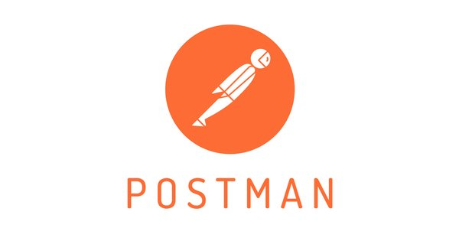

* PyCharm is used as IDE.
* For visualization of the plots, Matplotlib, Seaborn and Plotly are used.
* Heroku is used for deployment of the model.
* Tableau/Power Bl is used for dashboard creation.
* SQLlight is used to retrieve, insert, delete, and update the database.
* Front end development is done using HTML/CSS
* GitHub is used as version control system.
* Postman is used for model retraining apporch

2.7 Constraints

The Thyroid Detection system must be user friendly, as automated as possible and users should not be required to know any of the workings.

2.8 Assumptions

The main objective of the project is to implement the use cases as previously mentioned (2.2 Problem Statement) for new dataset that comes through API. Machine Learning based Thyroid detection model is used for detecting the above-mentioned use cases based on the input data. It is also assumed that all aspects of this project have the ability to work together in the whet designer is expecting.

## Design Details

3.1 Process Flow

For identifying the different types of Thyroid, we will use a Machine learning base model. Below is the process flow diagram is as shown below.

Proposed methodology

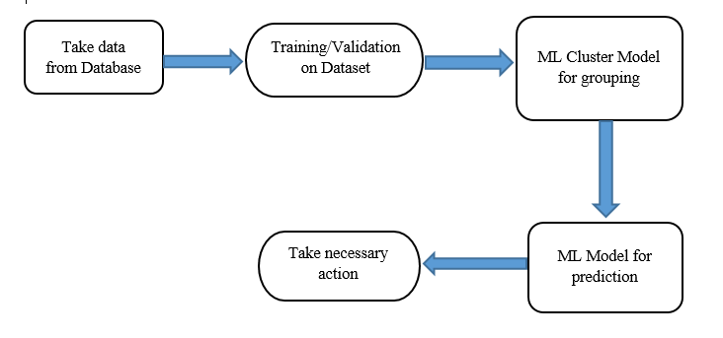

3.1.1 Model Training and Evaluation

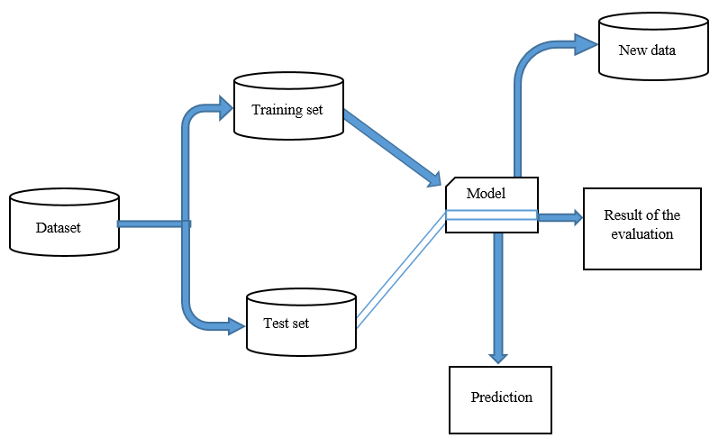

3.1.2 Deployment Process

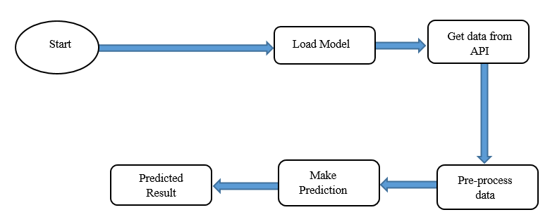

3.2 Event log

The system should log every event so that the user will know what process is running internally.

Initial Step-By-Step Description:

1. The System identifies at what step logging required
2. The System should be able to log each and every system flow.
3. System should not hang even after using so many loggings. Logging just because we can easily debug issues so logging is mandatory to do.
   1. Error Handling

Should errors be encountered, an explanation will be displayed as to what went wrong? An error will be defined as anything that falls outside the normal and intended usage.

### Performance

The Thyroid detection is used for detect so it should be as accurate as possible. So that it will not mislead the concern authorities (like hospitals, cops, etc..). Also, model retraining is very important to improve the performance.

#### 4.1 Reusability

The code written and the components used should have the ability to be reused with no problems.

4.2 Application Compatibility

#### The different components for this project will be using Python as an interface between them. Each component will have its own task to perform, and it is the job of the Python to ensure proper transfer of information.

4.4 Resource Utilization

When any task is performed, it will likely use all the processing power available until that function is finished

4.4 Deployment

**

## Dashboards

Dashboards will be implemented to display and indicate certain KPls and relevant indicators for the unveiled problems that if not addressed in time could cause catastrophes of unimaginable impact.

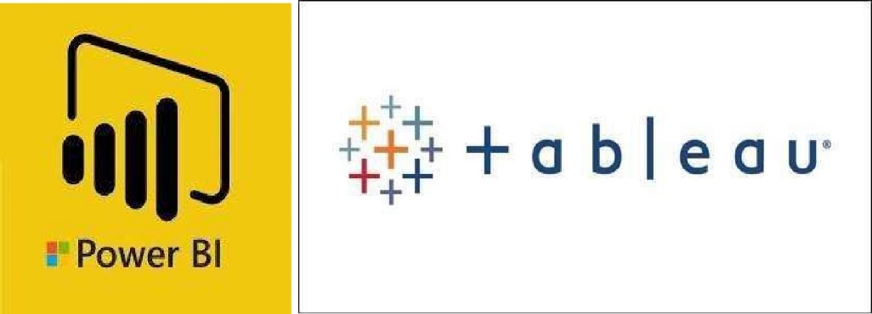

As and when, the system starts to capture the historical/periodic data for a user, the dashboards will be included to display charts over time with progress on various indicators or factors.

### 5.1 "KPIs (Key Performance Indicators)

## Key indicators displaying a summary of the person’s health and physique as compared to a normal individual with similar basic traits

## 1. Time and workload reduction using TD Model.

## 2. Comparison of accuracy of model prediction and doctor’s prediction.

## 3. Estimated risk on a patient's chance of obtaining thyroid disease.

### 6 Conclution

### Thyroid Detection using Machine Learning is a project idea that aims a smart and precise way to predict thyroid disease. We have made use of logistic regression algorithm to train our dataset and to predict thyroid disease with more accuracy. Here the machine is trained to detect whether the person normal, hyperthyroid hypothyroidism based on the user’s input.

hypothyroidism based on the user’s input. So when

user enters data in web app the data will be processed in backend (model) and the result will be displayed on the screen. Our objective was to give society an efficient and precise way of machine learning which can be used in applications aiming to perform disease detection.

Further development can be due by using image processing of ultrasonic scanning of thyroid images to

predict thyroid nodules and cancer, which cannot be recognized in blood test report. By combining both the results, thyroid disease prediction can cover all thyroid related diseases.

### References

1. https://www.ncbi.nlm.nih.gov/pmc/articles/PMC6143469/
2. <https://en.wikipedia.org/wiki/Thyroid_disease>