Social Media Analysis – SQL Assignment
Submitted by :-Ritik Bhoi
Project Overview
Project Title: Social Pulse — Engagement Analytics for a Meta/Instagram-Style Platform
Background
This project analyzes a simulated Instagram-clone social platform (the ig_clone database) covering 100 users, 257 posts, 21 hashtags, and nearly 24,000 total interactions (likes, comments, and follows). The goal was to turn raw relational data into a data-driven story that supports real product, growth, and marketing decisions.
Objective
- Audit the platform's data for quality and reliability
- Understand who the platform's users are and how they behave (posting, liking, commenting, following)
- Identify the platform's most valuable creators and its most disengaged segments
- Translate every finding into a concrete recommendation for retention, content strategy, and ad targeting
Dataset
- 7 relational tables: users, photos, comments, likes, follows, tags, photo_tags
- 100 users · 257 posts · 7,488 comments · 8,782 likes · 7,623 follows · 21 hashtags · 501 photo-tags
Approach & Tools
- SQL (joins, window functions, CTEs, self-joins) to answer 13 objective and 10 subjective business questions
- Each finding paired with a visualization and a business-facing recommendation
- Structured as: SQL Analysis → Business Insight → Action
Deliverables
- A 15-chapter storytelling presentation of key engagement insights
- A companion Word report with full code, output, visualizations, and detailed recommendations for every question

Objective Questions

1. Are there any tables with duplicate or missing null values? If so, how would you handle them?
Approach:
Reviewed all 7 tables to check both duplicate records and missing NULL values. The total number of rows was compared with the number of unique records to identify possible duplicates, while SUM(column IS NULL) was used to count missing values in important columns.
Why these SQL concepts were used:
COUNT(*) → counts the total number of records in each table.
COUNT(DISTINCT ...) → identifies the number of unique records based on the relevant columns.
CONCAT() → combines columns to check unique combinations, such as user_id + photo_id.
SUM(column IS NULL) → counts the number of NULL/missing values in each column.
UNION ALL → combines the results from all 7 tables into one output.
0 → used for tables where the second NULL check is not applicable.
Query Used:
SELECT 'comments' AS table_name,
COUNT(*) AS total_rows,
COUNT(DISTINCT CONCAT(user_id, '-', photo_id)) AS unique_records,
SUM(user_id IS NULL) AS null_user_id,
SUM(photo_id IS NULL) AS null_photo_id
FROM comments
UNION ALL
SELECT 'follows',
COUNT(*),
COUNT(DISTINCT CONCAT(follower_id, '-', followee_id)),
SUM(follower_id IS NULL),
SUM(followee_id IS NULL)
FROM follows
UNION ALL
SELECT 'likes',
COUNT(*),
COUNT(DISTINCT CONCAT(user_id, '-', photo_id)),
SUM(user_id IS NULL),
SUM(photo_id IS NULL)
FROM likes
UNION ALL
SELECT 'photo_tags',
COUNT(*),
COUNT(DISTINCT CONCAT(photo_id, '-', tag_id)),
SUM(photo_id IS NULL),
SUM(tag_id IS NULL)
FROM photo_tags
UNION ALL
SELECT 'photos',
COUNT(*),
COUNT(DISTINCT CONCAT(image_url, '-', user_id)),
SUM(image_url IS NULL),
SUM(user_id IS NULL)
FROM photos
UNION ALL
SELECT 'tags',
COUNT(*),
COUNT(DISTINCT tag_name),
SUM(tag_name IS NULL),
0
FROM tags
UNION ALL
SELECT 'users',
COUNT(*),
COUNT(DISTINCT username),
SUM(username IS NULL),
0
FROM users;

Output:
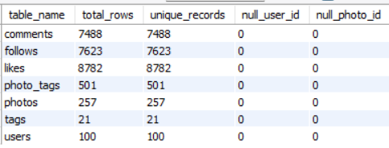
Insight
This analysis helps identify data-quality issues across all 7 tables. Tables with a difference between total and unique records may contain duplicates, while tables with NULL counts greater than zero contain missing values.
If all NULL counts are 0 and total_rows = unique_records, the tables have no identified missing values or duplicate combinations based on the columns checked.

Recommandation
Duplicates: Review duplicate records before removing them. Genuine duplicates can be deleted after verification.
NULL values: Do not automatically delete records containing NULLs. Mandatory missing values should be investigated and corrected where possible, while optional fields can remain NULL.
Prevention: Use appropriate PRIMARY KEY and UNIQUE constraints to prevent duplicate records in the future.

2. What is the distribution of user activity levels (e.g., number of posts, likes, comments) across the user base?
Approach:
Reviewed user activity across the platform by calculating the number of posts, likes, and comments associated with each user. The users table was joined with the photos, likes, and comments tables using LEFT JOIN so that users with no activity were also included in the results.

Why these SQL concepts were used:
LEFT JOIN → ensures that all users are included, even if they have no posts, likes, or comments.
COUNT(DISTINCT ...) → counts each activity without double-counting records caused by multiple joins.
GROUP BY → groups the activity counts for each individual user.
ORDER BY → sorts users from the most active to the least active based on posts, likes, and comments.

SQL:
SELECT u.id AS user_id, u.username,
COUNT(DISTINCT p.id) AS posts,
COUNT(DISTINCT l.user_id) AS likes,
COUNT(DISTINCT c.id) AS comments
FROM users u
LEFT JOIN photos p ON u.id = p.user_id
LEFT JOIN likes l ON u.id = l.user_id
LEFT JOIN comments c ON u.id = c.user_id
GROUP BY u.id, u.username
ORDER BY posts DESC, likes DESC, comments DESC;

Output:-
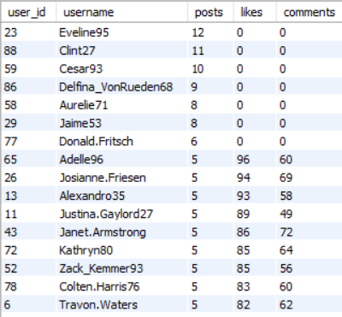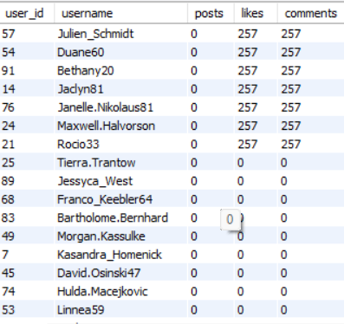
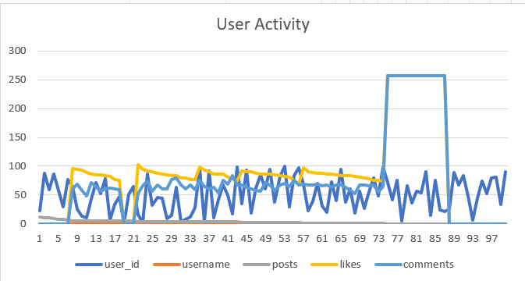
Insight:
The results show the distribution of activity across the user base. Users with higher counts of posts, likes, and comments can be considered more active users, while users with lower counts are relatively less active. Users with zero activity across these categories represent inactive or less-engaged users.
Recommandation
The query produces a user-level activity summary showing the number of posts, likes, and comments for each user. Users are ordered based on their activity levels, with users having higher numbers of activities appearing first. The activity counts can be used to categorize users into highly active, moderately active, and low/inactive groups. This segmentation can help identify highly engaged users, understand overall platform engagement, and develop targeted strategies to increase activity among less-active users.

3. Calculate the average number of tags per post (photo_tags and photos tables).

SQL:
Approach:
Calculated the average number of tags assigned to each post by joining the photos and photo_tags tables. The total number of tags was divided by the total number of distinct posts that have tags, and the result was rounded to two decimal places.

Why these SQL concepts were used:
JOIN → connects the photos table with photo_tags using photo_id.
COUNT(tag_id) → counts the total number of tags assigned to posts.
COUNT(DISTINCT p.id) → counts the number of unique posts.
ROUND(..., 2) → rounds the average to two decimal places.

Query Used:
SELECT
ROUND(COUNT(pt.tag_id) / COUNT(DISTINCT p.id), 2) AS avg_tags_per_post
FROM photos p
JOIN photo_tags pt
ON p.id = pt.photo_id;
Output:

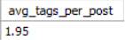

Insight:-

The result indicates how many tags are assigned to a post on average. A higher average means posts are generally associated with more tags, while a lower average indicates that posts typically have fewer tags.

Recommandation
The calculated average can be used to understand how users categorize their posts and how frequently tags are used across the platform. This can also help evaluate tagging behavior and improve tag-based search or content discovery.
Calculates the average number of tags per post using photos and photo_tags.

4. Identify the top users with the highest engagement rates (likes, comments) on their posts and rank them.

Approach:
Analyzed the engagement received by each user's posts by counting the number of likes and comments on their uploaded photos. The total engagement was calculated by adding likes and comments together. A window function was then used to rank users from the highest to the lowest engagement.

Why these SQL concepts were used:
JOIN → connects users with the photos they have uploaded.
LEFT JOIN → includes posts even if they have no likes or comments.
COUNT(DISTINCT ...) → counts unique likes and comments without double-counting caused by multiple joins.
SUM of likes and comments → calculates the total engagement received by each user's posts.
RANK() OVER → ranks users based on their total engagement.
GROUP BY → groups the results for each user.
ORDER BY → displays users according to their engagement rank.
SELECT u.id AS user_id,

Query Used:
u.username,
COUNT(DISTINCT l.user_id) AS likes,
COUNT(DISTINCT c.id) AS comments,
COUNT(DISTINCT l.user_id)+COUNT(DISTINCT c.id) AS total_engagement,
RANK() OVER (ORDER BY COUNT(DISTINCT l.user_id)+COUNT(DISTINCT c.id) DESC) AS engagement_rank
FROM users u JOIN photos p ON u.id=p.user_id
LEFT JOIN likes l ON p.id=l.photo_id LEFT JOIN comments c ON p.id=c.photo_id
GROUP BY u.id,u.username ORDER BY engagement_rank;

Output:-
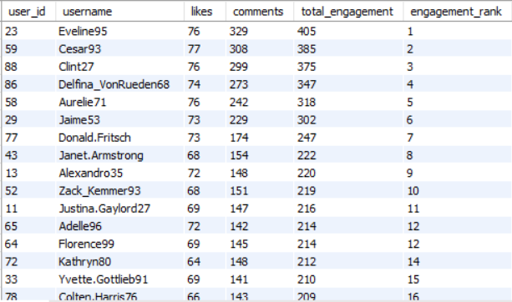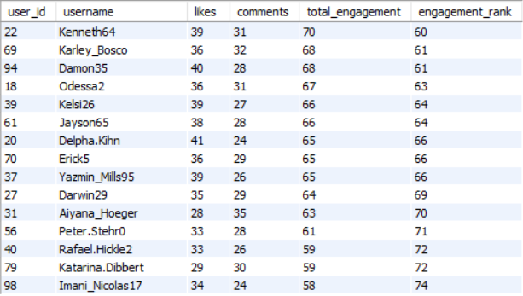

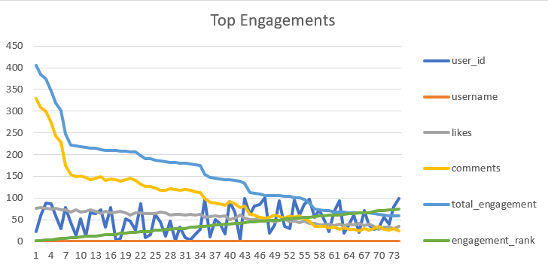
Insight:-
The query produces a ranked list of users showing their total likes, total comments, total engagement, and engagement rank. Users with higher engagement on their posts receive a better rank.
Recommandation
The results identify the users whose posts receive the highest levels of engagement. Engagement is measured using two main activities: likes and comments. A higher total engagement indicates that a user's posts are generating more interaction from other users.

5. Which users have the highest number of followers and followings?

Approach:
Analyzed the follows table to calculate the number of followers and following connections for each user. Two LEFT JOINs were used to separately identify users who follow them and users whom they follow. The results were then grouped by user and sorted by follower count and following count.

Why these SQL concepts were used:

LEFT JOIN → ensures that all users are included, even if they have no followers or following connections.
COUNT(DISTINCT ...) → counts unique followers and following relationships.
GROUP BY → groups the follower and following counts for each user.
ORDER BY → ranks users with the highest number of followers first, followed by their following count.

Query Used:
SELECT
u.id AS user_id,
u.username,
COUNT(DISTINCT f1.follower_id) AS followers_count,
COUNT(DISTINCT f2.followee_id) AS following_count
FROM users u
LEFT JOIN follows f1 ON u.id = f1.followee_id
LEFT JOIN follows f2 ON u.id = f2.follower_id
GROUP BY u.id, u.username
ORDER BY followers_count DESC, following_count DESC;

Output:-

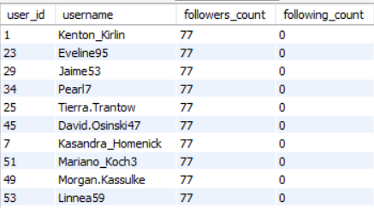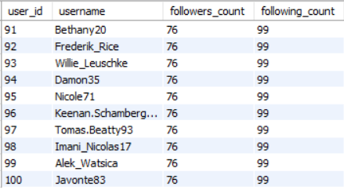

Insight:
The results identify users with the largest number of followers and the highest number of following connections. A higher follower count indicates greater popularity or reach on the platform, while a higher following count indicates a larger network of connections.
For example, a user with 1,000 followers has a greater audience than someone with 100 followers, while a user following 500 people has a larger network of connections.
Recommandation
Follower and following counts can be used to understand user popularity, reach, and networking behavior. These metrics can also help identify influential users and users who are highly connected within the platform.

6. Calculate the average engagement rate (likes, comments) per post for each user.
Approach:
Calculated the average engagement received by each user's posts using the total number of likes and comments divided by the total number of posts. The results were rounded to two decimal places and sorted from the highest to the lowest average engagement.

Why these SQL concepts were used:
JOIN → connects users with their posts.
LEFT JOIN → includes posts even when they have no likes or comments.
COUNT(DISTINCT ...) → counts unique likes, comments, and posts.
ROUND(..., 2) → rounds the average engagement to two decimal places.
GROUP BY → calculates the engagement separately for each user.
ORDER BY → displays users with the highest average engagement first.

Query Used:
SELECT u.id AS user_id,
u.username,
ROUND((COUNT(DISTINCT l.user_id)+COUNT(DISTINCT c.id))/COUNT(DISTINCT p.id),2) AS avg_engagement_per_post
FROM users u JOIN photos p ON u.id=p.user_id
LEFT JOIN likes l ON p.id=l.photo_id LEFT JOIN comments c ON p.id=c.photo_id
GROUP BY u.id,u.username ORDER BY avg_engagement_per_post DESC;

Output:-
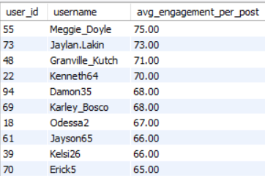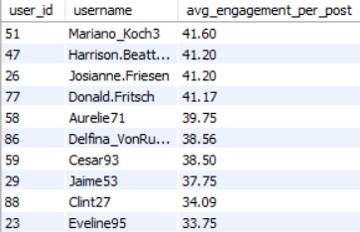
Insight:-
The query returns the average number of likes and comments received per post for each user.
The average engagement per post is calculated as:
Average Engagement per Post = (Likes + Comments) / Total Posts
A higher value indicates that a user's posts receive more interaction on average, while a lower value indicates lower engagement per post.
Recommandation
This metric can be used to compare users based on the quality of engagement their posts receive, rather than only looking at their total number of posts or total engagement.

7. Get the list of users who have never liked any post (users and likes tables)
Approach:
Identified users who have never liked any post by comparing all users with the records in the likes table. A LEFT JOIN was used to retain every user, including users who have no matching record in the likes table. Users where the matching likes.user_id is NULL were identified as users who have never liked a post.

Why these SQL concepts were used:
LEFT JOIN → keeps all users in the result, even when they have no likes.
WHERE ... IS NULL → identifies users with no matching record in the likes table.
users and likes tables → are used to compare the complete user base with users who have liked posts.

Query Used:
SELECT u.id,
u.username
FROM users u
LEFT JOIN likes l ON u.id=l.user_id WHERE l.user_id IS NULL;

Output:-
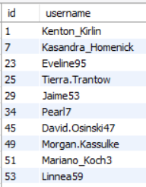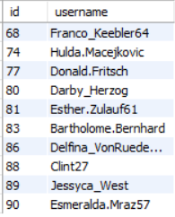
Insight:
The query returns the user ID and username of users who have never liked any post.
The results identify users who have not interacted with any post through likes. These users may represent a group with low engagement or inactive behavior on the platform.
Recommandation
These users can be analyzed separately to understand why they are not engaging with posts. The information can also be useful for identifying opportunities to improve user engagement and encourage interaction with content.

8. How can you leverage user-generated content (posts, hashtags, photo tags) to create more personalized and engaging ad campaigns?
Approach:
Identified popular hashtags by analyzing the number of posts, users, and likes associated with each hashtag. The tags table was connected with photo_tags to identify hashtags used on posts, while the photos table was used to identify the users who created those posts. The likes table was then used to measure engagement with hashtag-related posts.

Why these SQL concepts were used:
JOIN → connects the tags, photo_tags, and photos tables to identify hashtags and the posts/users associated with them.
LEFT JOIN → connects the likes table so that posts can be analyzed based on their likes.
COUNT(DISTINCT pt.photo_id) → calculates the number of unique posts associated with each hashtag.
COUNT(DISTINCT p.user_id) → calculates the number of unique users using each hashtag.
COUNT(l.photo_id) → calculates the total number of likes received by posts associated with each hashtag.
GROUP BY tag_name → groups the results for each hashtag.
ORDER BY total_likes DESC → displays the hashtags with the highest engagement first.

Query Used:
SELECT
t.tag_name,
COUNT(DISTINCT pt.photo_id) AS total_posts,
COUNT(DISTINCT p.user_id) AS total_users,
COUNT(l.photo_id) AS total_likes
FROM tags t
JOIN photo_tags pt
ON t.id = pt.tag_id
JOIN photos p
ON pt.photo_id = p.id
LEFT JOIN likes l
ON pt.photo_id = l.photo_id
GROUP BY t.tag_name
ORDER BY total_likes DESC;

Output:-
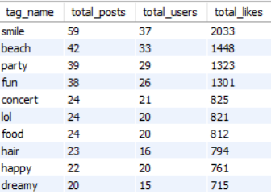
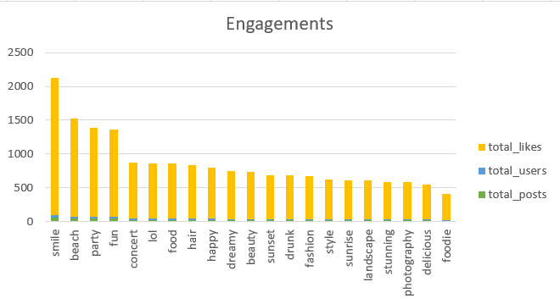

Insight:-
The query identifies which hashtags are most popular and receive the highest engagement. Hashtags with a high number of posts and likes indicate topics that users are actively interested in. The number of users also shows how widely a particular hashtag is being used.

Recommandation
User-generated content can be used to understand users' interests and preferences. Popular hashtags can identify trending topics, while posts and photo tags can help identify the products, brands, or subjects users are interested in. Advertisers can use these insights to segment users and show them personalized advertisements related to their interests, which can improve engagement and campaign effectiveness.

9. Are there any correlations between user activity levels and specific content types (e.g., photos, videos, reels)? How can this information guide content creation and curation strategies?

Approach:-
Analyzed user activity using the available photos, likes, and comments tables. The dataset records content in the photos table, but it does not have a column that identifies whether the content is a photo, video, or reel. Therefore, a direct comparison between photos, videos, and reels cannot be performed using this dataset.
Instead, user activity can be measured using the number of posts, likes, and comments for each user.

Why these SQL concepts were used:-
LEFT JOIN → keeps all users, including users with no posts, likes, or comments.
COUNT(DISTINCT p.id) → calculates the number of posts created by each user.
COUNT(DISTINCT l.photo_id) → calculates the number of posts liked by each user.
COUNT(DISTINCT c.id) → calculates the number of comments made by each user.
GROUP BY → summarizes activity for each user.
ORDER BY → ranks users based on their activity levels.
Query Used:
SELECT
u.id AS user_id,
u.username,
COUNT(DISTINCT p.id) AS total_posts,
COUNT(DISTINCT l.photo_id) AS total_likes,
COUNT(DISTINCT c.id) AS total_comments
FROM users u
LEFT JOIN photos p
ON u.id = p.user_id
LEFT JOIN likes l
ON u.id = l.user_id
LEFT JOIN comments c
ON u.id = c.user_id
GROUP BY u.id, u.username
ORDER BY total_posts DESC, total_likes DESC, total_comments DESC;

Output:-
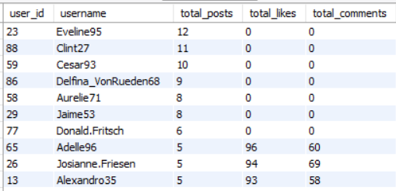
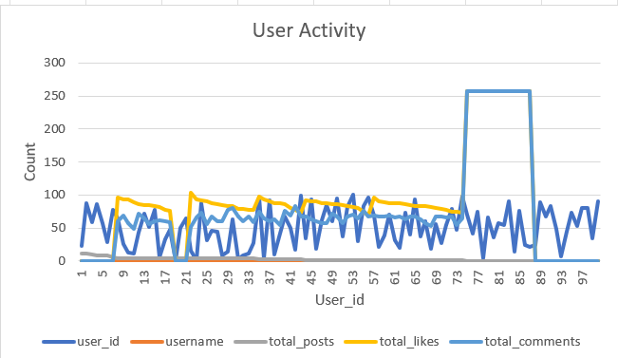

Insight:-
The query identifies users with higher and lower activity based on their posts, likes, and comments. However, the dataset does not contain separate content types such as videos or reels, so we cannot determine whether users are more active with photos, videos, or reels.

Recommandation
The dataset shows user activity through posts, likes, and comments, but it does not provide separate information for photos, videos, and reels. Therefore, a direct correlation between activity levels and different content types cannot be calculated.
If content-type information were available, businesses could compare engagement across photos, videos, and reels and focus content creation on the formats receiving the highest engagement. High-performing content types could also be prioritized in recommendations and advertising campaigns.

10. Calculate the total number of likes, comments, and photo tags for each user.
Approach:
Calculated the total number of likes, comments, and photo tags associated with each user's posts. The users table was connected to photos, likes, comments, and photo_tags using LEFT JOIN so that all users were included, even if their posts had no interactions.

Why these SQL concepts were used:
LEFT JOIN → includes all users and their posts, even when there are no likes, comments, or tags.
COUNT(DISTINCT ...) → counts unique interactions and avoids duplicate counting caused by multiple joins.
GROUP BY → calculates the totals separately for each user.
ORDER BY → sorts users based on the number of likes received.

Query Used:
SELECT
u.id,
u.username,
COUNT(DISTINCT l.user_id) AS total_likes_received,
COUNT(DISTINCT c.id) AS total_comments_received,
COUNT(DISTINCT pt.photo_id, pt.tag_id) AS total_photo_tags_on_posts
FROM users u
LEFT JOIN photos p
ON p.user_id = u.id
LEFT JOIN likes l
ON l.photo_id = p.id
LEFT JOIN comments c
ON c.photo_id = p.id
LEFT JOIN photo_tags pt
ON pt.photo_id = p.id
GROUP BY
u.id,
u.username
ORDER BY
total_likes_received DESC;
Output:- 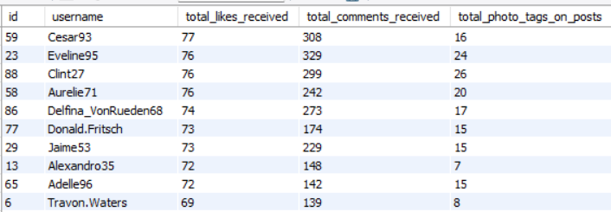
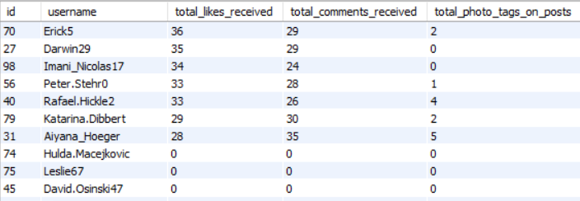
Insight:
The query displays each user's total likes received, comments received, and photo tags associated with their posts.
Likes received → show how many likes the user's posts received.
Comments received → show the number of comments made on the user's posts.
Photo tags → show the number of tags associated with the user's photos.
Purpose → these metrics help measure the overall engagement and interaction received by each user's content.
For example, if Alice's posts receive 500 likes, 80 comments, and 20 photo tags, these values will be shown for Alice.

Recommandation
These metrics can be used to identify users whose content receives high levels of interaction and to understand overall engagement patterns across the platform.

11. Rank users based on their total engagement (likes, comments, shares) over a month.
Approach:
Ranked users based on the total engagement received by their posts. Engagement was calculated using likes and comments, as these are the engagement metrics available in the dataset. A RANK() window function was used to assign an engagement rank to each user.

Why these SQL concepts were used:
- JOIN → connects users with the photos they have uploaded.
- LEFT JOIN → includes posts even when they have no likes or comments.
- COUNT(DISTINCT ...) → counts unique likes and comments.
- RANK() OVER → ranks users according to their total engagement.
- GROUP BY → calculates engagement totals for each user.
- ORDER BY → displays users from the highest to the lowest engagement.

Query Used:
SELECT u.id,
u.username,
COUNT(DISTINCT l.user_id) AS total_likes,
COUNT(DISTINCT c.id) AS total_comments,
COUNT(DISTINCT l.user_id)+COUNT(DISTINCT c.id) AS total_engagement,
RANK() OVER (ORDER BY COUNT(DISTINCT l.user_id)+COUNT(DISTINCT c.id) DESC) AS engagement_rank
FROM users u
JOIN photos p
ON u.id=p.user_id
LEFT JOIN likes l
ON p.id=l.photo_id
LEFT JOIN comments c
ON p.id=c.photo_id
GROUP BY u.id,u.username
ORDER BY engagement_rank;

Output:-
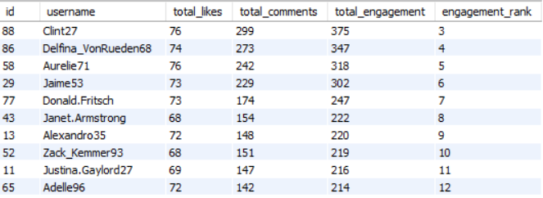
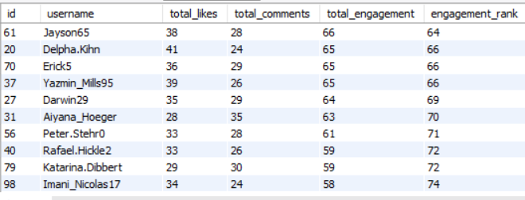

Recommandation
The query produces a ranked list of users showing their total likes, total comments, total engagement, and engagement rank.
Insight:
Likes & comments → are available in the dataset and can be used to measure engagement.
Shares → no shares field or table is provided, so shares cannot be included in the calculation.
Engagement rank → users with higher numbers of likes and comments receive a higher ranking.

Monthly Filter:
The current query calculates engagement across the available dataset and does not restrict the results to a specific month. To perform a monthly analysis, a date column and a specific month would be required.
For example, to analyze January 2026, a date condition could be applied to the relevant date column, such as:
WHERE date >= '2026-01-01'
AND date < '2026-02-01'

12. Retrieve the hashtags that have been used in posts with the highest average number of likes. Use a CTE to calculate the average likes for each hashtag first.

Approach:
Calculated the average number of likes received by posts associated with each hashtag. A Common Table Expression (CTE) was used first to calculate the average likes for every hashtag. The final query then sorted the hashtags from the highest to the lowest average number of likes.

Why these SQL concepts were used:
- CTE (WITH) → creates a temporary result containing the average likes for each hashtag.
- JOIN → connects tags, photo_tags, and like counts for each photo.
- Subquery → calculates the total number of likes received by each photo.
- AVG() → calculates the average number of likes for posts associated with each hashtag.
- GROUP BY → calculates the average separately for each hashtag.
- ORDER BY → sorts hashtags from the highest to the lowest average likes.

Query Used:
WITH hashtag_likes AS (
SELECT t.tag_name,
AVG(like_count) AS avg_likes
FROM tags t
JOIN photo_tags pt
ON t.id=pt.tag_id
JOIN (SELECT photo_id,COUNT(*) AS like_count
FROM likes GROUP BY photo_id) l
ON pt.photo_id=l.photo_id
GROUP BY t.tag_name)
SELECT tag_name,
avg_likes
FROM hashtag_likes
ORDER BY avg_likes DESC;

Output:-
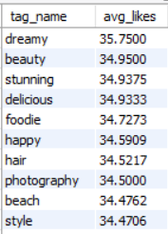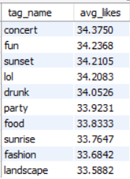

Insight:
The query returns a list of hashtags along with their average number of likes, ordered from the highest average to the lowest.
The CTE calculates the average number of likes received by posts associated with each hashtag. This helps identify which hashtags are associated with posts that generate higher engagement.
For example, if #travel averages 500 likes while #food averages 300 likes, #travel ranks higher because posts using that hashtag receive more likes on average.
Recommandation
Hashtags with higher average likes can be considered high-engagement topics. This information can be used to identify popular content themes, improve content recommendations, and guide users or marketers toward hashtags associated with stronger engagement.

13. Users Who Followed Back Later

Approach:
Identified users who eventually followed each other back by comparing the follows table with itself. A self-join was used to find pairs of users where the first user followed the second user, and the second user later followed the first user. The created_at timestamps were compared to determine the order of the two follows.

Why these SQL concepts were used:
- SELF JOIN → compares records within the same follows table to identify reciprocal follow relationships.
- Matching follower and followee IDs → identifies users who followed each other.
- created_at comparison → determines which user followed first and which user followed back later.
- JOIN condition → ensures that only reciprocal follow relationships are returned.

Query Used:
SELECT f1.follower_id AS user_1,f1.followee_id AS user_2,
f1.created_at AS first_follow_date,f2.created_at AS second_follow_date
FROM follows f1 JOIN follows f2
ON f1.follower_id=f2.followee_id AND f1.followee_id=f2.follower_id
AND f1.created_at<f2.created_at;

Output:-
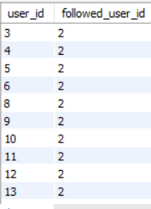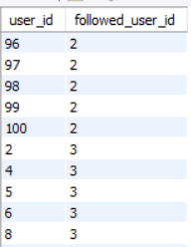

Insight:-
The query displays the two users involved in the reciprocal follow, along with the date of the first follow and the date of the follow-back.
The results identify users who eventually followed each other. The created_at comparison also shows who followed first and who followed back later.
For example, if User 1 follows User 2 on January 1 and User 2 follows User 1 on January 5, the query identifies this as a reciprocal follow relationship.
Recommandation
This analysis can be used to understand two-way connections and relationship-building behavior on the platform. It can also help identify users who are more likely to form mutual connections after an initial follow.

Subjective Questions

1. Based on user engagement and activity levels, which users would you consider the most loyal or valuable? How would you reward or incentivize these users?

Approach
Identify the Top most engaged users based on the total likes and comments received on their posts.

Why these SQL concepts were used:
JOIN → connects the users table with photos to identify the posts created by each user.
LEFT JOIN → connects likes and comments while keeping users whose posts may have no likes or comments.
COUNT(DISTINCT l.user_id) → counts the unique likes received on each user's posts.
COUNT(DISTINCT c.id) → counts the comments received on each user's posts.
Total Engagement → adds likes and comments to measure overall user engagement.
GROUP BY → calculates the engagement separately for each user.
ORDER BY → ranks users from highest to lowest based on total engagement.

Query Used:-
SELECT
u.id AS user_id,
u.username,
COUNT(DISTINCT l.user_id) AS likes_received,
COUNT(DISTINCT c.id) AS comments_received,
COUNT(DISTINCT l.user_id) + COUNT(DISTINCT c.id) AS total_engagement
FROM users u
JOIN photos p
ON u.id = p.user_id
LEFT JOIN likes l
ON p.id = l.photo_id
LEFT JOIN comments c
ON p.id = c.photo_id
GROUP BY u.id, u.username
ORDER BY total_engagement DESC;

Output:-
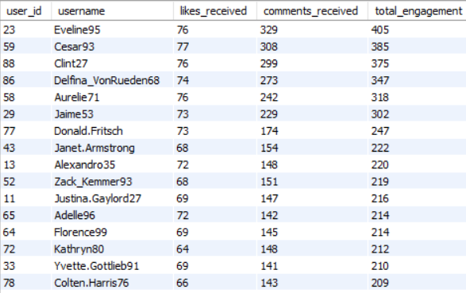
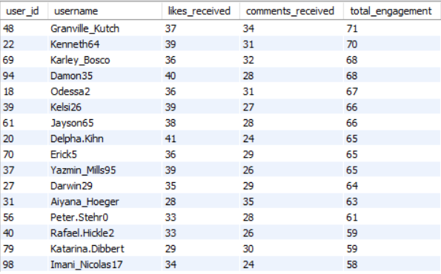

Insight:-
Users with higher total engagement are considered more valuable because their content generates greater interaction from the community.

Recommendation:-
Identify and reward highly engaged users: Analyze user activity across key metrics such as number of posts, likes received, comments, followers, and overall engagement rate to identify the platform’s most active and influential users. Recognize these users through exclusive badges and profile highlights, provide early access to new features, and offer personalized content and recommendations based on their interests and activity. You can also introduce loyalty programs, special rewards, milestone incentives, and community recognition to encourage continued participation and make highly engaged users feel valued.
2. For inactive users, what strategies would you recommend to re-engage them and encourage them to start posting or engaging again?
Approach:-
Identify users with no posts, likes, or comments and consider them inactive users. Analyze this group separately to understand their lack of engagement.

Why these SQL concepts were used:
LEFT JOIN → keeps all users, including users with no activity.
WHERE ... IS NULL → identifies users who have no posts, likes, or comments.
AND → ensures the user is inactive across all three activities.

Query Used:-
SELECT
u.id AS user_id,
u.username
FROM users u
LEFT JOIN photos p
ON u.id = p.user_id
LEFT JOIN likes l
ON u.id = l.user_id
LEFT JOIN comments c
ON u.id = c.user_id
WHERE p.id IS NULL
AND l.user_id IS NULL
AND c.id IS NULL;

Output:-
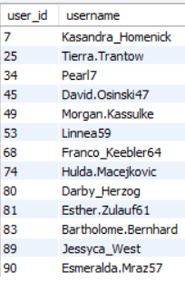

Insight:-
Inactive users represent an opportunity for user retention and re-engagement. They may have lost interest, may not know how to use certain features, or may not be receiving relevant content.

Recommendation:-
Re-engage inactive users: Segment inactive users based on how long it has been since their last activity—for example, users inactive for 7, 30, or 60+ days. Create targeted re-engagement campaigns for each segment by sending personalized notifications, relevant content recommendations, trending posts, and updates from accounts they follow. Offer limited-time rewards, bonus points, exclusive badges, or special incentives to motivate them to return, post content, like, comment, and interact with the community. This approach helps bring inactive users back while making the communication more relevant to their interests and previous behavior.

3. Which hashtags or content topics have the highest engagement rates? How can this information guide content strategy and ad campaigns?
Approach
Analyze hashtags based on the number of likes received by posts using each hashtag. Hashtags with higher engagement can be considered popular content topics.

Why these SQL concepts were used:
- JOIN → connects hashtags with the posts where they are used.
- LEFT JOIN → includes hashtags even if their posts have no likes.
- COUNT(DISTINCT l.user_id) → counts unique likes received by posts associated with each hashtag.
- COUNT(DISTINCT pt.photo_id) → counts the number of posts using each hashtag.
- GROUP BY → calculates engagement separately for each hashtag.
- ORDER BY → ranks hashtags from highest to lowest engagement

Query Used:-
SELECT
t.tag_name,
COUNT(DISTINCT l.user_id) AS total_likes,
COUNT(DISTINCT pt.photo_id) AS total_posts
FROM tags t
JOIN photo_tags pt
ON t.id = pt.tag_id
LEFT JOIN likes l
ON pt.photo_id = l.photo_id
GROUP BY t.tag_name
ORDER BY total_likes DESC;

Output:-

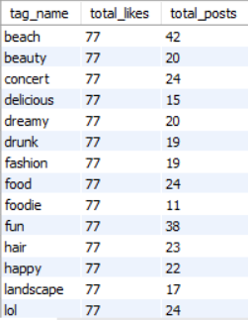
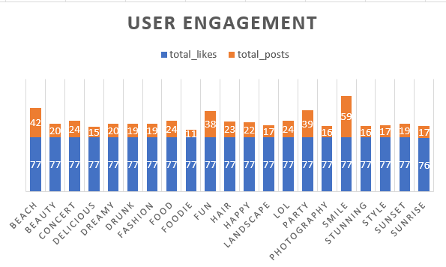

Insight:-
High-engagement hashtags indicate topics that attract more user interaction. For example, if #travel receives significantly more likes than #food, travel-related content may have stronger engagement in this dataset.

Recommendation:-
Content Strategy:
Create more content around high-engagement topics.
Encourage creators to use relevant high-performing hashtags.
Monitor hashtag performance regularly to identify changing trends.
Ad Campaign Strategy:
Create audience segments around popular content topics.
Use high-engagement topics to develop relevant advertising campaigns.
For example, if #travel performs strongly, travel-related brands could target users interested in travel content.

4. Are there any patterns or trends in user engagement based on demographics (age, location, gender) or posting times? How can these insights inform targeted marketing campaigns?

Approach
Analyze the number of posts created during each hour to identify peak posting times and understand when users are most active.

Why these SQL concepts were used:
HOUR(created_dat) → extracts the hour from the posting timestamp.
COUNT(*) → counts how many posts were created during each hour.
GROUP BY → groups posts according to their posting hour.
ORDER BY DESC → shows the hours with the highest number of posts first.

Query Used:-
SELECT
HOUR(created_dat) AS posting_hour,
COUNT(*) AS total_posts
FROM photos
GROUP BY HOUR(created_dat)
ORDER BY total_posts DESC;

Output:-
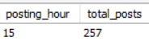
Insight
If certain hours have significantly more posts than others, those periods can be considered high-activity periods. For example, if 8 PM has the highest number of posts, users may be more active around that time.

Recommendation
Schedule advertisements, notifications, promotional campaigns, and new content during high-activity hours to increase the chances of reaching active users. Analyze engagement across available user segments: Compare engagement levels across age groups, locations, genders, and posting times, but only when the corresponding fields are actually available in the dataset schema. Identify which available segments and time windows generate the highest levels of likes, comments, shares, posts, or overall engagement, and use those insights to create more targeted campaigns and optimize content publishing schedules. If a field such as age, gender, location, or posting timestamp is not present in the schema, exclude it from the analysis rather than making assumptions or claiming results that cannot be supported by the available data.

5. Based on follower counts and engagement rates, which users would be ideal candidates for influencer marketing campaigns? How would you approach and collaborate with these influencers?

Approach:-
Identify users who have both a large follower base and strong engagement. These users are potential influencer candidates because they can provide both audience reach and interaction.

Why these SQL concepts were used:
LEFT JOIN → keeps all users, including those with no followers or engagement.
COUNT(DISTINCT f.follower_id) → calculates the number of followers for each user.
COUNT(DISTINCT l.user_id) → calculates likes received on the user's posts.
COUNT(DISTINCT c.id) → calculates comments received on the user's posts.
Total engagement → combines likes and comments to measure audience interaction.
GROUP BY → calculates the metrics separately for each user.
ORDER BY → prioritizes users with higher follower counts and engagement.

Query Used:-

SELECT
u.id AS user_id,
u.username,
COUNT(DISTINCT f.follower_id) AS followers,
COUNT(DISTINCT l.user_id) AS likes,
COUNT(DISTINCT c.id) AS comments,
COUNT(DISTINCT l.user_id) + COUNT(DISTINCT c.id) AS total_engagement
FROM users u
LEFT JOIN follows f
ON u.id = f.followee_id
LEFT JOIN photos p
ON u.id = p.user_id
LEFT JOIN likes l
ON p.id = l.photo_id
LEFT JOIN comments c
ON p.id = c.photo_id
GROUP BY u.id, u.username
ORDER BY followers DESC, total_engagement DESC;

Output:-

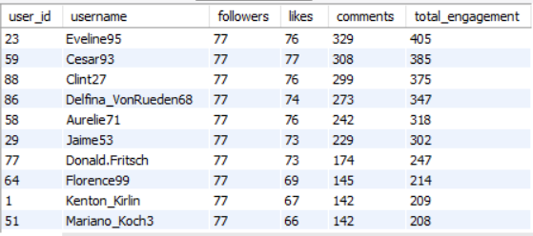

Insight:-
A user with many followers but very low engagement may not be as valuable as someone with a smaller audience but highly engaged followers.
Therefore, ideal influencer candidates should have:
High Followers + High Engagement = Strong Influencer Potential

Recommendation:-
Prioritize high-value creators and influencers: Identify users who combine large follower bases with consistently strong engagement, rather than selecting users based on follower count alone. Prioritize these users for relevant brand collaborations, sponsored campaigns, product promotions, and community initiatives that match their audience and content interests. Each collaboration should define clear deliverables, such as the number of posts, videos, stories, mentions, or campaign activities, along with timelines and expectations. Track performance using measurable metrics such as reach, impressions, likes, comments, shares, clicks, conversions, and engagement rate to evaluate campaign effectiveness and identify the creators who deliver the strongest results for future partnerships.

6. Based on user behavior and engagement data, how would you segment the user base for targeted marketing campaigns or personalized recommendations?

Approach
Segment users based on their overall activity:
Highly Active → frequent posting and high interaction.
Moderately Active → regular but lower engagement.
Low Activity → limited posting and interaction.

Why these SQL concepts were used:
LEFT JOIN → includes all users, even users with no activity.
COUNT(DISTINCT) → counts posts, likes, and comments without duplicate counting.
CASE → divides users into different activity segments.
GROUP BY → calculates activity for each user.
ORDER BY → organizes users by their segments.

Query Used:-
SELECT
u.id AS user_id,
u.username,
COUNT(DISTINCT p.id) AS posts,
COUNT(DISTINCT l.user_id) AS likes,
COUNT(DISTINCT c.id) AS comments,
CASE
WHEN COUNT(DISTINCT p.id) + COUNT(DISTINCT l.user_id) + COUNT(DISTINCT c.id) >= 10
THEN 'Highly Active'
WHEN COUNT(DISTINCT p.id) + COUNT(DISTINCT l.user_id) + COUNT(DISTINCT c.id) >= 5
THEN 'Moderately Active'
ELSE 'Low Activity'
END AS user_segment
FROM users u
LEFT JOIN photos p
ON u.id = p.user_id
LEFT JOIN likes l
ON p.id = l.photo_id
LEFT JOIN comments c
ON p.id = c.photo_id
GROUP BY u.id, u.username
ORDER BY user_segment;

Output:- 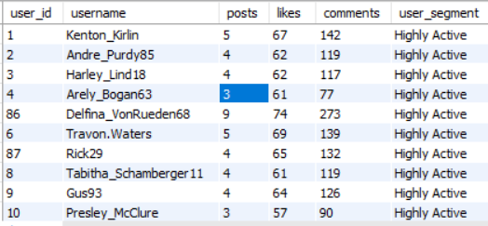
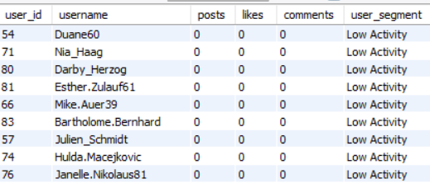

Insight
Different user segments require different marketing strategies. Highly active users are more likely to respond to new features and premium campaigns, while low-activity users may need incentives to become engaged.

Recommendation:-
This segmentation can help the platform deliver more relevant recommendations and targeted marketing campaigns instead of using the same strategy for every user.
Segment | Marketing Strategy
Highly Active | Exclusive features, loyalty rewards, influencer/creator campaigns
Moderately Active | Personalized content and engagement campaigns
Low Activity | Welcome-back offers, notifications, contests, posting incentives

7. If data on ad campaigns (impressions, clicks, conversions) is available, how would you measure their effectiveness and optimize future campaigns?
Approach:-
Measure campaign effectiveness using impressions, clicks, and conversions.
CTR = (Clicks / Impressions) × 100
Conversion Rate = (Conversions / Clicks) × 100
Compare these metrics across campaigns to identify high- and low-performing campaigns.

Why these SQL concepts were used:
CTR → measures how effectively an ad attracts clicks.
Conversion Rate → measures how effectively clicks result in conversions.
NULLIF() → prevents division-by-zero errors.
ROUND() → rounds the calculated percentages.
ORDER BY → identifies the best-performing campaigns.

Query Used:-
SELECT
campaign_id,
impressions,
clicks,
conversions,
ROUND(clicks * 100.0 / NULLIF(impressions, 0), 2) AS ctr,
ROUND(conversions * 100.0 / NULLIF(clicks, 0), 2) AS conversion_rate
FROM ad_campaigns
ORDER BY conversion_rate DESC;

Insight:
A campaign with high impressions but low CTR may need better ad creative or targeting.
A campaign with high CTR but low conversions may indicate problems with the offer, landing page, or audience quality.
A campaign with high CTR and high conversion rate is performing well.

Recommendation:
Increase budget for high-performing campaigns.
Improve the creative or targeting for campaigns with low CTR.
Optimize the landing page or offer when clicks are high but conversions are low.
Test different audiences, creatives, messages, and ad formats.
Shift future budgets toward campaigns with consistently strong conversion rates.

8. How can you use user activity data to identify potential brand ambassadors or advocates who could help promote Instagram's initiatives or events?

Approach
Identify users who receive high likes and comments on their posts as potential advocates.

Why these SQL concepts were used:
JOIN → connects users with their posts.
LEFT JOIN → includes posts even when they have no likes or comments.
COUNT(DISTINCT) → counts likes and comments without double-counting.
GROUP BY → calculates engagement for each user.
ORDER BY → shows users with the highest engagement first.

Query Used:-
SELECT
u.id AS user_id,
u.username,
COUNT(DISTINCT l.user_id) AS likes,
COUNT(DISTINCT c.id) AS comments
FROM users u
JOIN photos p ON u.id = p.user_id
LEFT JOIN likes l ON p.id = l.photo_id
LEFT JOIN comments c ON p.id = c.photo_id
GROUP BY u.id, u.username
ORDER BY likes DESC, comments DESC;

Insight:-
Users with high followers and high engagement are stronger ambassador candidates than users who only have a large follower count.

Recommendation
Invite suitable users to participate in Instagram initiatives, events, feature launches, and community campaigns. Offer incentives such as exclusive access, recognition, rewards, or collaboration opportunities. Track their engagement and participation to measure the success of the ambassador program.
Identify and engage high-value users: Identify users who demonstrate high engagement, consistent activity, strong follower networks, and relevant content to find the best candidates for community initiatives, creator programs, partnerships, and promotional campaigns. Evaluate users using available signals such as posts, likes, comments, followers, follows, tags, and engagement levels, while ensuring that only supported fields are used. Invite suitable users to relevant initiatives with clear participation requirements, campaign objectives, and expected deliverables. After the campaign, track available performance indicators such as engagement, reach, interactions, clicks, or conversions to measure impact and determine which users and initiatives deliver the strongest results.

9. How would you approach this problem, if the objective and subjective questions weren't given?

Approach
If the objective and subjective questions were not provided, I would approach the project by first understanding the business objective and available data. I would then explore the database to identify important tables, relationships, and useful metrics.

The process would be:-
Understand the business objective → identify what the business wants to improve or measure.
Understand the database schema → review tables, columns, primary keys, and relationships.
Clean and validate the data → check for NULL values, duplicates, incorrect values, and data quality issues.
Perform exploratory analysis → analyze users, posts, likes, comments, followers, and hashtags.
Identify key KPIs → such as user activity, engagement, follower growth, and content performance.
Find patterns and trends → identify highly active users, popular hashtags, engagement patterns, and inactive users.
Segment users → group users based on their activity and engagement levels.
Create visualizations → use charts to communicate important findings clearly.
Generate actionable insights → convert the analysis into recommendations for marketing, engagement, and user retention.
Present findings → summarize the key insights and business recommendations for stakeholders.

Insight
Without predefined questions, the analysis should be data-driven rather than question-driven. The goal is to explore the available data, identify meaningful patterns, and determine which findings can support business decisions.

Recommendation
I would follow a structured approach:
Business Objective → Data Understanding → Data Cleaning → Exploratory Analysis → KPI Analysis → Segmentation → Visualization → Insights → Recommendations

10. Assuming there's a "User_Interactions" table tracking user engagements, how can you update the "Engagement_Type" column to change all instances of "Like" to "Heart" to align with Instagram's terminology?
Approach
Find all records where the engagement type is "Like" and update those values to "Heart".

Why these SQL concepts were used:
UPDATE → modifies existing records in the table.
SET → changes the value of Engagement_Type from Like to Heart.
WHERE → ensures that only records where Engagement_Type = 'Like' are changed.

Query Used:-
UPDATE User_Interactions
SET Engagement_Type = 'Heart'
WHERE Engagement_Type = 'Like';

Insight
This standardizes the engagement terminology to "Heart", aligning it with Instagram's terminology.

Recommendation:-
This change standardizes the engagement terminology to Heart, aligning it with Instagram's terminology.Since User_Interactions does not exist in the provided dataset, this query should be treated as a hypothetical example based on the assumption in the question. It should not be executed against your current database.

