**Yogdaan**

*A*

***Project***

*Submitted*

*in partial fulfillment*

*for the award of the Degree of*

**BSc. IT**

Session 2016-2019

Submitted By:

**Ritik Dutta**

**Himani Sharma**

**Kartik Sharma**

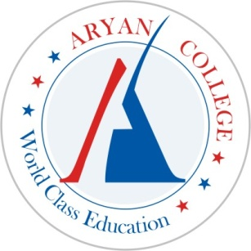

**ARYAN** **COLLEGE**

LOHAGAL,

AJMER-305001

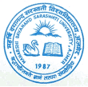

MAHARSHI DAYANAND SARASWATI UNIVERSITY

**AJMER (RAJ.) INDIA**

**ACKNOWLEDGEMENT**

We find ourselves to be privileged to have golden opportunity to develop website on Picturesque. To carry out this work has been both a great pleasure and privilege to us. To develop a successful website, one needs understanding and co-ordination from all those who are directly and indirectly involved in this.

We take this opportunity to express our sincere thanks to **Mr. Amar Pal Singh Shekhawat,** **Director**, **Aryan College, Ajmer** for giving us a free hand to show our capability, his active cooperation and valuable suggestions throughout our project work.

**Himani Sharma**

**Kartik Sharma**

**Ritik Dutta**

**PREFACE**

We have developed this website about **Donation** using HTML, CSS and Java Script. This website is designed to carry out best of photographic experience.

The main thing, which has been kept in mind during this web development, is our best efforts to make it easy, attractive & user friendly. Through this project, we have tried to keep the look and feel of the website very simple but attractive at the same time. It has been done to reduce the manual and mental tedious work .The energy and resources saved using this program can be utilized for other critical area of Donation.

This website shows details about **the scope and the excitement this field can deliver.** It provides expansion in the various aspects of the Donations.

**TABLE OF CONTENTS**

|  |  |  |
| --- | --- | --- |
| **S.No.** | **Topic** | **Page No.** |
| 1. | Case Study | **1** |
| 2. | Working Environment | **2** |
| 3. | Page Description & HTML Code & CSS | **3-68** |
| 4. | Scope for Further Development | **69** |
| 5. | Bibliography | **70** |