Installing Python

Installing python in windows 10 :

Step-1: Browse through the site www.python.org

Step-2: Click on Downloads

Step-3: Select the option for windows
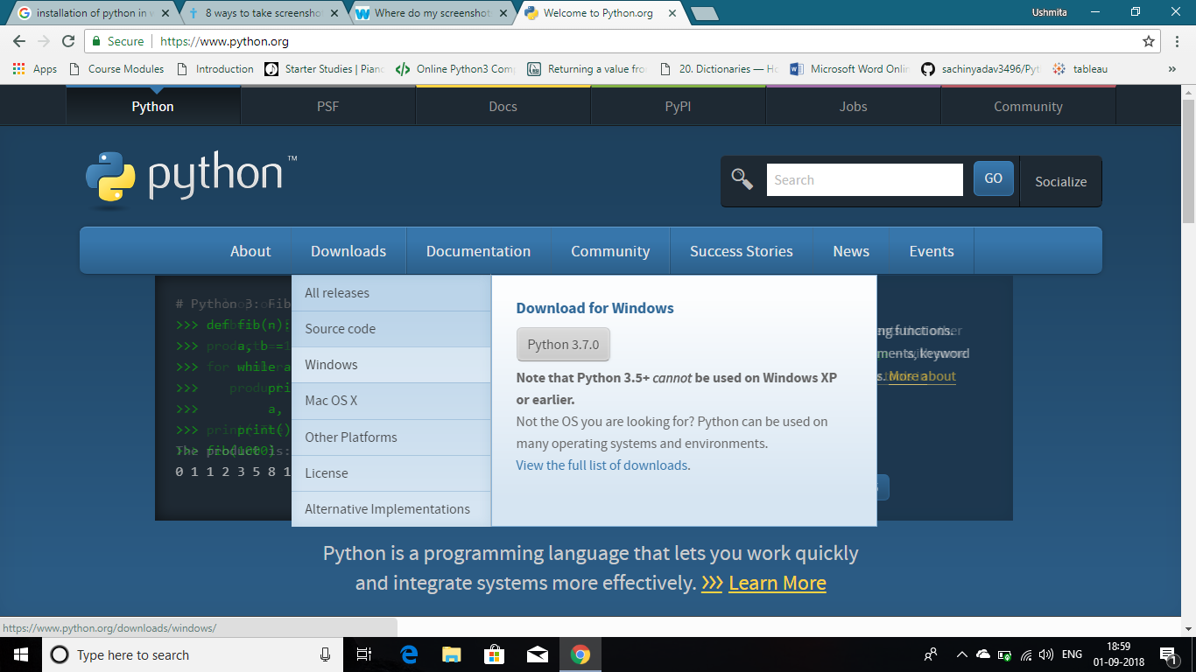

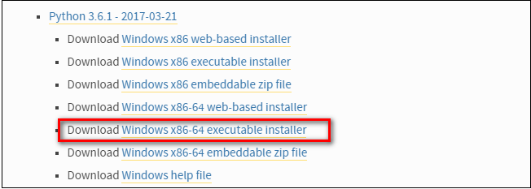
Step-4: Click on the Python 3.6 windows executable installer link.

Step-5: After downloading, run the installer.
Don’t forget to check the option Add python 3.6 to path.

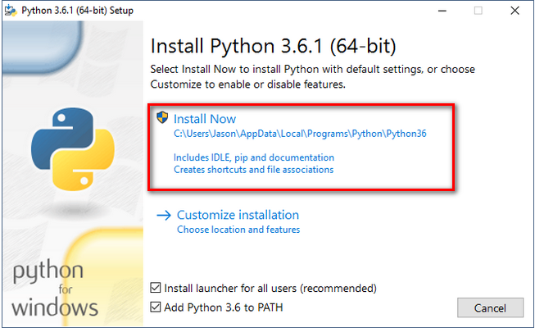

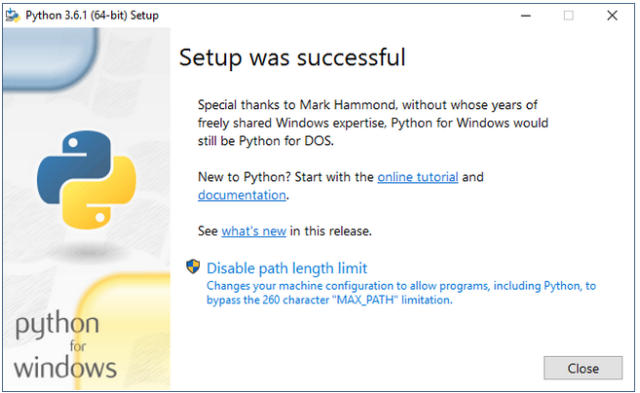
Step-6 : Close the window after installation.

Step-7: After installing Python 3, you can use the command line trick of typing python --version to check that it is installed correctly and the path variable is set.

Installing Anaconda for python


Anaconda contains porting for all the popular python libraries that can be used in data science . The most important being scikit-learn, numpy, pandas, scipy etc. Plus it also comes with the jupyter notebook and Ipython distribution. So, it saves you from importing numerous libraries separately.

Step-1: Visit the Anaconda downloads page on the link : https://www.anaconda.com/download

Step-2: Download preferable version of Anaconda for windows.
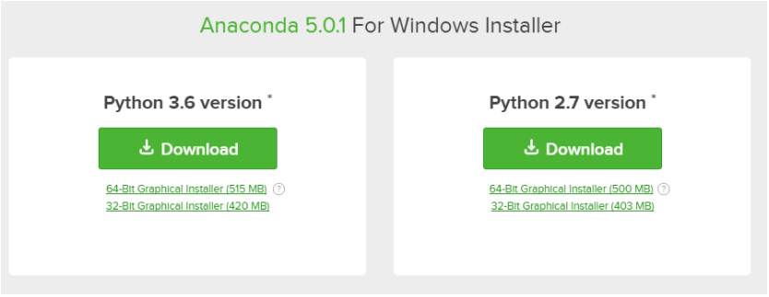

Step-3 : Open and run the installer and go with the default settings.
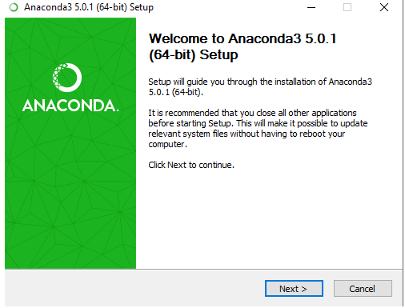

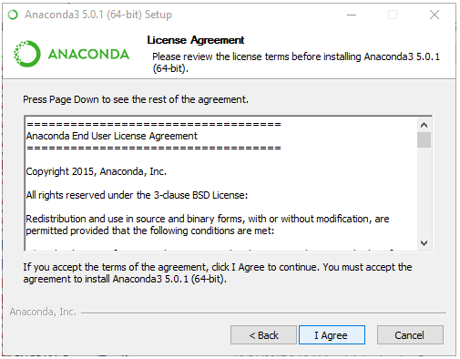

Step-4: Then a dialogue box appears asking to add anaconda to path variable. It isn’t recommended if you have more than one version otherwise do check this option mendatorily to access anaconda and through command line directly.
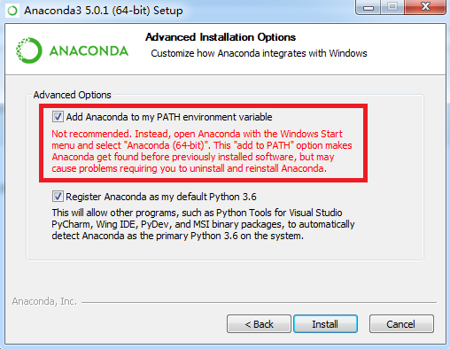

Step-5 : Click on install to install anaconda with the preferred settings.

Setting the path variable

Step-1: Open the This PC icon on the desktop.

Step-2: Go to the location where Anaconda is installed.

Step-3: Copy the path.

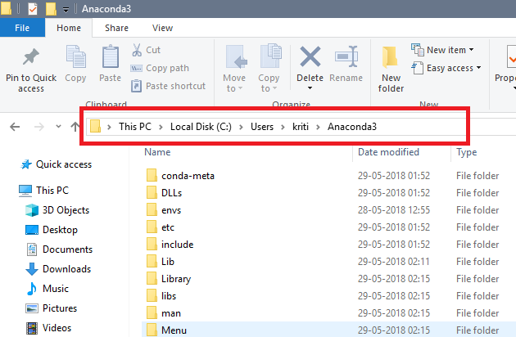

Step-4: Right click and then click on properties.

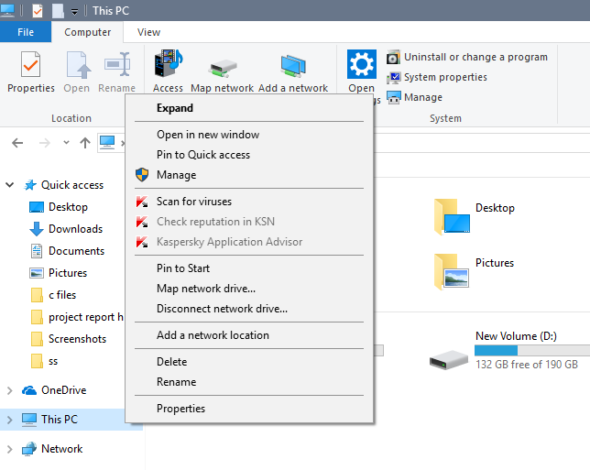

Step-5: Click on the Advanced Settings.
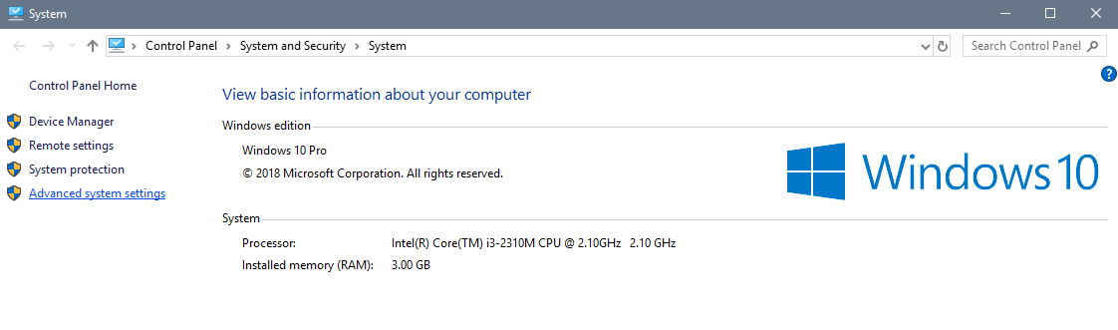

Step-6: Now click on the Environment Variable.
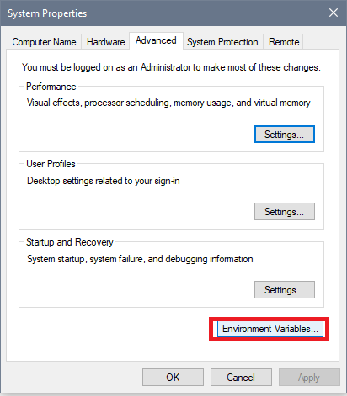

Step-7: Now in the bottom half of the dialogue box i.e System Variables, click on the path option and then click Edit.
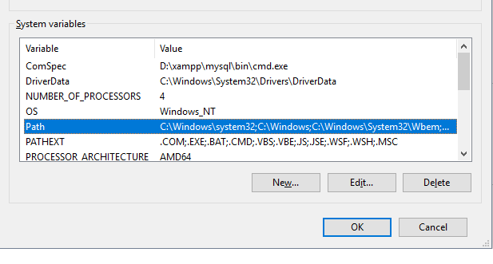

Step-8: Then click new and paste the path of the location where Anaconda is installed.

