SOFTWARE REQUIREMENTS SPECIFICATION (SRS)
BBAT104 Fundamentals of TQM | Inventory Management System | Q14 Improve Navigation

Field | Value
Student | Ritik Kumar
Roll No. | 2520301005
S.No. | 136
Programme / Section | B.Tech CSE / C
Academic Session | 2026-27
Baseline System | Inventory Management System
Quality Goal | Q14 - Improve Navigation

1. Introduction
This SRS defines the requirements for an academic Inventory Management System developed under BBAT104 Fundamentals of TQM. The system is designed around Q14, Improve Navigation, and is intended to provide a clear, consistent and fast route between inventory modules.

2. Scope
The system supports product records, suppliers, stock movements, dashboard indicators and quality-oriented inventory reports. The Q14 enhancement layer improves how users move between these functions without changing the underlying inventory domain.

3. User Classes
Admin/store staff can maintain inventory records and stock movement information. Management users can review dashboard and exception information. The academic evaluator uses the system to verify CRUD operation quality and Q14 navigation behaviour.

4. Functional Requirements
FR-01 Product Create; FR-02 Product Read; FR-03 Product Update; FR-04 Product Delete; FR-05 Supplier display; FR-06 Stock IN/OUT recording; FR-07 Low-stock identification; FR-08 Dashboard KPI tiles; FR-09 Top navigation; FR-10 Breadcrumb trails; FR-11 Home button; FR-12 Keyboard shortcuts.

5. Q14 Quality Requirements
QR-01 Top navigation must remain available across major pages. QR-02 Breadcrumbs must identify the current page. QR-03 Dashboard tiles must provide direct access to major modules. QR-04 Home button must return to dashboard. QR-05 Shortcuts must reduce repeated mouse navigation.

6. Non-Functional Requirements
Usability: consistent controls and labels. Reliability: validation and database constraints. Performance: local SQLite operations should be responsive for academic-scale data. Maintainability: modular Python files. Testability: smoke test and documented defect log. Portability: Python 3.x with Tkinter and SQLite3.

7. Data Requirements
Users, categories, suppliers, products, stock movements and audit logs are persisted in SQLite. Product SKU is unique. Quantity, reorder level and price are non-negative. Stock OUT cannot exceed current quantity.

8. External Interfaces
User interface: desktop Tkinter GUI. Data interface: SQLite3. SQC outputs: Matplotlib/Pandas scripts and documentation. Version control: Git/GitHub as required by the course guideline.

9. Acceptance Criteria
All four core product CRUD operations work; stock movement updates quantity; all five Q14 features are visible and usable; invalid quantities are rejected; low-stock report identifies products at or below reorder level; TQM artefacts document identified risks and improvement actions.

10. Constraints
This is an academic/local desktop implementation. No claim is made that it is production-ready for enterprise-scale deployment, authentication hardening, concurrency, or remote database infrastructure.

11. Traceability
The design traces from the assigned baseline and Q14 quality goal to the five navigation features, then to CTQs, FMEA, defect logging, Pareto analysis, Fishbone root-cause analysis and PDCA improvement.

12. System Architecture
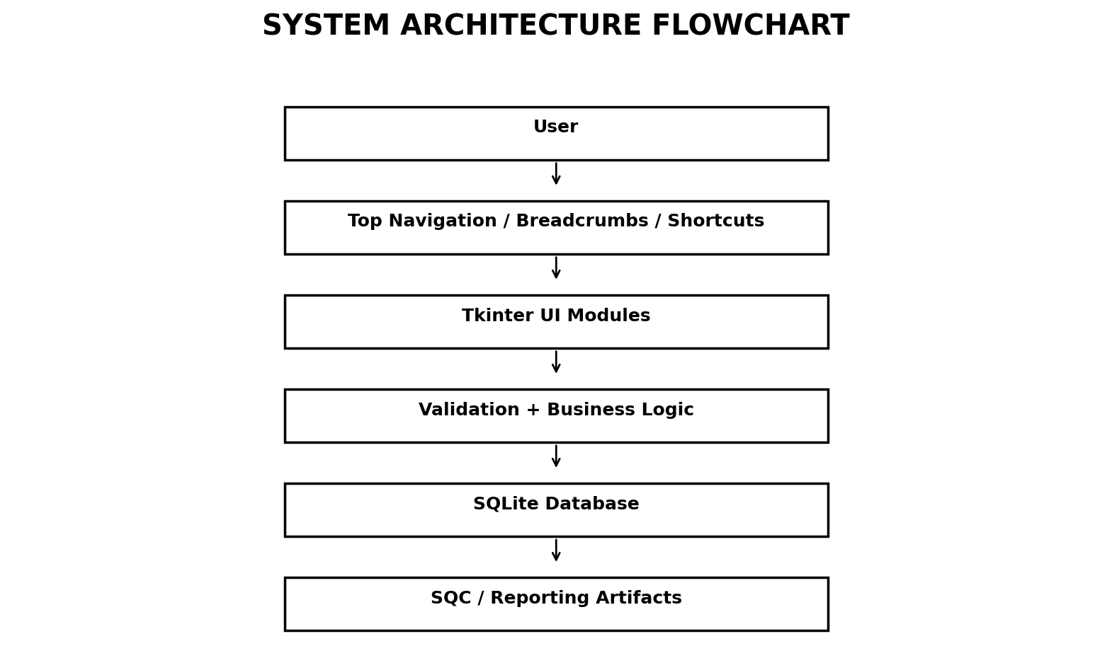
Figure 1. System architecture flowchart.

13. Navigation Specification
Q14 Feature | Implementation in Project | Quality Intent
Breadcrumb Trails | Navigation: Home › Current Page is displayed above the content area. | Maintains context and reduces wrong-page actions.
Top Navigation Bar | Home, Products, Suppliers, Stock, Reports are persistent menu actions. | Provides consistent access to major modules.
Shortcuts | Ctrl+H/P/S/R and F1. | Reduces navigation time for repeat users.
Dashboard Tiles | Total Products, Low Stock, Total Suppliers, Units in Stock. | Creates quick decision points and direct module access.
Home Button | ← Home is present in the title area and returns to the dashboard. | Provides a safe universal return path.

14. Test Scenarios
ID | Scenario | Expected Result
TC-01 | Open application | Dashboard opens with four KPI tiles.
TC-02 | Open Products | Breadcrumb shows Home › Products; product grid loads.
TC-03 | Use Home button | Dashboard displayed.
TC-04 | Press Ctrl+S | Stock page displayed.
TC-05 | Press F1 | Shortcut table displayed.
TC-06 | Add product with negative quantity | Validation error shown.
TC-07 | Record OUT greater than stock | Operation rejected.
TC-08 | Delete selected product | Product removed after confirmation.

