BBAT104 FUNDAMENTALS OF TQM - COURSE PROJECT REPORT
Inventory Management System | Q14 - Improve Navigation

Student Detail | Assigned Value
Student | Ritik Kumar
Roll No. | 2520301005
S.No. | 136
Programme / Section | B.Tech CSE / C
Academic Session | 2026-27
Baseline System | Inventory Management System
Quality Goal | Q14 - Improve Navigation

Certificate / Declaration
This project report is prepared for academic evaluation under BBAT104 Fundamentals of Total Quality Management for the 2026-27 session. The artefacts are structured to match the supplied course project guidelines and the individual allocation for S.No. 136.

Executive Summary
The project develops a desktop Inventory Management System and applies Total Quality Management tools to software quality. The assigned quality goal is Q14 - Improve Navigation. The system therefore integrates breadcrumb trails, a persistent top navigation bar, keyboard shortcuts, dashboard navigation tiles and a universal Home button. TQM analysis is supported by a CTQ tree, SIPOC process map, FMEA matrix with RPN calculations, defect logging, checksheet, Pareto analysis, Fishbone root-cause analysis and a PDCA cycle.

1. Assignment Mapping and Guideline Compliance
The supplied guideline states that the baseline software system is assigned from the roll-number digit and that each student must implement any five suggested features associated with their sequential quality goal. It also requires four review milestones covering setup/SRS, CRUD plus quality features, FMEA/SIPOC/CTQ/defect logging, and SQC/PDCA, followed by final demonstration/viva and GitHub documentation.
Requirement from Guideline | Project Implementation | Status
Assigned baseline | Inventory Management System | Completed
Assigned goal | Q14 - Improve Navigation | Completed
Five Q14 features | Breadcrumb, Top Nav, Shortcuts, Dashboard Tiles, Home Button | Completed
Base CRUD | Product Create, Read, Update, Delete | Completed
SRS + architecture + scope | SRS.docx + architecture figure | Completed
FMEA + SIPOC + CTQ + defect log | Included in this report | Completed
Pareto + Fishbone + Checksheet + PDCA | Included in this report | Completed
README + User Manual | README.md + User_Manual.md | Completed
30 meaningful commits | Local Git history scaffold provided; GitHub push required by student | Action required

2. Problem Definition
Inventory users can lose time when related modules are separated by inconsistent navigation, when there is no visible return path, or when the current page is unclear. These issues can create avoidable operational friction even when the underlying CRUD functions work. Q14 therefore targets navigation quality rather than adding domain functionality that was not assigned.

3. Objectives
- Provide a complete local inventory CRUD base.
- Improve navigation consistency and page orientation.
- Reduce unnecessary clicks and navigation confusion.
- Measure navigation-related defects using SQC tools.
- Apply PDCA to identify and prioritize improvements.

4. System Modules and Q14 Features
Module / Feature | Description | Quality Contribution
Dashboard | Four KPI tiles plus quick-navigation actions. | Fast orientation and direct module entry.
Products | Create/read/update/delete product records. | Core CRUD base for review 2.
Suppliers | Supplier master visibility. | Supports inventory context.
Stock | IN/OUT movement recording with validation. | Maintains stock state.
Reports | Inventory value and low-stock exceptions. | Decision support and quality evidence.
Breadcrumbs | Current route shown as Home › Page. | Context clarity.
Top navigation | Persistent major-module buttons. | Consistent navigation.
Shortcuts | Ctrl+H/P/S/R and F1. | Fast access.
Dashboard tiles | KPI cards open relevant modules. | Reduced navigation effort.
Home button | Universal return to dashboard. | Safe recovery path.

5. CTQ Analysis
The Critical-to-Quality tree translates the navigation need into measurable attributes. The principal CTQs are contextual clarity, persistent access, quick return and low-effort keyboard navigation.
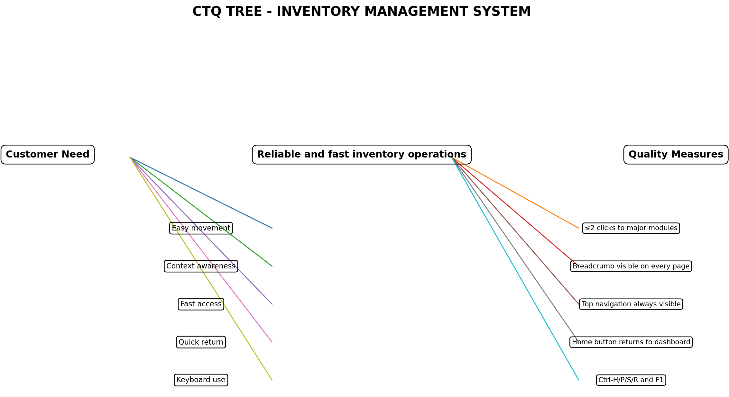
Figure 2. CTQ Tree.

6. SIPOC Process Audit Map
The SIPOC map defines suppliers, inputs, process steps, outputs and customers so that navigation failures can be considered as process defects instead of isolated interface complaints.
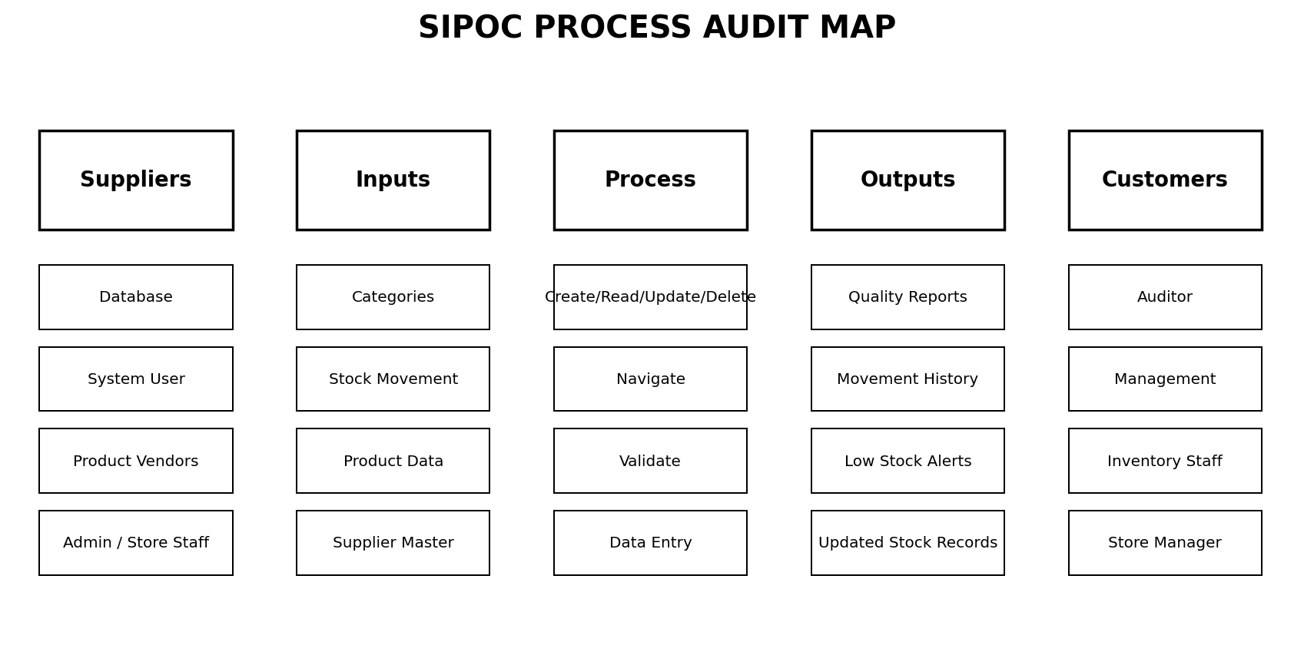
Figure 3. SIPOC process audit map.

7. FMEA Matrix and RPN Analysis
Risk Priority Number is calculated as RPN = Severity × Occurrence × Detection, as specified in the supplied guideline. Higher RPN values are treated as higher-priority risks.
Failure Mode | Cause | Effect | S | O | D | RPN
User cannot tell current page | Navigation context unclear | Wrong actions / extra clicks | 7 | 6 | 4 | 168
No universal return path | Home action unavailable | User gets stuck in module | 8 | 5 | 4 | 160
Major module hidden | Inconsistent top navigation | Longer task time | 8 | 5 | 5 | 200
Shortcut not documented | User unaware of keys | Missed efficiency benefit | 5 | 7 | 5 | 175
Tile label ambiguous | Dashboard action unclear | Wrong module opened | 6 | 5 | 5 | 150
Inconsistent button placement | Layout drift between pages | Increased learning time | 6 | 5 | 6 | 180
Invalid stock movement | Input not validated | Wrong inventory quantity | 9 | 4 | 3 | 108
Duplicate SKU | Unique identifier not enforced | Data duplication | 8 | 3 | 3 | 72
Low-stock exception missed | No visible report | Potential stockout | 8 | 4 | 5 | 160
Database write failure | Unhandled exception | Data loss / app interruption | 9 | 2 | 6 | 108
Priority interpretation: the navigation-specific risks with the highest RPN are inconsistent button placement (180), major module visibility (200), and current-page ambiguity (168). These findings directly justify the Q14 feature set. Domain-quality risks such as invalid stock movement are retained because reliable navigation should lead users to valid operations, not merely faster invalid actions.

8. Defect Logging and Checksheet
A checksheet was used to aggregate observed or simulated navigation defect occurrences for academic SQC analysis. The data is intentionally small and transparent so the Pareto logic can be reproduced.
Defect Type | Frequency
No clear return path | 14
Module hidden from nav | 10
Too many clicks | 8
Shortcut unavailable | 6
Breadcrumb absent | 5
Inconsistent labels | 3
Dashboard tile unclear | 2
Other | 2
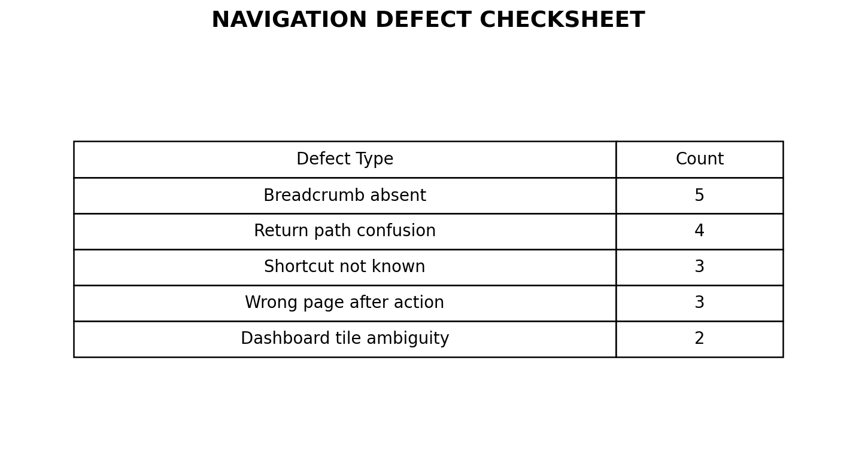
Figure 4. Defect checksheet visual.

9. Pareto Analysis (80/20)
The first four causes account for 38 of 50 logged defects, or 76%. Including the fifth cause raises the cumulative share to 86%. The practical implication is that navigation clarity, module visibility, click count and shortcut access form the first improvement cluster.
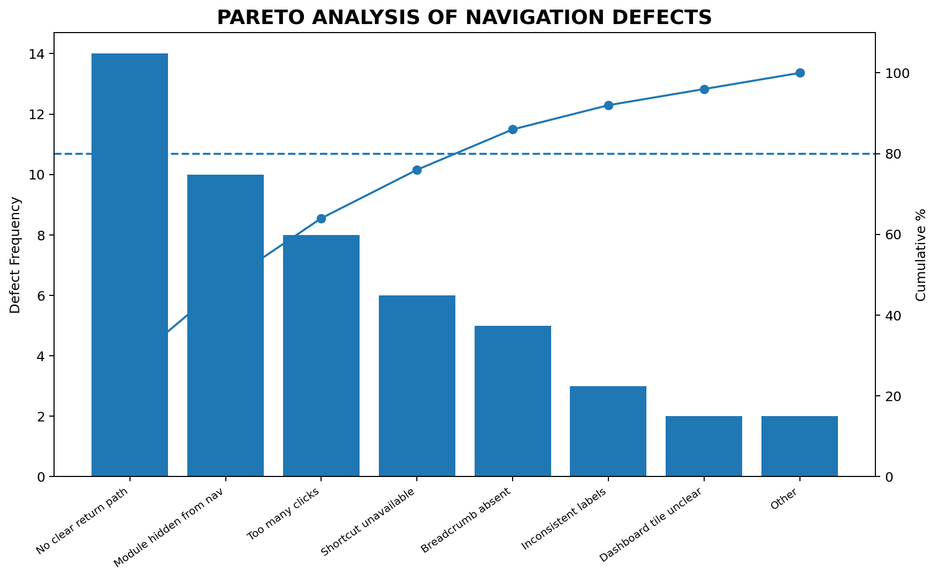
Figure 5. Pareto chart of navigation defects.

10. Ishikawa / Fishbone Root Cause Analysis
Root causes are grouped under People, Process, Software Code and Infrastructure, matching the categories required by the course guideline. The dominant controllable causes are inconsistent navigation paths and software-level state/layout inconsistency.
Fishbone Branch | Root Causes
People | Unfamiliar with shortcuts; new-user training need
Process | Inconsistent page return path; too many navigation choices
Software Code | Missing current-page state; inconsistent button placement
Infrastructure | Low-resolution display; keyboard-focus differences
Figure 6 is supplied as a standalone Fishbone diagram in the artifacts folder.

11. PDCA Continuous Improvement Cycle
Phase | Project Action | Evidence / Metric
Plan | Identify navigation friction and rank failure modes. | FMEA; CTQ; target: fewer navigation defects.
Do | Implement five Q14 features in the GUI. | Top nav, breadcrumbs, shortcuts, tiles, Home.
Check | Review defect frequencies and high-RPN risks. | Checksheet; Pareto; test scenarios.
Act | Standardize successful navigation patterns and document them. | README, user manual, shortcut screen, coding structure.

12. TQM Principles Applied
TQM Principle | Application in This Project
Customer Focus | Navigation is designed around user effort and context needs.
Continuous Improvement (Kaizen) | PDCA is used to review defect data and refine the navigation layer.
Process-Centric Approach | SIPOC documents the end-to-end information flow.
Fact-Based Decision Making | FMEA/RPN and Pareto frequencies support prioritization.
Error Prevention (Poka-Yoke) | Validation prevents negative stock, excessive stock-out and invalid quantities.

13. Software Testing Summary
Test ID | Input / Action | Expected Result | Status
TC-01 | Launch application | Dashboard with KPI tiles | Pass
TC-02 | Click Products | Products page + breadcrumb | Pass
TC-03 | Click Home | Dashboard displayed | Pass
TC-04 | Ctrl+S | Stock page displayed | Pass
TC-05 | F1 | Shortcut help displayed | Pass
TC-06 | Negative product quantity | Validation error | Pass
TC-07 | Stock OUT > available | Rejected | Pass
TC-08 | Delete selected product | Confirmation then delete | Pass
TC-09 | Low-stock report | Products at/below reorder level | Pass

14. Implementation Structure
Path | Purpose
run.py | Application entry point.
app/app.py | Tkinter UI, navigation shell, dashboard, CRUD screens and dialogs.
app/db.py | SQLite schema, connection helper and demo seed data.
tests/test_smoke.py | Schema smoke test.
requirements.txt | Python supporting packages for SQC.
README.md | Project setup and traceability.
docs/SRS.docx | Detailed software requirements specification.
artifacts/ | TQM diagrams and SQC visual outputs.

15. User Manual
- Run `python run.py` from the project folder.
- Use the top navigation to open Home, Products, Suppliers, Stock and Reports.
- Use the Home button at any time to return to the dashboard.
- Use Ctrl+H, Ctrl+P, Ctrl+S, Ctrl+R, or F1 for shortcut navigation.
- In Products, use Add Product to create records and double-click a row to edit. Use Delete Selected to remove a chosen record.
- In Stock, record IN or OUT movements; an OUT movement cannot exceed current stock.
- Use Reports to inspect inventory value and low-stock exceptions.

16. GitHub and Submission Readiness
The course guideline requires a public repository named BBAT104_TQM_[RegNo], regular commits with a minimum of 30 meaningful commits, GitHub Issues, README, screenshots, architecture diagrams and user manual. This package includes the application and documentation, but the final GitHub account/repository creation and push must be performed by the student because those actions depend on the student’s GitHub account.
Recommended Commit Sequence | Meaningful Change
C01 | Initialize repository and README
C02 | Create project folder structure
C03 | Add SQLite database schema
C04 | Add demo seed data
C05 | Add product model queries
C06 | Build application shell
C07 | Add top navigation bar
C08 | Add breadcrumb trail
C09 | Add Home button
C10 | Add dashboard KPI tiles
C11 | Add shortcut bindings
C12 | Build product list
C13 | Build product create dialog
C14 | Build product update flow
C15 | Add product delete flow
C16 | Build supplier module
C17 | Build stock movement module
C18 | Add stock validation
C19 | Build reports page
C20 | Add audit log writes
C21 | Add smoke test
C22 | Create CTQ tree
C23 | Create SIPOC map
C24 | Create FMEA matrix
C25 | Create defect checksheet
C26 | Create Pareto chart
C27 | Create Fishbone diagram
C28 | Add PDCA documentation
C29 | Add user manual
C30 | Polish README and submission docs

17. Viva Preparation
Question | Answer
Why was Q14 selected? | It is the exact individually assigned quality goal for S.No. 136.
Why use breadcrumbs? | They show current context and reduce navigation confusion.
What is the FMEA RPN formula? | Severity × Occurrence × Detection.
What is Pareto analysis used for? | To isolate the small number of defect causes responsible for most observed defects.
Why use SIPOC? | To map the complete process from suppliers and inputs to outputs and customers.
Why Fishbone? | To organize potential root causes before selecting corrective actions.
What is PDCA? | Plan, Do, Check, Act; a continuous improvement cycle.
How does the software prevent stock errors? | It validates non-negative quantities and prevents stock OUT beyond available quantity.
What are the five Q14 features? | Breadcrumb trails, top navigation bar, shortcuts, dashboard tiles, Home button.

18. Conclusion
The completed project combines a functioning Inventory Management System with a focused Q14 navigation-quality improvement program. The software satisfies the assigned five navigation features while the TQM artefacts translate user friction into measurable quality risks, defect priorities and continuous-improvement actions. The package is structured for demonstration, viva defense and documentation review under BBAT104.

References / Source Basis
1. BBAT104: Fundamentals of TQM, Course Project Guidelines, Allotment & Marking Scheme, Academic Session 2026-27, supplied by the user.
2. TQM Project Allotment sheet, supplied by the user, S.No. 136 mapping to Ritik Kumar, Roll No. 2520301005, Inventory Management System, Q14 Improve Navigation.

