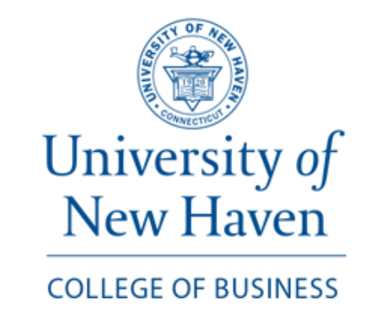

3/22/2024

To the Admission Committee,

I am writing to recommend Ritik Mishra for your esteemed Master of Science in Data Science at University of New Haven. As the Chair of the Business Analytics Department at University of New Haven, I have had the pleasure of overseeing Ritik's progress through the MS in Business Analytics program, from which he is set to graduate in May with a very impressive GPA.

Ritik’s academic excellence is matched by his remarkable dedication and passion for data science and analytics. His ability to grasp complex concepts, combined with a relentless pursuit of knowledge, sets him apart. Ritik has not only excelled in his coursework but has also demonstrated his skills through a variety of projects, showcasing a keen analytical mind and a creative approach to problem-solving.

What makes Ritik truly stand out, however, is his character. His journey to this point has been fueled by resilience and a strong work ethic. He has shown that determination and a love for learning can overcome the toughest of challenges. His positive attitude and willingness to help his peers have made him a valued member of our academic community.

Moreover, Ritik has effectively applied his knowledge outside the classroom, notably during his time with Sequel, a start-up aimed at streamlining the job recruitment process with AI. This experience has not only honed his technical skills but also underscored his potential to impact the field positively. Ritik’s involvement in this project exemplifies his capacity to lead, innovate, and collaborate effectively, even in a remote setting.

Given Ritik’s academic achievements, practical experience, and personal qualities, I am confident he will excel in a program like MS in Data Science and make significant contributions to the field of data science. Ritik possesses the intellect, motivation, and ethical grounding to become a leader in his chosen field. I wholeheartedly support his application and look forward to the remarkable advancements he will undoubtedly bring to the data science community.

Please do not hesitate to contact me if you require further information or insights into Ritik's achievements and capabilities.

Sincerely,

Gazi M Duman, Ph.D.

Chair, Economics & Business Analytics

Pompea College of Business

University of New Haven