

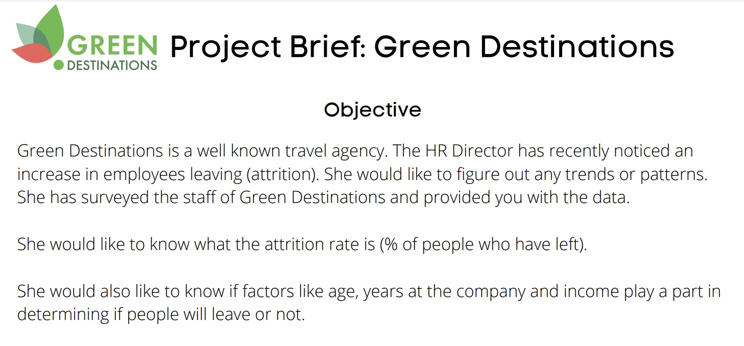

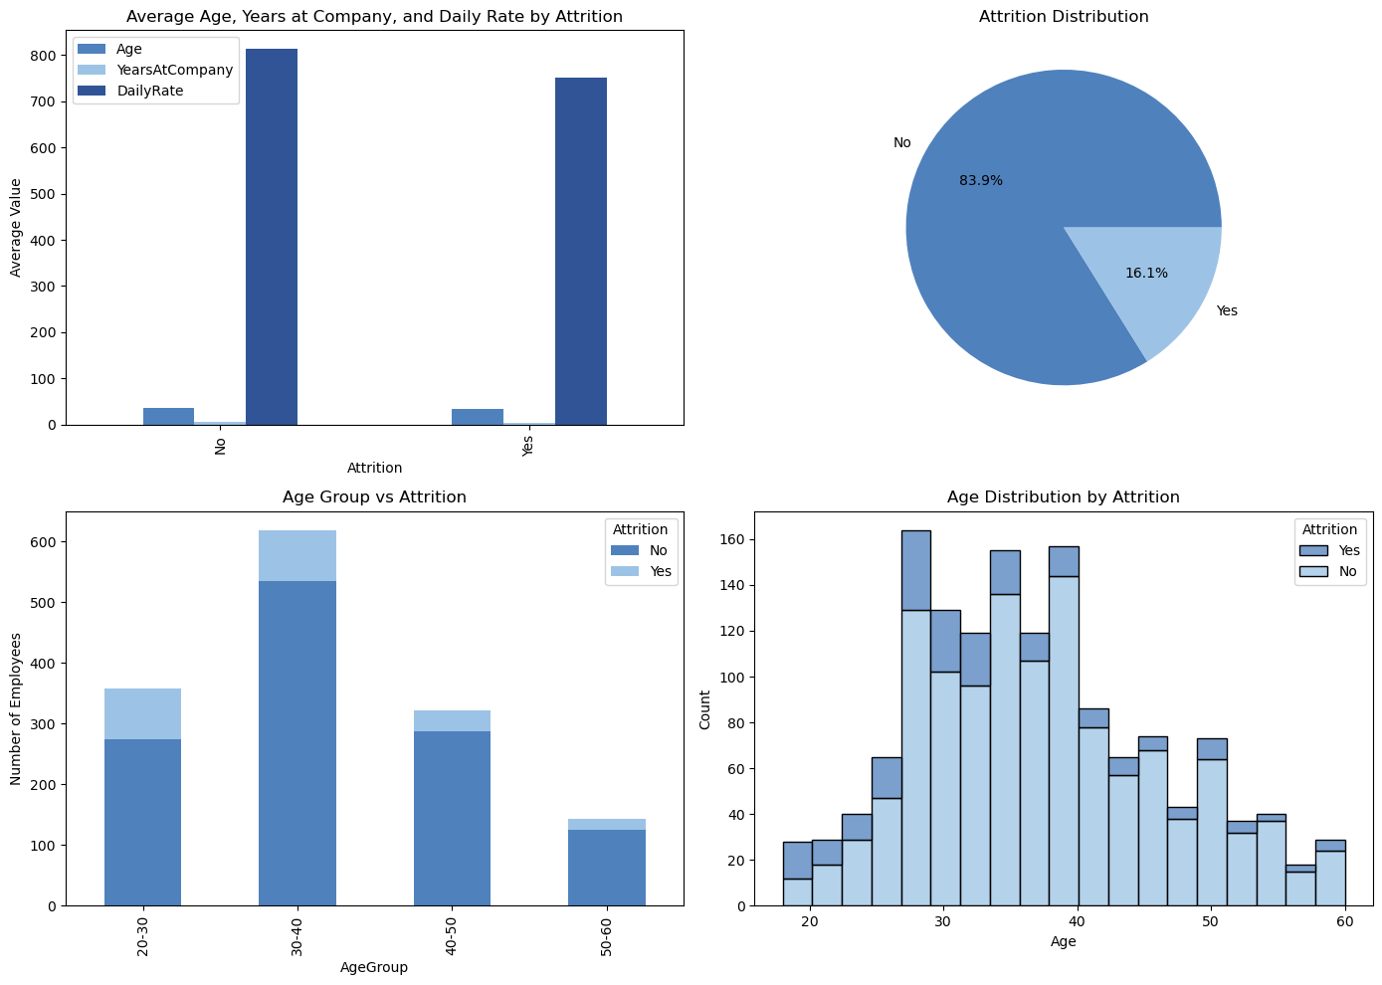

**1. Average Age, Years at Company, and Daily Rate by Attrition**

**Analysis**

This bar chart highlights the difference in the **average age**, **years of service**, and **daily rate (income)** between employees who stayed (No) and those who left (Yes).

* Employees who stayed (Attrition: No) have a **higher average daily rate** compared to those who left, suggesting that **income** may be a key driver of attrition.
* There is no significant difference between the average age and years of service of employees who stayed versus those who left. This indicates that **age** and **tenure** alone may not be strong predictors of employee attrition.

**Key Insights**

* **Income plays a critical role**: Employees who earn less tend to leave more frequently.
* **Actionable Suggestion**: HR could investigate potential salary adjustments for employees in lower-income brackets as a retention strategy.

**2. Attrition Distribution (Pie Chart)**

**Analysis**

The pie chart provides an overview of the proportion of employees who left versus those who stayed:

* **16.1% of the workforce has left**, while **83.9% have remained** with the organization.
* While the attrition rate might not seem excessive, it is essential to investigate underlying factors, as attrition incurs recruitment and training costs, as well as potential disruptions to team performance.

**Key Insights**

* Although the majority of employees remain with the company, the **16.1% attrition rate** is noteworthy and should be addressed.
* **Actionable Suggestion**: Regular employee engagement surveys and exit interviews could help uncover specific reasons for attrition, allowing the company to take preventive actions.

**3. Age Group vs Attrition (Stacked Bar Chart)**

**Analysis**

This chart explores how **attrition varies across different age groups**. It shows:

* Employees in the **30-40 age group** have the highest number of departures.
* The **20-30 age group** also experiences attrition, though to a lesser extent than the 30-40 group.
* Employees in the **40-50** and **50-60** age groups tend to stay with the company more often, showing lower attrition rates.

**Key Insights**

* **30-40 age group** is particularly vulnerable to attrition. Employees in this group may face mid-career challenges, such as balancing work and family responsibilities or seeking growth opportunities.
* **Actionable Suggestion**: HR should consider **targeted retention strategies** for employees in the 30-40 age range, including offering development opportunities, mentoring programs, or flexible work arrangements.

**4. Age Distribution by Attrition (Histogram)**

**Analysis**

The histogram shows the distribution of employees’ **age** and how it correlates with attrition.

* The highest number of employees leaving are in their **30s and early 40s**.
* Employees aged **20-30** also show attrition but to a lesser extent.
* Employees older than **50** show much lower levels of attrition, indicating a more stable group in terms of employment.

**Key Insights**

* Employees in their **30s and early 40s** show the highest likelihood of leaving, aligning with findings from the stacked bar chart.
* **Actionable Suggestion**: Focus on enhancing career progression pathways and ensuring job satisfaction for younger and mid-career employees. Tailored career growth programs or retention bonuses for these age groups could be effective.

**Overall Summary & Recommendations**

**Key Outcomes**:

* **Attrition is highest in employees in the 30-40 age range**, with lower income levels being a contributing factor.
* The overall attrition rate is **16.1%**, which, while not alarming, warrants attention to maintain workforce stability and reduce the costs associated with employee turnover.

**Strategic Recommendations**:

1. **Address Income Disparities**: Consider salary adjustments for lower-paid employees or provide opportunities for financial growth to reduce income-driven attrition.
2. **Targeted Retention Programs**: Focus on employees in their **30s and 40s**, who seem to be at higher risk of leaving. Offering career development opportunities, mentorship, and flexible work arrangements could help in retaining this group.
3. **Employee Engagement Initiatives**: Implement regular check-ins, career planning sessions, and employee satisfaction surveys to identify and address attrition risk factors before they result in employee departures.

By focusing on these areas, Green Destinations can work toward reducing attrition rates and fostering a more engaged, motivated, and loyal workforce.