
ai driven predictive maintenance in advanced manufacturing


Prepared by ritik tickoo
supervisor: Dr. roopak sinha
deakin university

Table of Contents

1 | Project overview
2 | Context
3 | Objectives
4 | Dataset Selection
5 | Dataset Understanding
6 | Proposed Modelling Approach
7 | Planned Workflow  - Data Cleaning  - Data Preprocessing  - Feature Engineering  - Model Training  - Model Evaluation
8 | ROI Analysis Framework  - Reactive Maintenance  - Predictive Maintenance  - Cost Comparison  - Downtime Reduction
9 | Supervisor Feedback
10 | References

Project overview
This research internship project focuses on the development of a working AI-driven predictive maintenance model for advanced manufacturing environments using machine learning and industrial sensor datasets. The project aims to analyse engine degradation patterns and estimate Remaining Useful Life (RUL) using operational settings and sensor measurements collected from simulated run-to-failure engine scenarios.
The project utilises the NASA CMAPSS turbofan engine degradation dataset, which contains multiple engine operational cycles, sensor measurements, and degradation behaviour data. Machine learning models such as Decision Tree and Random Forest will be explored to identify degradation trends and support predictive maintenance decision-making.
The overall objective of the project is to develop a working predictive maintenance model capable of analysing engine degradation patterns and estimating Remaining Useful Life (RUL) using industrial sensor data and machine learning techniques. The project will also explore data preprocessing, feature engineering, model evaluation, and ROI comparison between reactive and predictive maintenance strategies within Industry 4.0 environments.
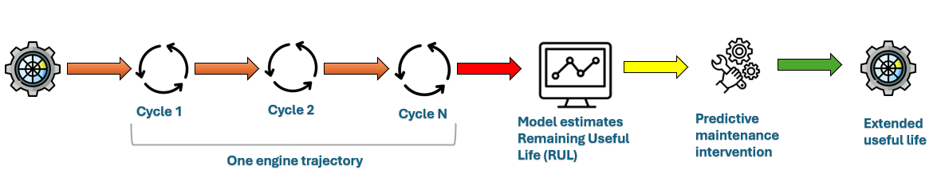

Figure 1: Engine Operational Lifecycle and Maintenance Process

The diagram illustrates different operational cycles of the engine followed by Remaining useful life estimation(RUL) by machine learning model before engine breakdown. This Allows the maintenance to be performed before breakdown, so that the engine lifespan improves for an extended period of time.

Project Context
Modern manufacturing industries increasingly rely on automated machinery and high-value equipment to maintain operational efficiency and productivity. Unexpected equipment failures can result in production downtime, operational disruption, increased maintenance costs, and financial losses. Traditional reactive maintenance approaches repair equipment only after failure occurs, which can be costly and inefficient in advanced manufacturing environments.
Predictive maintenance uses artificial intelligence and machine learning techniques to identify potential equipment failures before breakdown occurs using operational and sensor-based data. This project is situated within the context of Industry 4.0 and smart manufacturing, where organisations are increasingly adopting data-driven maintenance strategies to improve operational reliability, reduce downtime, optimise maintenance scheduling, and maximise return on investment (ROI).

Objectives
The internship project aims to achieve the following objectives:
Objective No. | Objective
1 | Analyse the NASA CMAPSS turbofan engine degradation dataset and understand operational settings, sensor measurements, and Remaining Useful Life (RUL) prediction workflows.
2 | Develop a predictive maintenance framework using Python and machine learning models to identify engine degradation patterns and estimate Remaining Useful Life (RUL).
3 | Build a structured data workflow involving data ingestion, data cleaning, preprocessing, feature engineering, model training, and model evaluation.
4 | Explore and compare machine learning approaches such as Decision Tree and Random Forest models for predictive maintenance modelling.
5 | Evaluate model performance using testing datasets and RUL target files to assess prediction accuracy and reliability.
6 | Compare reactive maintenance and predictive maintenance approaches by analysing operational downtime, maintenance costs, and potential Return on Investment (ROI) improvements.

Data selection
- Dataset Name: NASA CMAPSS Turbofan Engine Degradation Dataset
- Source:NASA Prognostics Center of Excellence (available through Kaggle and NASA repository)
- Dataset Description:The dataset contains simulated run-to-failure data for turbofan jet engines developed using the C-MAPSS simulation model by NASA. The dataset is commonly used for predictive maintenance and Remaining Useful Life (RUL) prediction research.
- Each engine contains multiple operational cycles and sensor measurements representing engine health over time. The objective is to predict the Remaining Useful Life (RUL) of engines before system failure occurs.
- The dataset contains: Training datasets,Testing datasets, RUL target files, Sensor and operational setting measurements
NASA has created 4 datasets with different complexity ranging from easiest to most complex.
FD001 | Easiest dataset with one operating condition and one fault mode
FD002 | Multiple operating conditions with one fault mode
FD003 | One operating condition with multiple fault modes
FD004 | Most complex dataset with multiple operating conditions and fault modes

- Selected Dataset:
- FD001 dataset subset
- Reason for Selection:
For the initial phase of this project, the FD001 dataset has been selected due to its lower complexity and suitability for initial data exploration, preprocessing, and model development.

Dataset understanding and exploratory data analysis(eda)
- Data overview: The FD001 dataset contains about 20631 rows and 26 variables including unit number, operational setting,operational cycle information and different sensor measurements.The dataset represents degradation data of 100 turbofan engines that are used till failure. Initial inspection of the dataset confirmed that the dataset contains no missing values or duplicate records. Data types were also checked and they were found suitable for the analysis.
- Engine Lifecycle Analysis: Engine lifecycle analysis was performed by calculating the maximum operational cycles for each engine unit. The results showed significant variability across the dataset, with the minimum engine lifecycle recorded at 128 cycles and the maximum lifecycle reaching 362 cycles. The average engine lifespan was approximately 206 operational cycles.The variability suggested that different engines degrade at different life cycle making it suitable for predictive maintenance and Remaining useful life prediction analysis.
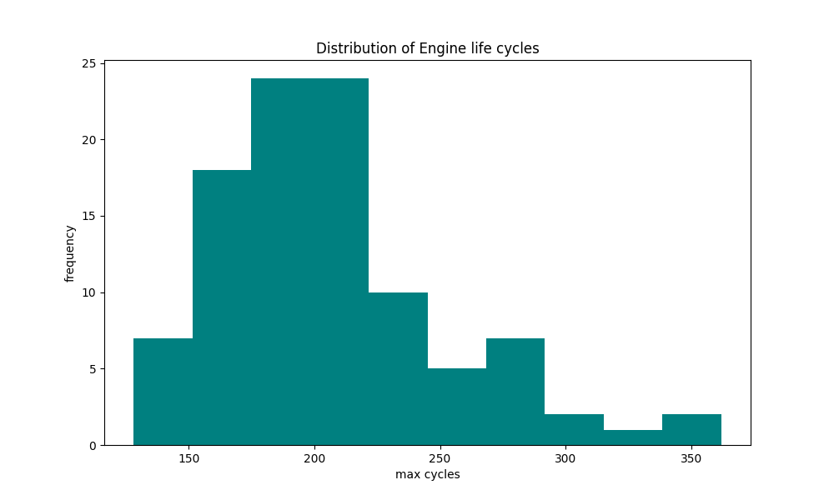

Figure 2: Distribution of Engine Lifecycle Durations

- Sensor Trend Analysis: Sensor trend analysis was initially conducted by analysing batches of sensor measurements across operational cycles. Several sensors appeared relatively stable and exhibited minimal variation throughout the engine lifecycle, suggesting limited degradation-related behaviour.
To further investigate sensor behaviour, individual sensor trend analysis was performed for selected sensors. For example, Sensor 7 was analysed against operational cycles for a representative engine, where gradual degradation-related changes and variability were observed over time. Manual inspection of all 21 sensors across 100 engines was not practically feasible. Therefore, additional statistical techniques were used to support systematic sensor selection and feature analysis.
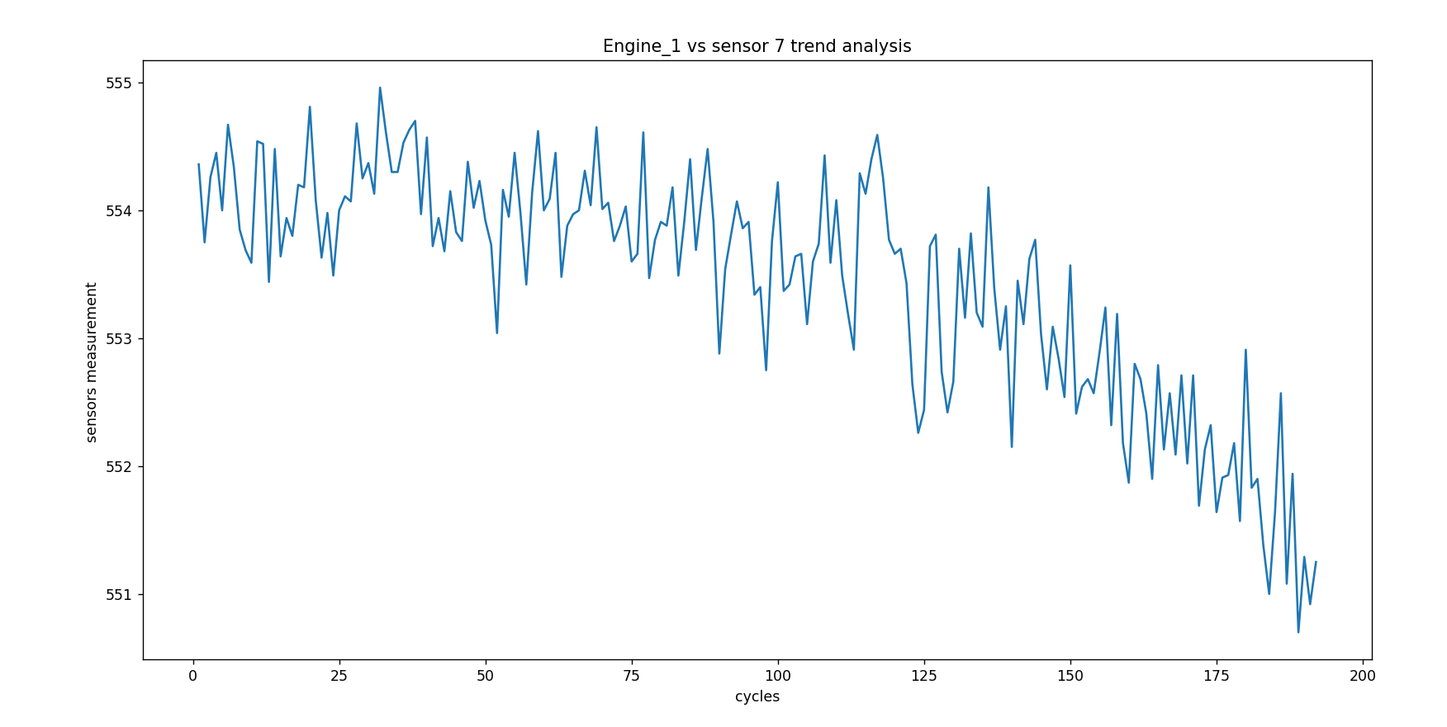
Figure 3: Sensor 7 Trend Analysis Across Operational Cycles
- RUL generation: The Remaining Useful Life (RUL) variable was generated using the maximum operational cycle of each engine. RUL was calculated by subtracting the current operational cycle from the maximum lifecycle of the corresponding engine unit. The generated RUL values serve as the target variable for predictive maintenance modelling and machine learning prediction tasks.
Equation:
RUL = Maximum Cycle − Current Cycle

- Correlation Analysis: To identify informative sensors for predictive maintenance modelling, correlation analysis was performed between sensor measurements and Remaining Useful Life (RUL). Sensors exhibiting stronger positive or negative correlation with RUL were considered more relevant for degradation analysis and model development. Prior to correlation analysis, standard deviation analysis was used as an initial screening technique to identify sensors exhibiting meaningful variability. Sensors with low variability and near-constant behaviour were considered less informative.The correlation analysis assisted in selecting sensors strongly associated with degradation behaviour and helped reduce unnecessary feature complexity for future modelling stages.

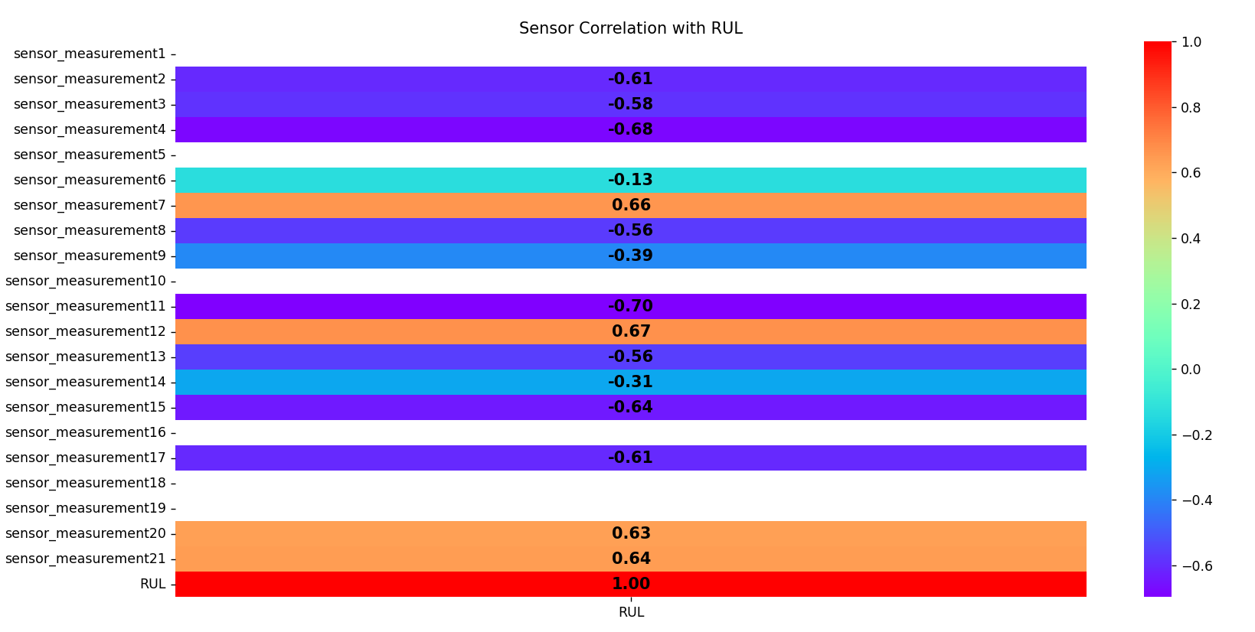
Figure 4: Correlation Between Sensor Measurements and Remaining Useful Life (RUL)

