**CS450 Project Database Application Deliverable:**

**Ritika Raju G01153229**

**This Application was created using JAVA Net Beans, SQL and Jasper Forms.**

1. “A way for a “manager” (student) to enter the SSN of a manager (like Borg, or any other manager), and the SQL Query would check if indeed that SSN matches a manager’s SSN. If the test is OK, then the manager can input the employee information. If the SSN does not match a manager’s SSN, then print that the SSN does not correspond to a manager and then stop.”

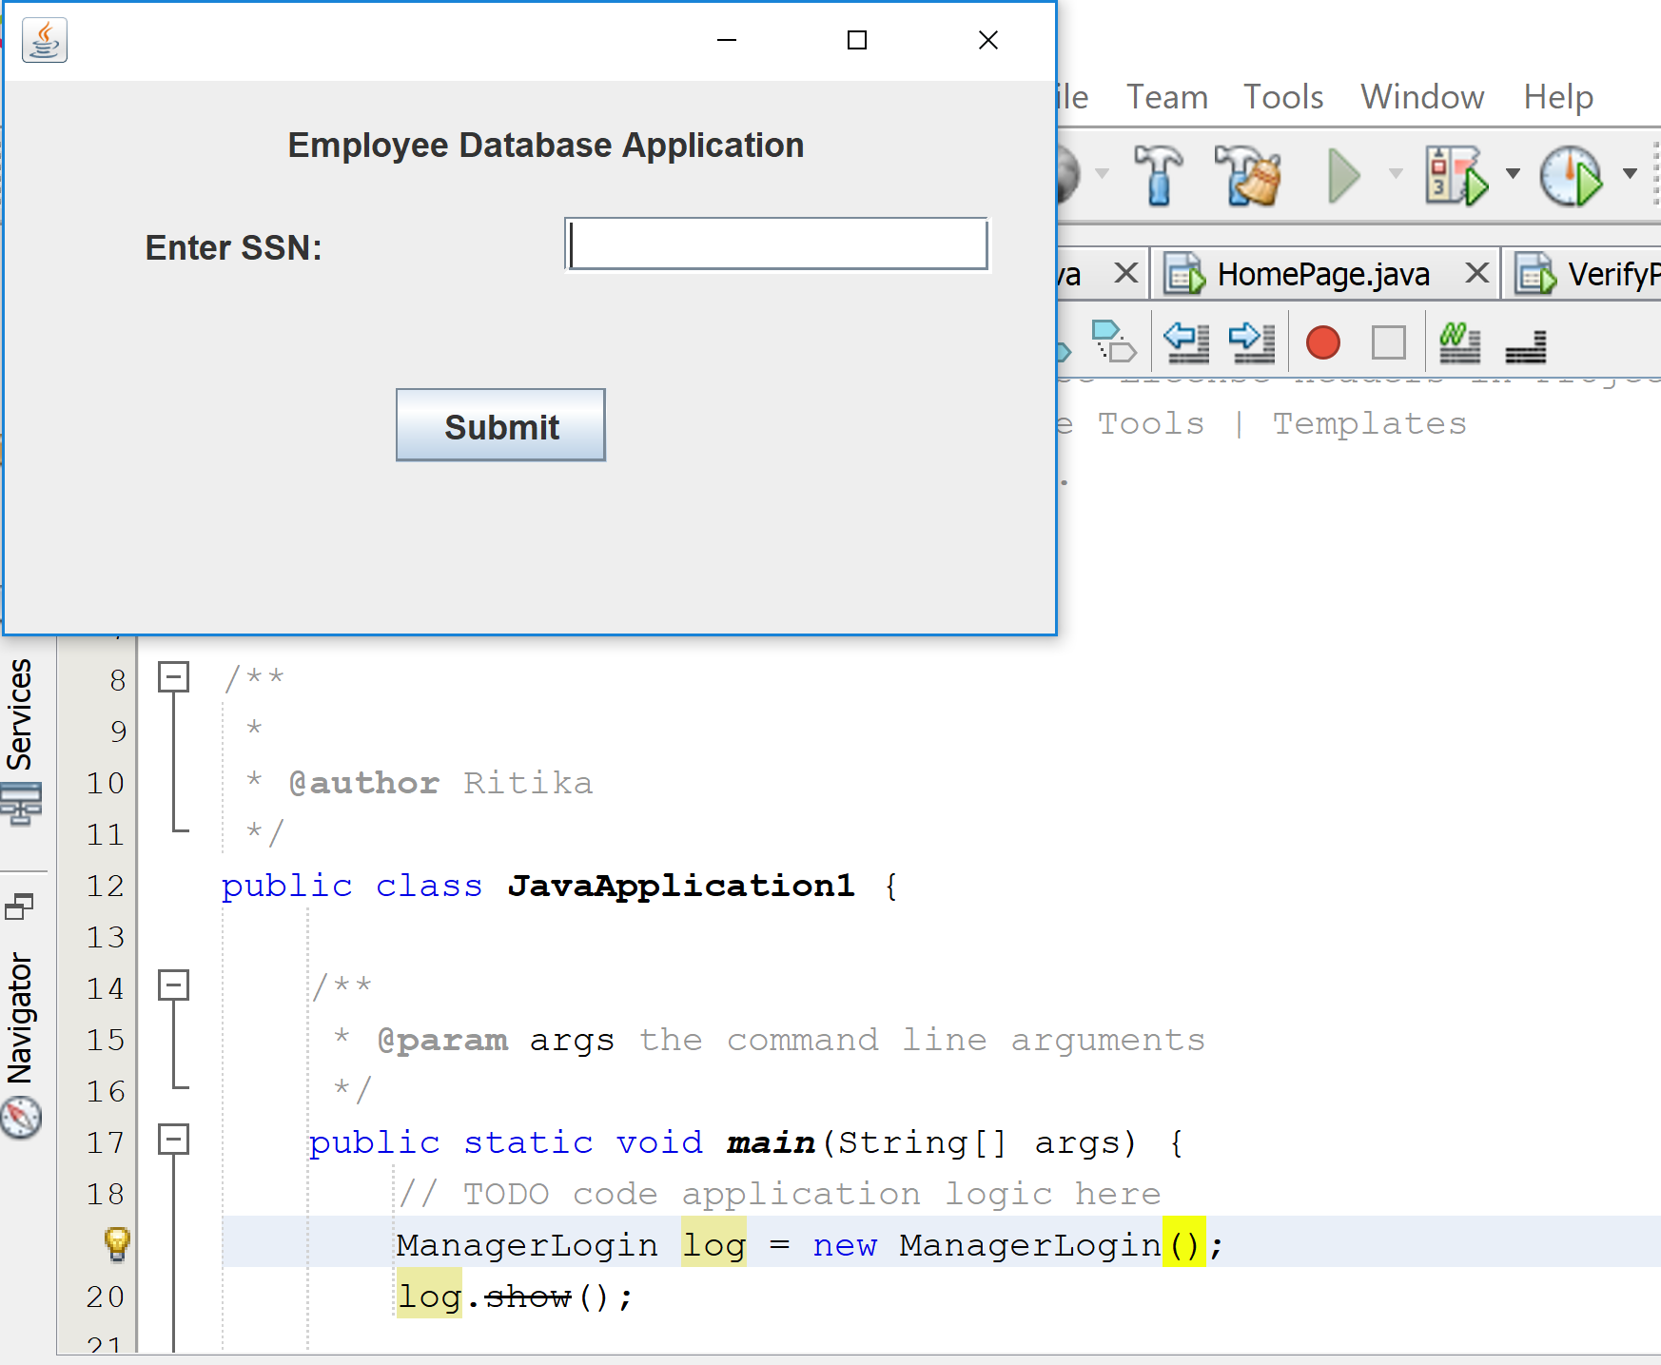

1. Next the manager must be able to insert a new employee into the COMPANY database and employee table. My code handles errors like presence of NULL fields, incorrect date formats, incorrect department number, incorrect SSN format etc. For example, If empty fields are present my application would throw a dialog box as shown in the image below.

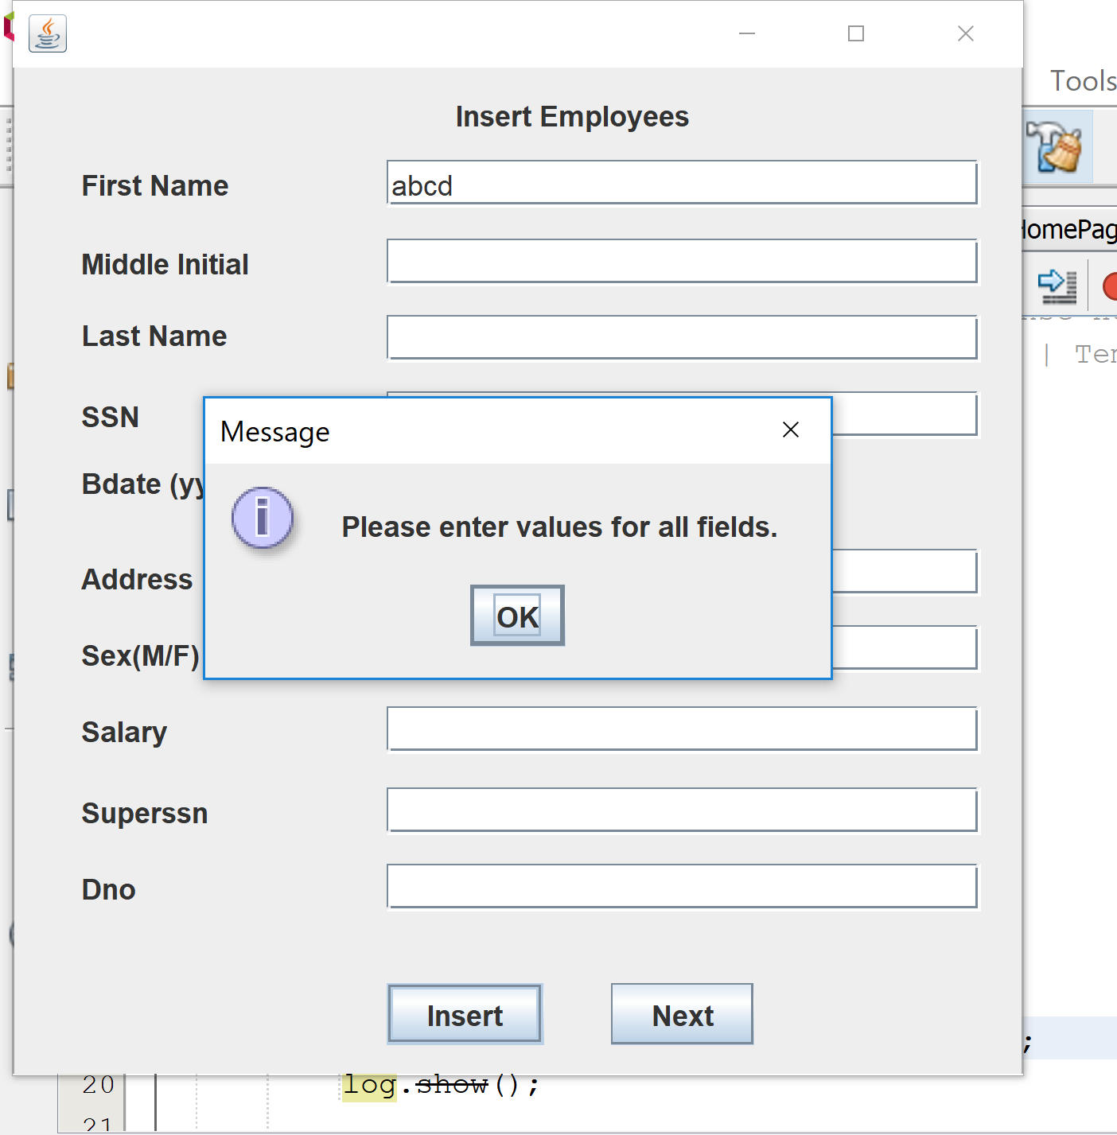

1. Once the new employee details are entered, projects are assigned in such a way that it doesn’t exceed 40 hours for each employee.

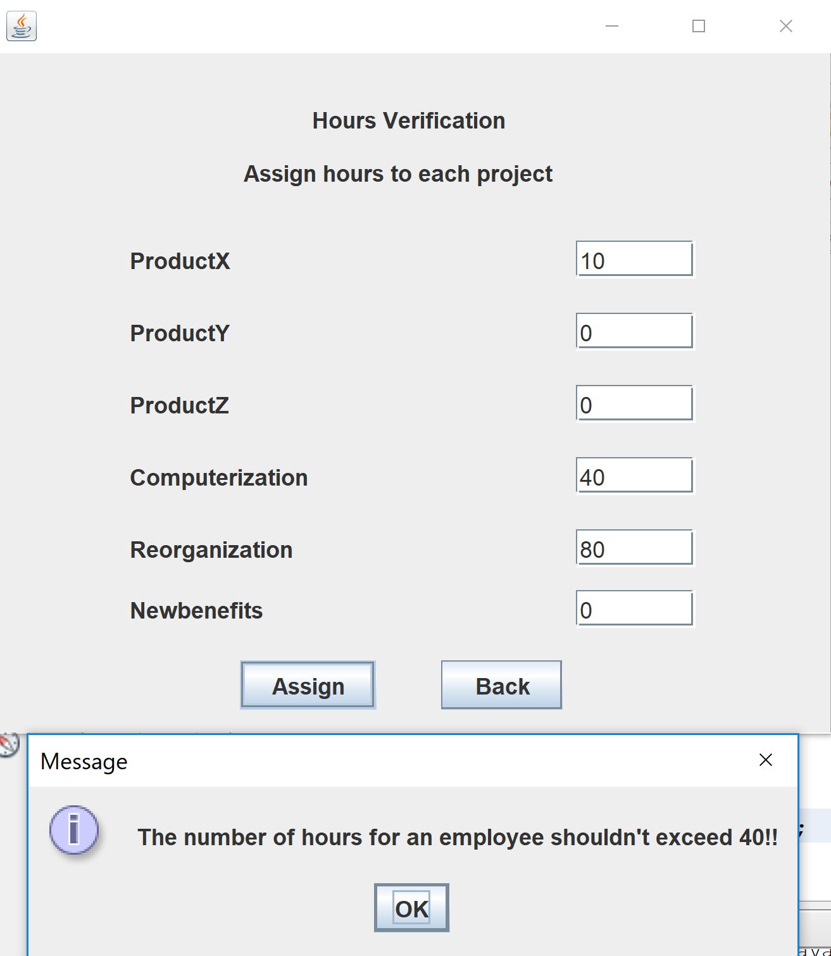

1. There is an option to choose to add dependents for the employee. If No is picked, the application directly generates reports. If YES is picked, a maximum of 3 dependents is allowed to be added into the database.

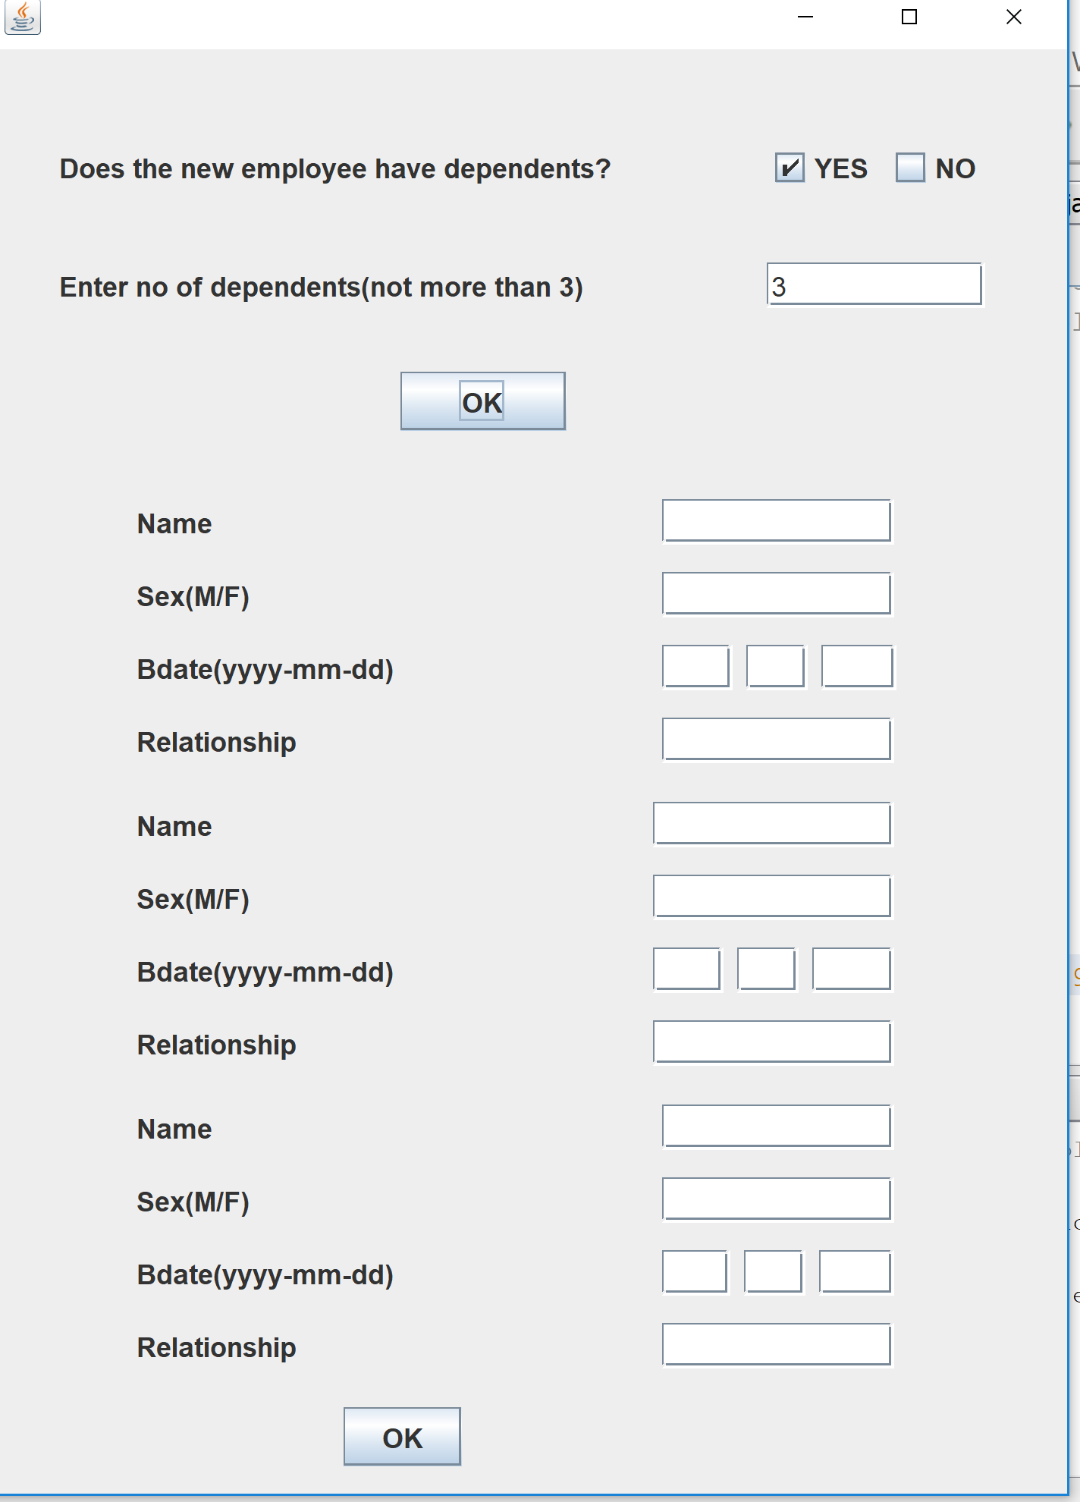

1. Lastly, printable reports are generated using Jasper Forms. A sample of the reports shown in the movie are included.

