**Network Architecture**

**Project 2**

**Socket Programming**

**Submitted by:**

**Ritika Chowdri**

**16230840**

**Socket Programming**

A socket is one of the most fundamental technologies of computer network programming. Sockets allow network software applications to communicate using standard mechanisms built into network hardware and operating systems.

A socket represents a single connection between exactly two pieces of software (a so-called point-to-point connection). More than two pieces of software can communicate with client/server or distributed systems by using multiple sockets. For example, many Web browsers can simultaneously communicate with a single Web server via a group of sockets made on the server.

Socket-based software usually runs on two separate computers on the network, but sockets can also be used to communicate locally (inter process) on a single computer. Sockets are bidirectional, meaning that either side of the connection is capable of both sending and receiving data. Sometimes the one application that initiates communication is termed the "client" and the other application the "server," but this terminology leads to confusion in peer to peer networking and should generally be avoided.

This report consists of the source code for client and server: Client.py and Server.py which has been successfully compiled using Python.

The source code is below:

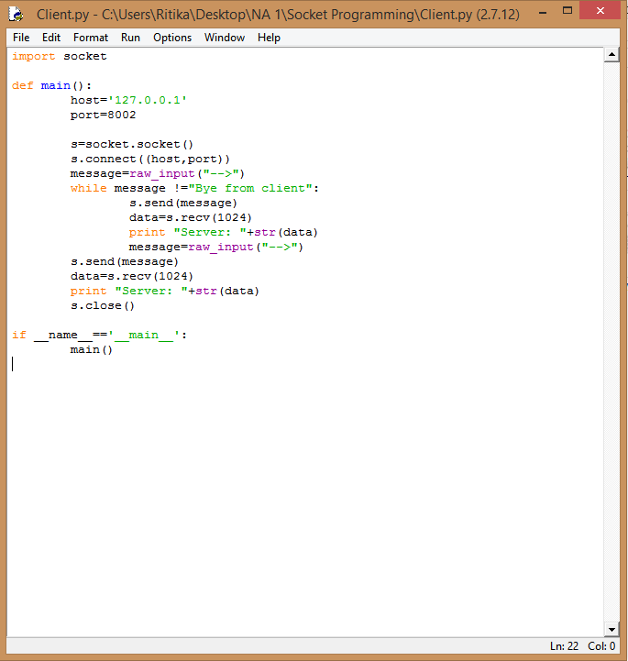

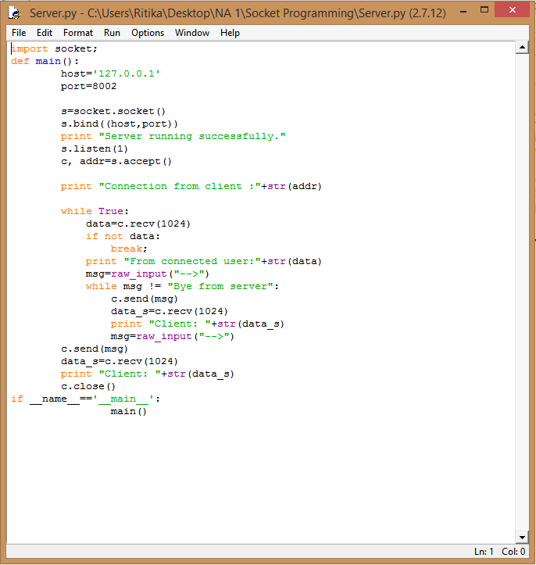

The client and the server codes are in running mode and I was able to establish communication between client and server.

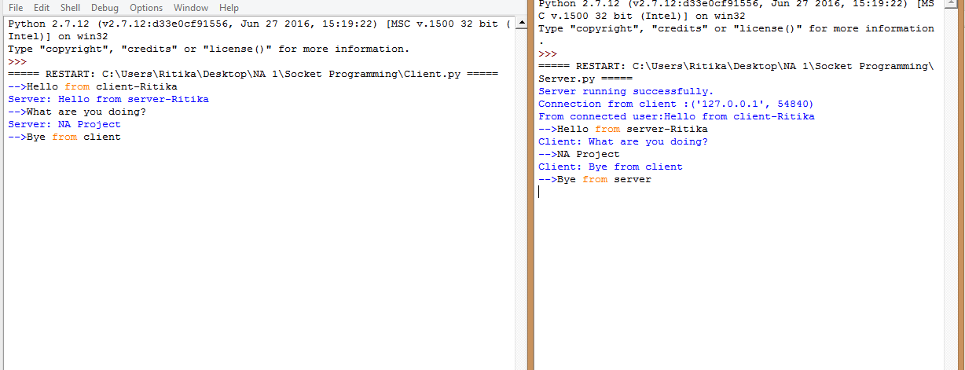

A file named ‘Homework.txt’ with few lines of content was created and send from client to server.

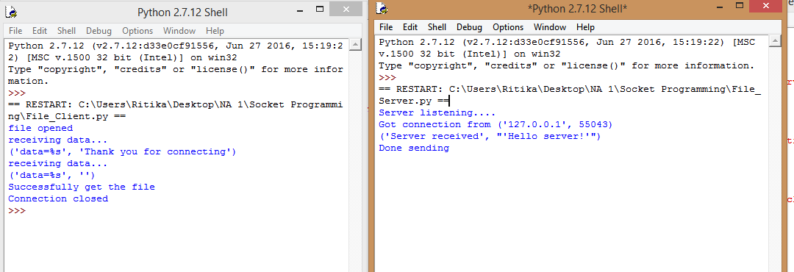

Source code:

For server

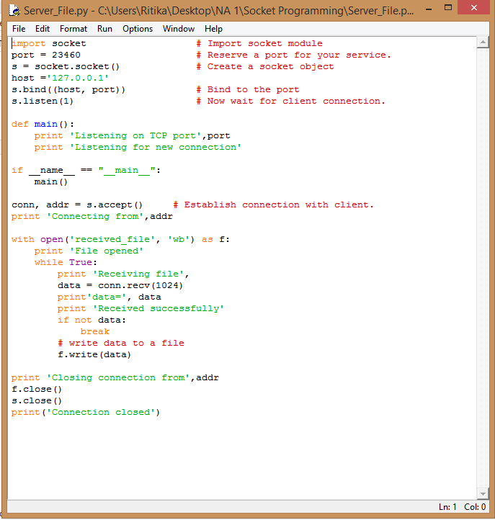

For client

