**Exp: To design automatic led Diwali lights such that it only works during night and can generate two patterns which can be toggled with switch (a)Pattern- LED blinks with a freq of 500msecs (b)LED blinks with a freq of 1 sec.**

**Circuit Diagram:**

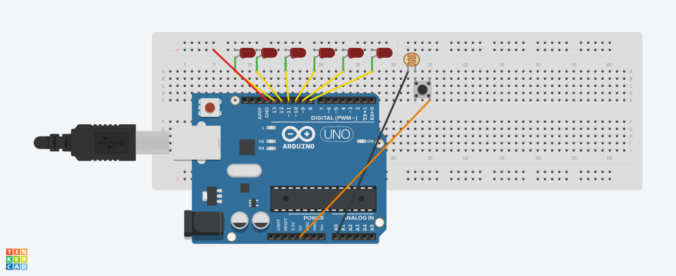

**Theory:**

**Concept Used:**

In this experiment, we build the circuit and plug our Arduino board into our computer. We start the Arduino Software (IDE) and enter the code below to flash LED’s (Light Emitting Diode), which is held together on the Breadboard along with other components.

**Learning and Observations:**

The code we entered is done to give instructions to the Arduino Uno board. Arduino is an open-source electronics platform based on easy-to-use hardware and software. [Arduino boards](https://www.arduino.cc/en/Main/Products) are able to read inputs - light on a sensor, a finger on a button, or a Twitter message - and turn it into an output - activating a motor, turning on an LED, publishing something online. We can tell our board what to do by sending a set of instructions to the microcontroller on the board.

**Precautions:**

(1) The coding done on the software should be correct in every manner. All the errors should be avoided i.e. syntax, logical errors etc.

(2) All the wires and elements should be connected tightly and properly and according to the coding done on the system.

(3) Positive and Negative terminals should be put in correct order.

(4) First build the circuit by connecting all the elements on the breadboard and then connect it with the Arduino.

**Problems and Troubleshooting:**

(1) The incorrect coding might cause problems in the working of hardware. This can be corrected by learning C++ and practicing it on the software.

(2) Hardware should be correctly fitted on the Breadboard or they might get fuse or get permanently damaged.

(3) Arduino wire must be checked if they are loose or not. And the ports should be properly cleaned before using, they might cause problem in future.

(4) LED’s should be correctly connected otherwise may get short circuited.

**Learning Outcome:**

From this experiment we have learn how to code in the Arduino software and how to flash LED’s bulb. We have connected sensor which light LED’s only in dark and follows two pattern – One is LED’s glow at frequency of 500msecs and Second is LED’s glow at frequency of 1 sec. We get to know how the code which we write in the Arduino software gives instructions to the Arduino Uno board.