**Cyclistic Bike Riding Case Study Report**

* **Scenario**

Cyclistic is a bike-share company in Chicago. The company’s future success depends on maximizing the number of annual memberships. The business task is to understand how casual riders and annual members use Cyclistic bikes differently  and design a new marketing strategy to convert casual riders into annual members.

* **Business Task**

To increase the future success of Cyclistic (a bike sharing company) in Chicago. To identify and analyze how casual riders and annual members use Cyclistic bikes differently.

* **Ask Phase**
* **Problem Statement**

To identify and analyze how casual riders and annual members use Cyclistic bikes differently.

* **How it is helpful**
* Through my insights the Cyclistic company will get to know the days in a month when the casual and annual riders hire a bike.
* They will get to know the months in the year when the casual and annual riders hire a bike.
* The days in the month when the casual riders hire a bike.
* **Key Stakeholders :**
* My Manager (Lily Moreno)
* Cyclistic Executive Team
* Cyclistic Analytics Team
* **Prepare**
* Identify how it’s organized.
* Excel sheets
* .csv files
* Download data and store it appropriately.
* Data is downloaded from past previous 12 months from June 2020 to May 2021 and stored in a folder(named “Bike_trips_original_27_06_2021” imported in the R Studio

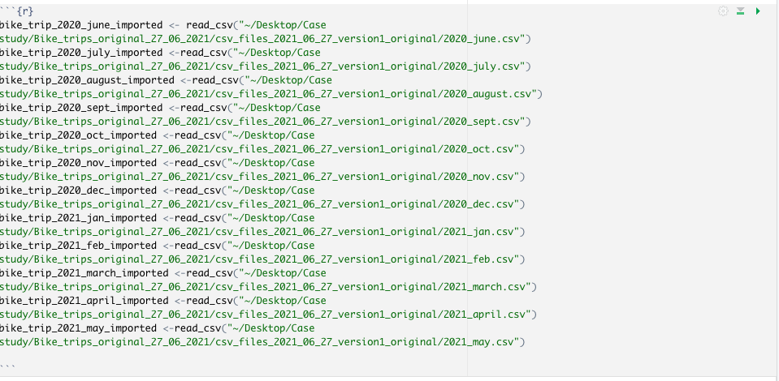

* Sort and filter the data.

We are going to use the data from June 2020 to May 2021 .We will sort the data according to the starting data. We will merge data of all the months (June 2020 to May 2021)

* Determine the credibility of the data.

The data belongs to public data set .Data contains records of last 12 months. The data is current and comprehensive. Data has 13 columns namely : ride_id,rideable_type ,started_at

,ended_at, start_station_name , start_station_id , end_station_name ,end_station_id ,start_lat ,start_lng ,end_lat ,end_lng ,member_casual

* **Process**
* Key tasks
* Check the data for errors.
* Checked for whitespaces,mismatched values and null values in the data
* Choose your tools.
* Excel and R studio
* Transform the data so you can work with it effectively.
* Merge all the cleaned data by importing it from excel to R studio
* Document the cleaning process
* Omitted irrelevant columns like staring Starting station Id, Ending Station Id, Starting Station latitude and longitude, Ending station latitude and longitude
* Omitted the rows in which there were empty cell values
* Sorted the data according to “started_at” in ascending order
* Added a column “ride_length” to find difference between start and end time of a ride
* Added a column “day_of_week” to find which day of the week the ride took place
* Added a column “month_of_ride” to find which day of the week the ride took place
* **Analyse**
* Key tasks
* Aggregate your data so it’s useful and accessible.

Using R studio combined all the rows from different data frames together into one dataframe named “Bike_trips_merge_12_months”

* Organize and format your data.

The data is organised and formatted like provided border outline to cells,columns in bold and sorted.

* Perform calculations

Next we have used pivot tables to calculate average ride length ,monthly average ride length and count of rides of both casual and members riders.

Average ride length 1st screenshot

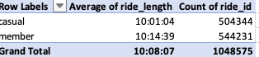

Average Ride Length Weekly(7-Days) 2nd screenshot

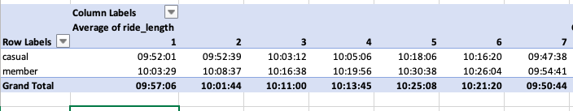

Count of rides: 3rd screenshot

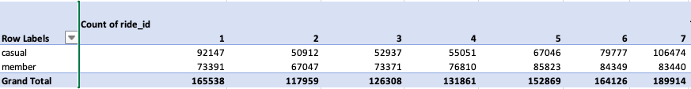

Average Ride Length and Count of Riders -Monthly 4th screenshot

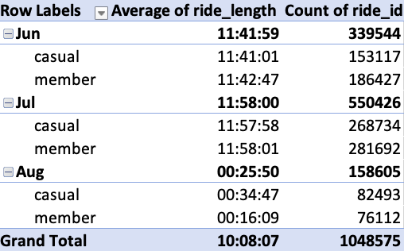

Yearly Analysis 5th screenshot

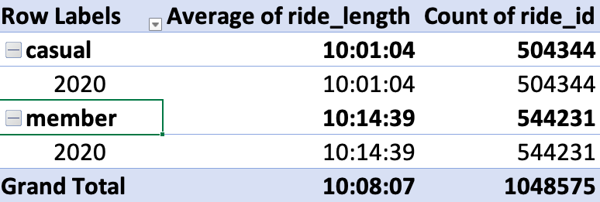

* Identify trends and relationships
* Average ride length of members is more than the casual riders as depicted in 1st screenshot
* Average count of member riders is also more than casual riders as depicted in 1st screenshot
* Members riders average ride length is always greater than average ride length of casual riders on all the days in a week as depicted in 2nd screenshot
* Casual riders are more on Sundays as depicted in 3rd screenshot
* On monthly basics, in the month of august casual riders average ride length is more than member riders as depicted in 4th screenshot
* The count of casual riders  is more (82493) in the month of August as compared to other months as depicted in 4th screenshot
* On yearly basics membership riders have more average ride length and number of riders as depicted in 5th screenshot

**Share :**

Summary of the data

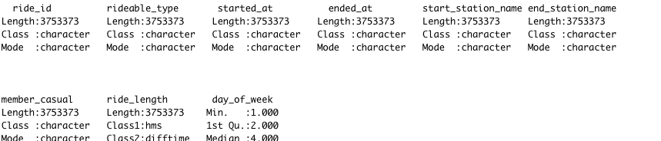

Plots :

* Casual riders more on weekends

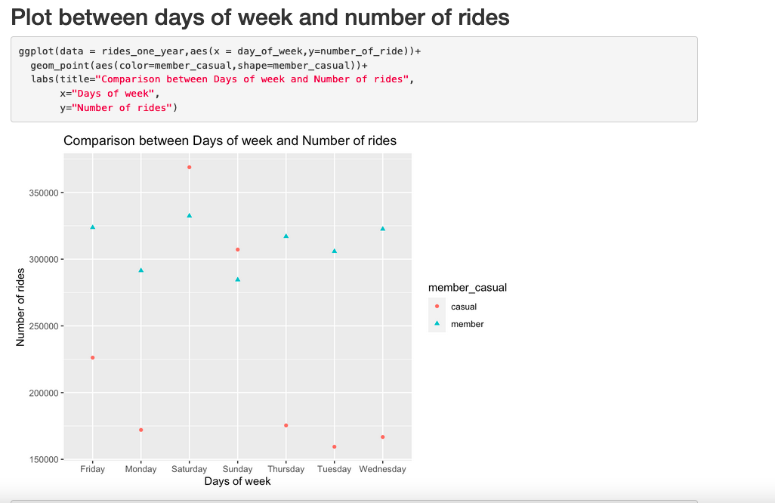

* In the month of august the casual riders are more than member riders

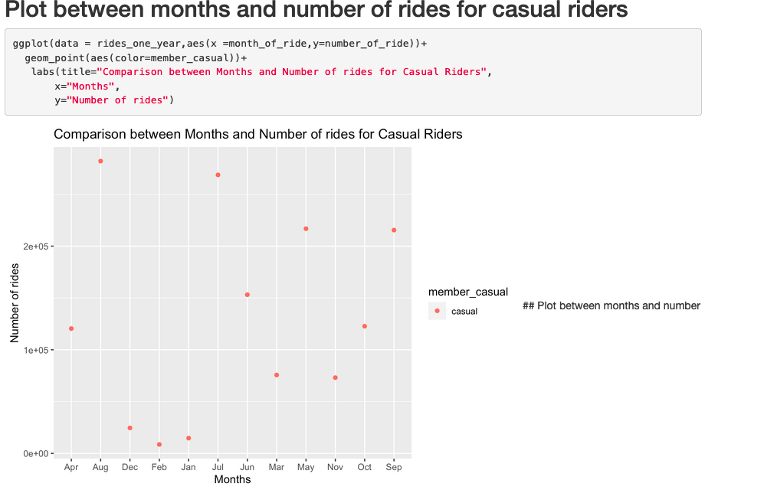

* Casual and member riders plot

# 

# ACT

**What is your final conclusion based on your analysis?**

* Average ride length and count of riders of members are more than the casual riders yearly and monthly
* Casual riders are more on Sundays (weekends)
* On monthly basics, in the month of august casual riders average ride length and count of casual riders  are more than member riders
* On yearly basics membership riders have more average ride length and number of riders

**How could your team and business apply your insights?**

* Vouchers, discounts on bikes, offers and complimentary gift can be given to casual riders specially on Sundays(weekends) and in the month of August.
* Discounts on longer ride length for casual riders .

**What next steps would you or your stakeholders take based on your findings?**

* Focus more on weekends and in the month of August for converting casual to member riders
* Promotions or banners near casual riders residential area to attract more customers.