Operating System Practical Exam

**Q1 Output :**

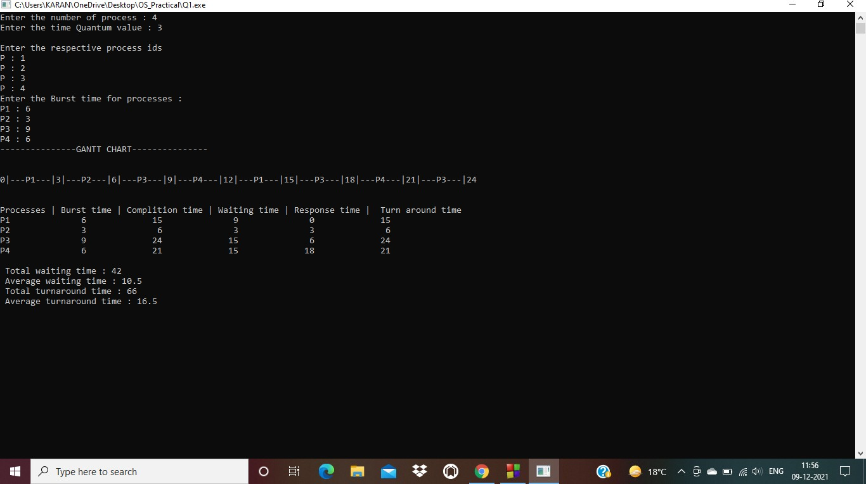

**Q2 Output :**

