**CSCE 606, Spring 19**

**Team** – RWBY

**ITERATION 1**

**Product Owner** – Rohan Singh Wilkho

**Scrum master** – Rui Kou

**Team member**– Harish Krishnamoorthy, Jiacheng Li, Ritika kamtam, Kamal Akshitha

**Client** – Academic Success Centre, Texas A&M University

**Customer Meeting Details** –

No client meeting for Iteration 1.

One of the requirement from client during Iteration 0 is to be able to run the legacy code. Client mentioned that they were not able to run the legacy code and see any web pages when previous team hand over the code. So the client want us to fix bugs in the legacy code so that we can at least tell them (the client) what page/function does the legacy code offer.

During this iteration, we spent large amount of time trying to understand the implementation of the legacy code and fix bugs in the code. A large portion of our time were spent on fixing multiple bugs on the very first page (Log-in page). By the end of iteration 1, we were able to launch the website locally, and tested the function of each web page. Though we were still not able to push the code to Heroku successfully, with the bugs fixed, we tested and summarized the functionality of the legacy code, which meet the requirement of the client.

**USER STORIES:**

1. Feature: Sign up in Study tracker

As a Student

So that I can use Study Tracker

I want to create an account and sign up in Study Tracker with my TAMU Email ID

Status: Completed

1. Feature: Login to Study Tracker using TAMU Email ID

As a user

So that I can view and edit my study sessions

I want to login to Study Tracker with my TAMU Email ID

Status: Completed

1. Feature: Addition of Tasks

As a student

So that I can add new tasks

I want to add details of my tasks and sessions for a particular subject

Status: Completed

1. Feature: Dashboard of Study Tracker

As a student

So that I can manage my study goals

I want to view my study schedules and current completion status

Status: Completed

**Lo-Fi SKETCHES AND STORY BOARD:**

Both Lo-Fi sketches and story board stays the same as last iteration (iter 0). Because there is no need to meet with client (since we focus on debugging legacy code).

LO-FI SKETCHES:

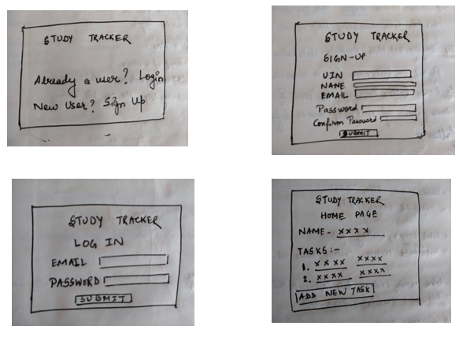

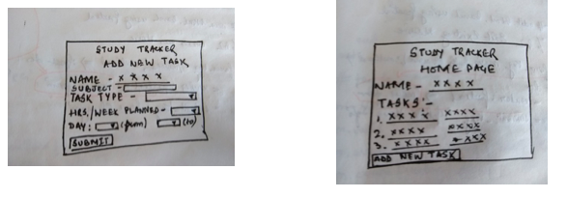

STORYBOARD:

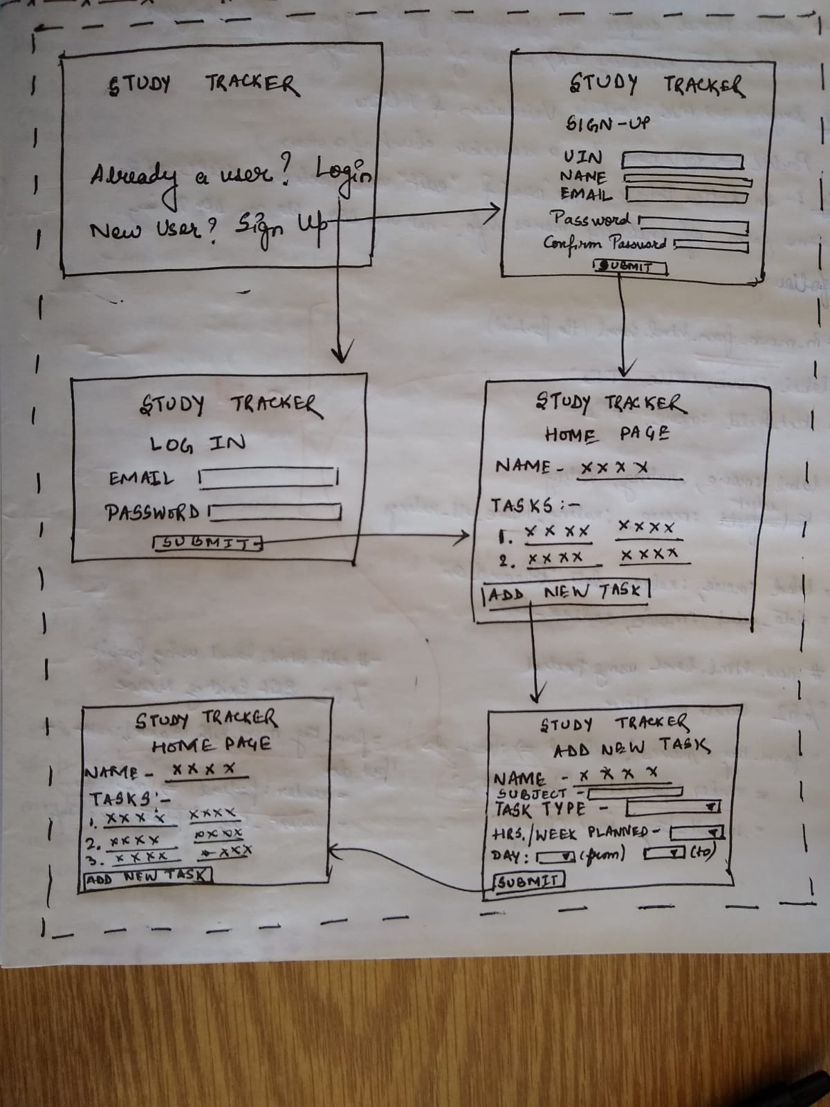

Pivotal Tracker - <https://www.pivotaltracker.com/n/projects/2318740>

GitHub - <https://github.com/theharishkm/Study-Tracker>