**CSCE 606, Spring 19**

**Team** – RWBY

**ITERATION 0**

**Product Owner** – Ritika Kamtan

**Scrum master** – Rohan Singh Wilkho

**Client** – Academic Success Centre, Texas A&M University

**Customer Meeting Details** –

Conference Room, 10th Floor, Rudder Tower, Texas A&M University

1st March, 2019

3:30 PM – 4:00 PM

The Academic Success Center of Texas A&M University is keen on developing a web app to enable its students to create and track their study schedules, study and homework plans. They want to create a new application instead of using already existing applications to keep it free from any distractions (like sports, movies, etc.)

They intend to create a personalized web application wherein every student (who has signed up) would be having a profile, to which s/he could login through her/his TAMU Email id. Within the profile, the students should be able to add tasks, they should be able to enter the time they think they would need for completing a particular task, which in-turn would aid them to monitor the progress of the task. On timely completion of a task, the students might receive some incentives to motivate them to continue their good work for other tasks as well. It was also thought that it would be good if the students would be able to receive reminders/notifications for approaching deadlines.

This is a legacy project, work on which work was initiated in the previous semester. But, the clients mentioned that they were not able to use any part of the app. Even, before the first meeting with the client, we had also tried to run the app locally as well using the Heroku app, but could not get past the first page. Therefore, the initial requirements for this semester remain the same.

Therefore, we have decided to first make this app up and running, fulfilling the minimum requirements and take further steps from there. In order to do that, we would be reading the entire code step by step, trying to figure out the bugs and then, de-bug it. If time permits, we would be more than willing to implement additional user stories in the app.

**USER STORIES:**

1. Feature: Sign up in Study tracker

As a Student

So that I can use Study Tracker

I want to create an account and sign up in Study Tracker with my TAMU Email ID

1. Feature: Login to Study Tracker using TAMU Email ID

As a user

So that I can view and edit my study sessions

I want to login to Study Tracker with my TAMU Email ID

1. Feature: Addition of Tasks

As a student

So that I can add new tasks

I want to add details of my tasks and sessions for a particular subject

1. Feature: Dashboard of Study Tracker

As a student

So that I can manage my study goals

I want to view my study schedules and current completion status

LO-FI SKETCHES:

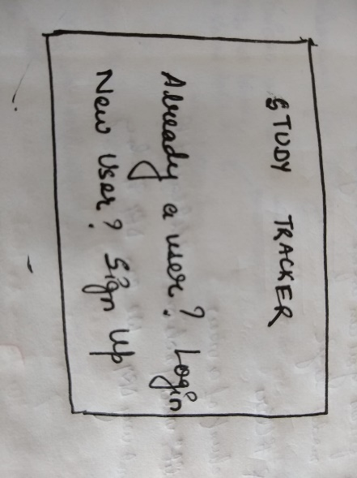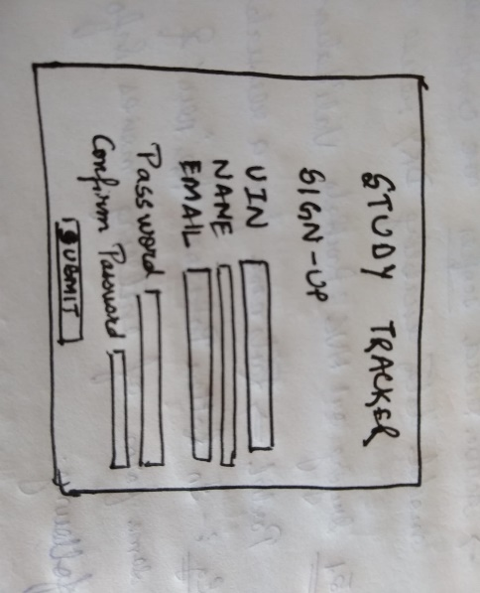

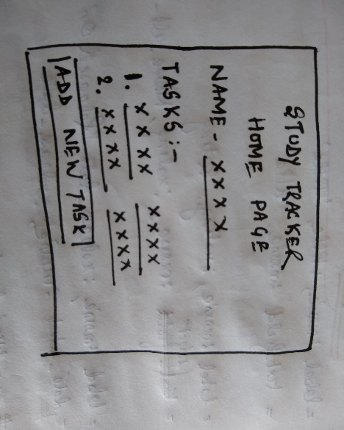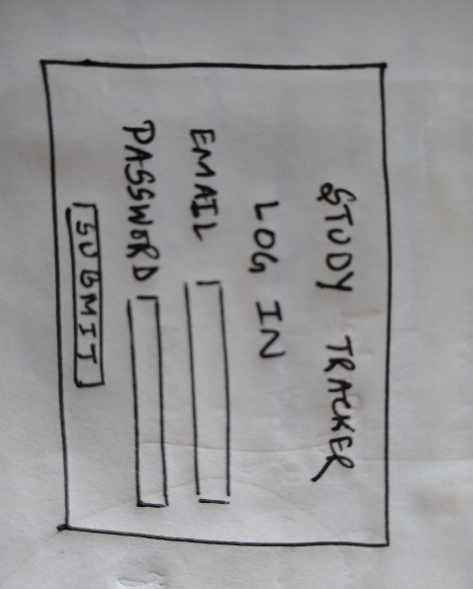

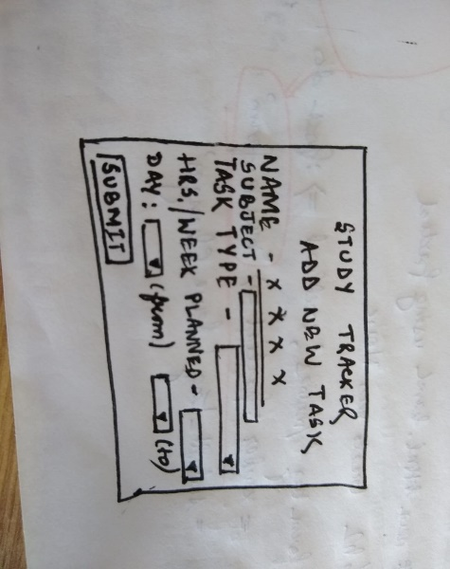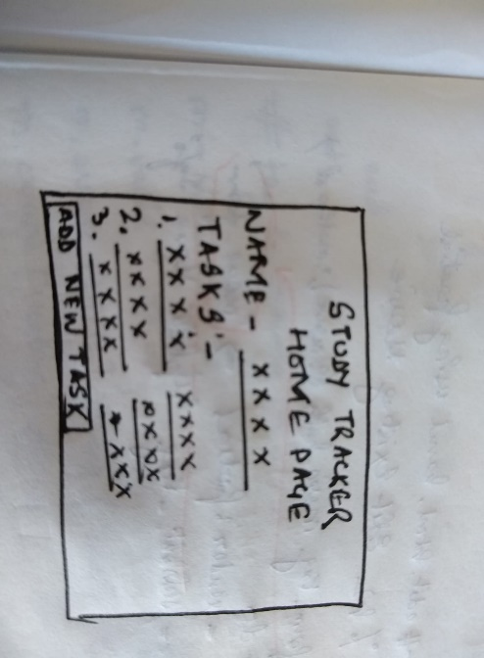

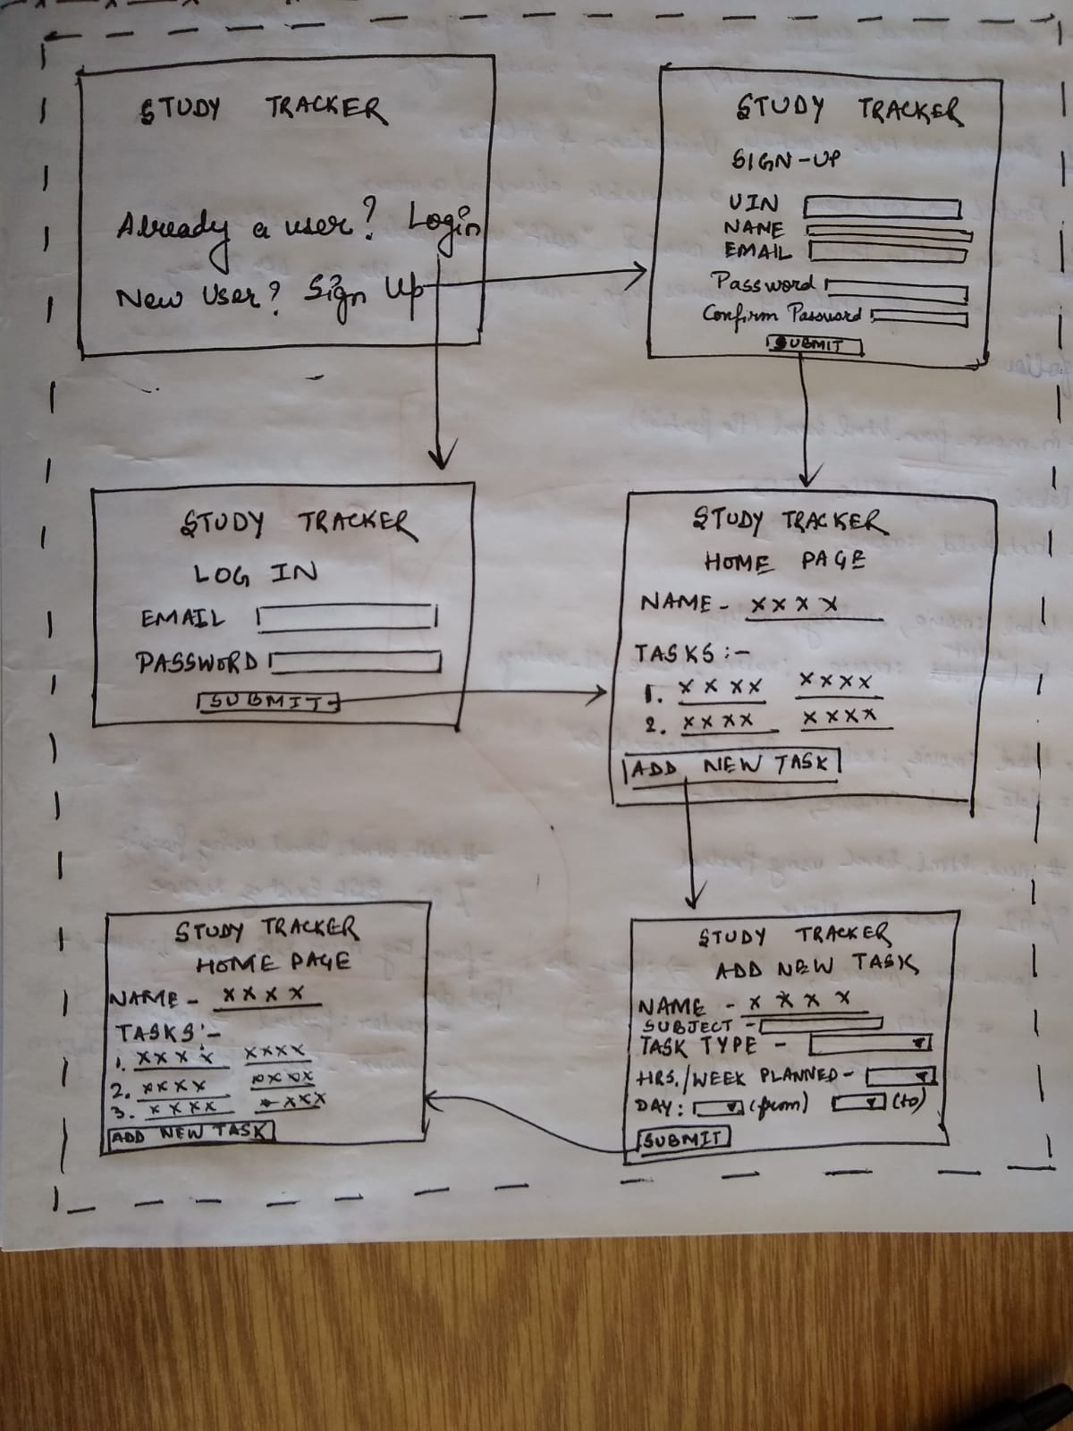STORYBOARD:

Pivotal Tracker - <https://www.pivotaltracker.com/n/projects/2318740>

GitHub - <https://github.com/HolyRail/Study-Tracker>

Video - [https://vimeo.com/325026693](https://vimeo.com/325026693%20)