**CSCE 606, Spring 19**

**Team** – RWBY

**ITERATION 1**

**Product Owner** – Rohan Singh Wilkho

**Scrum master** – Kamalakshitha Aligeri

**Team member**– Harish Krishnamoorthy, Jiacheng Li, Ritika kamtam, Rui Kou

**Client** – Academic Success Centre, Texas A&M University

**Customer Meeting Details** –

Conference Room, 10th Floor, Rudder Tower, Texas A&M University

2nd April, 2019

2:30 PM – 3:00 PM

Client mentioned that they want to able to edit the study plan, update the calendar, and let the instructions wherever needed to be clear and crisp. So the client want us to add instructions on home page that assists students on doing various tasks like create a new study plan, edit or update the existing study plan.

During this iteration, we spent large amount of time trying to align the days with dates, segregating schedules into three categories (upcoming, missed and completed) and redirecting the students to Academic Success Center website for more information. By the end of iteration 2, we were able to update the calendar, provide a link to edit or update a schedule, provide instructions on home page to guide students in creating a study plan. Though we were still not able to push the code to Heroku successfully, with the bugs fixed, we tested and summarized the functionality of the legacy code, which meet the requirement of the client.

**USER STORIES:**

1. Feature: Add Academic Success Centre Logo

As a Student

So that I can get further assistance

I want a link to get re-directed to Academic Success Centre

Status: Completed

1. Feature: Add instructions on Home page

As a student

So that I can easily use the application

I want instructions on home page

Status: Completed

1. Feature: Adding edit

As a student

So that I can edit schedule

I want a edit schedule link

Status: Completed

1. Feature: Align to date

As a student

So that I can schedule based on dates

I want dates to be aligned with days in calendar

Status: Completed

LO-FI SKETCHES:

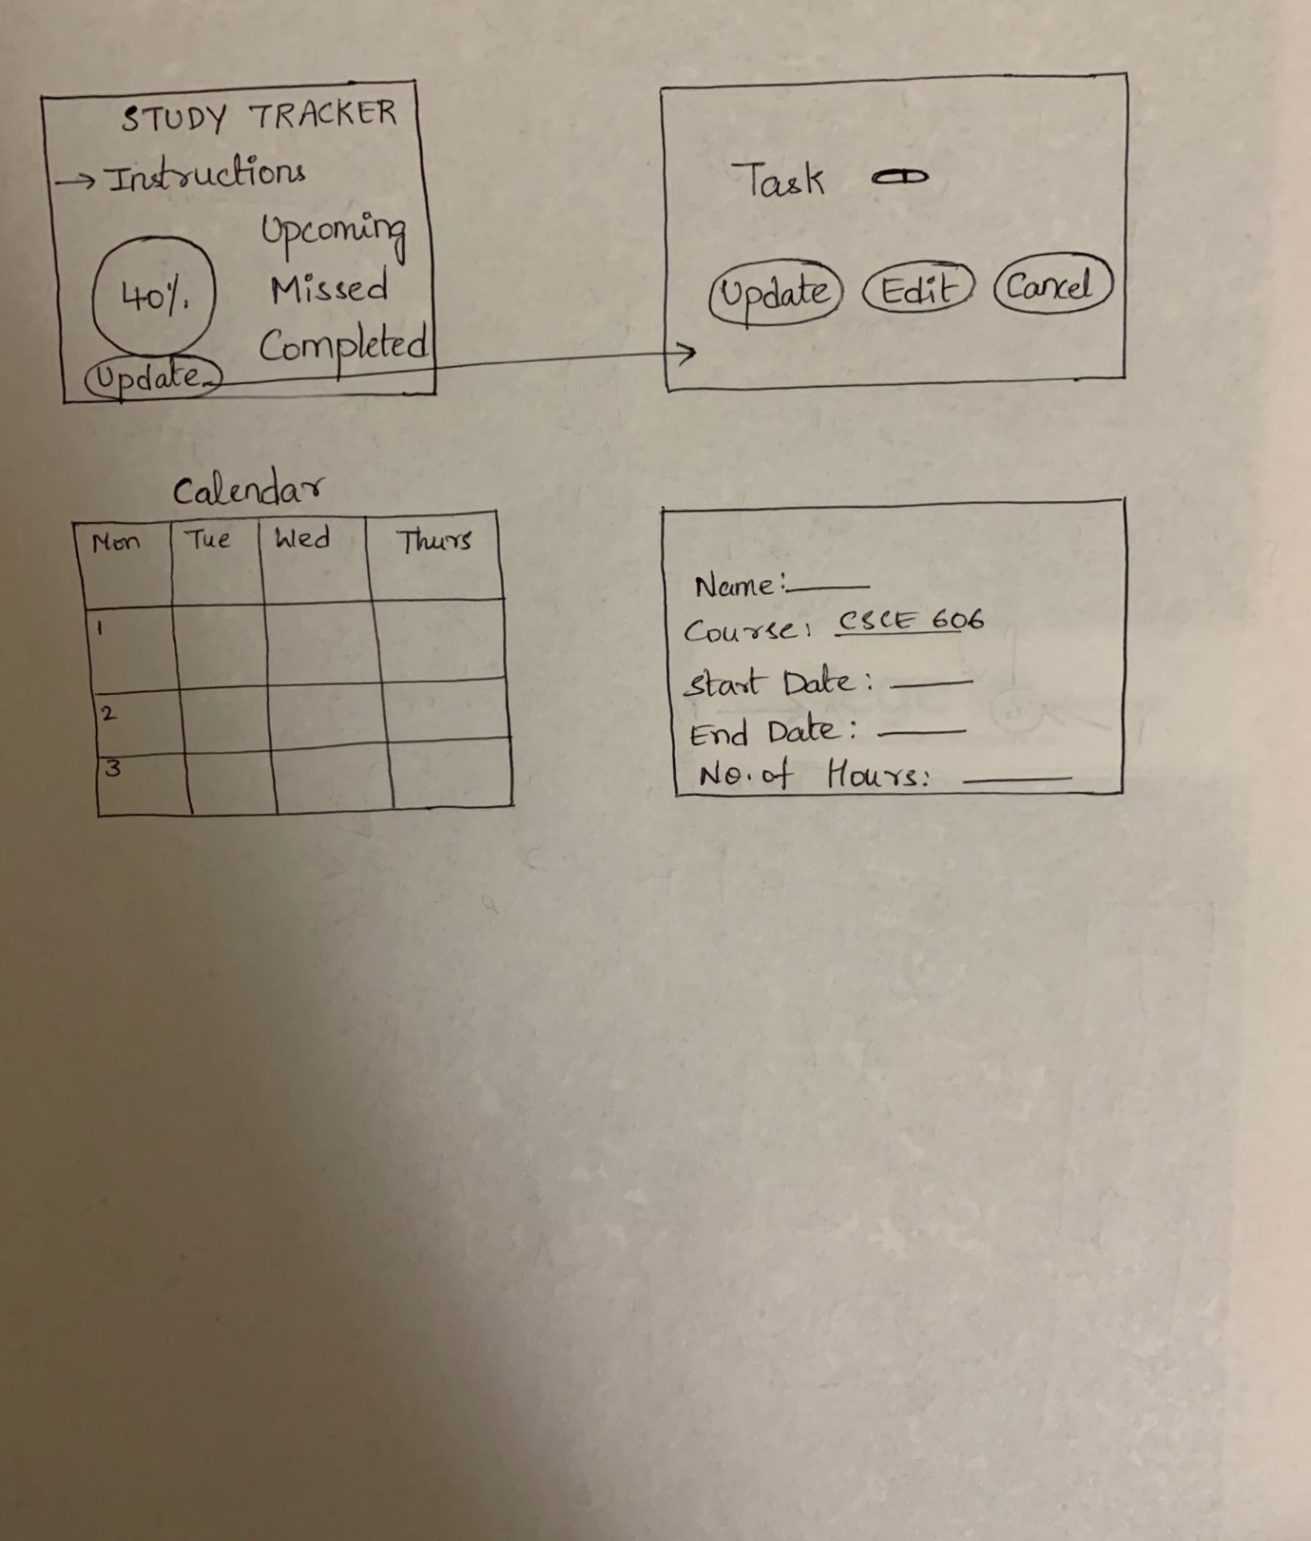

STORYBOARD:

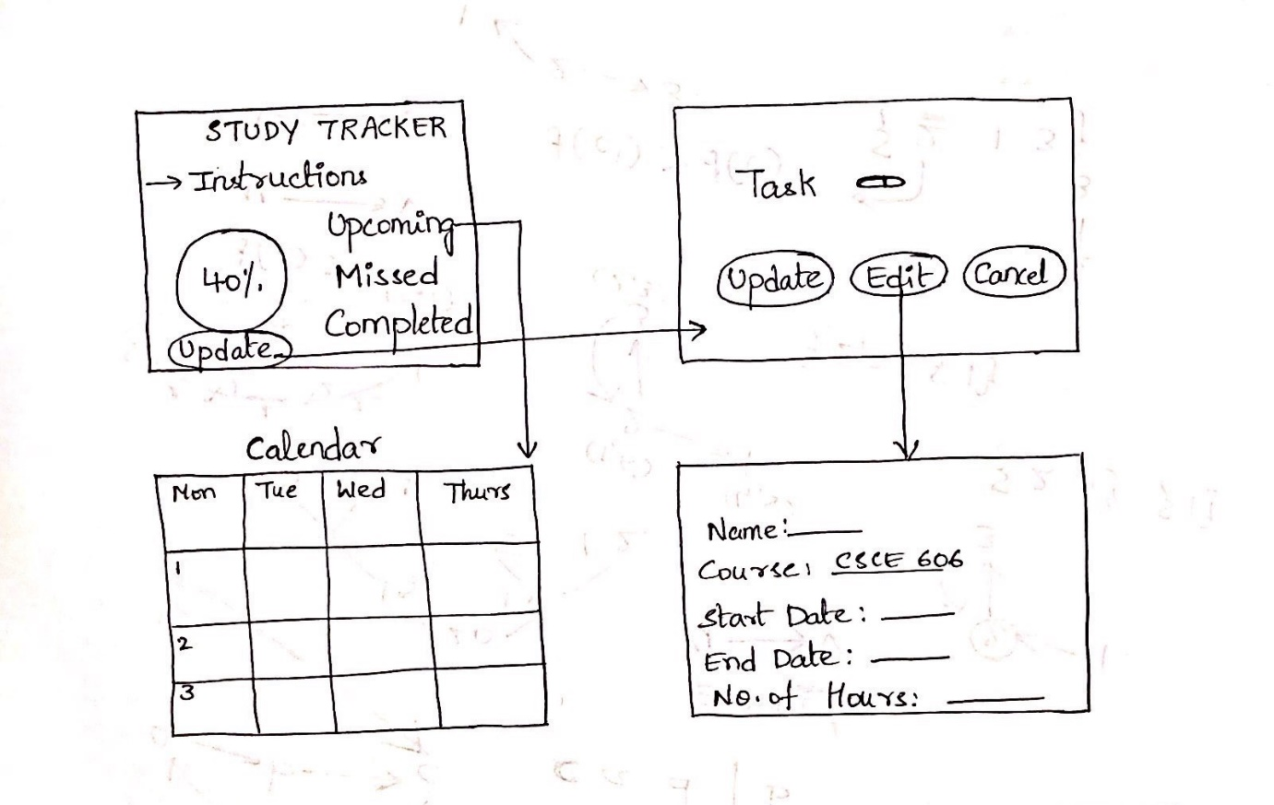

Pivotal Tracker - <https://www.pivotaltracker.com/n/projects/2318740>

GitHub - <https://github.com/theharishkm/Study-Tracker>