Latent Diffusion on FashionMNIST: Analysis
Ritika Mukesh Neema · DATA 266 · Seed 6638 · November 2, 2026
A 14.49M-parameter class-conditional U-Net trained in the Stable Diffusion VAE latent space (4×16×16) for 50 epochs reaches a noise-prediction loss of 0.0932 and generates recognizable, class-correct FashionMNIST images, with guidance scale w = 3 giving the best balance of quality and diversity.

1. VAE compression and reconstruction
FashionMNIST images (28×28) were resized to 128×128, repeated to three channels and encoded with stabilityai/sd-vae-ft-mse into 4×16×16 latents, an 8× spatial reduction (49,152 pixel values to 1,024 latent values, 48× fewer). Latents were scaled by 0.18215.
Metric | Value
Reconstruction MSE, [-1, 1] scale (512 test images) | 0.00077
Reconstruction MSE, [0, 1] scale | 0.00019
Scaled latent std (train set) | 1.26

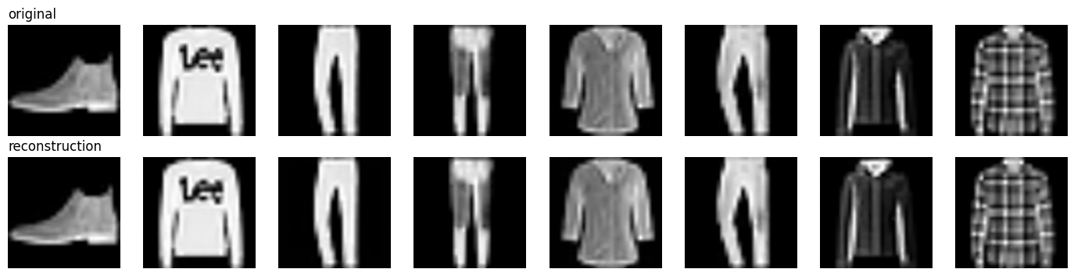
Figure 1. Originals (top) and VAE reconstructions (bottom).
Reconstruction error is very small, so the VAE is not the quality bottleneck: any blur or artifacts in samples come mostly from the diffusion model. A scaled latent std of about 1.26 is close to unit variance, which is what the Gaussian noise schedule assumes, so the standard 0.18215 factor is appropriate even for this grayscale dataset.

2. Forward diffusion in latent space
The forward process uses T = 1000 steps with a linear β schedule from 1e-4 to 0.02, and z_t = √ᾱ_t · z_0 + √(1 − ᾱ_t) · ε.
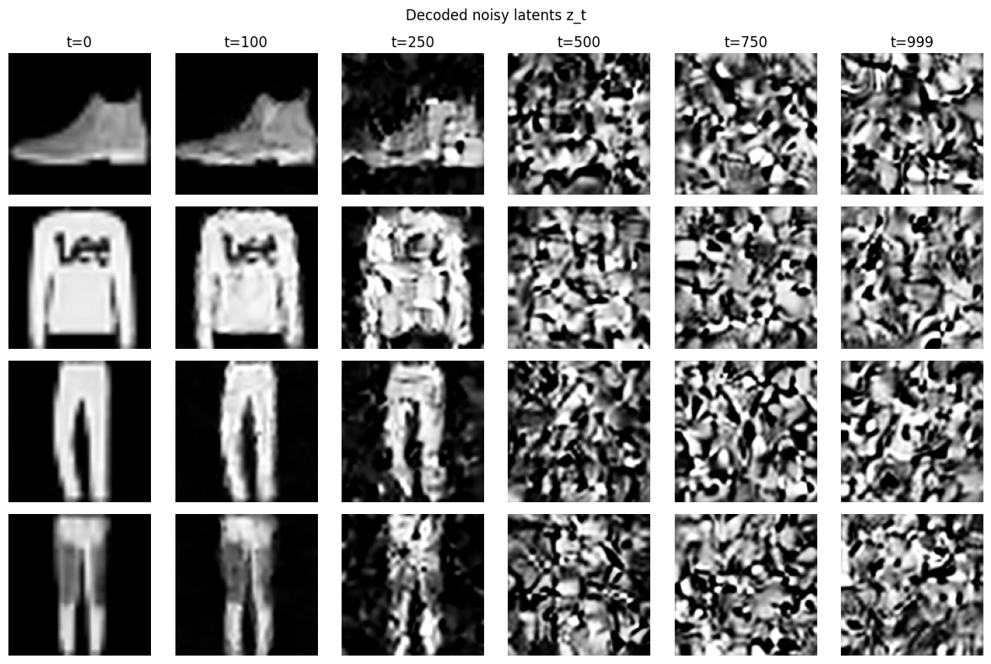
Figure 2. Decoded noisy latents at t = 0, 100, 250, 500, 750, 999.
- t = 100: the garment is intact with slight softening.
- t = 250: the silhouette survives but texture and fine detail (for example the logo on the sweater) break up into decoded noise.
- t = 500 and beyond: no recognizable structure remains; by t = 750 and 999 the decoded images are pure texture noise.
Structure is therefore destroyed mostly between t = 100 and t = 500, so the denoiser does its most informative work in that range. Decoded noise looks blobby rather than pixel-grain because noise is added to 16×16 latents and then upsampled 8× by the decoder.

3. Denoiser and training
The U-Net uses base width 64 with multipliers (1, 2, 4), two residual blocks per level, GroupNorm and SiLU, a sinusoidal time embedding passed through an MLP, and self-attention at 16×16 resolution and in the bottleneck. A learned label embedding (10 classes plus a null label) is added to the time embedding, and labels are replaced by the null label with probability 0.1 during training.
Training ran for 50 epochs at LR 2e-5 with batch size 128 (AdamW, gradient clipping at 1.0), taking 17.9 minutes on an A100 (83 minutes on a T4).
Epoch | 1 | 6 | 11 | 21 | 31 | 41 | 50
Loss | 0.359 | 0.121 | 0.110 | 0.102 | 0.096 | 0.096 | 0.093

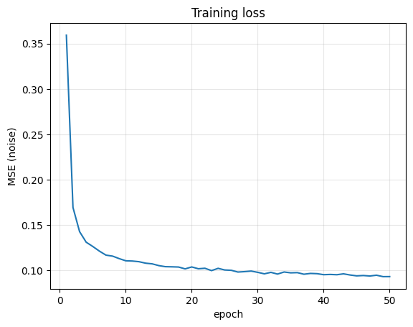
Figure 3. Training loss (noise-prediction MSE) per epoch.
Loss drops fast in the first 6 epochs and then declines slowly. It had not fully plateaued at epoch 50, so a higher LR or more epochs would likely improve sample quality. The A100 and T4 runs gave nearly identical loss curves (0.0932 vs 0.0931 at epoch 50), so the result is reproducible across hardware with seed 6638.

4. Sampling and classifier-free guidance
Sampling uses 1000-step DDPM in latent space with ε̂ = ε(z_t, ∅) + w · [ε(z_t, c) − ε(z_t, ∅)], followed by VAE decoding. The 64-image grid (labels 0–9 repeated, w = 3) shows the correct class for nearly every cell, with sharp edges and varied garments.
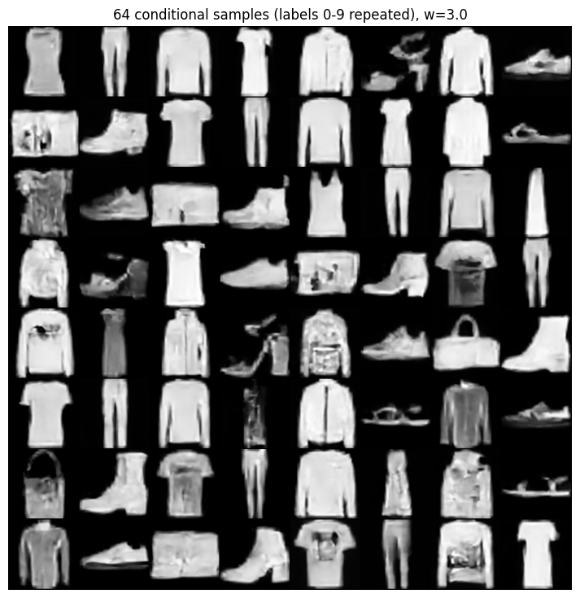
Figure 4. 64 conditional samples (labels 0–9 repeated), w = 3.
Guidance w | Class fidelity | Visual quality | Diversity
0 (unconditional) | Mostly wrong; ignores the label | Mixed, some blobs | Highest
1 | Mostly correct | Soft but plausible | High
3 | Correct for most classes | Cleanest overall | Moderate
7.5 | Strongest | High-contrast, saturated, texture lost | Lowest

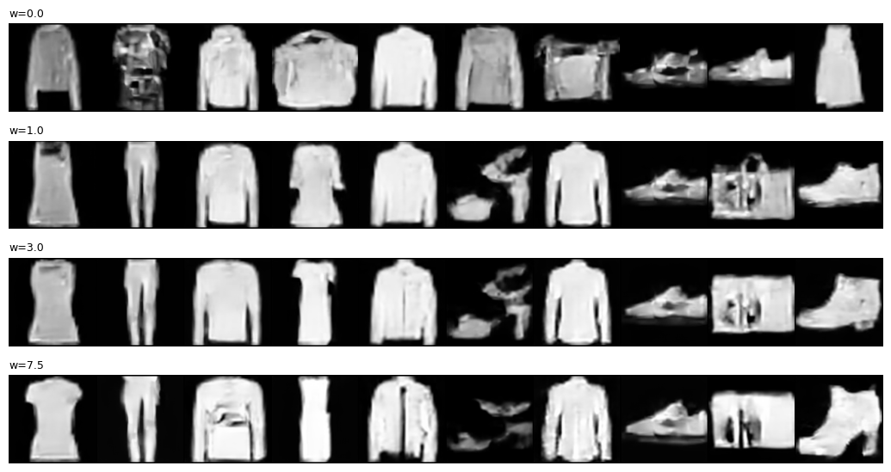
Figure 5. Guidance comparison; columns are classes 0–9, rows are w = 0, 1, 3, 7.5.
Higher guidance trades diversity and naturalness for class adherence. Beyond w ≈ 3 the model over-sharpens: garments become bright and flat, and difficult classes (sandals, bags) degrade into artifacts. Bags and sandals are weak even at w = 3, likely because their shapes are less regular and the model is under-trained at LR 2e-5.

5. Limitations
- The low LR of 2e-5 leaves the loss still falling; samples show occasional noisy textures (some shirts and bags).
- Quality is limited by the 16×16 latent grid on a 128×128 upsampled input, which is far larger than the native 28×28 images.
- No quantitative generation metric (FID or classifier accuracy) was computed; conclusions rest on visual inspection of the grids.
- Only one guidance scale (w = 3) was used for the main grid; w = 0, 1, 3 and 7.5 were compared on one sample per class.

