HW2.5 — GPU Assignment I
Precision, Bandwidth, and the Cost of Attention
GPU: NVIDIA GeForce RTX 4090
UUID: GPU-5b052ad1-4272-40db-4b25-c930bf32b547
Driver / CUDA: 595.95 / 13.2
Vendor specs (NVIDIA Ada GPU Architecture whitepaper): Ada Lovelace / AD102, TSMC 4N, GDDR6X 384-bit, ~1008 GB/s peak bandwidth, 512 4th-gen Tensor Cores (FP16/BF16/TF32/INT8/FP8), 82.6 TFLOPS FP32, 450 W TDP.

Table HW2.5.1 — Summary
Measurement | Your GPU | Notes
Peak achieved TFLOPS (BF16) | 164.37 | N=8192, 30 reps
% of theoretical peak (BF16) | ~99.6% | vs. ~165 TFLOPS dense FP16 tensor spec
Effective bandwidth (GB/s) | 910.63 (90.3%) | elementwise copy, 1 GiB/buffer
Naive attention OOM length | 26832 OK / 26833 OOM | mem-fraction 0.9 cap; single-token resolution
Fused attention OOM length | not reached (tested to 32768) | SDPA scales ~linearly, not quadratically
Steady-state / peak throughput | 100.0% | 48.457 / 48.467 calls/s
Throttle onset | ~5 s (power-limit) | not thermal; temp plateaued at 75-76C

Part A — Provenance
Captured via nvidia-smi -q on the lab machine (rtx4090_nvidia_smi_q.txt). UUID, driver, CUDA version, VRAM, and power limit were auto-parsed into rtx4090_provenance_auto.json. Vendor-doc fields are cited from NVIDIA's own Ada GPU Architecture whitepaper (https://images.nvidia.com/aem-dam/Solutions/geforce/ada/nvidia-ada-gpu-architecture.pdf).

Part B — Precision and Achieved Throughput
30 repetitions per (N, precision) configuration, timed with CUDA events after a 10-call warmup.
N | FP32 | TF32 | FP16 | BF16
1024 | 44.72 | 65.14 | 98.46 | 120.07
4096 | 52.98 | 79.03 | 167.09 | 157.91
8192 | 52.31 | 86.41 | 162.89 | 164.37
16384 | 50.25 | 86.95 | 157.91 | 160.57
(Achieved TFLOPS; see rtx4090_part_b_throughput.csv)
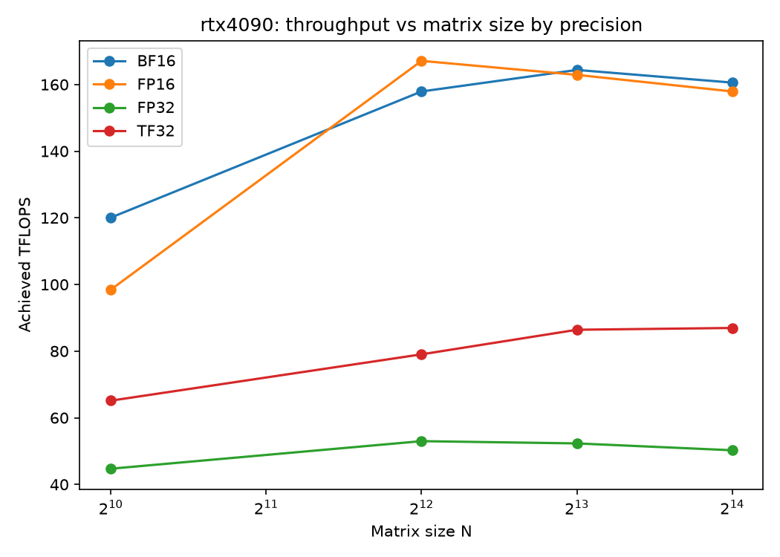
Figure 1. Achieved TFLOPS vs. matrix size, by precision.

Plateau behavior
FP32 and TF32 are already near their plateau by N=4096 and stay flat (within ~5%) through N=16384 — FP32 doesn't use tensor cores on Ada, so its ceiling is the CUDA-core FMA rate, reached once N is large enough to keep the SMs fully occupied. FP16/BF16 (tensor core paths) peak earliest at N=4096 (167.09/157.91) and settle slightly lower at N=8192-16384 (~160-165); small matrices (N=1024) never reach the plateau because the matmul is too short to amortize kernel-launch overhead and fill all SMs — at N=1024, tensor-core throughput is only ~73-75% of its N>=4096 value.
Achieved FP32 (~50-53 TFLOPS) sits well below the 82.6 TFLOPS FP32 spec peak; this is expected, since that spec figure assumes ideal occupancy rarely reached by a single unfused matmul call at these sizes — a ~60-64% peak-utilization figure is reasonable for measured throughput.

Part C — Bandwidth-Bound vs. Compute-Bound
Operation | Result | Arithmetic Intensity
Memory-bound (copy, 1 GiB/buffer) | 910.63 GB/s (90.3% of ~1008 GB/s spec) | 0 FLOPs/byte
Compute-bound (matmul, N=8192, FP32) | 54.54 TFLOPS achieved | 1365.33 FLOPs/byte (=N/6)

Roofline classification: ridge point = peak_TFLOPS / peak_bandwidth = 165e12 / 1008e9 ~= 164 FLOPs/byte (using measured BF16 peak as the compute ceiling). The matmul's AI (1365) is roughly 8x past the ridge point — solidly compute-bound, consistent with it reaching near-peak TFLOPS in Part B. The copy sits at AI=0, deep on the memory-bound side, and achieves 90% of peak bandwidth, close to the practical ceiling for a simple copy kernel.

Part D — The Cost of Attention
Config: batch=1, heads=8, head_dim=64, dtype=float16.
S | Naive latency | Naive peak mem | Fused latency | Fused peak mem
512 | 0.08-0.21 ms | 0.02 GB | 0.03-0.04 ms | 0.01 GB
1024 | 0.07-0.18 ms | 0.05 GB | 0.05-0.08 ms | 0.01 GB
2048 | 0.40 ms | 0.15 GB | 0.10 ms | 0.02 GB
4096 | 1.86-1.93 ms | 0.56 GB | 0.30 ms | 0.03 GB
8192 | 7.21-7.23 ms | 2.19 GB | 1.11-1.17 ms | 0.04 GB
16384 | 28.65-28.68 ms | 8.67 GB | 4.44-4.48 ms | 0.08 GB
20480 | 44.35-44.43 ms | 13.51 GB | 6.66-6.84 ms | 0.09 GB
24576 | 64.89-65.01 ms | 19.44 GB | 9.85-10.00 ms | 0.11 GB
28672 | 325.23 ms (uncapped) / OOM (capped) | 26.43 GB (uncapped) | 13.55-13.68 ms | 0.13 GB
32768 | 1172.97 ms (uncapped, WDDM spillover) | 34.50 GB (uncapped) | 17.82-17.91 ms | 0.14 GB

OOM boundary (naive): largest OK = 26832, smallest OOM = 26833 (single-token resolution via binary search).

Methodology note — Windows/WDDM
On this Windows/WDDM system, an uncapped run never raised torch.cuda.OutOfMemoryError even past 34.5 GB reported peak allocation on a 24 GB card. The latency jump at S=28672->32768 (65ms -> 325ms -> 1173ms, a 5x then 18x slowdown) is WDDM's driver-level "shared GPU memory" fallback silently spilling allocations into system RAM over PCIe rather than raising CUDA OOM. To recover a genuine, physical-VRAM-bound OOM boundary as specified, the CUDA allocator was capped to 90% of VRAM (torch.cuda.set_per_process_memory_fraction(0.9)), which produced the clean 26832/26833 boundary above.
OOM boundary (fused): not reached up to S=32768, the largest tested. Fused (SDPA/FlashAttention) memory scales close to linearly with sequence length (0.01 GB at S=512 -> 0.14 GB at S=32768, a 64x increase in S for a 14x increase in memory) rather than quadratically, so it does not hit a VRAM wall in the range tested here.
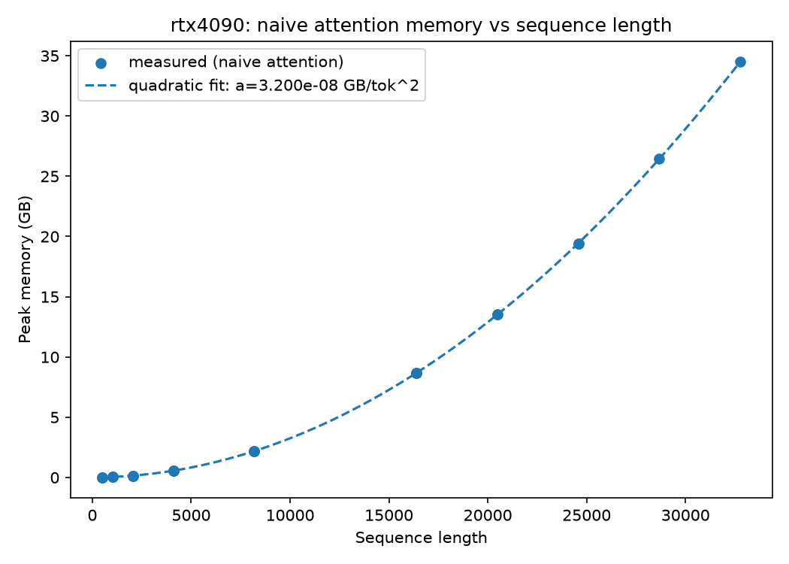
Figure 2. Naive attention peak memory vs. sequence length, with quadratic fit.

Quadratic memory fit (naive)
Measured coefficient: a = 3.200e-08 GB/token^2. Theory: the dominant term comes from materializing the (B,H,S,S) scores/weights tensors in fp16 — with B=1, H=8, 2 bytes/element, one such tensor alone contributes B*H*2/1e9 = 1.6e-08 GB/token^2. The measured coefficient (3.2e-08) is almost exactly 2x that, consistent with the naive implementation holding both the pre-softmax scores tensor and the post-softmax weights tensor as separate full (B,H,S,S) allocations simultaneously.

Speedup and mechanism
Fused vs. naive: ~6.4x at S=16384 (4.46ms vs 28.65ms), ~6.5x at S=24576 (10.00ms vs 64.89ms) — consistent across scale.
What the fused kernel avoids: FlashAttention-style fused SDPA never materializes the full (S,S) score or weight matrix in global memory. It tiles the computation, keeping blocks of Q/K/V and partial softmax statistics in fast on-chip SRAM, and accumulates the output incrementally across tiles using an online-softmax algorithm. This avoids both the O(S^2) memory footprint (peak memory stays effectively O(S) here) and the extra global-memory read/write traffic naive attention pays for writing out and re-reading the full attention matrix, which is why it is also several times faster despite doing asymptotically the same FLOPs.

Part E — Sustained Load and Thermal Behaviour
20-minute sustained load, matmul N=8192 FP32, sampled every 5s.
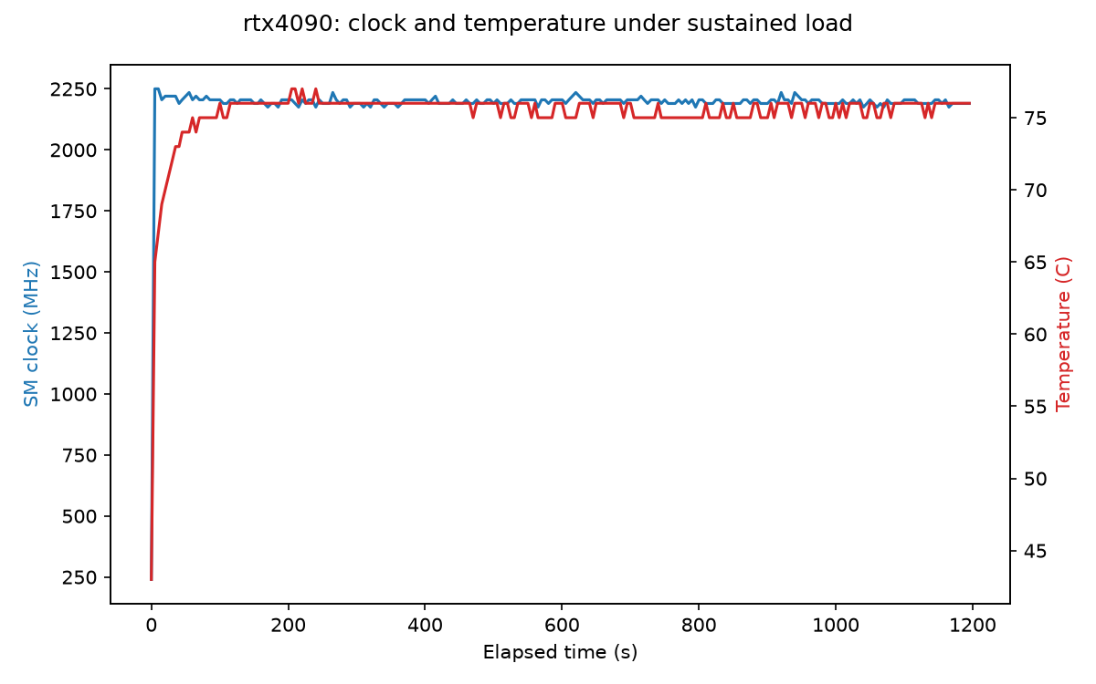
Figure 3. SM clock and temperature vs. elapsed time under sustained load.
Signal | Observation
Temperature | Climbed from 43C (idle) to ~65-76C within ~100s, then held flat at 75-76C for the remainder.
Power | Reached the 450W cap within the first 5s sample and stayed pegged at 448-450W for the entire run.
Clock | Oscillated narrowly between 2175-2250 MHz throughout, hunting around the power ceiling rather than ramping down.
Throttle onset | ~5s. Power-limit throttling, not thermal: temperature plateaued at 75-76C, well below the ~90C thermal limit typical for this card, while power sat at its 450W TDP the entire time.
Throughput retention | Peak (first 30s) = 48.467 calls/s; steady-state (final 5 min) = 48.457 calls/s -> 100.0% retention.

The fine-grained clock oscillation (a few dozen MHz around the power ceiling) produced no measurable throughput loss between the "cold" and steady-state windows — the power ceiling was reached almost immediately and throughput was stable from then on, rather than showing a classic thermal-ramp degradation curve.

AI Use
AI assistance (Claude, Anthropic) was used for: authoring the benchmark scripts, environment setup troubleshooting (Python/pip/git PATH issues, CUDA-enabled torch build selection), a code-review catch of a malformed f-string prior to running it, diagnosis of Windows WDDM's memory-spillover behavior and the torch.cuda.set_per_process_memory_fraction fix used to recover a genuine OOM boundary, and vendor-spec citation lookup from NVIDIA's Ada whitepaper. All numerical results in this report were produced by running the scripts on the author's own RTX 4090 GPU-lab reservation; no values were AI-generated or estimated. See AI_USE.md for full detail.

