Improving RAG with Reranking, Chunking, and Conversational Memory
Analysis Report · DATA 266 · Ritika Mukesh Neema · November 2026

1. Summary
This report builds a retrieval-augmented generation (RAG) retrieval pipeline over the first 100 papers of the ccdv/arxiv-summarization document subset. It compares retrieval with and without cross-encoder reranking, two chunking strategies, and retrieval with and without conversational memory, using Precision@K, Recall@K and MRR. A follow-up section tests three improvements: hybrid BM25 + dense retrieval, a larger reranker, and an anchored memory design.
- Reranking helps, mostly on detail questions. With sentence-aware chunks, P@5 rose from 0.45 to 0.60 on detail queries and from 0.725 to 0.800 overall.
- Sentence-aware chunking (S2) beats fixed windows (S1) once reranking is on: P@5 0.800 vs 0.775 and R@10 0.638 vs 0.619, with MRR tied at 1.000.
- Memory has the largest effect. Follow-up questions that rely on a pronoun scored P@5 = 0.0 without memory and 0.5–0.6 with it.
- Anchored memory is the clearest improvement. It matched or beat concatenation memory in all four configurations, reached MRR 1.000 in three of four, and did not degrade an unrelated follow-up question, where concatenation dropped P@5 to 0.0.
- Recommended configuration: S2 sentence-aware chunks, dense retrieval, MiniLM cross-encoder reranking, and anchored memory.

2. Data and preprocessing
The notebook loads train[:100] of the document subset (203,037 training papers in total). Articles average 4,937 words (min 446, max 24,354). In this dataset, equations and citations are replaced by @xmath and @xcite tokens, and punctuation is space-separated. Preprocessing removes the placeholders (0 remain after cleaning), rejoins punctuation and hyphenated words, splits text into sentences on the dataset's newline markers, and drops fragments shorter than four words.

3. Methods

3.1 Chunking strategies
Both strategies use the same 120-word budget, so the comparison isolates where chunk boundaries fall rather than how long chunks are. The budget was cut from 150 to 120 words after the first run showed that 16% of fixed-window chunks exceeded the embedding model's 256-token limit.
Strategy | Chunks | Mean words | Ends on sentence | Over 256 tokens
S1 fixed window (120 words, 24 overlap) | 5,164 | 120.0 | 7% | 7.8%
S2 sentence-aware (≤120 words, 1-sentence overlap) | 5,723 | 106.3 | 98% | 5.7%

3.2 Embedding, indexing and retrieval
Chunks are embedded with all-MiniLM-L6-v2 (384 dimensions, normalized) and stored in two persistent ChromaDB collections, one per strategy, using cosine HNSW. Two sanity checks passed for both collections: the stored count equals the chunk count, and a chunk used as a query retrieves itself at rank 1. Without reranking, the system returns the top-K chunks by cosine similarity. With reranking, it takes the top 20 candidates and rescores each (query, chunk) pair with cross-encoder/ms-marco-MiniLM-L-6-v2.

3.3 Conversational memory
The baseline memory keeps the last two user turns and prepends them to the follow-up question (concatenation), so a pronoun such as "it" is retrieved together with the words that define it. Without memory, the follow-up question is sent on its own.

3.4 Queries and relevance
Four target papers among the first ten documents were located by a phrase from their abstracts: additive-model learning rates (doc 0), random phase diffusers (doc 3), synaptic memory (doc 7) and radial-velocity planet detection (doc 9). The evaluation set has eight single-turn queries: four topic queries (Q1–Q4) and four detail queries (Q5–Q8) that ask about one specific finding. It also has two dependent conversations (C1, C2), whose second turn uses "it" or "they".
Relevance was defined manually as a rubric. A chunk counts as relevant if it comes from the target paper, contains a required term (detail queries only), and contains at least a minimum number of hand-picked answer terms. Recall@K is computed against every chunk in the collection that meets the rubric. The rubric yields 15–34 relevant chunks per topic query and 2–7 per detail query.

3.5 Metrics
Precision@K is the share of the top K results that are relevant. Recall@K is the share of all relevant chunks that appear in the top K. MRR is the reciprocal rank of the first relevant chunk. K = 3, 5 and 10 are computed; the report focuses on P@5, R@5, R@10 and MRR.

4. Results

4.1 Without vs with reranking
Configuration (all Q1–Q8) | P@5 | R@5 | R@10 | MRR
S1, no rerank | 0.725 | 0.433 | 0.544 | 0.938
S1, rerank | 0.775 | 0.483 | 0.619 | 1.000
S2, no rerank | 0.725 | 0.385 | 0.588 | 1.000
S2, rerank | 0.800 | 0.453 | 0.638 | 1.000
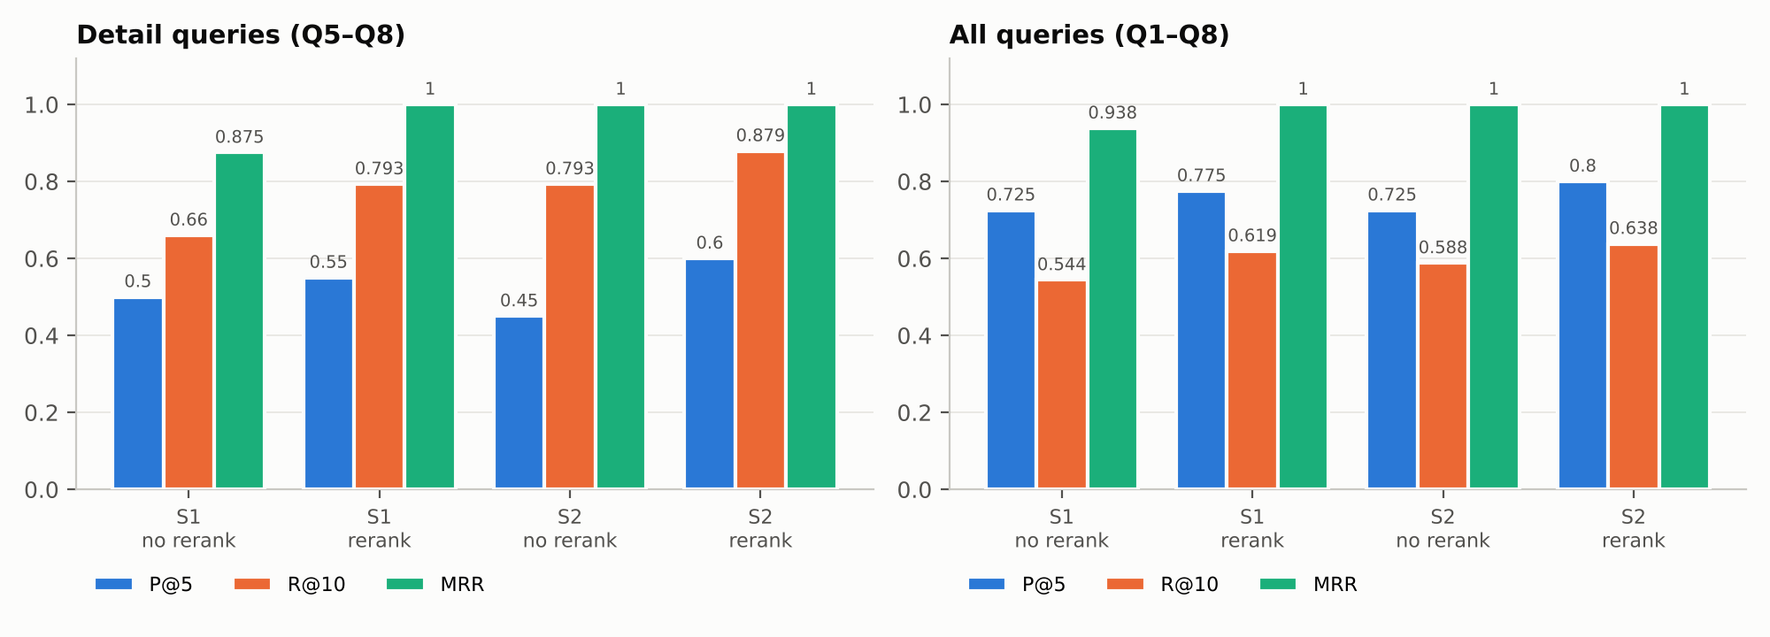
Figure 1. Reranking and chunking. Left: detail queries (Q5–Q8); right: all queries.
Reranking improved both strategies. For S1, P@5 rose from 0.725 to 0.775, R@10 from 0.544 to 0.619, and MRR from 0.938 to 1.000. For S2, P@5 rose from 0.725 to 0.800 and R@10 from 0.588 to 0.638. The gain comes mostly from the detail queries: S2's P@5 went from 0.45 to 0.60 and R@10 from 0.793 to 0.879. Topic queries were already at P@5 0.95–1.00 without reranking, because nearly any chunk of the right paper is useful for them.
The bi-encoder compares a query vector with a chunk vector built separately, so it ranks by overall topical similarity. The cross-encoder reads the query and chunk together, so it can promote the passage that states the specific finding. For Q1, for example, it moved the passage on the paper's main learning-rate theorems to rank 1. A reranker can only reorder its 20 candidates, so it cannot recover a relevant chunk the first stage missed.

4.2 Chunking strategy 1 vs strategy 2
Configuration (all Q1–Q8) | P@5 | R@5 | R@10 | MRR
No rerank: S1 fixed window | 0.725 | 0.433 | 0.544 | 0.938
No rerank: S2 sentence-aware | 0.725 | 0.385 | 0.588 | 1.000
Rerank: S1 fixed window | 0.775 | 0.483 | 0.619 | 1.000
Rerank: S2 sentence-aware | 0.800 | 0.453 | 0.638 | 1.000

With reranking, S2 has the higher P@5 (0.800 vs 0.775) and R@10 (0.638 vs 0.619), the same MRR, and on detail queries P@5 0.60 vs 0.55 and R@10 0.879 vs 0.793. Without reranking the result is mixed. S2 has the higher MRR (1.000 vs 0.938) and R@10 (0.588 vs 0.544), while S1 is ahead on detail-query P@5 (0.50 vs 0.45). S1 also leads on R@5 in both settings.
There are two reasons the strategies differ. First, 98% of S2 chunks end on a sentence boundary, compared with 7% of S1 chunks, so S2 hands the models complete statements rather than claims cut mid-sentence. This matters most to the cross-encoder, which reads the full text, which is why S2's advantage shows up mainly with reranking. Second, S2 chunks are shorter, so fewer of them are truncated by the embedder (5.7% vs 7.8%). However, S2 produces more chunks (5,723 vs 5,164) and therefore more relevant chunks per query. That enlarges the Recall@K denominator and explains S1's higher R@5.

4.3 Without vs with conversational memory
Dependent follow-ups (C1-T2, C2-T2) | P@5 | R@5 | R@10 | MRR
S1, rerank, no memory | 0.0 | 0.000 | 0.000 | 0.000
S1, rerank, memory | 0.6 | 0.306 | 0.597 | 1.000
S2, rerank, no memory | 0.0 | 0.000 | 0.045 | 0.083
S2, rerank, memory | 0.6 | 0.325 | 0.558 | 0.750
S1, no rerank, memory | 0.5 | 0.264 | 0.472 | 0.667
S2, no rerank, memory | 0.5 | 0.305 | 0.539 | 1.000
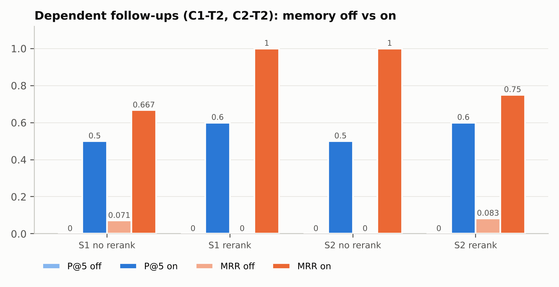
Figure 2. Follow-up turns with memory off vs on (concatenation memory).
The follow-up questions ("What results do the authors report for it…", "Which instruments… were they obtained with?") contain no topic words. Without memory they retrieved unrelated papers: for C1-T2 the top three came from docs 90, 82 and 40, which cover particle-physics fits, galaxy counts and document accessibility. P@5 was 0.0 in all four configurations, and MRR was at most 0.083. With memory, P@5 rose to 0.5–0.6 and MRR to 0.667–1.000. This was the largest effect in the study.
The weakness of concatenation is that the rewritten query still carries the full turn-1 sentence. A chunk that answers turn 1 instead of turn 2 can therefore rank first, which is why S2 with reranking reached MRR 0.75 rather than 1.0. Section 5 addresses this.

5. Improvements
Three changes were added on top of the unchanged baseline. The baseline pipeline was reproduced exactly inside the new code before any comparison was made.
- I1 Hybrid retrieval: BM25 keyword search is combined with dense search using Reciprocal Rank Fusion (k = 60, depth 50), so the candidate pool includes exact-term matches such as RKHS or detector.
- I2 Larger reranker: BAAI/bge-reranker-base (278M parameters) rescores a 40-candidate pool, compared with MiniLM-L6 (22.7M) over 20.
- I3 Anchored memory: a question is rewritten only if it is a real follow-up (it contains a pronoun or has two or fewer content words). The rewrite adds turn-1 keywords instead of the whole turn-1 sentence. When at least 3 of the previous turn's top-5 chunks come from one paper, retrieval is restricted to that paper with a ChromaDB metadata filter. A new conversation, C3, tests a topic switch: a diffuser question followed by an unrelated synaptic-memory question.

5.1 Retrieval pipelines (detail queries Q5–Q8)
Pipeline | S1 P@5 | S1 R@10 | S1 MRR | S2 P@5 | S2 R@10 | S2 MRR
Dense | 0.50 | 0.660 | 0.875 | 0.45 | 0.793 | 1.000
Dense + MiniLM (baseline) | 0.55 | 0.793 | 1.000 | 0.60 | 0.879 | 1.000
Hybrid | 0.45 | 0.843 | 0.750 | 0.55 | 0.893 | 1.000
Hybrid + MiniLM | 0.60 | 0.864 | 1.000 | 0.60 | 0.879 | 1.000
Hybrid + BGE (pool 40) | 0.50 | 0.879 | 0.875 | 0.65 | 0.879 | 1.000

Hybrid retrieval raised recall. Without reranking, detail-query R@10 rose from 0.660 to 0.843 on S1 and from 0.793 to 0.893 on S2, because BM25 adds chunks that contain the exact query terms. On its own it lowered S1's MRR (0.875 to 0.750 on detail queries). Combined with the MiniLM reranker it gave the best S1 result: detail P@5 0.60, R@10 0.864, MRR 1.000, and overall P@5 0.800, which matches S2. For S2, Hybrid + MiniLM was identical to the baseline on detail queries. Hybrid search therefore compensates for fixed-window chunking but adds little once chunks are sentence-aware.
The larger reranker was mixed. On S2 it produced the best detail-query P@5 (0.65 vs 0.60, one more relevant chunk across the 20 top-5 slots). On S1 it was worse than Hybrid + MiniLM: overall P@5 fell from 0.800 to 0.650 and detail P@5 from 0.60 to 0.50. On Q3 it ranked a chunk the rubric marks non-relevant first (S1 MRR 0.5). With about 12 times the parameters and no consistent gain, it is not worth the extra cost on this corpus. Because the model and the pool size changed together, this comparison cannot separate their effects.

5.2 Anchored memory
Follow-up MRR (P@5) | None | Concat | Anchored
S1, Dense + MiniLM | 0.000 (0.0) | 1.000 (0.6) | 1.000 (0.7)
S1, Hybrid + BGE | 0.100 (0.1) | 0.750 (0.6) | 1.000 (0.7)
S2, Dense + MiniLM | 0.083 (0.0) | 0.750 (0.6) | 1.000 (0.6)
S2, Hybrid + BGE | 0.050 (0.0) | 0.375 (0.3) | 0.750 (0.5)
Topic switch C3, S2, Dense + MiniLM | 1.000 (1.0) | 0.100 (0.0) | 1.000 (1.0)
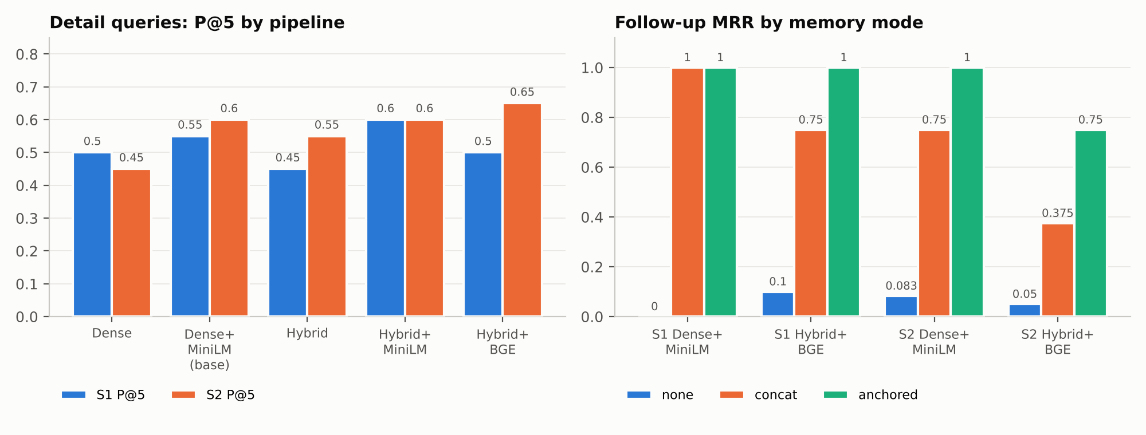
Figure 3. Left: detail-query P@5 by pipeline. Right: follow-up MRR by memory mode.
Anchored memory matched or beat concatenation in all four configurations. It raised MRR to 1.000 in three of them and raised P@5 to 0.7 on S1 under both pipelines. The follow-up check worked as designed: it rewrote C1-T2 and C2-T2, restricting them to docs 3 and 9, and left C3-T2 unchanged. On the topic switch, concatenation mixed the diffuser topic into the synaptic-memory question and dropped P@5 to 0.0 in every configuration (MRR at most 0.167). Anchored memory gave exactly the same scores as no memory. The weakest memory combination was concatenation with Hybrid + BGE on S2 (P@5 0.3). A likely cause is that BM25 responds strongly to the many turn-1 words in a long concatenated query, which favours chunks that answered turn 1.

6. Recommended configuration
S2 sentence-aware chunking, dense retrieval, the MiniLM cross-encoder reranker, and anchored memory. It scores P@5 0.800, R@10 0.638 and MRR 1.000 on single-turn queries (detail P@5 0.60, R@10 0.879), P@5 0.6 and MRR 1.000 on dependent follow-ups, and P@5 1.0 and MRR 1.000 on the topic switch. Using fixed-window chunks requires adding hybrid BM25 retrieval to reach the same single-turn precision.

7. Limitations
- The evaluation is small: 12 queries over 4 target papers, all among the first ten documents. One query changes an average by up to 0.05 in P@5 and 0.125 in MRR.
- Relevance is a term-based rubric, not a full human judgment. It can credit a chunk that contains the terms without answering the question, and it can miss paraphrased answers. For example, in the Q5 comparison it marked 5 of 5 BGE results relevant, including notation-heavy passages. The pooled review table supports manual overrides, but none were applied.
- Q8 has only two relevant chunks, which caps its P@5 at 0.40 for every method.
- Equations are removed and the text is lowercased, which weakens math-heavy passages. 5.7–7.8% of chunks are still truncated at the embedder's 256-token limit.
- Latency was not measured, and the BGE comparison changes both the model and the candidate pool size.

8. Reproducibility
Everything ran in Google Colab on a CUDA (T4) GPU with SEED = 6638. Retrieval, reranking and evaluation are deterministic. Sections 1–10 produced identical metrics in two separate runs. All built-in checks passed: placeholder removal, chunk-length limits, index counts, self-retrieval at rank 1, target-paper lookup, baseline reproduction, and follow-up detection. Full tables are in METRICS.md, and the cell-by-cell log is in RUN_LOG.txt.

