**Industrial Internship Report on**

**”Banking Information System Prototype”**

**Prepared by**

**Ritika Shivaliya**

|  |
| --- |
| *Executive Summary* |
| This report provides an overview of the **Banking Information System** project developed during an internship facilitated by Upskill Campus in partnership with UniConverge Technologies Pvt Ltd (UCT).  This internship offered the opportunity to address real-world requirements in the banking sector by creating a Java-based prototype.  Over six weeks, the project covered key functionalities essential to a banking system, from user registration to transaction handling.  The experience enabled practical skill application and deepened my understanding of software development in a real-world context. |

**TABLE OF CONTENTS**

1 Preface 3

2 Introduction 4

2.1 About UniConverge Technologies Pvt Ltd 4

2.2 About upskill Campus 8

2.3 Objective 9

2.4 Reference 9

2.5 Glossary 10

3 Problem Statement 11

4 Existing and Proposed solution 12

5 Proposed Design/ Model 13

5.1 High Level Diagram 13

6 Performance Test 14

6.1 Test Plan/ Test Cases 14

6.2 Test Procedure 14

6.3 Performance Outcome 14

7 My learnings 15

8 Future work scope 16

# Preface

During the six-week internship, I progressed through foundational and advanced Java topics before applying my knowledge to the Banking Information System project. This project, selected among several options, was an invaluable opportunity to engage in real-world problem-solving. I am grateful to Upskill Campus and UniConverge Technologies for providing this experience and to my mentors for their guidance.

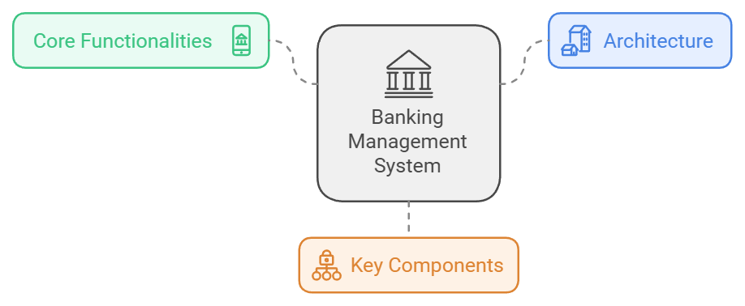

During this internship, I had the opportunity to enhance my understanding of Java programming and gain hands-on experience with core concepts like object-oriented programming, interfaces, inheritance, and error handling. The Banking Information System project allowed me to apply these skills in a practical context, simulating real-world banking operations and enhancing my problem-solving abilities.

Working on this project deepened my understanding of data persistence, file handling, and basic user authentication, as well as the importance of designing efficient and user-friendly systems. I also learned how to document my work and use version control with GitHub, which are essential skills for collaborative software development.

To my juniors and peers: Embrace every learning opportunity, whether it’s theoretical or practical. Hands-on experience will not only solidify your technical knowledge but also improve your confidence in tackling real-world challenges. Don’t hesitate to ask questions or seek feedback; learning from others is a key part of growth in any field. I encourage you to make the most of internships and projects, as these experiences will shape your professional skills and open doors to new opportunities .

# Introduction

## About UniConverge Technologies Pvt Ltd

A company established in 2013 and working in Digital Transformation domain and providing Industrial solutions with prime focus on sustainability and RoI.

For developing its products and solutions it is leveraging various**Cutting Edge Technologies e.g. Internet of Things (IoT), Cyber Security, Cloud computing (AWS, Azure), Machine Learning, Communication Technologies (4G/5G/LoRaWAN), Java Full Stack, Python, Front end**etc.



1. UCT IoT Platform **(****)**

**UCT Insight** is an IOT platform designed for quick deployment of IOT applications on the same time providing valuable “insight” for your process/business. It has been built in Java for backend and ReactJS for Front end. It has support for MySQL and various NoSql Databases.

* It enables device connectivity via industry standard IoT protocols - MQTT, CoAP, HTTP, Modbus TCP, OPC UA
* It supports both cloud and on-premises deployments.

It has features to  
• Build Your own dashboard  
• Analytics and Reporting  
• Alert and Notification  
• Integration with third party application(Power BI, SAP, ERP)  
• Rule Engine

 

1. **Smart Factory Platform (****)**

Factory watch is a platform for smart factory needs.

It provides Users/ Factory

* with a scalable solution for their Production and asset monitoring
* OEE and predictive maintenance solution scaling up to digital twin for your assets.
* to unleased the true potential of the data that their machines are generating and helps to identify the KPIs and also improve them.
* A modular architecture that allows users to choose the service that they what to start and then can scale to more complex solutions as per their demands.

Its unique SaaS model helps users to save time, cost and money.

 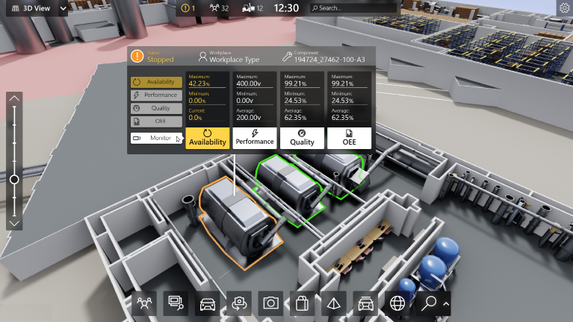

1.  based Solution

UCT is one of the early adopters of LoRAWAN teschnology and providing solution in Agritech, Smart cities, Industrial Monitoring, Smart Street Light, Smart Water/ Gas/ Electricity metering solutions etc.

1. Predictive Maintenance

UCT is providing Industrial Machine health monitoring and Predictive maintenance solution leveraging Embedded system, Industrial IoT and Machine Learning Technologies by finding Remaining useful life time of various Machines used in production process.



## About upskill Campus (USC)

upskill Campus along with The IoT Academy and in association with Uniconverge technologies has facilitated the smooth execution of the complete internship process.

USC is a career development platform that delivers **personalized executive coaching** in a more affordable, scalable and measurable way.



Seeing need of upskilling in self paced manner along-with additional support services e.g. Internship, projects, interaction with Industry experts, Career growth Services

<https://www.upskillcampus.com/>

upSkill Campus aiming to upskill 1 million learners in next 5 year

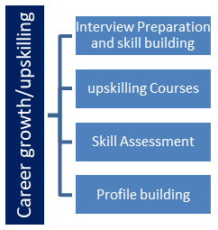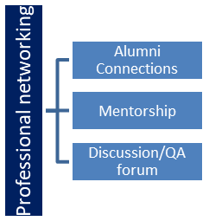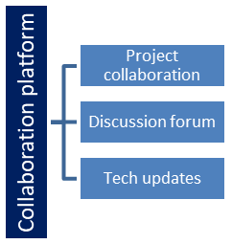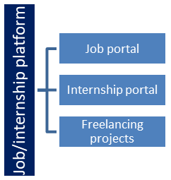

## The IoT Academy

The IoT academy is EdTech Division of UCT that is running long executive certification programs in collaboration with EICT Academy, IITK, IITR and IITG in multiple domains.

## Objectives of this Internship program

The objective for this internship program was to

 ☛ get practical experience of working in the industry.

 ☛ to solve real world problems.

 ☛ to have improved job prospects.

 ☛ to have Improved understanding of our field and its applications.

 ☛ to have Personal growth like better communication and problem solving.

## Reference

[1] Java Programming Documentation – Oracle. Available at: <https://docs.oracle.com/javase/>

[2] GitHub Documentation – GitHub. Available at: <https://docs.github.com/>

[3] Guidance from UniConverge Technologies (UCT) Mentors  
Practical insights and feedback from mentors at UCT were invaluable in designing and implementing project features according to industry standards.

## Glossary

|  |  |
| --- | --- |
| Terms | Acronym |
| API | Application Programming Interface |
| Data Persistence | The storage of data beyond the lifespan of the program, often achieved through files. |
| JVM | The engine that runs Java applications, making them platform-independent. |
| User Authentication | A security process that verifies a user's identity, typically through passwords, to secure access to systems. |

# Problem Statement

This project involved developing a **Banking Information System Prototype** with essential functionalities to simulate real-world banking operations. The primary focus was on implementing core banking functions like user registration, deposit, withdrawal, and transaction history, ensuring both usability and data security.

# Existing and Proposed solution

**Existing Solutions**: Most commercial banking systems are comprehensive, but this prototype focuses on a simplified version for educational purposes.

**Proposed Solution**: The system allows user account creation, secure login, transactions, and balance management with file-based data persistence for temporary storage. Error handling is included for invalid or insufficient funds.

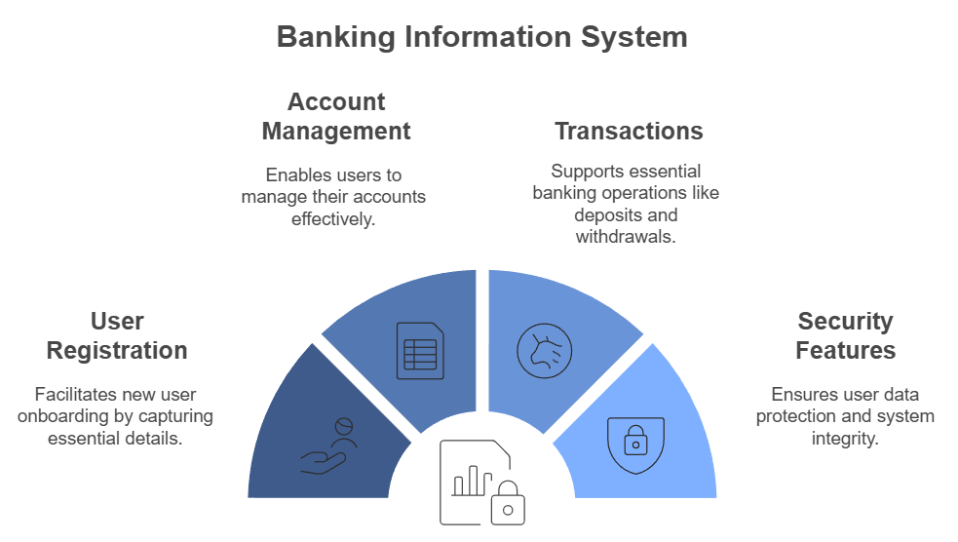

* **High-Level Design**

The prototype consists of modular components, including user management, transaction handling, and data persistence, using Java’s object-oriented approach.

* **Low-Level Design**

Classes for User, Transaction, and Bank were created, and a command-line interface facilitates user interaction.

## Code submission (Github link)

<https://github.com/RitikaShivaliya/upskillCampus>

## Report submission (Github link) :

<https://github.com/RitikaShivaliya/upskillCampus>

## 

# Proposed Design/ Model

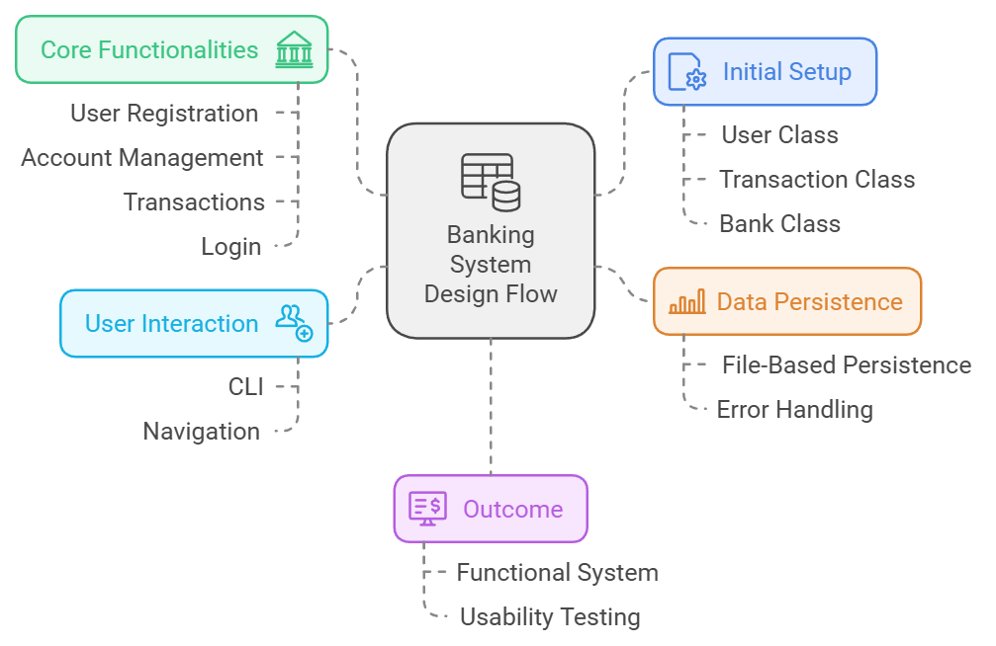

## High Level Diagram

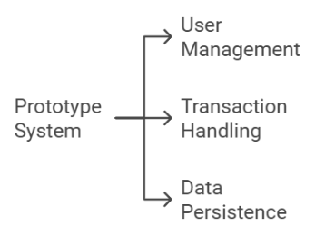The prototype consists of modular components, including user management, transaction handling, and data persistence, using Java’s object-oriented approach.

Figure 1: HIGH LEVEL DIAGRAM OF THE SYSTEM

## Low Level Diagram

Classes for User, Transaction, and Bank were created, and a command-line interface facilitates user interaction.

# Performance Test

* **Test Plan/Test Cases**

The system was tested for core functions like registration, transaction processing, and error handling.

* **Test Procedure and Outcome**

All functionalities were verified to work as expected, with successful transaction updates and error handling. Constraints were minimal, suitable for an educational prototype.

## Test Plan/ Test Cases

The test plan focused on verifying core functionalities and handling edge cases. Key test cases included:

* **User Registration**: Verify new users can register with valid details and receive unique account numbers.
* **Login Authentication**: Test correct password and account number combinations for successful logins, and verify failed login attempts for invalid credentials.
* **Deposit and Withdrawal**: Ensure deposits increase balance accurately, and withdrawals decrease balance while handling insufficient funds errors.
* **Fund Transfer**: Verify successful transfers between accounts and correct updates to both sender’s and recipient’s balances.
* **Data Persistence**: Test saving and reloading data from files to ensure data retention across sessions.

## Test Procedure

* **Functional Testing**: Execute each core function (registration, login, deposit, withdrawal, transfer) under typical conditions and boundary cases, using various user inputs.
* **Error Handling Verification**: Test scenarios like insufficient funds, invalid account numbers, and incorrect login details to confirm proper error messages are displayed.
* **Persistence Testing**: Restart the application after performing transactions to ensure that user data and transaction history are correctly loaded from files.

## Performance Outcome

The prototype performed well for its intended functions, with successful execution of user registration, account transactions, and data persistence. Error handling worked as expected, providing clear feedback for invalid operations. While file-based data storage performed adequately for testing, it highlighted a need for database integration to support larger datasets and concurrent access in future iterations. Overall, the system’s functionality met expectations for a simplified, console-based prototype

# My learnings

Each week of the internship built up knowledge toward the final project:

* **Weeks 1-3**: Covered Java fundamentals, including its platform independence and introductory programming concepts.
* **Weeks 4-6**: Focused on Java concepts like interfaces, abstract classes, and method overloading, leading into the Banking Information System project and report submission via GitHub.

These experiences greatly enhanced my programming skills and understanding of software application in real-world projects.

# Future work scope

Potential enhancements for the Banking Information System prototype include developing a graphical user interface (GUI) to improve usability and make the system more accessible to non-technical users. Enhancing data security through encryption and advanced authentication methods (e.g., two-factor authentication) would increase system security and user trust. Finally, implementing a database such as MySQL or PostgreSQL for persistent data storage would replace file-based storage, allowing for more robust, scalable data management that better suits real-world banking applications. These improvements would significantly elevate the system’s functionality and bring it closer to an industry-standard solution.