How I Extract Job Skills Using NLP?
Final Internship Project Report
NLP-Based Job Skill Extraction, Normalization & Analytics
Prepared by: Ritika Singh
TABLE OF CONTENTS
1. Introduction
2. Problem Statement & Objectives
3. Project Scope & Use Case
4. Technology & Tools Used
5. System Architecture & Methodology
6. Dataset Collection & Understanding
7. Exploratory Data Analysis (EDA)
8. Data Cleaning & NLP Preprocessing
9. Skill Taxonomy Development
10. Rule-Based Skill Extraction
11. Statistical & Semantic NLP Techniques
12. Named Entity Recognition (NER)
13. Machine Learning Model
14. Transformer-Based Model
15. Model Evaluation & Comparison
16. Error Analysis
17. Skill Normalization & Categorization
18. Dashboard & Data Visualization
19. Application / API Development
20. Testing & Results
21. Challenges & Limitations
22. Conclusion
23. Future Scope
24. Internship Learning Outcomes
25. References
26. Appendix
1. Introduction
This project focuses on extracting technical and professional skills from unstructured job descriptions using Natural Language Processing (NLP). Job descriptions contain technologies, tools, databases, programming languages and competencies, but these are normally written as free text. The project converts this unstructured information into structured skill data and then uses the result for evaluation, normalization, visualization and application development.
2. Problem Statement & Objectives
Job descriptions may express the same skill in several forms. For example, Python can appear as Python3, Python 3 or Python programming, while Power BI can appear as PowerBI, Power BI or Power-BI. The project therefore aims to automate extraction and create a consistent representation of skills. Business objective: support recruitment analytics. Technical objective: build and evaluate multiple NLP extraction methods, normalize results and expose them through analytics and an API/application. Expected outcome: a reusable job-skill extraction pipeline.
3. Project Scope & Use Case
The scope covers data understanding, preprocessing, skill taxonomy, rule-based extraction, statistical and semantic NLP, NER, ML, transformer experiments, evaluation, error analysis, normalization, dashboard development and application/API development. The recruitment use case is to identify required skills from job descriptions and make those skills usable for job-market analytics, matching, candidate ranking and skill-gap analysis.
4. Technology & Tools Used
Python was used for the main implementation. Pandas and NumPy supported data processing. NLTK and spaCy supported NLP processing and NER. Scikit-learn supported TF-IDF and Logistic Regression. Sentence Transformers supported semantic similarity. Transformers supported pretrained NER experiments. Power BI was used for analytics. ReactJS was used for the frontend, FastAPI for the backend, SQLite for persistence and JWT for authentication. The final application uses ReactJS + FastAPI.
5. System Architecture & Methodology
The complete workflow is: Job Description/Input → Cleaning & Preprocessing → Skill Taxonomy/Aliases → Dictionary/Regex/Phrase Matching → TF-IDF/N-grams/Semantic Similarity → NER → ML → Transformer → Evaluation → Error Analysis → Normalization → Categorization → Dashboard/API. The application architecture is ReactJS Frontend → FastAPI Backend → SQLite → NLP Extraction → Normalization → Category Mapping → Results/History.
6. Dataset Collection & Understanding
The main final working dataset is clean_jobs_with-skills.csv with 7,996 job records. Fields include company, education, experience, industry, jobdescription, jobid, joblocation_address, jobtitle, numberofpositions, payrate, postdate, site_name, skills, uniq_id, clean_description, original_length, clean_length and extraction outputs. The original skills field was not treated as technical-skill ground truth because it represents job/function information. A separate evaluation file containing 487 records was used for model comparison.
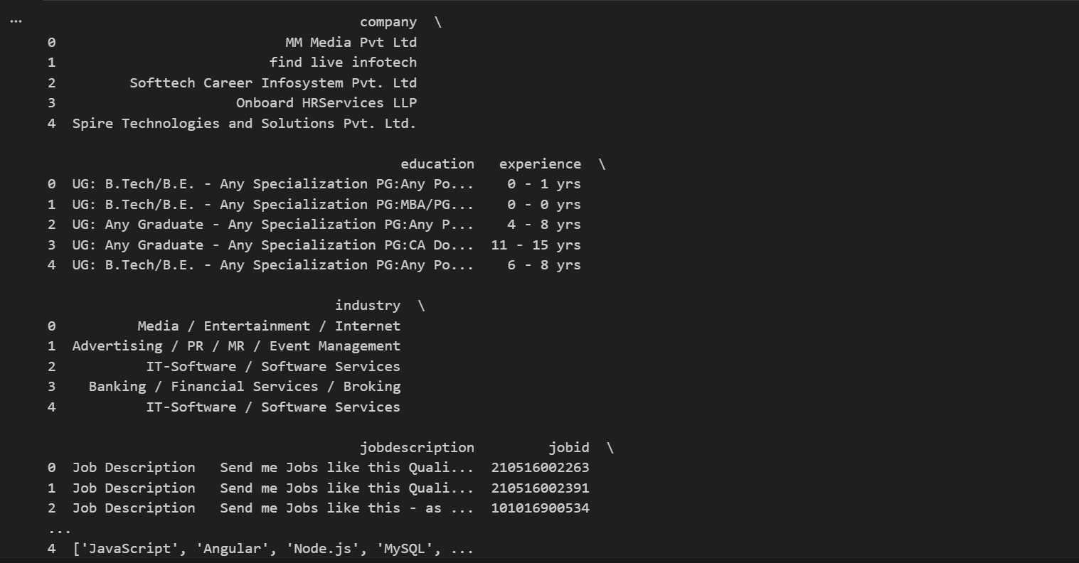
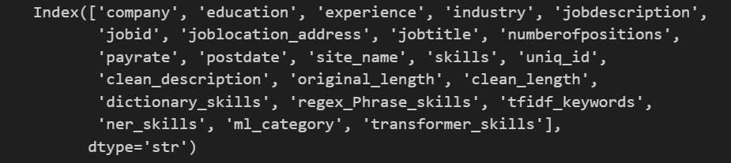

7. Exploratory Data Analysis (EDA)
EDA included inspection of job titles, locations, industries, description lengths, missing values and duplicates. Original and cleaned text lengths were compared. Visual analysis was used to understand job-demand patterns. Postdate was retained for later skill-trend analysis in Power BI.
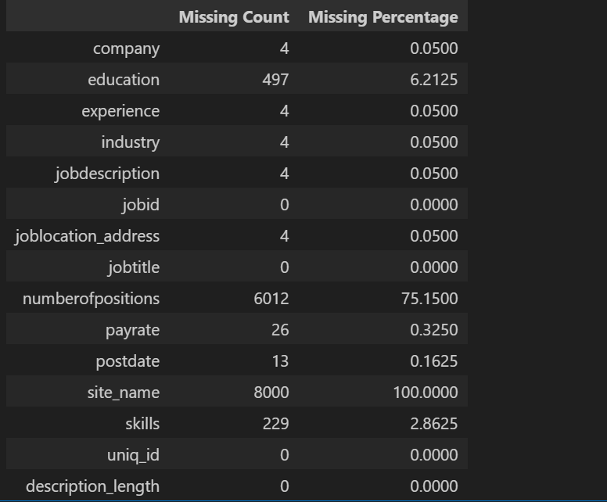
Visualizations:
Top 10 Job Titles
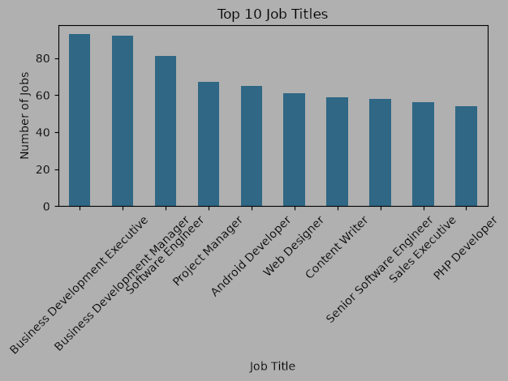
Top 10 Job Locations
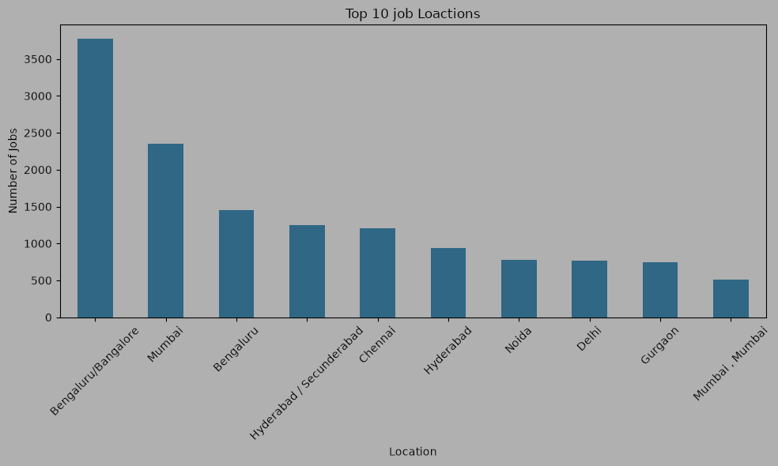
Job Description Length Distribution
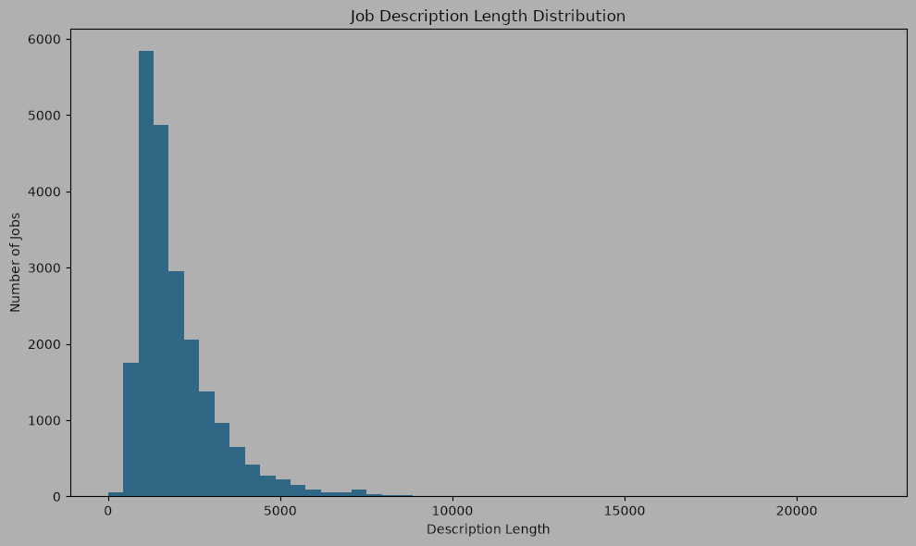
Missing Values by Column
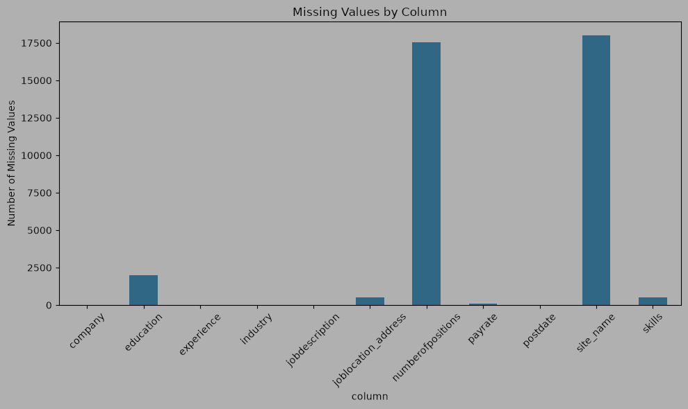

Top 10 Companies
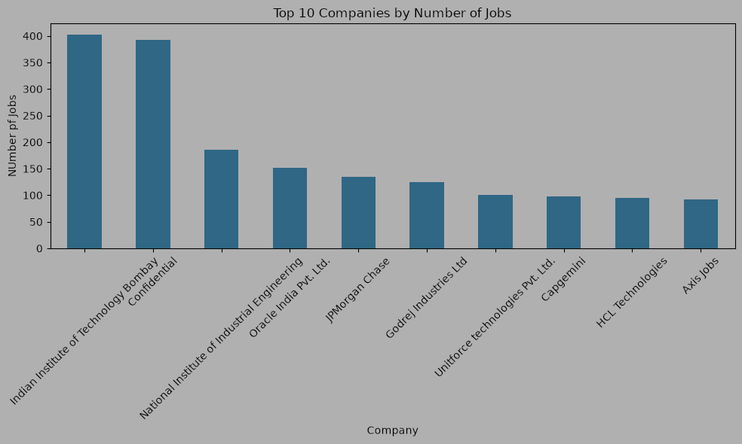

Experience Distribution
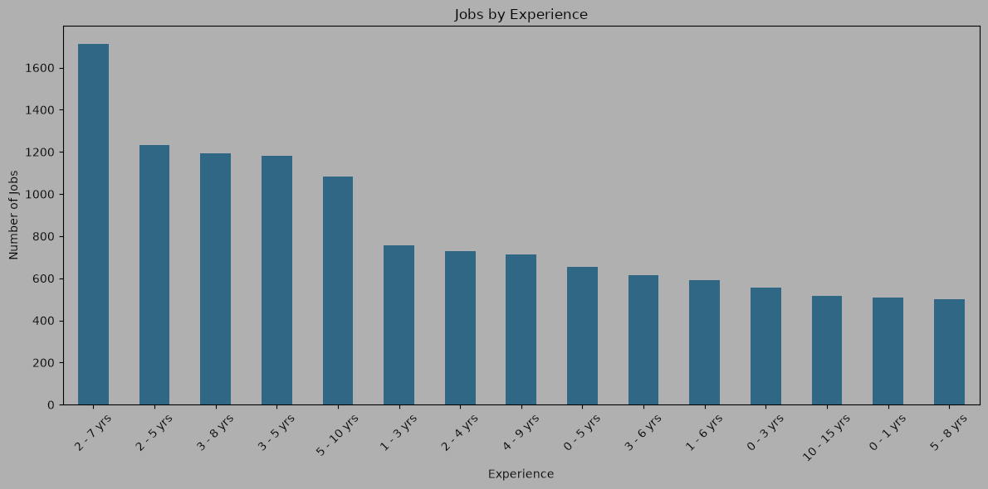

8. Data Cleaning & NLP Preprocessing
A clean_description field was created from jobdescription. Cleaning included text normalization, formatting/noise reduction and whitespace cleanup. original_length and clean_length were retained for quality analysis. NLP experiments included tokenization, stopword handling, stemming, lemmatization and sentence segmentation where appropriate.
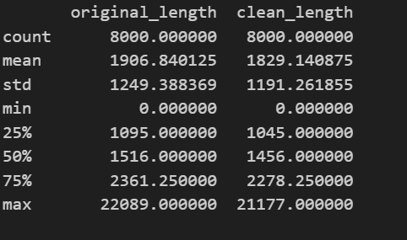

9. Skill Taxonomy Development
A domain-specific taxonomy was created with canonical skill names, categories and aliases. Examples include Python, SQL, Power BI and PostgreSQL. Categories cover areas such as Programming, Database, Data Analytics, Data Science, Machine Learning, Cloud, DevOps, AI/NLP and related domains. The taxonomy supports both extraction and normalization
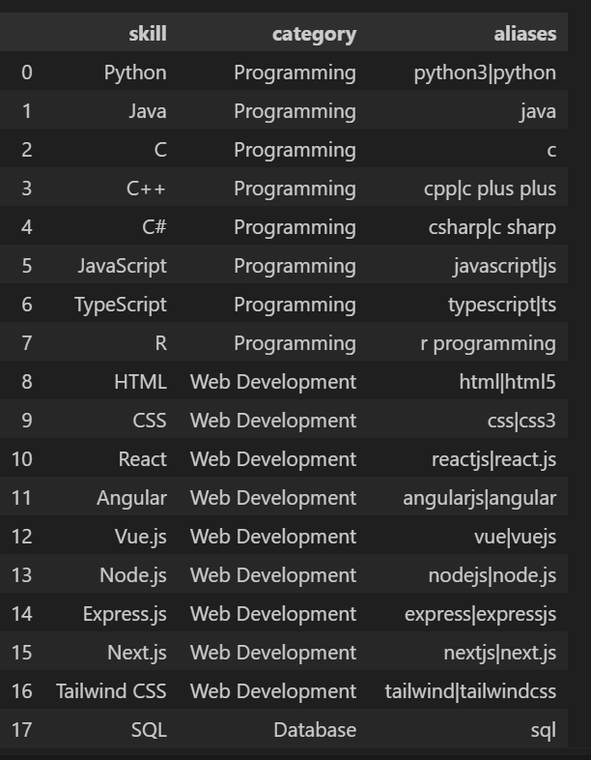
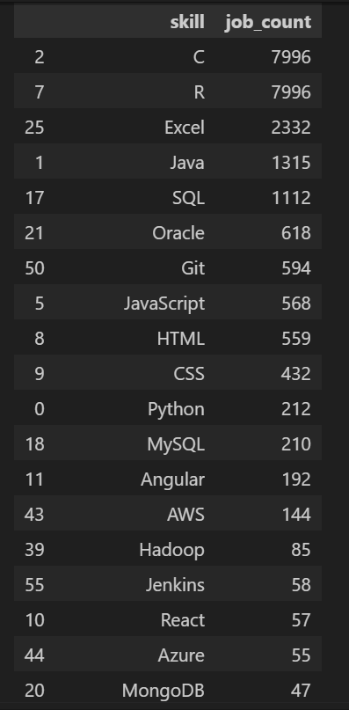

10. Rule-Based Skill Extraction
Dictionary matching detects known taxonomy terms. Regex supports flexible patterns and variants. Phrase matching supports multi-word technical phrases. The approach is interpretable and useful for known skills, but it depends on taxonomy coverage and can miss unknown technologies.
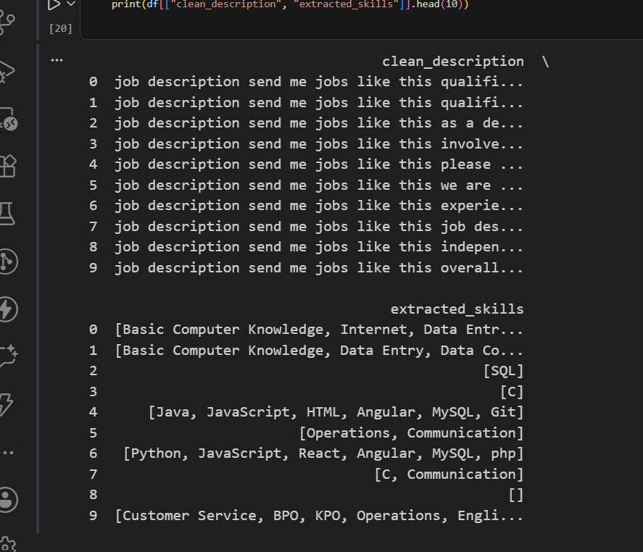
Visualization:
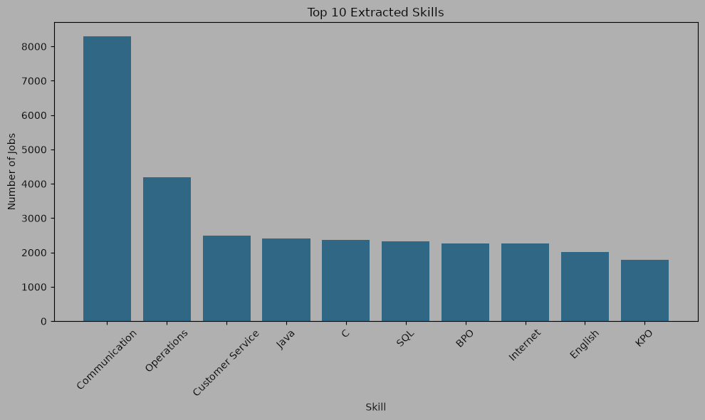
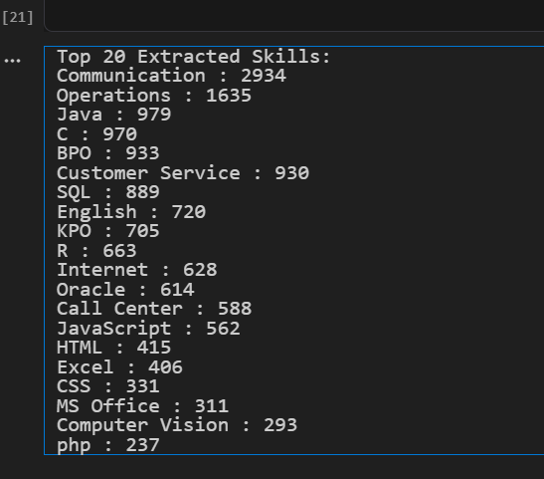

11. Statistical & Semantic NLP Techniques
TF-IDF was used to identify statistically important terms, with N-grams explored for multi-word expressions. Sentence Transformers using all-MiniLM-L6-v2 were used for semantic similarity between text phrases and taxonomy skills. Threshold experiments showed the trade-off between false positives and missed skills; very high thresholds could produce empty results.
Calculate Score by TF-IDF keywords
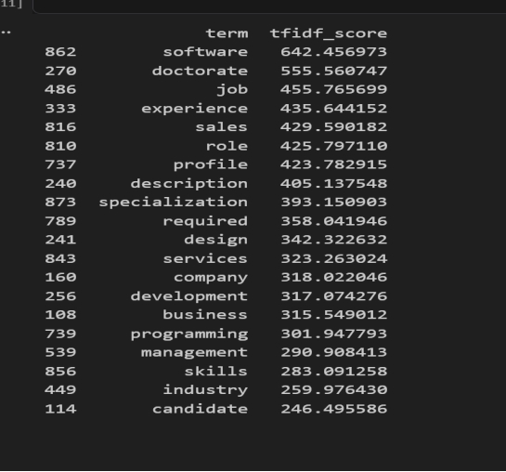

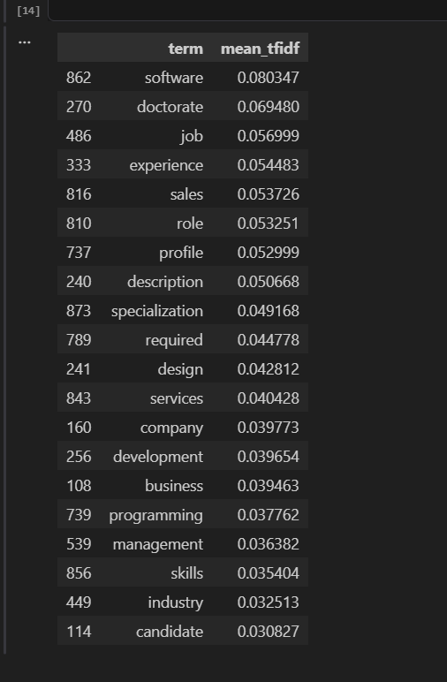
This showed that TF-IDF identifies both technical terms and general job-related terms.
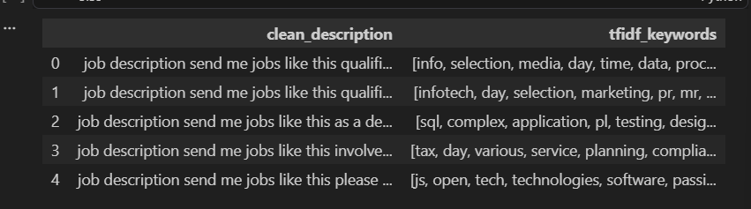
Visualization:
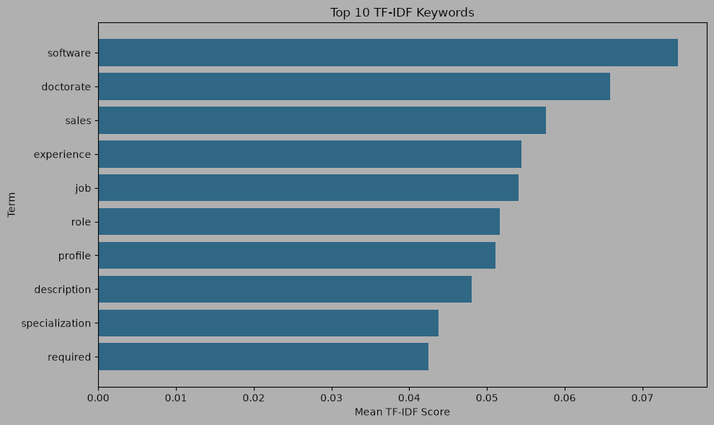
Comparing TF-IDF with Skill Taxonomy
The TF-IDF terms were compared with the previously created skill taxonomy.
The comparison helped identify which TF-IDF terms were already known skills.
Some matching skills were:
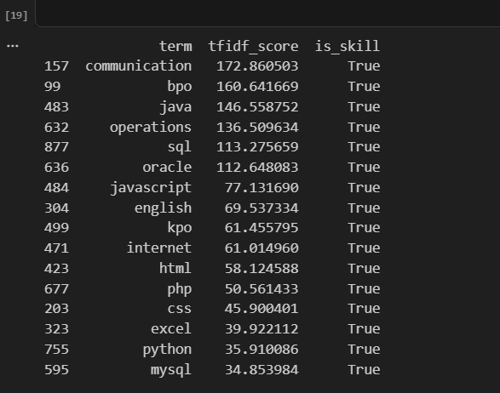
N-gram Output:
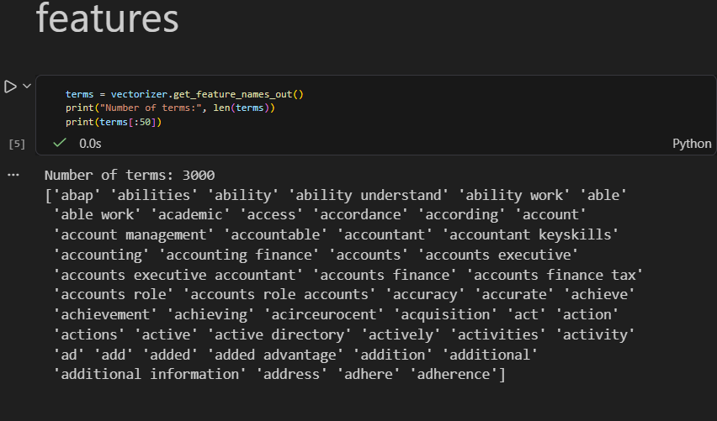
Top 20 Unigram
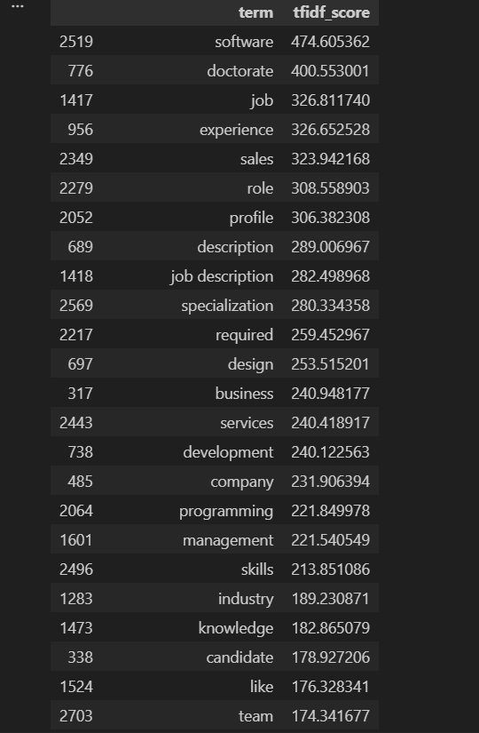
Top 20 Bigrams
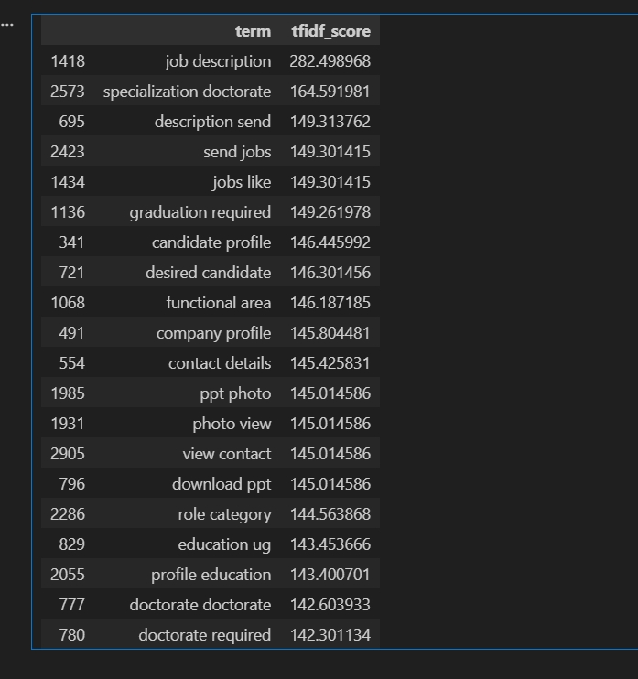
Top 20 Trigrams
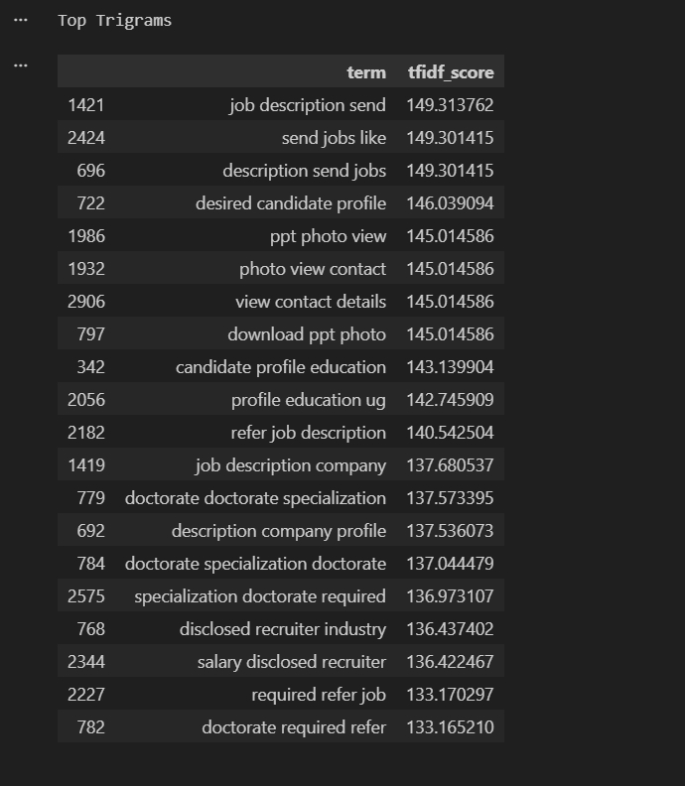
Visualization
Top bigrams and trigrams were visualized using Matplotlib.
The visualizations helped understand which multi-word phrases had higher TF-IDF scores.
The following charts were created:
- Top 10 Unigrams
- Top 10 Bigrams
- Top 10 Trigrams
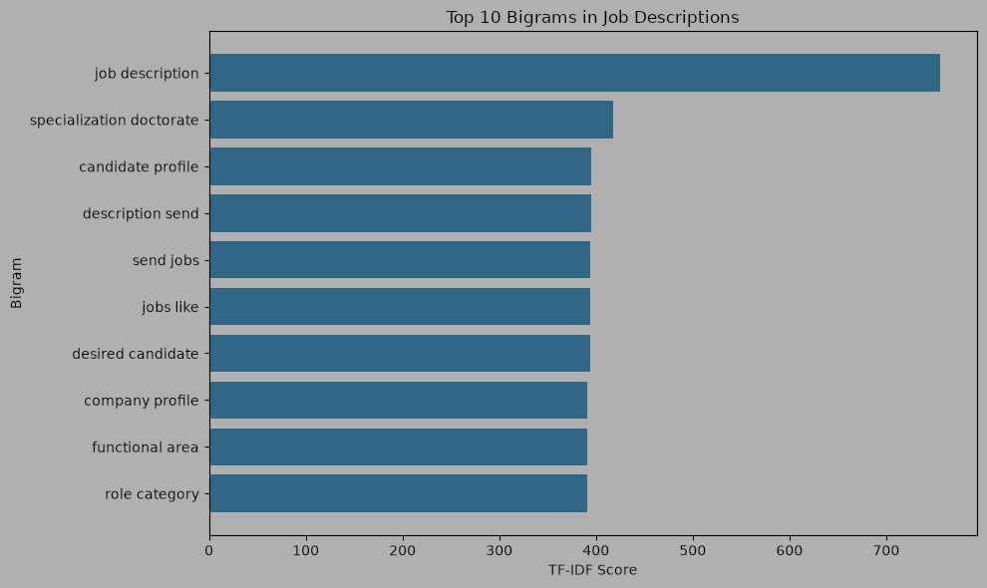
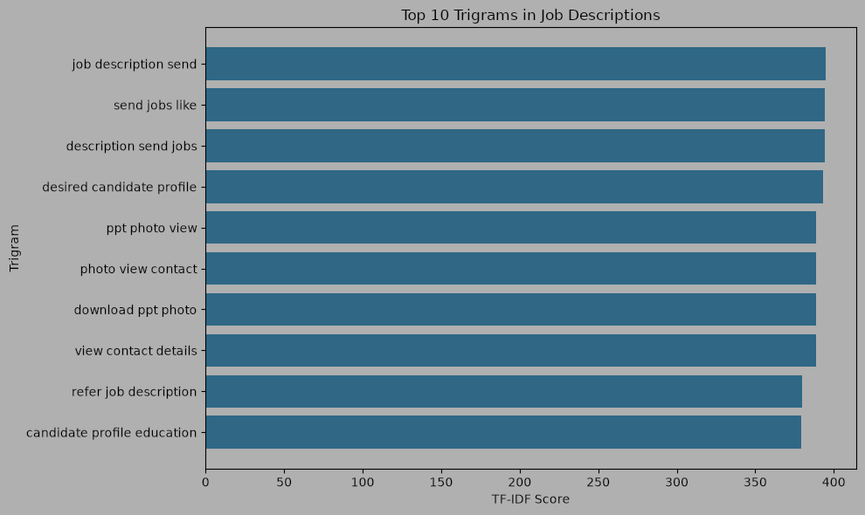
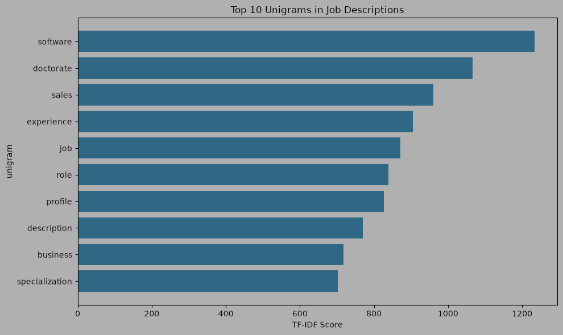
Word embedding and Semantic smimilarity:
Cosine Similarity
Cosine similarity was used to calculate how similar two embeddings ar
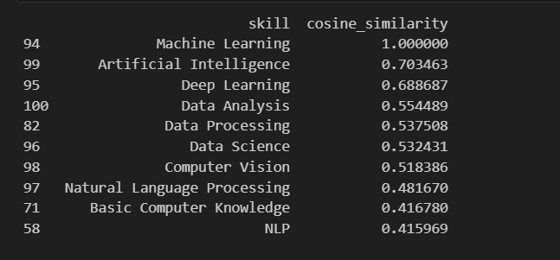
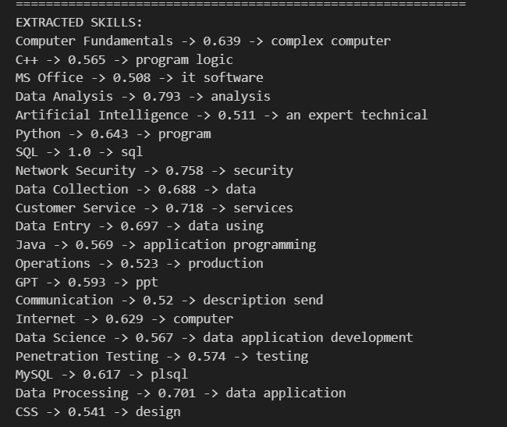
Readable Output
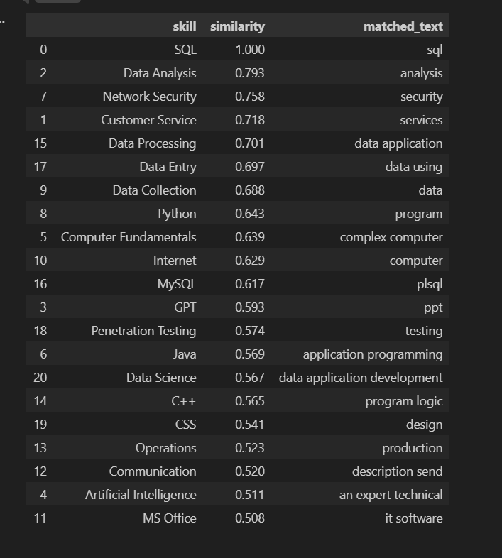

JobTitle vs Semantic skills Output
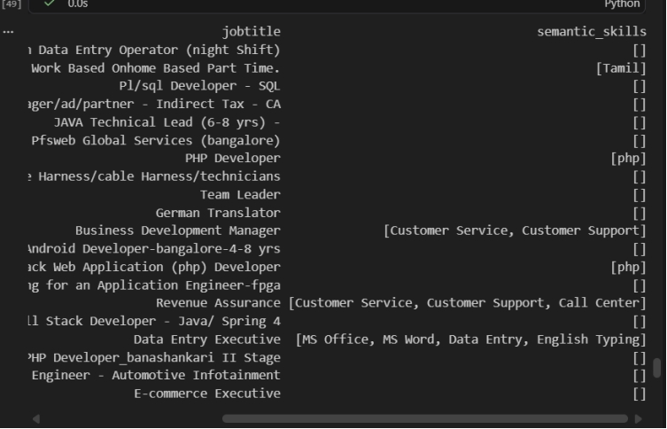

12. Named Entity Recognition (NER)
spaCy NER and custom entity concepts such as SKILL, TOOL, TECHNOLOGY, DATABASE and CLOUD_PLATFORM were explored. General-purpose NER often misclassified technical terms; examples included AWS as ORG, Google Cloud as PERSON and PostgreSQL as GPE. This demonstrated the need for domain-specific NER.
Testing Standard spaCy NER
First, the standard spaCy NER model was tested with technical terms.
Example input:
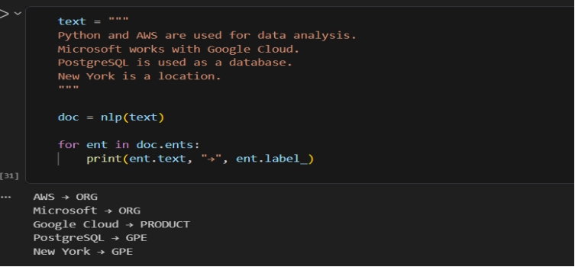
Result
The experiment demonstrated that standard spaCy NER is not sufficient for reliable technical skill extraction.
The custom PhraseMatcher approach successfully allows technical entities to be assigned project-specific labels.
Example:
Python → SKILL
AWS → CLOUD_PLATFORM
PostgreSQL → DATABASE
Power BI → TOOL
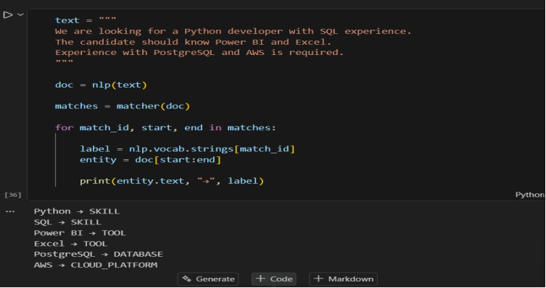
Match dataset Clean description
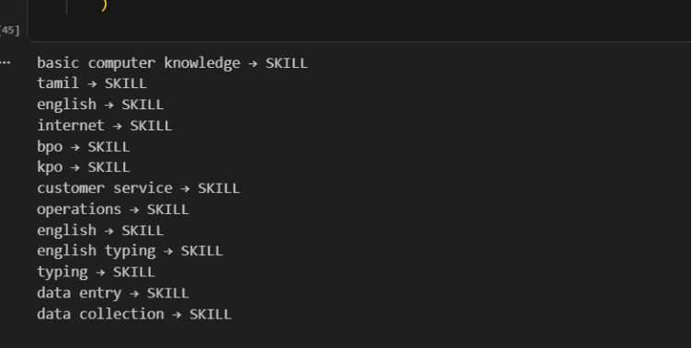
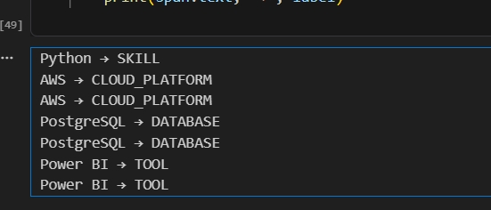

13. Machine Learning Model
A supervised TF-IDF + Logistic Regression pipeline was developed with labeled examples and reusable vectorizer, model and label-encoder artifacts. On the project evaluation set the ML approach achieved Precision, Recall , F1-score and Accuracy, giving it the best F1-score among the compared methods.
Skill -> Category -> label
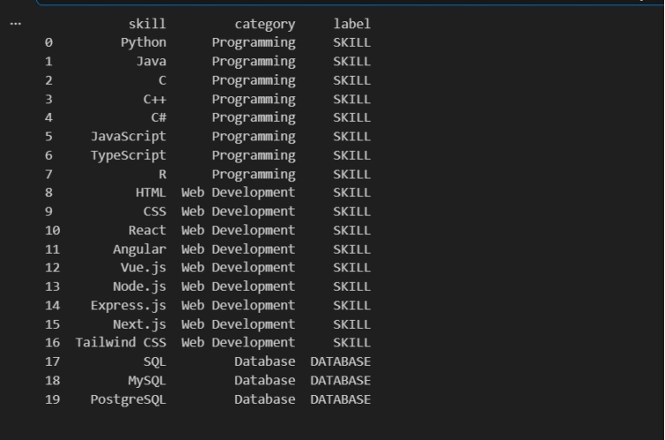
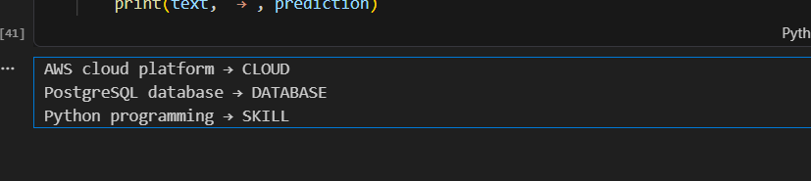
Classification_report
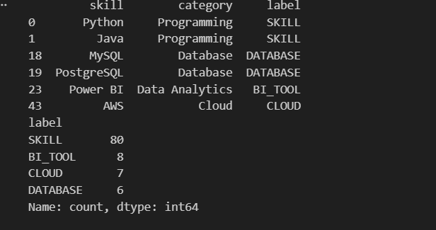
Classification_report
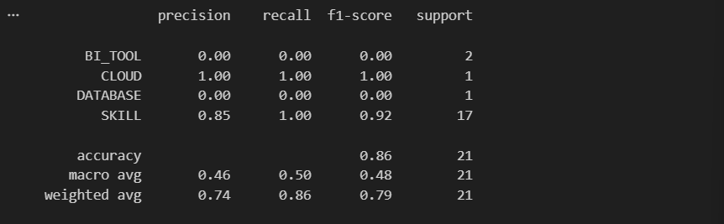
The model achieved 86% accuracy. However, the classification report shows poor performance for BI_TOOL and DATABASE because the dataset contains fewer examples for these categories. The model performs better on the SKILL and CLOUD categories. More balanced training data would improve classification performance.

14. Transformer-Based Model
The project experimented with the pretrained dslim/bert-base-NER transformer model. It uses context for entity extraction, but many technical skills were returned as the generic MISC label because the model is not specifically trained for recruitment technology skills. A pretrained Transformer model is powerful for general entity recognition, but it does not automatically understand domain-specific entities such as technical skills. Domain-specific training or a skill taxonomy is required for reliable technical skill extraction.
Basic Test
The following sentence was tested:
Experience with Python, SQL and AWS.
The Transformer produced:
Python → MISC
SQL → MISC
AWS → MISC
with high confidence scores.
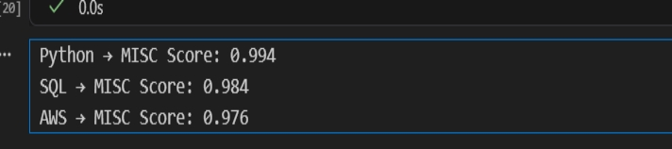
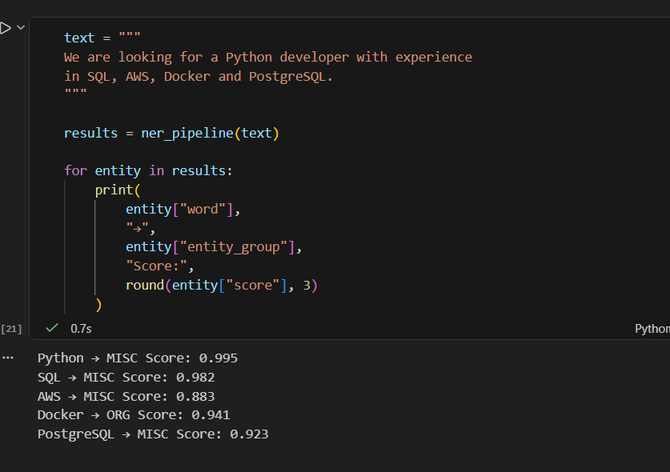
Output:
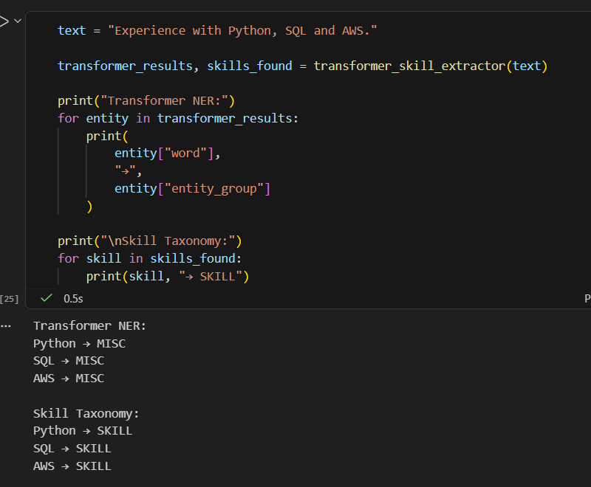
The taxonomy-based extractor successfully identified job-related skills such as:
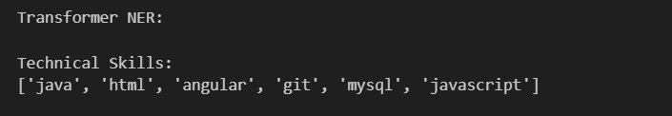
This demonstrates how NLP techniques become more advanced as the project progresses.
Compare dataset:
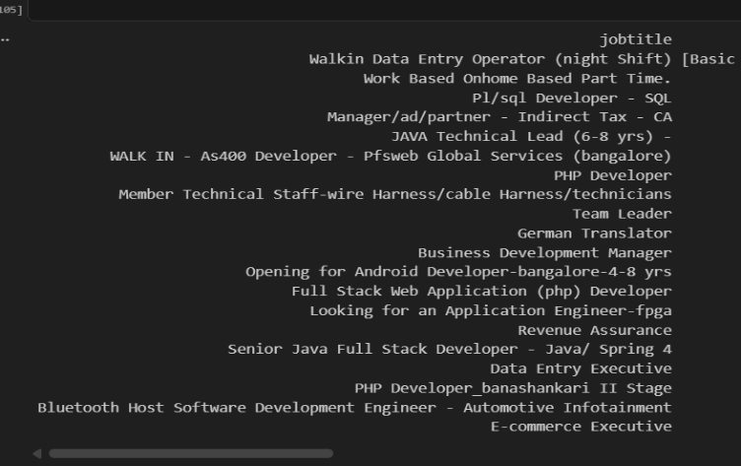
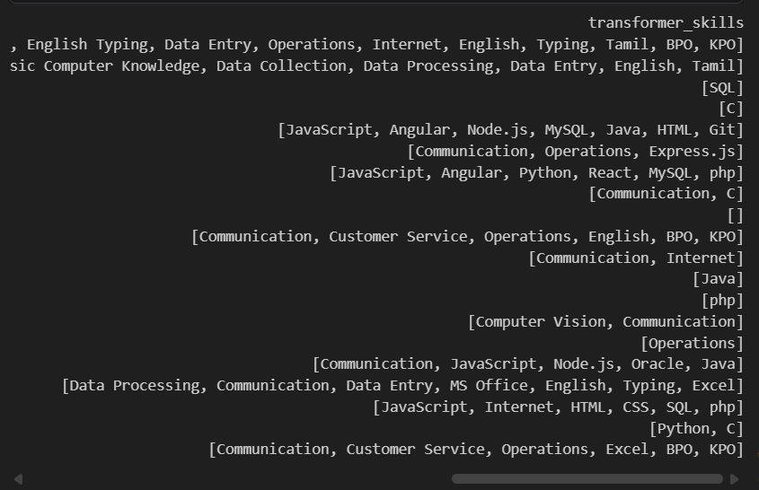
15. Model Evaluation & Comparison
The evaluated methods were Dictionary, Regex, TF-IDF, NER, ML Model and Transformer. Dictionary: P 0.4979, R 0.9350, F1 0.6498, Accuracy 0.9812. Regex: P 0.4953, R 0.9350, F1 0.6476, Accuracy 0.9810. TF-IDF: P 0.8880, R 0.3583, F1 0.5106, Accuracy 0.9872. NER: P 0.5209, R 0.9327, F1 0.6685, Accuracy 0.9828. ML: P 0.6342, R 0.7398, F1 0.6830, Accuracy 0.9872. Transformer: P 0.5166, R 0.9614, F1 0.6721, Accuracy 0.9825. ML had the best F1; Transformer had the best recall.
Model Comparison
The final comparison was stored in:
model_comparison.csv
The comparison table contains:
- Method
- Precision
- Recall
- F1 Score
- Accuracy
The actual values were calculated from the project dataset rather than using example values.
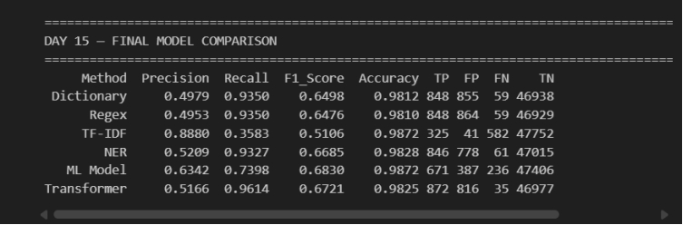
Result Interpretation
Dictionary-Based Extraction
The Dictionary approach achieved:
- Precision: 0.4979
- Recall: 0.9350
- F1-Score: 0.6498
The high recall shows that dictionary matching can identify many skills present in the taxonomy.
However, precision was relatively low because some words can occur in a job description without actually representing a technical skill.
Regex + PhraseMatcher
Regex and PhraseMatcher achieved:
- Precision: 0.4953
- Recall: 0.9350
- F1-Score: 0.6476
Its performance was very similar to dictionary matching.
This method is useful when exact patterns and phrases need to be detected.
TF-IDF
TF-IDF achieved:
- Precision: 0.8880
- Recall: 0.3583
- F1-Score: 0.5106
TF-IDF produced the highest precision among the evaluated methods.
However, its recall was significantly lower.
This happened because TF-IDF identifies important words based on their statistical importance rather than understanding whether a word represents a specific skill.
Therefore, it may identify relevant keywords but miss many actual skills.
NER
NER achieved:
- Precision: 0.5209
- Recall: 0.9327
- F1-Score: 0.6685
NER was able to identify many entities from job descriptions.
However, general-purpose NER models are not specifically trained for technical skill extraction. Therefore, some technical terms may receive incorrect entity labels.
Machine Learning Model
The Machine Learning skill extractor achieved:
- Precision: 0.6342
- Recall: 0.7398
- F1-Score: 0.6830
The ML model achieved the highest F1-Score among all evaluated methods.
This indicates a better balance between identifying actual skills and avoiding incorrect predictions.
Therefore, based on F1-Score, the ML Model was the best-performing approach in this evaluation.
Transformer
The Transformer approach achieved:
- Precision: 0.5166
- Recall: 0.9614
- F1-Score: 0.6721
The Transformer achieved the highest recall.
This means it detected the largest proportion of reference skills.
However, its precision was lower than the ML model, meaning it also generated more incorrect predictions.
Best Performing Methods
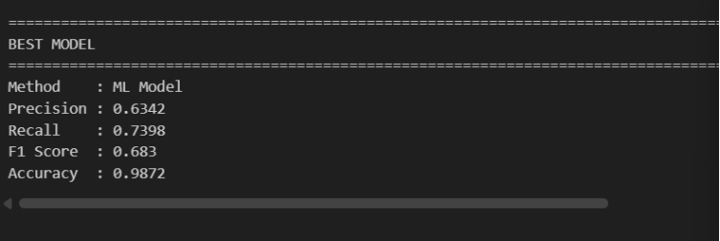
Best F1-Score
ML Model — 0.6830
This indicates the best balance between Precision and Recall.
Best Recall
Transformer — 0.9614
This indicates that the Transformer identified the largest number of actual skills.
Best Precision
TF-IDF — 0.8880
However, its low recall means it missed many skills.
A method with high Precision produces fewer incorrect skill predictions.
A method with high Recall identifies more of the actual skills.
A high F1 Score indicates a good balance between Precision and Recall.
For this project, Precision, Recall, and F1 Score were given greater importance than Accuracy because skill extraction is an entity/extraction task.
Confusion Metrix
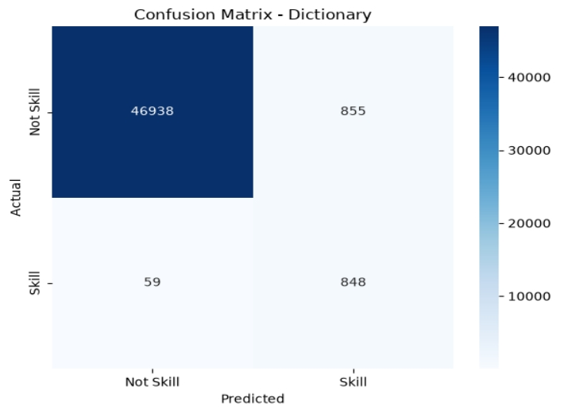
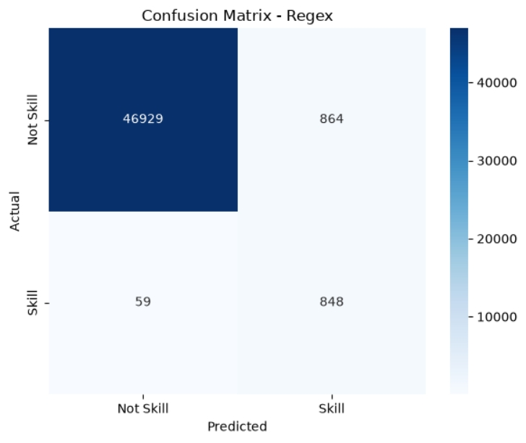
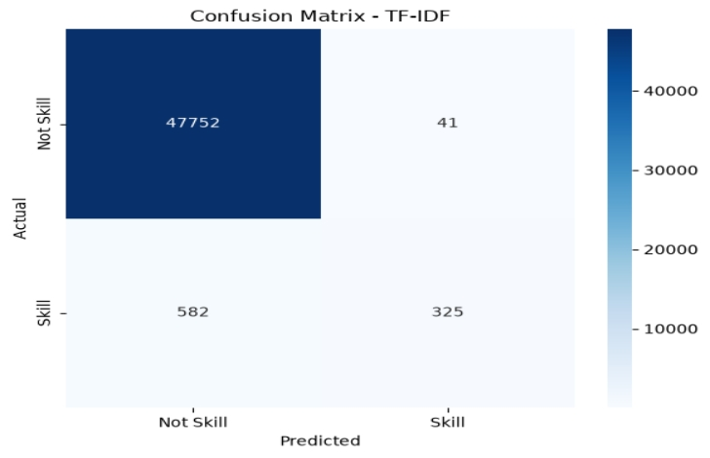

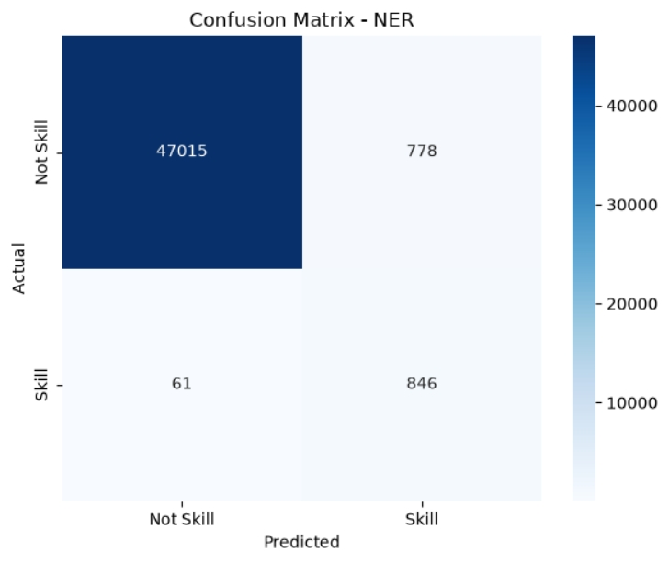
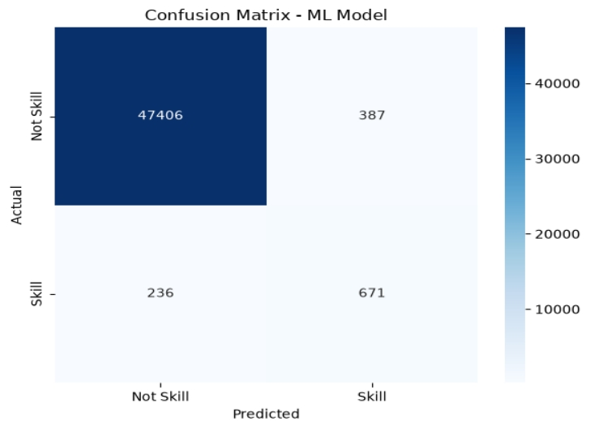
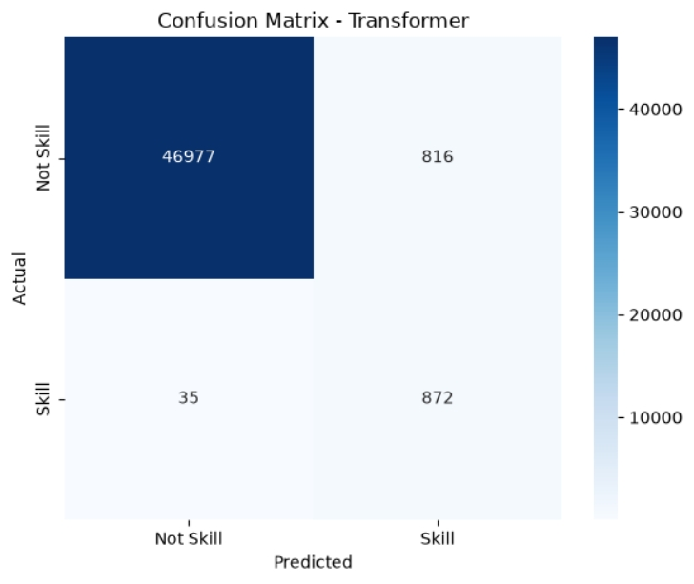
Traditional dictionary and regex approaches achieved high recall but lower precision. TF-IDF achieved high precision but low recall. NER provided high recall but had difficulties with technical terminology.
The Machine Learning model achieved the best F1-Score of 0.6830, while the Transformer achieved the highest recall of 0.9614.
Therefore, the Machine Learning model provided the best overall balance in this evaluation.

16. Error Analysis
A total of 573 error records were analyzed. Categories were False Positive, False Negative, Wrong Entity, Partial Entity, Synonym Problem, Spelling Problem, Unknown Skill and Duplicate Skill. The analysis showed that variant spellings, synonyms, incomplete entities and missing taxonomy entries were important failure sources.
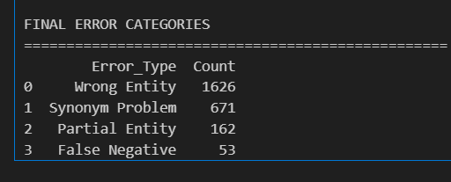
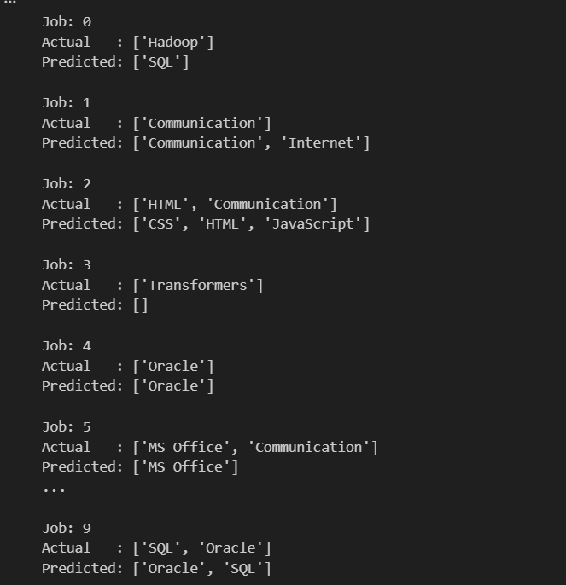
Error Analysis Table
The final table contains:
- Job ID
- Text
- Actual Skills
- Predicted Skills
- False Positive
- False Negative
- Error Category
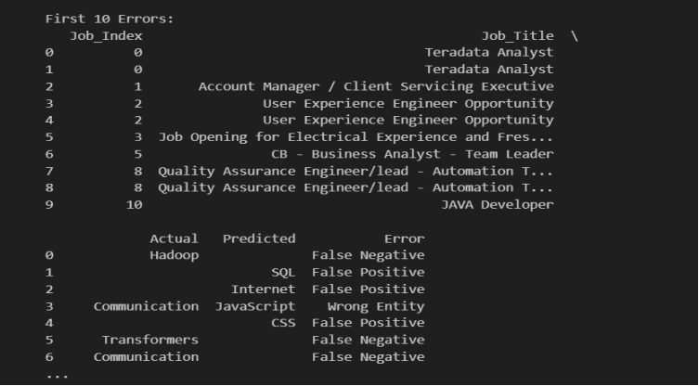
First 10 rows error Analysis
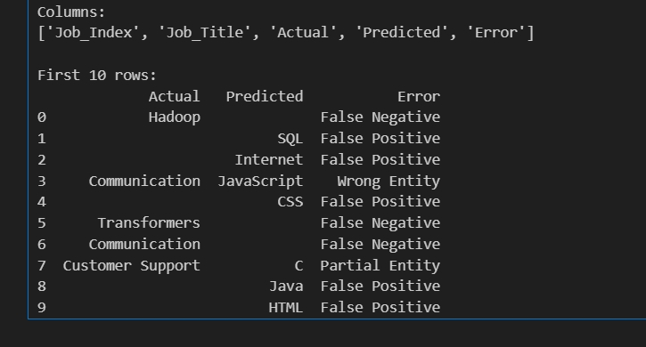

Excel sheet :
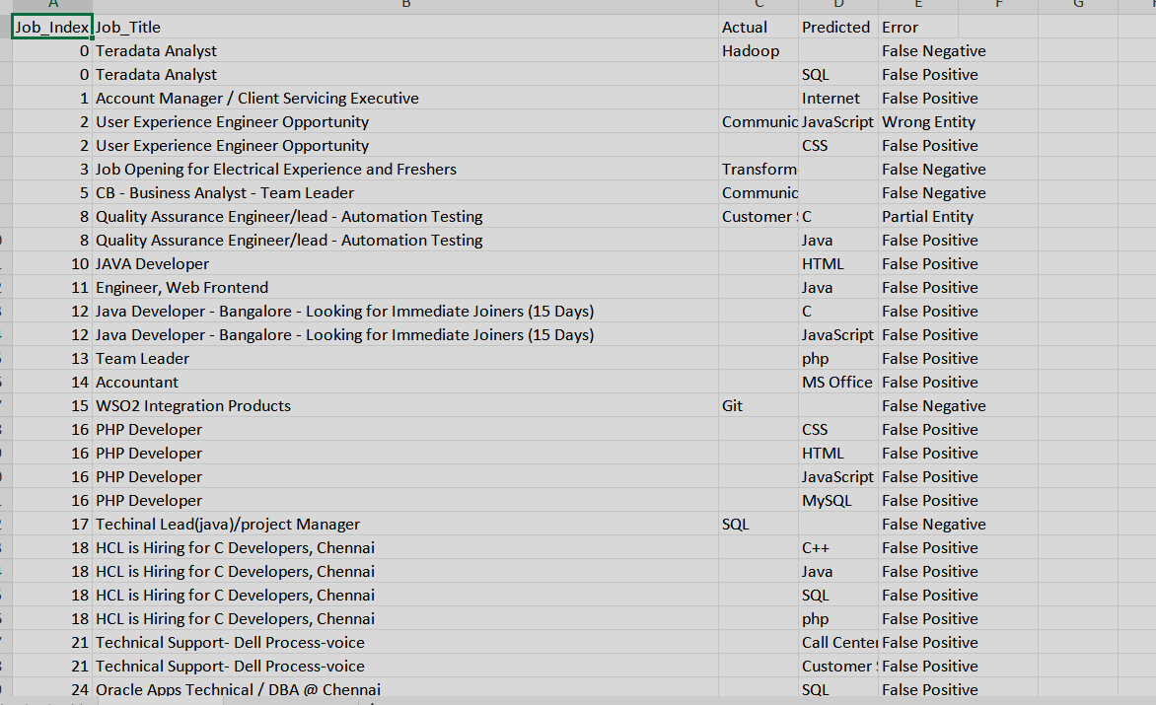

17. Skill Normalization & Categorization
The Day 17 normalization flow is Raw Skill → Lowercase → Remove Special Characters → Alias Matching → Canonical Skill. Examples: python3, python 3 and Python programming → Python; PowerBI, Power BI and Power-BI → Power BI; postgres → PostgreSQL. The normalization deliverable is normalized_skills.csv. Categorization maps canonical skills to their taxonomy categories.
Canonical Skill
After successful matching, the original variation is replaced by the canonical taxonomy name.
Examples:
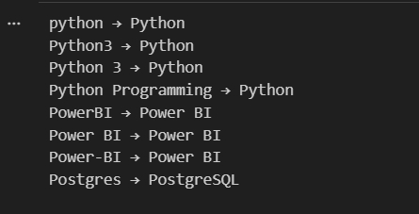
Example of Normalized Output
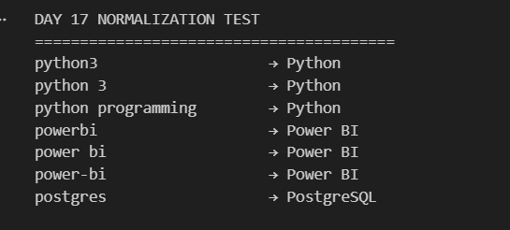

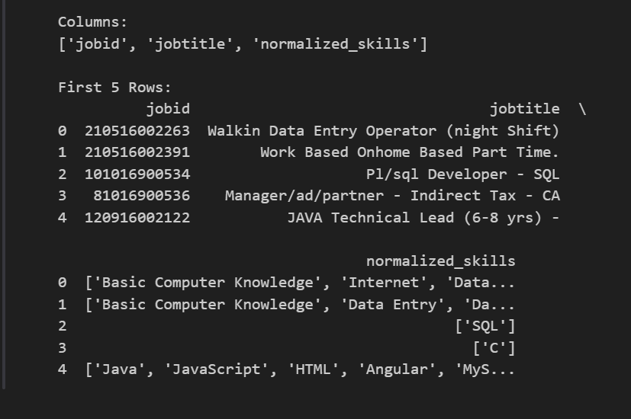

18. Dashboard & Data Visualization
The Power BI dashboard includes KPIs for Total Jobs, Unique Skills, Top Skill, Top Job Role, Most Required Technology and Top Skill Category. Visuals include Top 20 Skills, Skill Demand by Job Role, Skill Category Distribution, Skill Trends and Top Job Roles. Slicers include Job Role, Industry and Post Date. Because skill expansion can create multiple rows per job, Total Jobs should use distinct job IDs.
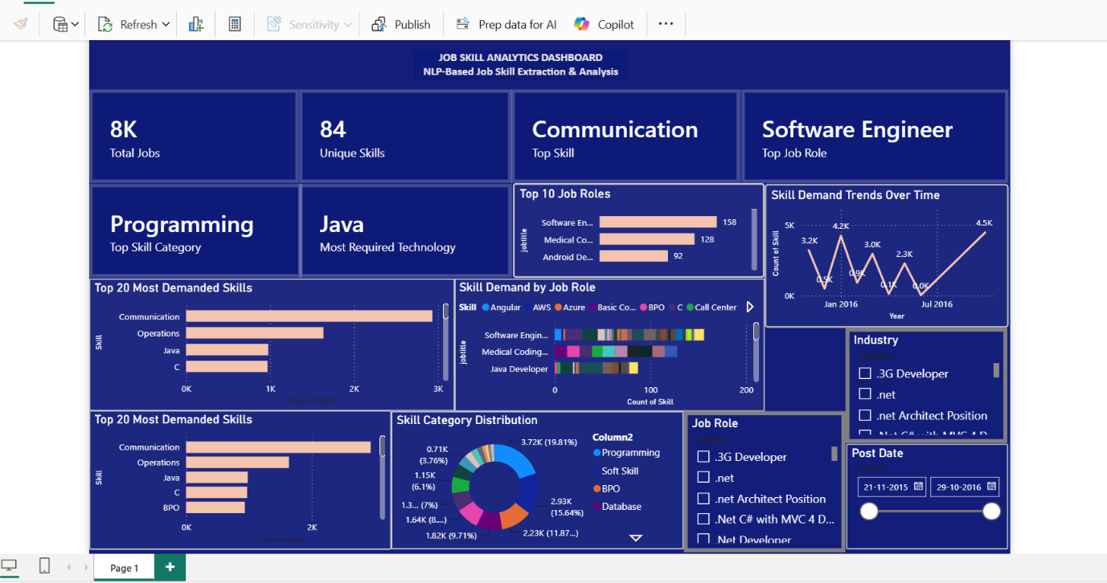
19. Application / API Development
The final application uses ReactJS, FastAPI and SQLite. It provides Register, Login, Dashboard, extraction, Results, History, Profile and Logout flows. JWT-based authentication and password hashing are used. The extraction API processes text, extracts skills, normalizes them, maps categories and stores history. Recommended technologies are produced by a simple rule-based recommendation layer.
USER
│
▼
ReactJS Frontend
┌────────────┼────────────┐
│ │ │
Register Login Dashboard
│
▼
Job Description Input
│
▼
FastAPI Backend
│
▼
NLP Skill Extraction
│
┌─────────────────┼─────────────────┐
▼ ▼ ▼
Preprocessing Skill Extraction Normalization
│ │
└────────┬────────┘
▼
Category Mapping
│
▼
Recommended Technologies
│
▼
SQLite DB
│
▼
Results to Frontend
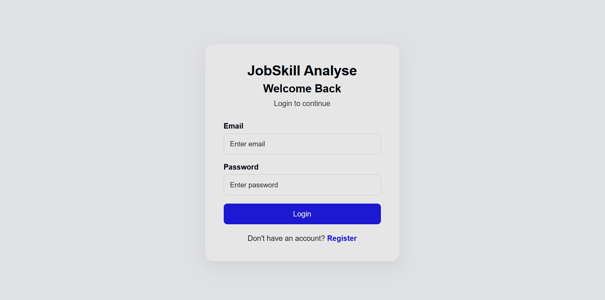
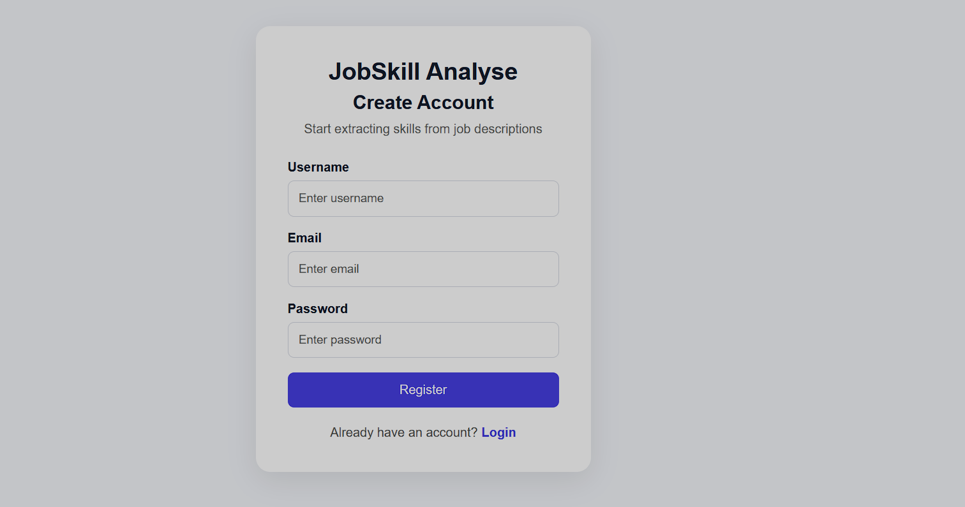

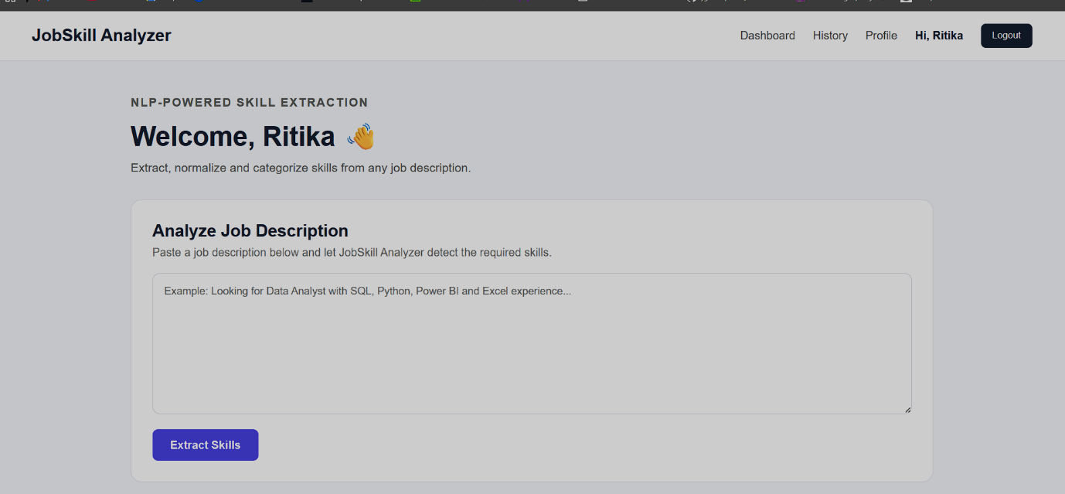
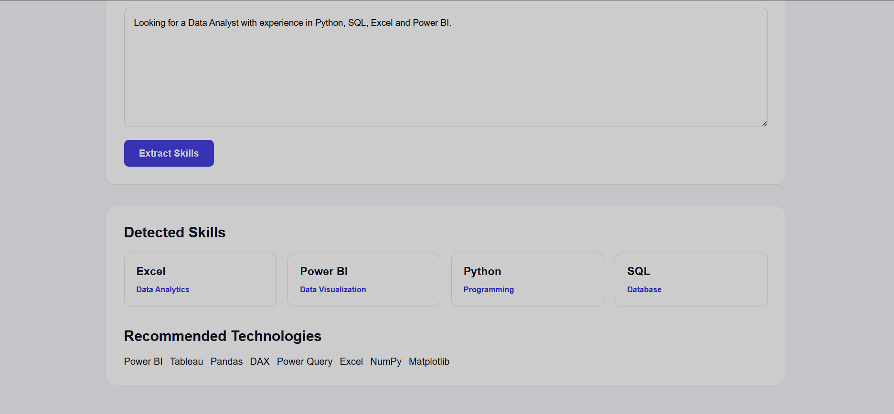
20. Testing & Results
Testing was performed progressively on smaller samples before larger runs, especially for semantic extraction. The final working dataset contains 7,996 records. Model outputs were validated through the dedicated evaluation dataset. Normalization was tested on common aliases. The application was tested through registration, login, protected dashboard access, extraction and history. A representative application result is Excel → Data Analytics, Power BI → Data Visualization, Python → Programming and SQL → Database.
21. Challenges & Limitations
Key limitations include taxonomy dependence, general-purpose NER errors, semantic threshold tuning, TF-IDF non-skill terms, limited labeled training data and generic transformer labels. Job descriptions also contain abbreviations, spelling variations and compound skills. The current recommendation engine is rule-based rather than learned from job-market behavior. The application is a development-stage system and needs production hardening for deployment.
22. Conclusion
The project developed an end-to-end NLP workflow for extracting job skills from unstructured descriptions. Multiple approaches were implemented and evaluated, followed by error analysis and normalization. The structured output was connected to Power BI analytics and a ReactJS + FastAPI application. The project demonstrates how NLP experimentation can be converted into a practical recruitment analytics product.
23. Future Scope
Future work includes domain-specific transformer fine-tuning, larger and continuously updated taxonomies, automatic discovery of new technologies, resume-job matching, candidate ranking, skill-gap analysis, personalized learning recommendations, data-driven recommendations, multilingual support and production deployment with monitoring and model versioning.
24. Internship Learning Outcomes
The project provided practical learning in NLP preprocessing, rule-based extraction, semantic similarity, NER, supervised ML, transformer models, evaluation metrics, error analysis, taxonomy design, Power BI, ReactJS, FastAPI, SQLite, JWT authentication, API integration and debugging.and also this internship is provide lots of learning new technology and languages.
25. References
Relevant resources include documentation for Pandas, NumPy, NLTK, spaCy, Scikit-learn, Sentence Transformers, Hugging Face Transformers, FastAPI, ReactJS and Power BI. Project-specific references also include the dataset, taxonomy files, evaluation results and generated model artifacts. Exact dataset provenance should be recorded from the original dataset source used for submission.and dataset Source: kaggle.com
26. Appendix
Main artifacts include clean_jobs_with-skills.csv, clean_jobs_normalized.csv, normalized_skills.csv, day15_skill_results.csv, model_comparison.csv, Error_Analysis_Report.xlsx, ml_skill_extractor.pkl, ml_skill_vectorizer.pkl and ml_skill_label_encoder.pkl. Suggested screenshots for the final report are the dataset/EDA notebook, taxonomy, extraction outputs, model comparison, error analysis, normalization, Power BI dashboard, Login/Register, Dashboard, Results, History and Profile.
Data Cleaning:
import re
def clean_text(text):
text = str(text).lower()
text = re.sub(r"http\S+|www\S+", "", text)
text = re.sub(r"[^a-zA-Z0-9\s]", " ", text)
text = re.sub(r"\s+", " ", text)
return text.strip()

df["clean_description"] = df["jobdescription"].apply(clean_text)
Rule Based skill extraction
def extract_skills(text):
text = text.lower()
found_skills = []

for skill, aliases in skill_dictionary.items():
for alias in aliases:
if re.search(r"\b" + re.escape(alias) + r"\b", text):
found_skills.append(skill)
break

return list(set(found_skills))

df["dictionary_skills"] = df["clean_description"].apply(
extract_skills
)
spaCy NER
import spacy

nlp = spacy.load("en_core_web_sm")

text = "Python and AWS are used for data analysis."

doc = nlp(text)

for ent in doc.ents:
print(ent.text, "→", ent.label_)
Model Evaluation & Comparison
from sklearn.metrics import (
precision_score,
recall_score,
f1_score,
accuracy_score
)

precision = precision_score(
y_true, y_pred, average="weighted"
)

recall = recall_score(
y_true, y_pred, average="weighted"
)

f1 = f1_score(
y_true, y_pred, average="weighted"
)

accuracy = accuracy_score(y_true, y_pred)

