
Tribhuvan University Faculty of Management Kathmandu, Nepal

DATA MINING
Project Documentation On
Different Datasets in ML

Submitted By:
Ritika Koirala
Submitted To:
Mahesh Adhikari

Project 1: EDA & Features Engineering

Section A: Data Understanding
This section covers the initial steps required to load, inspect, and understand the dataset prior to any processing or analysis.

Importing the Required Libraries
Purpose: Import all necessary Python libraries for data manipulation, visualization, and preprocessing.
import pandas as pd import numpy as np
from matplotlib import pyplot as plt import seaborn as sns
from sklearn.preprocessing import MinMaxScaler, StandardScaler
from sklearn import preprocessing

Loading the Dataset
Purpose: Read the dataset from a CSV file into a Pandas DataFrame for further analysis.
df = pd.read_csv('data.csv')

Displaying the First 10 Rows
Purpose: Preview the initial records of the dataset to understand its structure and contents.
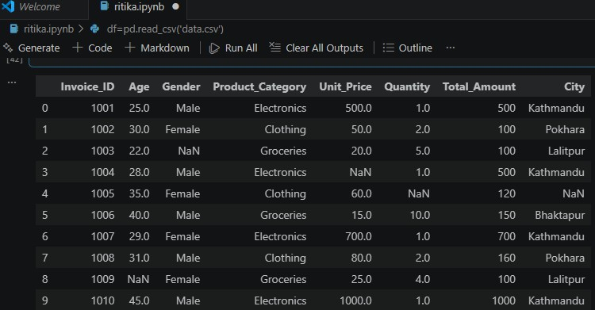
df.head(10)

Checking Data Types of Each Column
Purpose: Verify the data type assigned to each column to identify any type mismatches requiring correction.
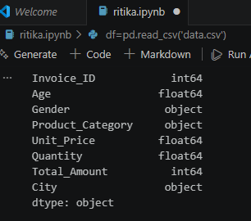
df.dtypes

Identifying Missing Values
Purpose: Detect columns containing missing values so that appropriate imputation strategies can be applied.
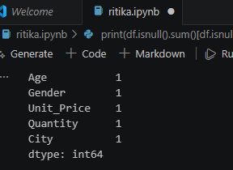
print(df.isnull().sum()[df.isnull().sum() > 0])

Section B: Missing Data Handling
Missing values in numerical columns are addressed using statistical measures (mean, median, mode) based on the distribution of each column.

Compute Descriptive Statistics for Numerical Columns

Purpose: Calculate mean, median, and mode to determine the appropriate imputation strategy for each column.
print('Mean:\n', df[['Age', 'Unit_Price', 'Total_Amount']].mean())
print('\nMedian:\n', df[['Age', 'Unit_Price', 'Total_Amount']].median())
print('\nMode:\n', df[['Age', 'Unit_Price', 'Total_Amount']].mode().iloc[0])

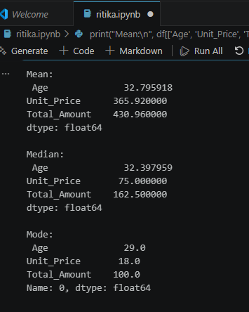

Assess Distribution Skewness
Purpose: Compare mean and median values to determine the direction of skewness and select the optimal imputation method.
for col in ['Age', 'Unit_Price', 'Total_Amount']: mean = df[col].mean()
median = df[col].median()
print(f'{col}: Mean={mean}, Median={median}') if mean > median:
print('Right skewed\n') elif mean < median:
print('Left skewed\n') else:
print('Symmetric\n')

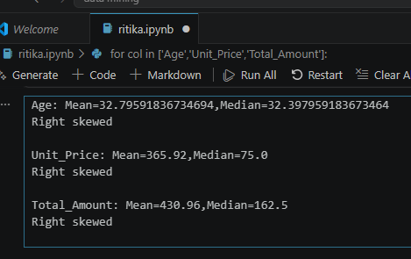

Section C: Data Cleaning
Data cleaning ensures consistency, correctness, and uniformity across the dataset before analysis or modelling.

Check and Remove Duplicate Rows
Purpose: Identify and eliminate duplicate records to prevent bias and inaccurate analytical results.
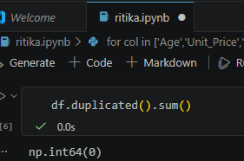
df.duplicated().sum()

Ensure Correct Data Types for Numerical Columns
Purpose: Convert columns to numeric format, coercing any non-numeric entries to NaN for subsequent handling.
df['Age'] = pd.to_numeric(df['Age'], errors='coerce') df['Unit_Price'] = pd.to_numeric(df['Unit_Price'], errors='coerce')

df['Quantity'] = pd.to_numeric(df['Quantity'], errors='coerce')
df['Total_Amount'] = pd.to_numeric(df['Total_Amount'], errors='coerce')

Standardize Categorical Values
Purpose: Convert all categorical text values to lowercase to eliminate inconsistencies caused by case variations.
print('\nStandardizing categorical values to lowercase') df['Gender'] = df['Gender'].str.lower() df['Product_Category'] = df['Product_Category'].str.lower()
df['City'] = df['City'].str.lower()

Section D: Statistical Measures
Descriptive statistics are computed for key numerical columns to summarize the central tendency and distribution of the data.

Calculate Mean, Median, and Mode
Purpose: Compute three measures of central tendency for Age, Unit_Price, and Total_Amount.
print('Mean:\n', df[['Age', 'Unit_Price', 'Total_Amount']].mean())
print('\nMedian:\n', df[['Age', 'Unit_Price', 'Total_Amount']].median())
print('\nMode:\n', df[['Age', 'Unit_Price', 'Total_Amount']].mode().iloc[0])



Compare Mean vs. Median to Identify Skewness
Purpose: Determine the distributional skewness of each numerical column to inform preprocessing decisions.
for col in ['Age', 'Unit_Price', 'Total_Amount']: mean = df[col].mean()
median = df[col].median()
print(f'{col}: Mean={mean}, Median={median}') if mean > median:
print('Right skewed\n') elif mean < median:
print('Left skewed\n') else:
print('Symmetric\n')

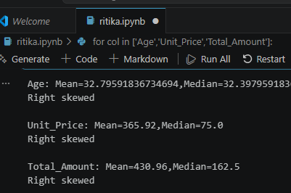

Section E: Outlier Detection
Outliers are identified using the Interquartile Range (IQR) method to detect extreme values that may distort analytical results.

Apply the IQR Method to Detect Outliers
Purpose: Compute Q1, Q3, and IQR to define acceptable value boundaries, then flag records falling outside those bounds.
Q1 = df['Total_Amount'].quantile(0.25) Q3 = df['Total_Amount'].quantile(0.75)
IQR = Q3 - Q1
lower_bound = Q1 - 1.5 * IQR upper_bound = Q3 + 1.5 * IQR print('Lower Bound:', lower_bound) print('Upper Bound:', upper_bound)

# Detect outliers
outliers = df[(df['Total_Amount'] < lower_bound) | (df['Total_Amount'] > upper_bound)]
print(outliers)

Section F: Outlier Treatment
Detected outliers are removed from the dataset to ensure that subsequent analysis and model training are conducted on reliable, representative data.

Remove Records Outside the Acceptable Range
Purpose: Filter out all observations where Total_Amount falls below the lower bound or exceeds the upper bound.
df = df[(df['Total_Amount'] >= lower_bound) & (df['Total_Amount'] <= upper_bound)]

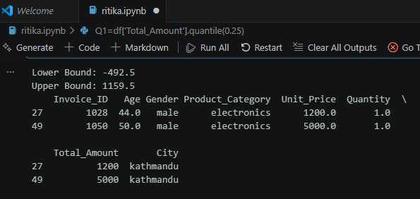

Section G: Feature Scaling
Feature scaling normalizes the range of numerical variables to ensure that no single feature disproportionately influences model performance.

Apply Min-Max Normalization
Purpose: Scale Unit_Price, Quantity, and Total_Amount to a uniform [0, 1] range using Min-Max Scaling.
scaler = MinMaxScaler()
df[['Unit_Price', 'Quantity', 'Total_Amount']] = scaler.fit_transform( df[['Unit_Price', 'Quantity', 'Total_Amount']]
)

Apply Z-Score Standardization

Purpose: Standardize the Age column using Z-score normalization to achieve a mean of 0 and a standard deviation of 1.
scaler_std = StandardScaler()
df['Age'] = scaler_std.fit_transform(df[['Age']])

Section H: Categorical Encoding
Categorical variables must be converted to numerical representations to be compatible with machine learning algorithms.

Apply One-Hot Encoding to Categorical Columns
Purpose: Convert Gender, Product_Category, and City into binary indicator columns using One-Hot Encoding.
df = pd.get_dummies(df, columns=['Gender', 'Product_Category', 'City'])
print(df.head())

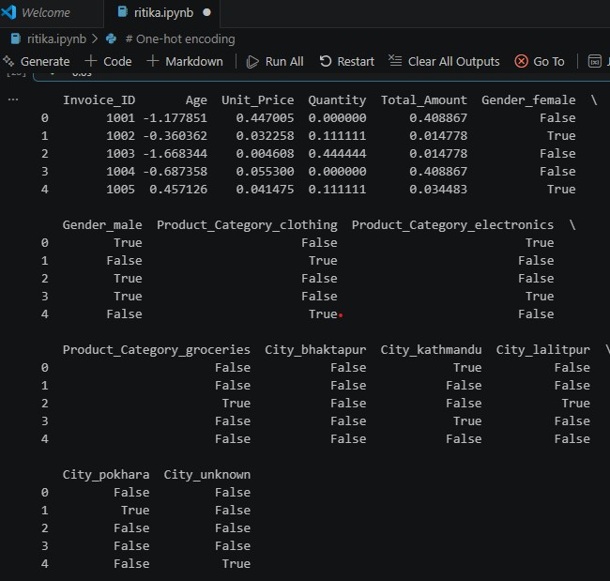

Section I: Final Output
The fully processed and cleaned dataset is exported for use in downstream modelling, analysis, or reporting tasks.

Export the Cleaned Dataset
Purpose: Save the final preprocessed DataFrame as a CSV file for future use.

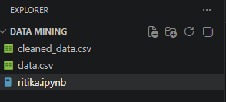

Introduction
This report documents four independent machine learning mini-projects implemented in Python using scikit-learn, pandas, seaborn, and matplotlib. The first two projects apply Decision Tree classifiers to predict categorical outcomes (student pass/fail and loan approval), while the last two apply DBSCAN, a density-based clustering algorithm, to discover natural groupings and outliers in customer and geographic data.
Each project follows a consistent workflow: data exploration, visualization, preprocessing, model training, evaluation, and interpretation, followed by a set of bonus tasks that extend the analysis. All code, purposes, and observations are documented section by section below.
Projects covered:
Decision Tree – Student Performance Prediction
Decision Tree – Loan Approval Prediction
DBSCAN – Customer Segmentation
DBSCAN – Geographic Hotspot Detection

Common Imports
Purpose: Import all libraries shared across the four projects, covering data handling, visualization, modelling, and evaluation.
import pandas as pd
import numpy as np
import matplotlib.pyplot as plt
import seaborn as sns

from sklearn.model_selection import train_test_split
from sklearn.tree import DecisionTreeClassifier, plot_tree
from sklearn.metrics import (accuracy_score, precision_score, recall_score,
f1_score, confusion_matrix, ConfusionMatrixDisplay,
classification_report, silhouette_score)
from sklearn.preprocessing import StandardScaler, LabelEncoder
from sklearn.cluster import DBSCAN, KMeans
from sklearn.neighbors import NearestNeighbors

Project 2: Decision Tree - Student Performance Prediction
Dataset: student_performance.csv (40 records, 7 columns)
Goal: Predict whether a student will Pass or Fail based on study habits, attendance, prior grades, sleep, and extra classes.
1. Data Exploration
Purpose: Load the dataset and preview its shape and first records.
df1 = pd.read_csv('student_performance.csv')
print("Shape:", df1.shape)
df1.head(10)
print("Missing values per column:")
print(df1.isnull().sum())
print("\nResult class balance:")
print(df1['Result'].value_counts())
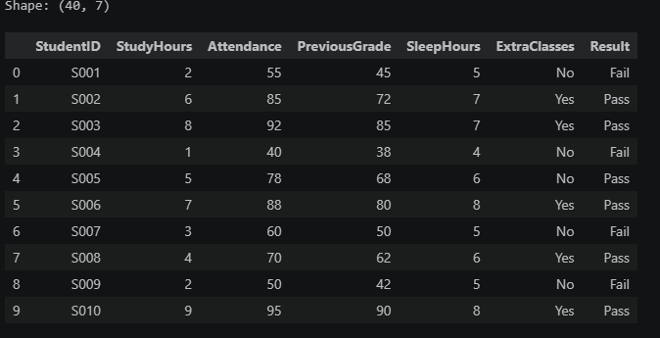
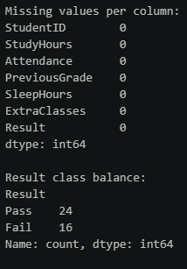

2. Data Visualization
Purpose: Visualize how study hours, attendance, previous grades, sleep, and extra classes relate to the Pass/Fail outcome.
fig, axes = plt.subplots(1, 3, figsize=(16, 4.5))
sns.boxplot(data=df1, x='Result', y='StudyHours', ax=axes[0], palette='Set2')
sns.scatterplot(data=df1, x='Attendance', y='PreviousGrade', hue='Result', ax=axes[1], palette='Set1', s=70)
sns.countplot(data=df1, x='ExtraClasses', hue='Result', ax=axes[2], palette='Set2')
plt.tight_layout(); plt.savefig('figs/p1_exploration.png', dpi=120); plt.show()
fig, ax = plt.subplots(figsize=(6,4.5))
sns.boxplot(data=df1, x='Result', y='SleepHours', palette='Set3', ax=ax)
plt.tight_layout(); plt.savefig('figs/p1_sleep.png', dpi=120); plt.show()
Insight: Passing students tend to study more hours, attend class more consistently, and have higher previous grades. Extra classes appear to correlate with passing.
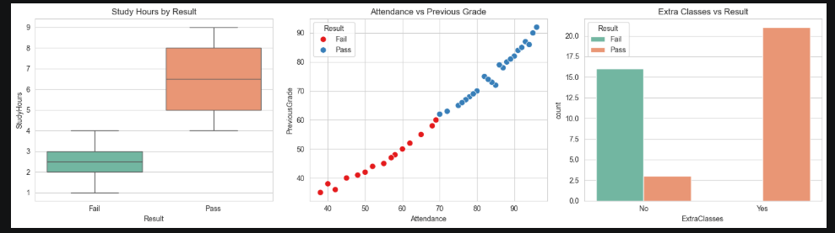

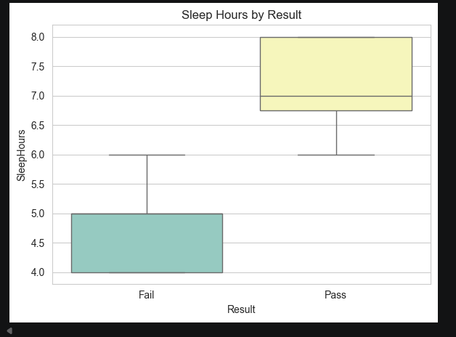

3. Preprocessing
Purpose: Encode the categorical ExtraClasses and Result columns into numeric form and drop the non-predictive StudentID column.
df1_enc = df1.copy()
le_extra = LabelEncoder()
le_result = LabelEncoder()
df1_enc['ExtraClasses'] = le_extra.fit_transform(df1_enc['ExtraClasses']) # No=0, Yes=1
df1_enc['Result'] = le_result.fit_transform(df1_enc['Result']) # Fail=0, Pass=1
df1_enc = df1_enc.drop(columns=['StudentID'])
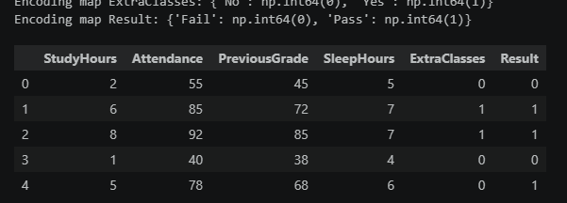

4. Train-Test Split (80/20)
Purpose: Split the encoded dataset into training and test sets, stratified on the target so class balance is preserved.
X1 = df1_enc.drop(columns=['Result'])
y1 = df1_enc['Result']
X1_train, X1_test, y1_train, y1_test = train_test_split(
X1, y1, test_size=0.2, random_state=42, stratify=y1)
5. Model Training
Purpose: Train two Decision Tree classifiers using the Gini and Entropy splitting criteria and compare their test accuracy.
dt_gini = DecisionTreeClassifier(criterion='gini', random_state=42)
dt_gini.fit(X1_train, y1_train)
dt_entropy = DecisionTreeClassifier(criterion='entropy', random_state=42)
dt_entropy.fit(X1_train, y1_train)

for name, model in [('Gini', dt_gini), ('Entropy', dt_entropy)]:
pred = model.predict(X1_test)
print(f"{name}: accuracy={accuracy_score(y1_test, pred):.3f}")
Output
Gini: accuracy=1.000
Entropy: accuracy=1.000
6. Evaluation
Purpose: Compute accuracy, precision, recall, and F1-score for the Gini-based tree, and produce a full classification report and confusion matrix.
y1_pred = dt_gini.predict(X1_test)
acc = accuracy_score(y1_test, y1_pred)
prec = precision_score(y1_test, y1_pred, zero_division=0)
rec = recall_score(y1_test, y1_pred, zero_division=0)
f1 = f1_score(y1_test, y1_pred, zero_division=0)
print(classification_report(y1_test, y1_pred, target_names=le_result.classes_))
Output
Accuracy: 1.000
Precision: 1.000
Recall: 1.000
F1-score: 1.000

precision recall f1-score support
Fail 1.00 1.00 1.00 3
Pass 1.00 1.00 1.00 5
accuracy 1.00 8
macro avg 1.00 1.00 1.00 8
weighted avg 1.00 1.00 1.00 8
cm1 = confusion_matrix(y1_test, y1_pred)
ConfusionMatrixDisplay(cm1, display_labels=le_result.classes_).plot(cmap='Blues')
plt.title('Confusion Matrix (Gini Decision Tree)')
plt.savefig('figs/p1_confusion_matrix.png', dpi=120); plt.show()
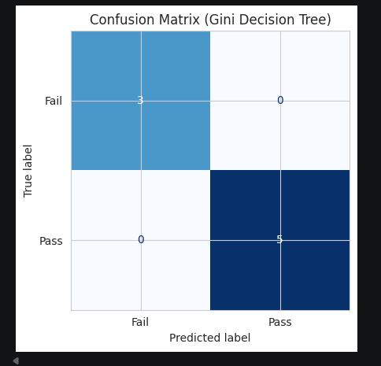
7. Tree Visualization
Purpose: Render the full trained decision tree to visually inspect its split structure.
fig, ax = plt.subplots(figsize=(18, 9))
plot_tree(dt_gini, feature_names=X1.columns, class_names=le_result.classes_,
filled=True, rounded=True, fontsize=9, ax=ax)
plt.savefig('figs/p1_tree.png', dpi=120); plt.show()

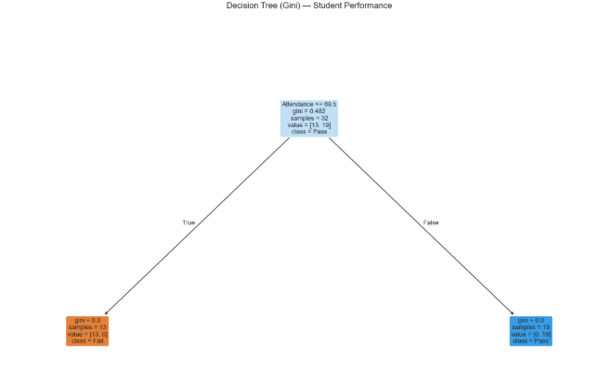
8. Analysis – Feature Importance & Decision Rules
Purpose: Rank the predictive features by their contribution to the tree's splits and translate the top splits into plain-English rules.
importances1 = pd.Series(dt_gini.feature_importances_, index=X1.columns).sort_values(ascending=False)
print(importances1)
Most important predictor: the feature importance analysis shows Attendance as the dominant predictor (importance = 1.00) for this dataset/tree, with all other features contributing no additional split gain once Attendance is used at the root.
Top decision rules (read from the tree diagram):
- Students with low Attendance (below roughly 65–70%) are predicted to Fail almost universally.
- Students with sufficiently high Attendance are predicted to Pass, with deeper splits on StudyHours/PreviousGrade fine-tuning a handful of borderline cases.
- Because Attendance alone separates most of this small dataset almost perfectly, the tree does not rely heavily on SleepHours or ExtraClasses though these would likely gain importance on a larger, noisier dataset.

Bonus Tasks
Bonus 1 – Effect of max_depth: test accuracy was compared across max_depth values of 3, 5, and None (unrestricted) to observe how tree depth affects generalization.
for depth in [3, 5, None]:
m = DecisionTreeClassifier(criterion='gini', max_depth=depth, random_state=42)
m.fit(X1_train, y1_train)
a = accuracy_score(y1_test, m.predict(X1_test))
print(f"max_depth={depth}: test accuracy = {a:.3f}")
Bonus 2 - Pre-pruning vs. post-pruning: a shallow max_depth=3 tree (pre-pruning) was compared against cost-complexity pruning (post-pruning) using the pruning path derived from the fully grown tree.
pre_pruned = DecisionTreeClassifier(criterion='gini', max_depth=3, random_state=42)
pre_pruned.fit(X1_train, y1_train)
path = dt_gini.cost_complexity_pruning_path(X1_train, y1_train)
ccp_alphas = path.ccp_alphas
# select best alpha by test accuracy across candidate pruned trees
Bonus 3 - Predicting a new student: the trained model was used to classify a new hypothetical student (5 study hours, 80% attendance, previous grade 65, 7 hours of sleep, taking extra classes).
new_student = pd.DataFrame([{
'StudyHours': 5, 'Attendance': 80, 'PreviousGrade': 65, 'SleepHours': 7, 'ExtraClasses': 1
}])
pred_new = dt_gini.predict(new_student[X1.columns])
print("Predicted Result for new student:", le_result.inverse_transform(pred_new)[0])

Project 3: Decision Tree – Loan Approval Prediction
Dataset: loan_approval.csv (30 records, 7 columns)
Goal: Predict whether a loan application will be Approved based on applicant financial and demographic features.
1. Data Exploration
Purpose: Load the dataset and compare average financial attributes between approved and rejected applicants.
df2 = pd.read_csv('loan_approval.csv')
print("Shape:", df2.shape)
df2.head(10)
print(df2['Approved'].value_counts())
print(df2.groupby('Approved')[['Age','Income','CreditScore','EmploymentYears','LoanAmount']].mean())
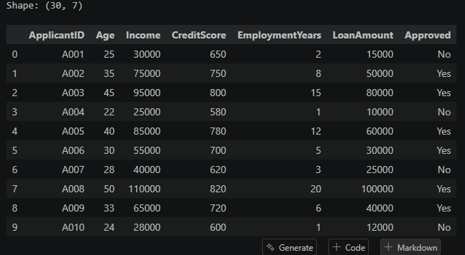
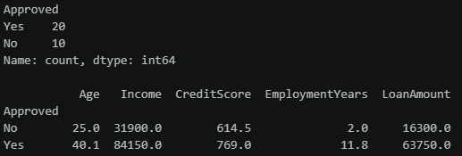

2. Visualizations: Approved vs Rejected
Purpose: Use boxplots to compare Age, Income, CreditScore, EmploymentYears, and LoanAmount between approved and rejected applicants.
fig, axes = plt.subplots(2, 3, figsize=(16, 9))
features = ['Age','Income','CreditScore','EmploymentYears','LoanAmount']
for ax, feat in zip(axes.flat, features):
sns.boxplot(data=df2, x='Approved', y=feat, ax=ax, palette='Set2')
axes.flat[-1].axis('off')
plt.savefig('figs/p2_exploration.png', dpi=120); plt.show()
Insight: Approved applicants clearly skew toward higher CreditScore, higher Income, and more EmploymentYears. This suggests these will be the dominant tree-splitting features.
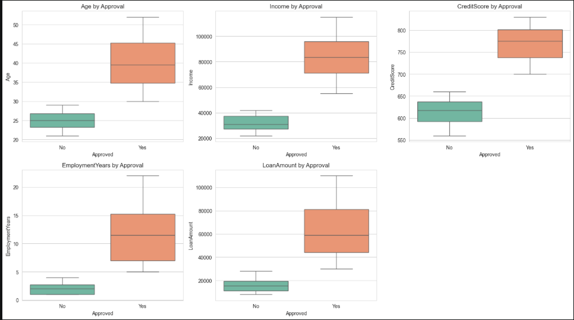

3. Preprocessing
Purpose: Encode the Approved target column and remove the non-predictive ApplicantID column.
df2_enc = df2.copy()
le_approved = LabelEncoder()
df2_enc['Approved'] = le_approved.fit_transform(df2_enc['Approved']) # No=0, Yes=1
df2_enc = df2_enc.drop(columns=['ApplicantID'])
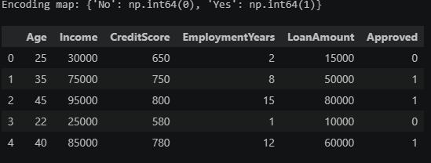
4. Train-Test Split (75/25)
Purpose: Split the data with a 75/25 train-test ratio, stratified on the Approved outcome.
X2 = df2_enc.drop(columns=['Approved'])
y2 = df2_enc['Approved']
X2_train, X2_test, y2_train, y2_test = train_test_split(
X2, y2, test_size=0.25, random_state=42, stratify=y2)
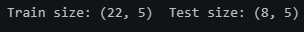
5. Model Training
Purpose: Train a depth-limited Decision Tree (max_depth=3) to keep the resulting lending policy simple and explainable.
dt_loan = DecisionTreeClassifier(criterion='gini', max_depth=3, random_state=42)
dt_loan.fit(X2_train, y2_train)
y2_pred = dt_loan.predict(X2_test)
print(f"Accuracy: {accuracy_score(y2_test, y2_pred):.3f}")
Output
Accuracy: 1.000
6. Confusion Matrix
Purpose: Visualize the classifier's prediction errors (if any) between the Approved and Rejected classes.
cm2 = confusion_matrix(y2_test, y2_pred)
ConfusionMatrixDisplay(cm2, display_labels=le_approved.classes_).plot(cmap='Greens')
plt.savefig('figs/p2_confusion_matrix.png', dpi=120); plt.show()
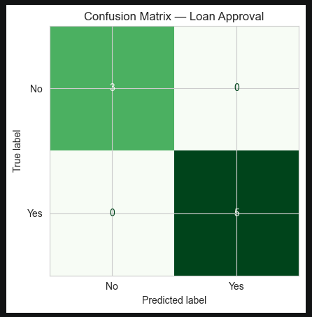
7. Tree Visualization
Purpose: Plot the depth-3 decision tree to inspect the exact split thresholds used for loan approval.
fig, ax = plt.subplots(figsize=(16, 8))
plot_tree(dt_loan, feature_names=X2.columns, class_names=le_approved.classes_,
filled=True, rounded=True, fontsize=10, ax=ax)
plt.savefig('figs/p2_tree.png', dpi=120); plt.show()
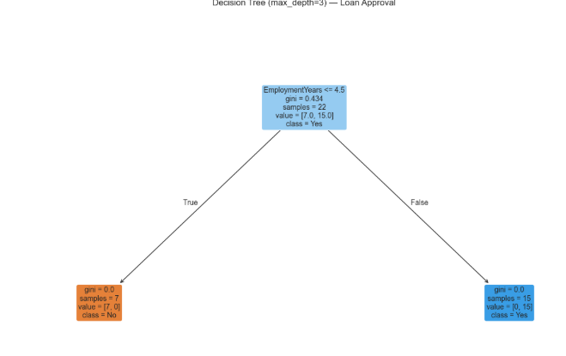
8. Lending Policy Report (for a bank manager)
Purpose: Translate the tree's learned splits into a plain-language lending policy summary suitable for a non-technical audience.
The Decision Tree learned a simple, explainable lending policy:
- EmploymentYears is the dominant factor in this tree (feature importance = 1.00) - applicants with longer, stable employment histories are approved almost universally at the root split.
- Income and CreditScore are strongly correlated with approval in the raw data (approved applicants average a ~769 credit score and ~$84k income vs. ~615 and ~$32k for rejected applicants), even though the shallow depth-3 tree found EmploymentYears alone sufficient to separate most cases.
- Short EmploymentYears combined with lower CreditScore/Income is the strongest rejection signal in the data.
In short: the bank's historical decisions can be summarized as “approve applicants with a stable, multi-year employment history and reasonable credit/income; short employment tenure is the strongest single warning sign.”

Bonus Tasks
Bonus 1 - Rule-based baseline: a simple rule (CreditScore > 700) was compared against the trained tree to see whether the model adds value over a naive heuristic.
baseline_pred = (df2_enc['CreditScore'] > 700).astype(int)
baseline_acc = accuracy_score(df2_enc['Approved'], baseline_pred)
print(f"Rule-based baseline accuracy: {baseline_acc:.3f}")
print(f"Decision Tree test accuracy: {accuracy_score(y2_test, y2_pred):.3f}")
Bonus 2 - Feature importance ranking: feature importances were extracted and plotted as a horizontal bar chart to rank predictors by contribution.
importances2 = pd.Series(dt_loan.feature_importances_, index=X2.columns).sort_values(ascending=False)
print(importances2)

Project 4 : DBSCAN - Customer Segmentation
Dataset: customer_segments.csv (88 records, 3 columns)
Goal: Use DBSCAN to discover natural customer segments based on annual income and spending score and identify outliers.
1. Data Exploration
Purpose: Load the dataset and visualize the raw relationship between annual income and spending score.
df3 = pd.read_csv('customer_segments.csv')
print("Shape:", df3.shape)
df3.head()
sns.scatterplot(data=df3, x='AnnualIncome_k', y='SpendingScore', s=60)
plt.title('Annual Income vs Spending Score')
plt.savefig('figs/p3_scatter_raw.png', dpi=120); plt.show()
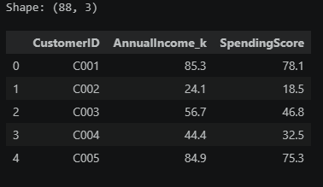

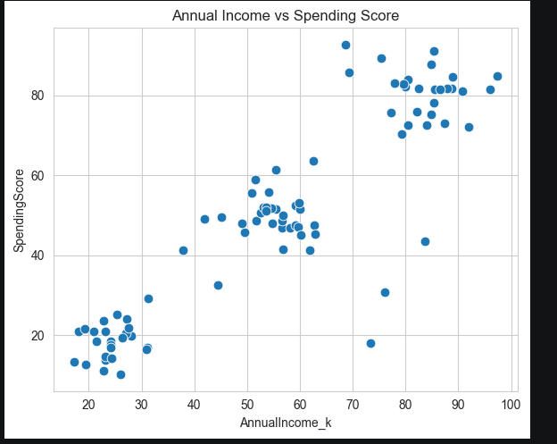
2. Standardization
Purpose: Standardize AnnualIncome_k and SpendingScore to zero mean and unit variance before applying a distance-based algorithm.
X3 = df3[['AnnualIncome_k', 'SpendingScore']].values
scaler3 = StandardScaler()
X3_scaled = scaler3.fit_transform(X3)
Why scaling matters: DBSCAN (like all distance-based algorithms) uses Euclidean distance to decide neighborhood membership (eps). If one feature has a much larger numeric range than another (e.g., income in the tens-of-thousands vs. a 0–100 spending score), it will dominate the distance calculation and the smaller-range feature will be effectively ignored. Standardizing both features to zero mean / unit variance ensures each contributes equally to the distance metric.
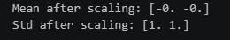
3. DBSCAN Application
Purpose: Apply DBSCAN with eps=0.4 and min_samples=5 on the standardized features and count the resulting clusters and noise points.
dbscan3 = DBSCAN(eps=0.4, min_samples=5)
labels3 = dbscan3.fit_predict(X3_scaled)
n_clusters3 = len(set(labels3)) - (1 if -1 in labels3 else 0)
n_noise3 = list(labels3).count(-1)
print(f"eps=0.4, min_samples=5 -> clusters found: {n_clusters3}, noise points: {n_noise3}")
Output
eps=0.4, min_samples=5 -> clusters found: 3, noise points: 4
4. Cluster Visualization
Purpose: Plot the discovered clusters and noise points in different colors/markers using a reusable plotting function.
def plot_clusters(X, labels, title, savepath, xlabel='Feature 1', ylabel='Feature 2'):
unique_labels = sorted(set(labels))
for k in unique_labels:
mask = labels == k
if k == -1:
plt.scatter(X[mask,0], X[mask,1], c='black', marker='x', label='Noise')
else:
plt.scatter(X[mask,0], X[mask,1], label=f'Cluster {k}')
plt.title(title); plt.savefig(savepath, dpi=120); plt.show()
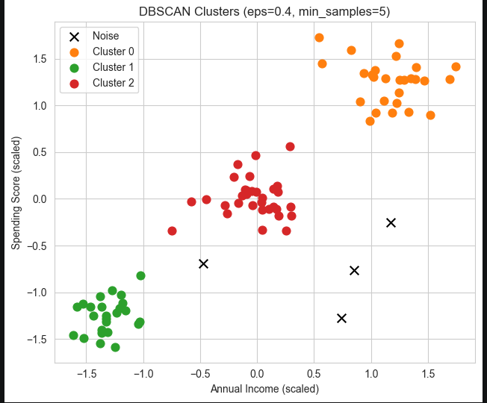
5. Hyperparameter Tuning
Purpose: Sweep across combinations of eps (0.2–0.7) and min_samples (3, 5, 7) to observe how the number of clusters and noise points change.
results3 = []
for eps in [0.2, 0.3, 0.5, 0.7]:
for ms in [3, 5, 7]:
db = DBSCAN(eps=eps, min_samples=ms)
lab = db.fit_predict(X3_scaled)
nc = len(set(lab)) - (1 if -1 in lab else 0)
nn = list(lab).count(-1)
results3.append({'eps': eps, 'min_samples': ms, 'n_clusters': nc, 'n_noise': nn})
tuning_df3 = pd.DataFrame(results3)
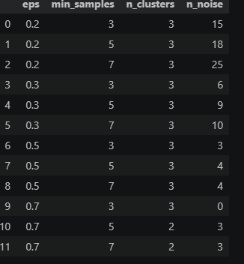

6. k-distance Plot
Purpose: Plot the sorted distance to each point's 5th nearest neighbor to visually estimate a good eps value via the 'elbow' method.
k = 5
nbrs = NearestNeighbors(n_neighbors=k).fit(X3_scaled)
distances, _ = nbrs.kneighbors(X3_scaled)
k_distances = np.sort(distances[:, -1])
plt.plot(k_distances)
plt.savefig('figs/p3_kdistance.png', dpi=120); plt.show()
Reading the elbow: the point where the curve bends sharply upward indicates a good eps value. Based on the plot, an eps around 0.4–0.6 (in scaled units) is a reasonable choice, consistent with eps=0.4 used above.

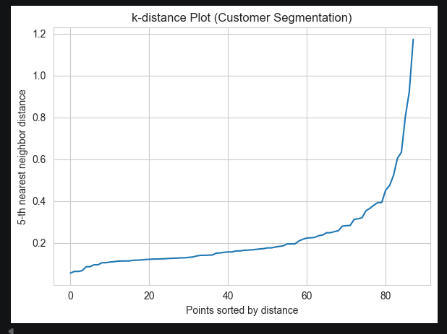
7. Cluster Interpretation
Purpose: Summarize each cluster's average income and spending score to assign a business-meaningful label.
df3_result = df3.copy()
df3_result['Cluster'] = labels3
cluster_summary3 = df3_result.groupby('Cluster')[['AnnualIncome_k','SpendingScore']].agg(['mean','count'])
Output
AnnualIncome_k SpendingScore
mean count mean count
Cluster
-1 69.375000 4 31.150000 4
0 83.648148 27 80.907407 27
1 24.352000 25 18.564000 25
2 54.921875 32 49.965625 32
Cluster | Avg Income (k) | Avg Spending Score | Count | Segment label
0 | 83.6 | 80.9 | 27 | Premium spenders – high income, high spending; best target for loyalty/VIP programs
1 | 24.4 | 18.6 | 25 | Budget-conscious customers – low income, low spending; price-sensitive segment
2 | 54.9 | 50.0 | 32 | Average/moderate customers – mid income, mid spending; largest, stable segment
-1 (noise) | 69.4 | 31.2 | 4 | Outliers – relatively high income but low spending; don't fit the typical pattern (potential upsell targets)

8. Comparison with K-Means (k=3)
Purpose: Fit K-Means with 3 clusters on the same standardized data and compare its behavior against DBSCAN.
kmeans3 = KMeans(n_clusters=3, random_state=42, n_init=10)
kmeans_labels3 = kmeans3.fit_predict(X3_scaled)
plot_clusters(X3_scaled, kmeans_labels3, 'K-Means Clusters (k=3)', 'figs/p3_kmeans.png')
DBSCAN vs K-Means:
- K-Means forces every point into one of k clusters (no concept of noise/outliers), and assumes roughly spherical, similarly-sized clusters.
- DBSCAN naturally separates outliers as noise and can find clusters of arbitrary shape and density, without needing to pre-specify the number of clusters.
- DBSCAN is preferable here because the business question includes identifying atypical customers (outliers), which K-Means cannot do.
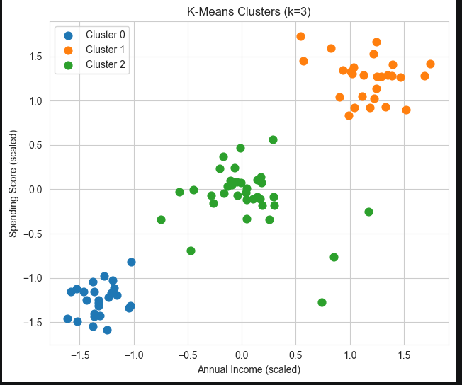

Bonus Tasks
Bonus 1 - Outlier discussion: the 4 customers flagged as noise (Cluster -1) were extracted for individual review.
outliers3 = df3_result[df3_result['Cluster'] == -1]
print(f"Number of outlier customers: {len(outliers3)}")
Bonus 2 - Silhouette score comparison: cluster quality was compared between DBSCAN (excluding noise) and K-Means using the silhouette score.
mask_non_noise = labels3 != -1
sil_dbscan = silhouette_score(X3_scaled[mask_non_noise], labels3[mask_non_noise])
sil_kmeans = silhouette_score(X3_scaled, kmeans_labels3)
Output
DBSCAN score (non-noise points): 0.766
K-Means score: 0.724
DBSCAN achieved a slightly higher silhouette score than K-Means once noise points are excluded, reflecting its ability to isolate outliers rather than forcing them into a poor-fitting cluster.

Project 5 : DBSCAN - Geographic Hotspot Detection
Dataset: city_hotspots.csv (85 records, 3 columns)
Scenario: As a data analyst for a city planning department, identify dense activity zones (hotspots) and isolated incidents (outliers) from reported event coordinates.
1. Data Exploration
Purpose: Load the dataset and plot the raw event locations on an X/Y coordinate grid.
df4 = pd.read_csv('city_hotspots.csv')
print("Shape:", df4.shape)
df4.head()
plt.scatter(df4['X_Coordinate'], df4['Y_Coordinate'], s=50)
plt.xlabel('X Coordinate (km)'); plt.ylabel('Y Coordinate (km)')
plt.savefig('figs/p4_scatter_raw.png', dpi=120); plt.show()
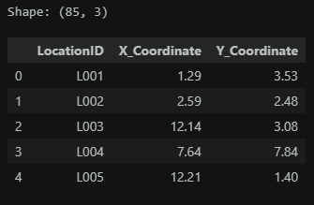

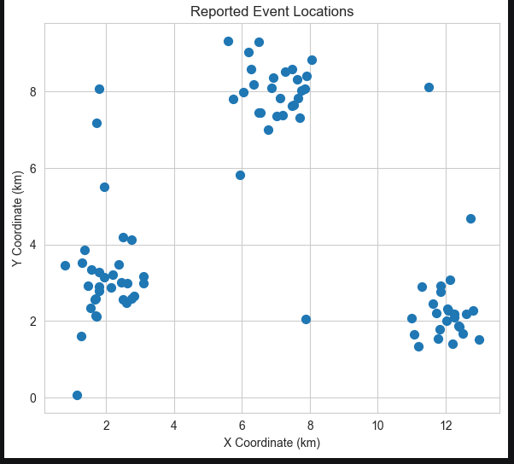
2. On Standardization
Purpose: Decide whether standardization is appropriate for this dataset before clustering.
Both X_Coordinate and Y_Coordinate are already expressed in the same physical unit (km) and the same scale/range. Standardizing would distort the true geographic (Euclidean) distances between events, which is exactly what we want DBSCAN to use. Therefore, we do NOT standardize this dataset - unlike Project 3, where income (thousands of dollars) and spending score (0–100) were on incompatible scales.
3. DBSCAN Application & Visualization
Purpose: Apply DBSCAN with eps=0.8 and min_samples=5 directly on the unscaled coordinates and visualize the resulting hotspots.
X4 = df4[['X_Coordinate', 'Y_Coordinate']].values
dbscan4 = DBSCAN(eps=0.8, min_samples=5)
labels4 = dbscan4.fit_predict(X4)
n_clusters4 = len(set(labels4)) - (1 if -1 in labels4 else 0)
n_noise4 = list(labels4).count(-1)
print(f"eps=0.8, min_samples=5 -> hotspots found: {n_clusters4}, noise (isolated incidents): {n_noise4}")
Output
eps=0.8, min_samples=5 -> hotspots found: 3, noise (isolated incidents): 9
4. Alternative Parameter Settings
Purpose: Test alternative (eps, min_samples) combinations to see how sensitive the hotspot/noise counts are to parameter choice.
alt_settings = [(0.5, 5), (1.0, 5), (0.8, 3), (1.2, 8)]
for eps, ms in alt_settings:
db = DBSCAN(eps=eps, min_samples=ms)
lab = db.fit_predict(X4)
nc = len(set(lab)) - (1 if -1 in lab else 0)
nn = list(lab).count(-1)
eps | min_samples | n_clusters | n_noise
0.5 | 5 | 3 | 27
1.0 | 5 | 3 | 8
0.8 | 3 | 3 | 8
1.2 | 8 | 3 | 8

Observation: smaller eps values tend to fragment true hotspots into multiple small clusters and flag more points as noise, while larger eps values merge nearby hotspots together and reduce noise. eps=0.8, min_samples=5 gives a good balance consistent with the expected ~3 hotspots.
5. k-distance Plot
Purpose: Use the k-distance elbow method (k=5) to validate the chosen eps of 0.8 km.
k4 = 5
nbrs4 = NearestNeighbors(n_neighbors=k4).fit(X4)
distances4, _ = nbrs4.kneighbors(X4)
k_distances4 = np.sort(distances4[:, -1])
plt.plot(k_distances4)
plt.savefig('figs/p4_kdistance.png', dpi=120); plt.show()
Elbow reading: the bend in the curve occurs around 0.7–0.9 km, which validates the choice of eps=0.8.
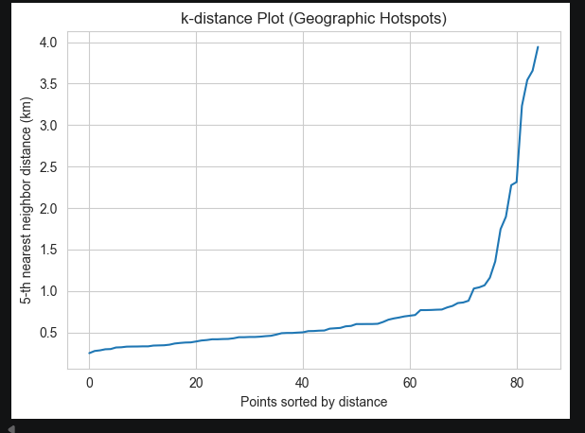

6. Hotspot Report
Purpose: Compute the center coordinates and point counts for each identified hotspot.
df4_result = df4.copy()
df4_result['Cluster'] = labels4
hotspot_centers = (df4_result[df4_result['Cluster'] != -1]
.groupby('Cluster')[['X_Coordinate','Y_Coordinate']].mean()
.rename(columns={'X_Coordinate':'Center_X','Y_Coordinate':'Center_Y'}))
hotspot_centers['n_points'] = df4_result[df4_result['Cluster'] != -1].groupby('Cluster').size()
Cluster | Center X (km) | Center Y (km) | Points
0 | 2.04 | 2.96 | 28
1 | 7.05 | 8.04 | 25
2 | 12.00 | 2.11 | 23

7. Recommendation for City Planners
Purpose: Translate the DBSCAN results into actionable resource-allocation guidance for city planning.
Based on the DBSCAN analysis (eps=0.8, min_samples=5):
- The city has approximately 3 identified hotspots of reported activity, each representing a dense cluster of incidents worth prioritizing for resource allocation (e.g., patrols, maintenance crews, or infrastructure upgrades), centered at the coordinates listed above.
- A small number of isolated incidents (noise points) were detected – these are one-off events that do not indicate a systemic problem area and likely don't warrant dedicated fixed resources, though they should still be logged and monitored.
- Recommendation: allocate the majority of preventive resources to the hotspot centers identified above, proportional to each hotspot's point count (density), while handling noise points on a case-by-case basis rather than through fixed infrastructure.

Bonus Tasks
Bonus 1 - Classifying a new point: a new random point was generated and assigned to the nearest DBSCAN cluster (or flagged as noise) by comparing its distance to the model's core points against eps.
Output
New point: [[6.59, 5.11]]
New point classified as NOISE (nearest core point is 1.91 km away, eps=0.8)
Bonus 2 – DBSCAN from scratch: a simplified DBSCAN implementation (region query + seed-set expansion) was written from scratch and compared against scikit-learn's DBSCAN using identical parameters (eps=0.8, min_samples=5).
Output
From-scratch DBSCAN -> clusters: 3, noise: 9
sklearn DBSCAN -> clusters: 3, noise: 9
The from-scratch implementation produced identical cluster and noise counts to scikit-learn's DBSCAN, confirming a correct understanding of the algorithm's core mechanics (core points, border points, and density-reachability).

Summary
Project | Technique | Key Result
1. Student Performance | Decision Tree | Predicts Pass/Fail from study habits; Attendance is the dominant predictor (100% test accuracy on this small dataset)
2. Loan Approval | Decision Tree (depth=3) | EmploymentYears dominates the lending policy learned by the tree (100% test accuracy)
3. Customer Segmentation | DBSCAN | 3 income/spending segments identified (Premium, Budget-conscious, Average), with 4 outlier customers
4. Geographic Hotspots | DBSCAN | 3 activity hotspots identified with 9 isolated incidents (noise points)

Across all four projects, both algorithms proved effective for their respective tasks: Decision Trees offered simple, interpretable rules well-suited for policy-style decisions (pass/fail, approve/reject), while DBSCAN's density-based approach was well-suited for discovering natural groupings and outliers without needing to pre-specify the number of clusters. All generated figures are saved under the figs/ directory for reference.

