Workshop organised by

ADS Foundation
Attended through

S.P.B Patel Engineering College, Mehsana
Submitted by
Name | Ritika Pandey
Enrollment No. | 240390107041
Branch | Computer Engineering
Semester | 5th

Report on topic
SUSTAINABILITY
ANALYSIS DASHBOARD
(Power BI Project)

1. Executive Summary
This project uses Microsoft Power BI to present sustainability-related indicators in an interactive dashboard. The report is divided into two pages: the first page provides an overview of energy, water, emissions, recycling, and sustainability performance; the second page focuses on environmental trends, renewable energy, waste recycling, green cover, and sustainability ratings.
The dashboard combines KPI cards, line and area charts, bar and column charts, a pie chart, a donut chart, a treemap, a gauge, and slicers. These visuals help users explore environmental measures and compare results across categories.
Important interpretation note: the screenshots show selected slicer values (for example, a single city or sector in some visuals). Therefore, the numbers visible in the screenshots are filtered results, not necessarily totals for the entire dataset. The dataset is educational/synthetic; values should not be presented as official measurements of real cities.

2. Project Objectives
- Summarize important sustainability measures in a single interactive report.
- Monitor energy consumption, renewable energy, water consumption, CO₂ emissions, waste, recycling, and green cover.
- Compare sustainability indicators across cities, sectors, energy sources, months, and rating categories.
- Allow users to filter visuals with Year, City, Region, and Sector slicers.
- Practise data loading, visual selection, aggregation, formatting, and report design in Power BI.

3. Tools and Dataset
Tool: Microsoft Power BI Desktop.
The model includes fields such as Year, Month, Quarter, City, Region, Sector, Energy_Source, Energy_Consumption_kWh, Renewable_Energy_kWh, Renewable_Energy_%, Water_Consumption_L, Waste_Generated_kg, Waste_Recycled_kg, Recycling_Rate_%, CO2_Emissions_kg, Public_Transport_Usage_%, Green_Cover_%, Air_Quality_Index, Sustainability_Score, and Sustainability_Rating.
The wider project dataset was prepared as synthetic educational data. Before reporting row counts, ensure the 50,000-row workbook is the data source currently loaded in Power BI. The screenshots alone do not verify the full row count.

4. Page One - Sustainability Analysis Dashboard
Purpose: provide a high-level summary of sustainability performance and let the user explore monthly trends, energy sources, sector comparisons, ratings, and geographic/category filters.

4.1 KPI Cards

Total Energy Consumption
Sum of Energy_Consumption_kWh. The card aggregates energy consumption for the currently selected filters. The screenshot shows 16.84K.

Total Water Consumption
Sum of Water_Consumption_L. This displays the total water consumption in the active filter context. The screenshot shows 18.00K.

Total CO₂ Emissions
Sum of CO2_Emissions_kg. This summarizes emissions for the active filter context. The screenshot shows 6.67K.

Average Recycling Rate
Average of Recycling_Rate_%. This gives the mean recycling-rate value for the selected records. The screenshot shows 63.03.

Average Sustainability Score
Average of Sustainability_Score. This summarizes the score for selected records. The screenshot shows 47.86.

4.2 Sustainability Score by Month - Line Chart
Fields: Month on the X-axis and Average of Sustainability_Score on the Y-axis. A line chart is suitable for showing how a measure changes over time. Peaks indicate months with higher average scores and dips indicate lower average scores within the selected data. The screenshot shows the score rising around May and August and falling around October. Because some months are not visible, check whether filters or missing data explain the gaps.

4.3 Average Sustainability Score by City - Bar Chart
Fields: City and Average of Sustainability_Score. Horizontal bars make category comparisons easy. In the screenshot only Ahmedabad appears, so the chart may be restricted by the selected City/Region/Sector slicers or interactions. Clear slicer selections to compare multiple cities.

4.4 Energy Consumption by Source - Pie Chart
Fields: Energy_Source and Sum of Energy_Consumption_kWh. Each slice represents a source's share of total energy consumption under the current filters. The screenshot shows Grid at about 40.28%, Biomass at about 35.15%, and Solar at about 24.58%. These percentages describe only the currently displayed selection, not necessarily the entire dataset.

4.5 CO₂ Emissions by Sector Bar Chart
Fields: Sector and Sum of CO2_Emissions_kg. This chart compares total emissions across sectors. The screenshot shows Public Services only, around 6.7K, which suggests the visual is filtered to one sector. Clear the Sector slicer or check visual interactions to show the intended comparison.

4.6 Waste Generated vs Recycled by Sector Clustered Column Chart
Fields: Sector on the X-axis and Sum of Waste_Generated_kg plus Sum of Waste_Recycled_kg on the Y-axis. Side-by-side columns compare the amount generated with the amount recycled in each sector. In the screenshot only Public Services appears. Clear slicer selections to compare all sectors.

4.7 Sustainability Rating Distribution Donut Chart
Fields: Sustainability_Rating as the legend and Count of Record_ID as values. The slices show how many records belong to each rating category, such as Poor, Good, and Needs Improvement. The screenshot shows 8 records in total under the current filters: 5 Poor (62.5%), 2 Good (25%), and 1 Needs Improvement (12.5%). These are filtered counts and should not be interpreted as the full dataset distribution.

4.8 Slicers Year, City, Region, Sector
Slicers are interactive filters. Selecting a value should update the visuals that interact with that slicer. They are useful for comparing one year with another, examining a city or region, or isolating a sector. In the screenshot, values such as 2024, West, Ahmedabad, and Public Services appear selected, explaining why some charts show only one category.

5. Page Two Sustainability Insights & Environmental Trends
Purpose: provide a second view focused on renewable energy, waste recycling, green cover, environmental trends, energy by sector, and a gauge for the sustainability score.

5.1 Total Renewable Energy - KPI Card
Intended field: Sum of Renewable_Energy_kWh. The screenshot shows 8.89K. This represents the total renewable energy value for the active filters. A clear title and kWh unit help users understand what is being measured.

5.2 Total Waste Recycled - KPI Card (Correction Needed)
The card title says 'Total Waste Recycled', but the screenshot's field label reads 'Sum of Waste_Generated_kg' and the displayed value is 1.16K. This means the visual appears to use Waste_Generated_kg rather than Waste_Recycled_kg. To correct it, select the card, remove Waste_Generated_kg, drag Waste_Recycled_kg into the card, choose Sum, and keep the title 'Total Waste Recycled'.

5.3 Average Green Cover - KPI Card (Correction Needed)
The card title says 'Average Green Cover', but the screenshot shows 'Sum of Green_Cover_%' and 474.02. For an average percentage, change the field aggregation from Sum to Average. Then rename the visual title to 'Average Green Cover (%)'. This avoids adding percentages across records, which is usually not meaningful.

5.4 Monthly CO₂ Emissions Trend - Area Chart
Fields: Month on the X-axis and Sum of CO2_Emissions_kg on the Y-axis. The filled area emphasizes the magnitude of emissions over time. The screenshot has visible points for selected months and shows higher values around January and October, with lower values around March and August. Confirm that all months are represented and sorted chronologically; missing months can result from filters or unavailable records.

5.5 Sustainability Rating Distribution - Donut Chart
Fields: Sustainability_Rating and Count of Record_ID. The screenshot shows 11 records in the current filter context: 6 Good (54.55%), 3 Needs Improvement (27.27%), and 2 Poor (18.18%). The chart provides a quick view of rating composition for the currently selected data.

5.6 Energy Consumption by Sector - Treemap
Fields: Sector as category and Sum of Energy_Consumption_kWh as values. Each rectangle represents a sector; larger rectangles indicate a larger energy total. The screenshot shows only Commercial, so check and clear the Sector slicer or other filters if the intention is to compare all sectors.

5.7 Count of Sector by Waste_Generated_kg - Visual to Review
The screenshot shows a chart titled 'Count of Sector' with 'Waste_Generated_kg' as the grouping/measure, producing many thin horizontal lines. This is not a clear sustainability KPI and may be an accidental or incorrectly configured visual. Consider deleting it or replacing it with a meaningful chart, such as Waste Generated vs Recycled by Sector, using Sector on the axis and Sum of both waste fields as values.

5.8 Sum of Energy_Consumption_kWh by City - Bar Chart
Fields: City and Sum of Energy_Consumption_kWh. This visual compares energy consumption between cities. The screenshot shows Bhubaneswar only, which indicates filtering to one city. Clear the City slicer to see a broader comparison.

5.9 Average Sustainability Score - Gauge
Value: Average of Sustainability_Score; minimum: Minimum Score (0); maximum: Maximum Score (100). The gauge in the screenshot reads 62.20. The arc indicates the score relative to the 0–100 scale. The target value is currently not needed unless a target score has been defined. A gauge is useful for one headline measure but does not explain why the score is high or low.

5.10 Slicers - City, Sector, Year
These filters let users explore the second page by city, sector, and year. The screenshot shows selections such as Bhubaneswar, Commercial, and 2024. Those selections appear to restrict multiple visuals to one category. Clear selections when you want to see overall patterns.

6. How to Read the Dashboard Together
- Use the KPI cards first to get a quick summary of the selected records.
- Use the line and area charts to examine changes across months.
- Use the pie and donut charts to understand category shares and rating composition.
- Use the bar and column charts to compare categories, cities, or sectors.
- Use the treemap to compare relative energy totals by sector.
- Use the gauge to view the average sustainability score on a 0–100 scale.
- Change one slicer at a time when investigating a question, then clear selections to return to the broader view.

7. Key Observations from the Screenshots
- Page One KPI values shown are 16.84K energy consumption, 18.00K water consumption, 6.67K CO₂ emissions, 63.03 average recycling rate, and 47.86 average sustainability score. These reflect the screenshot's filter state.
- The first page's rating donut displays 8 records in the current selection; the second page's rating donut displays 11. This difference is likely due to different page-level slicer selections.
- The second page's gauge displays an average sustainability score of 62.20 for its current selection.
- Several category charts show only one city or sector. This limits comparisons and is likely caused by slicer selections or visual interactions.
- The waste-recycled KPI and green-cover KPI need aggregation/field corrections before final presentation.
- The 'Count of Sector' chart should be checked or replaced because it does not clearly communicate an intended sustainability insight.

8. Recommended Corrections Before Submission
Item | Recommended action
Correct the waste KPI | Use Sum of Waste_Recycled_kg, not Waste_Generated_kg.
Correct the green-cover KPI | Use Average of Green_Cover_% and label it as a percentage.
Review slicer selections | Clear selected City, Sector, Region, and Year values when you want all categories to be visible.
Review the unusual Count of Sector visual | Replace it with a meaningful comparison or remove it.
Check month order | Ensure months are sorted chronologically rather than alphabetically and verify whether missing months are filtered out.
Check aggregation and units | Use Sum for totals, Average for rates/scores when appropriate, Count for record distribution, and include units such as kWh, kg, L, and %.
Verify the loaded dataset | If your assignment requires 50,000 rows, verify the actual loaded table before stating that the dashboard uses all 50,000 records.
Clarify the source | State that the project dataset is synthetic/educational rather than official environmental data.

9. Limitations
- The visible values depend on slicer selections and may not represent the whole dataset.
- The dataset is synthetic and should not be used to make factual claims about real environmental conditions.
- A dashboard shows patterns and summaries; it does not by itself prove that one factor causes another.
- Map visuals were disabled during development, so a functioning map is not visible in the provided screenshots.

10. Conclusion
The Sustainability Analysis Dashboard demonstrates how Power BI can convert structured environmental data into interactive visuals. The first page provides an overview of key sustainability measures and comparisons, while the second page focuses on renewable energy, waste, green cover, monthly emissions, energy by sector, ratings, and an overall score gauge. The slicers allow users to narrow the analysis to selected years, cities, regions, and sectors.
After correcting the two KPI field/aggregation issues, reviewing the unusual chart, and clearing slicers when full comparisons are needed, the report will be more reliable and easier to explain. Future improvements could include a working map, targets for emissions and recycling, and verified real-world data.

Appendix: Quick Glossary
KPI: Key Performance Indicator: a headline metric used to track performance.
Aggregation: A calculation applied to many rows, such as Sum, Average, or Count.
Slicer: An interactive filter that limits the data shown in report visuals.
Filter context: The records currently included after slicer and visual filters are applied.
Treemap: A visual that uses rectangle size to compare values across categories.
Gauge: A visual that places one value on a scale between a minimum and maximum.
Synthetic data: Artificially generated data for practice or demonstration, not official measurements.
Screenshot of the dashboard:
Page 1:
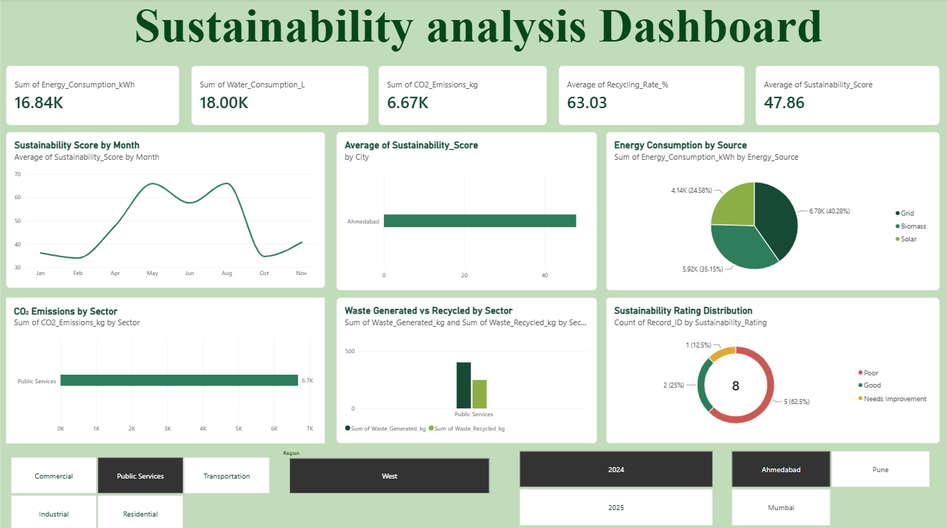
Figure 1: Sustainability Analysis Dashboard

Page 2:
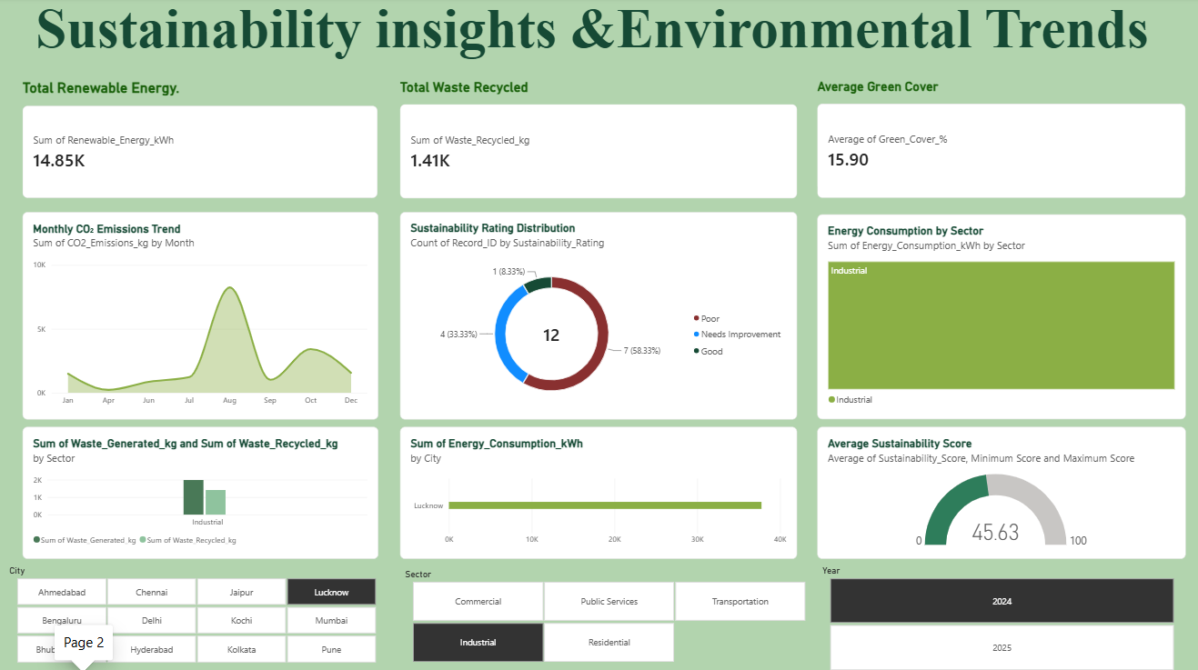
Figure 2: Sustainability Insights & Environmental Trends
Dataset link: https://1drv.ms/x/c/c95f2bce69e1adda/IQAaCqhM_tUDQr3-ilzTtyJIAcm-pgow1nZgHhhBhLBaNAE?e=XcDiZ1

