Assessment
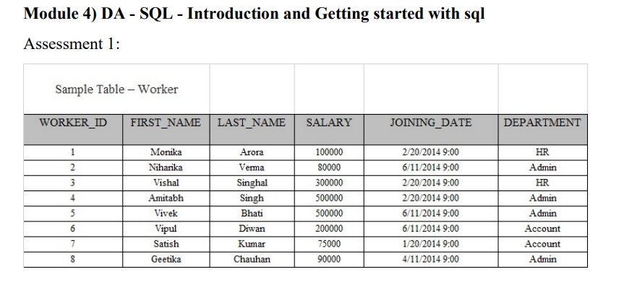

Q1. Write an SQL query to print all Worker details from the Worker table order by FIRST_NAME Ascending and DEPARTMENT Descending.
- SELECT * FROM Worker ORDER BY FIRST_NAME ASC, DEPARTMENT DESC;

Q2. Write an SQL query to print details for Workers with the first names “Vipul” and “Satish” from the Worker table.
- SELECT * FROM Worker WHERE FIRST_NAME IN ('Vipul', 'Satish');

Q3. Write an SQL query to print details of the Workers whose FIRST_NAME ends with ‘h’ and contains six alphabets.
- SELECT * FROM Worker WHERE FIRST_NAME LIKE '_____h';

Q4. Write an SQL query to print details of the Workers whose SALARY lies between 1.
- SELECT * FROM Worker WHERE SALARY BETWEEN 100000 AND 500000;

Q5. Write an SQL query to fetch duplicate records having matching data in some fields of a table.
- SELECT FIRST_NAME, LAST_NAME, SALARY, COUNT(*)
FROM Worker
GROUP BY FIRST_NAME, LAST_NAME, SALARY
HAVING COUNT(*) > 1;

Q6. Write an SQL query to show the top 6 records of a table.
- SELECT * FROM Worker LIMIT 6;

Q7. Write an SQL query to fetch the departments that have less than five people in them.
- SELECT DEPARTMENT, COUNT(*)
FROM Worker
GROUP BY DEPARTMENT
HAVING COUNT(*) < 5;

Q8. Write an SQL query to show all departments along with the number of people in there.
- SELECT DEPARTMENT, COUNT(*)
FROM Worker
GROUP BY DEPARTMENT;

Q9. Write an SQL query to print the name of employees having the highest salary in each department.
- SELECT DEPARTMENT, MAX(SALARY)
FROM Worker
GROUP BY DEPARTMENT;

Question 2
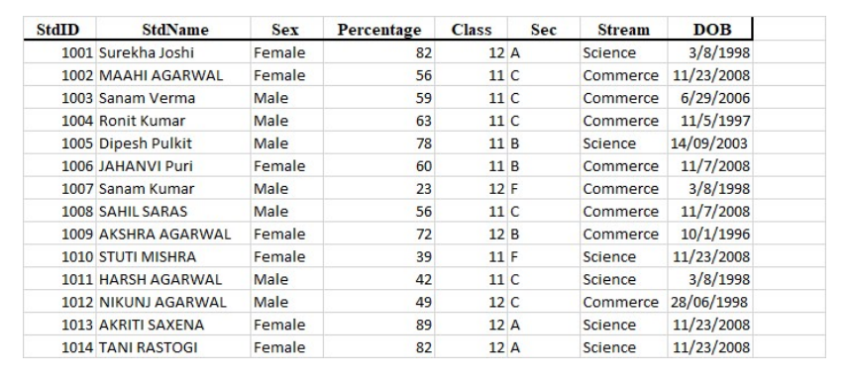

Q1. To display all the records form STUDENT table.
- SELECT * FROM student;

Q2. To display any name and date of birth from the table STUDENT
- SELECT StdName, DOB FROM student;

Q3. To display all students record where percentage is greater of equal to 80 FROM student table.
- SELECT * FROM student WHERE percentage >= 80;

Q4. To display student name, stream and percentage where percentage of student is more than 80.
- SELECT StdName, Stream, Percentage FROM student WHERE Percentage > 80;

Q5. To display all records of science students whose percentage is more than 75 form student table.
- SELECT * FROM student WHERE Stream = 'Science' AND Percentage > 75;
SUBMITTED BY :- Ritik Darji

