Q1->
Client: client is have there own browser send request to the server.
Server: server can know the IP address to that client device. Where the request was coming to server. Then interact with the database and sends request to finding some details regarding the portfolio like project, skills, education. Database send back request to the server. Server can send back to request to added the response it. The client successfully seen the webpage on browser
Diagram:
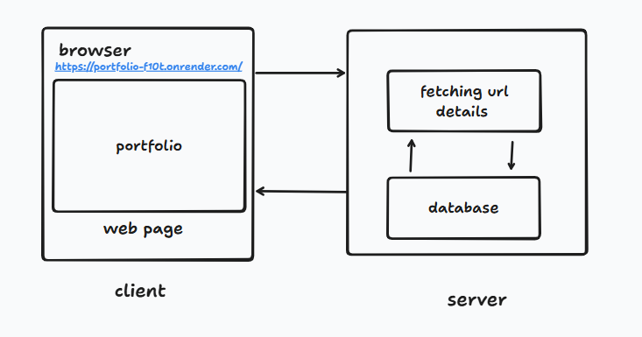

Q2->
Because we only communicate with the server by using the https requested. There are multiple methods they can help to do this work. If suppose we can used GET request to server they can retrieve data from database. If is status success they give data other wise reject it.
Q3->
There are 3 way to write CSS.
- Inline CSS
- Internal CSS
- External CSS
There are higher precedence’s Inline > Internal > External. The best to used External CSS, for achieving durability as well as reuses ability.
Q4->
<p id="intro" class="note">Hello</p>
There are 4 types of CSS selector to follows:
- * -> Universal selector
- P -> Tag name selector
- .note -> class selector
- #intro -> id selector
In between higher precedence order will be #intro > .note > p > *.
Q5->
- Margin -> give space outside of div.
- Padding -> give space inside of div.

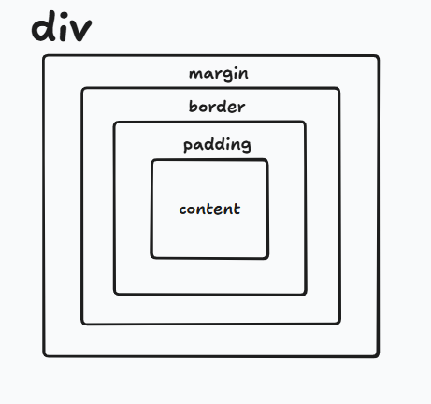

box-sizing: border
It is give height and width according to you content, padding, border.
Q6->
The JavaScript directly run on the browser.
Every browser have a JS Engine using that they can run directly on browser.
There will be have complier but way is work different like java and c++.
- Plain text files.
- The browser download and complier JS engine just in time.
- Executes code in m/s before runs.
Q7->
When you image it a=5 and a = “hello” , both point to same address location.
They value is change and save both side.
If a numeric value is though out program and suddenly change into string they numeric value also change in string than it showing mismatch output.
In JS, there are 3 types of datatype:
- Var -> It can be initialize again and again when how many time used.
- Let -> It cannot be initialize again and again. Every one used only this.
- Const -> It can used for holding the constant value.
Q8->
1. static -> it is normal position only move to right and bottom
2. relative -> if only change apply relative block can move with position other have unchanged.
3. Absolute -> The absolute block change position and other box change position automatically
4. fixed -> Fixed in every side from viewpoint.
Top, right, bottom, left -> This all are offset using that we can move position.
Q9->
display: flex ;
->The flex is align items horizontally.
flex = 1, 2, 1;
-> they auto take width like (25%,50%,25%) = 100%
gap = 10px;
->It is a special property only used with flex to add gap between items.
justify-content: center;
->justify content according the parent box

