CHINOOK MUSIC STORE PROJECT

OBJECTIVE QUESTIONS

(Q1) Does any table have missing values or duplicates? If yes, how would you handle it?
ANS- I run following queries to check missing values (NULL) in different columns across multiple tables.
Query
SELECT 'customer' AS table_name, 'company' AS column_name, COUNT(*) AS null_count
FROM customer
WHERE company IS NULL
UNION ALL
SELECT 'customer', 'state', COUNT(*)
FROM customer
WHERE state IS NULL
UNION ALL
SELECT 'customer', 'postal_code', COUNT(*)
FROM customer
WHERE postal_code IS NULL
UNION ALL
SELECT 'customer', 'phone', COUNT(*)
FROM customer
WHERE phone IS NULL
UNION ALL
SELECT 'customer', 'fax', COUNT(*)
FROM customer
WHERE fax IS NULL
UNION ALL
SELECT 'employee', 'reports_to', COUNT(*)
FROM employee
WHERE reports_to IS NULL
UNION ALL
SELECT 'track', 'composer', COUNT(*)
FROM track
WHERE composer IS NULL;
select * from employee;

Observation-
- In customer table, 3 columns have null or missing values.
- Company column – 49 values
- State column – 29 values.
- Fax column – 47 values.
- In track table, only composer column has 978 null values.
- In employee table, only employee-id has 1 null value.

Run following query to updates the categorical missing values-
SET SQL_SAFE_UPDATES = 0;
UPDATE customer SET company='Unknown' WHERE company is NULL;
UPDATE customer SET state='Unknown' WHERE state IS NULL;
UPDATE customer SET postal_code='Unknown' WHERE postal_code IS NULL;
UPDATE customer SET phone='Unknown' WHERE phone IS NULL;
UPDATE customer SET fax='Unknown' WHERE fax IS NULL;
UPDATE track SET composer='Unknown' WHERE composer is NULL;
SET SQL_SAFE_UPDATES = 1;
Observation- In employee table, one NULL value in reports_to column is valid because the highest-level manager has no reporting manager.

Run following queries for Checking the duplicates values for each table-
SELECT title, artist_id, COUNT(*) AS count_of_duplicates
FROM album
GROUP BY title, artist_id
HAVING COUNT(*)>1;

SELECT email, COUNT(*) AS count_of_duplicates
FROM employee
GROUP BY phone, email
HAVING COUNT(*)>1;

SELECT name, COUNT(*) AS count_of_duplicates
FROM genre
GROUP BY name
HAVING COUNT(*)>1;

SELECT invoice_id, track_id, unit_price, quantity, COUNT(*) AS count_of_duplicates
FROM invoice_line
GROUP BY invoice_id, track_id, unit_price, quantity
HAVING COUNT(*) > 1;

SELECT name, COUNT(*) AS duplicates
FROM media_type
GROUP BY name
HAVING COUNT(*) > 1;

SELECT name, COUNT(*) AS count_of_duplicates
FROM playlist
GROUP BY name
HAVING COUNT(*) > 1;

SELECT name, album_id,
media_type_id, genre_id,
composer, milliseconds, bytes,
unit_price, COUNT(*) AS count_of_duplicates
FROM track
GROUP BY name, album_id,
media_type_id, genre_id,
composer, milliseconds,
bytes,unit_price
HAVING COUNT(*) > 1;
Observation- only 2 tables have duplicate values, one table is invoice_line and other is playlist.

Run following queries to remove duplicates values in both tables, following queries were used-
WITH remove_duplicates AS (
SELECT
playlist_id,
ROW_NUMBER() OVER (
PARTITION BY name
ORDER BY playlist_id
) AS cnt_duplicates
FROM playlist
)
DELETE FROM playlist
WHERE playlist_id IN (
SELECT playlist_id
FROM remove_duplicates
WHERE cnt_duplicates > 1
);

WITH remove_duplicates AS (
SELECT
invoice_line_id,
ROW_NUMBER() OVER (
PARTITION BY invoice_id,
track_id,
unit_price,
quantity
ORDER BY invoice_line_id
) AS cnt_duplicates
FROM invoice_line
)
DELETE FROM invoice_line
WHERE invoice_line_id IN (
SELECT invoice_line_id
FROM remove_duplicates
WHERE cnt_duplicates > 1);

Run following queries for Rechecking duplicates to validate the cleanup-
SELECT name,COUNT(*) AS duplicate_count
FROM playlist
GROUP BY name
HAVING COUNT(*) > 1;

SELECT invoice_id,track_id,unit_price,quantity,
COUNT(*) AS duplicate_count
FROM invoice_line
GROUP BY invoice_id,track_id,unit_price,quantity
HAVING COUNT(*) > 1;

(Q2) Find the top-selling tracks and top artist in the USA and identify their most famous genres.
ANS- Top-selling tracks in the USA based on count-
Query
SELECT
t.name,
COUNT(*) as track_count
FROM invoice_line il
JOIN invoice i on il.invoice_id=i.invoice_id
JOIN customer c on c.customer_id=i.customer_id
JOIN track t on t.track_id=il.track_id
WHERE c.country='USA'
GROUP BY t.name
ORDER BY track_count DESC
LIMIT 10;

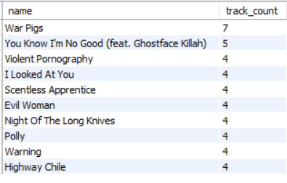

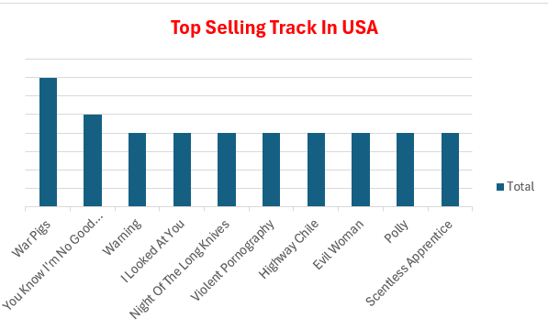

- Top Artists in the USA based on sale-
Query
SELECT
ar.name AS artist_name,
COUNT(*) AS total_sales
FROM invoice_line il
JOIN invoice i ON il.invoice_id = i.invoice_id
JOIN customer c ON c.customer_id = i.customer_id
JOIN track t ON t.track_id = il.track_id
JOIN album al ON al.album_id = t.album_id
JOIN artist ar ON ar.artist_id = al.artist_id
WHERE c.country = 'USA'
GROUP BY ar.name
ORDER BY total_sales DESC
LIMIT 10;

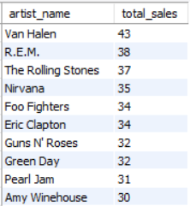

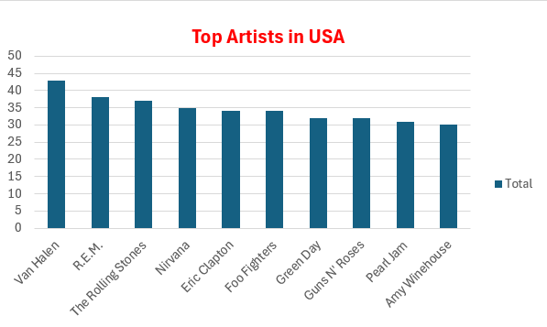

- Top most famous genre in USA based on the total sales-
Query
SELECT g.name AS genre,
COUNT(*) AS total_sales
FROM invoice_line il
JOIN invoice i ON il.invoice_id = i.invoice_id
JOIN customer c ON c.customer_id = i.customer_id
JOIN track t ON t.track_id = il.track_id
JOIN genre g ON g.genre_id = t.genre_id
WHERE c.country = 'USA'
GROUP BY g.name
ORDER BY total_sales DESC
LIMIT 10;

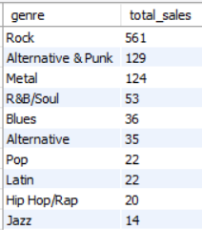

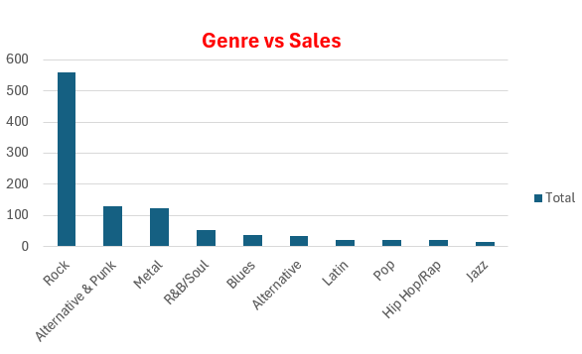

Insights-
- War Pigs is the Top Selling Track in USA.

- Van Halen is the Top Artist among all the artists in USA based on total sales.

- Rock genre is the Most famous genre in USA followed by Alternative & Punk and Metal.
Recommendations-
- Focus promotions on high-demand artists and tracks to increase sales in the USA market.

- Focus marketing and promotional strategies on top-performing genres like Rock, etc. to drive higher customer engagement and sales.

(Q3) What is the customer demographic breakdown (age, gender, location) of Chinook's customer base?
ANS- For customer demographic analysis, I run following queries.
- City-wise total customers-
SELECT
city,
COUNT(*) AS total_customers
FROM customer
GROUP BY city
ORDER BY total_customers DESC;
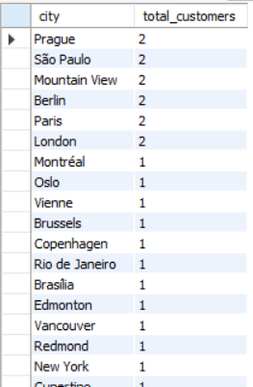

- Total Count of customers per country-

SELECT
country,
COUNT(*) AS total_customers
FROM customer
GROUP BY country
ORDER BY total_customers DESC;

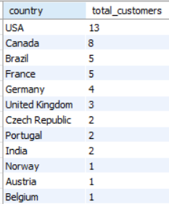

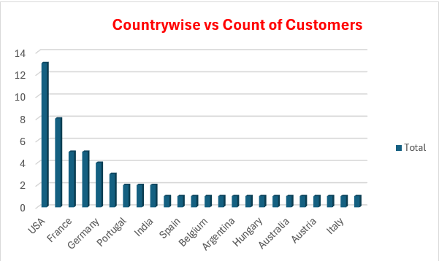

- Total Customers per city per country-
SELECT
country,
city,
COUNT(*) AS total_customers
FROM customer
GROUP BY country, city
ORDER BY total_customers DESC;

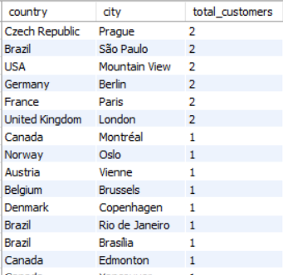

Insights-
- Top 3 countries have highest number of customers like USA have 13, Canada have 8, and Brazil have 5 customers.

- For each country and each city, top 3 are (Czech Republic, Prague), (Brazil, Sao Paulo) & (USA, Mountain View) has highest customer counts.
Recommendations-
- More Promotions and marketing campaigns on top countries to append more customers, which ultimately increases sales.

- Targeting other country-city regions by marketing strategies
To maintains the customer engagement & sales.

(Q4) Calculate the total revenue and number of invoices for each country, state, and city.
ANS- I run following queries to calculate revenue and invoice counts for each country, state and city.
- Country wise total revenue and no of invoices-
SELECT
c.country,
SUM(il.unit_price * il.quantity) AS total_revenue,
COUNT(DISTINCT i.invoice_id) AS total_invoices
FROM invoice i
JOIN invoice_line il
ON il.invoice_id = i.invoice_id
JOIN customer c
ON c.customer_id = i.customer_id
GROUP BY c.country
ORDER BY total_revenue DESC,total_invoices DESC;

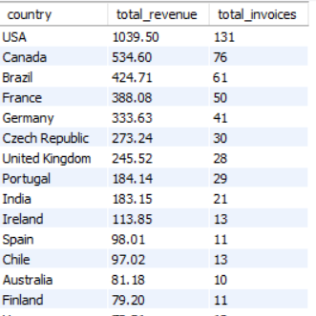

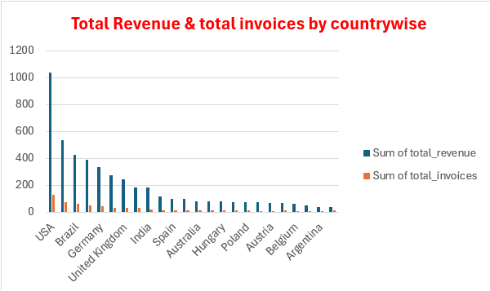

- City wise total revenue and total invoices-
SELECT
c.city,
SUM(il.unit_price * il.quantity) AS total_revenue,
COUNT(DISTINCT i.invoice_id) AS total_invoices
FROM invoice i
JOIN invoice_line il
ON il.invoice_id = i.invoice_id
JOIN customer c
ON c.customer_id = i.customer_id
GROUP BY c.city
ORDER BY total_revenue DESC,total_invoices DESC;

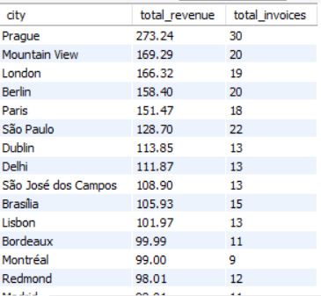

- State wise total invoices and total revenue-
SELECT
c.state,
SUM(il.unit_price * il.quantity) AS total_revenue,
COUNT(DISTINCT i.invoice_id) AS total_invoices
FROM invoice i
JOIN invoice_line il
ON il.invoice_id = i.invoice_id
JOIN customer c
ON c.customer_id = i.customer_id
GROUP BY c.state
ORDER BY total_revenue DESC,total_invoices DESC;

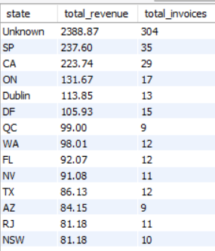

Insights-
- USA, Canada, and Brazil show the highest customer concentration and revenue contribution.

- Sales and invoices are heavily driven by a few top-performing cities and states.
Recommendations-
- Focus marketing and promotional efforts on high-performing regions to maximize revenue growth.

- Expand targeted campaigns in low-performing regions to improve customer reach and engagement.

(Q5) Find the top 5 customers by total revenue in each country.
ANS- In each country, top 5 customers based on total revenue.

Query-

WITH customer_revenue AS ( SELECT
c.customer_id,
CONCAT(c.first_name, ' ', c.last_name) AS customer_name,
c.country,
SUM(il.unit_price * il.quantity) AS total_revenue
FROM invoice i
JOIN invoice_line il
ON i.invoice_id = il.invoice_id
JOIN customer c
ON i.customer_id = c.customer_id
GROUP BY c.customer_id,c.first_name,c.last_name,c.country
),
ranked_customers AS (
SELECT *,
DENSE_RANK() OVER (PARTITION BY country ORDER BY total_revenue DESC) AS rnk
FROM customer_revenue
)
SELECT *
FROM ranked_customers
WHERE rnk <= 5
ORDER BY total_revenue DESC, country;
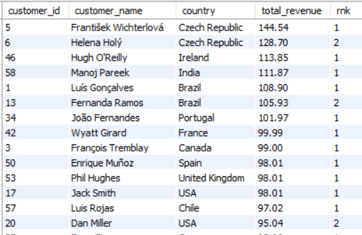

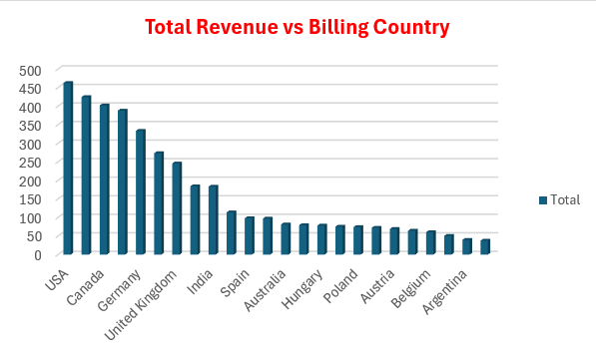

Insights-
- Overall, customers of USA generating highest total revenue, followed by Canada and Germany.

- Individually, two customers of Czech Republic contributing highest revenue.

- As compared to other countries, Argentina, Belgium & Austria generating lowest revenue.

Recommendations-
- Target Top countries especially first three for high value market campaigns and future expansions.

- Evaluate customers performance of countries like Argentina, Belgium and Austria & suggest improvement marketing strategies to increase their engagement and revenue.

(Q6) Identify the top-selling track for each customer.
ANS- I run the following query to identify the top-selling track for each customer.
Query-
WITH customer_track_sales AS (
SELECT
c.customer_id,
CONCAT(c.first_name, ' ', c.last_name) AS full_name,
t.track_id,
t.name AS track_name,
SUM(il.quantity) AS total_sales
FROM track t
JOIN invoice_line il
ON t.track_id = il.track_id
JOIN invoice i
ON il.invoice_id = i.invoice_id
JOIN customer c
ON i.customer_id = c.customer_id
GROUP BY c.customer_id, full_name, t.track_id, t.name
),
ranked_tracks AS (
SELECT *,
DENSE_RANK() OVER (
PARTITION BY customer_id
ORDER BY total_sales DESC, track_id
) AS rnk
FROM customer_track_sales
)
SELECT
customer_id,
full_name,
track_id,
track_name,
total_sales
FROM ranked_tracks
WHERE rnk = 1
ORDER BY total_sales DESC;

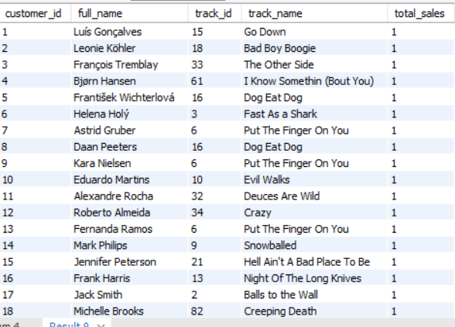

Insights-
- All customers in the dataset are included with their respective top-selling track and customer name details.

- For every customer, the selected top track has been purchased only once, showing no repeated purchase of the same track.
Recommendations-
- Encourage customers to explore more music through personalized recommendations and playlists.

- Improve engagement strategies like suggested tracks and cross-selling to increase repeat listening and overall sales.

(Q7) Are there any patterns or trends in customer purchasing behaviour (e.g., frequency of purchases, preferred payment methods, average order value)?
ANS-
- Total frequency (count invoices) per customer over year.
Query
SELECT
c.customer_id,
CONCAT(c.first_name, ' ', c.last_name) AS full_name,
YEAR(i.invoice_date) AS purchase_year,
COUNT(i.invoice_id) AS purchase_count
FROM customer c
JOIN invoice i
ON c.customer_id = i.customer_id
GROUP BY
c.customer_id,
c.first_name,
c.last_name,
YEAR(i.invoice_date)
ORDER BY c.customer_id,purchase_year;
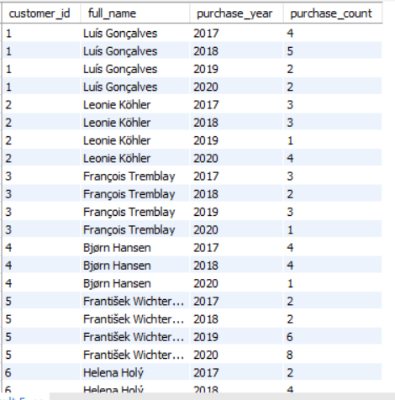

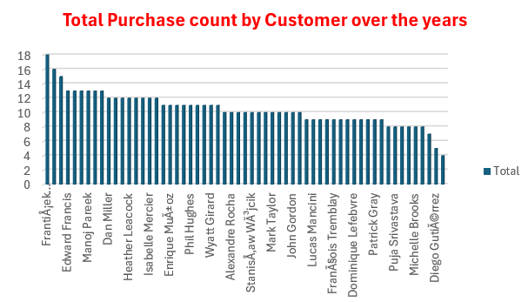
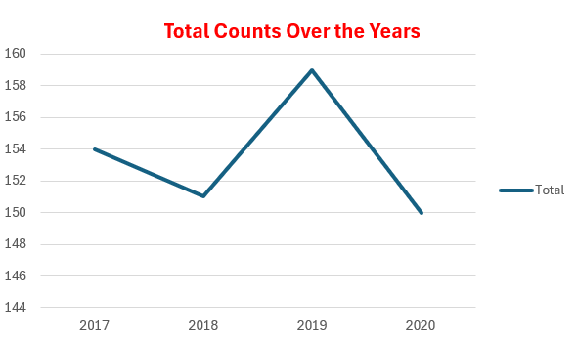

- Average order value and total invoices per customer.
Query-
SELECT
customer_id,
AVG(total) AS avg_order_value,
COUNT(invoice_id) AS total_purchase_count
FROM invoice
GROUP BY customer_id
ORDER BY customer_id, avg_order_value DESC;

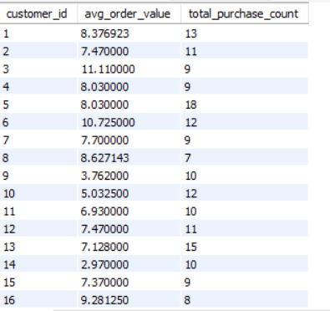

Insights-
- Franti Ajek Wichterlov Aj (customer id5) has the highest purchase frequency followed by Madalena Sampaio (customer id 35) & Fernanda Ramos (customer id13).
These customers represent the most engaged and loyal customer segment.

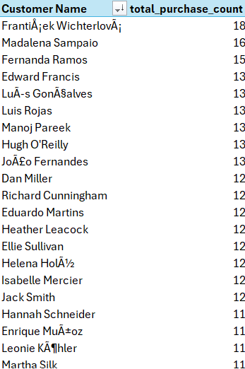

- Purchase activity was highest in 2019, while there is slight variation is noticed in other years, overall showing customer purchasing remained relatively stable over the 4 years.

Total purchase counts across all the years reached 614 invoices, showing active customer base.
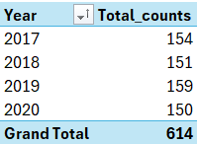

- Customer id 3 has the highest average order value (AOV), despite making fewer purchases while customer id 5 has highest no of purchase count but comparatively lower AOV.

Recommendations-
- Top repeat customers should be rewarded with loyalty programs, personalized offers, and membership benefits to improve retention.

- High order value customers should be targeted with premium product recommendations and exclusive deals to increase revenue.

- After 2019, purchase counts slightly decreased, so the company should run seasonal promotions, re-engagement campaigns, and personalized marketing to increase customer activity again.

- Customers with low purchase count and low order value should be encouraged through discounts, bundle offers, and targeted recommendations to improve engagement and spending.

(Q8) What is the customer churn rate?
ANS- Customer churn rate means the percentage of customers who stopped purchasing over a specific time period.
Query-
WITH latest_date AS (
SELECT MAX(invoice_date) AS max_date
FROM invoice
),
customer_last_purchase AS (
SELECT
customer_id,
MAX(invoice_date) AS last_purchase
FROM invoice
GROUP BY customer_id
)
SELECT
COUNT(CASE
WHEN last_purchase < DATE_SUB(
(SELECT max_date FROM latest_date),
INTERVAL 3 MONTH
) THEN 1 END) AS churned_customers,

COUNT(*) AS total_customers,
ROUND(
COUNT(CASE
WHEN last_purchase < DATE_SUB(
(SELECT max_date FROM latest_date),
INTERVAL 3 MONTH
)
THEN 1 END) * 100.0 / COUNT(*),
2) AS churn_rate_percentage
FROM customer_last_purchase;

Insights-
- Out of 59 total customers, 22 customers became inactive and did not make purchases in the last 3 months.

- The customer churn rate is 37.29%, which indicates a moderate level of customer loss and reduced repeat purchases.
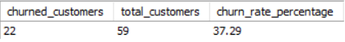

Recommendations-
- Analyse purchasing behaviour of churned customers to identify reasons for inactivity.

- Provide rewards and discounts strategies to improve customer retention.

- Run re-engagement campaigns and personalized offers for inactive customers.

(Q9) Calculate the percentage of total sales contributed by each genre in the USA and identify the best-selling genres and artists.
ANS-
- Percentage Contribution of Sales by Genre in the USA.
- Query
SELECT
g.name AS genre,
ROUND(SUM(il.unit_price * il.quantity),2) AS genre_revenue,
ROUND(
100 * SUM(il.unit_price * il.quantity)/(
SELECT
SUM(il2.unit_price * il2.quantity)
FROM invoice_line il2
JOIN invoice i2
ON il2.invoice_id = i2.invoice_id
WHERE i2.billing_country = 'USA'),
2) AS pct_of_total_sales
FROM invoice_line il
JOIN invoice i
ON il.invoice_id = i.invoice_id
JOIN track t
ON il.track_id = t.track_id
JOIN genre g
ON t.genre_id = g.genre_id
WHERE i.billing_country = 'USA'
GROUP BY g.name
ORDER BY genre_revenue DESC;

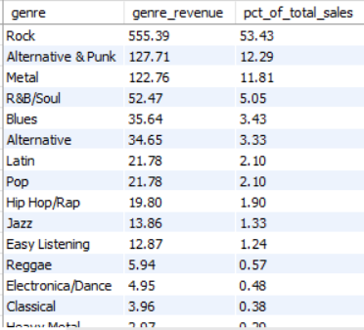

- Best selling genres in the USA.
Query
SELECT
g.name AS genre,
ROUND(SUM(il.unit_price * il.quantity),2) AS total_revenue
FROM invoice_line il
JOIN invoice i
ON il.invoice_id = i.invoice_id
JOIN track t
ON il.track_id = t.track_id
JOIN genre g
ON t.genre_id = g.genre_id
WHERE i.billing_country = 'USA'
GROUP BY g.name
ORDER BY total_revenue DESC;

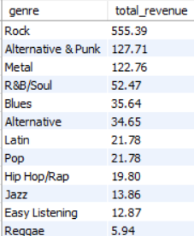

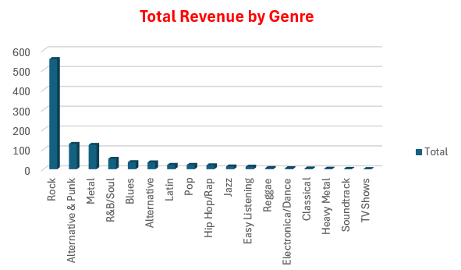

- Top 10 Best Selling Artists in the USA.
Query
SELECT
a.name AS artist,
ROUND(SUM(il.unit_price * il.quantity),2) AS total_revenue
FROM invoice_line il
JOIN invoice i
ON il.invoice_id = i.invoice_id
JOIN track t
ON il.track_id = t.track_id
JOIN album al
ON t.album_id = al.album_id
JOIN artist a
ON al.artist_id = a.artist_id
WHERE i.billing_country = 'USA'
GROUP BY a.name
ORDER BY total_revenue DESC;

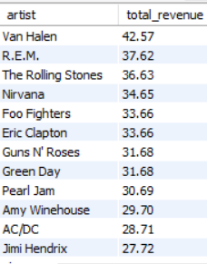

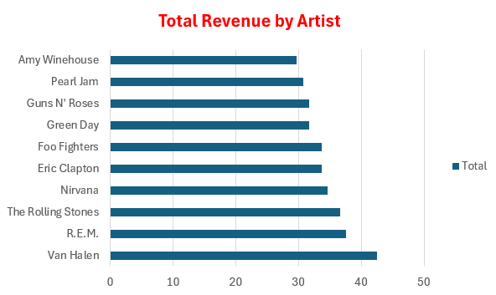

Insights-
- Rock genre is the best-selling genre in the USA, contributes around 53% of total USA sales, making it the highest revenue-generating genre, followed by Alternative & Punk and Metal.

- Van Halen, REM & The Rolling Stones are the top revenue generating artists in the USA.

- Genres such as TV Shows, Soundtrack, heavy metal, etc contributing the lowest sales, indicating lower customer demands.

Recommendations-
- Focus marketing campaigns and promotions on high-performing genres like Rock Music, Alternative & Punk, and Metal to maximize revenue and customer engagement.

- Promote top-performing artists such as Van Halen, R.E.M., and The Rolling Stones through featured playlists, recommendations, and exclusive offers.

- Improve sales for lower-performing genres like TV Soundtracks, Soundtrack, and Heavy Metal using discounts offers, rewards and targeted promotions to increase customer interest.

(Q10) Find customers who have purchased tracks from at least 3 different genres.
ANS- For finding customers who purchase at least three different genres, I run following query.
SELECT
c.customer_id,
CONCAT(c.first_name, ' ', c.last_name) as full_name,
COUNT(DISTINCT g.genre_id) AS genre_count
FROM customer c
JOIN invoice i ON c.customer_id = i.customer_id
JOIN invoice_line il ON i.invoice_id = il.invoice_id
JOIN track t ON il.track_id = t.track_id
JOIN genre g ON t.genre_id = g.genre_id
GROUP BY c.customer_id, full_name
HAVING genre_count >= 3
ORDER BY genre_count DESC, customer_id;
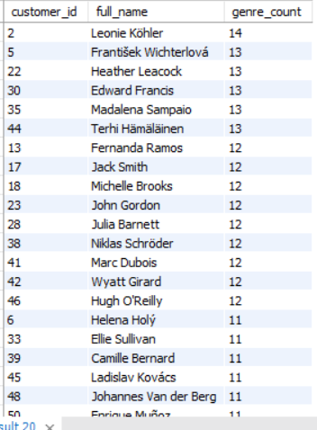

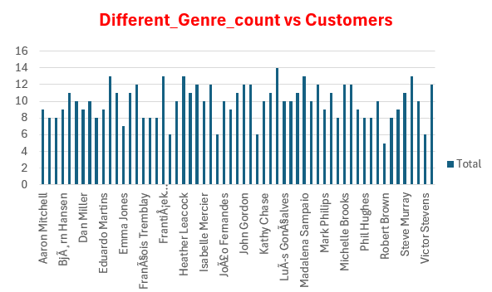

Insights-
- Leonie Köhler has the highest genre count with 14 genres, while several other customers purchased tracks from 13 different genres, showing strong engagement and diverse music preferences.

- Many customers purchased tracks across 10–13 genres, indicating that customers actively explore multiple music categories instead of sticking to a single genre.

- Some customers purchased from only 5–9 genres, showing lower engagement and limited genre exploration compared to highly active customers.

Recommendations-
- Customers who listen to many different genres should be given personalized playlists and special offers to keep them engaged and active.

- Customers with lower genre counts can be encouraged to explore more music through recommendations, discounts, and featured playlists.

(Q11) Rank genres based on their sales performance in the USA.
ANS- Following query is used to find genre’s ranking based on sales.
WITH genre_sales AS (
SELECT
g.name AS genre,
SUM(il.unit_price * il.quantity) AS revenue
FROM invoice_line il
JOIN invoice i
ON il.invoice_id = i.invoice_id
JOIN track t
ON il.track_id = t.track_id
JOIN genre g
ON t.genre_id = g.genre_id
WHERE i.billing_country = 'USA'
GROUP BY g.name
)
SELECT
genre,
revenue,
DENSE_RANK() OVER ( ORDER BY revenue DESC) AS rnk
FROM genre_sales
ORDER BY rnk;

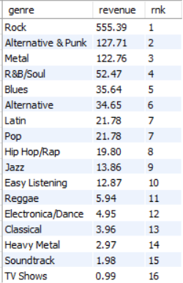

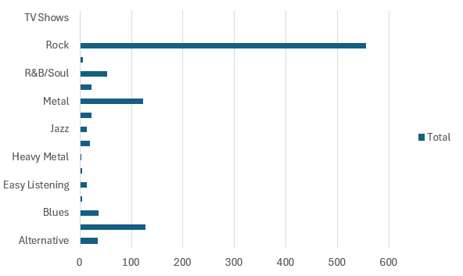

Insights-
- Rock, Alternative and Punk & Metal are top in the genres ranking based on revenue.

- TV Shows, Soundtrack, Heavy Metal, Classical, Electronica & Reggae are lowest in the genres ranking.

Recommendations-
- Focus on niche genres through promotional & marketing strategies to widen their customer base & improve revenue.

- Top ranking genres should be prioritized for further development to grow more customer engagement as they generating highest revenue.

(Q12) Identify customers who have not made a purchase in the last 3 months.
ANS- For identifying customers who don’t purchase in last 3 months, I run following query.

WITH customer_latest_order AS
(
SELECT
customer_id,
MAX (invoice_date) AS latest_purchase
FROM invoice
GROUP BY customer_id
)

SELECT
c.customer_id,
CONCAT (c.first_name, ' ', c.last_name) AS full_name,
DATEDIFF (CURDATE(), clo.latest_purchase) AS inactive_days
FROM customer c
JOIN customer_latest_order clo
ON c.customer_id = clo.customer_id
WHERE DATEDIFF (CURDATE (), clo.latest_purchase) > 90
ORDER BY inactive_days DESC;

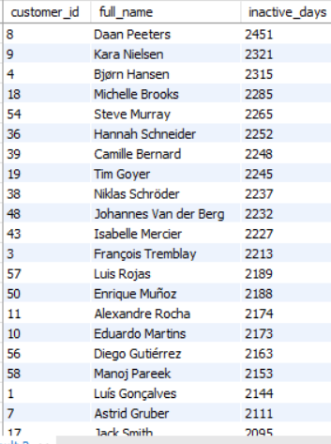

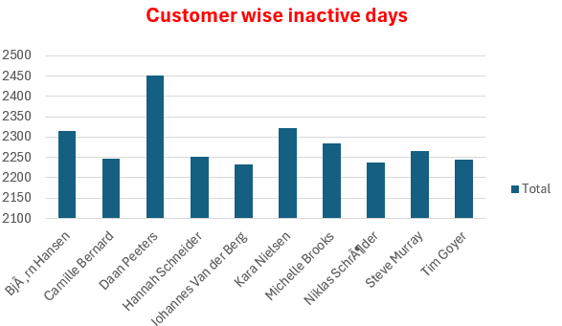

Insights-
- From given table, above customers can be considered as inactive or churn-risk customer as they have not purchased anything in last 3 months.

Recommendations-
- These customers can be targeted with re-engagement offers, discounts, and personalized recommendations to encourage repeat purchases.

SUBJECTIVE QUESTIONS

(Q1) Recommend the three albums from the new record label that should be prioritised for advertising and promotion in the USA based on genre sales analysis.
ANS- Top 3 albums in the USA based on genre’s sales ranking, I run following query.
WITH album_revenue AS (
SELECT
al.title AS album,
ar.name AS artist,
g.name AS genre,
SUM(il.unit_price * il.quantity) AS revenue
FROM invoice_line il
JOIN invoice i
ON il.invoice_id = i.invoice_id
JOIN track t
ON il.track_id = t.track_id
JOIN album al
ON t.album_id = al.album_id
JOIN artist ar
ON al.artist_id = ar.artist_id
JOIN genre g
ON t.genre_id = g.genre_id
WHERE i.billing_country = 'USA'
GROUP BY al.album_id,al.title,ar.name,g.name
)
SELECT *
FROM (
SELECT *,
DENSE_RANK() OVER (ORDER BY revenue DESC) AS rnk
FROM album_revenue
) rs
WHERE rnk <= 3;

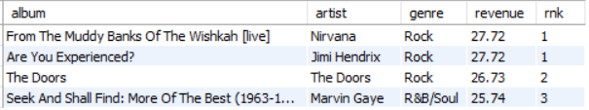

Insights-
- The top 3 albums generated the highest revenue in the USA, showing strong customer demand and popularity among listeners.

- These albums belong to popular artists and genres, indicating that customers prefer well-known music categories and artists.
Recommendations-
- Promote the top-selling albums through advertisements, featured playlists, and discount offers recommendations to increase sales further.

- Albums outside the top 3 can be improved using discounts, bundle offers, and better promotions to increase customer attention and sales.

- Analyse customer preferences for top albums and apply similar strategies to lower-performing albums and artists.

(Q2) Determine the top-selling genres in countries other than the USA and identify any commonalities or differences.
ANS- I run following query to find top selling genre in each country except USA.

Query
WITH genre_revenue AS (
SELECT
g.name AS genre,
c.country,
SUM(il.unit_price * il.quantity) AS revenue
FROM invoice_line il
JOIN invoice i
ON il.invoice_id = i.invoice_id
JOIN track t
ON il.track_id = t.track_id
JOIN genre g
ON t.genre_id = g.genre_id
JOIN customer c
ON c.customer_id = i.customer_id
WHERE i.billing_country <> 'USA'
GROUP BY g.name, c.country
)
SELECT * FROM
(SELECT *,
DENSE_RANK() OVER (PARTITION BY country ORDER BY revenue DESC) AS rnk
FROM genre_revenue) rs
WHERE rnk = 1
ORDER BY revenue DESC;

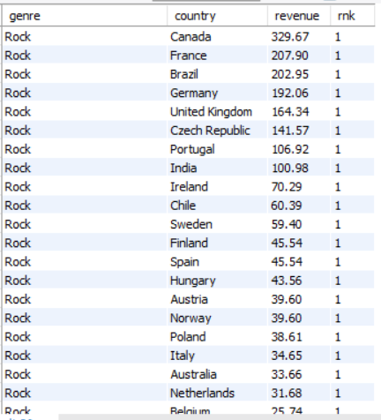

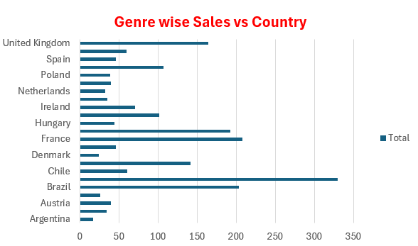

Insights-
- Rock is the top-selling genre in almost all countries outside the USA, showing strong global customer preference for Rock music.

- Argentina is the only country where Alternative & Punk is the top-selling genre instead of Rock, indicating a different regional music preference.

- Rock Genre generating highest revenue across all the countries, contributes 99% which shows strong high demand.

- The results show that customer music preferences are mostly similar across countries, with only slight regional variations.

Recommendations-
- Continue promoting Rock music globally through advertisement, rewards & discounts, since it performs strongly across most countries.

- In Argentina, focus more on promoting Alternative & Punk playlists, promotions, and recommendations to match local customer preferences.

(Q3) Customer Purchasing Behaviour Analysis: How do the purchasing habits (frequency, basket size, spending amount) of long-term customers differ from those of new customers? What insights can these patterns provide about customer loyalty and retention strategies?
ANS- To analyse customer purchasing behaviour, I calculated each customer’s spending, basket size, purchase frequency, and customer lifetime.
Then, customers were classified as long-term and short-term/new customers based on their average lifetime and compared accordingly.
Query-
WITH cte AS (
SELECT
i.customer_id,
MIN(i.invoice_date) AS first_purchase_date,
MAX(i.invoice_date) AS last_purchase_date,
SUM(i.total) AS total_spent,
SUM(il.quantity) AS items_bought,
COUNT(DISTINCT i.invoice_id) AS frequency,
TIMESTAMPDIFF(DAY, MIN(i.invoice_date), MAX(i.invoice_date)) AS customer_lifetime_days
FROM invoice i
LEFT JOIN invoice_line il
ON il.invoice_id = i.invoice_id
GROUP BY i.customer_id
),
avg_lifetime AS (SELECT AVG(customer_lifetime_days) AS avg_days
FROM cte
),
long_short_term AS (
SELECT
cte. *,
CASE
WHEN customer_lifetime_days > (SELECT avg_days FROM avg_lifetime)
THEN 'Long Term'
ELSE 'Short Term'
END AS customer_type
FROM cte
)
SELECT
customer_type,
COUNT(*) AS number_of_customers,
ROUND(AVG(total_spent), 2) AS avg_spending,
ROUND(AVG(items_bought), 2) AS avg_basket_size,
ROUND(AVG(frequency), 2) AS avg_purchase_frequency
FROM long_short_term
GROUP BY customer_type;

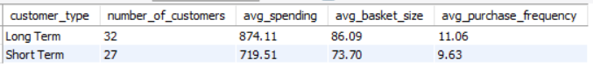

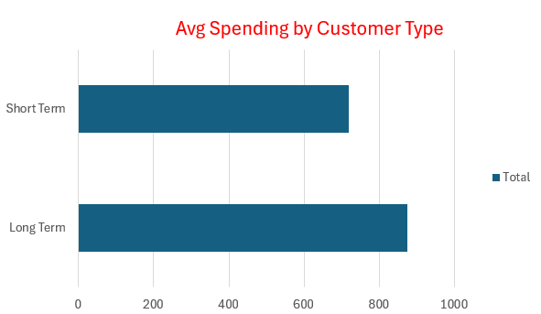

Insights-
- 32 Long-term customers have higher average spending (874.11) compared to 27 short-term customers (719.51), showing stronger customer value and loyalty.

- Long-term customers also have higher average basket size (86) and purchase frequency (11), indicating they purchase more items and buy more often.

- Short-term customers show comparatively lower engagement and spending, highlighting the importance of customer retention strategies.

Recommendations-
- Retain long-term customers through loyalty rewards, personalized offers like discount offers or coupons, and premium memberships to maintain repeat purchases.

- Encourage short-term customers to purchase more frequently using discounts, bundle offers, and targeted recommendations.

(Q4) Product Affinity Analysis: Which music genres, artists, or albums are frequently purchased together by customers? How can this information guide product recommendations and cross-selling initiatives?

ANS- To analyse product affinity, I identified genres, albums, and artists that were frequently purchased together in the same invoice. This helps understand customer buying patterns and cross-selling opportunities.
- Genres frequently purchased together-
Query
SELECT
g1.name AS genre_1,
g2.name AS genre_2,
COUNT(*) AS times_bought_together
FROM invoice_line il1
JOIN invoice_line il2
ON il1.invoice_id = il2.invoice_id
AND il1.track_id < il2.track_id
JOIN track t1 ON il1.track_id = t1.track_id
JOIN track t2 ON il2.track_id = t2.track_id
JOIN genre g1 ON t1.genre_id = g1.genre_id
JOIN genre g2 ON t2.genre_id = g2.genre_id
WHERE g1.genre_id <> g2.genre_id
GROUP BY g1.name, g2.name
ORDER BY times_bought_together DESC
LIMIT 10;
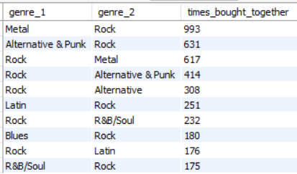

- Albums frequently purchased together-
Query
SELECT
al1.title AS album_1,
al2.title AS album_2,
COUNT(*) AS times_bought_together
FROM invoice_line il1
JOIN invoice_line il2
ON il1.invoice_id = il2.invoice_id
AND il1.track_id < il2.track_id
JOIN track t1 ON il1.track_id = t1.track_id
JOIN track t2 ON il2.track_id = t2.track_id
JOIN album al1 ON t1.album_id = al1.album_id
JOIN album al2 ON t2.album_id = al2.album_id
WHERE al1.album_id <> al2.album_id
GROUP BY al1.title, al2.title
ORDER BY times_bought_together DESC
LIMIT 10;


- Artists frequently purchased together-
Query
SELECT
ar1.name AS artist_1,
ar2.name AS artist_2,
COUNT(*) AS times_bought_together
FROM invoice_line il1
JOIN invoice_line il2
ON il1.invoice_id = il2.invoice_id
AND il1.track_id < il2.track_id
JOIN track t1 ON il1.track_id = t1.track_id
JOIN track t2 ON il2.track_id = t2.track_id
JOIN album al1 ON t1.album_id = al1.album_id
JOIN album al2 ON t2.album_id = al2.album_id
JOIN artist ar1 ON al1.artist_id = ar1.artist_id
JOIN artist ar2 ON al2.artist_id = ar2.artist_id
GROUP BY ar1.name, ar2.name
ORDER BY times_bought_together DESC
LIMIT 10;
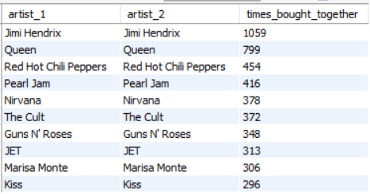

Insights-
- Metal and Rock Music are the most frequently purchased genre combination with 993 purchases, followed by Alternative & Punk and Rock with 631 purchases.

- Albums such as Are You Experienced? and Mezmerize are frequently purchased together, showing strong customer preference for related music collections.

- Artists like Jimi Hendrix, Queen, and Red-Hot Chili Peppers are commonly purchased together, indicating strong customer interest in similar artists and music styles.

- Customers who buy one popular genre or artist are likely to purchase similar music, creating strong opportunities for product recommendations and cross-selling.
Recommendations-
- Recommend similar genres, albums, and artists together to improve customer experience and increase sales.

- Create combo offers, playlists, and bundle recommendations for music frequently purchased together.

- Use customer buying patterns to give personalized recommendations and improve cross-selling opportunities.

- Promote related artists and albums on product pages to encourage customers to explore more music content.

(Q5) Regional Market Analysis: Do customer purchasing behaviours and churn rates vary across different geographic regions or store locations? How might these correlate with local demographic or economic factors?

ANS- To analyse regional market behaviour, I identified each customer’s latest purchase date by country and classified customers as churned if they had no purchases in the last 6 months.
Then, I calculated total customers, churned customers, and churn rate for each region to compare customer retention across countries.
Query-
WITH last_purchase AS (
SELECT
customer_id,
billing_country AS region,
MAX(invoice_date) AS last_order_date
FROM invoice
GROUP BY customer_id, billing_country
),
customer_status AS (
SELECT
lp.*,
CASE
WHEN lp.last_order_date < (SELECT DATE_SUB(MAX(invoice_date), INTERVAL 6 MONTH)
FROM invoice)
THEN 1 ELSE 0
END AS is_churned
FROM last_purchase lp
)
SELECT
region,
COUNT(*) AS total_customers,
SUM(is_churned) AS churned_customers,
ROUND(SUM(is_churned) * 100.0 / COUNT(*), 2) AS churn_rate
FROM customer_status
GROUP BY region
ORDER BY churn_rate DESC;

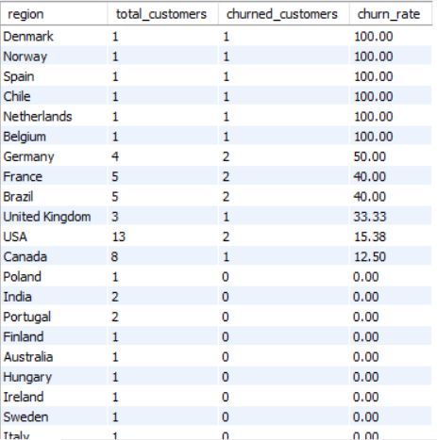

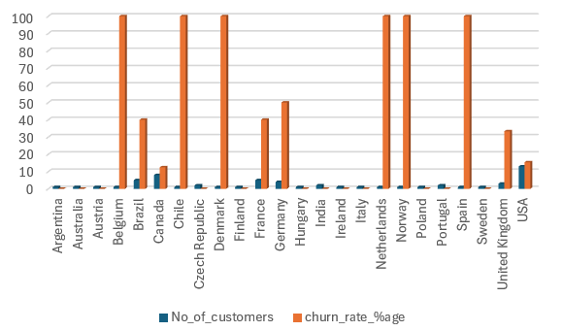

Insights-
- Countries like Denmark, Norway, Spain, Chile, Netherlands & Belgium shows 100% churn rate, indicating no recent customer activity.

- USA and Canada have lower churn rates and higher active customers, showing better customer retention and engagement.

- Customer purchasing behaviour and churn rates vary across regions, which may be affected by local demand, customer preferences, and market conditions.

Recommendations-
- Run promotions, discounts, and re-engagement campaigns in high churn regions to improve customer activity.

- Continue loyalty programs and personalized recommendations in low churn regions to maintain customer retention.

- Use region-wise customer preferences to provide localized recommendations and improve sales performance.

(Q6) Customer Risk Profiling: Based on customer profiles (age, gender, location, purchase history), which customer segments are more likely to churn or pose a higher risk of reduced spending? What factors contribute to this risk?

ANS- To identify high-risk customers, I analysed customer purchase frequency, total spending, and recent purchase activity.
Customers were segmented into high/low frequency and high/low value groups, and churn risk was identified based on no purchases in the last 6 months.

Query-
WITH customer_base AS (
SELECT
customer_id,
COUNT(invoice_id) AS total_purchases,
SUM(total) AS total_spent,
MAX(invoice_date) AS last_order_date
FROM invoice
GROUP BY customer_id
),
customer_flags AS (
SELECT
customer_id,
total_purchases,
total_spent,
CASE
WHEN total_purchases >= 10 THEN 'High Frequency'
ELSE 'Low Frequency'
END AS frequency_segment,

CASE
WHEN total_spent >= 100 THEN 'High Value'
ELSE 'Low Value'
END AS value_segment,
CASE
WHEN last_order_date < DATE_SUB('2020-12-30', INTERVAL 6 MONTH)
THEN 1 ELSE 0
END AS churned
FROM customer_base
)
SELECT
frequency_segment,
value_segment,
COUNT(*) AS customers,
SUM(churned) AS churned_customers,
ROUND(SUM(churned) * 100.0 / COUNT(*), 2) AS churn_rate
FROM customer_flags
GROUP BY frequency_segment, value_segment
ORDER BY churn_rate DESC;

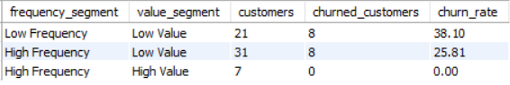

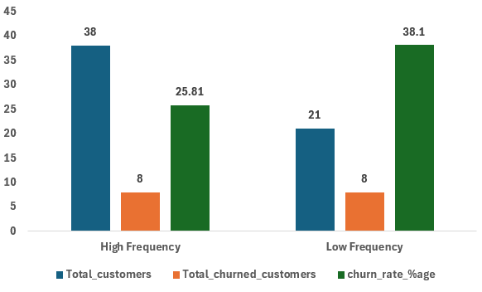

Insights-
- Low frequency and low value customers have the highest churn rate (38.10%), making them the highest-risk customer segment.

- High frequency but low value customers show moderate churn risk, indicating that frequent purchases alone do not guarantee high customer value.

- High frequency and high value customers have 0% churn rate, showing strong loyalty and consistent purchasing behaviour.

Main Factors- Lower spending, fewer purchases, and long inactivity periods are the main factors contributing to higher churn risk and reduced customer engagement.

Recommendations-
- Target low-value and low-frequency customers with discounts, offers, and personalized recommendations to improve engagement.

- Customers with low spending and fewer purchases should be targeted with discounts, personalized recommendations, and promotional offers to reduce churn risk.

- Encourage high-frequency customers to increase spending through bundle offers and premium product recommendations.

- Retain high-value customers using loyalty rewards, exclusive benefits, and personalized experiences.

(Q7) Customer Lifetime Value Modelling: How can you leverage customer data (tenure, purchase history, engagement) to predict the lifetime value of different customer segments?
This could inform targeted marketing and loyalty program strategies. Can you observe any common characteristics or purchase patterns among customers who have stopped purchasing?

ANS- Customer Lifetime Value can be estimated using customer spending, purchase frequency, tenure, and churn behaviour.
Customers with higher spending, frequent purchases, and longer tenure contribute more revenue over time, while customers with lower engagement are more likely to churn.

Query-
WITH customer_base AS
(SELECT
c.customer_id,
COUNT(i.invoice_id) AS total_orders,
SUM(i.total) AS total_spent,
MIN(i.invoice_date) AS first_purchase,
MAX(i.invoice_date) AS last_purchase,
DATEDIFF(MAX(i.invoice_date),MIN(i.invoice_date)) AS customer_tenure
FROM customer c

JOIN invoice i
ON c.customer_id = i.customer_id
GROUP BY c.customer_id
),
customer_segments AS
(SELECT
customer_id,
total_orders,
total_spent,
customer_tenure,
ROUND(total_spent / NULLIF(total_orders, 0),2) AS avg_order_value,
CASE
WHEN total_spent >= 100
THEN 'High Value'
ELSE 'Low Value'
END AS value_segment,
CASE
WHEN total_orders >= 10
THEN 'Frequent'
ELSE 'Infrequent'
END AS frequency_segment,
CASE
WHEN last_purchase <
DATE_SUB(
(SELECT MAX(invoice_date) FROM invoice),INTERVAL 6 MONTH)
THEN 'Churned'
ELSE 'Active'
END AS churn_status
FROM customer_base
)
SELECT
churn_status,
value_segment,
frequency_segment,
COUNT(*) AS customers,
ROUND(AVG(total_spent), 2) AS avg_spent,
ROUND(AVG(avg_order_value), 2) AS avg_order_value,
ROUND(AVG(customer_tenure), 0) AS avg_tenure_days
FROM customer_segments
GROUP BY churn_status,value_segment,frequency_segment
ORDER BY
churn_status,
avg_spent DESC;

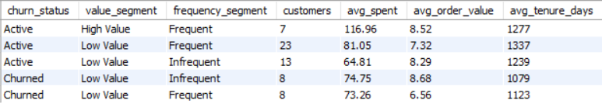

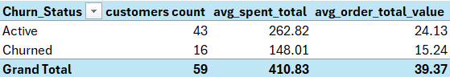

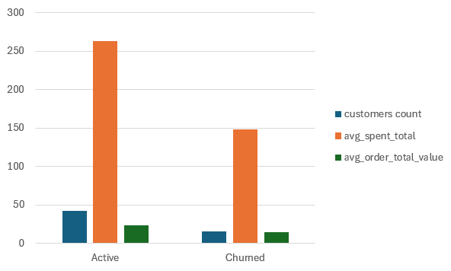

Insights-
- Overall, out of 59 customers, 43 are Active customers while 16 are Churned customers. Active customers show higher average spending and average order value.

- Customers who stopped purchasing mainly belong to the Low Value segment.

- Churned customers show comparatively lower average spending (74.75 and 73.26) than active high-value customers.

- Churned customers also have lower customer tenure (1079 and 1123 days), showing weaker long-term engagement.
- The churned frequent segment has the lowest average order value (6.56), indicating reduced spending behaviour before churn.

- Low spending and weaker engagement are common characteristics among customers who stopped purchasing.

Recommendations-
- Target low-value customers with personalized offers and discounts to improve engagement.

- Run re-engagement campaigns for customers showing reduced spending or lower order values.

- Provide loyalty benefits to encourage repeat purchases and improve retention.

- Monitor customer purchase frequency and recent spending patterns to identify churn risk early.

- Use email reminders and special promotions to retain customers before they stop purchasing completely.

(Q8) If data on promotional campaigns (discounts, events, email marketing) is available, how could you measure their impact on customer acquisition, retention, and overall sales?

ANS- Promotional campaigns can be evaluated by tracking changes in customer acquisition, retention, and sales metrics over time.

Customer Acquisition Impact-
- Check how many new customers came before and after campaign.

- See first purchase increase during campaign period.

- Compare lead conversion into customers.

- Identify which campaign brings more new customers.

- Check cost per customer to see if acquisition is efficient.

Customer Retention Impact-
- Compare repeat purchases before and after campaign.

- Check if churn rate goes down after campaigns.

- See how often customers are buying again.

- Track email engagement like opens and clicks.

- Check if customers are coming back more after campaigns.

Overall Sales Impact-
- Compare total sales before and after campaigns.

- Check change in average order value (AOV).

- See if sales go up during promotion periods.

- Check which product/category sales increase more.

- Measure if campaign is actually profitable (ROI).

Conclusion-
- Promotional campaigns like discounts, email marketing, and events clearly help in improving customer behaviour and sales performance. They bring in new customers, encourage existing customers to buy again, and help increase overall sales.

- From the analysis, it is important to track customer acquisition, retention, and sales changes before and after each campaign to understand what is working best.

- Campaigns are most effective when they not only increase sales in the short term but also help in building repeat customers and reducing churn in the long run.

(Q9) How would you approach this problem, if the objective and subjective questions weren't given?

ANS- If no objective or subjective questions are given, I start by understanding the Chinook music store data, cleaning it, exploring it for patterns, and then converting it into simple business insights to support decisions on sales, customers, and music trends.

- Firstly, I understand the data-
- Go through Chinook tables like customers, invoices, tracks, albums, artists, genres.

- Understand how all tables are connected using IDs.

- Check for missing values, duplicates, and data quality issues.

- Then I understand what business needs-
- Think what the music store is trying to improve (sales, customers, etc).

- Focus on revenue, customer behaviour, and popular music trends.

- Turn business objectives into simple KPIs like sales, churn, AOV, and customer value.

- Then I explore the data step by step-
- Check total sales, customers, and order patterns.

- Analyse sales by country, genre, artist, and album.
- Find which music types and customers are performing better.

- After that I analyse customers-
- Group customers based on spending and purchase frequency.

- Identify active and churned customers.

- Compare high-value and low-value customers.

- Then I check products and music performance-
- Find top tracks, albums, artists, and genres.

- Check which music categories are most purchased.

- Compare sales across different countries.

- Finally, I convert into insights and actions-
- Suggest promotions and loyalty programs for customers.

- Recommend marketing for low-engaged customers.

- Identify top music categories for business focus.

- Use customer and genre patterns to improve sales strategy.

(Q10) How can you alter the "Albums" table to add a new column named "Release Year" of type INTEGER to store the release year of each album?
ANS- To store the release year of each album, we can modify the Albums table by adding a new column using the ALTER TABLE statement.
Query-
ALTER TABLE album
ADD COLUMN Release Year INT;

- After adding the new column, we should check the table structure to confirm that the Release Year column has been added properly.
Query-
DESC album;
OR
SELECT * FROM album;

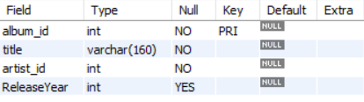

(Q11) Chinook is interested in understanding the purchasing behaviour of customers based on their geographical location. They want to know the average total amount spent by customers from each country, along with the number of customers and the average number of tracks purchased per customer. Write an SQL query to provide this information.

ANS- I run the following query to get country-wise customer purchasing behaviour output.

Query-
WITH customer_summary AS (
SELECT
i.customer_id,
SUM(i.total) AS total_spent,
SUM(il.quantity) AS tracks_purchased
FROM invoice i
JOIN invoice_line il
ON i.invoice_id = il.invoice_id
GROUP BY i.customer_id
)
SELECT
c.country,
COUNT(DISTINCT c.customer_id) AS num_customers,
ROUND(AVG(cs.total_spent), 2) AS avg_spent_per_customer,
ROUND(AVG(cs.tracks_purchased), 2) AS avg_tracks_per_customer
FROM customer c
JOIN customer_summary cs
ON c.customer_id = cs.customer_id
GROUP BY c.country
ORDER BY avg_spent_per_customer DESC;

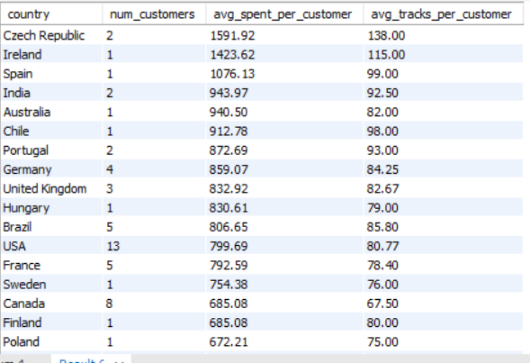

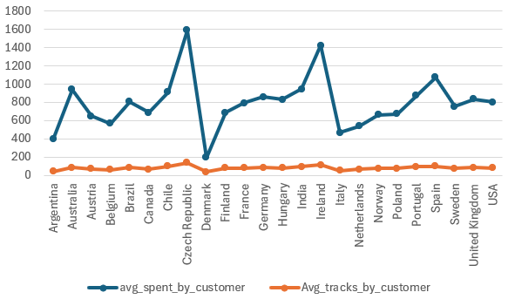

Insights-
- Czech Republic, Ireland, and Spain are the top 3 countries with the highest average spending per customer and highest average tracks per customer, showing strong customer value in these regions.

- The USA has the highest number of customers (13), followed by Canada (8), France (5), and Brazil (5), showing that USA is the biggest market in terms of customer base.

- Customer spending varies across different countries, showing clear geographical differences in purchasing behaviour.
- Some countries have higher average spending per customer, means customers from those regions contribute more revenue.

- Countries with more customers do not always have higher average spending per customer.

- Average tracks purchased per customer helps understand how actively customers are buying music in each country.

- Some regions show high engagement (more tracks purchased) but moderate spending.

Recommendations-
- Focus on USA for scaling revenue since it has the largest customer base.

- Prioritize top high-performing countries like Czech Republic, Ireland, Spain, India, etc for business expansion and campaigns.

- Focus marketing efforts on countries with higher average spending per customer to maximize revenue.

- Run targeted offers in low-spending countries to improve customer value.

- Design country-wise marketing strategies based on customer behaviour patterns.
- Use discounts or bundles or rewards to increase track purchases in low-engagement regions.

…………………………………THANK-YOU……………………………….

