RETAIL SALES
Data Cleaning & Business Insights Report
Task 02 — Data Cleaning & Business Insights
Prepared June 2026

1. Executive Summary
This report documents the end-to-end cleaning of a raw retail sales export and the business insights derived from the cleaned data. The source file contained 1,250 transaction records spanning January 2024 to June 2025, collected across 7 product categories, 4 regions, and 5 payment methods.
The raw data exhibited common real-world data quality issues: missing values across nearly every column, exact and partial duplicate records, inconsistent text casing and formatting, multiple date formats, and a small number of extreme outliers caused by data entry errors. After cleaning, the dataset was reduced to 1,199 valid, de-duplicated, standardized records ready for analysis.
₹1,28,34,430  Total Revenue | 1,199  Total Orders | ₹10,704  Avg Order Value | 4.01 / 5  Avg Rating

2. Data Cleaning Process

2.1 Missing Value Handling
Missing values were present across nearly every column in the raw export. Each was handled using a method appropriate to that field rather than a single blanket rule:
- Revenue and Unit Price: where one was missing but enough information existed (price, quantity, discount), the missing value was recalculated from the other fields rather than dropped.
- Quantity: missing values were imputed using the median quantity for that product category, since order size varies by category.
- Discount Percent: missing values were filled with 0%, the most common (modal) value in the dataset, representing "no discount applied."
- Category, Region, City, Payment Method: missing values were labeled "Unknown" rather than dropped, preserving the row for revenue analysis while flagging it for follow-up with the source system.
- Customer Rating: left as missing where genuinely not provided (a customer choosing not to rate is meaningful), and a HasRating flag column was added so analysts can filter ratings-based metrics correctly.
- 1 row(s) were dropped outright — these had no price and no revenue, making the transaction value unrecoverable.

2.2 Duplicate Removal
The raw file contained 35 fully exact duplicate rows and 15 additional rows sharing an Order ID with another record (re-entries differing only in name casing/whitespace — a common symptom of repeated manual entry or a failed retry during export). All duplicates were removed, keeping the first occurrence of each Order ID.

2.3 Data Formatting & Standardization
Several fields had inconsistent formatting that would silently break any group-by analysis if left as-is:
- Text casing: Category, Region, and Payment Method values appeared in mixed case (e.g. "electronics", "ELECTRONICS", "Electronic") and were mapped to a single canonical label per category.
- Whitespace: leading/trailing spaces in names and city fields (e.g. " Meena Choudhary ") were stripped.
- Dates: Order Date appeared in five different formats (YYYY-MM-DD, DD/MM/YYYY, MM-DD-YYYY, DD-Mon-YYYY, YYYY/MM/DD) across different rows — likely from multiple export sources or regional settings. All dates were parsed and standardized to ISO format (YYYY-MM-DD).
- Customer names and cities were standardized to title case for consistent reporting.

2.4 Outlier Detection
Outliers were detected using the Interquartile Range (IQR) method, with price and revenue evaluated per product category — since a high-end Electronics order and a high-end Books order represent very different things, a single global threshold would have wrongly flagged most electronics sales as outliers.
Field | Method | Outliers Flagged | Notes
Unit Price | IQR per category (1.5×) | 7 | Mostly data-entry pricing errors (~50× normal price)
Revenue | IQR per category (1.5×) | 93 | Largely legitimate high-quantity/high-value orders, flagged for review not removal
Quantity | IQR global (1.5×) | 72 | 4 impossible bulk orders (500 units) corrected to category median

Negative values were also corrected: 5 rows had a negative Unit Price and 4 rows had negative Revenue, both clear sign-entry errors. These were corrected to their absolute value rather than dropped, since the rest of the row's data was usable.
Rather than deleting all flagged outliers, each affected row carries a boolean flag column (UnitPrice_outlier, Quantity_outlier, Revenue_outlier) in the cleaned dataset. This lets analysts decide whether to include or exclude them per analysis, instead of silently losing potentially legitimate high-value transactions.

2.5 Cleaning Summary
Metric | Value
Raw rows | 1250
Exact duplicates removed | 35
Order ID duplicates removed | 15
Rows dropped (unrecoverable) | 1
Final clean rows | 1199
Columns in final dataset | 16 (12 original + 4 QA flag columns)

3. Business Insights

3.1 Revenue by Category
Electronics dominates total revenue at ₹80,40,841 from just 166 orders — driven by a high average order value of ₹48,439, roughly 4-20x higher than every other category. Home & Kitchen is a distant second.
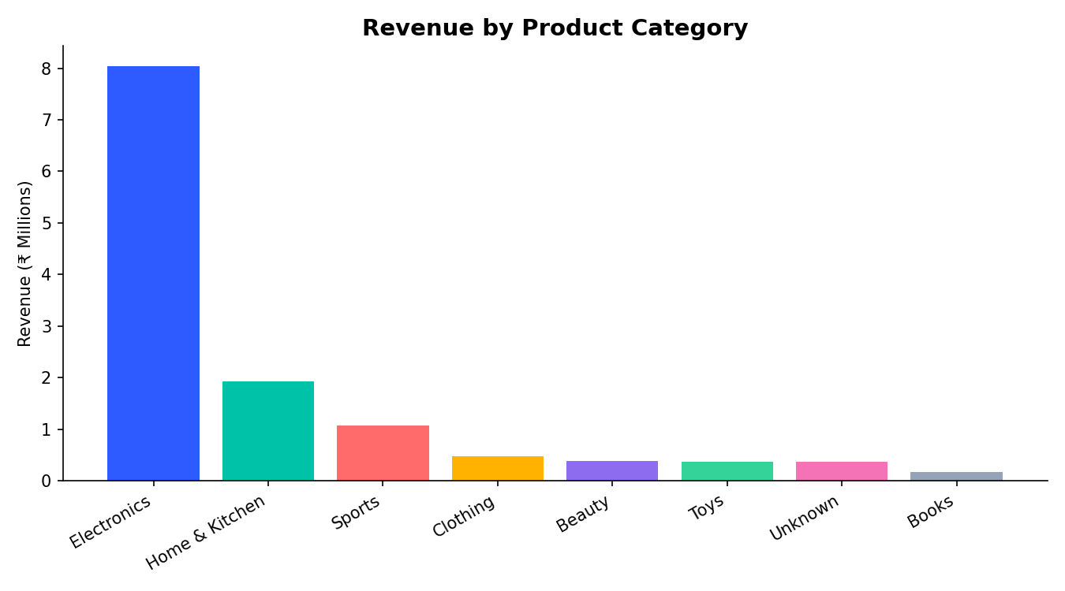
- Highest average order value: Electronics — high-ticket items drive outsized revenue per transaction.
- Lowest average order value: Books — high order count but low basket size; a candidate for bundling or upsell strategies.

3.2 Revenue by Region
Revenue is fairly evenly distributed across all four regions, with North and West marginally ahead. This suggests demand is not geographically concentrated — useful for inventory and logistics planning, as no single region requires disproportionate stock allocation.
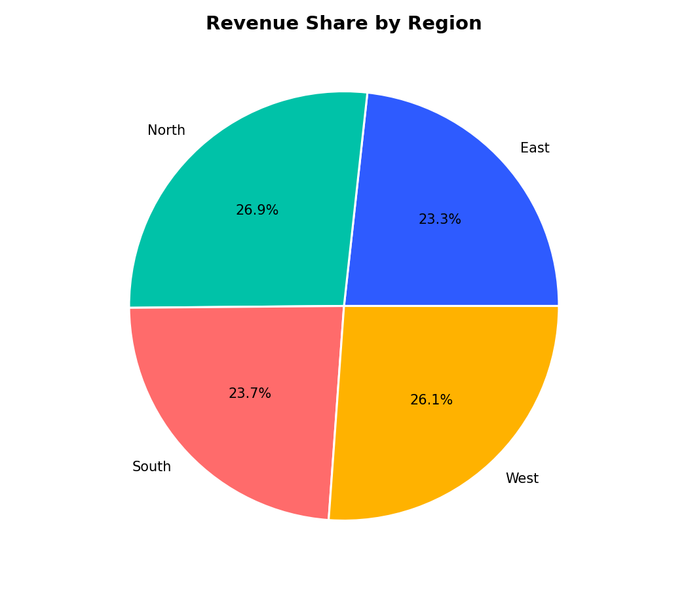

3.3 Monthly Revenue Trend
Revenue fluctuates month to month without a strong seasonal pattern, with notable peaks in March and October of 2024. The partial 2025-06 figure reflects an incomplete month in the dataset rather than a real decline.
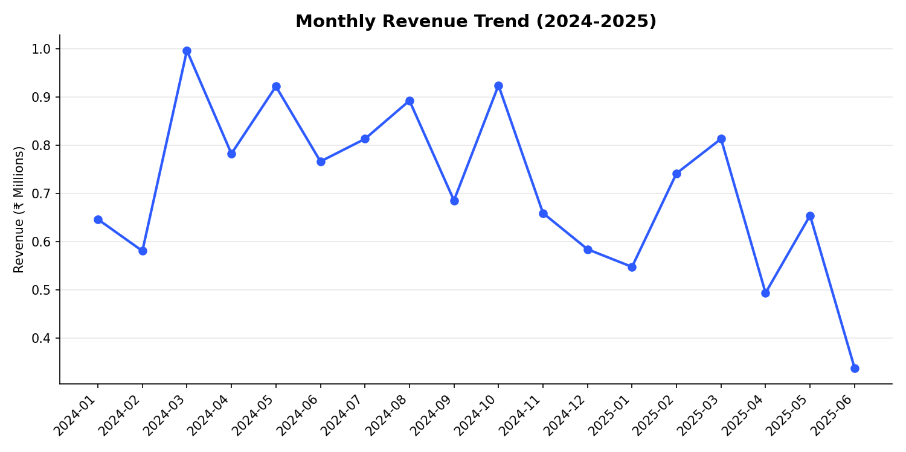

3.4 Payment Method Preferences
Cash on Delivery remains the leading payment method by revenue (₹31,83,622), narrowly ahead of Net Banking and UPI. Digital payment methods (UPI, Net Banking, Credit/Debit Card) combined account for the majority of revenue, indicating room to incentivize a further shift away from COD — which typically carries higher fulfillment cost and payment risk for the business.
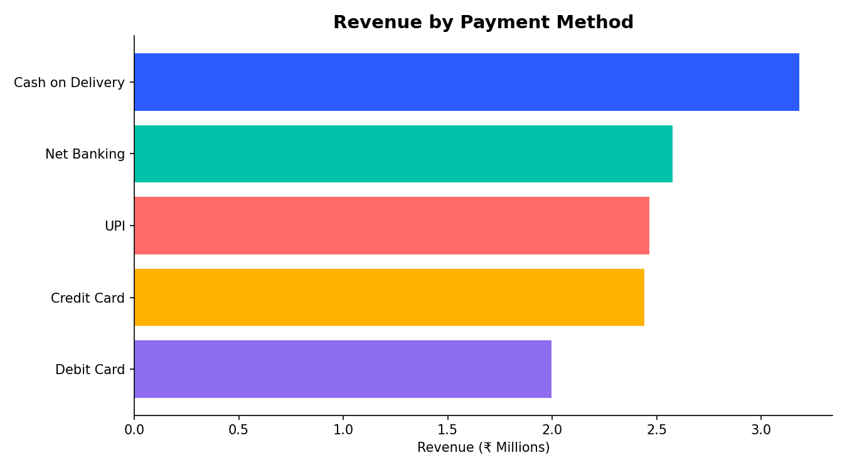

3.5 Customer Satisfaction vs. Revenue
Average order revenue rises with customer rating up to 4 stars, then dips slightly at 5 stars — suggesting satisfaction is not purely a function of how much a customer spends. Orders rated 1-2 stars still generate substantial average revenue, meaning low ratings are likely driven by service or product issues rather than price dissatisfaction.
Rating | Avg Revenue per Order
1 ★ | ₹8,095
2 ★ | ₹8,123
3 ★ | ₹8,724
4 ★ | ₹12,009
5 ★ | ₹10,923

3.6 Top Performing Cities
The top 10 cities by revenue are led by Kochi, followed by Lucknow and Bhubaneswar — a spread across South, North, and East regions rather than concentration in traditional metro hubs like Mumbai or Bengaluru. This is a useful, less-obvious signal for targeted regional marketing.
City | Revenue
Kochi | ₹13,09,308
Lucknow | ₹9,80,449
Bhubaneswar | ₹9,64,445
Jaipur | ₹9,57,517
Chandigarh | ₹9,54,300
Ahmedabad | ₹8,66,128

4. Key Recommendations
- Double down on Electronics merchandising and stock depth — it drives the large majority of revenue from a relatively small order count, so even small improvements in conversion or basket size here have outsized impact.
- Investigate the Books and Toys categories for bundling, cross-sell, or minimum-order-value promotions to lift their low average order value.
- Run a structured campaign to migrate Cash-on-Delivery customers to digital payment methods (e.g. a small UPI cashback) to reduce fulfillment risk and cost.
- Audit the data pipeline feeding this export — the volume of missing values, mixed date formats, and duplicate Order IDs suggests multiple source systems or manual re-entry steps that should be consolidated.
- Treat rows flagged as outliers (especially the 7 price outliers showing ~50× normal pricing) as a priority data-quality ticket with the source team, since these likely reflect a unit-of-measure or currency entry bug rather than real pricing.
- Investigate low-rating (1-2★) orders specifically for service/fulfillment issues, since revenue data shows these aren't simply low-value or discount-driven purchases.

5. Methodology Note
All cleaning steps were performed programmatically (Python/pandas) and are fully reproducible via the accompanying script (clean_data.py) and logged in cleaning_log.json. No manual row-by-row edits were made, ensuring the process can be re-run on future data exports with the same logic.

